Assignment to detect people and track them throughout the view

1. Libraries used in code
- centroidtracker
- trackableobject
- imutils
- numpy
- dlib
- opencv2
- argparse

2. Execution time of code (CPU and GPU division): Execution time: 1.9073486328125e-06, Frame per second: 23.12, Total spend time: 36.08

3. Code refactoring and optimization: One user define function is being created “human_detect_track” which performs all the operation under this function as detection, creating object ID, tracking human which is used to count the total unique human and count total human moving left and right side direction. The application is developed it will worked as it, only changes can be done in a direction section.

4. Data structure is used as array list and dictionary. The below is the algorithm of human detection and tracking.

Algorithm: Human Detection and Tracking with counting total no of unique humans
 | Input: real time video of movie object.
 | Output: Unique Human detected with tracking ID, Total no of unique human detected, Total no of moving human at left side direction, and total no of human moving right side direction.
1. | Create list of classes for object detection as person, bus, sofa, cup etc.
2. | Read a pre trained caffemodel and prototxt net file for detecting person.
3. | Initialize a variable weight=none and height=none of frame, totalframe =0, totalleft=0, totalright=0, frame_per_second.
4. | Initialize empty list x=[], empty[], empty2nd=[],trackers=[],bounding_rect=[]
5. | Initialize empty dictionary trackableObjects ={}
6. | Pass input realtime video of moving humans and start the frame per second time.
7. | While (True) do
 |  | Grabe the next frame to read in the video and handle it.
 |  | if (input video is not none and frame is none) then
 |  |  | Break, video has reached to end frame can not grab.
 |  | Resize the frame with size width=500 pixels, and convert to BGR to RGB.
 |  | if (frame dimensions is empty width and height is none) then
 |  |  | Set the frame shape.
 |  | Initialize status = waiting
 |  | if (can run a more computationally expensive object detection method in tracker) then
 |  |  | Status= detecting and initialize a new set of object trackers =[]
 |  |  | convert the frame to a blob and pass the blob through the network and obtain the detections.
 |  |  | for (loop the detections) do
 |  |  |  | extract the confidence (i.e., probability) associated with the prediction.
 |  |  |  | if (confidence > argument of confidence) then
 |  |  |  |  |  | extract the index of the class label from the detections list.
 |  |  |  |  |  | if (class label is not a person) then
 |  |  |  |  |  |  |  | continue
 |  |  |  |  |  | compute the (x, y)-coordinates of the bounding box for the object as startx, starty, endx and endy
 |  |  |  |  |  | construct a dlib rectangle object from the bounding box coordinates and then start the dlib correlation tracker.
 |  |  |  |  |  | add the tracker to a list of trackers so that it can be utilize it during skip frames.
 |  | else
 |  |  | Otherwise, it should utilize the object *trackers* rather than object *detectors* to obtain a higher frame processing throughput.
 |  |  | for (tracker in trackers) do
 |  |  |  | set the status of system to be 'tracking' rather than 'waiting' or 'detecting'
 |  |  |  | update the tracker and grab the updated position.
 |  |  |  | unpack the position object as startx as left position, starty as position top, endx as position right and endy as bottom position.
 |  |  |  | Insert the bounding box coordinates to the rectangles list as bounding_rect.
 |  | use the centroid tracker to associate the (1) old object centroids with (2) the newly computed object centroids.
 |  | for (objectid, centroid in objects) do
 |  |  | if (trackable object exists for the current object ID and there is no existing trackable object) then
 |  |  |  | Create a trackable objects as trackable humans.
 |  |  | else
 |  |  |  | otherwise, there is a trackable object so we can utilize it to determine direction.
 |  |  |  | the difference between the y-coordinate of the *current* centroid and the mean of *previous* centroids will tell in which direction the object is moving (negative for 'Left' and positive for 'right'.
 |  |  |  | if (object is counted or not) then
 |  |  |  |  | if (direction < 0 and centroid is above the center line) then
 |  |  |  |  |  |  | totalright = totalright+1 and insert it into a empty, and count the object as unique human right side
 |  |  |  |  | if (direction > 0 and centroid is below the center line) then
 |  |  |  |  |  |  | totalleft=totalleft+1 and insert it into a empty2nd, and count the object as unique human left side.
 |  |  |  |  | Now compute the sum of total unique people in the video.
 |  |  | store the trackableObjects in the dictionary with unique id, and draw both the ID of the object and the centroid of the object on the output frame.
 |  | Display all the output as total left side, right side moving unique human, and total no of unique humans with id.
 |  | increment the total number of frames processed as totalframe thus far and then update the FPS counter.
8. | Stop.

5. Steps to run the applications

- Install all the required Python dependencies: pip install -r requirements.txt
- Run inference on a test video file, head into the directory/use the command: python run.py --prototxt mobilenet_ssd/MobileNetSSD_deploy.prototxt --model mobilenet_ssd/MobileNetSSD_deploy.caffemodel --input videos/test1.mp4
- After it it display the below output by following above algorithm
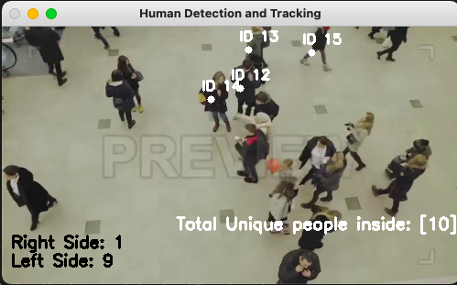
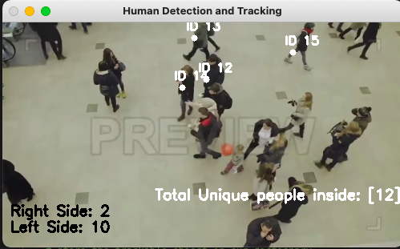

6. For detecting human, SSD Object Detection model has been applied which extracts feature map using a base deep learning network, which are CNN based classifiers, and applies convolution filters to finally detect objects. The above application implementation is using MobileNet as the base network in which Caffe is a deep learning framework. Caffe was developed as a faster and far more efficient alternative to other frameworks to perform object detection. Caffe can process 60 million images per day with a single NVIDIA K-40 GPU. That is 1 ms/image for inference and 4 ms/image for learning. SSD model weights and prototxt is being used in which input shape dimensions, convolution layer with parameters and activation function as relu is being define.
7. The above algorithm implementation is performing at accuracy 92-95% with using the given input video file. It still needs some improvements in the algorithm so that a unique human detections can perform well and assign a unique ID to every human in the video, because till now in the implemented algorithm blur humans are not able to detected so it unable to assign ID to blur humans which should need be to improve.

Reference
The data source has been taken from SSD Object Detection in Real Time (Deep Learning and Caffe) https://github.com/FreeApe/VGG-or-MobileNet-SSD
The above algorithm is taken from https://github.com/mailrocketsystems/AIComputerVision. And modifying the implementations as identifying unique human and also to count total number of unique human and total number of left and right side moving humans.

