**Assignment-1 Questions:**

**(Note: All answers should include an attached screenshot as proof of execution)**

1. What does CLI stand for, and how does it differ from GUI?

Ans:

CLI stands for **Command-Line Interface.**

| **Feature** | **CLI (Command-Line Interface)** | **GUI (Graphical User Interface)** |
| --- | --- | --- |
| **Interaction** | Text-based commands | Visual elements (buttons, icons, menus) |
| **Ease of Use** | Requires knowledge of commands | User-friendly and intuitive |
| **Remote Access** | Can be accessed via SSH remotely | Requires remote desktop tools |
| **Customization** | Highly customizable through scripts | Limited customization options |
| **Examples** | Bash, PowerShell | Windows, macOS |

1. Open a terminal and execute a simple command such as **echo "Hello**". Can you perform a similar action in a GUI? What are the advantages of using a CLI compared to a GUI?

Ans:

In Terminal

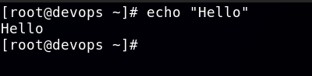

In GUI

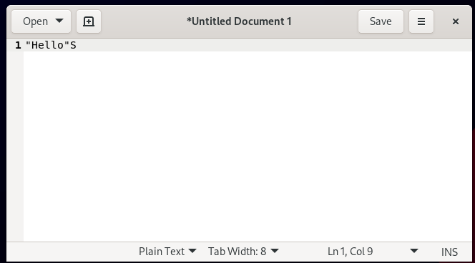

1. To convert a minimal CLI-based Linux interface into a GUI-based one, which packages are typically required? Find them

Ans:

rpm -qa | grep -E 'xorg|gnome|kde|xfce|lxde|plasma|lightdm|gdm|sddm'

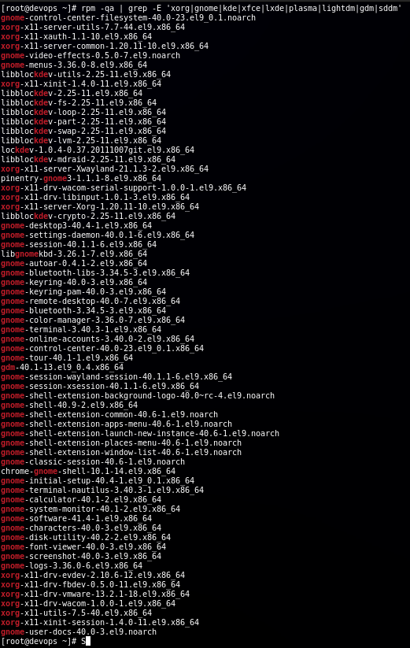

These are all the packages that are required to access the packages that are required to convert a minimal CLI-based Linux interface into a GUI-based one

1. What are terminals in Linux? How many virtual terminals are available on your system, and which key combination is used to access them?

Ans:

A terminal in Linux is a text-based interface that allows users to interact with the operating system by entering commands. It provides access to the shell, which executes commands.

Linux supports two types of terminals:

1. Virtual Terminals (TTYs)
2. Pseudo Terminals (PTs)

Linux provides **6 virtual terminals (TTY1 to TTY6)** by default

Ctrl + Alt + F1 to access TTY1

Ctrl + Alt + F2 to access TTY2

Ctrl + Alt + F3 to TTY3, and so on up to F6

1. Write the commands to check a file and a directory in a long listing format. How can you determine whether it is a file or a directory?

Ans:

The Command is “ ls -l <path>“. It is used to get the list of all the directories and files in long list format

The “ **d** ” at the start of each row shows that it is a Directory and “ – “ tell us that it is a File

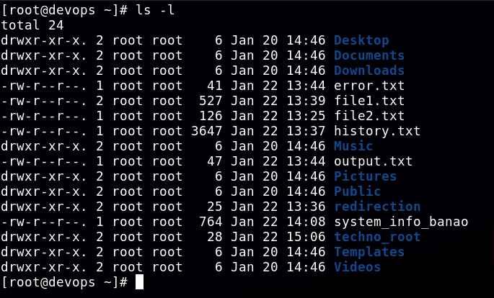

1. Which Linux commands are used to view the content of files and directories? Write the commands.

Ans:

The command that is used to view the content of the file is “ls <path>”. It give us the list of all available files and directory in the certain directory

The command “cat <filename>” is used to print the content of the entire file unto the terminal

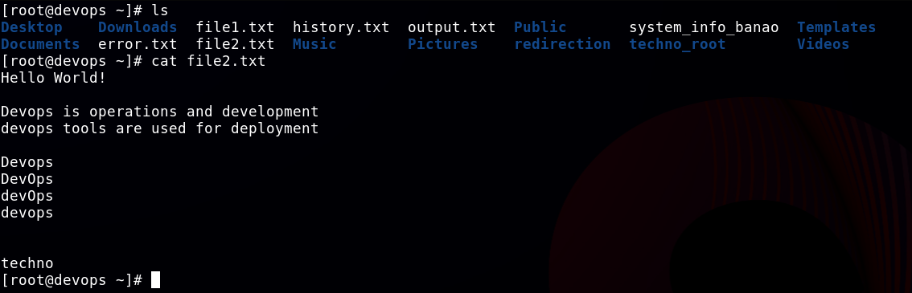

1. Change your current location to the **/etc/yum.repos.d** directory.
   * 1. Using the relative path method, create a file named **xyz.repo** under **the /etc/yum.repos.d/** directory.
     2. Using the absolute path method, create a file named **xyz.conf** under the **/etc/rsyslog.d/** directory.
     3. What differences did you observe between using a relative path and an absolute path?

Ans:

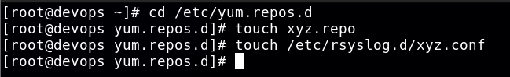

The Major Difference between using the Absolute path and relative path is that if we are already present in a directory, and we want to create the file , we have to give path Relative to the location. But if we Use absolute path we don’t have to worry about the current working directory, and we can just give the path of the file from the start “/”

1. List all files, including hidden ones, in the **/usr/bin/** directory with details like file permissions. Save the output to a file named **output.txt** in the **/mnt** directory. Write the command.

Ans:

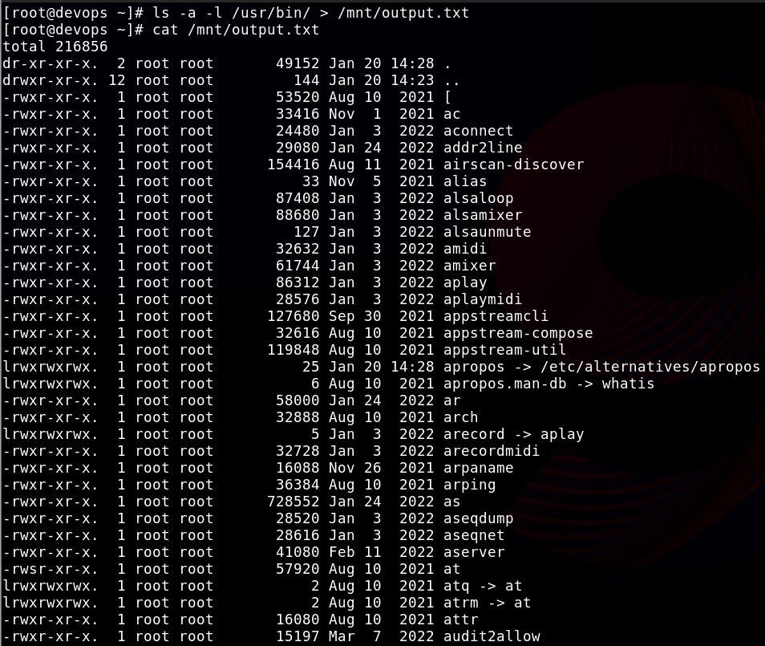

ls -a -l /usr/bin/ > /mnt/ouput.txt

1. Create the parent directories **/Techno/Udaipur/Rajasthan/India/Asia/Earth/Solar** using one command. Then, check the full structure with details in a long listing format. Write the commands.

Ans:

mkdir -p /Techno/Udaipur/Rajasthan/India/Asia/Earth/Solar

ls -lR /Techno

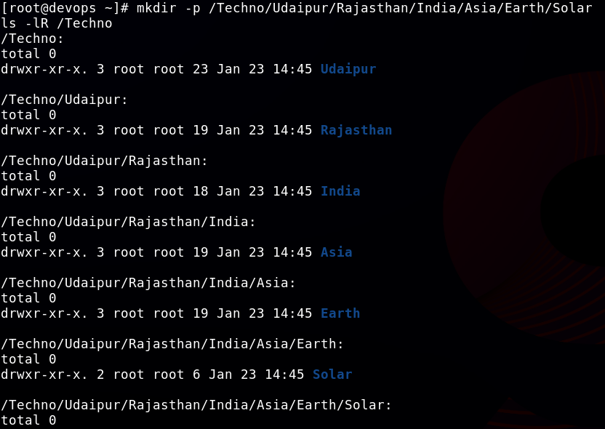

1. Create a file named “**Poem”** under the **/Techno/Udaipur/Rajasthan/** directory. Write the text **"Twinkle Twinkle Little Star"** into the file and save it. Perform all actions using the absolute path method.

Ans:



Touch /Techno/Udaipur/Rajasthan/Poem

echo "Twinkle Twinkle Little Star" > /Techno/Udaipur/Rajasthan/Poem

cat /Techno/Udaipur/Rajasthan/Poem

1. Delete the **/Techno/Udaipur** directory, including its contents, using a single Linux command. Write the command.

Ans:

rm -rf /Techno/Udaipur

ls -l /Techno

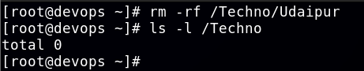

1. How can you view the manual page for the useradd command? From the manual page, identify which files are important for user administration.(Hint: Check the 'Files' Section)

Ans:

man useradd

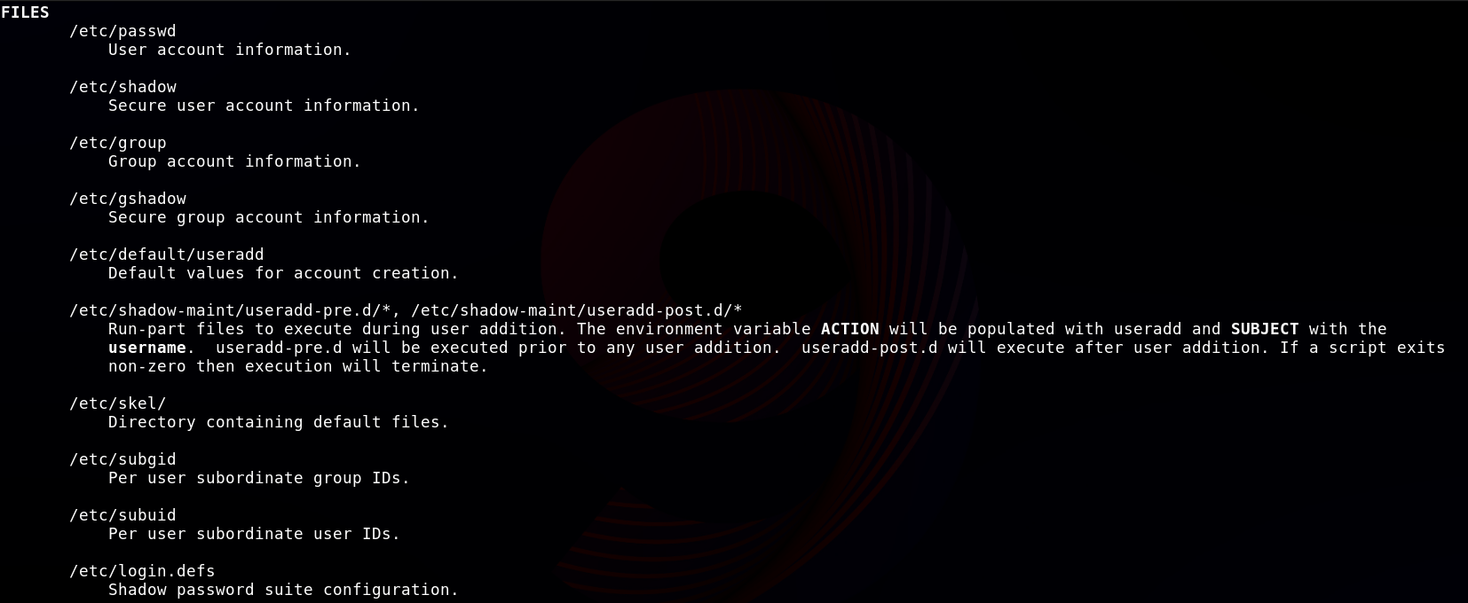

1. You have two files: **Fruits.txt and Vegetables.txt**, each containing related content.
   * 1. Write content in fruits.txt using **vi.** (EX: **mango, apple, kiwi, grapes, cherry)**.
     2. Write content in vegetables.txt using **nano.** (Ex: **potato, tomato, onion, chilli, garlic**).
     3. the single command to Combine the contents of both files into a single file named **vegetarian** and display its content.

Ans: 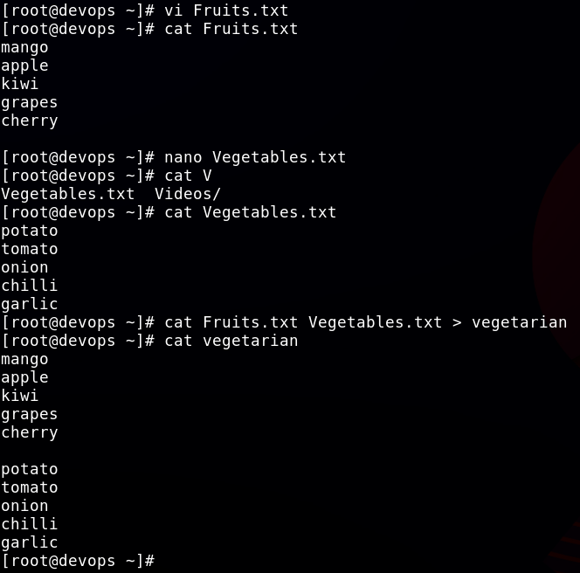

1. Write the command to copy all files, including related sub-files, from **/var** to a new location **/tmp/data/.** The output should be displayed during the copying process.

Ans:

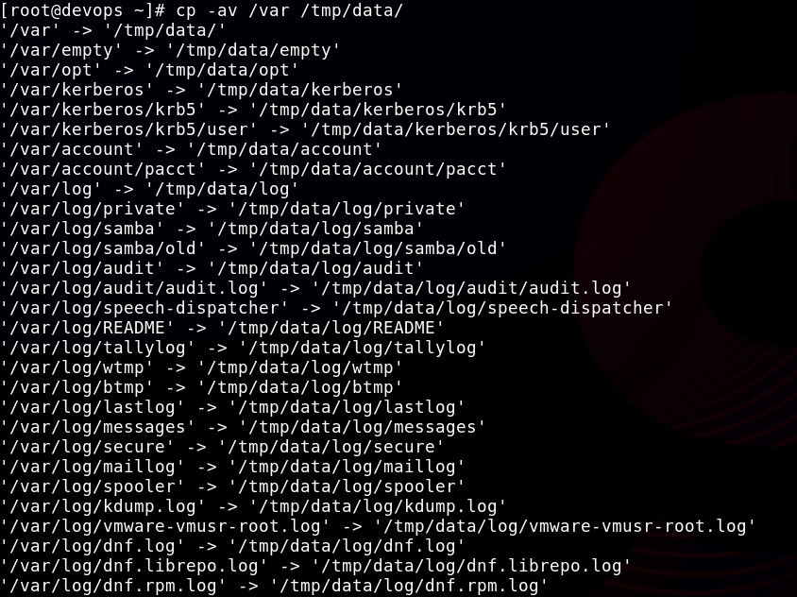

It gave a long output as multiple files were copied to /tmp/data

1. Rename the **file “Vegetrian.txt”** to **“Veg.txt”.** Write the command.

Ans:

mv Vegetrian.txt Veg.txt\

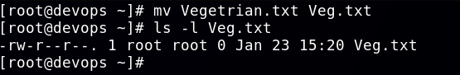

1. Open the file **“/etc/passwd** and locate the following lines using less and more:
   * 1. Search for the text "**Root**" using the less command.
     2. Search for the word "**root**" using the grep command.
     3. What is the use difference between more and less commands?

Ans:

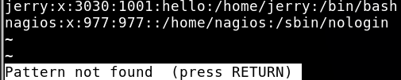

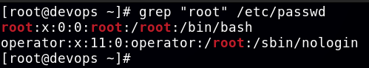

Use more when you just need to read forward in a file quickly.

Use less when you need to navigate, search, and analyze files in detail.

1. Perform the following tasks and write the commands to achieve them:
   * 1. Display the **top 7th** line of the /etc/passwd file.
     2. Display the **last 3** lines of the /etc/group file.
     3. Display the lines **11th to 15th** from the /etc/shadow file using a pipeline.
     4. Display **only the 16th** line of the /etc/passwd file.

Ans:

head -8 /etc/passwd | tail -1

tail -3 /etc/group

head -15 /etc/shadow | tail -5

sed -n '16p' /etc/passwd

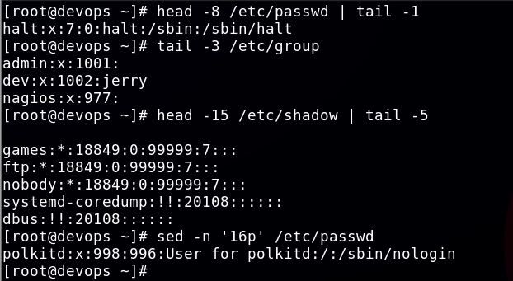

1. Perform the following tasks using the **grep** command on the **/etc/passwd** file:
   * **a.** Write a command to match and display lines containing the word **/sbin/nologin.**
   * **b.** Write a command to match and display lines containing the multiple words (**root, sbin,** and **/home**) simultaneously, ignoring typographical case errors. Save the output for all three matches into the file **/root/test**. Without loosing data.

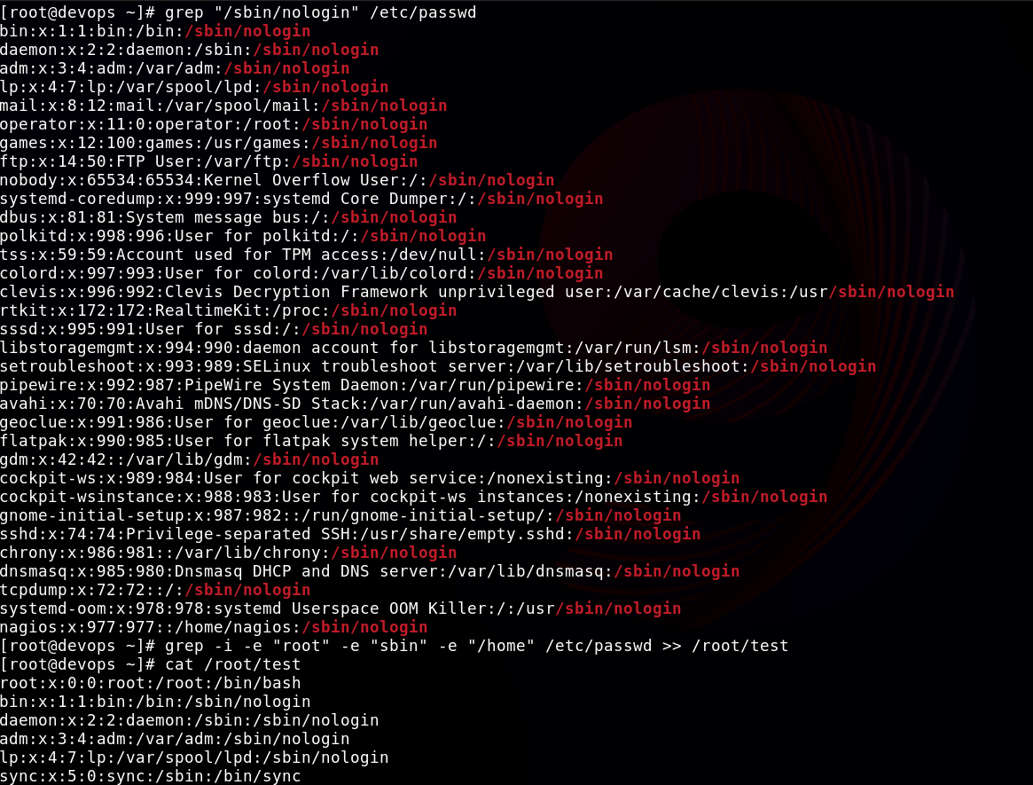

1. Replace Text Using **sed** Linux Commands
   * 1. Write the command to replace the word **localhost** with **localhost.localhost** in the file **/etc/hosts** without opening the file in an editor.
     2. The **/var/log/audit/audit.log** file contains audit log messages, some of which include the word “**success.”** Write the command to count how many lines contain the word success.

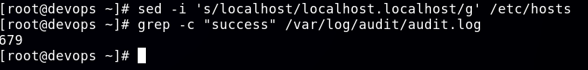

1. Create a directory named “**demo”** on “**/root**”.
   * 1. Create a file “**RedHat**” under the “demo” directory.
     2. Run the command “**vimtutor**” and save the output to the “RedHat” file.
     3. Now create a soft link of “RedHat” to “/etc/” location.
     4. Create a hard link of /var/log/messages to /etc/log.

