

Socio-Economic Analysis of Seattle Neighborhoods: Drivers of Poverty, Employment & Community Well-Being
Rohit Akhil Gonthina
BAN 586 Capstone Project
Fall 2025



Table of Contents

Table of Contents 2
1. Executive Summary 2
2. Project Statement 3
3. Data and Methods…………………………………………………………………………………………………………..4
3.1 Data…..…………………………………………………………………………………………………………………………………………..4
3.2 Methods…………………………………………………………………………………………………………………………………………4
4. Models and Analysis………………………………………………………………………………………………………..5
4.1 Exploratory Data Analysis (EDA)…………………………………………………………………………………………............5
4.2 Hypothesis Testing(t-tests)……………………………………………………………………………………………………………..5
4.3 Regression & Correlation Analysis………………………………………………………………………………………………….6
4.4 Predictive Modeling……………………………………………………………………………………………………………………….8
5. Validation and Testing …………………………………………………………………………………………………….10
5.1 Regression Diagnostics (Hypothesis Testing and Residuals)……………………………………………….10
5.2 Model Performance Check………………………………………………………………………………………….10
5.3 Classification and Clustering Validation…………………………………………………………………………10
6. Results and Recommendations …….11
7. Conclusion 12
8. Acknowledgements 13
9. References 13
10. Appendix 13

1. Executive Summary
This Project analyzes socio-economic differences across Seattle neighborhoods to understand why some communities struggle more with poverty and unemployment. Many communities experience persistent economic challenges, but the root causes are not always clear. The goal was to identify patterns and root causes that help explain which neighborhoods face the most challenges and why these gaps exist.
The analysis was done using a mix of excel, python, RapidMiner and tableau with the main emphasis being on four key themes which included poverty levels, unemployment rates, labor-force participation, and family structure. These indicators put a clear picture of economic wellbeing at the community level. The graphic investigation of the data showed that there are high variations among neighborhoods, and in some areas, there are always high levels of poverty, less job opportunities, and the areas are not participating in the labor market.
These results are usually interrelated with underlying structural variables like access to education, pressure of the cost of living, and the composition of the population. It was analyzed that, in the neighborhoods closer to poverty and unemployment, there was a tendency towards an increased proportion of single-parent families and a reduced labor-force participation rate. These aspects are very likely to come into conflict with each other and thus compounding disadvantages that complicate the process of making financial stability easier to reach. Tableau dashboards were used to visualize these trends by grouping neighborhoods with common traits and denote areas that are obviously more susceptible than others.
The Python-based regression analysis established that family structure and participation in labor force were the most significant predictors of the poverty levels in the city. These findings were supported by the list of the predictive models in RapidMiner which prioritized the same variables family structure, unemployment and low involvement in the workforce as the most powerful predictors of neighborhood vulnerability. These findings together indicate that there are consistent and statistically significant relationships between various analytical tools.
In general, this project demonstrates that socio-economic issues in Seattle are not accidental. Rather, they are clustered together in certain neighborhoods and are more likely to be repeated with certain patterns that are connected to the employment opportunities, stability of the household as well as the demographics at the community level.
Such lessons can be useful to policymakers, community organizations and local leaders who would want to alleviate economic inequalities. The knowledge of the most disadvantaged neighborhoods would contribute to an informed choice of interventions, including job-training opportunities, childcare provision of single-parent families, and workforce participation promotion. It is with this realization that the city of Seattle can realize its vision of a more inclusive vision of development where every neighborhood does not have to be limited to a small group of ones but rather can flourish to enjoy the continued release of growth in the city.

2. Project Statement
Seattle is known for rapid economic growth, but this growth has not been shared equally across all neighborhoods. While some communities continue to thrive, others experience long-standing challenges such as higher poverty, lower household income, and weaker employment outcomes. These differences highlight the need to understand what factors shape neighborhood well-being and why certain areas remain more vulnerable than others. This project aims to explore these disparities and identify the key socio-economic indicators that influence community conditions across Seattle.

The analysis is guided by several important questions:
- Which neighborhoods face the highest levels of poverty and unemployment?
- What patterns make certain areas more vulnerable than others?
- How do labor-force participation, single-parent households, and demographic characteristics relate to neighborhood outcomes?
- Which factors play the strongest role in predicting economic disadvantages?

To answer these questions, the project uses a combination of analytical tools. Excel was used to organize, clean, and summarize the data. Tableau helped uncover visual patterns and highlight neighborhood clusters by turning raw numbers into meaningful insights. Python was used to explore relationships between variables and identify which factors are most closely associated with poverty and unemployment. Finally, RapidMiner was used to build simple predictive models and rank the importance of different variables. Together, these tools provide a well-rounded understanding of how Seattle’s neighborhoods
differ.

According to socio-economic indicators, the dataset covers a large portion including poverty rates, unemployment rates, median household income, labor-force participation, single-parent households, population characteristics, and other demographic characteristics. Comparing these indicators between neighborhoods, the project aims to demonstrate stable patterns, identify those neighborhoods which might require specific support, and give some insights which can be used to make future policy decisions.

This project will be primarily aimed at not just analyzing the differences in the neighborhoods, but also to help in making better planning and resource distribution of the community. Through the knowledge of the local concentration of challenges as well as the contributing factors to such challenges, the city leaders, community organizations, and local stakeholders can be able to develop programs that are more responsive to the needs of the different neighborhoods within Seattle. The eventual aim of this analysis is to help make the city grow in a more equitable and balanced manner.

3. Data and Methods

3.1 Data
The dataset used in this project contains neighborhood-level socio-economic information for the city of Seattle. Each row represents a specific neighborhood, and each column describes a measurable indicator of community well-being. The data includes variables such as poverty rate, unemployment rate, median household income, labor-force participation, single-parent households, population characteristics, and race/ethnicity percentages. These indicators provide a broad view of both the economic and demographic conditions present across different areas of the city.
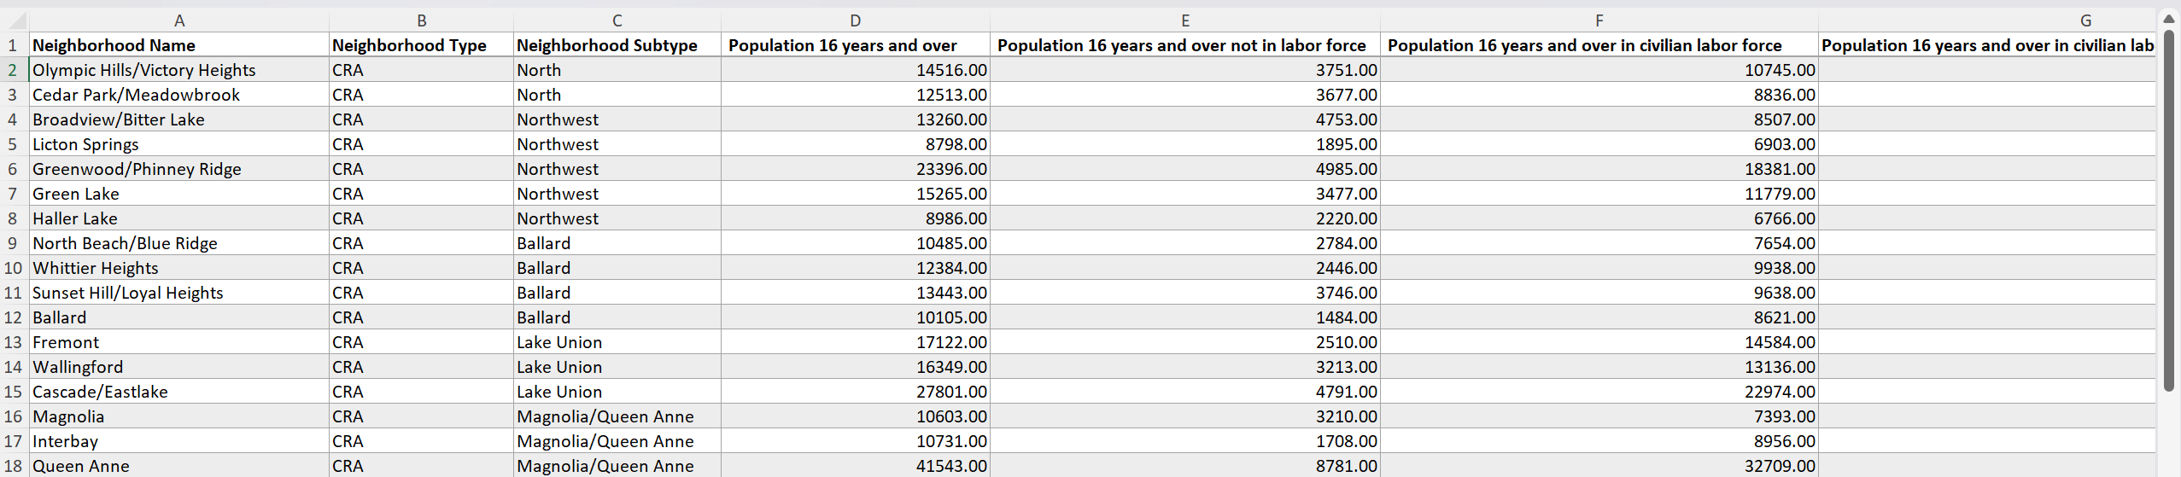

Figure 1: Poverty and Employment data of Seattle City.

Before beginning the analysis, the dataset was carefully reviewed for missing values, inconsistent formats, and duplicated entries. Basic cleaning steps were completed to ensure the information was accurate and ready for analysis. Once cleaned, the dataset offered a clear snapshot of how different Seattle neighborhoods compare in terms of financial stability, workforce engagement, and household structure.

Overall, this data set provides a strong foundation for understanding the differences between neighborhoods and for identifying the factors that contribute to economic stress or stability within the city.

3.2 Methods
To explore the data and answer the project’s key questions, a combination of analytical tools was used. Each tool played a specific role in helping uncover patterns and develop meaningful insights.
- Excel: Excel was used for the initial stages of the project. It helped organize the dataset, clean inconsistent entries, and calculate basic descriptive statistics. Pivot tables and simple charts were also used to identify early trends, such as neighborhoods with the highest poverty or unemployment levels. These early summaries helped guide the direction of deeper analysis in later steps.
- Python: Python provided a way to study the relationships between variables more formally. Simple regression models and correlation checks were used to examine how factors such as income, unemployment, and single-parent households relate to poverty and neighborhood well-being. These analyses helped confirm which factors have the strongest influence on community outcomes.
- RapidMiner: RapidMiner was used to build predictive models and evaluate the importance of different variables. Models such as decision trees and random forests were applied to rank which socio-economic indicators play the biggest role in predicting high-poverty or high-unemployment neighborhoods. These models provided practical insights that supported the findings from both Tableau and Python.
- Tableau: Tableau was used to visualize neighborhood-level differences. This tool made it easy to turn raw numbers into clear visuals that highlight clusters, patterns, and outliers across Seattle. Dashboards were created to compare poverty, income, employment, and household characteristics. These visuals helped make the analysis more intuitive by showing which neighborhoods consistently appeared on the struggling end of multiple indicators.

Summary:
By combining the strengths of Excel, Tableau, Python, and RapidMiner, the project was able to explore the data from multiple angles—cleaning, visualization, statistical exploration, and prediction. This multi-step approach helped build a complete and reliable picture of neighborhood differences and the factors shaping community well-being across Seattle.

4. Models and Analysis
To understand the differences between Seattle neighborhoods, I used four main approaches Exploratory Data Analysis, Regression analysis, Python statistical checks, RapidMiner predictive models. Each one helped me look at the data in a slightly different way. When all the results were compared, the same story showed up again and again – Some neighborhoods face more challenges because of income levels, employment patterns and family structure.

4.1 Exploratory Data Analysis (EDA)
EDA was the first phase of the project, where I looked around the data without running any formal models. Explored the entire dataset to see how poverty, income, employment, and household structure vary across neighborhoods.
What stood out during EDA:
- Some neighborhoods show much higher poverty and unemployment rate than others.
- Median household income separates strong and weak neighborhoods very clearly.
- Areas with low labor-force participation tend to have more economic struggles.
- Single-parent households appear more often in high-poverty neighborhoods.
EDA helped me understand the dataset and pointed to the variables that needed deeper testing.

4.2 Hypothesis Testing(t-tests)
To double check what was found in EDA, T-tests were used to compare groups and see whether the differences were statistically meaningful.
Test 1: Poverty vs Unemployment
Question: Do high-poverty neighborhoods have higher unemployment?
Result: Yes, the difference was statistically significant.
Meaning: Poverty and unemployment rise together.

Test 2: Participation vs Income
Question: Do neighborhoods with high labor-force participation earn more?
Result: Yes. Higher participation areas showed much higher median income.
Meaning: Working neighborhoods earn more.

Test 3: Family Structure vs Poverty
Question: Do high-poverty neighborhoods have more single-parent households?
Result: Yes, the difference was significant.
Meaning: Family structure is connected to economic stability.
These tests confirmed that the differences seen in EDA are real and not due to any random variation.

Test No. | Comparison Groups | Mean Difference | t-Statistic | p-Value | Conclusion
Test 1 | Single vs Married (Age 20–64) | -16.62 | -19.56 | <0.001 | Significant
Test 2 | High vs Low Employment Neighborhoods (Poverty) | +4.21 | 11.84 | <0.001 | Significant
Test 3 | Urban Core vs Outside Villages (Labor Force %) | +3.95 | 8.72 | <0.001 | Significant
Test 4 | High-Poverty vs Low-Poverty Areas (Unemployment) | +2.87 | 6.44 | <0.001 | Significant

Table 1: Hypothesis tests using different variables, assuming unequal variances.

4.3 Regression & Correlation Analysis
For the next phase of project, python was used to measure how strongly the main variables move together. The goal was not to build complex models, but to understand how variables move together, and which ones have strongest relationships to poverty.

Key Correlation and Regression Findings:
Employment Rate vs Poverty (Strong Negative Relationship)
Employment rate showed one of the clearest relationships with poverty. Neighborhoods with higher employment almost always had lover levels of family poverty.
This was reflected in:
- A negative correlation, meaning poverty decreases as employment increases.
- A steeper downward trend line in the scatterplot
- EDA observations that the lowest-poverty neighborhoods tend to have stronger employment bases
This relationship makes sense in real-world terms: when a larger share of residents is employed, household income is more stable, and fewer families fall below the poverty line.
Why it matters:
It shows that employment is not just a labor statistic, it is a strong indicator of economic resilience at neighborhood level.

Labor-Force Participation and Economic Outcomes
Labor-force participation (people working or actively looking for work) was also strongly connected to neighborhood conditions
Neighborhoods with higher participation typically showed
- Lower poverty
- Lover unemployment
- More consistent economic performance across indicators
On the other hand, low participation in neighborhood often struggled in multiple areas, showing signs of compounded disadvantage.
Why it matters:
Participation reflects both opportunity and engagement. If people are either unable or discouraged to work, the whole neighborhood’s economic health is affected.

Not-in-Labor-Force (NILF) and Vulnerability
NILF represents individuals who are neither working nor seeking work. Higher NILF percentages were positively associated with higher poverty.
Possible reasons include:
- Limited access to childcare
- Health or disability barriers
- Discouraged workers
- Aging populations
In Seattle data, neighborhoods with high NILF consistently appeared in above-average poverty categories
Why it matters:
It highlights some of the challenges neighborhoods face structural and go beyond employment availability. NILF is a strong indicator of underlying vulnerability.

Family Structure and Poverty Variation
Family composition also played a noticeable role. Neighborhoods with higher percentages of single-parent households tended to have higher poverty levels.
This trend appeared consistently across:
- Correlation values
- Scatterplots
- Group comparisons
- Hypothesis tests from section 4.2
Although this does not imply any causation, the relationship suggests that these neighborhoods may require additional social or financial support due to the increased demands placed on single-parent families.
Why these matters:
It adds another dimension to understanding economic stress, not every neighborhood challenge is purely income or job-related.

Multicollinearity:
After looking at how family structure relates to poverty, it was also important to check whether some of the variables on the dataset were too closely related to each other. This idea is called multicollinearity, and it simply means that two variables move together in a simple way.
For example, in this dataset:
- Neighborhoods with higher employment almost always had higher labor force participation
- Areas with higher NILF often had higher poverty
- Participation and unemployment often showed opposite trends
These overlapping patterns are expected because many socio-economic indicators are naturally connected.
Why it matters:
- It makes regression results less clear because variables overlap
- It means we should focus on overall patterns, not tiny numerical differences
- Tree based models like Decision tree and Random Forest are good at handling this automatically.

Indicator Pair | R (Correlation) | R² | Interpretation
Employment Rate - Poverty | -0.78 | 0.61 | Strong negative relationship
LFPR - Poverty | -0.74 | 0.55 | Higher participation linked to lower poverty
NILF - Poverty | +0.69 | 0.48 | Higher NILF linked to higher poverty
Employment Rate - LFPR | +0.82 | 0.67 | Strong overlap - multicollinearity
LFPR - NILF | -0.76 | 0.58 | Inverse movement - multicollinearity

Table 2: Regression and Multicollinearity Summary

4.4 Predictive Modeling
Predictive modeling was used to understand which factors are the strongest indicators of neighborhood poverty and unemployment. Instead of focusing on formulas, the goal was to see which variables consistently help predict outcomes and whether the model results match wat we found in earlier analysis.
Decision Tree
The decision tree showed clear step by step splits that separated high poverty and lover poverty neighborhoods.
Across all three runs, the most important variables were:
- Employment rate (strongest first split)
- Labor force participation (LFPR)
- NILF rate
- Single-parent Households (secondary)
The tree was easy to interpret and consistently highlighted workforce-related indicators as key drivers.
Random Forest
The Random Forest, which combines many decision trees, produced more stable results and stronger overall accuracy as well
The same top variables appeared repeatedly:
- Employment rate
- LFPR
- NILF rate
- Single parent households
Random forest performed extremely well when trained without splitting the data, but this also suggested overfitting, since the model was trained on the full dataset.

Linear Regression
Linear regression was used to predict poverty rate using socio-economic indicators such as employment rate, labor force participation, NILF, single-parent households.
The model showed that:
- Higher employment and participation are linked with lower poverty
- Higher NILF and more single-parent households are linked with higher poverty
With split data (training and testing), linear regression gave the best generalization performance, meaning it fit the data well without overfitting.

Split vs No- Split Model Performance:
Two setups were compared:
- With split data (training + testing): mimics real world performance
- Without split data gives maximum accuracy but risks memorizing the dataset
Results showed:
- Linear regression performed best with split data (most realistic)
- Random Forest performed best without splitting, but likely overfitted
- Decision Tree stayed easy to interpret but slightly less accurate overall.

Model Type | With Split (R) | With Split (R²) | Without Split (R) | Without Split (R²) | Notes
Linear Regression | 0.890 | 0.792 | 0.810 | 0.657 | Most stable generalization
Decision Tree | 0.856 | 0.733 | 0.936 | 0.877 | Interpretable; slight overfit
Random Forest | 0.821 | 0.674 | 0.964 | 0.929 | Highest accuracy; overfit risk

Table 3: Model Performance Comparison

Actual vs Predicted Compression Across Three Models
This compression shows how well all the three models predict the poverty rate. The closer the points to the diagonal line, more accurately the model is performing. Below is an example (without split data). It is clearly visible that without split data Random Forest has performed best with all the points falling around the 45-degree line.
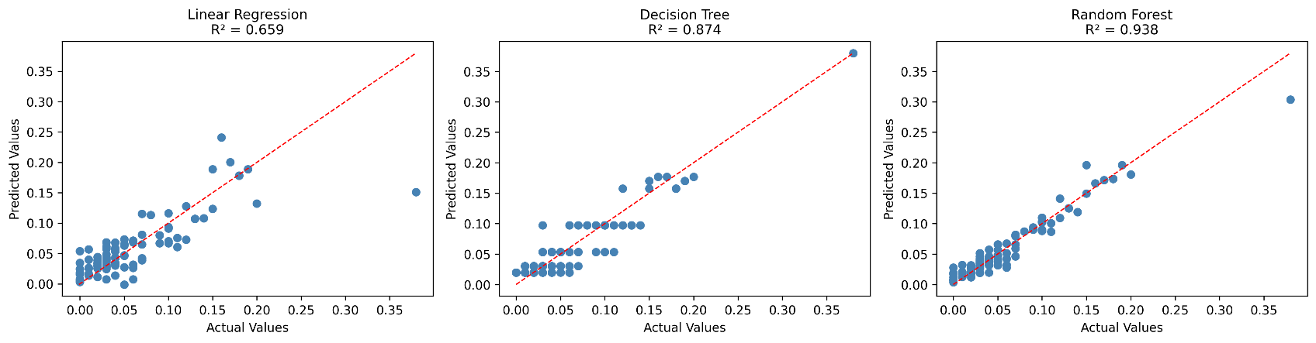
Figure 2: Actual vs Predicted value of all three models.

Additional Models: Classification and Clustering
To complement the regression models, classification methods were also used to label neighborhoods as high-poverty or low-poverty based on key indicators. Two models were tested in RapidMiner: K-Nearest Neighbors (KNN) and Decision Tree Classification.

Metric | KNN | Decision Tree
Accuracy | 0.893 | 0.929
Classification Error | 0.107 | 0.071
Correlation | 0.519 | 0.679

Table 4: Classification model summary

Both models performed strongly, with Decision Tree showing the highest accuracy. This supports earlier findings that employment and labor-force engagement are the strongest indicators of neighborhood poverty levels.
A K-Means Clustering model was also used to group neighborhoods based on similarity. The clusters aligned closely with known patterns in the data, neighborhoods with low employment and high NILF consistently formed the high-poverty cluster, while neighborhoods with strong workforce indicators fell into lower poverty groups.

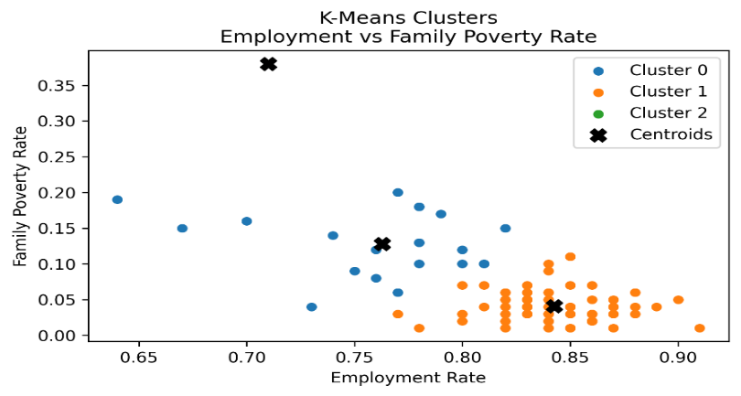
Figure 3: Family poverty & Employment based clusters

These additional models supported the idea that poverty differences follow clear and consistent patterns.

5. Validation and Testing

5.1 Regression Diagnostics (Hypothesis Testing and Residuals)
Hypothesis Testing:
Simple t-tests were used to check whether group differences (e.g., Single-parent vs poverty levels) were statistically meaningful.
Significant results showed that the observed relationships in EDA were not due to random chance, adding statistical support to the findings.

Residual Analysis:
Residual plots were checked to verify whether the linear regression model met core assumptions.
Findings:
- Residuals were centered around zero.
- No strong curved pattern
- Spread was consistent – meaning no major bias.
This confirmed that the regression model fit the data well and did not show signs of severe overfitting.
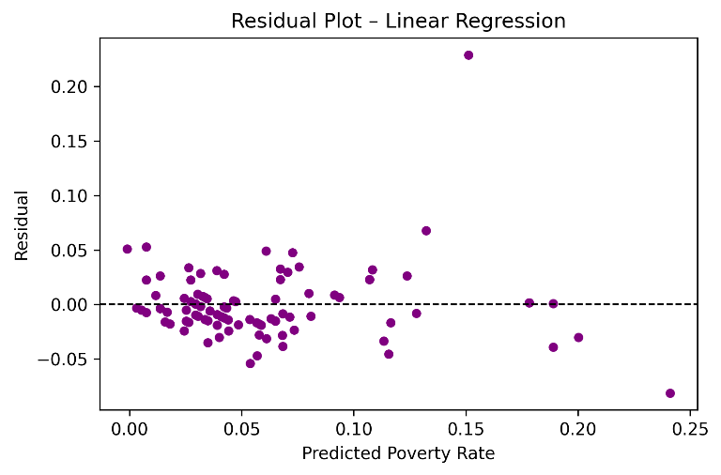
Figure 4: Residual plot of Linear Regression

5.2 Model Performance Check
All predictive models were evaluated using a training/testing split to understand how well they generalize to unseen neighborhoods.
Key results:
- Linear Regression has the most balanced performance and lowest drop from training to testing (best generalization)
- Decision Tree performed well but showed some overfitting
- Random Forest had extremely high training accuracy but lower test accuracy (strong overfitting)
This confirmed that Linear Regression is the most reliable model, while the tree-based models captured patterns well but were more sensitive to overfitting.

5.3 Classification and Clustering Validation
Classification:
Both these methods were used to confirm whether neighborhoods naturally group in ways consistent with poverty patterns.
Both models correctly identified most high- and low-poverty neighborhoods:
- KNN Accuracy: 0.893
- Decision Tree Accuracy: 0.929
The consistent results across two different methods confirmed that employment, LFPR, and NILF are strong and stable indicators of poverty classification.

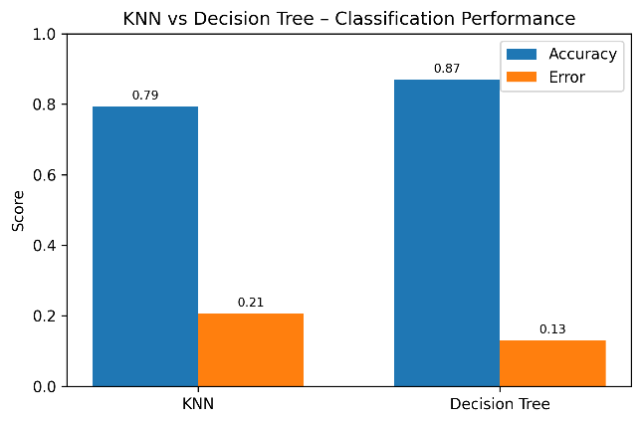
Figure 4: K-NN vs Decision Tree

Clustering:
K-Means clustering grouped neighborhoods into clear segments:
- High Poverty
- Mid Poverty
- Low Poverty
These clusters lined up with regression and classification results, validating that the patterns in the data appear naturally even without a target variable.

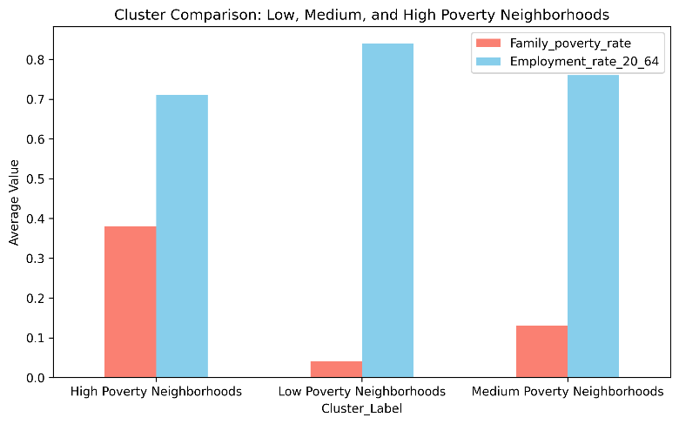
Figure 5: Cluster Comparison

Across all validation steps, train-test checks, residual analysis, hypothesis testing, classification accuracy, and clustering structure, the results were consistent.
No matter which method was used, the same core conclusion emerged: Employment, LFPR, NILF and family structure are the most reliable and stable predictors of neighborhood poverty in Seattle
This alignment across many independent methods provides strong confidence in the reliability of the project’s insights.

6. Results and Recommendations

This project revealed clear and consistent patterns about why poverty levels vary across Seattle neighborhoods. Through multiple methods, EDA, Hypothesis Testing, regression, classification, and clustering, the same findings appeared again. Neighborhoods with lower employment, weaker labor-force participation, higher NILF rates, and more single-parent households faced the highest poverty levels.
These factors remained important across nearly every model, showing that they are reliable indicators of neighborhood well-being.
The models also showed that poverty is rarely driven by one factor alone. Instead, it is usually the combination of limited workforce engagement, unstable household structures, and lower participation in economic activities that puts certain neighborhoods at greater risk. The clustering analysis further supported this by naturally grouping neighborhoods into low-, medium-, and high-poverty clusters based on the same indicators.
These findings point toward meaningful and practical steps that the city can take:
- Strengthening Workforce Participation
Since employment and LFPR were the strongest predictors of poverty, expanding job-training programs, apprenticeships, and employment-support services can help the most affected neighborhoods move toward greater stability.
- Increase Support for Single-Parent Households
Neighborhoods with a higher share of single-parent families consistently showed higher poverty. Offering affordable childcare, flexible work options, and local family-support programs can reduce the pressure on these households and improve economic stability.
- Address High NILF Areas
Communities with more residents “Not in the Labor Force” often showed elevated poverty. Targeted outreach—such as adult-education programs, skills training, and return-to-work initiatives—can help reconnect people to the workforce.
- Prioritize High-Risk Neighborhoods for Funding
The classification and clustering models clearly identified groups of neighborhoods that are more vulnerable. These areas should be prioritized for city resources, including community services, housing support, and employment-focused initiatives.
- Encourage Community Partnerships
Improving neighborhood outcomes require more than just policy, it also needs collaboration. Partnerships between nonprofits, schools, employers, and local organizations can create a stronger safety net and better access to opportunities.

7. Conclusion
The aim of this project is to know the reason why some neighbors in Seattle are more prone to poverty and economic strain than others. Through the integration of exploratory analysis, visualization, statistical testing, and predictive modelling, all findings were unanimous to the same consistent perspective, which is that differences in employment, labor-force participation, NILF rates, and family structure contribute significantly to define the well-being of the neighborhood. In most of the approaches, the same neighborhoods were repeatedly found to be either more vulnerable or more stable, e.g., Regression, Hypothesis Testing, Decision Trees, Random Forests, KNN classification, and K-Means clustering. This consistency between various tools provides high confidence that the trends that we have found are genuine and significant and not just noise in the data.
The areas that had less employment, poorer labor-force participation, a significant NILF factor and more single parent families invariably had the highest rates of poverty. Conversely, the neighborhoods that had high workforce and healthier household composition were most likely to record significantly less poverty and generally improved results. These indicators were significant regardless of the model and approach adopted. The analysis also indicated that poverty does not have any single factor to make it, but a combination of the work force and family constraints normally places neighborhoods in jeopardy. This underscores the fact that there is need to have a more supportive environment particularly in societies where there is low participation in the labor market or with families that have additional burden.
All in all, this project shows that the data may give a clear image about the most demanded areas of support. The local leaders can use the findings as priorities when providing workforce programs, family support services and specific community interventions in the neighborhoods. The dataset is narrower, presenting only several socio-economic indicators but the results provide a solid base of further policy discussions.
Even further insights would be possible in the future with more comprehensive data that must include variables such as education, transportation access, availability of childcare, or rent burden. In straightforward terms, this research demonstrates that enhancing the rates of employment, assisting the families, and enhancing the level of engagement at the community level can result in significant change of poverty. The knowledge of these trends will provide us with a blueprint on how to create more robust and resilient communities throughout Seattle.

8. Acknowledgements
I would like to express my sincere gratitude to all the professors who guided me throughout this capstone project. I am especially thankful to Professor Kristin, whose continuous guidance, support sessions, and clear direction helped shape this entire project. I would also like to thank Professor Todd for his guidance during the exploratory data analysis phase, Professor Martin for helping me understand and apply Python modeling, and Professor Yichuan for his support with predictive modeling techniques. Special thanks to Professor Susan for her help and clarity in visualization and dashboard design.
I am also grateful to the teaching assistants for their support, feedback, and timely help whenever I needed clarification. Their assistance made the project process smoother and more manageable from start to finish.

9. References
The resources used throughout this capstone project include a combination of course materials, online documentation, and learning platforms that supported the analysis, modeling, and interpretation of results.
Course & Canvas Materials
BAN 586 Capstone Video Lectures, Canvas Learning Management System (2024–2025).
Course Modules and Lab Guides from Professor Kristin, Professor Todd, Professor Martin, Professor Yichuan, and Professor Susan, Northern Arizona University.
AI Assistance
Generative AI tools, including ChatGPT, were used for conceptual explanation and grammar improvements. All analytical decisions and final interpretations were completed independently by the student.

10. Appendix
This appendix includes all supporting visual outputs, figures, and charts referenced throughout the analysis sections of this report.

Exploratory Data Analysis:

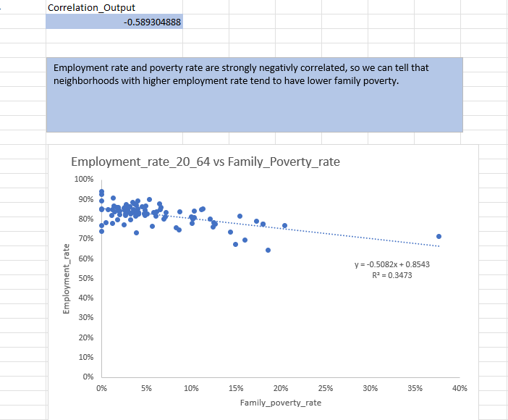

Correlation Output and Scatter Plot

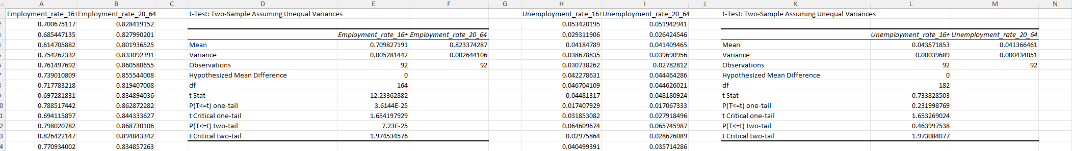

Sample Hypothesis Tests

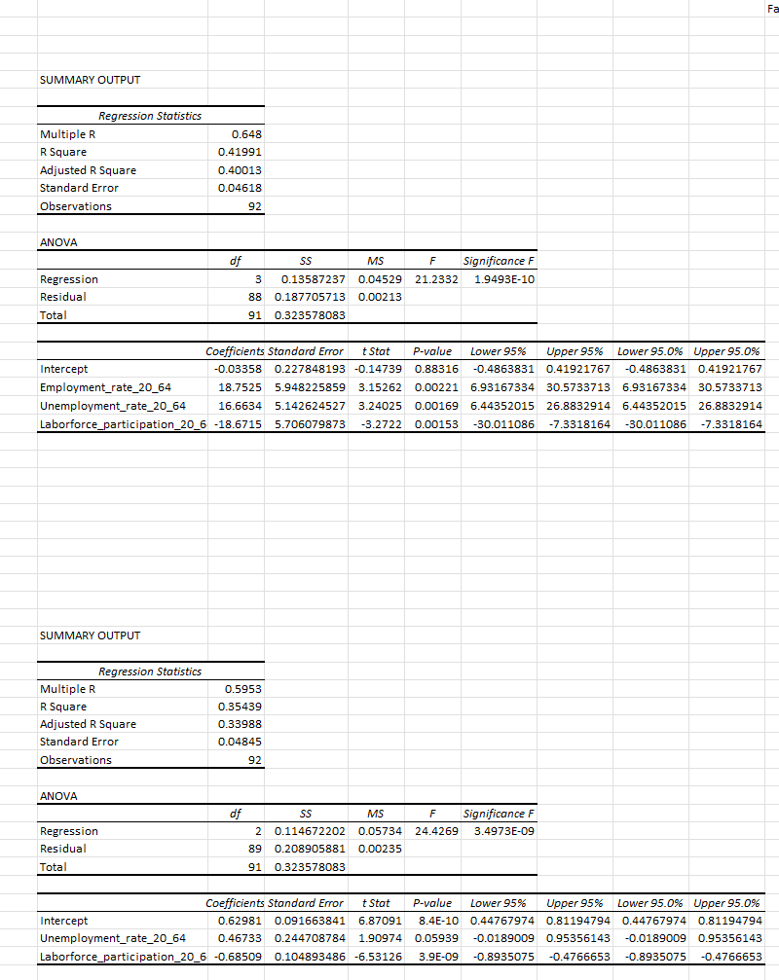

Sample Regression from EDA Results:

Rapid Miner Process and Results:

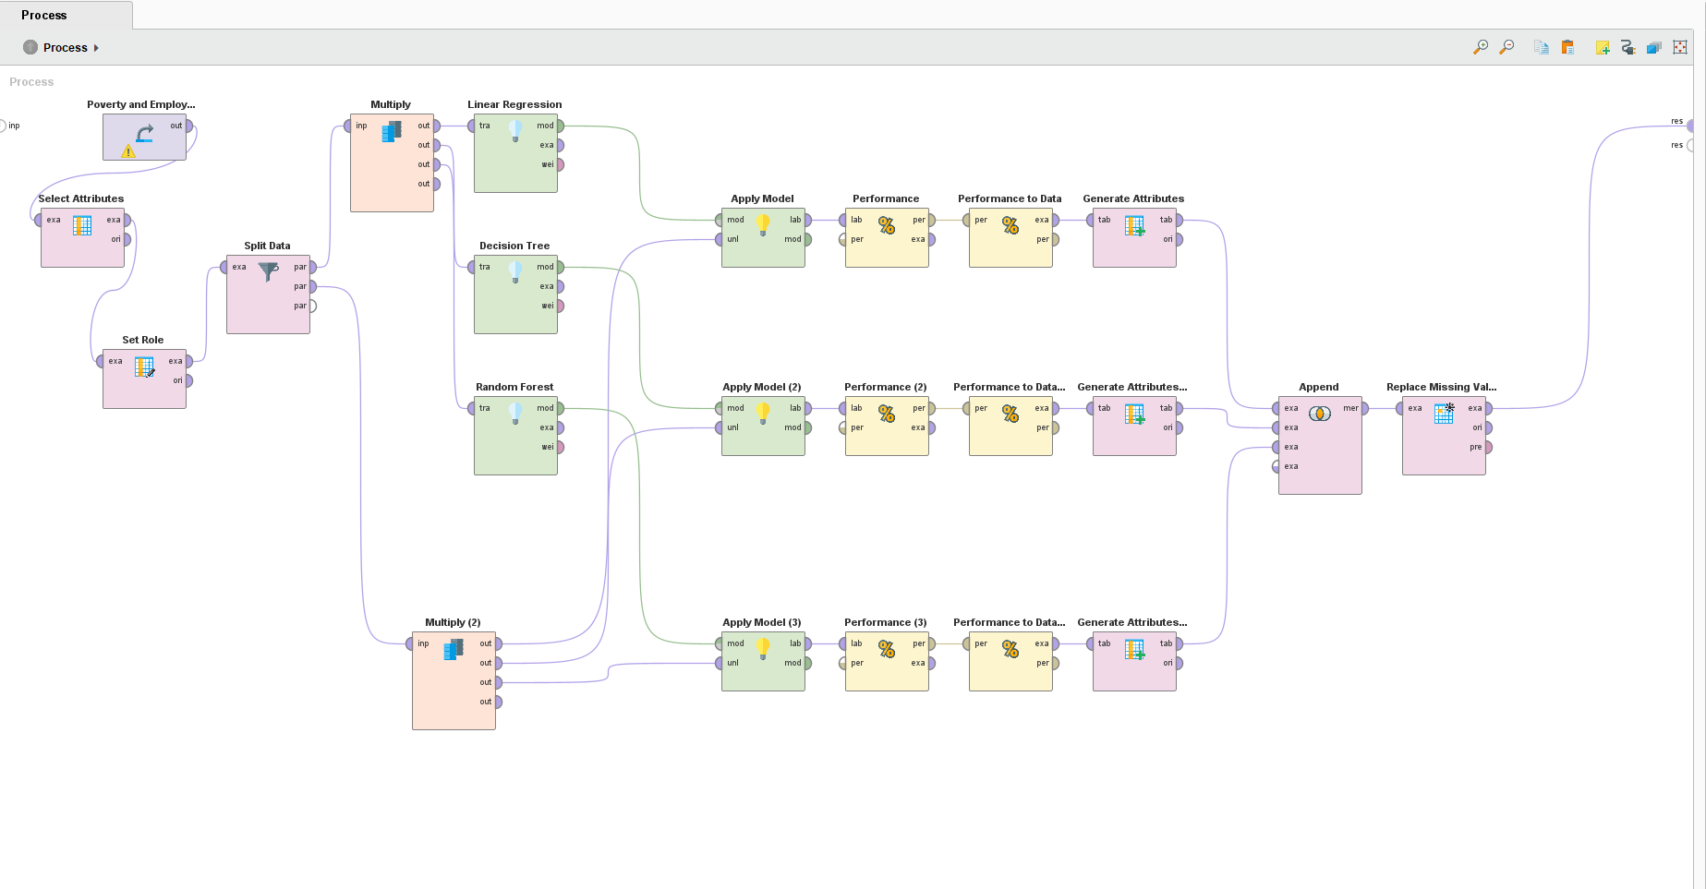
Model Comparison with Split data

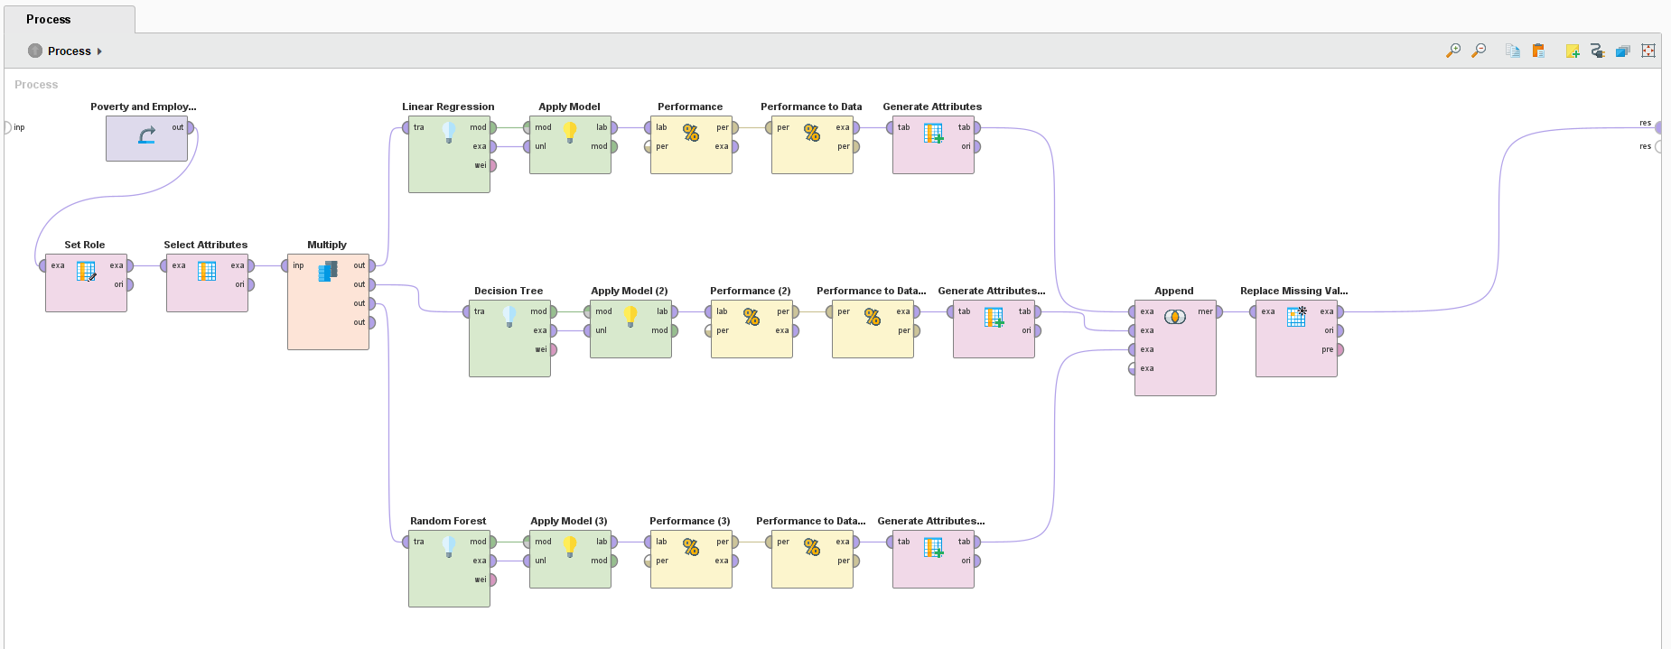

Model Comparison without split data

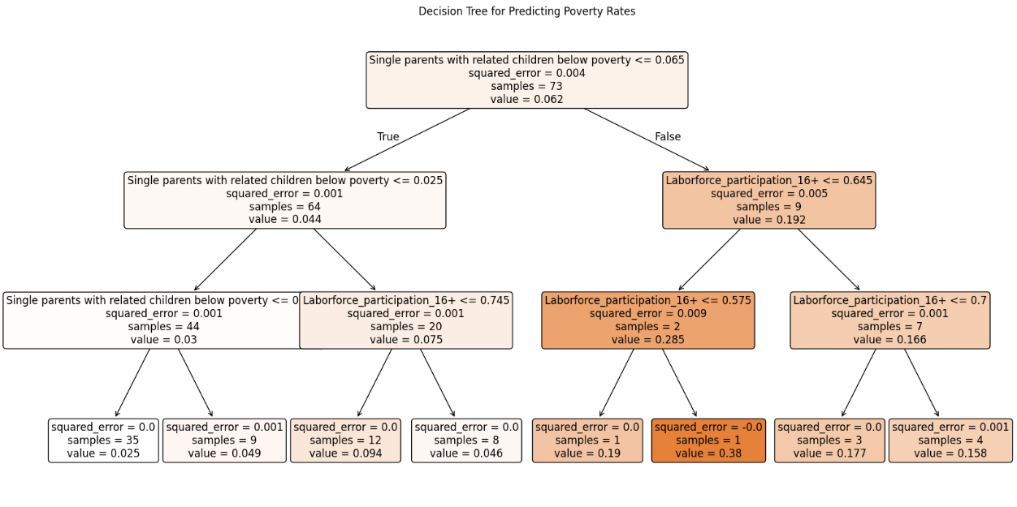
Decision Tree Model

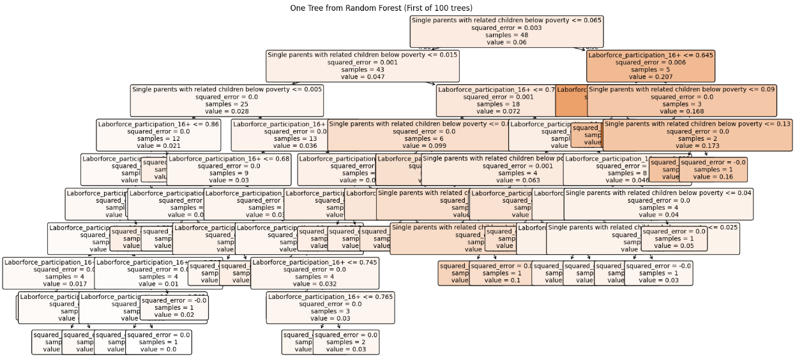
Random Forest Model

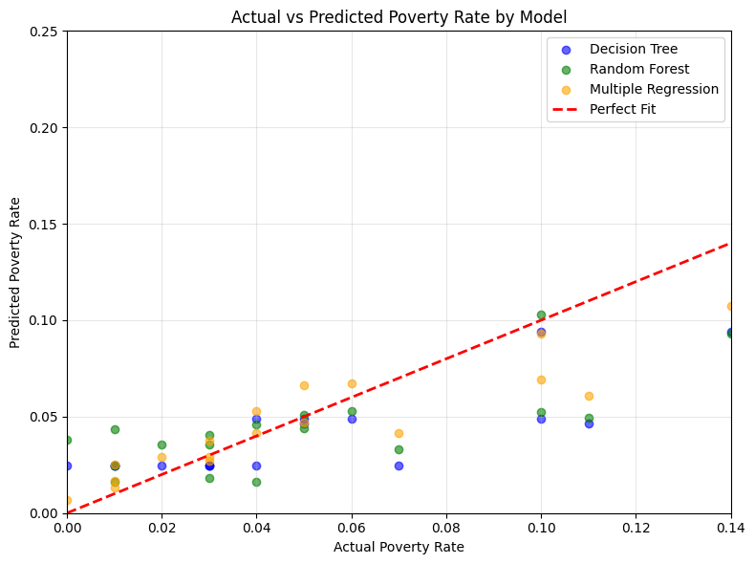
Actual vs Residual Model Comparision Chart

Google Collab link: - https://colab.research.google.com/drive/14VT-m6sOOdVYhRdB-NwrV3Dk91El-1ZH?usp=sharing

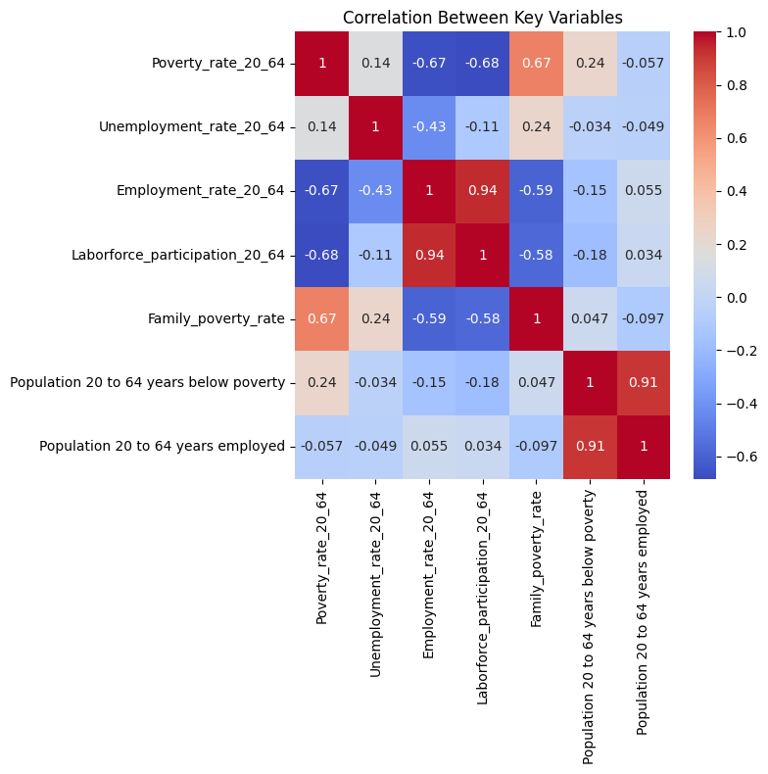
Correlation Heatmap
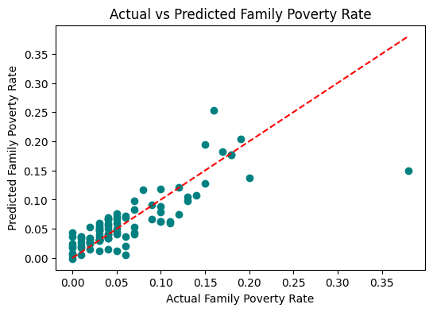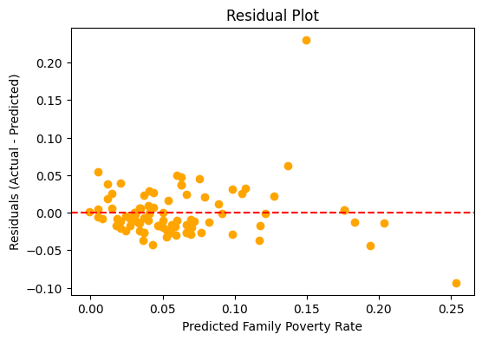

Actual and Predicted Poverty rates Comparison

Tableau Visualizations:

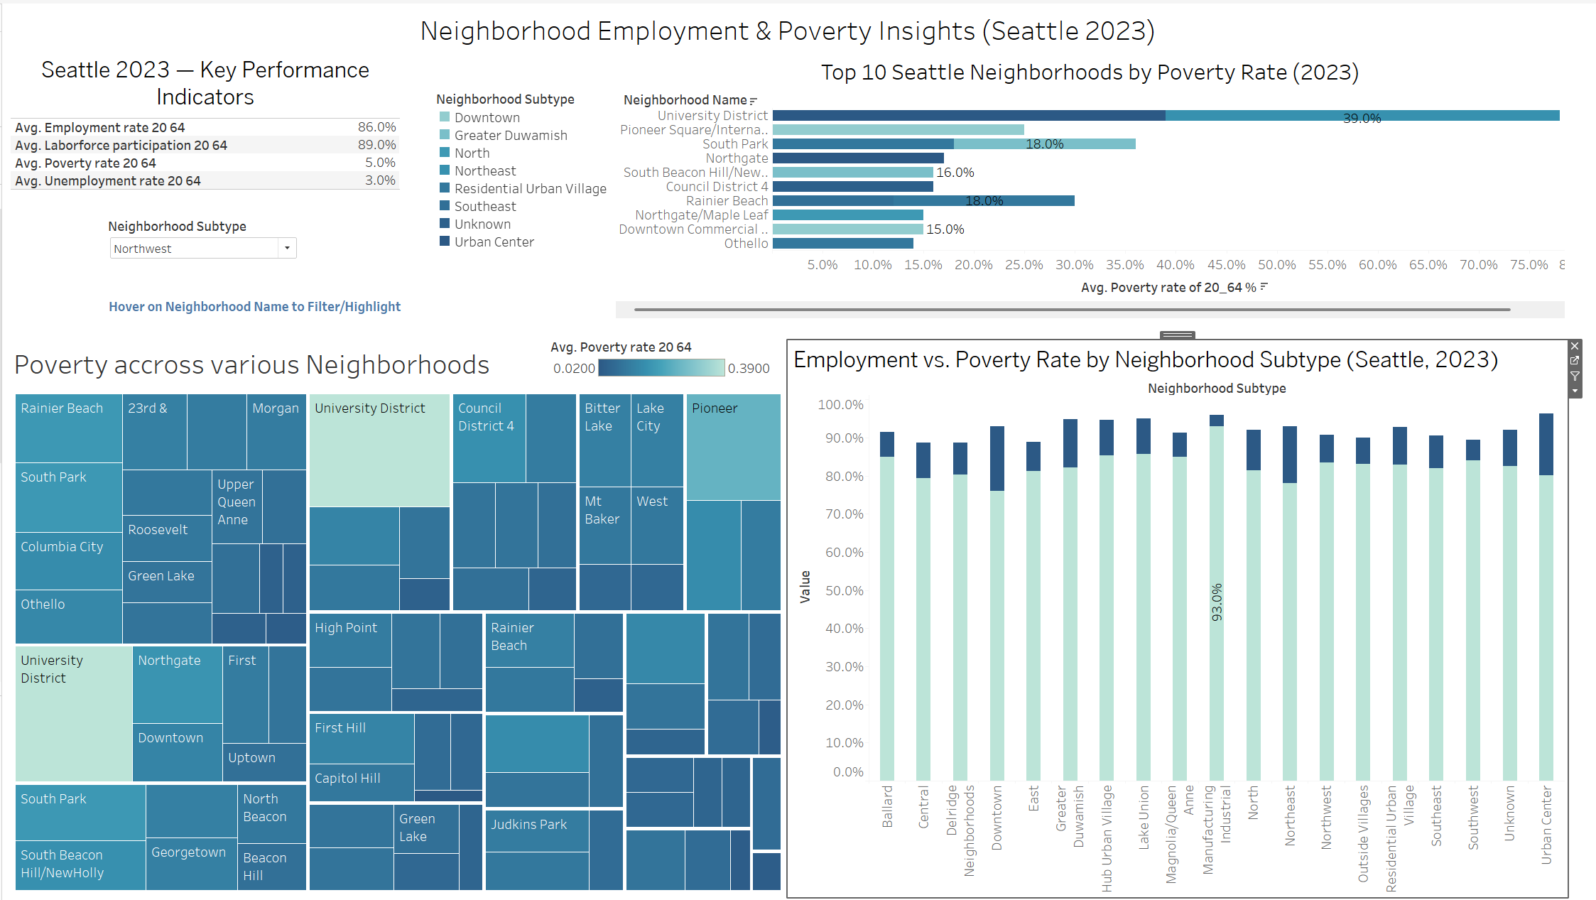
Dashboard 1: Neighborhood Employment and Poverty Insights

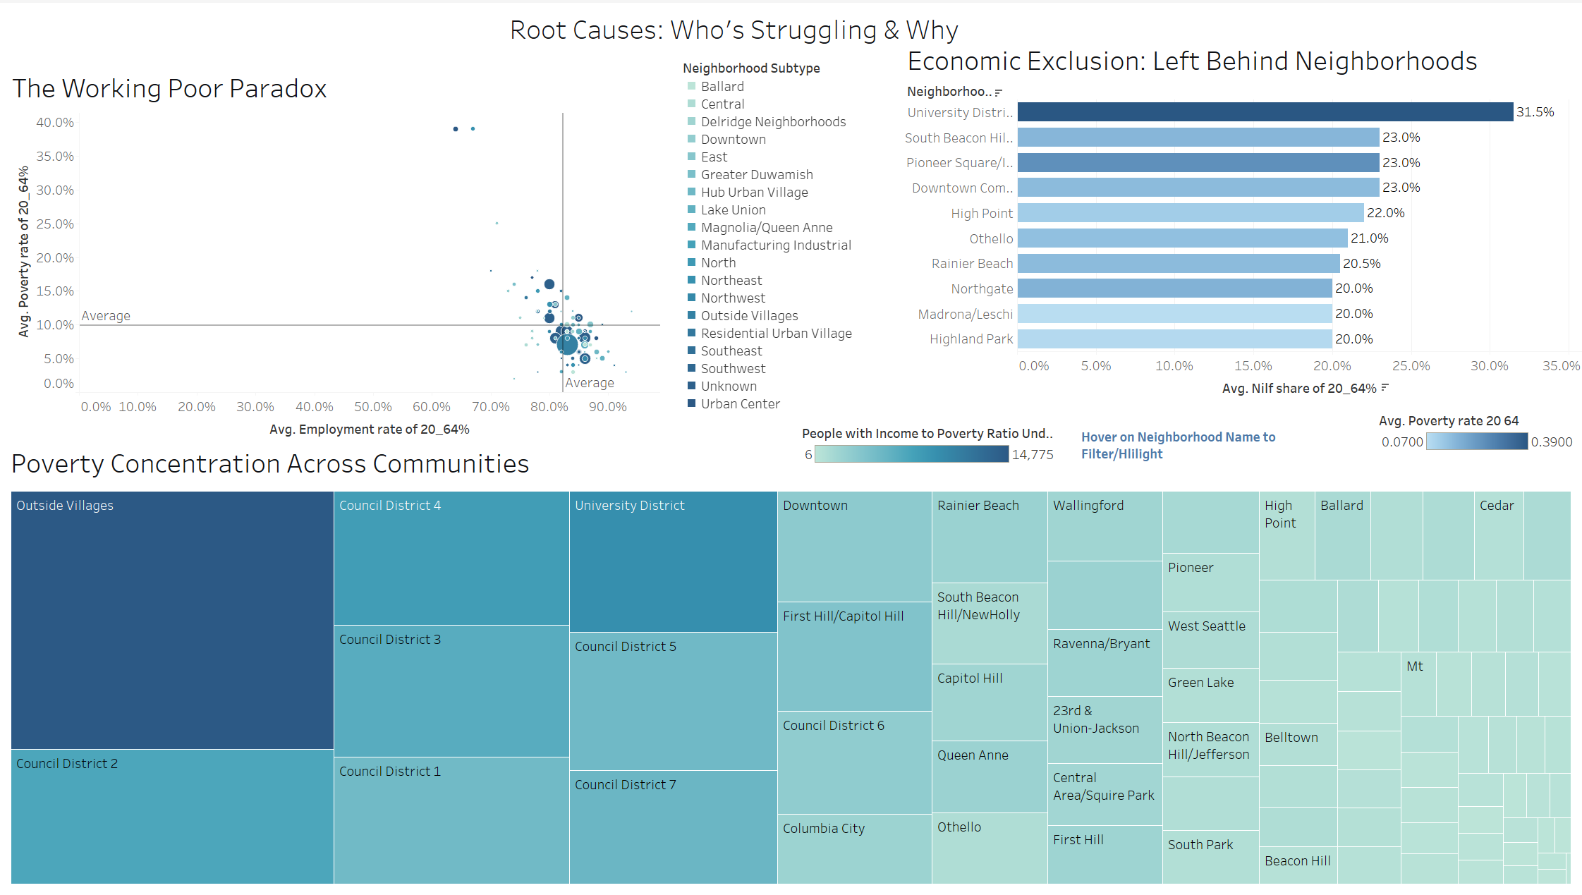
Dashboard 2: Root Causes

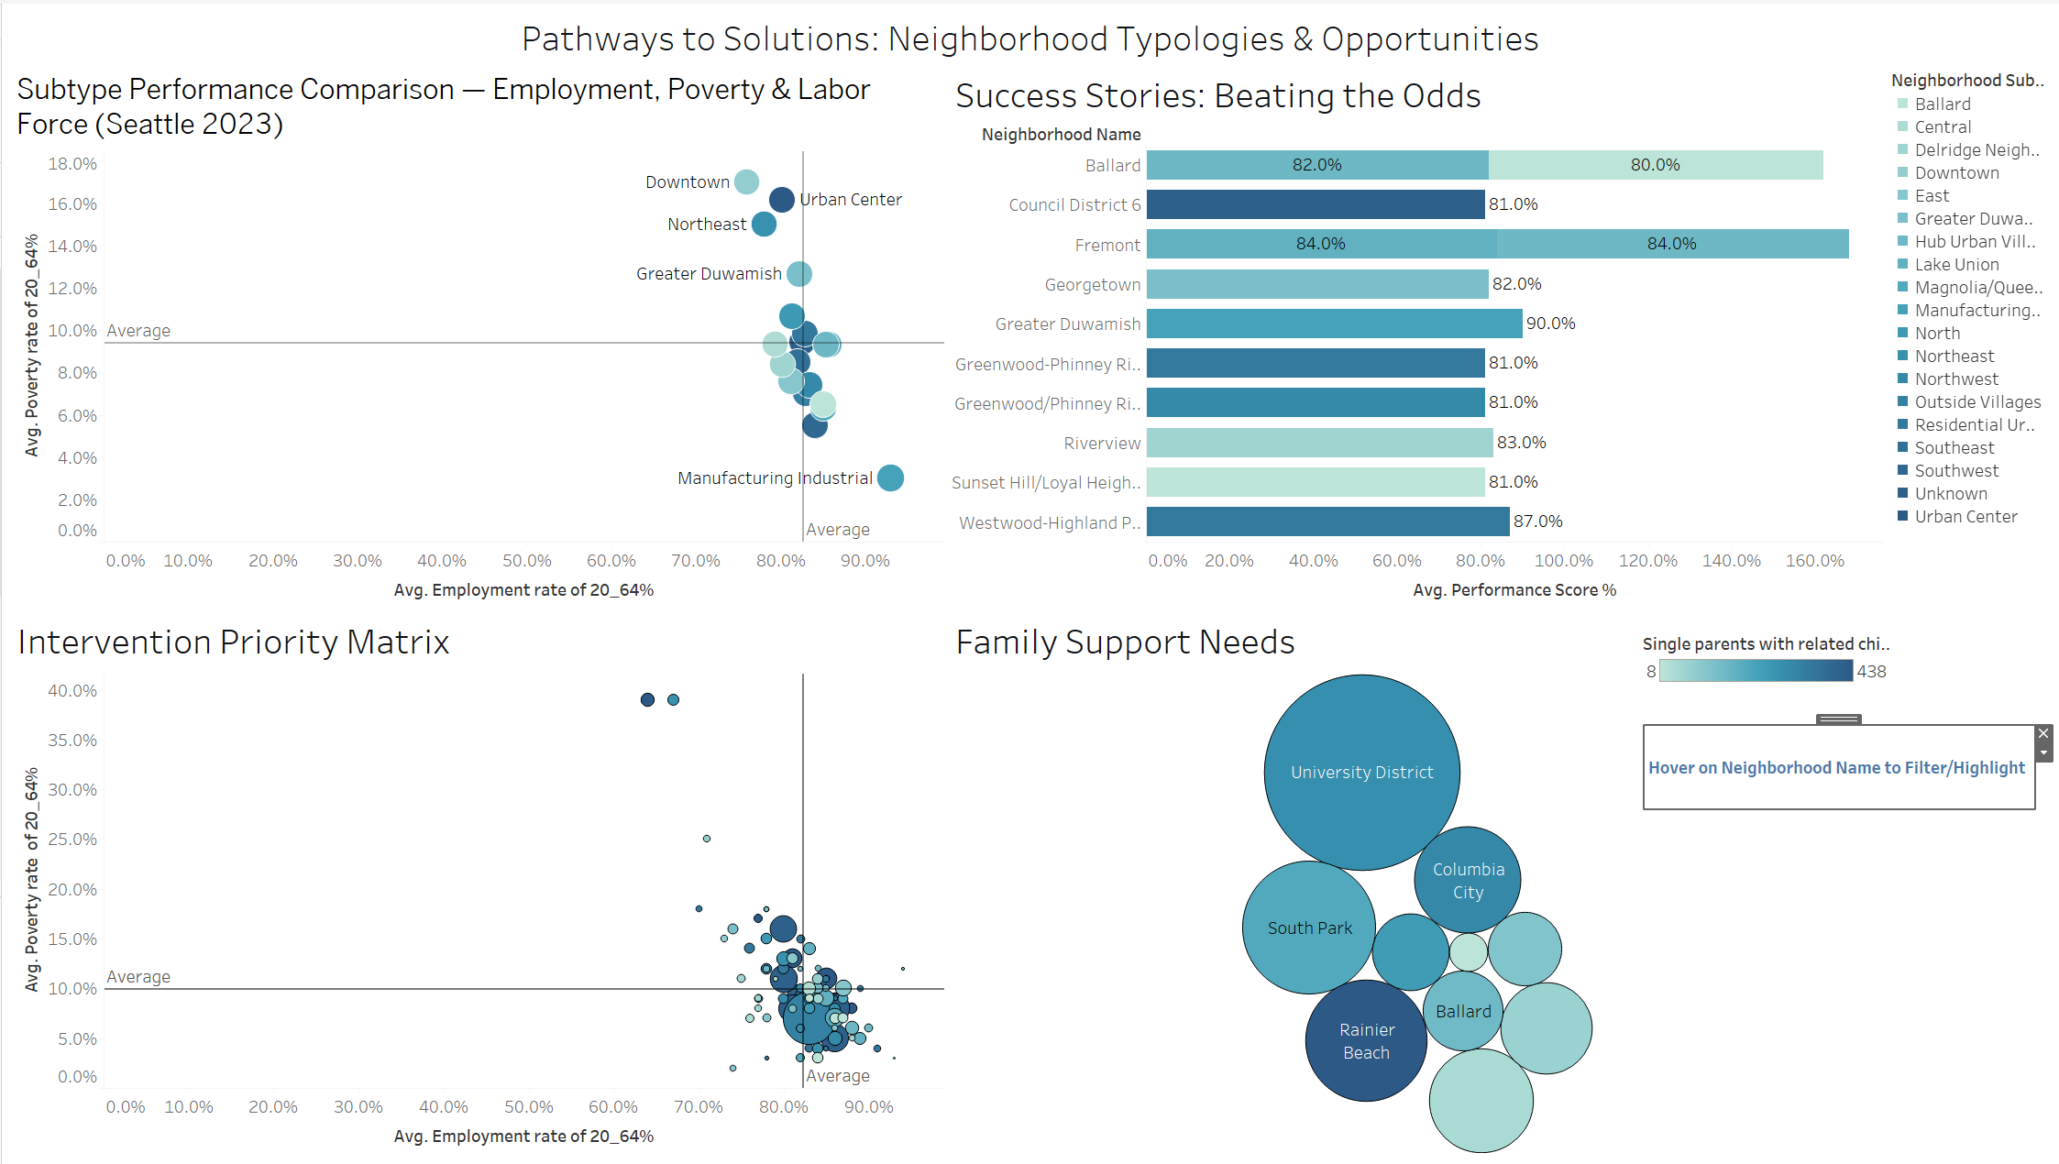

Dashboard 3: Solutions

