VELLORE INSTITUTE OF TECHNOLOGY
SCHOOL OF COMPUTER SCIENCE AND ENGINEERING
SWARA

Secure Wideband Adaptive Real-time Audio over UDP
A perceptually aware, mutually authenticated voice-chat system over UDP with importance-weighted forward error correction, joint quality control and overlay relay selection
FINAL PROJECT REPORT
Computer Networks · October 2026

SUBMITTED BY  Rohit Arora 24BDS0252  Ansh Gupta 24BDS0119  Amrit Raj 24BDS0104 | PROJECT GUIDE  Dr. Anitha E  Assistant Professor Sr. Grade 1  Department of Information Security  School of Computer Science and Engineering  anitha.e@vit.ac.in

Department of Information Security · School of Computer Science and Engineering
Vellore Institute of Technology

Project Details
 | PROJECT GUIDE  Dr. Anitha E  Assistant Professor Sr. Grade 1  Department of Information Security  School of Computer Science and Engineering  Vellore Institute of Technology  anitha.e@vit.ac.in

TEAM
# | Name | Registration number | Programme
1 | Rohit Arora | 24BDS0252 | B.Tech. · SCOPE, VIT
2 | Ansh Gupta | 24BDS0119 | B.Tech. · SCOPE, VIT
3 | Amrit Raj | 24BDS0104 | B.Tech. · SCOPE, VIT

Project title | SWARA — Secure Wideband Adaptive Real-time Audio over UDP
Course | Computer Networks
Department | Department of Information Security, School of Computer Science and Engineering
Institution | Vellore Institute of Technology
Submission | October 2026
Repository | https://github.com/rohitarora80905-glitch/swara-v1.0
Deliverables | Working voice-chat application over UDP (server, clients, web console), evaluation harness, research figures, this report

Abstract
Conventional voice-over-IP stacks treat every 20 ms packet of speech as equally valuable, protect all of them with the same redundancy, size the playout buffer against a loss target that ignores the delay it adds, and secure the call with handshakes that were designed for connection-oriented transports. This project presents SWARA (Secure Wideband Adaptive Real-time Audio over UDP), a complete, working voice-chat system built from the datagram up, together with the research evaluation that motivated its design.
SWARA's central idea is that packet loss should be judged by what the listener loses, not by how many packets were lost. A causal Perceptual Importance (PI) analyser scores each frame from its energy, voicing, zero-crossing rate, spectral flux and onset behaviour, and carries the score as an authenticated-but-readable octet in the packet header. A PI-weighted adaptive forward error correction scheme (PI-AFEC) spends a fixed Reed–Solomon parity budget on the frame groups that carry meaning and withholds it from silence, and protects vowel onsets with time-displaced anchor replicas that survive loss bursts a block code cannot. The NAVIK controller chooses codec bitrate, redundancy and DiffServ marking jointly by maximising the ITU-T G.107 E-model rating, distinguishes congestion from link loss through the one-way-delay trend, and couples the R-factor-optimal jitter buffer to the protection decision. SPARK, a stateless password-authenticated key agreement, mutually authenticates users in two round trips without ever sending the password, bounds reflection amplification at 0.31×, and migrates a call between networks in zero round trips; the relay forwards ChaCha20-Poly1305 ciphertext it cannot read. SETU, a distance-vector overlay, selects relay paths when the direct Internet route violates the triangle inequality.
The system is implemented in about 5,500 lines of Python over real UDP sockets, IMA-ADPCM speech coding with per-frame state reset, X25519/HKDF/ChaCha20-Poly1305 cryptography, and a FastAPI/uvicorn web console that runs instrumented live calls, A/B benchmarks and an interactive protocol toolkit. In the simulated evaluation, SWARA raises predicted MOS at 12 % loss from 3.38 (unprotected) and 3.37 (uniform FEC with the same budget) to 3.53, reaches the same quality as uniform FEC for 16.7 % less redundancy, keeps the measured optimum playout depth within 1 ms of its own choice, and authenticates in 397 bytes against roughly 1,900 bytes for DTLS-SRTP. In live calls over an impaired loopback path at 15 % loss with mean bursts of four packets, SWARA matches uniform FEC's perceptual damage (7.3 %) with 11 % less bandwidth and reduces it by 16 % relative to unprotected UDP; at 10 % loss it achieves the lowest damage of the three (4.2 %) at 12 % less bandwidth than uniform FEC. The evaluation also uncovered and corrected a scheduler defect in the project's own impairment injector that had silently disabled redundancy mid-call, illustrating why the measurement instrument must be validated before the protocol is judged.
Keywords — VoIP, UDP, forward error correction, unequal loss protection, Reed–Solomon, perceptual quality, E-model, jitter buffer, password-authenticated key exchange, X25519, ChaCha20-Poly1305, DiffServ, overlay routing.

Contents
Project Details i
Abstract ii
Contents iii
List of Figures v
List of Tables vii
Abbreviations viii
1 Introduction 1
1.1 Background 1
1.2 Motivation 1
1.3 Problem statement 2
1.4 Scope and contributions 2
1.5 Organisation of the report 3
2 Literature Survey 4
2.1 Packet loss recovery for streaming audio 4
2.2 Unequal protection and perceptual weighting 4
2.3 Playout scheduling and concealment 4
2.4 Objective quality assessment 5
2.5 Channel models 5
2.6 Secure real-time transport and key establishment 5
2.7 Network QoS and overlay routing 5
3 Research Gap 7
4 Objectives 8
5 Proposed Work 9
5.1 System architecture 9
5.2 Wire protocol 9
5.3 Perceptual importance analysis 11
5.4 PI-AFEC: importance-weighted adaptive FEC 12
5.5 SPARK: stateless password-authenticated key agreement 13
5.6 NAVIK: joint quality control 15
5.7 Receiver: estimation, repair and R-factor-optimal playout 16
5.8 SETU: voice-aware overlay routing 17
5.9 Speech codec with per-frame state reset 17
5.10 Evaluation methodology 18
6 Implementation 19
6.1 Technology stack 19
6.2 Repository layout 20
6.3 Module responsibilities 20
6.4 The live call pipeline 21
6.5 The relay server 22
6.6 The client 22
6.7 Demonstration harness and experiments 22
6.8 The web console and REST API 23
6.9 Server control launcher 24
6.10 Verification during development 25
6.11 Running the system 26
7 Results and Discussion 27
7.1 Experimental setup 27
7.2 Perceptual importance separates what matters 27
7.3 Quality under packet loss 28
7.4 Resilience to bursty loss 29
7.5 Quality returned per byte of redundancy 30
7.6 The jitter-buffer optimum 31
7.7 Handshake cost and security properties 32
7.8 Relay-path selection 33
7.9 Realistic network profiles 33
7.10 Live end-to-end calls 34
7.11 Discussion 37
7.12 Limitations 38
8 Conclusion 39
8.1 Future work 39
References 40
Appendix A Source Code Repository 42
A.1 Obtaining and running the code 42
A.2 Repository contents 42
A.3 Reproducibility 43
Appendix B Screenshots 44
B.1 Starting the server 44
B.2 A real call between three separate programs — both sides 44
B.3 Command-line clients on the relay hosted by the web console 46
B.4 Live Call Lab 50
B.5 A/B Benchmark 53
B.6 Network Simulator 55
B.7 Research Results 56
B.8 Protocol toolkit 64
B.9 Operations and API 71
Appendix C Source Code 74

List of Figures
Why not all losses are equal. Left: the perceptual damage weight used throughout this project rises superlinearly with a frame's importance and is penalised for consecutive losses. Centre: the E-model's delay impairment has a knee at 177.3 ms, so an over-deep jitter buffer is a quality defect. Right: for a fixed loss rate, clustered (bursty) loss is far more damaging than random loss. 2
SWARA end-to-end architecture for one direction of a call. Orange stages are the project's novel components; black stages are conventional. The relay in the middle forwards ciphertext it cannot read. 9
The 16-byte SWARA header and the composition of a wideband media datagram. The header and the optional 16-byte telemetry block are AEAD associated data: readable on the path, unforgeable. Everything after them is ciphertext. 10
PI-AFEC on three consecutive groups of k = 4 frames. The silent group receives no parity; its budget moves to the group carrying the vowel onset, which additionally earns an anchor replica displaced past the expected burst length. 13
The SPARK handshake and 0-RTT path migration, with on-the-wire sizes measured from the implementation. 14
The NAVIK control loop: receiver-side estimation feeds a single R-factor objective whose decisions drive the scheduler, the codec and the packet marking. 16
A triangle-inequality violation: the direct A–B path crosses a congested exchange while the two-hop path through C is far cheaper in voice-cost terms. 17
The Gilbert–Elliott loss model used by both the simulator and the live injector. 18
The four threads of a CallSession and the state they share. 21
The web console's Overview page: headline results, the twelve-stage pipeline, and the hosted relay card. 24
The SWARA Server Control window with the server running. 25
PI score distributions by speech class (violins show the full distribution, bars the mean) and the share of frames versus the share of importance held by silence. 28
Call quality under loss (left; shaded bands ±1 s.e.) and the reduction in perceptually weighted loss relative to the baseline (right). 29
Resilience to bursty loss (left) and the mechanism responsible for each recovery (right). 30
Quality returned per byte of redundancy. 31
Too shallow loses packets, too deep loses the conversation: the R-factor curve (left) and the end-to-end validation (right). 31
Call-setup cost in round trips and bytes. 32
SETU: distribution of the cost reduction on improved pairs (left) and the share of pairs by chosen route length (right). 33
Measured call quality across realistic network profiles (dashed line: the 3.6 “acceptable” threshold). 34
Terminal output of demo.py --compare at 15 % loss, mean burst 4, 12 ms jitter (25 s calls, 2 repeats per arm). 36
Terminal output of demo.py --compare at 10 % loss, mean burst 3, 10 ms jitter. 36
SWARA Server Control, opened by double-clicking “SWARA Server.bat”. The server was started with one click; the window shows the console address, the LAN address for other laptops, the hosted relay on udp:9000 and the live server log. 44
Terminal 1 — the relay (`python server.py --port 9000`) during the call: both users authenticated by SPARK and the call being relayed “keys not held”. 45
Terminal 2 — the callee (`python client.py --user bob … --wait`) during the call: authenticated in two round trips, incoming call accepted, media flowing. 45
Terminal 3 — the caller (`python client.py --user alice … --call bob`) during the call. 45
Terminal 1 after the call: the relay's complete log for the session. 45
Terminal 2 after the call — bob's own report: 1,021 frames sent with 287 parity and 17 replica packets; 1,015 played; 14 rebuilt by FEC; 102 concealed (10.0 %); no authentication failures. 46
Terminal 3 after the call — alice's own report: 1,021 frames sent with 273 parity and 32 replicas; 1,011 played; 7 rebuilt by FEC; 139 concealed (13.7 %); no authentication failures. 46
Relay & Users page while alice and bob (command-line clients) are in a call through the hosted relay. 47
Overview page during the same call: the hosted-relay card reports two users online and one call relayed. 48
The caller's terminal for the hosted-relay call (30 s, 10 % loss, burst 3, 10 ms jitter on alice's socket). 49
The callee's terminal for the hosted-relay call. 49
Live Call Lab before a call: audio source, call length, protection scheme, codec mode and the network sliders (presets from Clean to Poor 3G). 50
Live Call Lab during a call: the frame-fate map fills from left to right (bar height = PI; teal delivered, blue rebuilt from parity, violet anchor replica, red concealed), the sent and received waveforms, and the live gauges. 51
Live Call Lab after the call: the complete frame-fate map, the three time-series charts (network as measured, adaptation, quality), the call report with playable sent and received audio, the call log and the session table. 52
A/B Benchmark page before a run: audio source, seconds per call, repeats, and the network conditions shared by all three arms. 53
A/B Benchmark after a run at 15 % loss, burst 4, 12 ms jitter (20 s per arm): per-arm cards, the verdict, four comparison charts, the like-for-like table and the audio of each arm. 54
Network Simulator: the Congested 4G profile simulated for SWARA, uniform FEC and the baseline with MOS gauges, detailed per-system figures and the loss-accounting chart. 55
Research Results — loss sweep tab, with the interactive chart, the finding, the paper figure, the figure gallery and the regeneration control. 56
Research Results — burst sweep tab. 57
Research Results — overhead efficiency tab. 58
Research Results — PI distribution tab. 59
Research Results — jitter buffer tab. 60
Research Results — handshake tab. 61
Research Results — SETU overlay tab. 62
Research Results — network profiles tab. 63
Perceptual Analyzer: synthetic speech coloured by class with the PI trace, the ground-truth / label / FEC-plan strips, the frame inspector, the PI histogram and per-class statistics. 64
FEC Playground: an RS(6, 4) group with two data shards dropped and recovered; the PI-AFEC scheduler for a vowel-onset group. 64
FEC Playground after the “Burst” button: more shards lost than the code can repair — the frame must be concealed. 65
Quality & NAVIK: the E-model calculator with its impairment breakdown and the controller's decisions across loss rates. 66
SPARK Handshake: the six messages with sizes and timings, the derived keys matching on both sides, and the 0-RTT path migration. 67
SPARK Handshake with a wrong password: the envelope fails to open locally and AUTH_CONFIRM is never sent. 68
Packet Anatomy: the 16-byte header packed by Header.pack(), the hex dump, and what the AEAD protects. 69
SETU Overlay: a seven-node measured mesh, the converged route for the selected pair, and all pairs ranked by gain. 70
Relay & Users (idle): hosted relay status, the ready-to-paste client commands, the relay log and the user registry. 71
System & API: runtime, packages, the source-module inventory and every endpoint. 72
The generated OpenAPI documentation (Swagger UI) at /docs — the first five endpoint groups of thirty-seven documented routes. 73

List of Tables
Summary of the most relevant prior work and its relation to SWARA. 6
Research gaps and the SWARA component that addresses each. 7
Objectives and success criteria. 8
Header fields. 10
Datagram types. 10
Technology stack and versions used for the reported results. 19
Source modules and their responsibilities. 20
Web console pages. 23
Experimental configuration. 27
Perceptual importance score by speech class (0–255). 28
Loss sweep: predicted MOS (G.107) and perceptually weighted loss, mean of 5 seeds. 28
Burst sweep at 12 % loss: MOS and SWARA's recoveries per call by mechanism, mean of 4 seeds. 29
Overhead efficiency at 12 % loss, burst 4: MOS and redundancy actually spent for each nominal budget ρ. 30
Jitter-buffer depth: predicted R-factor and measured end-to-end MOS. 31
Measured handshake and media-protection cost. 32
Security properties of SPARK and how each is obtained. 32
Named profiles: predicted MOS, residual and perceptual loss, mouth-to-ear delay and redundancy, mean of 4 seeds. 34
Diagnosis of the injector defect: one call at 15 % loss, burst 4, 12 ms jitter, sampled once per second. 35
Live A/B comparison (demo.py, 25 s × 2 repeats, injector at both sockets). 35
Repository contents. 42

Abbreviations
ADPCM Adaptive Differential Pulse-Code Modulation (IMA variant, 4 bits per sample)
AEAD Authenticated Encryption with Associated Data
AF41 / EF / BE Assured Forwarding class 4 (DSCP 34), Expedited Forwarding (DSCP 46), Best Effort (DSCP 0)
AIMD Additive-Increase / Multiplicative-Decrease congestion control
API / REST Application Programming Interface / Representational State Transfer
CID Connection Identifier (32-bit, carried in every SWARA header)
CRC Cyclic Redundancy Check
DSCP Differentiated Services Code Point (6 bits of the IP header)
DTLS-SRTP Datagram TLS keying for the Secure Real-time Transport Protocol (the WebRTC baseline)
E-model ITU-T G.107 computational model mapping impairments to a transmission rating R
FEC Forward Error Correction
GF(2⁸) Galois field with 256 elements, the arithmetic of the Reed–Solomon code
GIL Global Interpreter Lock (CPython)
HKDF / HMAC HMAC-based Key Derivation Function / Hash-based Message Authentication Code
MDS Maximum Distance Separable (any k of k+r shards reconstruct the group)
MOS Mean Opinion Score (1–5, predicted here from R by G.107)
NAT Network Address Translation
NAVIK Network-Adaptive Voice-quality Integrated Kontroller (the joint optimiser)
OPAQUE Asymmetric password-authenticated key exchange (envelope construction borrowed by SPARK)
OWD One-Way Delay
PBKDF2 Password-Based Key Derivation Function 2
PI Perceptual Importance (0–255, one octet per frame)
PI-AFEC Perceptual-Importance-weighted Adaptive FEC
PLC Packet Loss Concealment
Ppl Packet-loss probability as consumed by the E-model (percent)
QoS Quality of Service
ROC Rollover Counter (SRTP-style reconstruction of a 16-bit sequence field)
RS(n, k) Systematic Reed–Solomon erasure code with k data and n−k parity shards
RTP / RTCP Real-time Transport Protocol / RTP Control Protocol
RTT Round-Trip Time
SETU Self-Evaluating Topology Underlay (the relay-selection overlay; Hindi “bridge”)
SIP Session Initiation Protocol
SPARK Stateless Password-Authenticated Retry & Key-agreement
SSE Server-Sent Events (console streaming)
SWARA Secure Wideband Adaptive Real-time Audio over UDP (Hindi/Sanskrit “voice, note”)
UDP User Datagram Protocol
VAD Voice Activity Detection
VoIP Voice over Internet Protocol
WRED Weighted Random Early Detection
X25519 Elliptic-curve Diffie–Hellman over Curve25519
ZCR Zero-Crossing Rate

1 Introduction

1.1 Background
Interactive voice is the application that first made the Internet's best-effort service model visible to ordinary users. Speech is captured in short frames — 20 ms is the common choice — and each frame is placed in its own datagram, because a conversation cannot wait for a retransmission: by the time a lost frame could be resent and delivered it is already too late to play. Voice therefore runs over UDP [46] with RTP framing [1], accepts that some datagrams will be lost, delayed or reordered, and relies on the receiver to hide the damage. Three impairments dominate the listener's experience: packet loss, which removes audio; delay, which, past roughly 150 ms mouth-to-ear, makes a conversation feel like a walkie-talkie exchange [3]; and jitter, the variation in delay, which must be absorbed by a playout buffer that itself adds delay.
Loss on real paths is not a coin flip. Queues overflow, radio links fade and handovers stall, so losses arrive in bursts [16], [17]. A single lost 20 ms frame can be concealed almost inaudibly by repeating or interpolating its neighbours [15]; a burst of eight consecutive losses cannot, because 160 ms of speech cannot be invented. Any protection scheme and any evaluation that assumes independent loss therefore overstates how well it will work in a hostel Wi-Fi network or on a congested 4G cell.
The standard defence is forward error correction (FEC): the sender transmits redundant information so that the receiver can rebuild a lost frame without a round trip [5], [6]. Modern stacks adapt the amount of redundancy to the measured loss rate [12], [47]. They all share one simplifying assumption that this project sets out to remove: every frame is worth the same amount of protection.

1.2 Motivation
Speech intelligibility is carried by a minority of frames. Voiced vowel nuclei carry the formant structure that identifies a phoneme; the onsets of vowels and plosives carry the transient cues that mark word boundaries; unvoiced fricatives such as /s/ and /f/ are noise-like and tolerate substitution; and roughly a third of a talker's frames in a two-way conversation are silence or background noise, which are perceptually free to lose. A loss-driven FEC scheme spends exactly as much protecting a frame of silence as a frame carrying a vowel onset. The parity packets spent on silence are pure overhead; the parity packets not spent on the onset are the ones the listener notices.
Three further observations motivated the design. First, the jitter buffer and the protection scheme are usually tuned independently, yet parity can only rescue a frame that is still waiting in the buffer when the parity arrives, so buffer depth bounds the usefulness of redundancy. Second, loss caused by congestion and loss caused by a fading link call for opposite responses — back off, or protect harder — and a controller that cannot tell them apart makes the wrong choice half the time [43]. Third, the security layer is usually bolted on afterwards: DTLS-SRTP [21] costs about three round trips and some two kilobytes before the first frame flows, offers no graceful handover when a phone moves from Wi-Fi to mobile data, and a naive UDP server that answers unauthenticated packets with larger ones becomes a reflection amplifier.
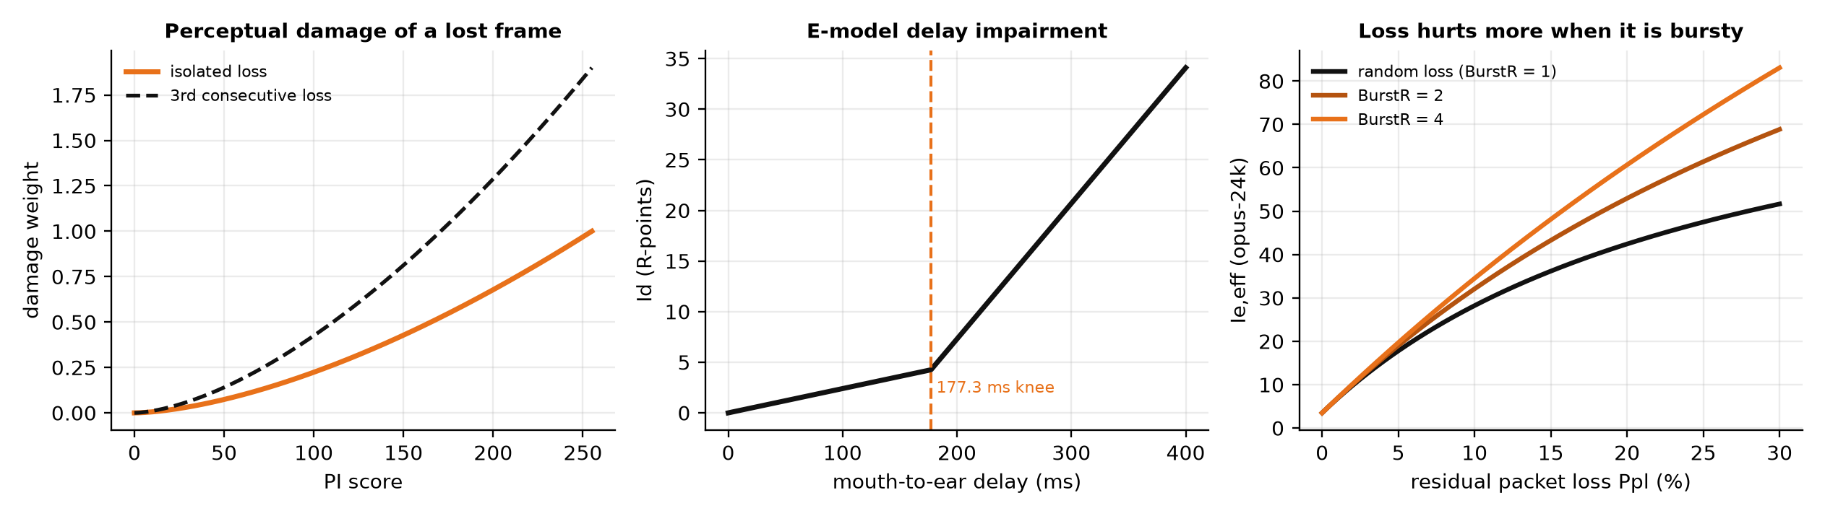
Figure 1. Why not all losses are equal. Left: the perceptual damage weight used throughout this project rises superlinearly with a frame's importance and is penalised for consecutive losses. Centre: the E-model's delay impairment has a knee at 177.3 ms, so an over-deep jitter buffer is a quality defect. Right: for a fixed loss rate, clustered (bursty) loss is far more damaging than random loss.

1.3 Problem statement
Design, implement and evaluate a voice-chat system over UDP that (i) allocates loss protection by the perceptual importance of each frame rather than uniformly, (ii) selects codec bitrate, redundancy, packet marking and playout depth jointly against a single objective quality model, (iii) authenticates users mutually with a password that never crosses the wire, in a minimal number of round trips, without creating amplification or denial-of-service exposure, and (iv) relays and routes media through infrastructure that cannot read it — and demonstrate the resulting quality gains with a like-for-like, reproducible evaluation against the conventional alternatives.

1.4 Scope and contributions
The project delivers a working application, not only a model. Real UDP sockets carry real ADPCM-coded speech, sealed with real X25519 / HKDF / ChaCha20-Poly1305 cryptography, between a relay server and command-line or web-console clients. The contributions are:
- PI analyser — a causal, single-frame-latency perceptual importance scorer whose output travels as authenticated associated data so that every element on the path can act on it without reading the speech (Section 5.3).
- PI-AFEC — a systematic Reed–Solomon erasure code over GF(2⁸) whose per-group parity is set by group importance under a fixed budget, plus deadline-bounded anchor replicas for the most important frames and a burst mode that redirects the budget when block coding is futile (Section 5.4).
- SPARK — a stateless, password-authenticated key agreement with an address-validation cookie, an OPAQUE-style credential envelope, triple Diffie–Hellman with forward secrecy, encrypted resumption tickets and zero-round-trip path migration (Section 5.5).
- NAVIK — a joint controller that maximises the predicted E-model rating over a codec-by-redundancy grid every 100 ms, with a burst-aware residual-loss model and a delay-trend discriminator between congestion and link loss (Section 5.6).
- R-factor-optimal playout — a jitter buffer whose depth maximises R rather than meeting a loss target, with perceptually weighted late-packet cost and a floor that guarantees the protection being paid for can actually be used (Section 5.7).
- SETU — a distance-vector overlay with a composite voice-aware link cost in which loss is expressed in decibels so that it adds along a path exactly as delay does (Section 5.8).
- A reproducible evaluation harness — a time-based Gilbert–Elliott impairment injector, an offline simulator that runs identical speech and identical channel realisations through SWARA and two comparators, and a web console with instrumented live calls, A/B benchmarks and an interactive toolkit (Sections 5.10 and 6).
Out of scope are a formal security proof of SPARK, subjective listening tests (quality is predicted with the G.107 model), recorded human speech (the corpus is a source-filter synthesiser, chosen to keep the evaluation self-contained and licence-free), and group calls with more than two participants, although SETU is designed with them in mind.

1.5 Organisation of the report
Chapter 2 surveys the literature on loss recovery, unequal protection, playout scheduling, quality assessment, secure real-time transport and overlay routing. Chapter 3 distils the research gaps and Chapter 4 states the objectives. Chapter 5 presents the proposed design component by component, with the wire protocol, algorithms and equations. Chapter 6 describes the implementation: modules, threads, the relay server and clients, the web console and the launcher. Chapter 7 reports the results of the simulated evaluation, the live end-to-end benchmarks and the diagnostic investigation that accompanied them, and discusses their limits. Chapter 8 concludes. Appendix A gives the repository, Appendix B the screenshots of every part of the running system, and Appendix C the source code.

2 Literature Survey
This chapter reviews the work on which SWARA builds, grouped by the problem each line of research addresses. Table 1 summarises the works most directly relevant to the design and notes what each leaves open.

2.1 Packet loss recovery for streaming audio
Perkins, Hodson and Hardman's survey [5] remains the standard taxonomy of loss recovery for audio: sender-driven techniques (retransmission, forward error correction, interleaving) and receiver-driven concealment (insertion, interpolation, regeneration). Its central observation is that retransmission is unusable for interactive voice, interleaving adds a delay proportional to its depth, and FEC is the only sender-side mechanism that repairs loss within a frame or two of delay. Bolot, Fosse-Parisis and Towsley [6] made FEC adaptive, choosing the redundancy level from the measured loss process with a Gilbert model and showing that rate-based adaptation is necessary because fixed redundancy either wastes bandwidth or fails when loss rises. The same loss-driven philosophy underlies the IETF payload formats for generic FEC [47] and the flexible FEC used by WebRTC [12], and the in-band low-bit-rate redundancy (LBRR) of the Opus codec [11].
The erasure codes themselves are well understood. Reed and Solomon's polynomial codes [7] are maximum-distance-separable: any k of k+r code words reconstruct the k data words. Rizzo [8] showed that a systematic Vandermonde-based construction over GF(2⁸) can be implemented with table lookups fast enough for software packet-level FEC, and that systematic codes have the decisive practical property that data packets are sent unmodified, so a group that arrives intact costs no decoding at all. SWARA's fec.py follows this construction.

2.2 Unequal protection and perceptual weighting
Mohr, Riskin and Ladner [9] introduced unequal loss protection for progressively coded images: because early bits of a progressive bit-stream matter more than later ones, assigning more parity to the important prefix degrades quality gracefully instead of catastrophically. The idea was adopted widely for layered video, but far less for speech, where the frames are not naturally ordered by importance — importance must be estimated from content. Jiang and Schulzrinne [10] compared loss-repair methods for VoIP under bursty loss and showed that the perceived benefit of FEC depends strongly on burst length and on where the redundancy is placed in time, concluding that loss repair must be optimised against perceived quality rather than raw loss. Clark [18] modelled how burst loss and recency affect subjective quality and argued that an equal-weight loss count is a poor predictor of what a listener reports.

2.3 Playout scheduling and concealment
Ramjee et al. [13] formulated adaptive playout as the problem of trading late-packet loss against added delay and proposed per-talkspurt adjustment driven by delay statistics. Liang, Färber and Girod [14] moved the adjustment inside talkspurts using time-scale modification and showed that playout scheduling and concealment should be designed together. ITU-T G.711 Appendix I [15] standardised a low-complexity concealment algorithm based on pitch-synchronous repetition with attenuation, establishing the practice that concealment should fade rather than repeat indefinitely. In all of this work the buffer objective is a loss target; the delay the buffer adds enters only as a secondary constraint.

2.4 Objective quality assessment
ITU-T P.800 [4] defines the Mean Opinion Score obtained from listening panels; because panels are expensive, transmission planning uses the ITU-T G.107 E-model [2], which combines a base rating with additive impairments for delay (Id), equipment and packet loss (Ie,eff) and an advantage factor (A) into a rating R on a 0–100 scale that maps to MOS. The model's Annex on bursty loss introduces the burst ratio, by which the same average loss is charged more when it is clustered. Sun and Ifeachor [19] validated and extended E-model-style prediction for VoIP codecs and loss conditions, and recommended it as the objective to optimise inside adaptive systems. SWARA takes this literally: the E-model is the objective of both the controller and the jitter buffer.

2.5 Channel models
Gilbert [16] and Elliott [17] introduced the two-state Markov model of a burst-noise channel; its packet-level form, with a good state that rarely drops and a bad state that almost always drops, is the standard model for Internet packet loss and is parameterised naturally by (loss rate, mean burst length). Its use for evaluating voice protection goes back at least to Bolot et al. [6] and Jiang and Schulzrinne [10].

2.6 Secure real-time transport and key establishment
SRTP [20] protects RTP media with an AEAD-style construction keyed out of band, reconstructing a 48-bit packet index from a 16-bit sequence number and a rollover counter and rejecting replays with a sliding window. DTLS-SRTP [21] derives SRTP keys from a DTLS handshake [22]; it is the WebRTC standard and the baseline against which SWARA's handshake is compared. DTLS introduced the stateless cookie exchange (HelloVerifyRequest) so that a server does not allocate state for a spoofed source, and QUIC [23] generalised it into the Retry mechanism, bounded amplification to a 3:1 ratio before address validation, and added connection identifiers that let a connection migrate to a new address without a new handshake. OPAQUE [24] is the asymmetric password-authenticated key exchange adopted by the IETF; its key idea is that the server stores an envelope — the client's long-term key sealed under a key stretched from the password — and never a password-equivalent, so a stolen database yields only an offline-attack target. SWARA composes these ideas with X25519 [25], HKDF [27], PBKDF2 [28] and ChaCha20-Poly1305 [26].

2.7 Network QoS and overlay routing
Differentiated Services [29] lets a sender mark each packet with a code point that routers map to a per-hop behaviour: Expedited Forwarding [30] for low-delay traffic and the Assured Forwarding classes [31] with their drop precedences. Combined with Random Early Detection [32] and its weighted variant, a congested router drops low-precedence packets first — a mechanism that can be made perceptually informed only if the marking reflects content. Andersen et al. [33] demonstrated with Resilient Overlay Networks that the Internet's routing frequently violates the triangle inequality at the application layer and that a small overlay measuring its own links can route around failures and congestion within seconds. Distance-vector routing with split horizon and poisoned reverse [34] gives such an overlay a convergent algorithm. Signalling reliability over UDP is handled in SIP [35] by retransmitting INVITE with an identifier that the callee answers idempotently.
Table 1. Summary of the most relevant prior work and its relation to SWARA.
Work | Contribution | Limitation addressed by SWARA
Perkins et al. 1998 [5] | Taxonomy of audio loss recovery; FEC as the only interactive sender-side repair | Treats all frames as equal; no content awareness
Bolot et al. 1999 [6] | Loss-driven adaptive FEC with a Gilbert channel model | Redundancy chosen from network state alone
Rizzo 1997 [8]; Reed–Solomon 1960 [7] | Fast systematic MDS erasure codes over GF(2⁸) | Block codes fail when bursts span the group; no time displacement
Mohr et al. 2000 [9] | Unequal loss protection by data importance (images) | Importance is structural, not estimated from speech content
Jiang & Schulzrinne 2002 [10] | Repair methods must be judged by perceived quality under bursty loss | No per-frame importance signal to act on
Ramjee et al. 1994 [13]; Liang et al. 2003 [14] | Adaptive playout against late-loss targets | Delay added by the buffer is not part of the objective
ITU-T G.107 [2]; Sun & Ifeachor 2006 [19] | E-model as an objective quality currency | Used for assessment, rarely as the controller's objective
SRTP / DTLS-SRTP [20], [21] | Standard media protection and keying | 3 RTT, ~1.9 kB setup; no password authentication; no 0-RTT migration
QUIC [23]; DTLS cookies [22] | Stateless address validation, amplification limit, connection migration | Not applied to a password-authenticated media relay
OPAQUE [24] | Envelope-based asymmetric PAKE | Composition with a datagram handshake and media keys left open
DiffServ [29]–[31]; RED [32] | Per-packet marking and precedence-aware dropping | Marking is static per flow, not per-frame importance
RON 2001 [33]; RIP [34] | Application-layer overlays beat direct routes; distance-vector convergence | Link cost not expressed in voice-quality terms

3 Research Gap
Reading the literature of Chapter 2 as a whole exposes six gaps between what is known and what deployed voice stacks do. SWARA is organised around closing each of them.
Table 2. Research gaps and the SWARA component that addresses each.
# | Gap | Evidence from the survey | SWARA response
G1 | Loss protection is content-blind: every frame receives the same redundancy | Adaptive FEC [6], [12], [47] adapts to loss rate only; unequal protection [9] was developed for images, not speech | PI analyser + PI-AFEC: parity by group importance, anchors for onsets
G2 | Block FEC cannot survive bursts that span the group, and interleaving is too slow for conversation | Interleaving delay [5]; burst sensitivity of repair [10] | Burst mode: budget redirected to time-displaced replicas of the most important frames
G3 | Playout depth and protection are decided separately although depth bounds what parity and replicas can rescue | Playout work [13], [14] targets late loss; FEC work assumes the buffer is deep enough | R-factor-optimal buffer with a protection floor; replica displacement bounded by depth
G4 | Quality proxies (loss, delay, throughput) conflict; no single objective ties codec, redundancy and marking together | E-model recommended as objective [19] but used for assessment | NAVIK maximises predicted R over a codec × redundancy grid with a burst-aware residual-loss model
G5 | Congestion loss and link loss are treated alike, so controllers back off when they should protect and protect when they should back off | AIMD reacts to any loss [43]; delay-gradient controllers exist for throughput, not for voice protection | Capacity estimate reacts to loss only when the one-way-delay trend rises
G6 | Secure call setup is expensive, stateful and brittle: multi-RTT, large, password-less, no handover; naive UDP servers amplify | DTLS-SRTP cost [21]; cookie/Retry and migration exist in QUIC [23] but not in a password-authenticated media service | SPARK: 2-RTT PAKE with stateless cookie, amplification < 1, ticket-based 0-RTT migration; blind relay
G7 | Direct Internet paths are often not the best paths for voice, and overlay costs ignore jitter and loss | RON [33] uses latency/loss heuristics; RIP [34] uses hop count | SETU: cost = owd + 2·jitter + 45·loss_dB, additive along paths; split horizon with poisoned reverse

A methodological gap also became apparent during the project and is recorded here because it shaped the evaluation: comparative measurements of protection schemes are easily contaminated by the measuring instrument. Stepping a loss model once per packet gives a scheme that sends more packets a different channel from the one it is being compared with; a scheduler thread that busy-waits distorts every timing the controller observes. Section 5.10 and Section 7.9 describe how both artefacts were found and removed.

4 Objectives
The project's objectives follow directly from the gaps of Chapter 3. Each is stated with the measurable criterion used to judge it in Chapter 7.
Table 3. Objectives and success criteria.
# | Objective | Success criterion
O1 | Score every 20 ms frame by its perceptual importance, causally, and carry the score in the packet header where the network can read but not forge it | Silence, unvoiced, voiced and onset frames occupy distinct score bands; silence holds < 2 % of total importance; score is AEAD associated data
O2 | Spend a fixed redundancy budget by importance (PI-AFEC) and protect onsets with deadline-bounded anchor replicas | At equal budget, lower perceptually weighted loss and higher predicted MOS than uniform adaptive FEC across a loss sweep; equal quality for less redundancy
O3 | Survive bursty loss where block coding fails | Advantage over uniform FEC persists as mean burst length rises; anchors account for recoveries when FEC recoveries collapse
O4 | Choose codec bitrate, redundancy and DSCP marking jointly by maximising the E-model rating, discriminating congestion from link loss | Controller never offers more than the capacity estimate; redundancy is held on lossy-but-uncongested paths; decision cost well below the 100 ms epoch
O5 | Size the playout buffer to maximise R and couple it to the protection decision | The depth chosen by the optimiser coincides with the depth that maximises measured end-to-end MOS
O6 | Authenticate users mutually with a password that never crosses the wire, in two round trips, with amplification below one and zero-round-trip migration | 397-byte, 2-RTT handshake; 20-byte RETRY to a 64-byte HELLO; migration in 0 RTT; the relay holds no media keys
O7 | Select relay paths that beat the direct route when the triangle inequality fails | Overlay converges in a handful of rounds; a measurable share of peer pairs gains from relaying
O8 | Deliver a usable application and a reproducible evaluation | Real calls between command-line clients through the relay; a web console that runs instrumented calls, benchmarks and tools; every figure regenerable from one script

5 Proposed Work
SWARA is a layered design in which one idea — judge loss by what the listener loses — propagates through every layer. This chapter presents the system top-down: the end-to-end architecture, the wire protocol, and then each component with its algorithm and the equations it implements. The names of the components are Hindi/Sanskrit words chosen to be memorable: swara (voice, musical note), navik (navigator), setu (bridge), spark (an acronym).

5.1 System architecture
Figure 2 shows one direction of one call. On the sender, 20 ms frames are captured, coded with a per-frame-independent ADPCM codec, scored by the perceptual importance analyser, grouped for Reed–Solomon parity and anchor replicas by the PI-AFEC scheduler, sealed with an AEAD cipher whose associated data is the header, marked with a DiffServ code point derived from the frame's importance, and sent on a plain UDP socket. The relay authenticates users, sets up calls and forwards ciphertext by connection identifier; it never holds a media key. On the receiver, datagrams are authenticated, de-duplicated with a replay window, reassembled — rebuilding missing frames from parity or replicas — scheduled by an R-factor-optimal playout buffer, decoded, concealed where nothing could be rebuilt, and played. A 16-byte telemetry report rides in the header of the reverse-direction media stream, closing the control loop without a single extra packet.
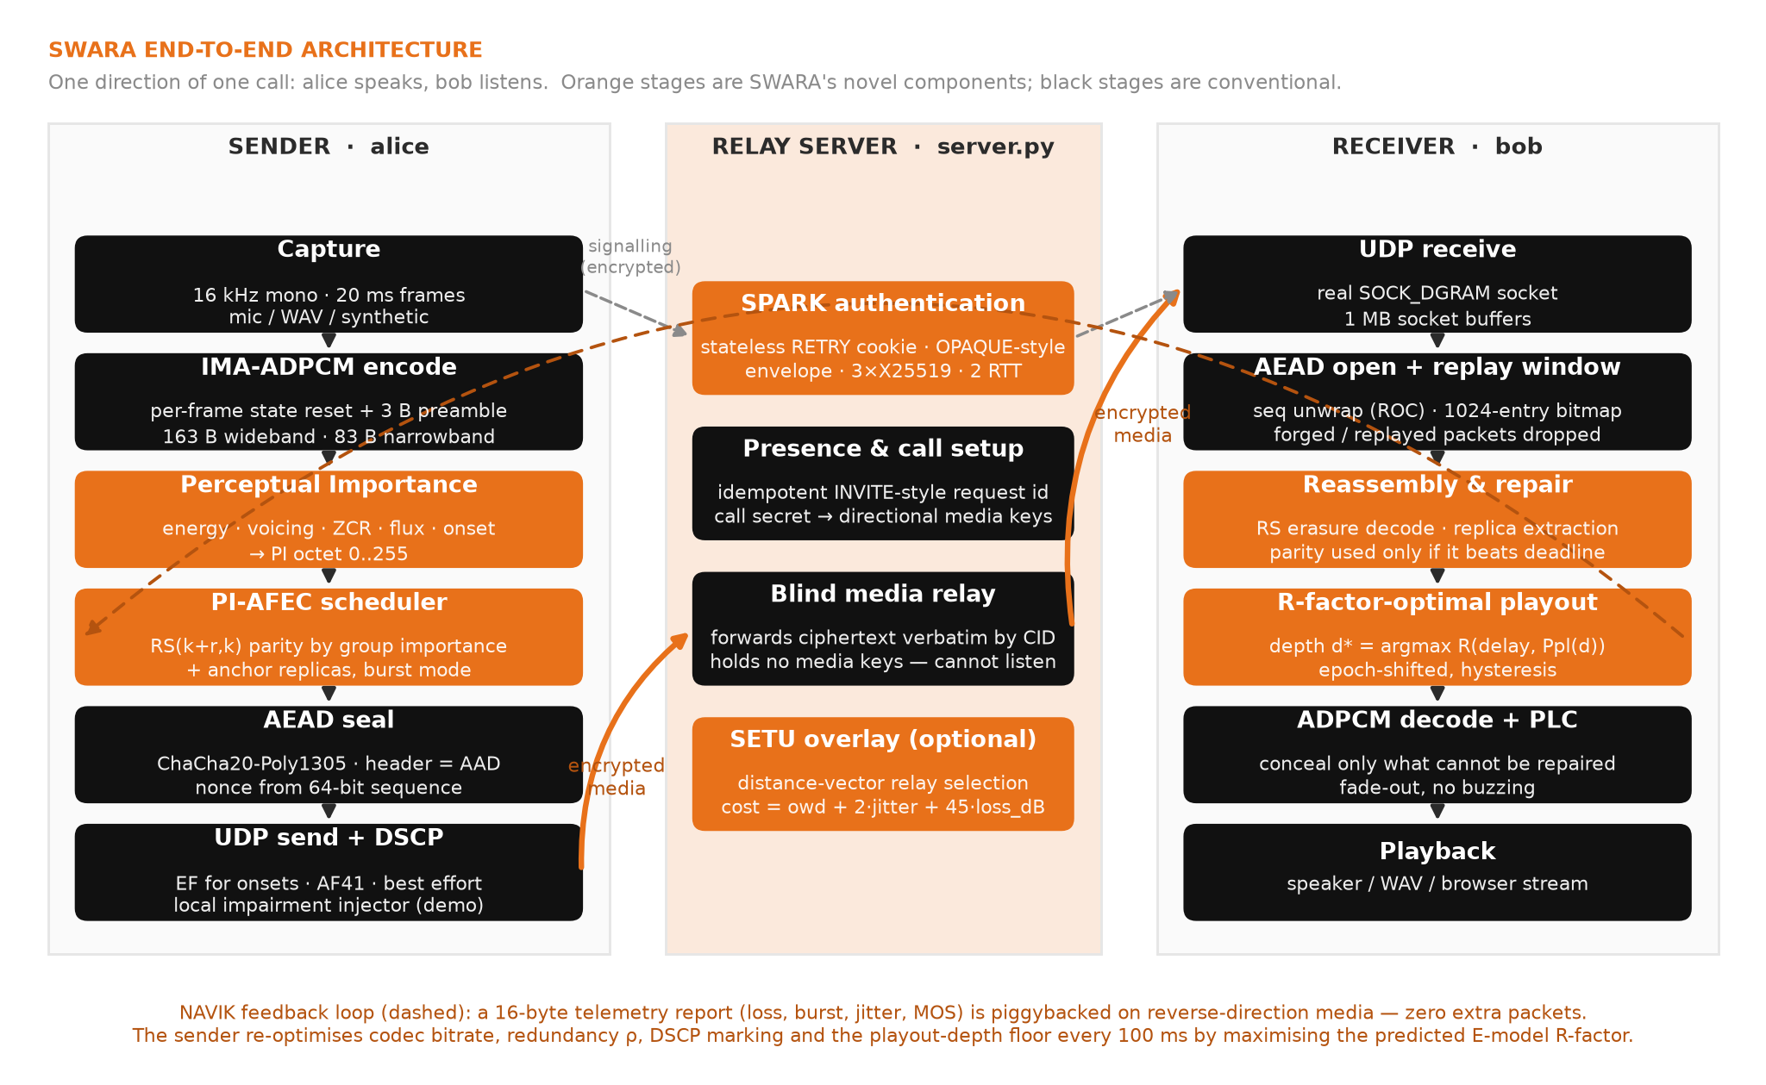
Figure 2. SWARA end-to-end architecture for one direction of a call. Orange stages are the project's novel components; black stages are conventional. The relay in the middle forwards ciphertext it cannot read.

5.2 Wire protocol
Every SWARA datagram is a single UDP payload of at most 1,200 bytes — below the smallest plausible path MTU, so no IP fragmentation ever occurs. There is no stream, no retransmission by default and no head-of-line blocking: a lost packet is a lost 20 ms of audio and nothing more. All datagrams begin with the 16-byte fixed header of Figure 3, packed in network byte order as struct "!BBHIIBBBB".
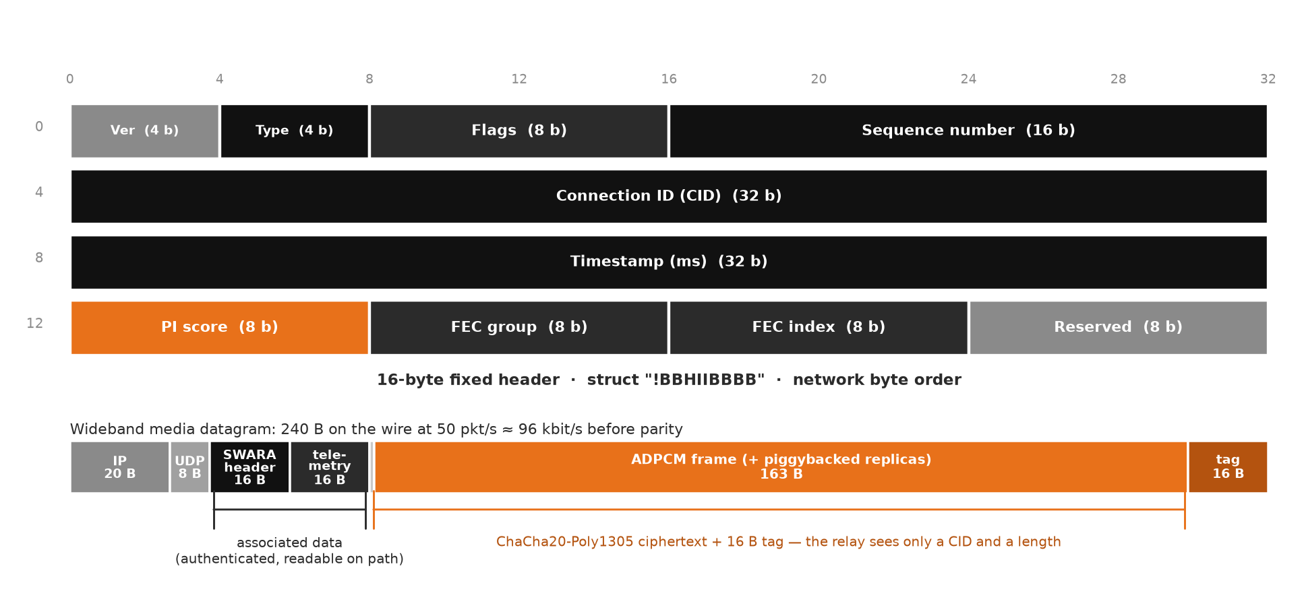
Figure 3. The 16-byte SWARA header and the composition of a wideband media datagram. The header and the optional 16-byte telemetry block are AEAD associated data: readable on the path, unforgeable. Everything after them is ciphertext.
Table 4. Header fields.
Field | Bits | Meaning
Version / Type | 4 + 4 | Protocol version (1) and datagram type (Table 5)
Flags | 8 | TELEMETRY_PIGGYBACK 0x01, MARKER 0x02 (first frame of a talkspurt), DSCP_EF 0x04, ENCRYPTED 0x08, LAST_IN_GROUP 0x10, RESUMED 0x20
Sequence number | 16 | Wire sequence; the receiver unwraps it to a 64-bit counter with an SRTP-style rollover counter, and that counter is the AEAD nonce input
Connection ID | 32 | Derived from the handshake (sessions) or minted by the relay (calls); survives NAT rebinding and path migration; the relay routes on it
Timestamp | 32 | Sender clock in milliseconds; feeds the RFC 3550 jitter estimate and the one-way-delay trend
PI score | 8 | Perceptual importance 0–255 — authenticated but not encrypted, so relays and DiffServ routers can act on it
FEC group / FEC index | 8 + 8 | Group identifier and position within the group; bit 7 of the index marks a parity shard
Reserved | 8 | Zero

Table 5. Datagram types.
Type | Code | Direction | Purpose
HELLO | 0 | client → server | Stateless probe, padded to 64 bytes
RETRY | 1 | server → client | 20-byte address-validation cookie
AUTH_INIT | 2 | client → server | Cookie + client ephemeral public key + username
AUTH_RESP | 3 | server → client | Salt + credential envelope + server ephemeral and static keys
AUTH_CONFIRM | 4 | client → server | Key-confirmation tag
AUTH_TICKET | 5 | server → client | Connection ID + encrypted resumption ticket
MEDIA | 6 | peer ↔ peer | One coded speech frame (plus piggybacked replicas)
FEC | 7 | peer ↔ peer | One Reed–Solomon parity shard
ANCHOR / TELEMETRY / NACK | 8–10 | peer ↔ peer | Reserved for standalone replicas, standalone telemetry and selective NACK (replicas and telemetry are normally piggybacked)
PATH_MIGRATE / PATH_ACK | 11–12 | client ↔ server | 0-RTT authenticated path migration and its validation
OVERLAY_LSA | 13 | peer ↔ peer | SETU distance-vector advertisement
BYE | 14 | any | Teardown
CONTROL | 15 | client ↔ server | Encrypted JSON signalling: call, incoming, call_ready, call_failed, hangup, ping/pong, who, bye

A media datagram's plaintext begins with a one-byte replica count followed by that many {displacement (1), length (2), payload} records and then the primary frame. Displacement rather than an absolute sequence number is used because a displacement survives 16-bit wrap. A parity datagram carries {base sequence (2), k (1), r (1), shard length (2)} followed by the shard. The telemetry block packs loss (×10⁴), mean burst (×100), jitter (×100 ms) and MOS (×1000) into four 16-bit fields with 8 reserved bytes. For the syllabus's error-control topic, packet.py also implements CRC-32 (the Ethernet FCS polynomial), the RFC 1071 Internet checksum that UDP itself carries [38], two-dimensional parity and Hamming(7,4) [39]; the design discussion in Section 5.4 explains why a real-time voice transport uses a detection code plus erasure coding rather than a bit-level correcting code.

5.3 Perceptual importance analysis
The PI analyser converts each 320-sample frame (20 ms at 16 kHz) into a single octet estimating how much intelligibility the listener would lose if that frame were missing. It is strictly causal — every feature uses only the current frame and state accumulated from past frames — because a real encoder cannot look ahead without adding delay. Five features are computed in O(N) or O(N log N):
- Energy E in dB, normalised to E′ ∈ [0, 1] against an adaptive noise floor (fast to fall, slow to rise) and an adaptive peak (fast attack, slow release), with a minimum span of 12 dB.
- Voicing V: the normalised autocorrelation peak in the 60–400 Hz pitch-lag range, computed by FFT, then rescaled against its measured operating range, V = clip((V_raw − 0.12)/0.45).
- Zero-crossing rate ZCR: the classic voiced/unvoiced discriminator; a high ZCR with low voicing identifies fricative noise.
- Spectral flux F: the half-wave-rectified difference between successive Hann-windowed magnitude spectra — energy that has just appeared, the signature of an onset.
- Voice activity: a frame is speech if it is more than 6 dB above the noise floor, or more than 4 dB above it with F > 0.62 (which admits 8 ms plosive bursts whose average energy is low).
PI_raw = 0.30·E′ + 0.34·V_eff + 0.20·F + 0.16·onset, V_eff = 0.6·V if (V < 0.4 and ZCR > 0.20) else V (1)
PI = 255 · min(1, boost · (0.12 + 0.88 · clip(PI_raw, 0, 1))) for speech; PI = 255 · 0.06 · E′ otherwise (2)
The onset term is a rising-edge detector, onset = clip(3.2 · (E′ − E′_prev)); a hard onset — the first speech frame after silence — forces onset = 1 and applies a multiplicative boost of 1.45, because losing the frame that begins a talkspurt destroys the word-boundary cue. The design targets, verified on the synthetic corpus (Section 7.2), are silence 0–25, steady fricatives 50–110, steady vowels 150–210 and onsets 210–255. The score's companion is the damage weight that turns a loss into a perceptual cost:
d(PI, run) = (PI / 255)^1.6 · (1 + 0.45 · min(run, 4)) (3)
The curve is superlinear — a frame twice as important is roughly three times as costly to lose — and consecutive losses are penalised because concealment degrades sharply once it has to invent more than about 40 ms of speech. Equation (3) is used in three places with the same constants: to score lost frames in the evaluation, to weight late packets in the jitter buffer, and to convert accumulated damage into the perceptual loss percentage fed to the E-model, Ppl_perc = 100 · Σ d / N. Using one function everywhere means the optimiser and the evaluator agree by construction.

5.4 PI-AFEC: importance-weighted adaptive FEC
Erasure code. Groups of k media frames are extended with r parity shards by a systematic Reed–Solomon code over GF(2⁸) with primitive polynomial 0x11D (the field of CD-ROM, QR codes and RAID-6). Multiplication is a 256 × 256 table so encoding is a sequence of vectorised XORs; the generator rows are Cauchy-style, m[i, j] = (a_i ⊕ b_j)⁻¹ with distinct a_i = i + 1 and b_j = 128 + j, normalised so that the r = 1 row reduces to plain XOR. Any square sub-matrix is invertible, which is the MDS property: any k of the k + r shards reconstruct the group. Decoding solves the small system for the missing data shards by Gauss–Jordan elimination over the field. The module verifies the MDS property at import time.
Why erasure coding rather than Hamming. A UDP datagram either arrives intact or not at all: the IP and UDP checksums and the AEAD tag discard corrupted packets, so the channel seen by the application is an erasure channel in units of whole frames. A bit-level correcting code such as Hamming(7,4) spends 75 % overhead correcting single-bit errors that the link layer has already removed; a packet-level erasure code spends its overhead on the failure mode that actually occurs.
Scheduler. For each group the scheduler computes the mean normalised importance Ḡ = mean(PI)/255 and a weight w = Ḡ^γ with γ = 0.65 (so moderately important groups are not starved). The weight is normalised by its own running mean w̄ so that the expected spend equals exactly the budget k·ρ handed down by the controller — the scheme redistributes the budget, it does not quietly discount it — and the group's budget in packets is
budget = k · ρ · clip(w / w̄, 0, 4), with budget = 0 whenever Ḡ < 0.08 (a silent group) (4)
The budget is split between parity and anchor replicas according to the estimated mean burst length B. An RS(k + r, k) group survives only if at least k of its k + r packets arrive; when the burst approaches the group's own span that condition fails almost every time the channel goes bad and every parity byte is wasted. Classical coding theory answers with interleaving, but an interleaver of depth D over k frames costs k·D frame times of delay — 480 ms for D = 3, k = 8 — and destroys interactivity. SWARA instead interleaves only what matters: in burst mode (B ≥ 0.75 k) the shares are 45 % parity / 55 % replicas, otherwise 85 % / 15 %. Fractional budgets are carried between groups rather than rounded away (with k = 4 a per-group budget of 0.4 packets would otherwise round to zero every time). Up to four replicas go to the highest-PI frames of the group, provided PI ≥ 170, each displaced by
D = clip(round(B) + 2, 3, 9) + 2 · slot frames, bounded in the live system by (depth − spread₉₅ − 20 ms) / 20 ms (5)
so that the copy clears the burst that killed the original and still beats the original's own playout instant after suffering the same delay spread as everything else. A replica is piggybacked onto an existing media packet — it costs only its payload bytes, not a second set of IP, UDP and SWARA headers. The uniform comparator used throughout the evaluation is the same code with r = round(k·ρ) for every group (probabilistically honouring fractions): a strong, correctly adapting baseline that simply cannot tell a vowel from a silence.
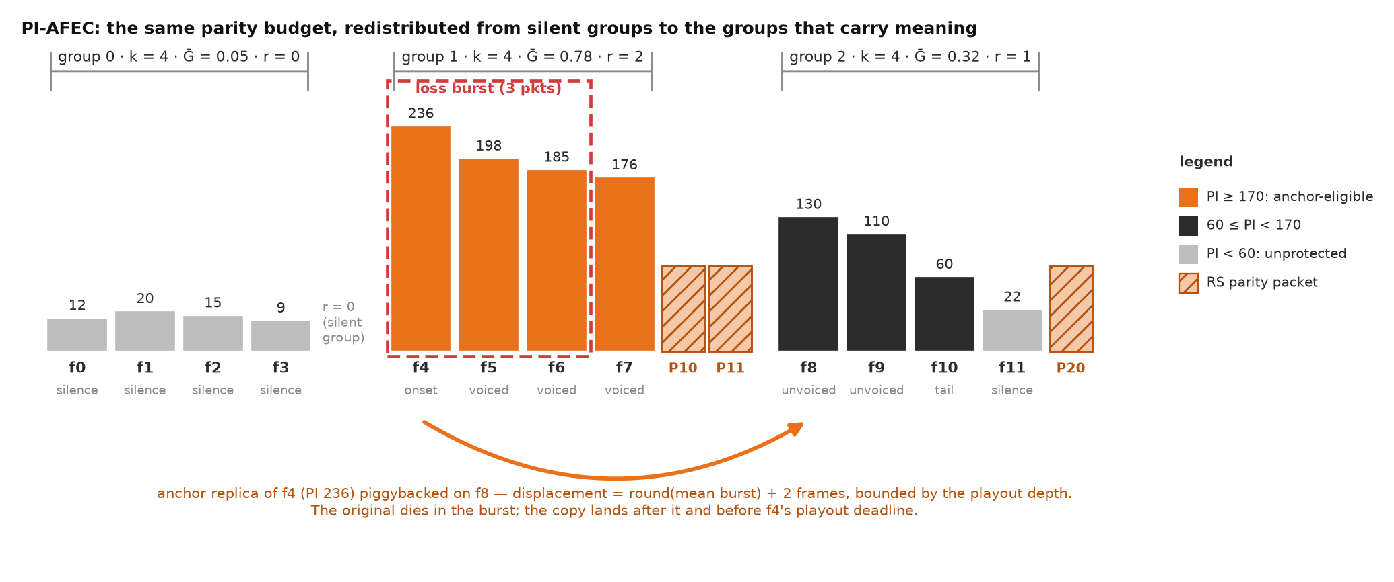
Figure 4. PI-AFEC on three consecutive groups of k = 4 frames. The silent group receives no parity; its budget moves to the group carrying the vowel onset, which additionally earns an anchor replica displaced past the expected burst length.

5.5 SPARK: stateless password-authenticated key agreement
The authentication problem for voice over UDP is not “how do I check a password”. It is: (a) UDP is trivially spoofable, so an unauthenticated first packet must never make the server allocate memory or emit a larger reply, or the service becomes a DDoS amplifier; (b) a password must never cross the wire, and a stolen server database must not yield anything replayable; (c) the handshake must not cost so many round trips that call setup feels slow — and after a Wi-Fi-to-mobile handover it must cost none, because the user is mid-sentence. SPARK addresses all three in the six messages of Figure 5.
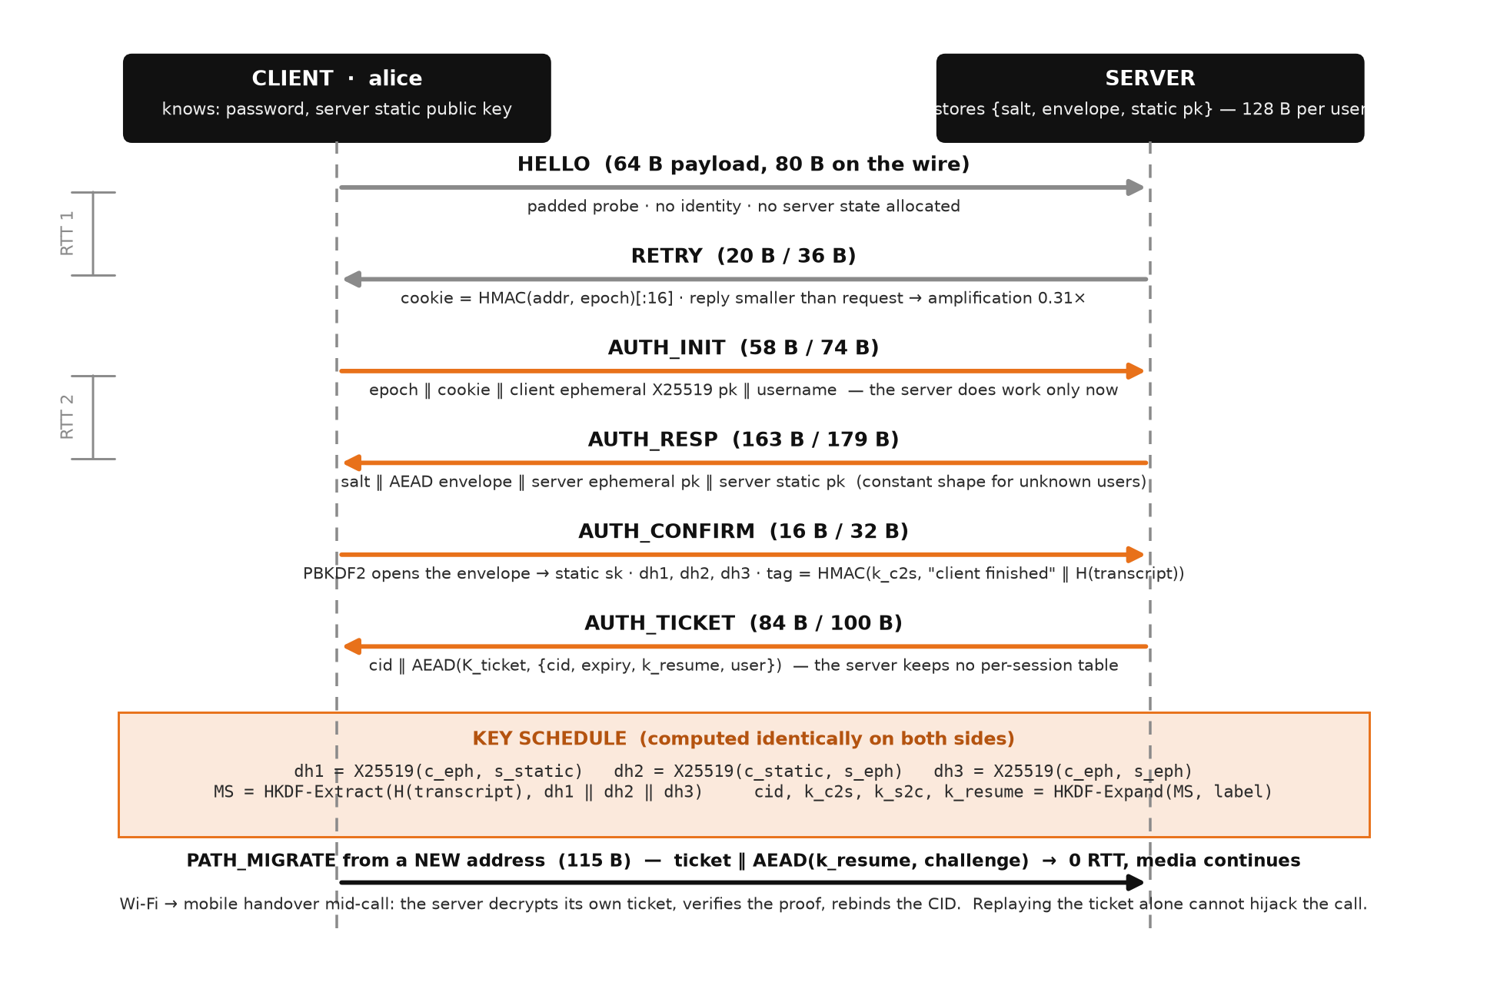
Figure 5. The SPARK handshake and 0-RTT path migration, with on-the-wire sizes measured from the implementation.
- Registration (once, out of band). The password is stretched with PBKDF2-HMAC-SHA256 (200,000 iterations, 16-byte salt) [28] into a key that seals an envelope: the client's static X25519 private and public keys under ChaCha20-Poly1305 with the username as associated data. The server stores only {salt, envelope, client static public key} — 128 bytes and nothing resembling a password or a verifier [24].
- HELLO → RETRY. The client sends a 64-byte padded probe revealing no identity. The server replies with a 20-byte cookie, HMAC(cookie_key, ip ‖ port ‖ epoch)[:16] with a 30-second epoch, allocating no state. Because the reply is smaller than the request the amplification factor is 20/64 = 0.31 [22], [23].
- AUTH_INIT. The client echoes the cookie — proving it can receive at the address it claims — with an ephemeral X25519 public key and its username. Only now does the server do work. For an unknown user it answers with a random envelope of identical shape, so the protocol is not a user-enumeration oracle.
- AUTH_RESP. Salt, envelope, a fresh server ephemeral public key and the server's static public key.
- AUTH_CONFIRM. The client re-derives the stretched key, opens the envelope (a wrong password fails locally and nothing is sent), and computes three Diffie–Hellman shares: dh1 = X25519(c_eph, s_static) authenticates the server, dh2 = X25519(c_static, s_eph) authenticates the client, dh3 = X25519(c_eph, s_eph) gives forward secrecy. With th = SHA-256 over every length-prefixed handshake byte, MS = HKDF-Extract(th, dh1 ‖ dh2 ‖ dh3) and the connection id and the keys k_c2s, k_s2c, k_resume are HKDF-Expand(MS, label) [25], [27]. The client proves key knowledge with tag = HMAC(k_c2s, “client finished” ‖ th)[:16].
- AUTH_TICKET. The server verifies the tag, binds the CID to the client's address, and issues ticket = nonce ‖ AEAD(K_ticket, cid ‖ expiry ‖ k_resume ‖ user). It keeps no per-session table for resumption.
- Path migration (0 RTT). From a new address the client sends ticket ‖ AEAD(k_resume, challenge). The server decrypts its own ticket, verifies the proof — an off-path attacker replaying the ticket alone cannot forge it — and rebinds the CID. Media continues without a round trip of silence.
Media protection. Each call receives a fresh 32-byte secret minted by the relay, from which two directional keys are derived; each party receives both keys inside a CONTROL message sealed under its own session key. Media packets are sealed with ChaCha20-Poly1305 [26]; the nonce is derived from (direction, 64-bit sequence) so none is transmitted — 12 bytes saved per packet, 4.8 kbit/s per stream. The 16-bit wire sequence is unwrapped with an SRTP-style rollover counter (otherwise every packet would fail authentication after 21.8 minutes), and a 1,024-entry sliding bitmap rejects replays [20]. Because the relay forwards datagrams verbatim and holds neither key, it cannot listen to the call it carries.

5.6 NAVIK: joint quality control
The sender has three dials and one budget: codec bitrate b (higher b lowers the codec impairment Ie), redundancy ρ (higher ρ lowers residual loss), DSCP marking, and the available capacity C with b(1 + ρ) + H ≤ C. Conventional stacks resolve this with a cascade of independent heuristics that can fight each other — the classic pathology is FEC added in response to congestion loss, which increases the offered load and deepens the congestion. NAVIK replaces the cascade with one objective, evaluated every 100 ms over a grid of seven nominal codec rates and nine redundancy levels (63 evaluations, tens of microseconds):
maximise R(codec(b), owd + depth + 25 ms, Ppl_res(ρ, p, B), B) s.t. b(1+ρ) + H ≤ 0.85·C_est, ρ ≤ ρ_max(p) (6)
Because R already contains the delay term, the congestion pathology cannot occur: redundancy that would push the offered rate past the estimate raises queueing delay, lowers R, and is refused. The safety rail ρ_max(p) = 0.65 for p < 3 % and max(0.15, 0.65 − 1.8 (p − 0.03)) above tapers redundancy as loss rises, since very high loss usually is congestion. H = 24 kbit/s is the header overhead of 50 packets per second of IP + UDP + SWARA + AEAD tag.
Residual-loss model. The probability that an RS(k + r, k) group cannot be decoded is the probability of more than r erasures among k + r packets. Under independent loss this is a binomial tail; under clustered loss the erasure count is over-dispersed, so NAVIK uses a beta-binomial with intra-class correlation ρ_c = (B − 1)/(B + 1). The difference matters: at 10 % loss with mean burst 4 the binomial predicts a group-failure rate about six times lower than reality, and a controller that believed it would under-provision exactly when protection is most needed. Anchor replicas are modelled independently of the block code — they survive unless an independent loss event hits them — because treating them as a modifier on RS made the controller believe protection was futile in exactly the burst-dominated conditions where the anchor is the only thing that still works.
Congestion versus loss. Naive AIMD backs off on any loss [43] — right on a wired path, wrong on a wireless one, where backing off starves the very redundancy the loss made necessary. Congestion has a signature random loss lacks: the queue fills before it overflows, so one-way delay rises first. NAVIK fits a line to the last 100 one-way-delay samples and treats loss as congestion only when the slope exceeds 8 ms/s, shrinking the capacity estimate by 12 % per epoch; loss with a flat trend is read as link loss and the rate is held (a gentle 0.5 % probe down), while a clean path lets the estimate track 1.25 × goodput.
DiffServ marking. The decision also fixes per-packet marking driven by importance: PI ≥ 160 → EF (46), 80 ≤ PI < 160 → AF41 (34), otherwise best effort [29]–[31]. A router applying WRED [32] to a congested queue drops from the lowest precedence first, so the network's own drop decision becomes perceptually informed without the router understanding — or being able to read — the speech.
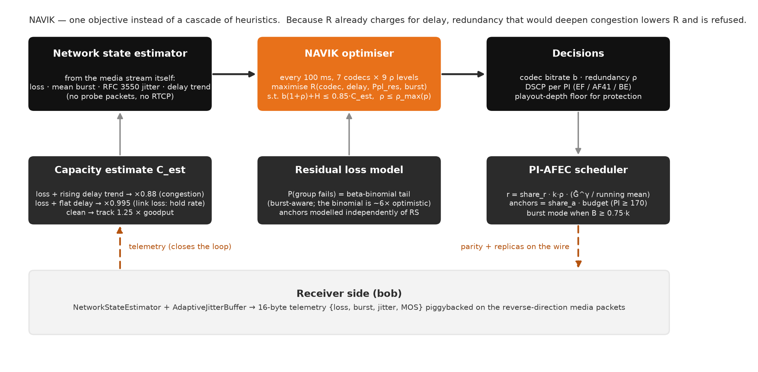
Figure 6. The NAVIK control loop: receiver-side estimation feeds a single R-factor objective whose decisions drive the scheduler, the codec and the packet marking.

5.7 Receiver: estimation, repair and R-factor-optimal playout
All network statistics are estimated from the media stream itself — no probe packets, no separate RTCP reports. The estimator tracks loss as 1 − seen/expected over the highest sequence number, mean burst as the mean length of the last 80 gaps, interarrival jitter with the RFC 3550 recursion J ← J + (|D| − J)/16 [1], the delay spread as the 95th minus 5th percentile of relative one-way delay, reordering and goodput.
A conventional adaptive jitter buffer targets a loss objective — “size the buffer so that at most 1 % of packets arrive late” — which treats the delay it adds as free. It is not: the E-model charges 0.024 R-points per millisecond and 0.134 per millisecond beyond 177.3 ms. SWARA chooses the depth that maximises the predicted rating directly,
d* = argmax_d R(codec, other_delay + d, 100 · late(d) · (0.25 + 1.5 · I_late), B) over d ∈ {0, 10, …, 180} ms (7)
where late(d) is the fraction of packets whose relative delay exceeds d and I_late is the mean damage weight of the packets currently arriving late. The optimum shifts deeper when late packets are important and shallower when they are silence. Depth changes are smoothed (hysteresis 0.35) because they are audible, and in the live system the depth is floored at the shallowest value at which the protection being paid for can work — (k + 1) frames for parity, (B + 2) frames plus the delay spread for replicas — on the principle that buying redundancy the buffer is too shallow to use is pure waste. Depth is changed on a running call by shifting the playout epoch: deepening is applied at once, shallowing at most 10 ms per epoch. At each 20 ms slot the playout thread takes the frame in sequence; if it is missing it attempts a Reed–Solomon reconstruction of its group (and the previous group, whose parity may have just arrived); if nothing can be rebuilt it conceals by repeating the previous frame with a gain of 1 − 0.35·run and tapered edges, fading to silence rather than buzzing.

5.8 SETU: voice-aware overlay routing
BGP picks paths on policy and AS-hop count, not on latency, jitter or loss, and the triangle inequality is frequently violated at the application layer: A → C → B can be measurably better than A → B [33]. SETU is a small application-layer overlay among call participants and relays that runs a distance-vector computation — Bellman–Ford with split horizon and poisoned reverse, the algorithm family of RIP [34] — over a composite link cost that expresses what voice cares about in one number:
cost(u, v) = 1.0 · owd_ms + 2.0 · jitter_ms + 45 · (−10 · log₁₀(1 − p)), relay hop penalty = 12 (8)
Expressing loss in decibels of survival probability is what makes the cost valid for shortest-path routing: losses then add along a path exactly as delays do (a 1 % link and a 2 % link compose to 2.97 %, and −10 log(0.99) − 10 log(0.98) = −10 log(0.9702) exactly). Jitter is weighted above raw delay because it forces a deeper playout buffer. Count-to-infinity is prevented by poisoned reverse and a cost ceiling; with tens of nodes convergence takes a handful of rounds.
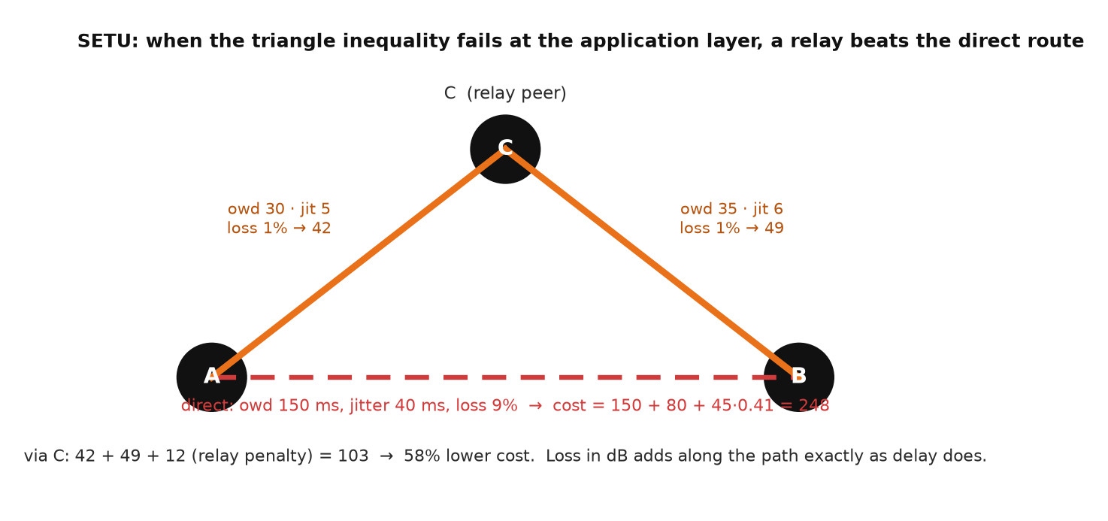
Figure 7. A triangle-inequality violation: the direct A–B path crosses a congested exchange while the two-hop path through C is far cheaper in voice-cost terms.

5.9 Speech codec with per-frame state reset
SWARA's codec is a real IMA ADPCM [36], [37]: 4 bits per sample, 4 : 1 compression of 16-bit PCM, with one deliberate modification. Standard ADPCM carries its predictor and step index continuously from block to block; over a lossy transport that is fatal, because one lost packet makes the decoder's predictor diverge from the encoder's and every subsequent frame decodes to noise until something resynchronises. SWARA resets the state at every frame boundary and transmits the starting predictor and step index in a 3-byte preamble, so every frame is independently decodable: packet loss damages exactly the frames that were lost and nothing else. The cost is a small loss of coding efficiency; the benefit is the property on which every repair mechanism above depends. Two modes give the controller something real to switch between: wideband (16 kHz, 320 samples, 163 bytes per frame, 65.2 kbit/s) and narrowband (8 kHz via an 8-tap anti-alias FIR, 83 bytes, 33.2 kbit/s). A codec designed for a file is the wrong codec for a network.

5.10 Evaluation methodology
Channel model. Both the offline simulator and the live impairment injector use the Gilbert–Elliott chain of Figure 8, parameterised as an operator would — “10 % average loss with a mean burst of 4 packets” — and solved as p_BG = 1/B, p_GB = p_BG · p/(1 − p). The simulator adds a base one-way delay, a heavy-tailed log-normal jitter component (which matches wide-area delay distributions far better than a Gaussian and is what makes buffer sizing genuinely hard), a token-bucket bottleneck queue with tail drop beyond 250 ms of queueing, and optional reordering and duplication. Seven named profiles span an ideal LAN, good and busy Wi-Fi, congested 4G, poor 3G, a hostel Wi-Fi network and a satellite link.
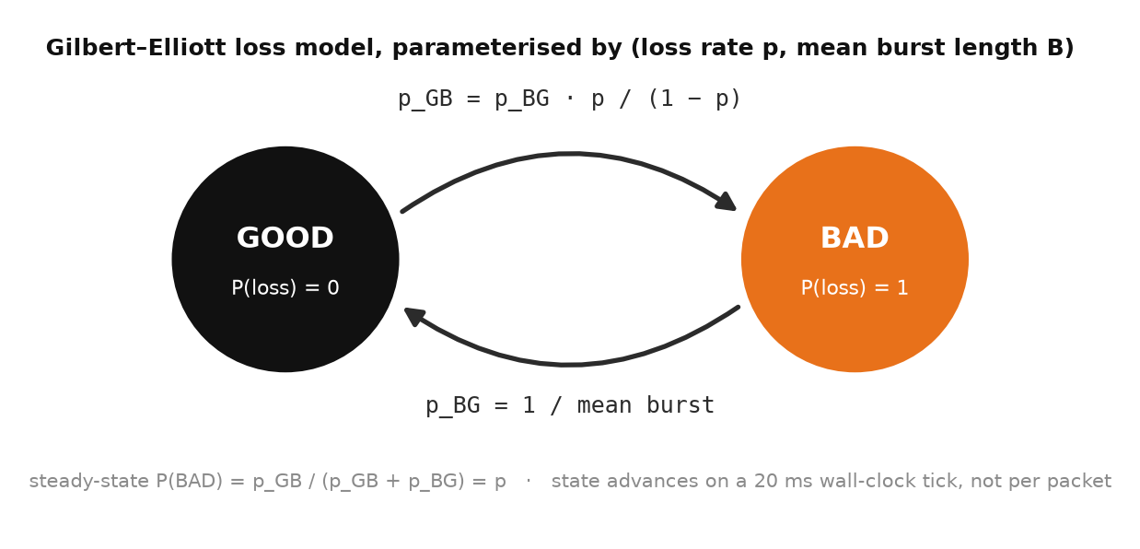
Figure 8. The Gilbert–Elliott loss model used by both the simulator and the live injector.
Time-based impairment. The live injector advances the chain on a 20 ms wall-clock tick, not once per packet. Physically a fade lasts a duration, not a number of packets; methodologically, stepping per packet means a configuration that transmits redundancy walks the chain further per unit time and therefore experiences a different channel from the one it is compared with — the project hit exactly that, with three arms configured for 15 % loss measuring 9.5 %, 12.3 % and 12.5 %. The injector also keeps two independent random streams (loss chain and jitter) and is reset to the same seed for every arm, so every arm faces the identical sequence of good and bad periods.
Comparators. Every result compares three systems on identical speech, identical channel realisation and — crucially — identical redundancy budget: the baseline (plain UDP, no FEC, a conventional buffer at the 95th percentile of delay plus 10 ms), uniform FEC (loss-driven adaptive FEC given exactly the redundancy SWARA spent, spread evenly over all groups — RFC 5109 / FlexFEC behaviour), and SWARA. Any gain over the second comparator is attributable to perceptual placement, not to “SWARA has FEC”. Quality is scored with the G.107 E-model using the perceptually weighted residual loss and the measured burst ratio; the corpus is a source-filter speech synthesiser (glottal pulse train or noise through formant resonators, talkspurts of 0.9–2.8 s with realistic phone durations), seeded so that every run is reproducible.

6 Implementation

6.1 Technology stack
Table 6. Technology stack and versions used for the reported results.
Layer | Technology | Role
Language / runtime | Python 3.14.3 (CPython), Windows 11, 20 logical CPUs | Protocol stack, relay, clients, simulator, web back end, launcher
Numerics | NumPy 2.5.3 | Vectorised GF(2⁸) arithmetic, FFT-based voicing and flux, estimators
Cryptography | pyca/cryptography 50.0.1 | X25519, HKDF-SHA256, ChaCha20-Poly1305; PBKDF2 and HMAC from the standard library
Transport | socket (AF_INET, SOCK_DGRAM), IP_TOS | Real UDP datagrams with DSCP marking and 1 MB socket buffers
Web API | FastAPI 0.141.1, Starlette 1.6.0, Pydantic 2.13.5, Uvicorn 0.52.4 | REST + Server-Sent Events console back end, OpenAPI documentation
Front end | Vanilla JavaScript (ES2020), Chart.js 4.4.1 (vendored), Web Audio API | Single-page console: live charts, frame-fate map, in-browser audio playback and recording
Figures | Matplotlib 3.11.1 | Research figures and report diagrams
Audio I/O | sounddevice 0.5.6 (optional) | Microphone and speaker backends; WAV and synthetic backends need nothing
Desktop launcher | Tkinter | Start / stop / restart the server and relay without a terminal

6.2 Repository layout
SWARA/
├── server.py registration, SPARK authentication, presence, call setup, blind media relay
├── client.py the voice-chat application: login, call placement, capture, playback
├── demo.py self-contained end-to-end demonstration and A/B harness
├── api_server.py FastAPI web console + REST API, hosts the relay inside uvicorn
├── launcher.py Tkinter "SWARA Server Control" window
├── swara/ the protocol stack (15 modules, ~4,000 lines)
│ ├── packet.py wire format, header pack/unpack, CRC-32, checksum, 2-D parity, Hamming(7,4)
│ ├── perceptual.py PI analyser and damage weight
│ ├── fec.py GF(2^8) Reed–Solomon, PI-AFEC scheduler, uniform comparator
│ ├── auth.py SPARK client/server, key schedule, media AEAD, ROC, replay window
│ ├── controller.py NAVIK joint optimiser, residual-loss model, DSCP mapping
│ ├── receiver.py network-state estimator, R-factor-optimal jitter buffer
│ ├── session.py live call pipeline: four threads per call end
│ ├── codec.py IMA ADPCM with per-frame reset, concealment
│ ├── net.py UDP endpoint, DSCP, time-based Gilbert–Elliott impairment injector
│ ├── emodel.py ITU-T G.107 E-model, perceptual Ppl
│ ├── overlay.py SETU distance-vector overlay
│ ├── channel.py Gilbert–Elliott channel for the offline evaluation, named profiles
│ ├── engine.py offline harness: SWARA vs uniform FEC vs baseline
│ ├── speech.py source-filter synthetic speech corpus
│ └── audio_io.py microphone / speaker, WAV and synthetic sources and sinks
├── webapp/ console back end: lab.py (instrumented calls), relay.py, tools.py
├── static/ console front end: index.html, css/app.css, js/core.js, js/pages/*.js, vendor/chart.umd.min.js
├── experiments/run_all.py the eight evaluation experiments → results.json + figures/
├── figures/ fig1 … fig8 (regenerated by run_all.py)
├── users.json credential records {salt, envelope, public key} — no passwords
└── SWARA Server.bat / start_console.bat one-click launchers

6.3 Module responsibilities
Table 7. Source modules and their responsibilities.
Module | Lines | Responsibility
swara/packet.py | 207 | 16-byte header, datagram types and flags, media/parity layouts, integrity primitives
swara/perceptual.py | 240 | Causal PI analyser (energy, voicing, ZCR, flux, onset, VAD) and damage weight
swara/fec.py | 398 | Table-driven GF(2⁸), systematic Reed–Solomon encode/decode, PI-AFEC and uniform schedulers
swara/auth.py | 475 | Registration, SPARK handshake (server and client), tickets, migration, MediaCipher, SequenceReconstructor, ReplayWindow
swara/controller.py | 281 | NAVIK: capacity estimate, beta-binomial group-failure model, grid search over codec × ρ, DSCP mapping
swara/receiver.py | 233 | NetworkStateEstimator, AdaptiveJitterBuffer (R-optimal), GroupBuffer
swara/session.py | 607 | CallSession: sender, receiver, playout and control threads; replica piggybacking; epoch-based playout; telemetry
swara/codec.py | 199 | IMA ADPCM encode/decode with per-frame preamble, narrowband resampling, concealment
swara/net.py | 240 | UdpEndpoint with counters and DSCP; Impairment injector (wall-clock Gilbert–Elliott, delay scheduler)
swara/emodel.py | 171 | R-factor, Id, Ie,eff with burst ratio, R→MOS, perceptual Ppl, quality labels
swara/overlay.py | 164 | SETU: link cost, distance-vector node, split horizon with poisoned reverse, convergence, path report
swara/channel.py | 193 | ChannelConfig, GilbertElliottChannel with queueing/reordering/duplication, named profiles
swara/engine.py | 342 | CallSimulator (pilot pass, planning, transmission, scoring) and the three-way compare()
swara/speech.py | 156 | SpeechGenerator: vowels, fricatives, plosives, silences; per-frame ground truth
swara/audio_io.py | 178 | AudioSource / AudioSink backends: live, WAV, synthetic, null
server.py | 246 | Relay: user store, SPARK phases, presence, idempotent call setup, verbatim media relay
client.py | 266 | Client: retransmitting handshake, INVITE-style call placement, keepalives, run_call
demo.py | 229 | One-process end-to-end demonstration; A/B harness with identical channel realisations
experiments/run_all.py | 511 | Eight experiments, results.json and all figures
api_server.py + webapp/ | 1,284 | REST API, SSE streaming, instrumented TracedSession, Benchmark, hosted relay, toolkit wrappers
static/ | ~3,000 | Console front end (14 JavaScript modules, stylesheet, HTML shell)
launcher.py | 482 | Desktop server-control window

6.4 The live call pipeline
CallSession owns one end of one call: the codec, the protection state and the two directional keys. It starts four daemon threads (Figure 9). The sender reads a frame, encodes it, scores it, prepends any replicas queued for this slot, seals the packet with the header and telemetry as associated data, marks the socket's DSCP from the frame's importance and sends; every k frames it closes the group, asks the scheduler for a plan, queues the chosen replicas at their displacements and emits the parity shards. It is paced against a monotonic clock so that scheduling error does not accumulate into drift. The receiver authenticates each datagram, unwraps the sequence number, rejects replays, stores media payloads and parity shards, extracts piggybacked replicas and updates the estimator. The playout thread fills to the target depth, then runs an absolute schedule anchored at an epoch — this is what allows the depth to be changed on a running call — and for each slot plays, repairs or conceals. The control thread, every 100 ms, snapshots the estimator, updates the capacity estimate from the delay trend, asks NAVIK for a decision, hands ρ and the burst estimate to the scheduler, optimises the buffer depth, floors it at the protection requirement and retargets the epoch.
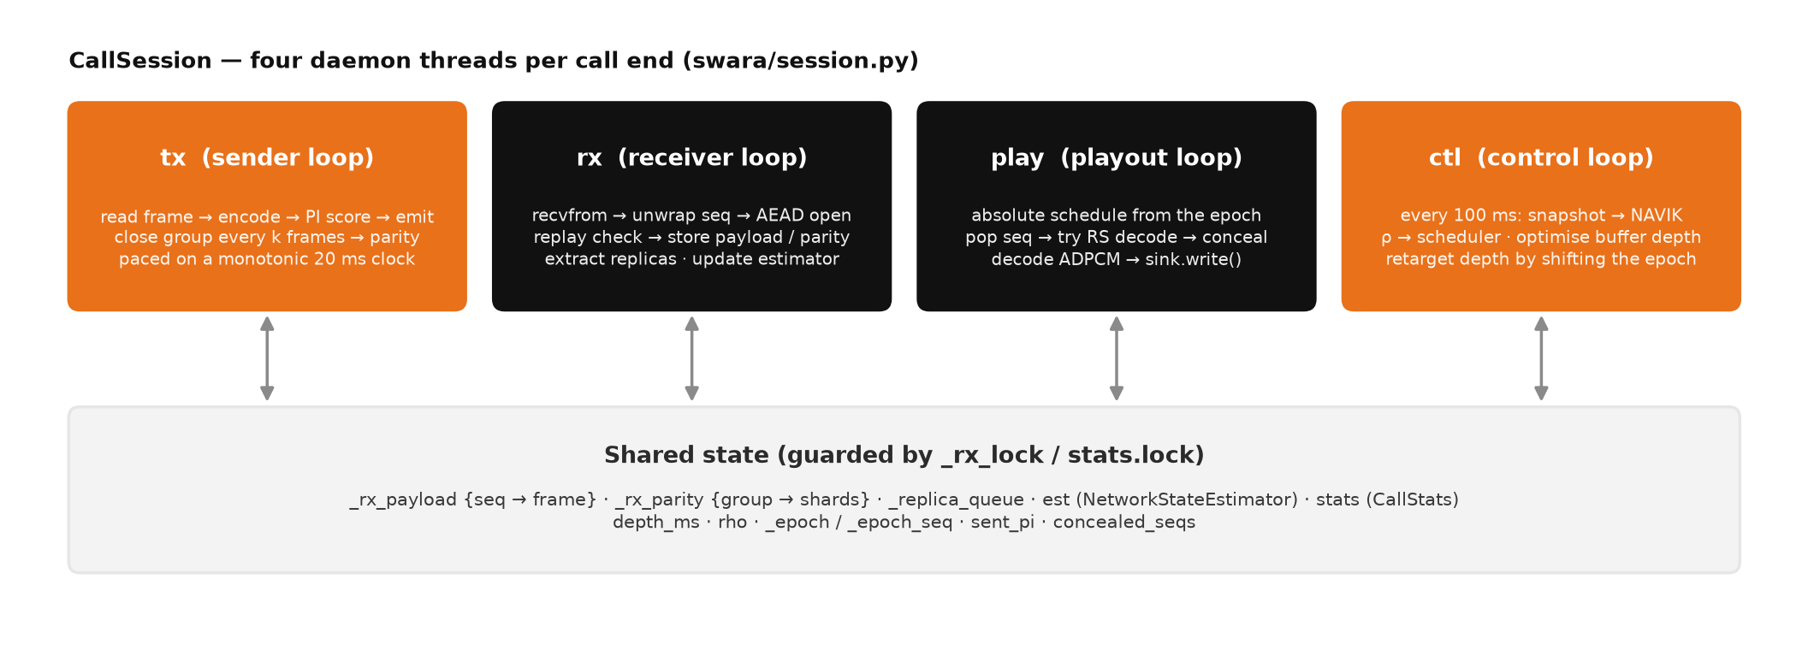
Figure 9. The four threads of a CallSession and the state they share.
Two design details were forced by measurement. First, the playout schedule is absolute rather than a free-running 20 ms tick: with a free-running tick the buffer depth is whatever happened to accumulate at start-up and can never change, so raising the depth later has no effect and parity that needs the extra slack arrives too late to be used. Second, replica displacement subtracts the 95th-percentile delay spread: ignoring it placed the copy about one frame too late and only 7 % of transmitted replicas were ever used.

6.5 The relay server
server.py binds one UDP socket and runs a single receive loop. The media relay is checked first because it has the highest volume: if the header's connection id names an active call, the datagram is forwarded verbatim to the other party and nothing else happens — no decryption, no parsing. Otherwise the datagram type selects a SPARK phase: HELLO is answered statelessly; AUTH_INIT is validated against the cookie and silently dropped if it fails (a spoofed source gets nothing); a retransmitted AUTH_INIT re-sends the first response so the transcript the client committed to is preserved; AUTH_CONFIRM completes the handshake and records the session by username and by CID. Encrypted CONTROL messages carry JSON signalling. Call placement mints a random 32-byte secret, derives the two directional keys and delivers them to each party under that party's own session key. Because UDP may lose either answer, the caller attaches a request id and retransmits; the server remembers the answer it already gave and repeats the same call_ready / incoming pair instead of minting a second call — the idempotent server half of SIP-style INVITE retransmission [35]. Keepalive ping messages refresh NAT bindings and let the server track the address at which a client is currently reachable.

6.6 The client
client.py is the user-facing application: python client.py --user alice --password secret1 --server host:9000 --call bob places a call and --wait answers one. Every handshake step is retried with a linearly growing timeout because UDP supplies no retransmission and SPARK's messages are all idempotent at the server. Audio comes from the microphone (--audio live, requiring sounddevice), a WAV file, or the synthetic generator; --protect swara|uniform|none is the A/B switch; --loss, --burst, --extra-delay and --jitter enable the local impairment injector for demonstrations; --narrowband selects the 33 kbit/s mode. A waiting client sends a keepalive every 15 s so that a NAT pinhole stays open while it is idle — the detail that makes a client that “works perfectly in testing” also work for real users.

6.7 Demonstration harness and experiments
demo.py starts a real server and two real clients in one process, each on its own UDP socket, runs an actual call through codec → PI → FEC → AEAD → UDP → relay → UDP → AEAD → repair → jitter buffer → codec, and reports frames sent, parity and replicas, frames rebuilt by FEC or saved by replicas, concealed frames, loss after repair, wire rate, waveform correlation and SNR (by exact FFT cross-correlation alignment of what was sent against what was heard), and authentication failures. With --compare the same call is performed three times — SWARA, uniform FEC, unprotected — on the identical channel realisation; --repeat averages runs. experiments/run_all.py runs the eight simulated experiments of Chapter 7 in about three minutes and regenerates results.json and all figures.

6.8 The web console and REST API
The web console (api_server.py, webapp/, static/) exposes the whole system through a browser. It is a FastAPI application served by uvicorn that also hosts the relay inside the same process, so command-line clients on this or another machine can log in and call each other while the console shows who is online and which calls are being relayed. Its thirteen pages are summarised in Table 8 and shown in Appendix B.
Table 8. Web console pages.
Page | What it does
Overview | Headline results from results.json, the twelve-stage pipeline (each stage links to its tool), an animated frame stream and the hosted-relay card with ready-to-paste client commands
Live Call Lab | Places a real instrumented call (relay + SPARK + AEAD over UDP) and streams it: per-frame fate map (delivered / rebuilt / replica / concealed, bar height = PI), sent vs received waveforms, live charts of network, adaptation and quality; “Listen live” plays the received audio in the browser; sliders change loss, burst, jitter and delay during the call; the caller's audio can be the user's own recording
A/B Benchmark | The same call under SWARA, uniform FEC and no protection over the identical channel, with charts, a like-for-like table and the audio of each arm
Network Simulator | The offline engine on demand with the named profiles, and a loss sweep
Research Results | Interactive versions of all eight experiments, the paper figures, and a button that regenerates them
Perceptual Analyzer | PI scores, class labels and the FEC plan for synthetic speech or the user's own recording, frame by frame
FEC Playground | Reed–Solomon encode / erase / decode by clicking packets; the PI-AFEC scheduler for one group
Quality & NAVIK | E-model calculator with the impairment breakdown; NAVIK decisions across loss rates
SPARK Handshake | Runs the real handshake in memory, message by message, including a wrong-password attempt and path migration
Packet Anatomy | Interactive 16-byte header packed by Header.pack() with the datagram composition
SETU Overlay | A random measured mesh, its converged routes and the pairs a relay improves
Relay & Users | Hosted relay status, signed-in users, active calls, log; register and delete users
System & API | Runtime, packages, module inventory and every endpoint; Swagger and ReDoc at /docs and /redoc

The instrumented call is a TracedSession subclass of CallSession that observes the reassembly buffer immediately before and after the base-class logic runs and records how every received frame was obtained, without changing the protocol. Telemetry, frame fates and the received PCM are streamed to the browser with Server-Sent Events five times a second; the audio is played gaplessly through the Web Audio API. Only one call or benchmark runs at a time because the media threads are paced against a wall clock and two concurrent calls would measure each other rather than the network. The 37 REST endpoints are documented by the generated OpenAPI schema (Figure 57).
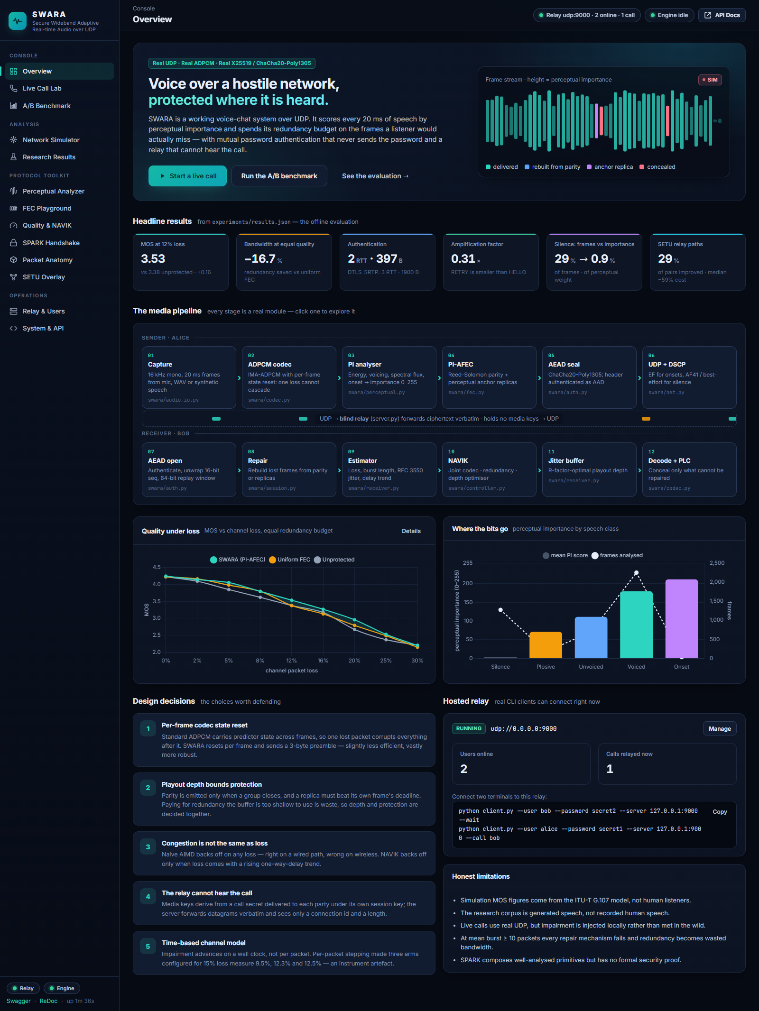
Figure 10. The web console's Overview page: headline results, the twelve-stage pipeline, and the hosted relay card.

6.9 Server control launcher
launcher.py is a small Tkinter window that starts, stops and restarts uvicorn and the hosted relay, shows the console URL and the LAN address for other laptops, the relay's signed-in users and calls, and the live server log (with routine polling requests filtered out). It remembers the chosen ports, moves to the next free port when another program holds the default (which happened on the development machine, where port 8000 was occupied), and offers to stop the server when the window is closed so nothing is left running. SWARA Server.bat opens it with one double-click.
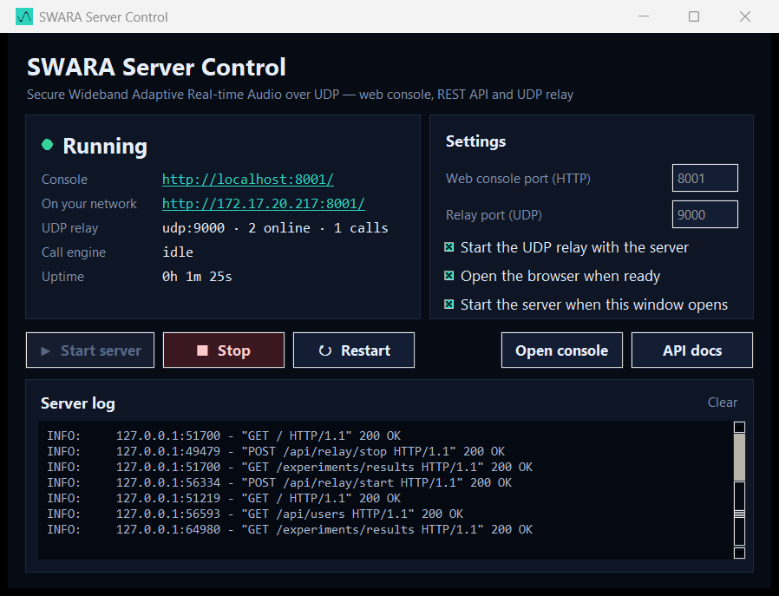
Figure 11. The SWARA Server Control window with the server running.

6.10 Verification during development
Every endpoint was exercised over HTTP with a smoke-test script; every console page was loaded in headless Chrome with the console log captured, and no JavaScript errors remained. The Reed–Solomon implementation is checked for the MDS property at import. The fairness properties of the impairment injector (two random streams, per-arm reset, wall-clock stepping) exist because earlier versions of the harness produced measurable artefacts, each of which is documented in the source. The final verification pass for this report found one more such artefact — a busy-waiting scheduler thread in the injector that distorted every timing the live controller observed — and corrected it; Section 7.9 reports the diagnosis and the before/after measurements, because an evaluation is only as trustworthy as its instrument.

6.11 Running the system
pip install -r requirements.txt # numpy, matplotlib, cryptography, fastapi, uvicorn (+ sounddevice)

# A real call between three terminals
python server.py --add-user alice --password secret1
python server.py --add-user bob --password secret2
python server.py --port 9000 # terminal 1
python client.py --user bob --password secret2 --wait # terminal 2
python client.py --user alice --password secret1 --call bob # terminal 3 (add --audio live for mic & speakers)

# One-command demonstration and A/B comparison
python demo.py --seconds 25 --loss 0.15 --burst 4 --jitter 12 --compare --repeat 2

# Web console (hosts the relay on udp:9000) and the desktop launcher
python -m uvicorn api_server:app --host 0.0.0.0 --port 8000 # then open http://localhost:8000
"SWARA Server.bat" # Windows: one-click launcher window

# Regenerate all research figures (~3 minutes)
python experiments/run_all.py

7 Results and Discussion
Two kinds of evidence are reported. The simulated evaluation (Sections 7.2–7.9) runs identical synthetic speech through identical channel realisations for the three systems and scores each with the E-model; it is the stable, repeatable picture averaged over seeds, and every figure is regenerated by experiments/run_all.py. The live evaluation (Section 7.10) places real calls — real sockets, real cryptography, real time — through the relay over an impaired loopback path; it is noisier, but it is the system as a user would run it. Section 7.11 discusses what the two together show, and Section 7.12 states the limits of the evidence.

7.1 Experimental setup
Table 9. Experimental configuration.
Experiment | Configuration
Machine | Windows-11-10.0.26200-SP0, 20 logical CPUs, Python 3.14.3; all three systems run on the same machine so that CPU effects are common to every arm
Speech corpus | Source-filter synthesiser, 16 kHz, 20 ms frames; talkspurts 0.9–2.8 s; seeds 5, 17, 29, 41 (53) unless stated
Loss sweep | Loss 0–30 %, mean burst 3, delay 40 ± 14 ms, capacity 800 kbit/s, 22 s calls, 5 seeds; k = 8
Burst sweep | Loss 12 %, mean burst 1–10, otherwise as above, 4 seeds
Overhead efficiency | Loss 12 %, burst 4; forced redundancy ρ ∈ {0 … 0.5} for SWARA and uniform FEC, 4 seeds
PI distribution | Six 14 s utterances (seeds 11, 23, 44, 57, 68, 79) with per-frame ground truth from the synthesiser
Jitter buffer | Loss 6 %, burst 3, delay 45 ± 22 ms with a heavier tail (σ = 0.7); forced depths 20–180 ms, 3 seeds
Handshake | In-process timing of the real SPARK implementation; 20,000 AEAD seals for the per-packet cost; DTLS-SRTP figures are published typical values
SETU overlay | 300 random 6-node overlays, 28 % of links through a congested exchange (70–190 ms, 20–60 ms jitter, 4–18 % loss), 4,500 pairs
Network profiles | Six named profiles (Section 5.10), 22 s calls, 4 seeds
Live calls | demo.py: 25 s calls, 2 repeats per arm, injector at both sockets; two conditions, 15 % / burst 4 / 12 ms jitter and 10 % / burst 3 / 10 ms jitter. Console benchmark: 20 s per arm at 15 % / 4 / 12. Three-terminal call: 20 s at 15 % / 4 / 12 on both clients

7.2 Perceptual importance separates what matters
Table 10 and Figure 12 show the PI score by speech class on 4,419 labelled frames. The analyser places the four classes in the bands it was designed for, with silence at a mean of 3.4 and talkspurt onsets at 211.5. The decisive statistic for the whole project is the last row: silence is 29.0 % of all frames but carries only 0.86 % of the total importance mass. Those frames are what PI-AFEC declines to protect, and that budget is what it moves to the frames that carry meaning.
Table 10. Perceptual importance score by speech class (0–255).
Class | Frames | Mean PI | 10th percentile | 90th percentile
Silence / noise | 1273 | 3.4 | 0.0 | 0.0
Plosive | 171 | 70.7 | 0.0 | 164.0
Unvoiced fricative | 694 | 111.1 | 91.0 | 130.0
Voiced vowel | 2251 | 179.6 | 160.0 | 209.0
Talkspurt onset | 30 | 211.5 | 135.9 | 255.0
Silence share of frames / of importance |  | 29.0 % / 0.86 %

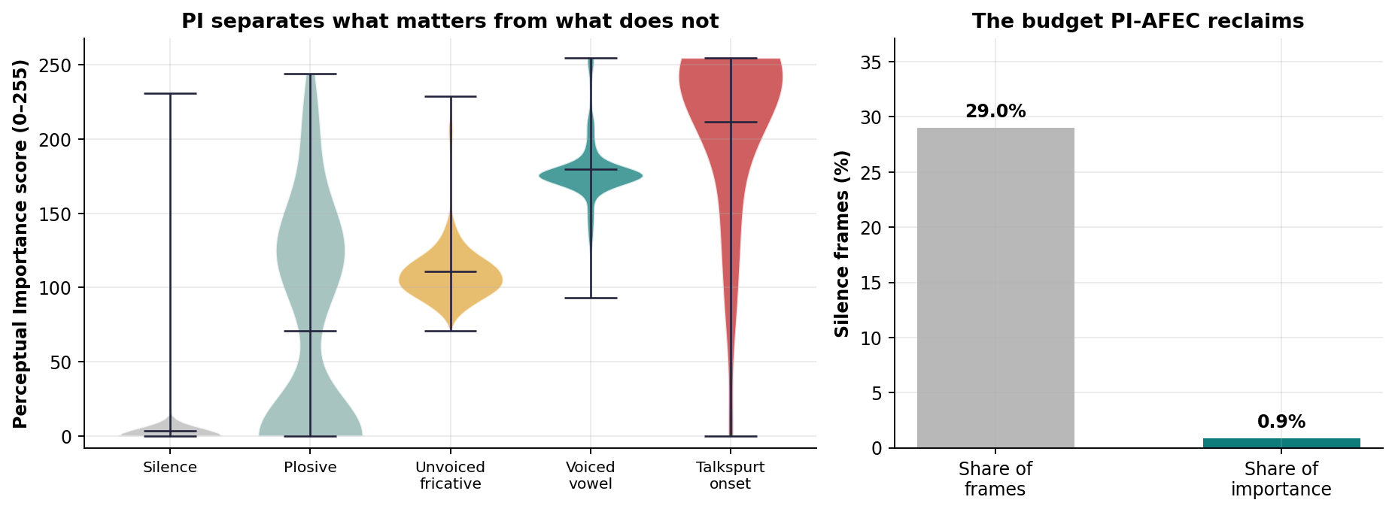
Figure 12. PI score distributions by speech class (violins show the full distribution, bars the mean) and the share of frames versus the share of importance held by silence.

7.3 Quality under packet loss
Table 11 and Figure 13 give the headline comparison: predicted MOS and perceptually weighted loss as channel loss rises from 0 to 30 % with a mean burst of 3, all three systems on the same speech, the same channel realisation and — for uniform FEC — the same redundancy SWARA spent. At 12 % loss SWARA scores 3.53 against 3.37 for uniform FEC and 3.38 unprotected, and its perceptual loss is 5.8 % against 7.3 % and 7.3 %. The advantage is largest in the 5–20 % band that corresponds to busy Wi-Fi and congested cellular links; at 30 % every scheme converges (2.20 / 2.15 / 2.21) because no amount of redundancy can replace a channel that drops almost a third of what is sent. Uniform FEC, note, is not uniformly better than no FEC: at 12–16 % loss its evenly spread parity buys nothing the baseline does not already get from concealment, while SWARA's placement still does.
Table 11. Loss sweep: predicted MOS (G.107) and perceptually weighted loss, mean of 5 seeds.
Channel loss | MOS baseline | MOS uniform FEC | MOS SWARA | Perc. loss baseline | Perc. loss uniform | Perc. loss SWARA
0 % | 4.22 | 4.22 | 4.24 | 0.5 % | 0.5 % | 0.0 %
2 % | 4.09 | 4.16 | 4.14 | 1.7 % | 1.0 % | 1.0 %
5 % | 3.85 | 3.98 | 4.05 | 3.7 % | 2.7 % | 1.8 %
8 % | 3.62 | 3.79 | 3.79 | 5.5 % | 4.1 % | 3.8 %
12 % | 3.38 | 3.37 | 3.53 | 7.3 % | 7.3 % | 5.8 %
16 % | 3.17 | 3.13 | 3.27 | 8.8 % | 9.2 % | 7.8 %
20 % | 2.67 | 2.79 | 2.96 | 12.7 % | 11.7 % | 10.1 %
25 % | 2.37 | 2.48 | 2.53 | 15.3 % | 14.4 % | 13.6 %
30 % | 2.21 | 2.15 | 2.20 | 16.9 % | 17.6 % | 16.6 %

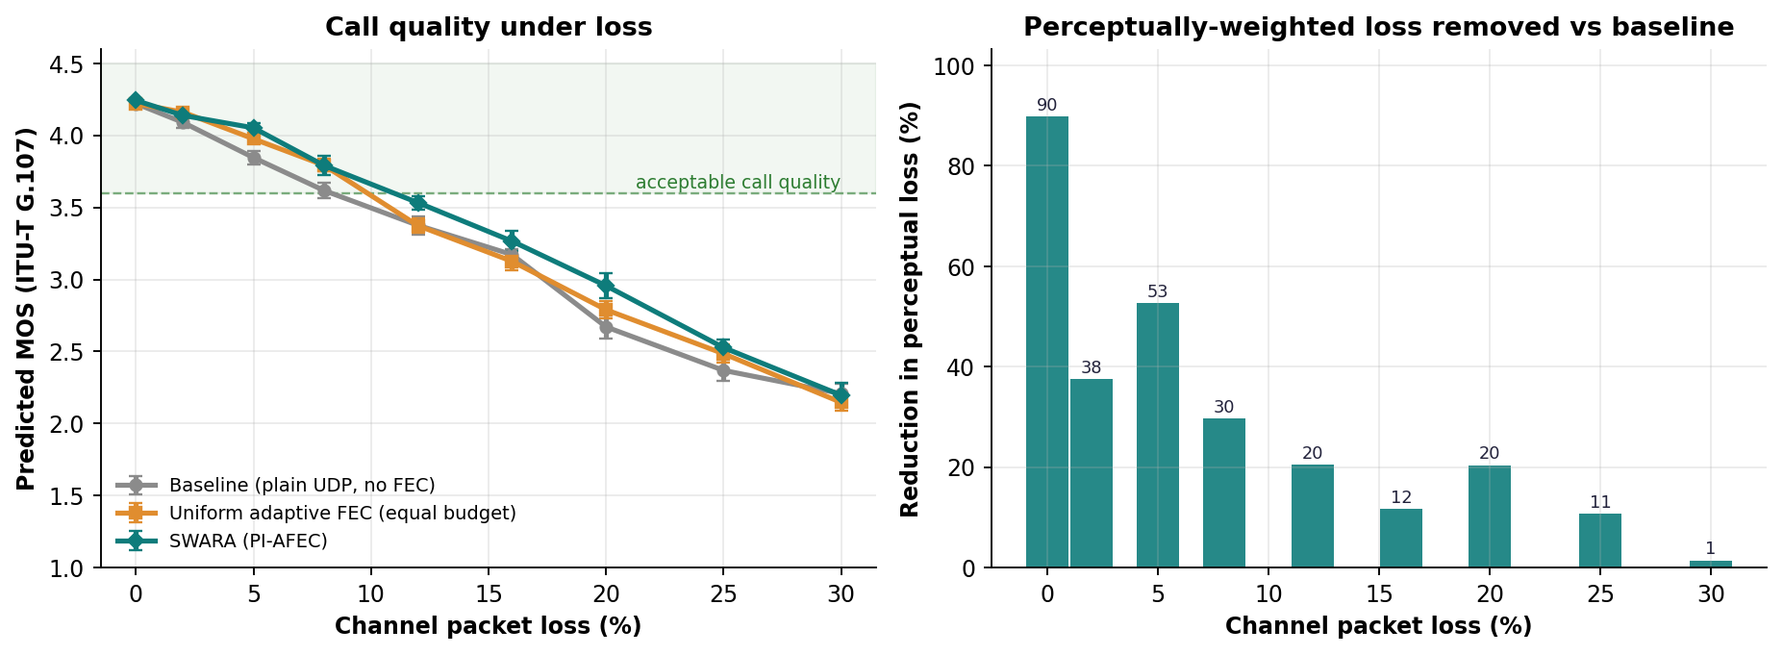
Figure 13. Call quality under loss (left; shaded bands ±1 s.e.) and the reduction in perceptually weighted loss relative to the baseline (right).

7.4 Resilience to bursty loss
Figure 14 fixes the loss rate at 12 % and varies the mean burst length from 1 to 10 packets. Two things are visible. First, SWARA holds its lead over both comparators up to a burst of 8 and only converges with them at 10, where — as the project's own README states — every repair mechanism fails and redundancy becomes wasted bandwidth. Second, the right-hand panel shows which mechanism does the rescuing: with isolated losses Reed–Solomon parity recovers 41.3 frames per call and anchors 4.3; by a burst of 6 the parity recoveries have collapsed to 2.3 while anchor recoveries have risen to 6.3. This is the burst-mode design decision of Section 5.4 doing exactly what it was built to do: when a block code cannot survive the burst, the time-displaced replica still can.
Table 12. Burst sweep at 12 % loss: MOS and SWARA's recoveries per call by mechanism, mean of 4 seeds.
Mean burst | MOS baseline | MOS uniform FEC | MOS SWARA | FEC recoveries | Anchor recoveries
1 | 3.79 | 3.89 | 4.02 | 41.3 | 4.3
2 | 3.58 | 3.64 | 3.80 | 21.3 | 4.3
3 | 3.37 | 3.37 | 3.53 | 15.5 | 3.5
4 | 3.28 | 3.49 | 3.55 | 14.0 | 1.8
6 | 2.96 | 3.13 | 3.41 | 2.3 | 6.3
8 | 3.03 | 3.17 | 3.28 | 3.0 | 6.8
10 | 2.89 | 2.84 | 2.80 | 1.8 | 5.3

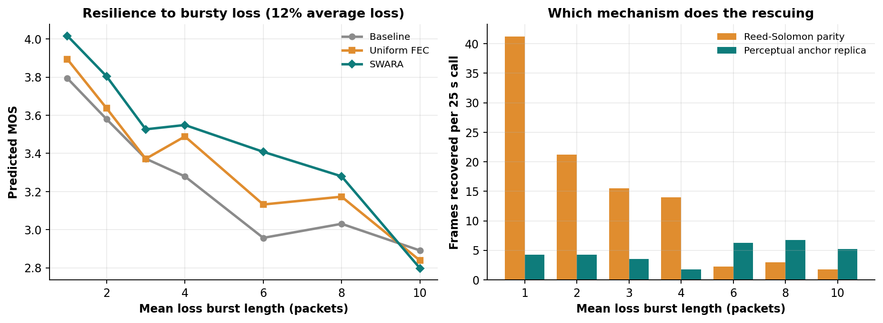
Figure 14. Resilience to bursty loss (left) and the mechanism responsible for each recovery (right).

7.5 Quality returned per byte of redundancy
Figure 15 plots MOS against the redundancy actually transmitted when both schemes are forced through the same budget ladder at 12 % loss and burst 4. Because PI-AFEC never spends on silent groups, it transmits less than the nominal budget (41.6 % at ρ = 0.5 against 50.0 % for uniform FEC) and yet reaches a higher MOS (3.44 versus 3.19). Reading the curves horizontally, SWARA reaches the quality uniform FEC attains at its maximum budget for 16.7 % less redundancy. This is the project's bandwidth claim: the same quality for fewer bytes, or more quality for the same bytes.
Table 13. Overhead efficiency at 12 % loss, burst 4: MOS and redundancy actually spent for each nominal budget ρ.
Nominal ρ | SWARA redundancy | SWARA MOS | Uniform redundancy | Uniform MOS
0.000 | 0.0 % | 3.18 | 0.0 % | 3.18
0.075 | 6.2 % | 3.07 | 7.6 % | 3.08
0.150 | 12.4 % | 3.16 | 15.3 % | 3.16
0.225 | 18.7 % | 3.17 | 22.4 % | 3.02
0.300 | 24.9 % | 3.04 | 30.4 % | 3.08
0.400 | 33.3 % | 3.30 | 40.3 % | 3.21
0.500 | 41.6 % | 3.44 | 50.0 % | 3.19
Equal-quality saving: 16.7 % of media bandwidth.
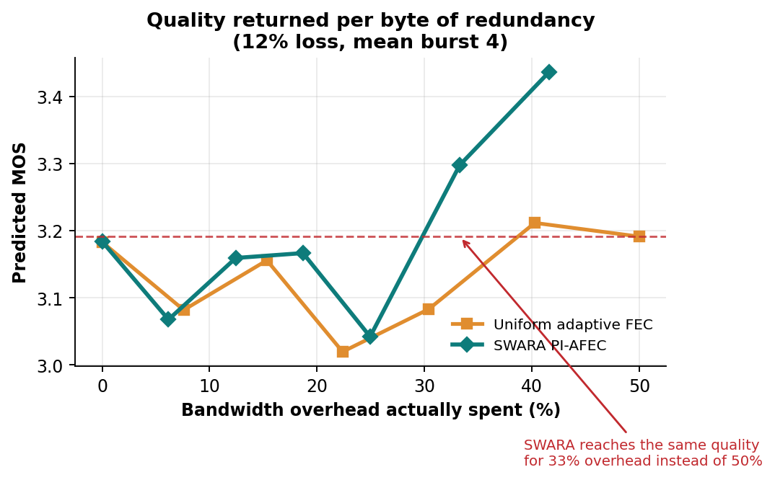
Figure 15. Quality returned per byte of redundancy.

7.6 The jitter-buffer optimum
Section 5.7 argued that “minimise late loss” is the wrong objective for a playout buffer. Figure 16 tests the alternative. The left panel is the optimiser's own view: the predicted R-factor over depth, peaking at 100 ms, from which SWARA chose 99.9 ms. The right panel is the ground truth: the end-to-end simulation re-run with the depth forced to each value. Measured MOS peaks at 100 ms (3.81); a shallow 20 ms buffer collapses to 2.11 because almost everything arrives late, and a deep 180 ms buffer falls back to 3.52 because the delay impairment past the 177 ms knee outweighs the packets it rescues. The optimiser's choice and the measured optimum coincide to within 1 ms, which validates both the model and the decision to make it the controller's objective.
Table 14. Jitter-buffer depth: predicted R-factor and measured end-to-end MOS.
Depth (ms) | 20 | 40 | 60 | 80 | 100 | 120 | 150 | 180
Predicted R | 23.6 | 60.8 | 77.0 | 82.4 | 84.2 | 82.6 | 79.1 | 75.3
Measured MOS | 2.11 | 3.46 | 3.69 | 3.78 | 3.81 | 3.79 | 3.68 | 3.52
Optimiser's choice 99.9 ms; measured optimum 100 ms.
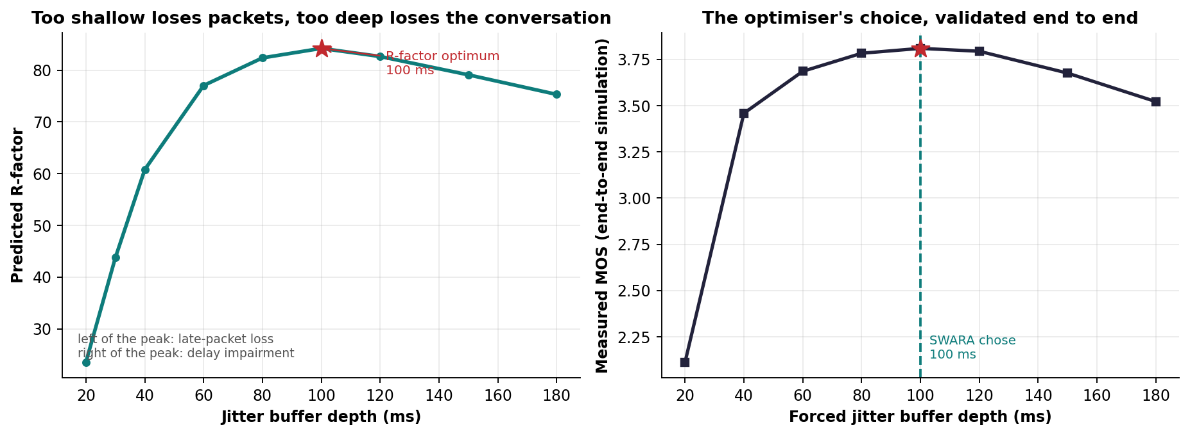
Figure 16. Too shallow loses packets, too deep loses the conversation: the R-factor curve (left) and the end-to-end validation (right).

7.7 Handshake cost and security properties
Table 15 and Figure 17 measure the real SPARK implementation. Mutual password authentication with forward secrecy completes in 2 round trips and 397 bytes, against three round trips and roughly 1,900 bytes for DTLS-SRTP — about 4.8× less setup traffic. The 73 ms of CPU is dominated by the deliberately expensive PBKDF2 stretching on the client; the server's own work per handshake is three X25519 operations and a few hashes. A network handover costs zero round trips and 115 bytes, and the server spends 11 µs on it. The RETRY reply is 20 bytes to a 64-byte HELLO, so the amplification factor is 0.31: an attacker spoofing HELLOs at a victim makes the victim receive less than it sent. The per-user record is 128 bytes and contains no password-equivalent. Sealing a media packet costs 3.0 µs — 0.015 % of a 20 ms frame budget — so encryption is never on the critical path.
Table 15. Measured handshake and media-protection cost.
Quantity | SPARK | DTLS-SRTP (typical) | Plain UDP
Round trips before media flows | 2 | 3 | 0
Handshake bytes on the wire | 397 | 1,900 | 0
Round trips to migrate a live call | 0 | new handshake | n/a
Migration bytes | 115 | — | —
Amplification factor (reply ÷ first packet) | 0.313 | ≤ 3 (DTLS 1.2 cookie) | —
Server record per user | 128 B, no verifier | certificate / SRTP keys | none
Mutual password authentication | yes | no (certificate fingerprints) | no
AEAD seal per packet | 3.02 µs | similar | none

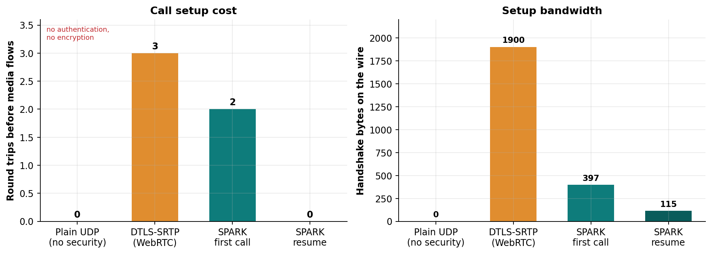
Figure 17. Call-setup cost in round trips and bytes.
Table 16. Security properties of SPARK and how each is obtained.
Property | Mechanism
No state before address validation | Stateless HMAC cookie bound to (address, 30 s epoch); AUTH_INIT without a valid cookie is silently dropped
No amplification | HELLO padded to 64 B; RETRY is 20 B; nothing larger is sent before the cookie returns
Password never on the wire | OPAQUE-style envelope opened locally with PBKDF2; a wrong password fails before anything is sent
No user enumeration | Unknown users receive a constant-shape random envelope
Mutual authentication | dh1 proves the server holds its static key; dh2 proves the client could open the envelope
Forward secrecy | dh3 between the two ephemeral keys; the transcript hash binds every byte of every message
Stolen database resistance | Server stores {salt, envelope, public key}; nothing is replayable at the server
Replay and forgery resistance on media | Deterministic nonces from the 64-bit sequence; 1,024-entry replay bitmap; header as AEAD associated data
Blind relay | Per-call directional keys delivered under each party's session key; the relay forwards ciphertext verbatim
Graceful handover | Encrypted resumption ticket + proof under k_resume; 0 RTT; replaying the ticket alone cannot hijack a call

7.8 Relay-path selection
Across 4,500 peer pairs in 300 random overlays in which 28 % of links cross a congested exchange, SETU found a relayed path cheaper than the direct route for 29.3 % of pairs, with a mean cost reduction of 55.0 % (median 58.8 %) on the pairs it improved. 3,174 pairs stayed direct, 1,244 took one relay, 78 took two and 4 took three; the distance-vector computation converged in 6 rounds. The result reproduces the RON observation [33] in voice-cost terms: the triangle inequality fails often enough that a small measured overlay is worth having.
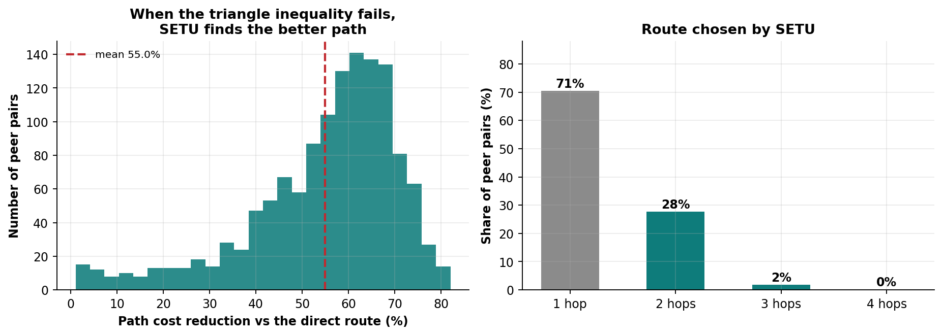
Figure 18. SETU: distribution of the cost reduction on improved pairs (left) and the share of pairs by chosen route length (right).

7.9 Realistic network profiles
Table 17 and Figure 19 summarise the six named profiles. On good Wi-Fi all three systems are at the ceiling (4.23); SWARA spends nothing it does not need. On busy Wi-Fi and congested 4G it leads by 0.17 and 0.14 MOS over uniform FEC and by 0.26 and 0.33 over the baseline, halving the perceptual loss on busy Wi-Fi (1.8 % against 4.4 %). On the hostel profile — 15 % loss in bursts of 8, the condition that motivated the project — it is the only system above 3.0. Two profiles are honest exceptions. On poor 3G (20 % loss, 110 ms base delay) uniform FEC is marginally ahead (1.73 vs 1.72): at that loss rate the controller's safety rail allows little redundancy and the deeper buffer SWARA chooses costs more than its placement gains. On the satellite profile (280 ms base delay) the same delay arithmetic applies: every millisecond of extra buffer is charged at the steep post-knee rate, so uniform FEC with the conventional shallower buffer edges ahead (2.88 vs 2.82) even though SWARA's residual and perceptual loss are the lowest of the three. SWARA's gains, in other words, come where loss rather than propagation delay is the binding impairment — which is where most real conversations are.
Table 17. Named profiles: predicted MOS, residual and perceptual loss, mouth-to-ear delay and redundancy, mean of 4 seeds.
Profile | MOS base / uniform / SWARA | Residual loss base / uni / SWARA | Perceptual loss base / uni / SWARA | Delay (ms) base / SWARA | Redundancy uni / SWARA
good wifi | 4.23 / 4.21 / 4.23 | 1.9 / 1.7 / 1.0 % | 0.6 / 0.8 / 0.4 % | 68 / 102 | 46.5 / 46.3 %
busy wifi | 3.77 / 3.85 / 4.02 | 8.3 / 7.1 / 4.0 % | 4.4 / 3.6 / 1.8 % | 108 / 163 | 46.5 / 46.3 %
congested 4g | 3.24 / 3.43 / 3.57 | 13.4 / 11.5 / 9.5 % | 7.8 / 6.3 / 4.3 % | 168 / 194 | 37.7 / 37.8 %
hostel wifi | 2.80 / 2.79 / 3.05 | 15.8 / 14.2 / 13.1 % | 10.6 / 10.5 / 7.8 % | 177 / 195 | 25.2 / 24.9 %
poor 3g | 1.55 / 1.73 / 1.72 | 22.4 / 21.1 / 21.0 % | 15.9 / 13.7 / 12.9 % | 276 / 292 | 10.0 / 10.1 %
satellite | 2.75 / 2.88 / 2.82 | 5.8 / 4.2 / 3.6 % | 2.4 / 1.6 / 1.4 % | 361 / 375 | 46.2 / 46.3 %

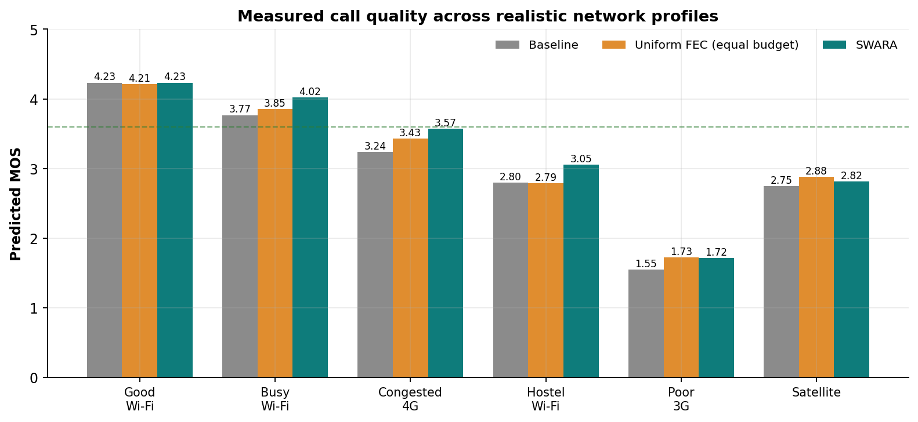
Figure 19. Measured call quality across realistic network profiles (dashed line: the 3.6 “acceptable” threshold).

7.10 Live end-to-end calls

7.10.1 Validating the instrument first
Before the live benchmarks were accepted, the controller's behaviour during a real call was inspected by sampling NAVIK's state once per second (Table 18). The first run showed the capacity estimate collapsing from 400 kbit/s to its 24 kbit/s floor within eight seconds, after which the optimiser could fit no codec and emitted no redundancy at all for the rest of the call; the delay trend it was reacting to swung between −101 and +73 ms/s although the configured jitter was 12 ms, and the receiver-side one-way delay had a standard deviation of 35–120 ms with a 95th-percentile spread of up to 410 ms. On a clean link the same quantities were 1.7 ms and 5 ms. The cause was not the controller. The impairment injector's delayed-delivery scheduler consumed its wake-up event only when its queue ran empty — which, during a call, never happens — so its wait returned immediately and the thread busy-spun, starving the four media threads of the interpreter lock. The two-line correction (consume the flag on every iteration; swara/net.py, Listing 9) restored a delay spread consistent with the configured jitter, a trend within ±4 ms/s, a redundancy of ρ = 0.375 held for the whole call, and 169 parity plus 33 replica packets in 15 s where there had been 46 plus 2. Every live result below was measured after the correction. The episode is reported in full because it is the project's methodological thesis in miniature: a protocol can only be judged through an instrument that has itself been validated.
Table 18. Diagnosis of the injector defect: one call at 15 % loss, burst 4, 12 ms jitter, sampled once per second.
Quantity | Clean link (reference) | Impaired, before correction | Impaired, after correction
One-way delay std. dev., last 100 packets | 1.7 ms | 35 – 120 ms | 7.7 – 11 ms
One-way delay spread (p95 − min) | 5 ms | 120 – 410 ms | 29 – 34 ms
Delay-trend samples seen by NAVIK | ±0.8 ms/s | −101 … +73 ms/s | −4 … +1.5 ms/s
Capacity estimate after 8 s | — | 24 kbit/s (floor) | 283 kbit/s
Redundancy ρ after 8 s | 0 (no loss) | 0 (could not fit) | 0.375
Parity + replica packets sent | 0 + 0 | 46 + 2 in 18 s | 169 + 33 in 15 s
Frames concealed at the receiver | 0.0 % | 20.0 % | 15.1 %

7.10.2 demo.py: three arms on an identical channel
Table 19 reports the one-command A/B harness: 25-second calls, two repeats per arm, the injector at both sockets, every arm on the identical realisation of loss and jitter. At 15 % loss with bursts of four, SWARA matches uniform FEC's perceptually weighted damage (7.3 % each) while transmitting 112 kbit/s against 126 — 11 % less bandwidth — and both cut the damage of unprotected UDP (8.7 %) by 16 %. The raw frame count tells the expected other half of the story: uniform FEC leaves fewer frames unrecoverable (11.1 % against 12.3 %) because it protects everything, silence included, and does so with 600 parity packets to SWARA's 328 plus 56 replicas. At 10 % loss with bursts of three, SWARA achieves the lowest damage of the three — 4.2 % against 4.3 % and 5.3 % — on 12 % less bandwidth than uniform FEC. Both runs are captured as real terminal output in Figures 20 and 21.
Table 19. Live A/B comparison (demo.py, 25 s × 2 repeats, injector at both sockets).
Condition | Arm | Parity / replicas | Rebuilt (FEC / replica) | Concealed | Unrecoverable | Wire kbit/s | Corr. | SNR dB | Perceptual damage
15 % / burst 4 / 12 ms | SWARA | 328 / 56 | 8.0 / 5.5 | 156.5 | 12.3 % | 111.8 | 0.924 | 8.5 | 7.3 %
 | Uniform FEC | 600 / 0 | 31.0 / 0 | 141.5 | 11.1 % | 126.3 | 0.924 | 8.5 | 7.3 %
 | Unprotected | 0 / 0 | 0 / 0 | 169.0 | 13.3 % | 87.7 | 0.914 | 8.0 | 8.7 %
10 % / burst 3 / 10 ms | SWARA | 356 / 48 | 11.0 / 5.0 | 105.5 | 8.3 % | 113.2 | 0.942 | 9.5 | 4.2 %
 | Uniform FEC | 628 / 0 | 25.5 / 0 | 96.0 | 7.5 % | 128.1 | 0.942 | 9.5 | 4.3 %
 | Unprotected | 0 / 0 | 0 / 0 | 119.0 | 9.3 % | 87.7 | 0.934 | 9.0 | 5.3 %
1,293 frames sent per call; authentication failures 0 in every run. Correlation and SNR compare the waveform heard by bob with the one alice sent, after FFT alignment.
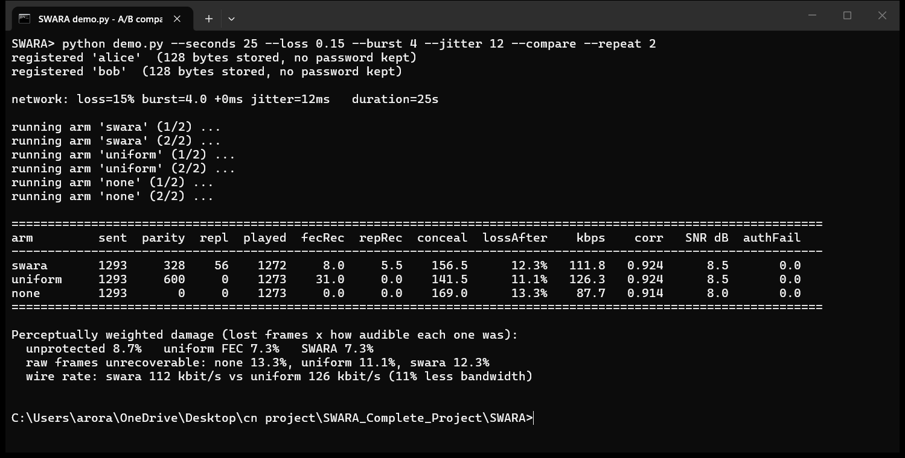
Figure 20. Terminal output of demo.py --compare at 15 % loss, mean burst 4, 12 ms jitter (25 s calls, 2 repeats per arm).
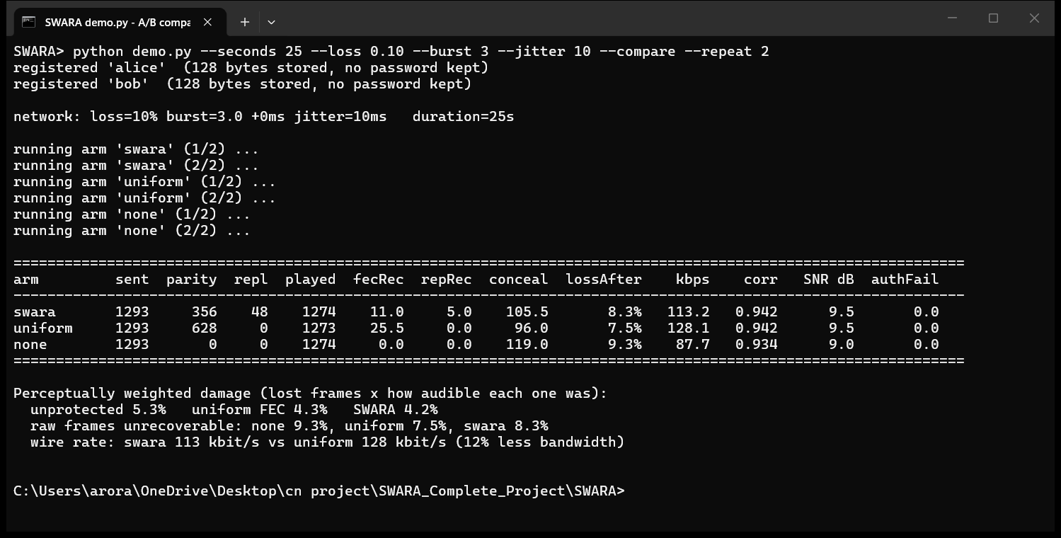
Figure 21. Terminal output of demo.py --compare at 10 % loss, mean burst 3, 10 ms jitter.

7.10.3 The web console benchmark and an instrumented call
The console's A/B Benchmark page (Figure 37) runs the same three arms as full instrumented calls — 20 s per arm at 15 % / burst 4 / 12 ms, one run each — and reports a like-for-like table with the audio of each arm. SWARA cut perceptual damage by 8 % versus unprotected UDP (10.9 % against 11.8 %) and by 3 % versus uniform FEC (11.2 %) while using 12 % less bandwidth (107.8 against 122.6 kbit/s); the estimated MOS ordering was 2.64 / 2.59 / 2.55. The single-call Live Call Lab (Figure 35) shows the mechanism frame by frame: in a 15 s call at 10 % loss with bursts of three, 750 frames were sent with 197 parity and 12 replica packets (26 % overhead, 107 kbit/s), 674 arrived, 6 were rebuilt from parity and 1 from a replica, 69 were concealed, SPARK authenticated the two parties in 190 and 858 ms, call setup took 826 ms, the jitter buffer settled at 118 ms, and the received waveform correlated with the sent one at 0.941 (SNR 9.4 dB) for a predicted MOS of 3.59. The frame-fate map in the same figure makes the design visible: the tallest bars — the onsets and vowels — are almost all teal, while the red concealments cluster in the low, silent valleys.

7.10.4 A call between separate programs
Finally, the system was run as a user would run it: server.py in one terminal, client.py --wait as bob in a second and client.py --call bob as alice in a third, with the injector enabled on both clients at 15 % / burst 4 / 12 ms (Figures 26–28). Both clients authenticated in two round trips (776 ms and 1,681 ms including PBKDF2), the server logged the call with the note that it holds no keys, and after 20 s each side printed its own report: bob sent 1,021 frames with 287 parity and 17 replica packets, rebuilt 14 frames from parity and concealed 102 (10.0 %); alice sent 1,021 frames with 273 parity and 32 replicas, rebuilt 7 and concealed 139 (13.7 %). Neither side saw a single authentication failure. Section B.2 shows the same three windows during the call.

7.11 Discussion
- The gain is where the theory says it should be. Across the loss sweep, burst sweep and profiles, SWARA's advantage over uniform FEC at an identical budget is concentrated at 5–20 % loss with bursts of 2–8 — the regime of busy Wi-Fi, hostel networks and congested cellular links — and it vanishes at 30 % loss and bursts of 10, exactly where no repair mechanism can work. Placement, not quantity, is the source of the gain: Table 13 shows SWARA transmitting less redundancy than uniform FEC at every budget and scoring higher.
- Raw and perceptual loss tell different stories, and both must be reported. In every live run uniform FEC leaves fewer frames unrecoverable while SWARA leaves fewer audible frames unrecoverable. A reader who looks only at the raw count will conclude SWARA is worse; a reader who looks only at the perceptual figure will not understand why. The project reports both and argues that the second is the one a listener experiences.
- Anchors and parity are complementary, not redundant. The burst sweep (Figure 14) shows parity doing the work at short bursts and replicas at long ones; a scheme with only one of them is good at only one end of the range.
- The buffer is part of the protection scheme. The jitter-buffer experiment validated the R-factor objective to within 1 ms, and the profiles show the price of it: SWARA's buffer is 20–55 ms deeper than the conventional one because it refuses to pay for parity it cannot use. On links where propagation delay is already past the knee (satellite, poor 3G) that price exceeds the benefit, and uniform FEC with a shallow buffer is marginally better.
- Live gains are smaller than simulated gains, for identifiable reasons. Live calls are short (the controller needs about half a second of arrivals before it acts), the capacity estimate decays slowly under sustained loss, the simulator's k = 8 groups are replaced by k = 4 to keep the playout depth conversational, and each sender sizes its redundancy from the loss on its receiving path — the telemetry report from the far end is carried and parsed but not yet used, so an asymmetric path is under-protected. None of these is intrinsic to the idea; all are listed as future work.
- Single runs are noisy. With a mean burst of four a 25-second call contains only about 47 loss bursts, few enough that which bursts land where matters as much as the scheme under test. The identical-realisation design removes the between-arm component of that noise, but not the between-run component; the two-repeat tables above are stable to roughly ±1 percentage point of perceptual damage, which is why the simulated, multi-seed evaluation remains the primary evidence.
- Security came at negligible cost. Two round trips, 397 bytes, 3 µs per packet and a relay that cannot listen — against a naive UDP service that is both a reflection amplifier and an open microphone.

7.12 Limitations
- Quality figures come from the ITU-T G.107 model fed with a perceptually weighted loss; no human listening tests were conducted.
- The research corpus is synthesised speech with the right structure (talkspurts, voiced and unvoiced phones, onsets) but not recorded human speech; the PI analyser's bands were tuned on it.
- Live calls use real UDP, but impairment is injected at the sending socket rather than encountered in the wild, and both ends run on one machine, so the delay statistics are those of the loopback path plus the injector.
- The control loop drives redundancy from the local receive-side estimator; the piggybacked telemetry is not yet consumed by the far end's decision, so paths that are lossy in only one direction are under-protected.
- At mean bursts of ten packets or more every repair mechanism fails and redundancy is wasted; the controller's safety rail limits but does not eliminate that waste.
- CPython's interpreter lock bounds the timing precision of a pure-Python media pipeline; the injector defect of Section 7.10.1 is an example of how sensitive the measurements are to it.
- SPARK composes well-analysed primitives but has no formal security proof; the cookie epoch (30 s) and ticket lifetime (1 h) are reasonable defaults, not tuned values.
- The web console runs one instrumented call or benchmark at a time by design.

8 Conclusion
This project set out to show that packet loss in a voice call should be judged by what the listener loses, and to build a complete system around that principle. SWARA scores every 20 ms frame by its perceptual importance, carries the score where the network can read but not forge it, spends a fixed redundancy budget on the frames that carry meaning, protects the most important of them with replicas that survive the bursts a block code cannot, chooses codec, redundancy, marking and playout depth jointly against a single standard quality model, and secures the whole conversation with a two-round-trip password-authenticated handshake behind a relay that cannot hear the call.
The evaluation supports the principle. At an identical redundancy budget SWARA raises predicted MOS at 12 % loss from 3.37 to 3.53, keeps its lead up to bursts of eight packets, reaches the same quality as uniform FEC for 16.7 % less redundancy, and leads on five of six realistic profiles — the exceptions being links where propagation delay, not loss, is the binding impairment. The R-factor-optimal playout buffer chose the depth that an exhaustive sweep confirmed as optimal. SPARK authenticates in 397 bytes with an amplification factor of 0.31 and migrates in zero round trips. In live calls the system matched uniform FEC's perceptual quality on 11 % less bandwidth at 15 % loss and bettered it at 10 %, and a three-terminal call between separate programs ran exactly as the design says it should.
Two lessons go beyond the numbers. The first is methodological: three of the artefacts the team had to remove — per-packet channel stepping, a shared random stream, and a busy-waiting scheduler — were defects of the measuring instrument that looked like properties of the protocol, and the final one was found only by instrumenting the controller during a real call. The second is architectural: the components that make SWARA work are not independent knobs. The buffer depth bounds the replica displacement; the replica displacement bounds what burst mode can rescue; the controller's objective is the same function the evaluator uses. Designing them together is what made the gains measurable.

8.1 Future work
- Use the far end's piggybacked telemetry, not only local receive-side statistics, to size redundancy on asymmetric paths.
- Replace IMA ADPCM with a modern codec such as Opus so that the controller's bitrate ladder changes real coding quality and not only the nominal E-model parameters.
- Validate the perceptual weighting with listening tests on recorded speech, and tune the PI bands on a human corpus.
- Complete SETU's role as a NAT-traversal fallback and extend the relay to multi-party calls with per-participant importance-aware forwarding.
- Study SPARK formally — in particular the composition of the cookie, the OPAQUE-style envelope and the resumption ticket — and add rate limiting on the server's PBKDF2 path.
- Port the media pipeline to a language without an interpreter lock, or to an asynchronous design, to tighten timing and allow several instrumented calls at once.

References
[1] H. Schulzrinne, S. Casner, R. Frederick and V. Jacobson, “RTP: A Transport Protocol for Real-Time Applications,” IETF RFC 3550, Jul. 2003.
[2] ITU-T Recommendation G.107, “The E-model: a computational model for use in transmission planning,” International Telecommunication Union, Geneva, Jun. 2015.
[3] ITU-T Recommendation G.114, “One-way transmission time,” International Telecommunication Union, Geneva, May 2003.
[4] ITU-T Recommendation P.800, “Methods for subjective determination of transmission quality,” International Telecommunication Union, Geneva, Aug. 1996.
[5] C. Perkins, O. Hodson and V. Hardman, “A survey of packet loss recovery techniques for streaming audio,” IEEE Network, vol. 12, no. 5, pp. 40–48, Sep.–Oct. 1998.
[6] J.-C. Bolot, S. Fosse-Parisis and D. Towsley, “Adaptive FEC-based error control for Internet telephony,” in Proc. IEEE INFOCOM, New York, NY, USA, 1999, pp. 1453–1460.
[7] I. S. Reed and G. Solomon, “Polynomial codes over certain finite fields,” Journal of the Society for Industrial and Applied Mathematics, vol. 8, no. 2, pp. 300–304, 1960.
[8] L. Rizzo, “Effective erasure codes for reliable computer communication protocols,” ACM SIGCOMM Computer Communication Review, vol. 27, no. 2, pp. 24–36, Apr. 1997.
[9] A. E. Mohr, E. A. Riskin and R. E. Ladner, “Unequal loss protection: Graceful degradation of image quality over packet erasure channels through forward error correction,” IEEE Journal on Selected Areas in Communications, vol. 18, no. 6, pp. 819–828, Jun. 2000.
[10] W. Jiang and H. Schulzrinne, “Comparison and optimization of packet loss repair methods on VoIP perceived quality under bursty loss,” in Proc. 12th Int. Workshop on Network and Operating Systems Support for Digital Audio and Video (NOSSDAV), Miami Beach, FL, USA, 2002, pp. 73–81.
[11] J.-M. Valin, K. Vos and T. Terriberry, “Definition of the Opus Audio Codec,” IETF RFC 6716, Sep. 2012.
[12] M. Zanaty, V. Singh, A. Begen and G. Mandyam, “RTP Payload Format for Flexible Forward Error Correction (FEC),” IETF RFC 8627, Jul. 2019.
[13] R. Ramjee, J. Kurose, D. Towsley and H. Schulzrinne, “Adaptive playout mechanisms for packetized audio applications in wide-area networks,” in Proc. IEEE INFOCOM, Toronto, Canada, 1994, pp. 680–688.
[14] Y. J. Liang, N. Färber and B. Girod, “Adaptive playout scheduling and loss concealment for voice communication over IP networks,” IEEE Transactions on Multimedia, vol. 5, no. 4, pp. 532–543, Dec. 2003.
[15] ITU-T Recommendation G.711 Appendix I, “A high quality low-complexity algorithm for packet loss concealment with G.711,” International Telecommunication Union, Geneva, Sep. 1999.
[16] E. N. Gilbert, “Capacity of a burst-noise channel,” Bell System Technical Journal, vol. 39, no. 5, pp. 1253–1265, Sep. 1960.
[17] E. O. Elliott, “Estimates of error rates for codes on burst-noise channels,” Bell System Technical Journal, vol. 42, no. 5, pp. 1977–1997, Sep. 1963.
[18] A. D. Clark, “Modeling the effects of burst packet loss and recency on subjective voice quality,” in Proc. IP Telephony Workshop, Columbia University, New York, NY, USA, Apr. 2001.
[19] L. Sun and E. C. Ifeachor, “Voice quality prediction models and their application in VoIP networks,” IEEE Transactions on Multimedia, vol. 8, no. 4, pp. 809–820, Aug. 2006.
[20] M. Baugher, D. McGrew, M. Naslund, E. Carrara and K. Norrman, “The Secure Real-time Transport Protocol (SRTP),” IETF RFC 3711, Mar. 2004.
[21] D. McGrew and E. Rescorla, “Datagram Transport Layer Security (DTLS) Extension to Establish Keys for the Secure Real-time Transport Protocol (SRTP),” IETF RFC 5764, May 2010.
[22] E. Rescorla and N. Modadugu, “Datagram Transport Layer Security Version 1.2,” IETF RFC 6347, Jan. 2012.
[23] J. Iyengar and M. Thomson (Eds.), “QUIC: A UDP-Based Multiplexed and Secure Transport,” IETF RFC 9000, May 2021.
[24] S. Jarecki, H. Krawczyk and J. Xu, “OPAQUE: An asymmetric PAKE protocol secure against pre-computation attacks,” in Advances in Cryptology – EUROCRYPT 2018, Lecture Notes in Computer Science, vol. 10822, Springer, 2018, pp. 456–486.
[25] A. Langley, M. Hamburg and S. Turner, “Elliptic Curves for Security,” IETF RFC 7748, Jan. 2016.
[26] Y. Nir and A. Langley, “ChaCha20 and Poly1305 for IETF Protocols,” IETF RFC 8439, Jun. 2018.
[27] H. Krawczyk and P. Eronen, “HMAC-based Extract-and-Expand Key Derivation Function (HKDF),” IETF RFC 5869, May 2010.
[28] K. Moriarty, B. Kaliski and A. Rusch, “PKCS #5: Password-Based Cryptography Specification Version 2.1,” IETF RFC 8018, Jan. 2017.
[29] K. Nichols, S. Blake, F. Baker and D. Black, “Definition of the Differentiated Services Field (DS Field) in the IPv4 and IPv6 Headers,” IETF RFC 2474, Dec. 1998.
[30] B. Davie et al., “An Expedited Forwarding PHB (Per-Hop Behavior),” IETF RFC 3246, Mar. 2002.
[31] J. Heinanen, F. Baker, W. Weiss and J. Wroclawski, “Assured Forwarding PHB Group,” IETF RFC 2597, Jun. 1999.
[32] S. Floyd and V. Jacobson, “Random early detection gateways for congestion avoidance,” IEEE/ACM Transactions on Networking, vol. 1, no. 4, pp. 397–413, Aug. 1993.
[33] D. Andersen, H. Balakrishnan, F. Kaashoek and R. Morris, “Resilient overlay networks,” in Proc. 18th ACM Symposium on Operating Systems Principles (SOSP), Banff, Canada, 2001, pp. 131–145.
[34] G. Malkin, “RIP Version 2,” IETF RFC 2453, Nov. 1998.
[35] J. Rosenberg et al., “SIP: Session Initiation Protocol,” IETF RFC 3261, Jun. 2002.
[36] Interactive Multimedia Association, “Recommended Practices for Enhancing Digital Audio Compatibility in Multimedia Systems,” Revision 3.00, Oct. 1992 (IMA ADPCM).
[37] H. Schulzrinne and S. Casner, “RTP Profile for Audio and Video Conferences with Minimal Control,” IETF RFC 3551, Jul. 2003.
[38] R. Braden, D. Borman and C. Partridge, “Computing the Internet Checksum,” IETF RFC 1071, Sep. 1988.
[39] R. W. Hamming, “Error detecting and error correcting codes,” Bell System Technical Journal, vol. 29, no. 2, pp. 147–160, Apr. 1950.
[40] S. Ramírez, “FastAPI,” https://fastapi.tiangolo.com, and Encode, “Uvicorn,” https://www.uvicorn.org (accessed Oct. 2026).
[41] Python Cryptographic Authority, “pyca/cryptography,” https://cryptography.io (accessed Oct. 2026).
[42] Chart.js contributors, “Chart.js,” version 4.4.1, https://www.chartjs.org (accessed Oct. 2026).
[43] V. Jacobson, “Congestion avoidance and control,” in Proc. ACM SIGCOMM, Stanford, CA, USA, 1988, pp. 314–329.
[44] ITU-T Recommendation G.113 Appendix I, “Provisional planning values for the equipment impairment factor Ie and packet-loss robustness factor Bpl,” International Telecommunication Union, Geneva, 2009.
[45] Python Software Foundation, “The Python Language Reference, version 3.14,” https://docs.python.org/3.14/ (accessed Oct. 2026).
[46] J. Postel, “User Datagram Protocol,” IETF RFC 768, Aug. 1980.
[47] A. Li (Ed.), “RTP Payload Format for Generic Forward Error Correction,” IETF RFC 5109, Dec. 2007.

Appendix A Source Code Repository
The complete project — protocol stack, relay and clients, demonstration harness, experiments, web console, launcher, figures and this report — is published on GitHub:
https://github.com/rohitarora80905-glitch/swara-v1.0
NOTE
The local working copy that produced every figure and screenshot in this report is SWARA_Complete_Project/SWARA.

A.1 Obtaining and running the code
git clone https://github.com/rohitarora80905-glitch/swara-v1.0
cd swara-v1.0
python -m venv .venv && .venv\Scripts\activate # Windows (use source .venv/bin/activate on Linux/macOS)
pip install -r requirements.txt

python demo.py --seconds 20 # the most reliable demonstration: 0 % loss, correlation ≈ 0.99
python demo.py --seconds 25 --loss 0.15 --burst 4 --jitter 12 --compare --repeat 2
python experiments/run_all.py # regenerates results.json and figures/ in ~3 minutes
python -m uvicorn api_server:app --host 0.0.0.0 --port 8000 # web console at http://localhost:8000, API docs at /docs

A.2 Repository contents
Table 20. Repository contents.
Path | Contents
swara/ | The protocol stack: 15 modules, listed in Appendix C
server.py, client.py, demo.py | Relay server, voice-chat client, one-process demonstration and A/B harness
api_server.py, webapp/, static/ | Web console back end (FastAPI), instrumented calls and tools, single-page front end
launcher.py, SWARA Server.bat, start_console.bat | Desktop server-control window and one-click launchers
experiments/run_all.py, experiments/results.json | The eight evaluation experiments and their machine-readable results
figures/fig1 … fig8 | Research figures reproduced in Chapter 7
users.json | Credential records (salt, envelope, public key) for the registered users
README.md, RUNME.txt, requirements.txt | Documentation, step-by-step run instructions, dependencies

A.3 Reproducibility
- Every simulated figure is regenerated by one command from fixed seeds; results.json is the single source of the numbers in Chapter 7 and the console's Research Results page.
- Every live comparison uses the identical-realisation injector (two random streams, per-arm reset, wall-clock stepping) so the three arms face the same sequence of good and bad periods.
- Every screenshot in Appendix B was captured from the running system on the date of this report; terminal outputs were additionally saved as text and are reproduced verbatim in the tables of Section 7.10.

Appendix B Screenshots
All screenshots are actual captures of the system running on the development machine (Windows 11) on the date of this report. Browser pages are full-length captures of the web console at 1600 px width; terminal windows are captured as displayed. Captions give the exact command or action that produced each view.

B.1 Starting the server
Figure 22. SWARA Server Control, opened by double-clicking “SWARA Server.bat”. The server was started with one click; the window shows the console address, the LAN address for other laptops, the hosted relay on udp:9000 and the live server log.

B.2 A real call between three separate programs — both sides
The classic three-terminal demonstration from the README: the relay in terminal 1, the callee (bob) waiting in terminal 2 and the caller (alice) dialling in terminal 3. The impairment injector was enabled on both clients (15 % loss, mean burst 4, 12 ms jitter) so that each side both suffers and repairs loss. The first three figures were captured during the call; the next three after it ended, when each client printed its own report.
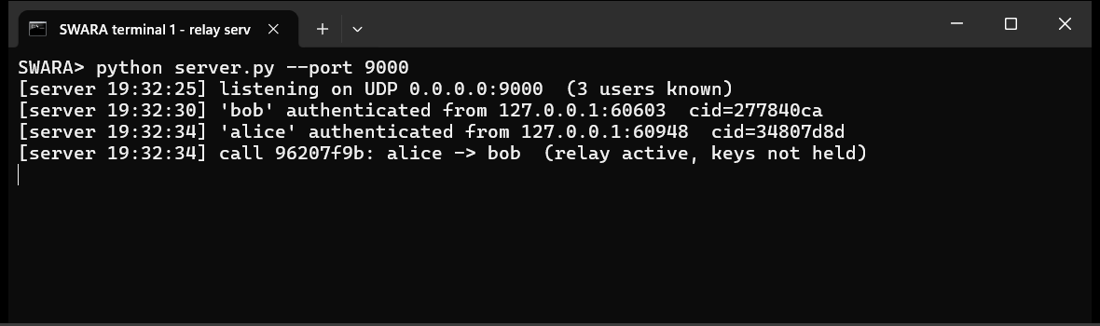
Figure 23. Terminal 1 — the relay (`python server.py --port 9000`) during the call: both users authenticated by SPARK and the call being relayed “keys not held”.
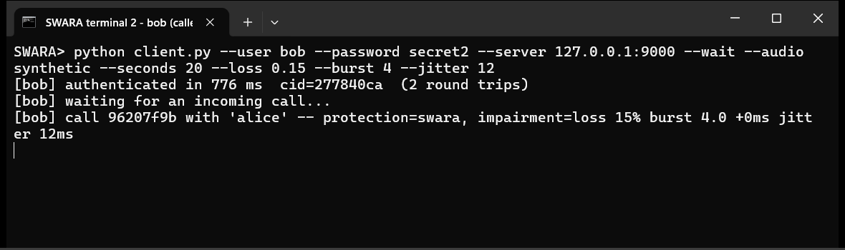
Figure 24. Terminal 2 — the callee (`python client.py --user bob … --wait`) during the call: authenticated in two round trips, incoming call accepted, media flowing.
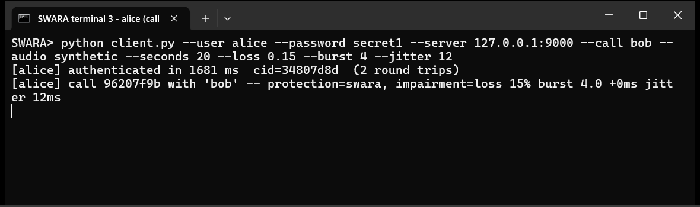
Figure 25. Terminal 3 — the caller (`python client.py --user alice … --call bob`) during the call.
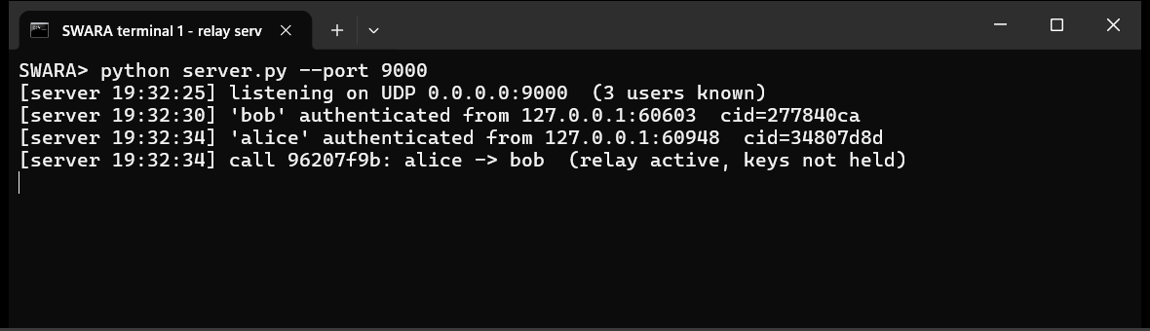
Figure 26. Terminal 1 after the call: the relay's complete log for the session.
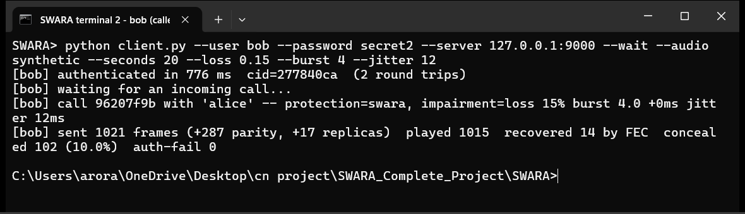
Figure 27. Terminal 2 after the call — bob's own report: 1,021 frames sent with 287 parity and 17 replica packets; 1,015 played; 14 rebuilt by FEC; 102 concealed (10.0 %); no authentication failures.
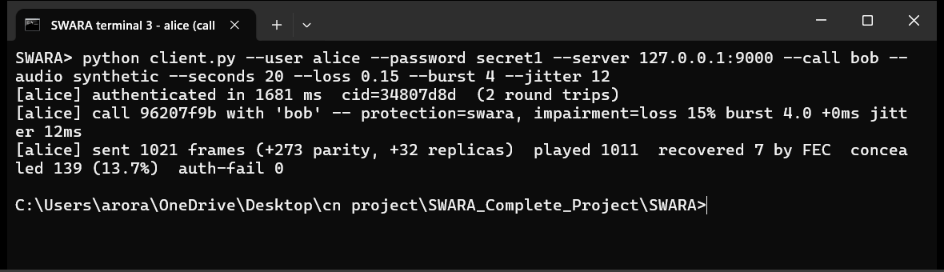
Figure 28. Terminal 3 after the call — alice's own report: 1,021 frames sent with 273 parity and 32 replicas; 1,011 played; 7 rebuilt by FEC; 139 concealed (13.7 %); no authentication failures.

B.3 Command-line clients on the relay hosted by the web console
The same two clients connected to the relay running inside the uvicorn process while the console watched. The Relay & Users page lists both users with their addresses and connection ids, the active call and its two endpoints, and the relay log; the Overview page's relay card shows “2 online · 1 call”.
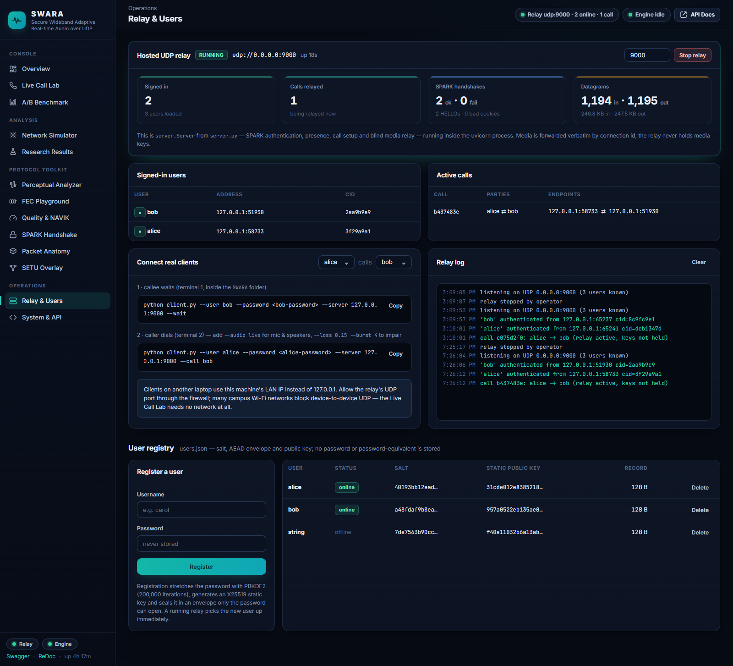
Figure 29. Relay & Users page while alice and bob (command-line clients) are in a call through the hosted relay.
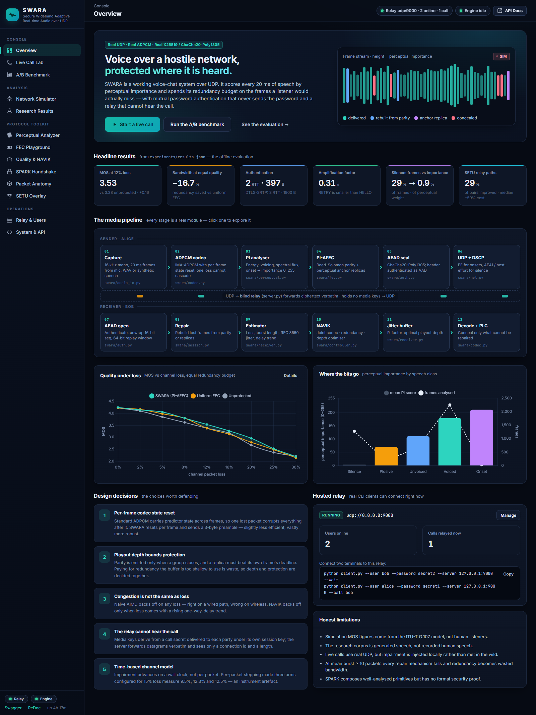
Figure 30. Overview page during the same call: the hosted-relay card reports two users online and one call relayed.
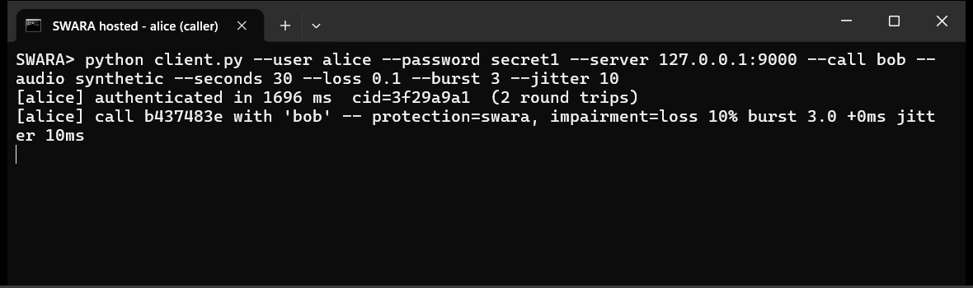
Figure 31. The caller's terminal for the hosted-relay call (30 s, 10 % loss, burst 3, 10 ms jitter on alice's socket).
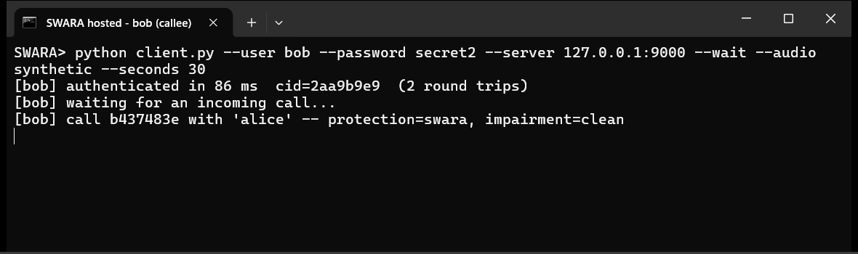
Figure 32. The callee's terminal for the hosted-relay call.

B.4 Live Call Lab
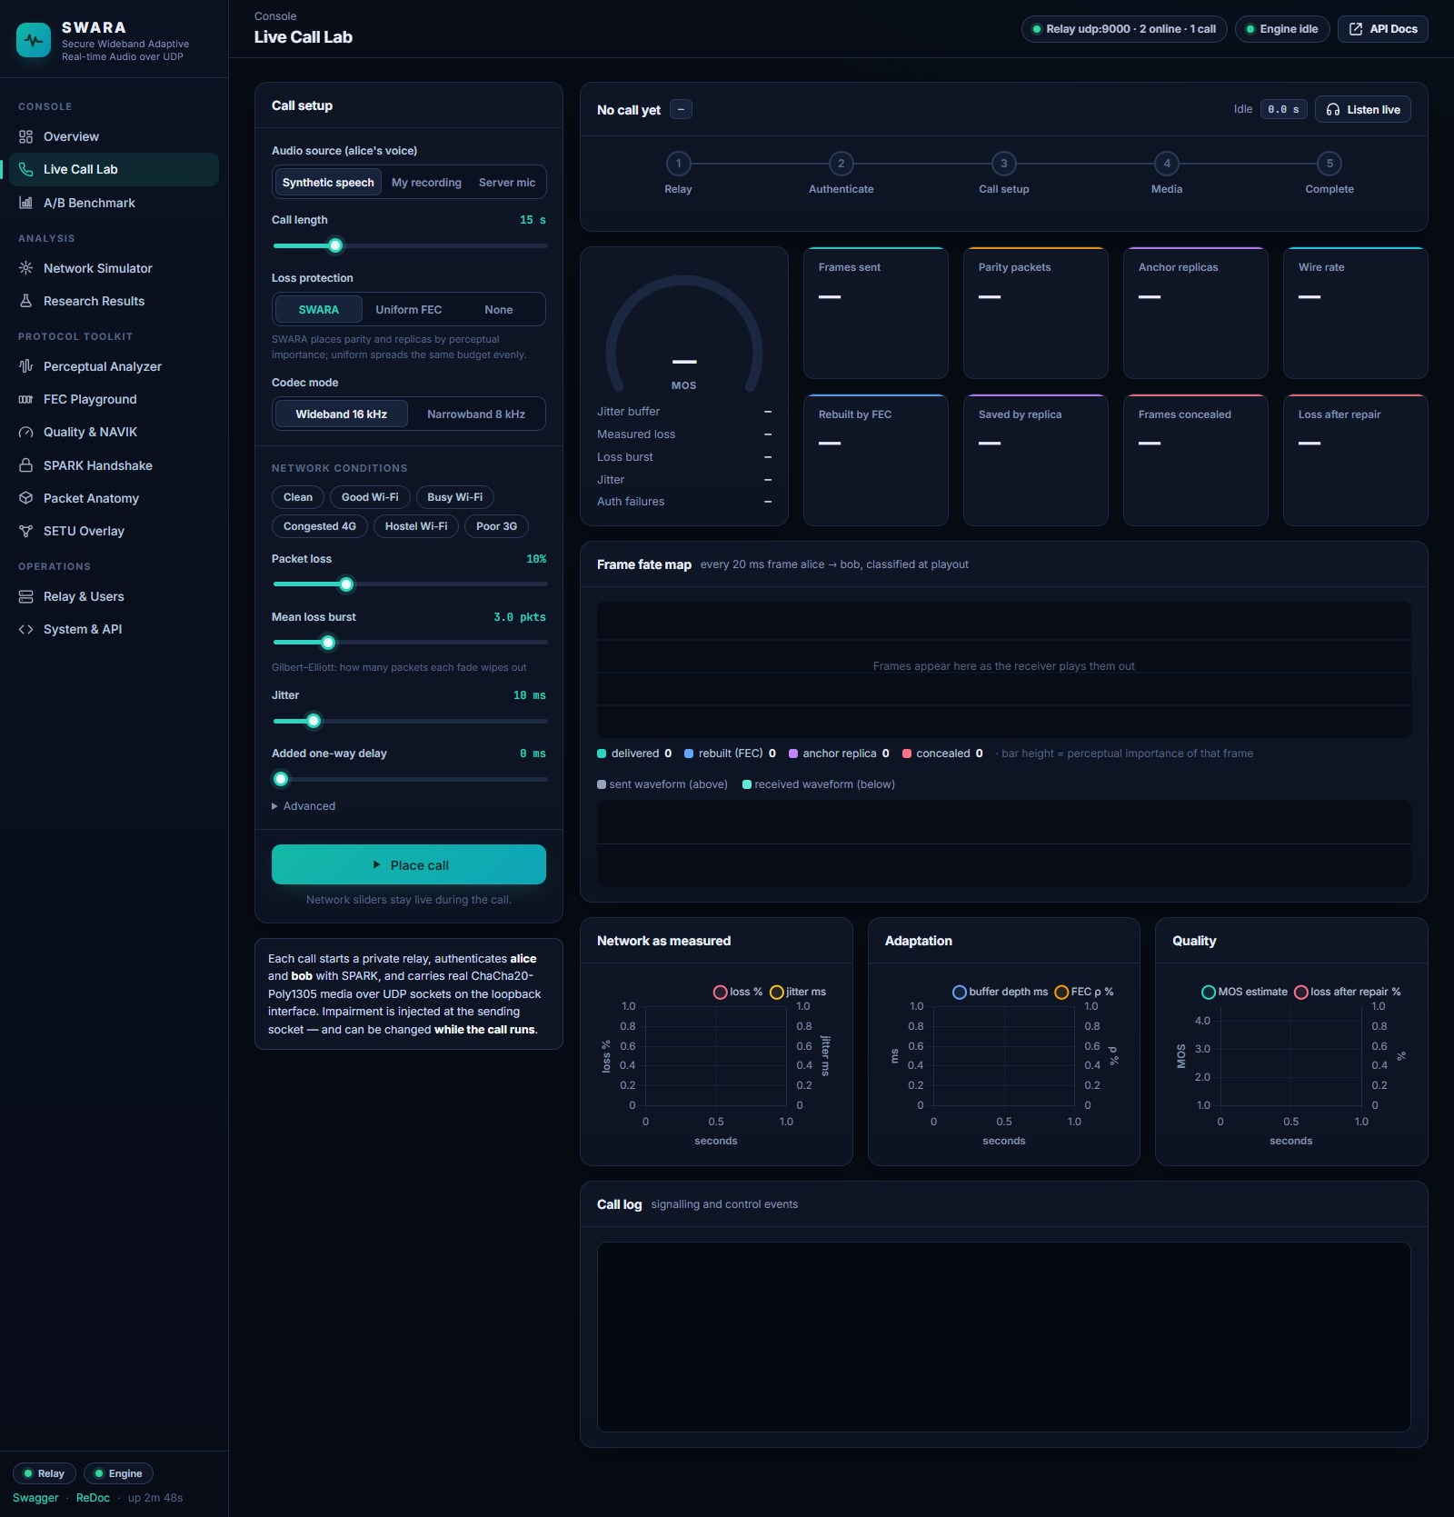
Figure 33. Live Call Lab before a call: audio source, call length, protection scheme, codec mode and the network sliders (presets from Clean to Poor 3G).
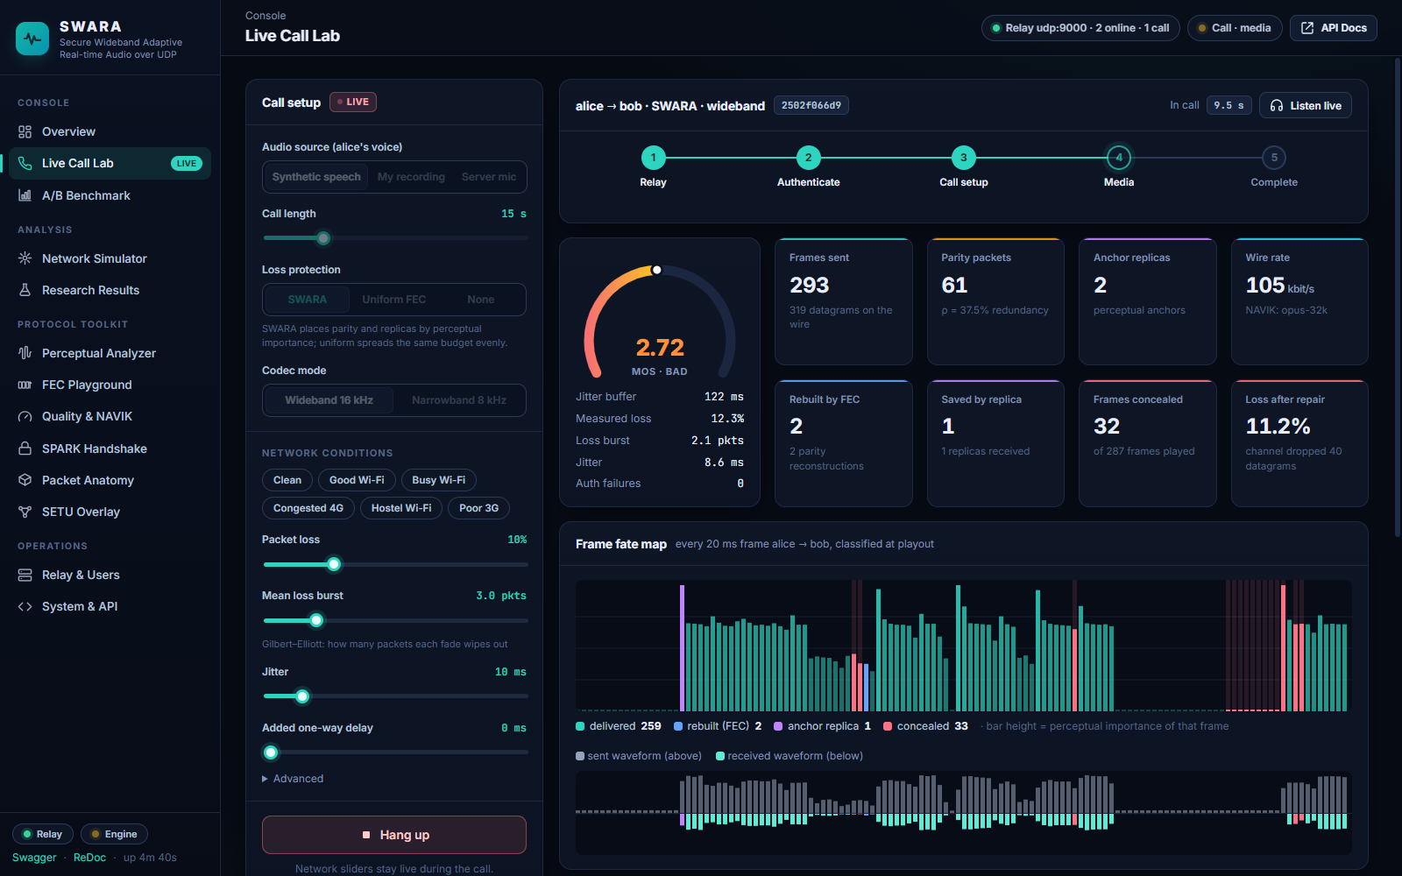
Figure 34. Live Call Lab during a call: the frame-fate map fills from left to right (bar height = PI; teal delivered, blue rebuilt from parity, violet anchor replica, red concealed), the sent and received waveforms, and the live gauges.
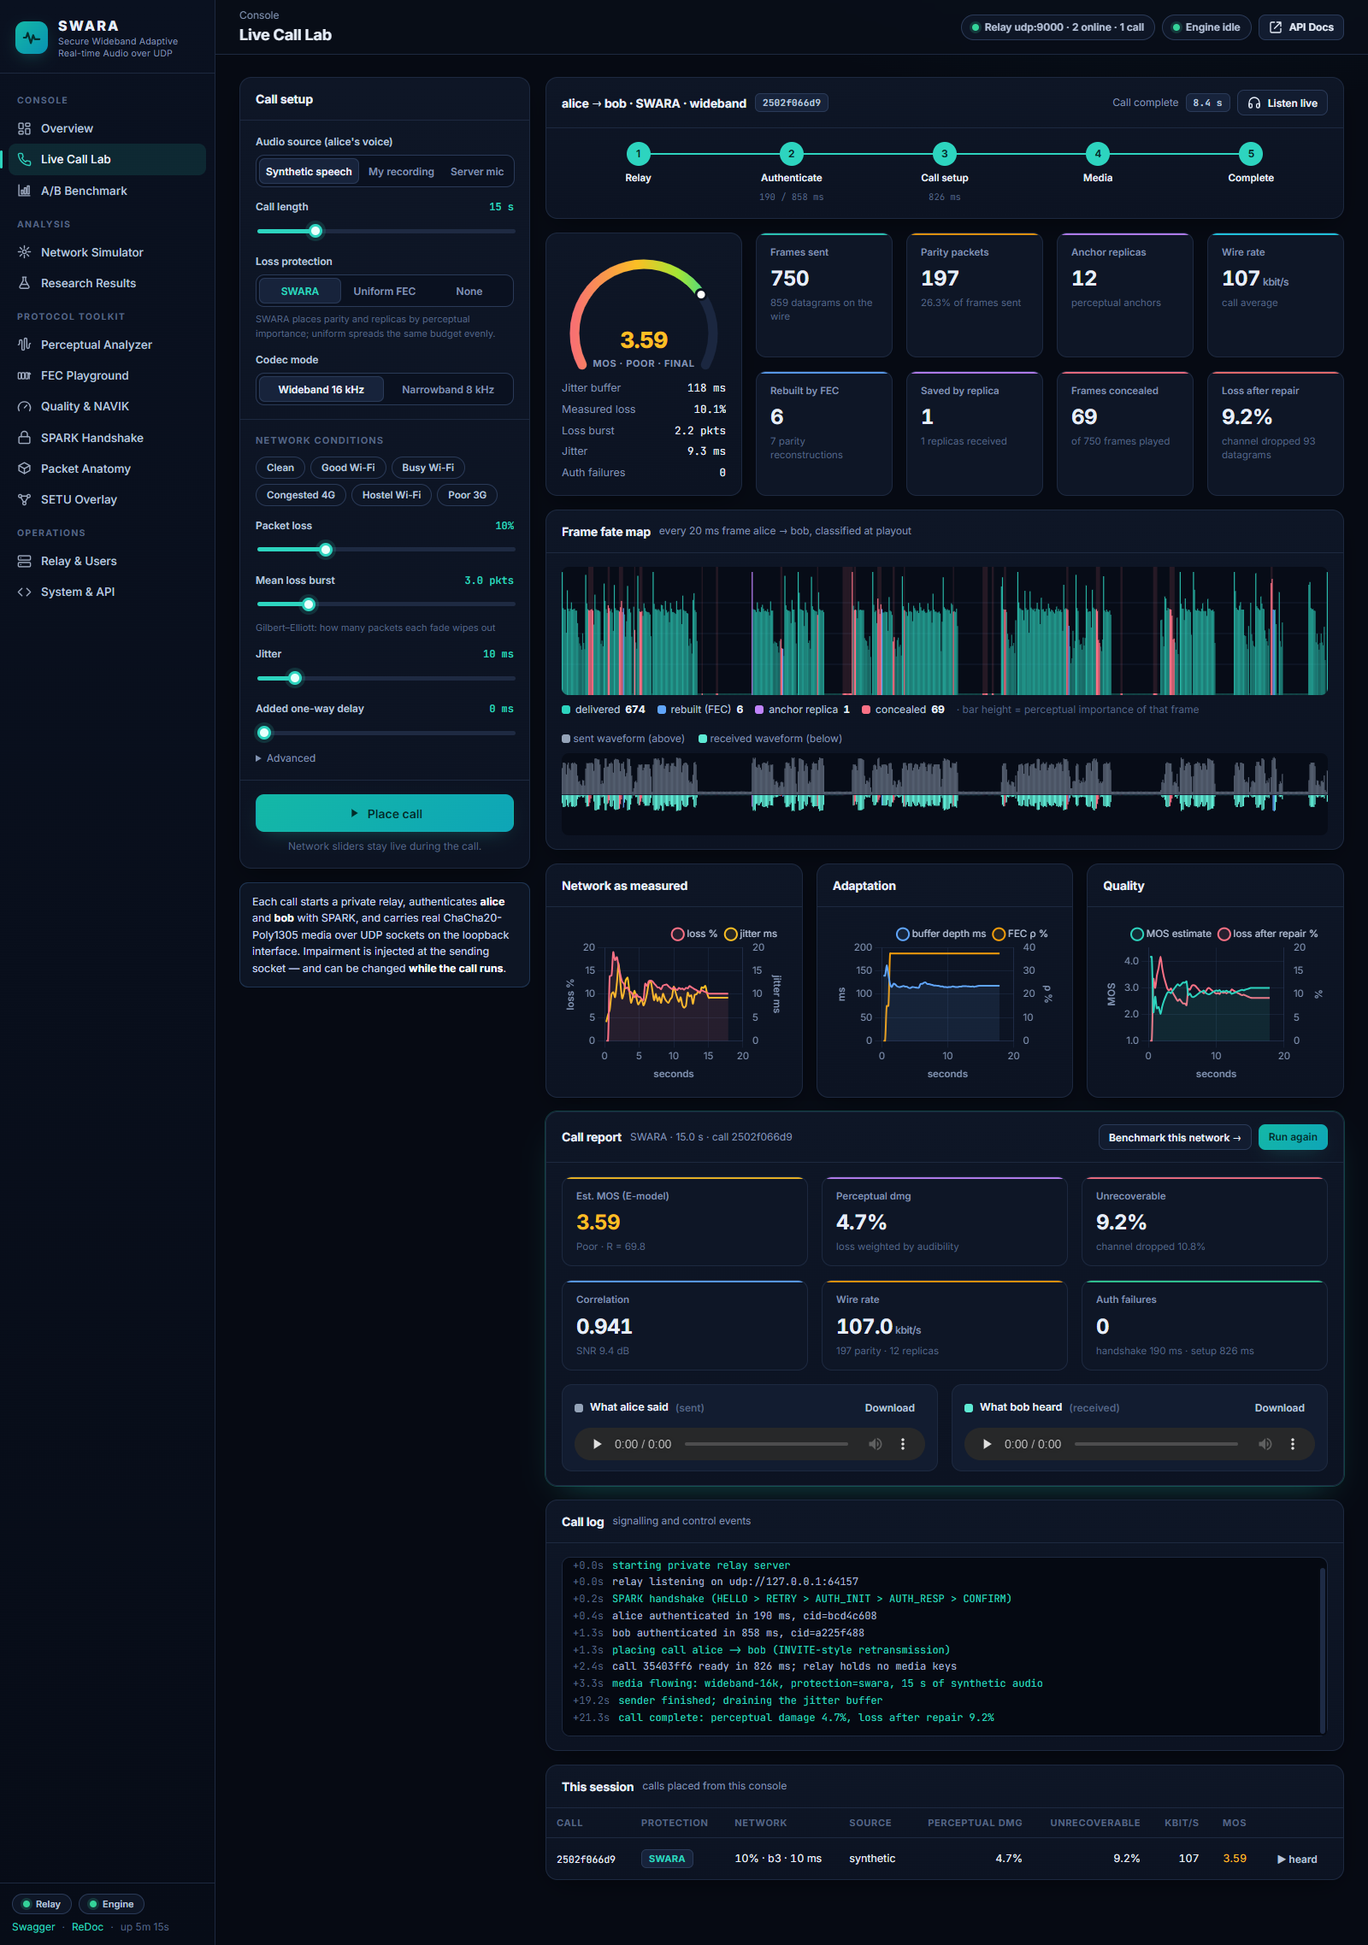
Figure 35. Live Call Lab after the call: the complete frame-fate map, the three time-series charts (network as measured, adaptation, quality), the call report with playable sent and received audio, the call log and the session table.

B.5 A/B Benchmark
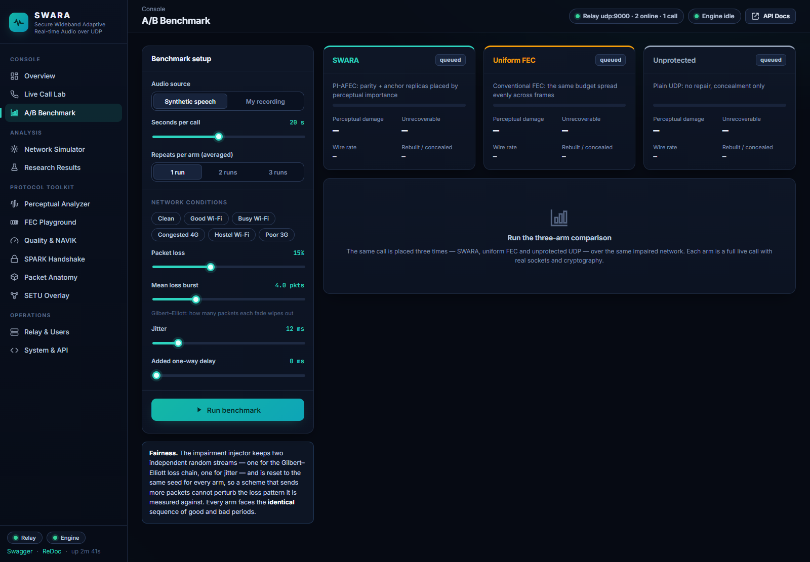
Figure 36. A/B Benchmark page before a run: audio source, seconds per call, repeats, and the network conditions shared by all three arms.
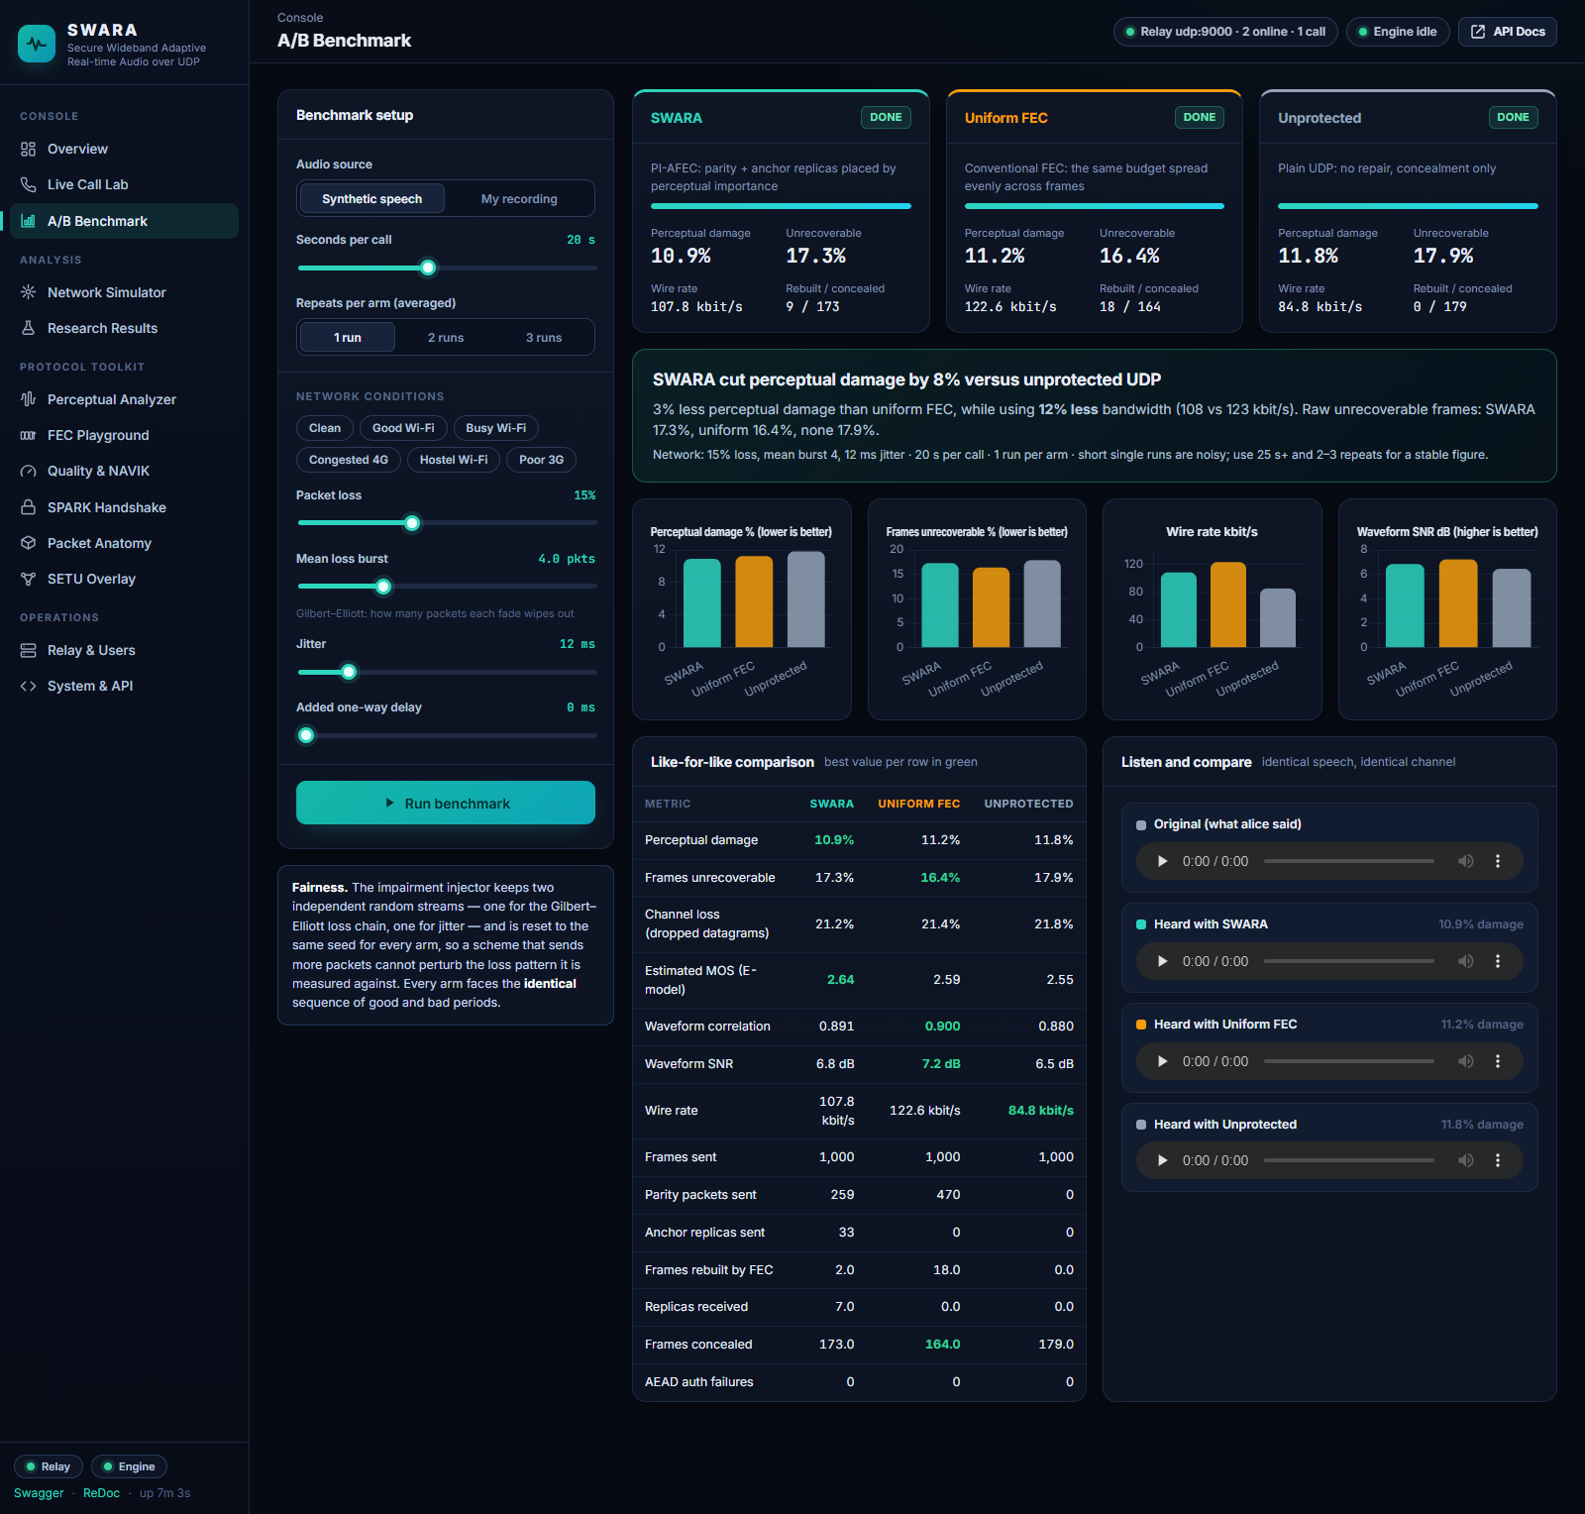
Figure 37. A/B Benchmark after a run at 15 % loss, burst 4, 12 ms jitter (20 s per arm): per-arm cards, the verdict, four comparison charts, the like-for-like table and the audio of each arm.

B.6 Network Simulator
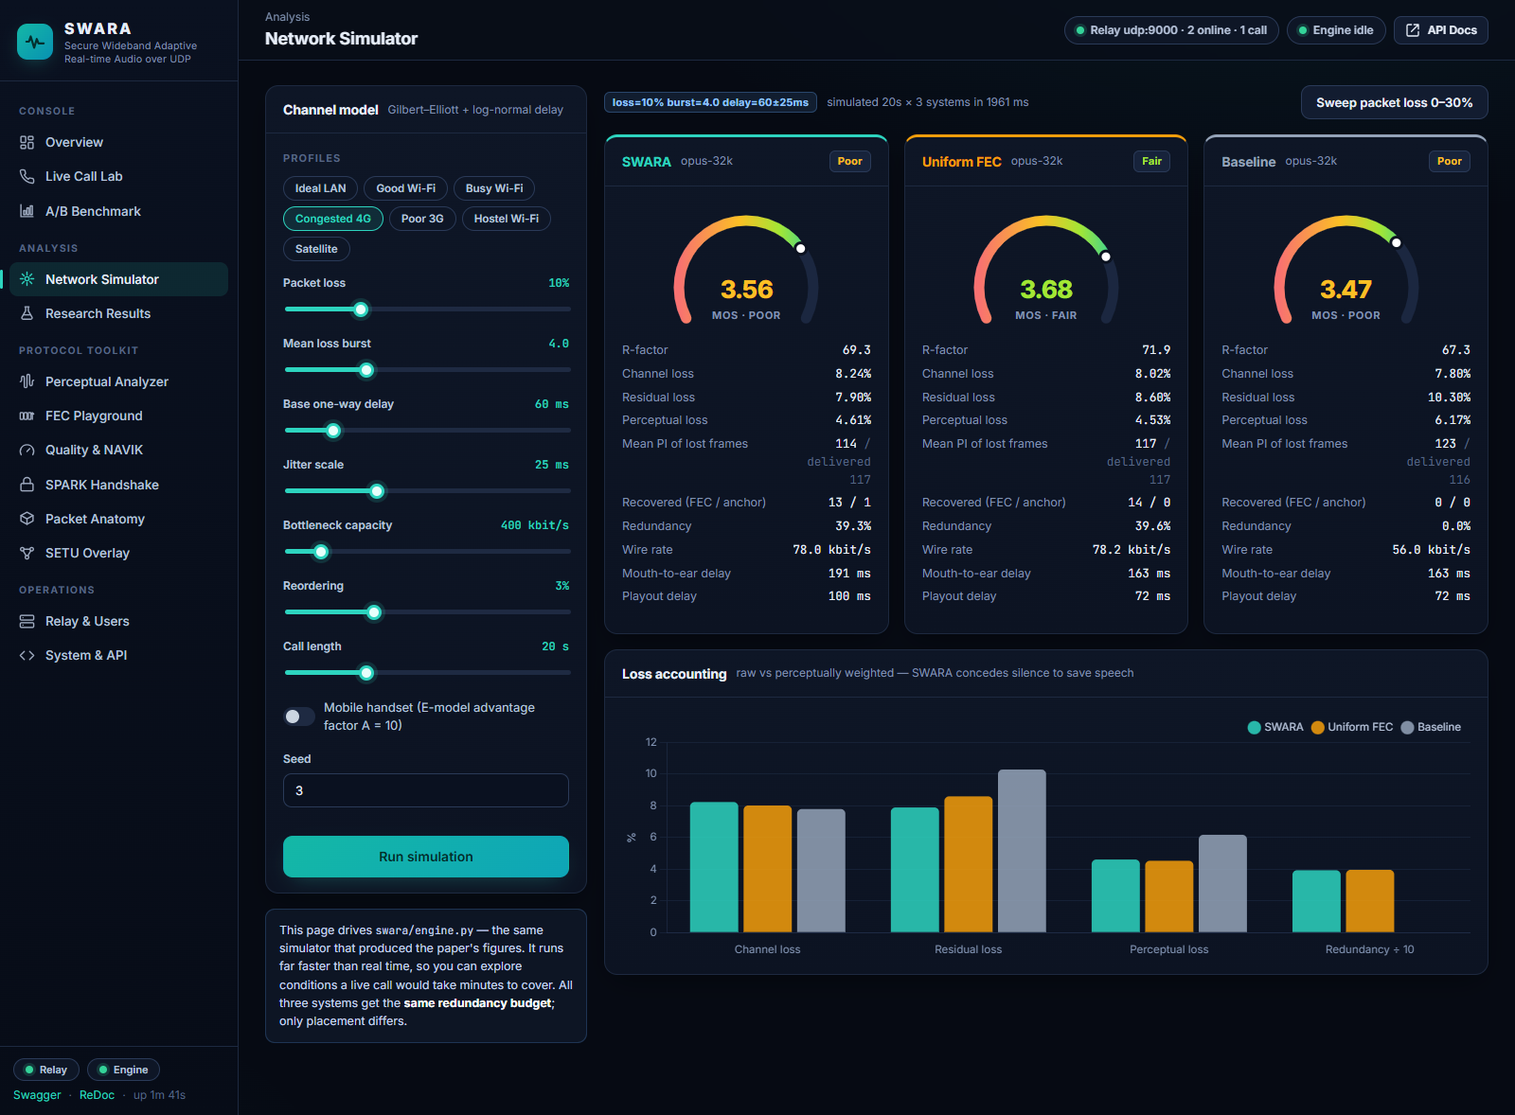
Figure 38. Network Simulator: the Congested 4G profile simulated for SWARA, uniform FEC and the baseline with MOS gauges, detailed per-system figures and the loss-accounting chart.

B.7 Research Results
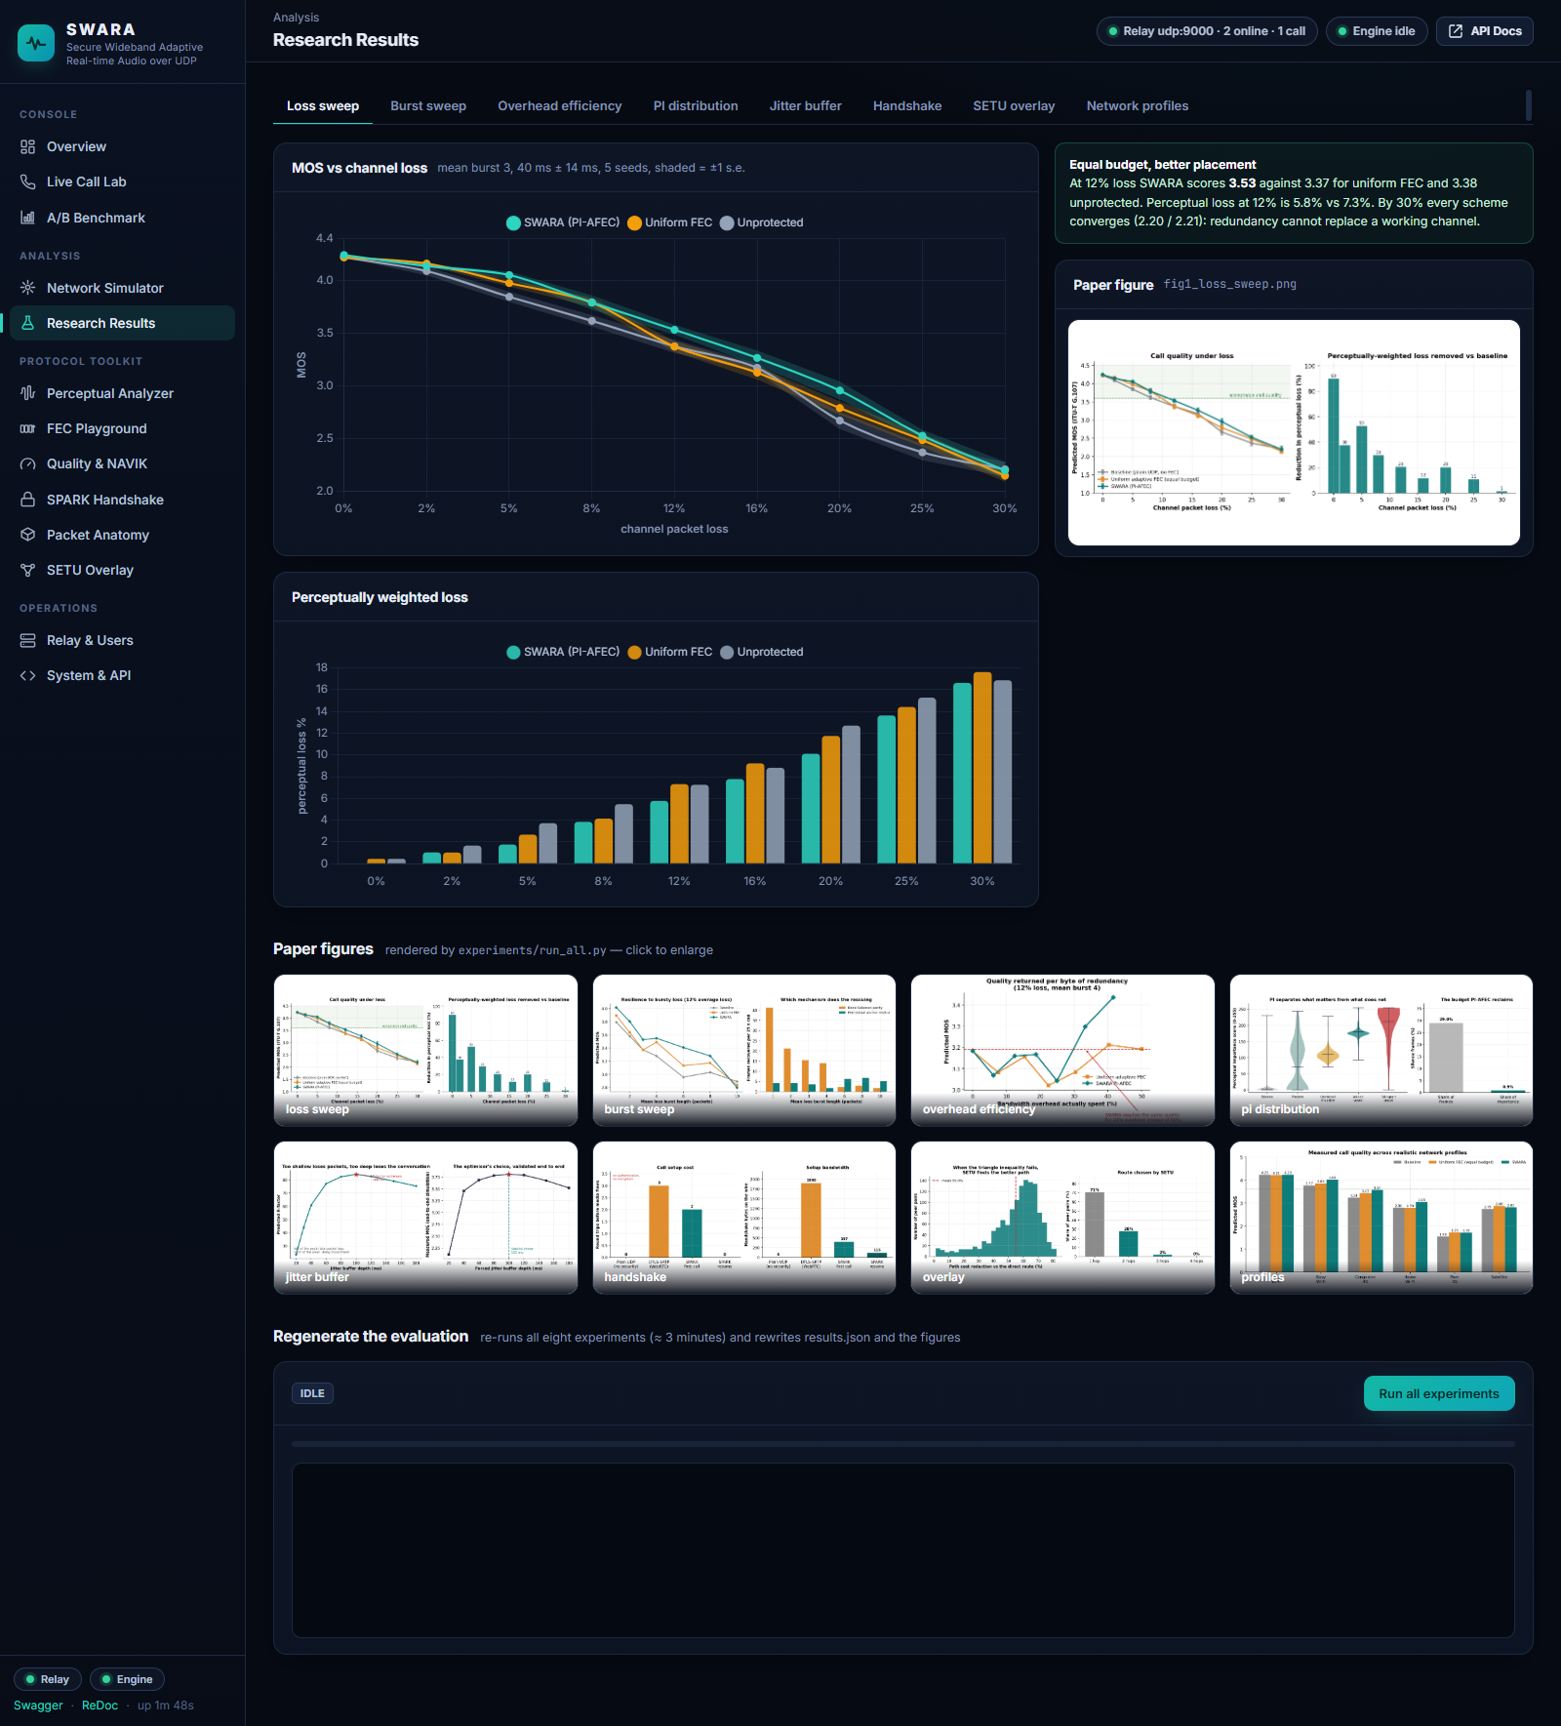
Figure 39. Research Results — loss sweep tab, with the interactive chart, the finding, the paper figure, the figure gallery and the regeneration control.
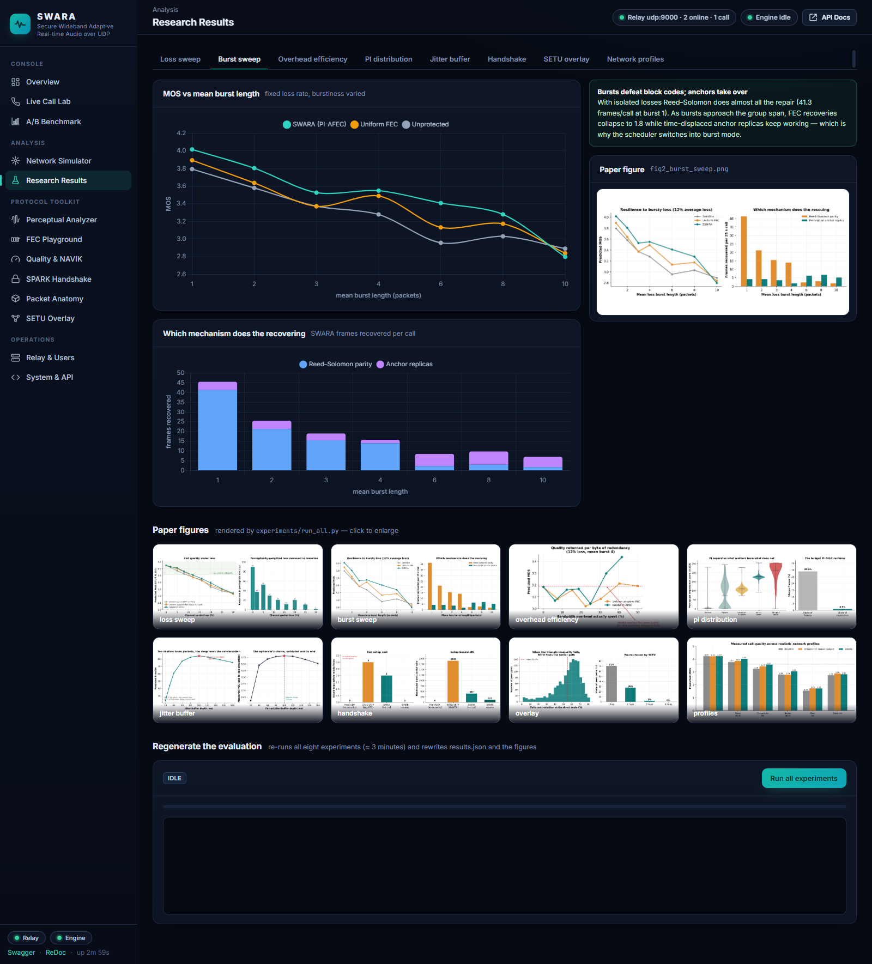
Figure 40. Research Results — burst sweep tab.
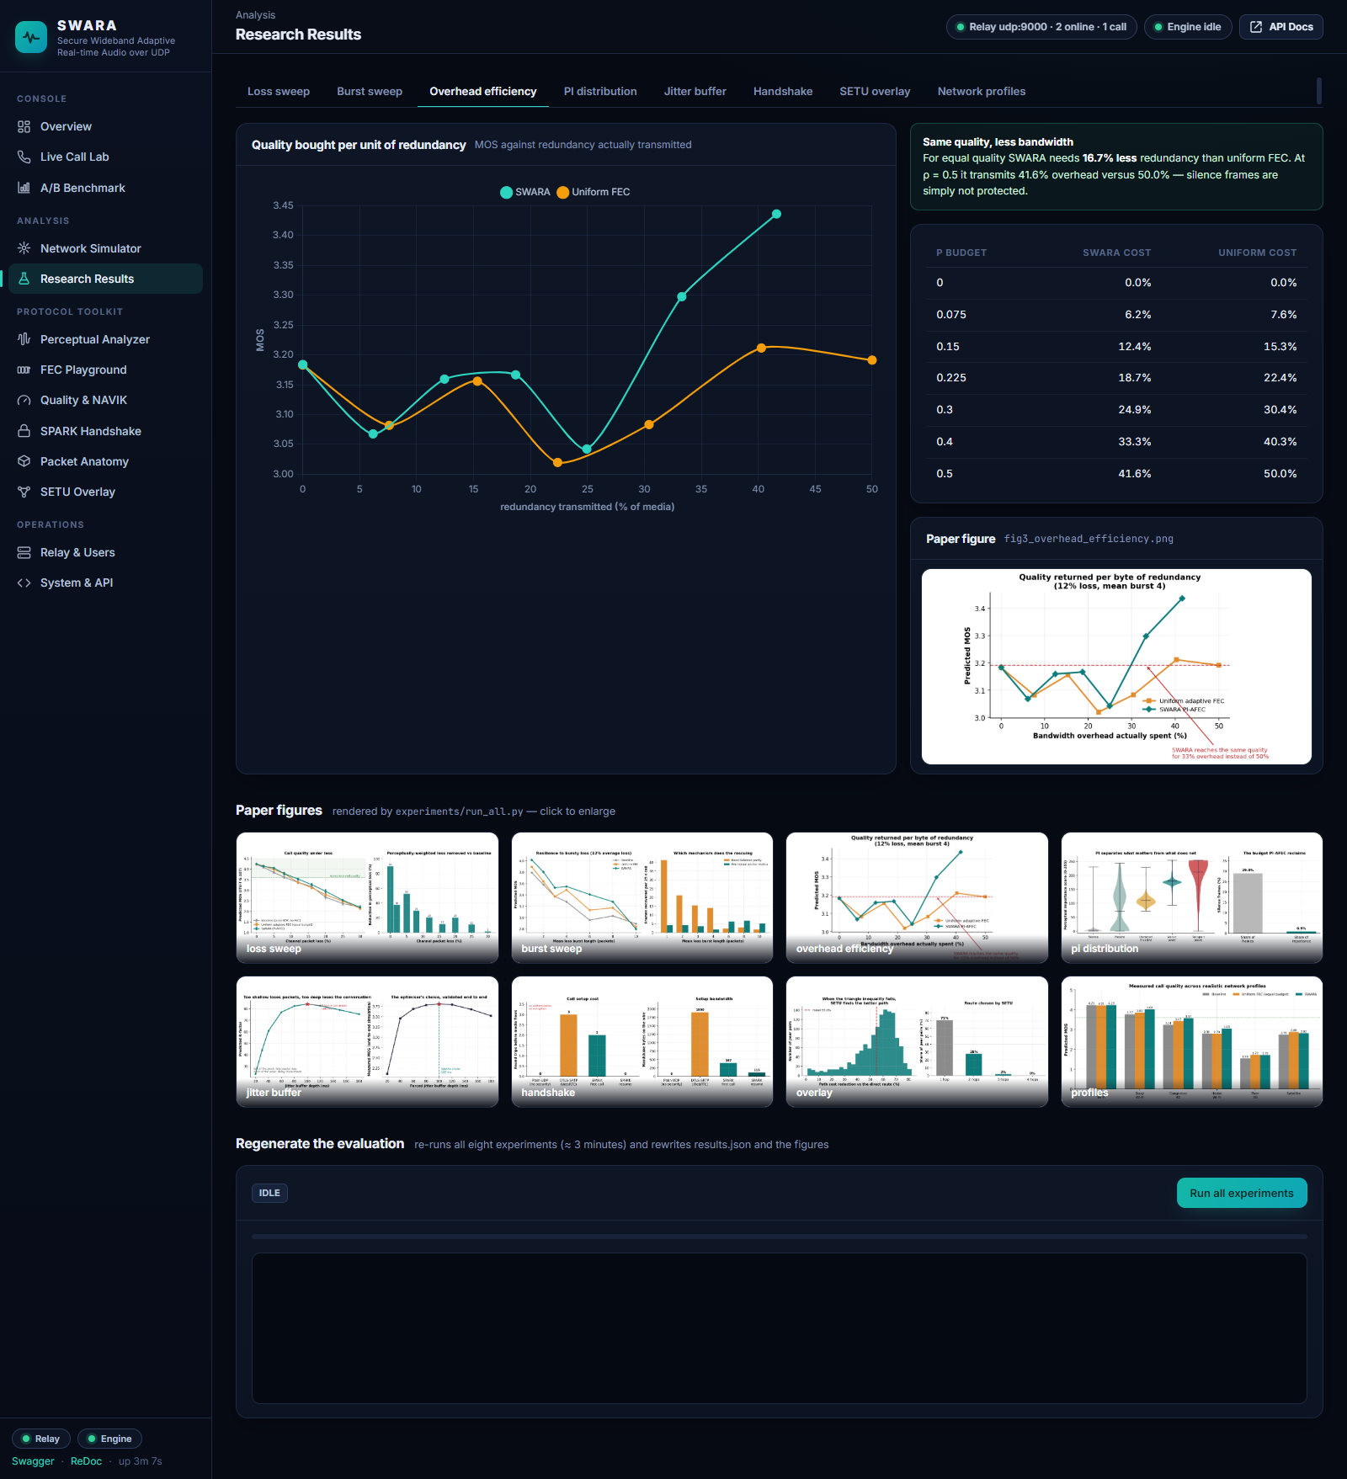
Figure 41. Research Results — overhead efficiency tab.
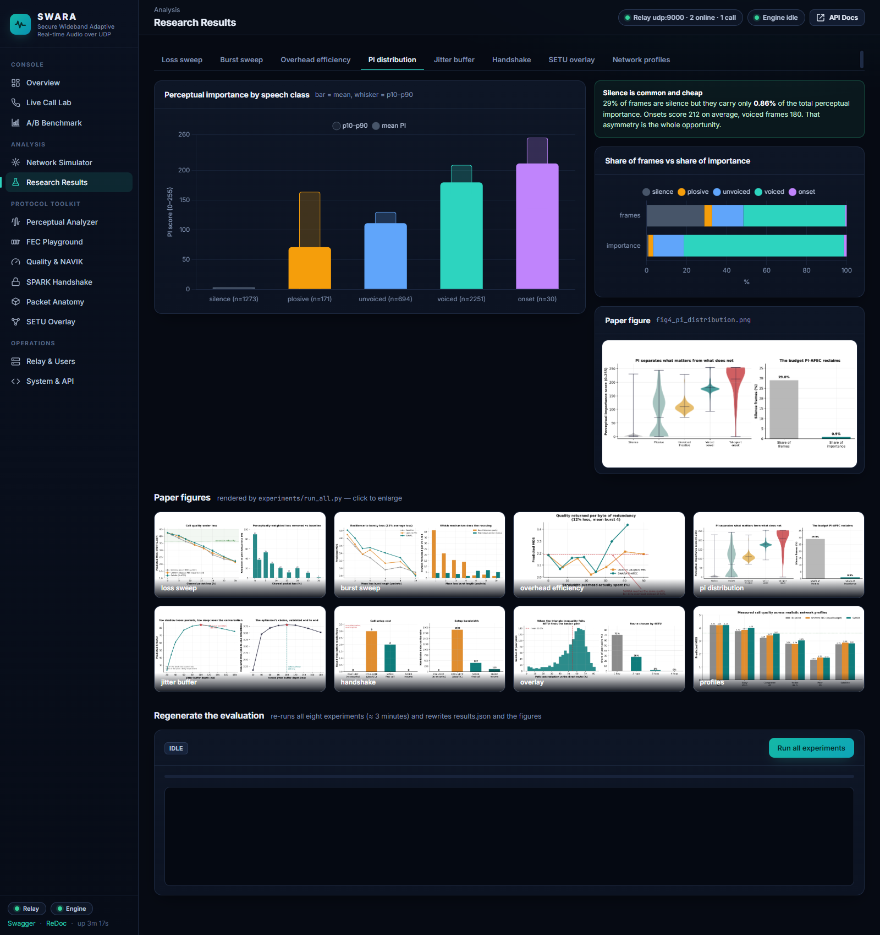
Figure 42. Research Results — PI distribution tab.
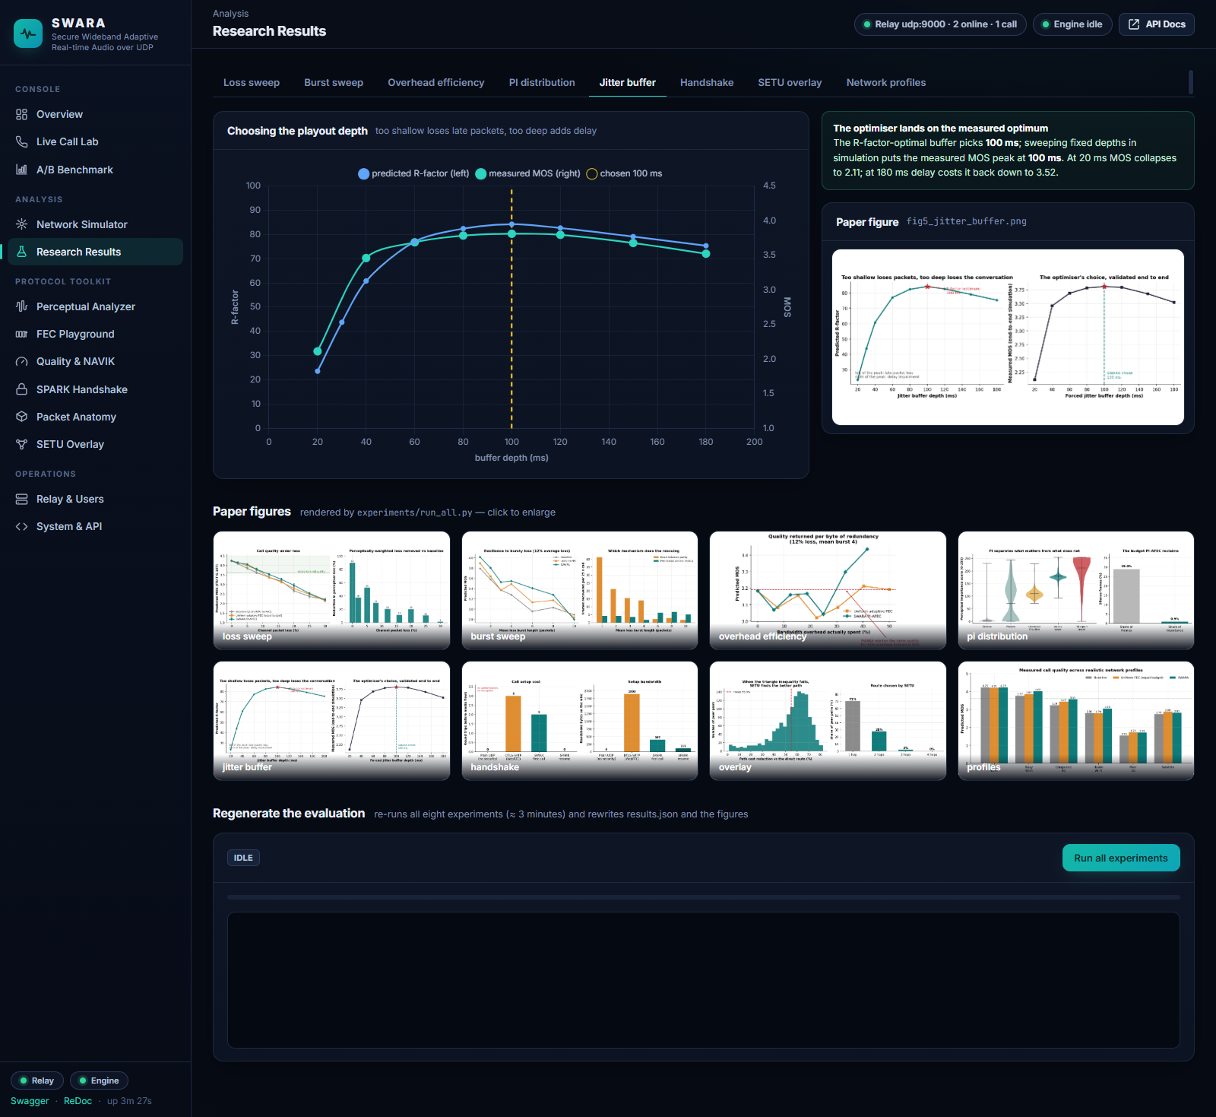
Figure 43. Research Results — jitter buffer tab.
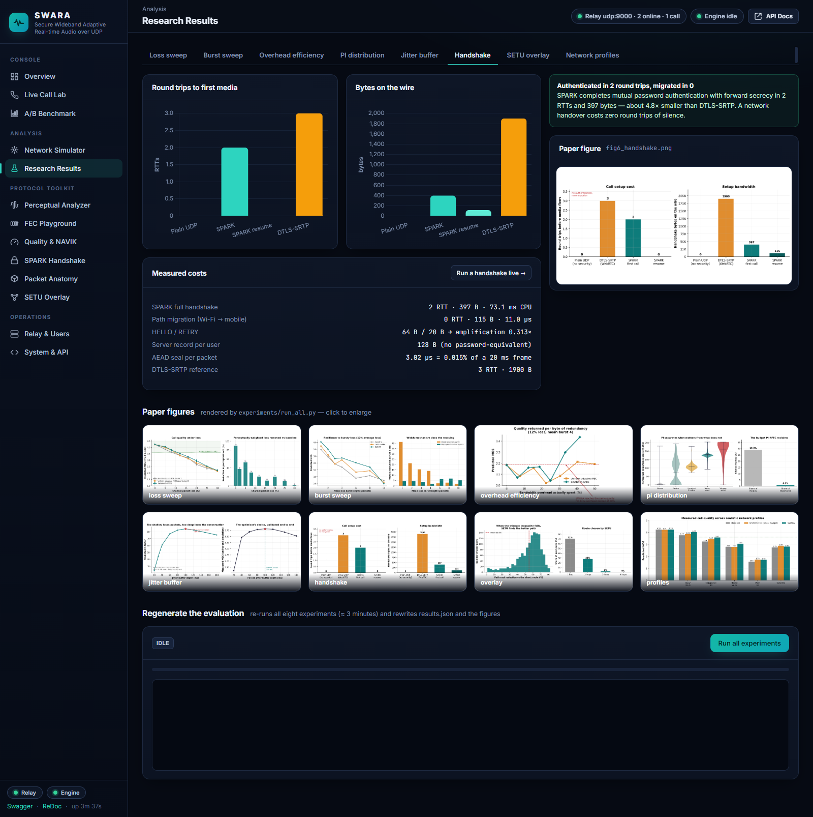
Figure 44. Research Results — handshake tab.
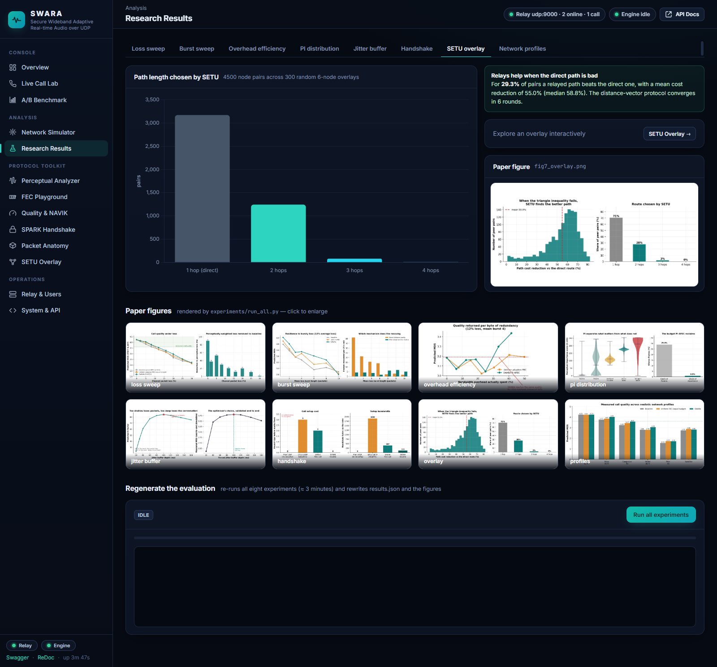
Figure 45. Research Results — SETU overlay tab.

Figure 46. Research Results — network profiles tab.

B.8 Protocol toolkit
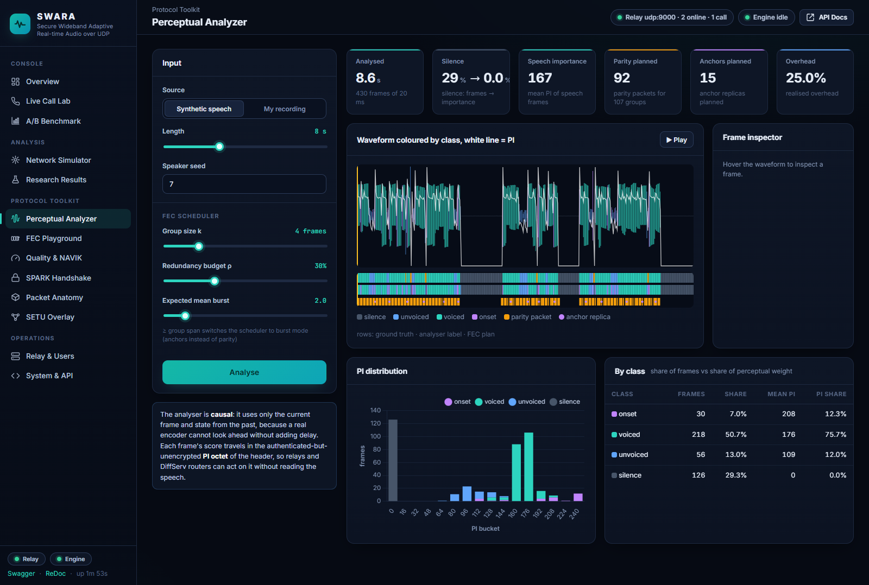
Figure 47. Perceptual Analyzer: synthetic speech coloured by class with the PI trace, the ground-truth / label / FEC-plan strips, the frame inspector, the PI histogram and per-class statistics.
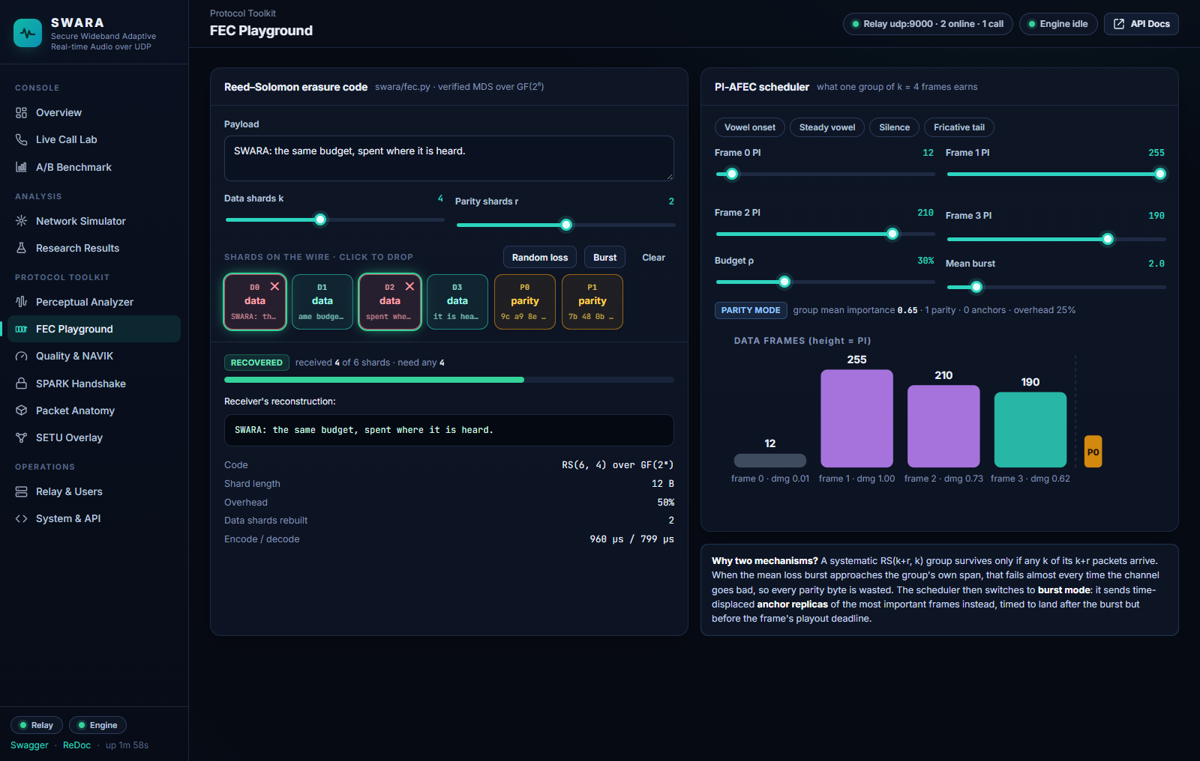
Figure 48. FEC Playground: an RS(6, 4) group with two data shards dropped and recovered; the PI-AFEC scheduler for a vowel-onset group.
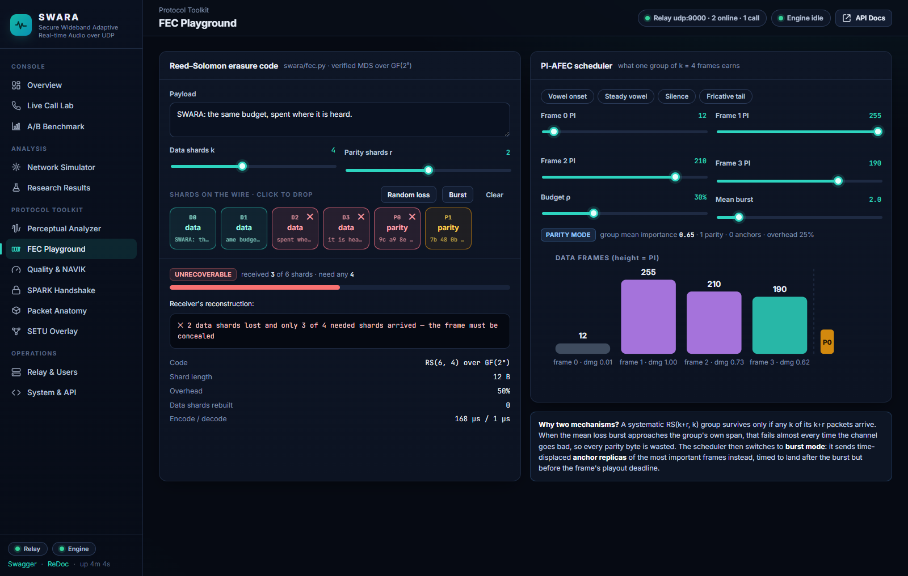
Figure 49. FEC Playground after the “Burst” button: more shards lost than the code can repair — the frame must be concealed.
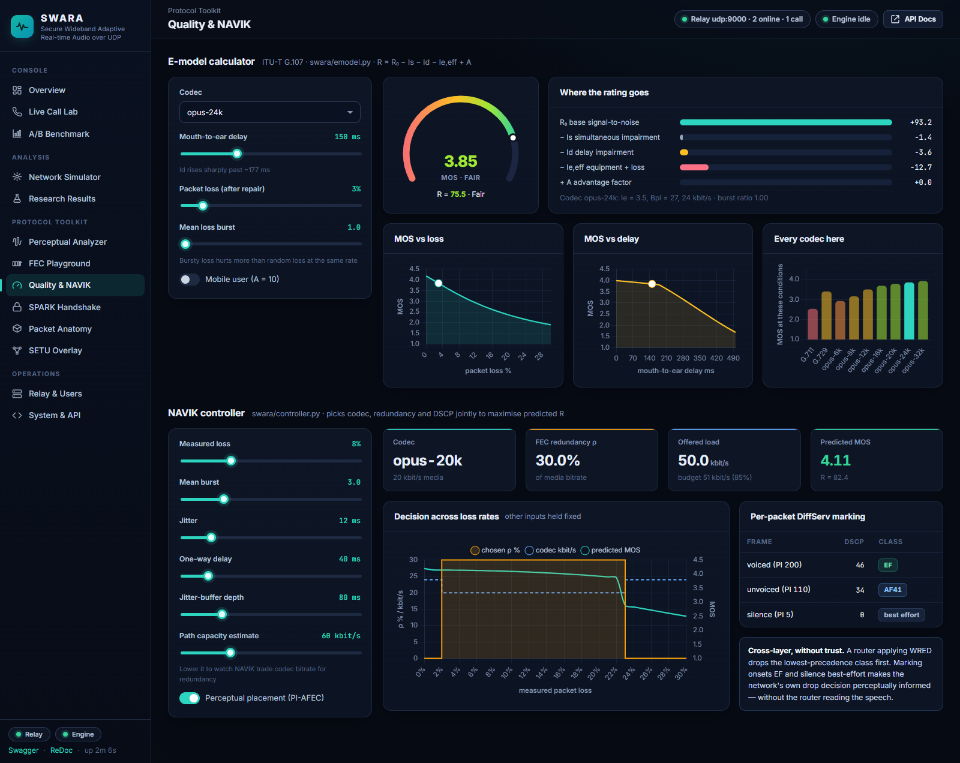
Figure 50. Quality & NAVIK: the E-model calculator with its impairment breakdown and the controller's decisions across loss rates.
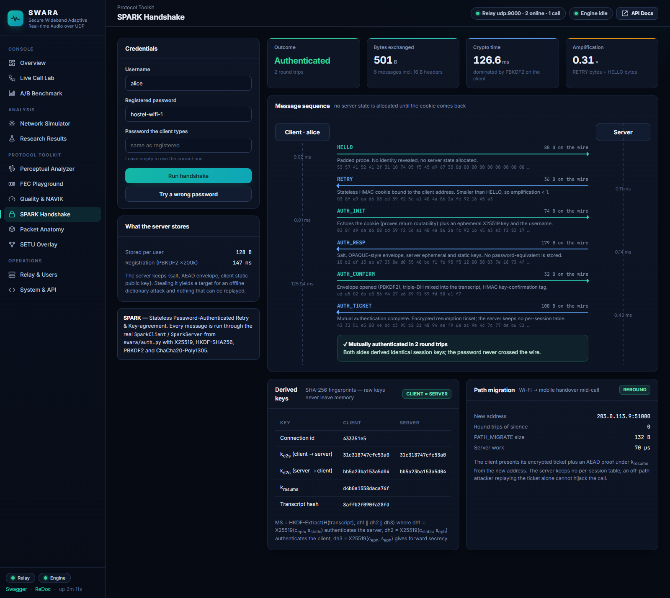
Figure 51. SPARK Handshake: the six messages with sizes and timings, the derived keys matching on both sides, and the 0-RTT path migration.
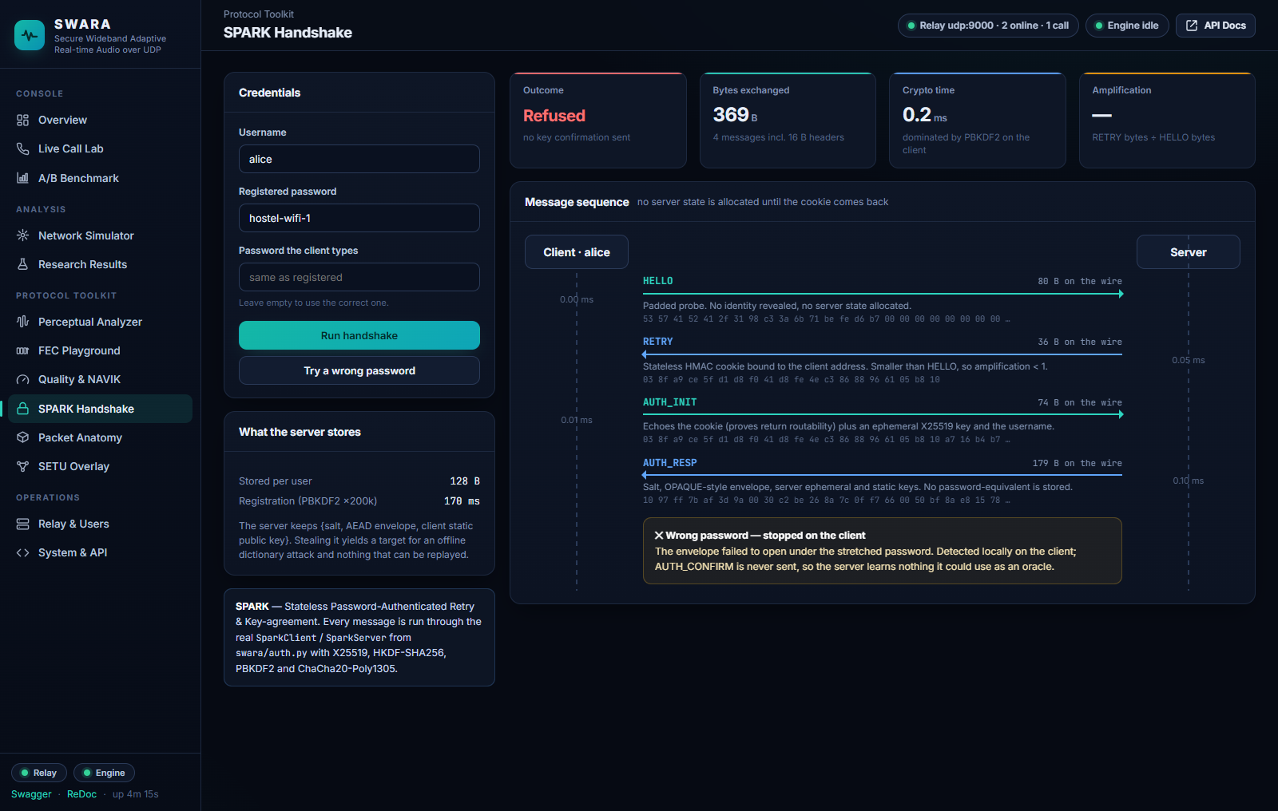
Figure 52. SPARK Handshake with a wrong password: the envelope fails to open locally and AUTH_CONFIRM is never sent.
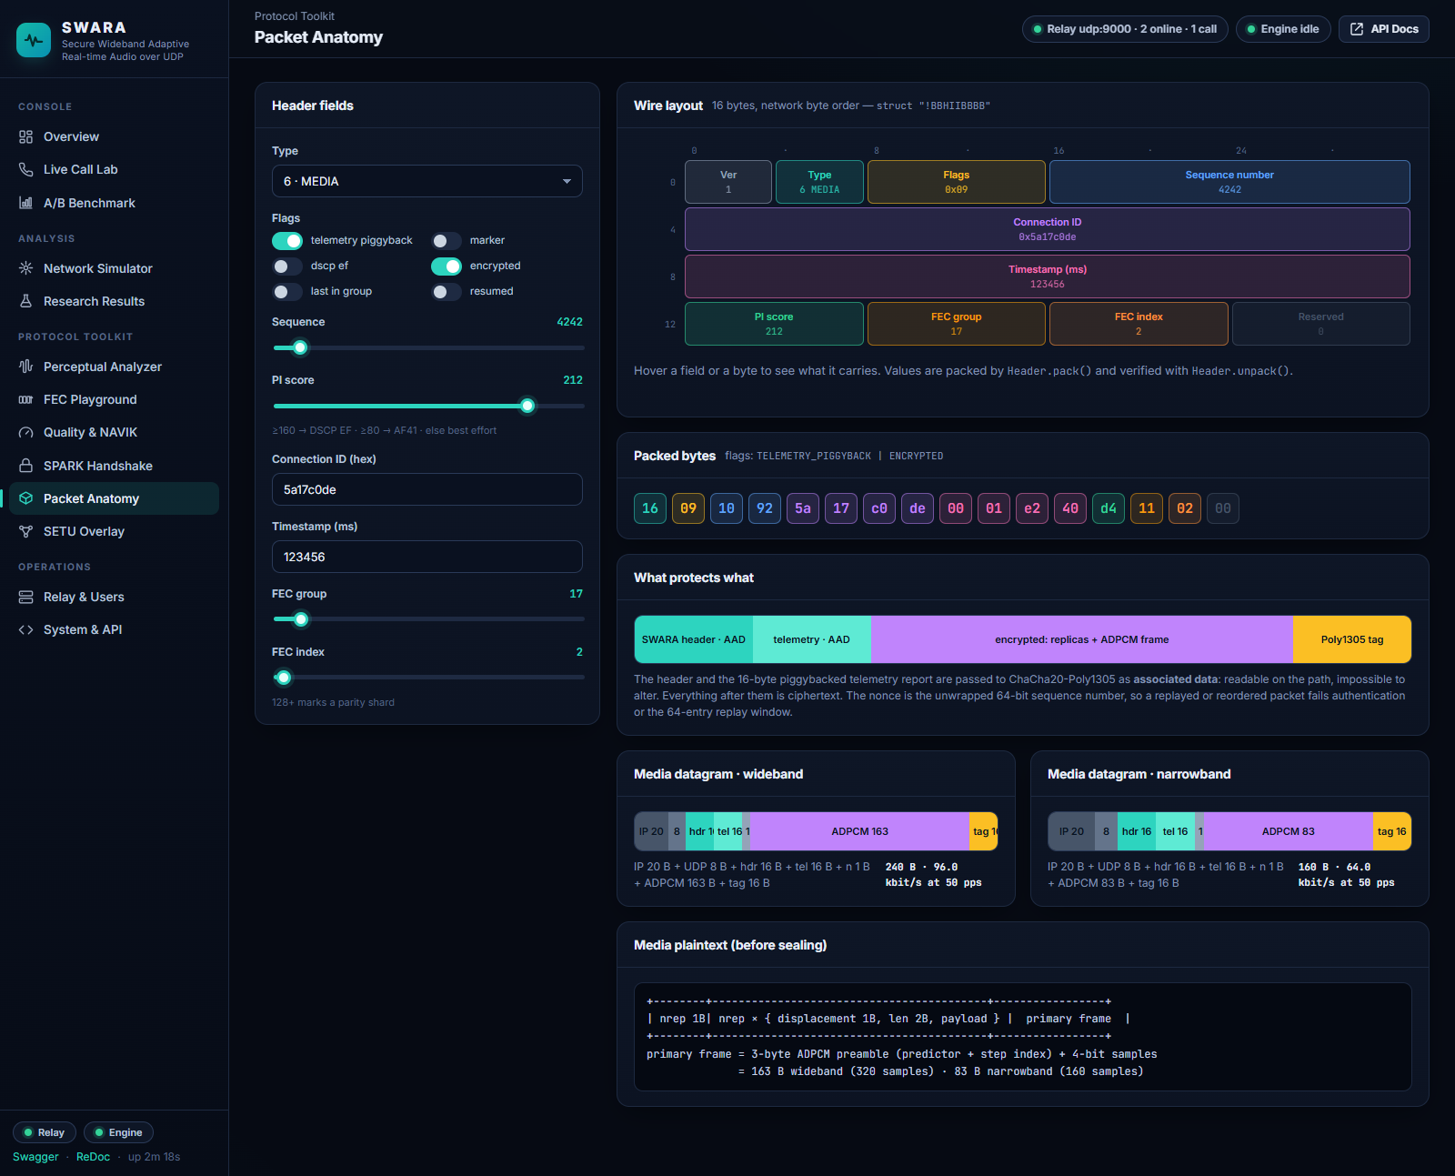
Figure 53. Packet Anatomy: the 16-byte header packed by Header.pack(), the hex dump, and what the AEAD protects.
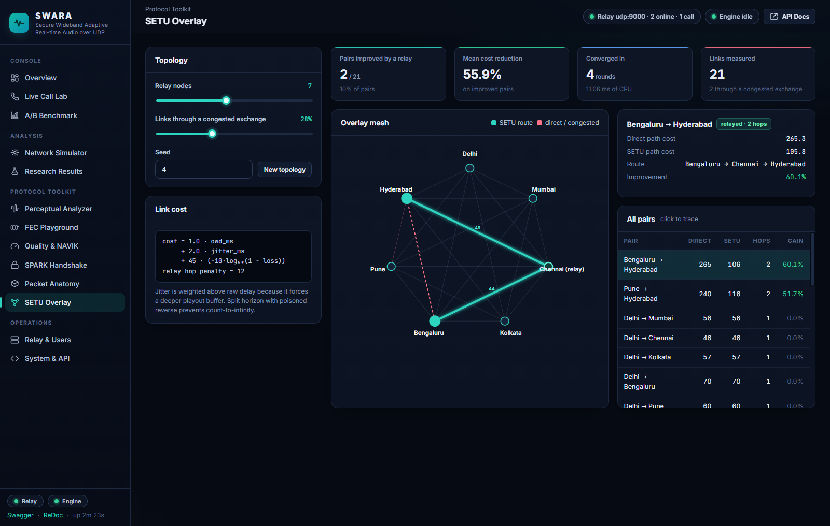
Figure 54. SETU Overlay: a seven-node measured mesh, the converged route for the selected pair, and all pairs ranked by gain.

B.9 Operations and API
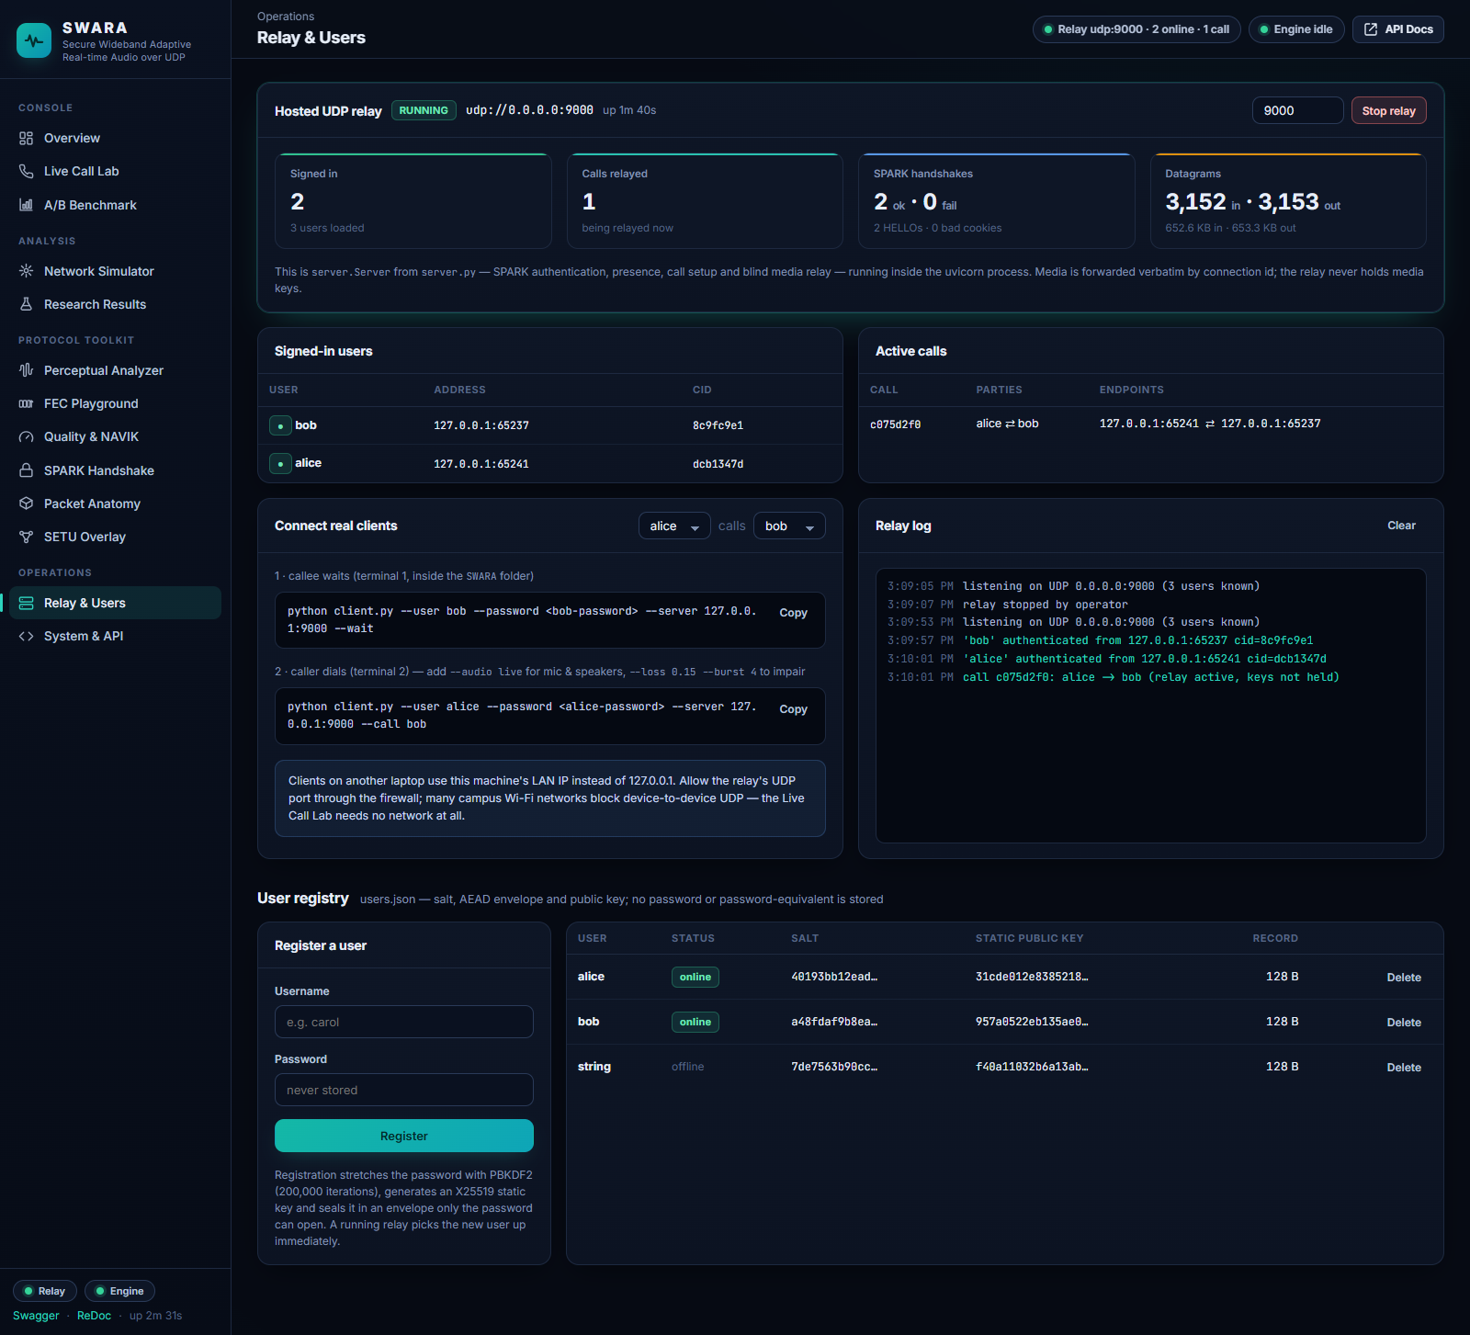
Figure 55. Relay & Users (idle): hosted relay status, the ready-to-paste client commands, the relay log and the user registry.
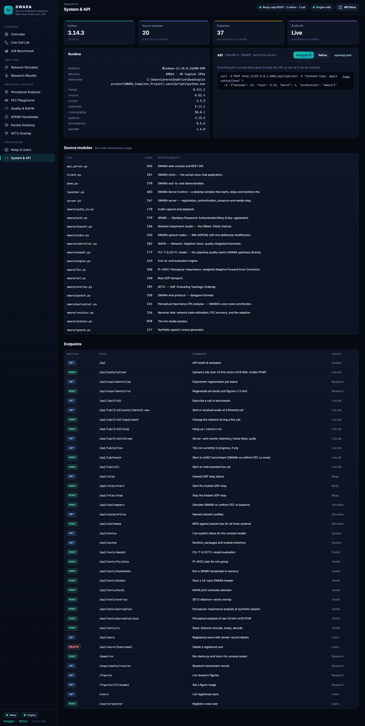
Figure 56. System & API: runtime, packages, the source-module inventory and every endpoint.
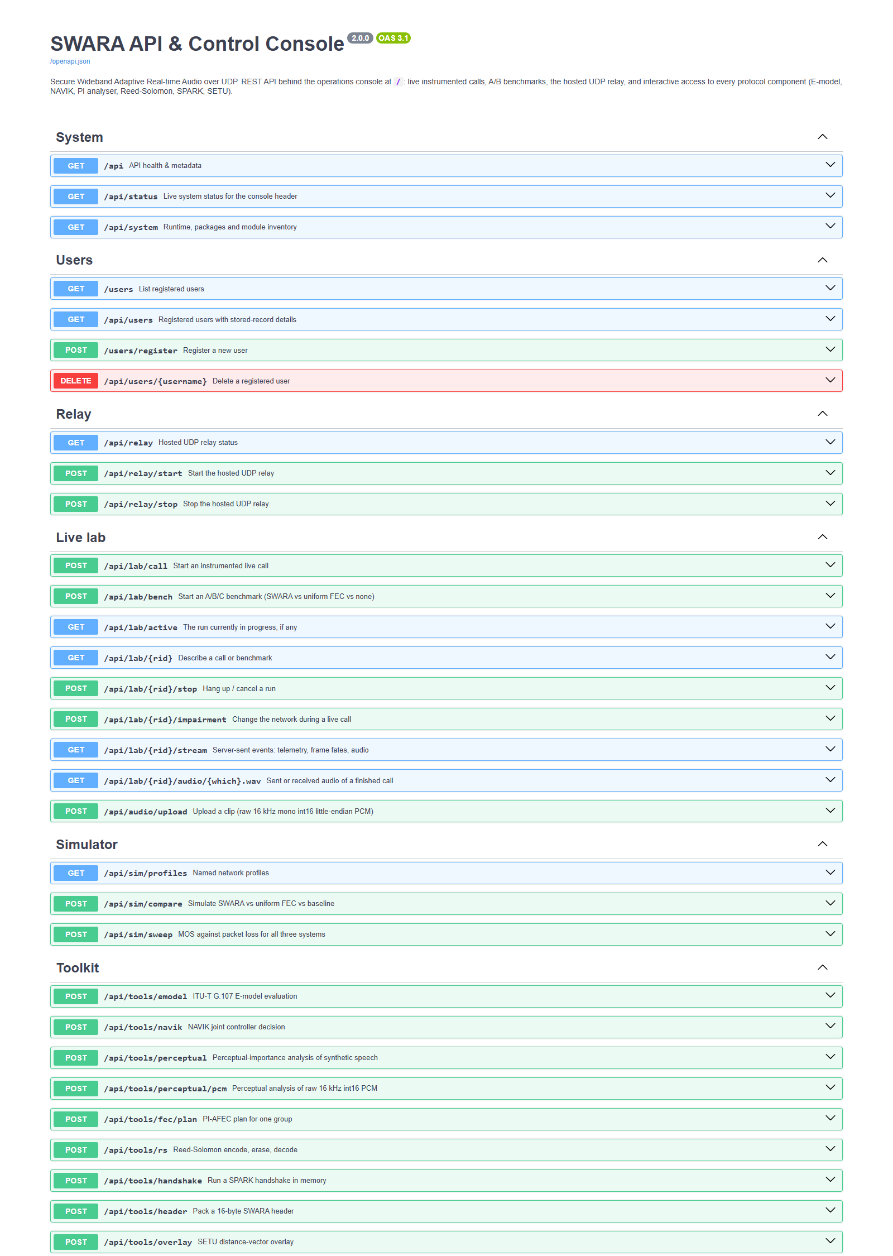
Figure 57. The generated OpenAPI documentation (Swagger UI) at /docs — the first five endpoint groups of thirty-seven documented routes.

Appendix C Source Code
The listings below reproduce the protocol stack (swara/), the relay, the client, the demonstration harness and the web API verbatim from the repository. The web console's back-end helpers (webapp/, 1,170 lines), its front end (static/, about 3,000 lines of JavaScript, CSS and HTML), the experiment script (experiments/run_all.py, 511 lines) and the launcher (launcher.py, 482 lines) are omitted for length and are available in the repository (Appendix A).
Listing 1 swara/packet.py 207 lines
Wire format: header, datagram types, flags, media/parity layouts; CRC-32, Internet checksum, 2-D parity and Hamming(7,4) for the error-control comparison.
1 """
2 SWARA wire protocol -- datagram formats.
3
4 Every SWARA datagram is a single UDP payload. There is no stream, no
5 retransmission-by-default, and no head-of-line blocking: a lost packet is a lost
6 20 ms of audio and nothing more.
7
8 Fixed header (16 bytes, network byte order):
9
10 0 1 2 3
11 0 1 2 3 4 5 6 7 8 9 0 1 2 3 4 5 6 7 8 9 0 1 2 3 4 5 6 7 8 9 0 1
12 +-------+-------+---------------+-------------------------------+
13 | Ver | Type | Flags | Sequence Number |
14 +-------+-------+---------------+-------------------------------+
15 | Connection ID (CID) |
16 +---------------------------------------------------------------+
17 | Timestamp (milliseconds) |
18 +---------------+---------------+---------------+---------------+
19 | PI Score | FEC Group | FEC Index | Reserved |
20 +---------------+---------------+---------------+---------------+
21
22 The PI Score octet is the heart of the design. It is *authenticated but not
23 encrypted* (it travels as AEAD associated data), so any element on the path --
24 the receiver, a relay, or a DiffServ-aware router -- can read how perceptually
25 important the enclosed 20 ms of speech is WITHOUT being able to read or forge
26 the speech itself.
27 """
28
29 from __future__ import annotations
30
31 import struct
32 import zlib
33 from dataclasses import dataclass, field
34
35 VERSION = 1
36 HEADER_LEN = 16
37 AEAD_TAG_LEN = 16
38 MAX_DATAGRAM = 1200 # stay under the smallest plausible path MTU, no fragmentation
39
40
41 class PType:
42 """Datagram type codes (4 bits)."""
43 HELLO = 0 # client -> server, stateless probe
44 RETRY = 1 # server -> client, anti-amplification cookie
45 AUTH_INIT = 2 # client -> server, cookie + ephemeral public key
46 AUTH_RESP = 3 # server -> client, salt + envelope + ephemeral public key
47 AUTH_CONFIRM = 4 # client -> server, key-confirmation tag
48 AUTH_TICKET = 5 # server -> client, encrypted resumption ticket
49 MEDIA = 6 # a coded speech frame
50 FEC = 7 # a Reed-Solomon parity packet
51 ANCHOR = 8 # perceptual anchor replica (duplicate of a high-PI frame)
52 TELEMETRY = 9 # standalone telemetry (normally piggybacked instead)
53 NACK = 10 # selective negative acknowledgement
54 PATH_MIGRATE = 11 # 0-RTT authenticated path migration
55 PATH_ACK = 12 # path validation response
56 OVERLAY_LSA = 13 # SETU overlay link-state / distance-vector advertisement
57 BYE = 14
58 CONTROL = 15 # encrypted signalling: call setup, presence, hangup
59
60 NAMES = {
61 0: "HELLO", 1: "RETRY", 2: "AUTH_INIT", 3: "AUTH_RESP",
62 4: "AUTH_CONFIRM", 5: "AUTH_TICKET", 6: "MEDIA", 7: "FEC",
63 8: "ANCHOR", 9: "TELEMETRY", 10: "NACK", 11: "PATH_MIGRATE",
64 12: "PATH_ACK", 13: "OVERLAY_LSA", 14: "BYE", 15: "CONTROL",
65 }
66
67
68 class Flag:
69 """Header flag bits."""
70 TELEMETRY_PIGGYBACK = 0x01 # a 16-byte telemetry report follows the header
71 MARKER = 0x02 # first frame of a talkspurt
72 DSCP_EF = 0x04 # sender requested Expedited Forwarding
73 ENCRYPTED = 0x08 # payload is AEAD-protected
74 LAST_IN_GROUP = 0x10 # final data frame of an FEC group
75 RESUMED = 0x20 # session was resumed 0-RTT
76
77
78 _HDR = struct.Struct("!BBHIIBBBB")
79
80
81 @dataclass
82 class Header:
83 ptype: int
84 flags: int = 0
85 seq: int = 0
86 cid: int = 0
87 ts_ms: int = 0
88 pi: int = 0 # perceptual importance, 0..255
89 fec_group: int = 0
90 fec_index: int = 0
91 reserved: int = 0
92 version: int = VERSION
93
94 def pack(self) -> bytes:
95 ver_type = ((self.version & 0x0F) << 4) | (self.ptype & 0x0F)
96 return _HDR.pack(
97 ver_type, self.flags & 0xFF, self.seq & 0xFFFF, self.cid & 0xFFFFFFFF,
98 self.ts_ms & 0xFFFFFFFF, self.pi & 0xFF, self.fec_group & 0xFF,
99 self.fec_index & 0xFF, self.reserved & 0xFF,
100 )
101
102 @classmethod
103 def unpack(cls, buf: bytes) -> "Header":
104 if len(buf) < HEADER_LEN:
105 raise ValueError("short datagram")
106 ver_type, flags, seq, cid, ts, pi, grp, idx, rsv = _HDR.unpack(buf[:HEADER_LEN])
107 return cls(
108 ptype=ver_type & 0x0F, version=(ver_type >> 4) & 0x0F, flags=flags,
109 seq=seq, cid=cid, ts_ms=ts, pi=pi, fec_group=grp, fec_index=idx,
110 reserved=rsv,
111 )
112
113 def __str__(self) -> str:
114 return (f"<{PType.NAMES.get(self.ptype, '?')} seq={self.seq} cid={self.cid:08x} "
115 f"pi={self.pi} grp={self.fec_group} idx={self.fec_index}>")
116
117
118 @dataclass
119 class Datagram:
120 header: Header
121 payload: bytes = b""
122 telemetry: bytes = b"" # optional 16-byte piggybacked report
123
124 def to_bytes(self) -> bytes:
125 if self.telemetry:
126 self.header.flags |= Flag.TELEMETRY_PIGGYBACK
127 return self.header.pack() + self.telemetry + self.payload
128
129 @classmethod
130 def from_bytes(cls, buf: bytes) -> "Datagram":
131 h = Header.unpack(buf)
132 off = HEADER_LEN
133 tel = b""
134 if h.flags & Flag.TELEMETRY_PIGGYBACK:
135 tel = buf[off:off + 16]
136 off += 16
137 return cls(header=h, payload=buf[off:], telemetry=tel)
138
139 @property
140 def size(self) -> int:
141 return HEADER_LEN + len(self.telemetry) + len(self.payload)
142
143
144 # --------------------------------------------------------------------------
145 # Integrity primitives.
146 #
147 # These exist partly because we genuinely use them, and partly because the
148 # course syllabus asks for error detection and correction -- so we implement
149 # the classic Data Link Layer codes and then show, with measurements, why a
150 # real-time voice transport uses a detection code (CRC) plus erasure coding
151 # rather than a bit-level correcting code (Hamming).
152 # --------------------------------------------------------------------------
153
154 def crc32(data: bytes) -> int:
155 """CRC-32 (IEEE 802.3 polynomial) -- the same code Ethernet puts in its FCS."""
156 return zlib.crc32(data) & 0xFFFFFFFF
157
158
159 def internet_checksum(data: bytes) -> int:
160 """RFC 1071 one's-complement checksum -- the code UDP itself carries."""
161 if len(data) % 2:
162 data += b"\x00"
163 total = 0
164 for i in range(0, len(data), 2):
165 total += (data[i] << 8) | data[i + 1]
166 total = (total & 0xFFFF) + (total >> 16)
167 return (~total) & 0xFFFF
168
169
170 def parity_2d(block: bytes, width: int = 8) -> bytes:
171 """Two-dimensional even parity: one parity bit per row and per column.
172
173 Detects all 1-, 2- and 3-bit errors and corrects any single-bit error.
174 """
175 rows = [block[i:i + width] for i in range(0, len(block), width)]
176 row_par = bytes((sum(bin(b).count("1") for b in r) & 1) for r in rows)
177 col_par = bytearray(width)
178 for r in rows:
179 for j, b in enumerate(r):
180 col_par[j] ^= b
181 return row_par + bytes(col_par)
182
183
184 _HAMMING_G = [0b1101, 0b1011, 0b1000, 0b0111, 0b0100, 0b0010, 0b0001]
185
186
187 def hamming74_encode(nibble: int) -> int:
188 """Hamming(7,4): 4 data bits -> 7 code bits, corrects any single-bit error."""
189 d = [(nibble >> i) & 1 for i in (3, 2, 1, 0)]
190 p1 = d[0] ^ d[1] ^ d[3]
191 p2 = d[0] ^ d[2] ^ d[3]
192 p3 = d[1] ^ d[2] ^ d[3]
193 return (p1 << 6) | (p2 << 5) | (d[0] << 4) | (p3 << 3) | (d[1] << 2) | (d[2] << 1) | d[3]
194
195
196 def hamming74_decode(code: int) -> tuple[int, bool]:
197 """Return (4-bit data, corrected?) after single-error correction."""
198 b = [(code >> i) & 1 for i in range(6, -1, -1)] # b[0]=p1 .. b[6]=d4
199 s1 = b[0] ^ b[2] ^ b[4] ^ b[6]
200 s2 = b[1] ^ b[2] ^ b[5] ^ b[6]
201 s3 = b[3] ^ b[4] ^ b[5] ^ b[6]
202 syn = (s3 << 2) | (s2 << 1) | s1
203 corrected = False
204 if syn:
205 b[syn - 1] ^= 1
206 corrected = True
207 return (b[2] << 3) | (b[4] << 2) | (b[5] << 1) | b[6], corrected

Listing 2 swara/perceptual.py 240 lines
The perceptual importance analyser and the damage weight.
1 """
2 Perceptual Importance (PI) analysis -- SWARA's core novel contribution.
3
4 Conventional VoIP treats every 20 ms packet as equally valuable. That is
5 demonstrably false. Human speech intelligibility is dominated by a minority of
6 frames:
7
8 * Voiced vowel nuclei carry the formant structure that identifies the phoneme.
9 * Plosive / vowel ONSETS carry the transient cues that mark word boundaries.
10 * Unvoiced fricatives (/s/, /f/) are noise-like: the ear tolerates substitution.
11 * Silence and background noise frames are perceptually free to lose.
12
13 The PI scorer converts each 20 ms frame into a single octet, 0..255, estimating
14 "how much damage does losing THIS packet do to what the listener understands".
15 That octet is then carried in the clear (but authenticated) in the SWARA header,
16 where the FEC scheduler, the DiffServ marker, the relay and the receiver's
17 concealment engine can all act on it.
18
19 Features, all computed in O(N) or O(N log N) on a 320-sample (20 ms @ 16 kHz) frame:
20
21 E frame energy in dB, normalised against an adaptive noise floor
22 V voicing probability from normalised autocorrelation peak (pitch strength)
23 ZCR zero-crossing rate, the classic voiced/unvoiced discriminator
24 F spectral flux against the previous frame -- an onset detector
25 VAD speech activity gate derived from the adaptive noise floor
26
27 PI_raw = w_E*E' + w_V*V + w_F*F' + w_O*onset_boost
28 PI = 255 * VAD * clip(PI_raw, 0, 1)
29
30 Design targets (verified in `analyse_corpus`):
31 silence / noise -> 0 - 25
32 steady unvoiced fricative -> 50 - 110
33 steady voiced vowel -> 150 - 210
34 vowel or plosive ONSET -> 210 - 255
35 """
36
37 from __future__ import annotations
38
39 import numpy as np
40 from dataclasses import dataclass, field
41
42 SAMPLE_RATE = 16_000
43 FRAME_MS = 20
44 FRAME_LEN = SAMPLE_RATE * FRAME_MS // 1000 # 320 samples
45
46 # Feature weights. Tuned so that the four target bands above are hit; the sum
47 # of the positive weights is 1.0 so PI_raw is naturally in [0, 1].
48 W_ENERGY = 0.30
49 W_VOICING = 0.34
50 W_FLUX = 0.20
51 W_ONSET = 0.16
52
53 # The raw normalised autocorrelation peak of a genuinely voiced frame sits
54 # around 0.5, not 1.0, because the analysis window contains only a few pitch
55 # periods. Rescaling against the measured operating range is what turns the
56 # feature into a usable voiced/unvoiced discriminator.
57 VOICING_FLOOR = 0.12
58 VOICING_SPAN = 0.45
59
60 # A frame that begins a talkspurt carries the word-boundary cue. Losing it
61 # costs far more than losing a frame in the middle of a steady vowel, so a hard
62 # onset earns a multiplicative boost on top of the additive features.
63 HARD_ONSET_BOOST = 1.45
64 SPEECH_FLOOR = 0.12 # any speech frame is worth at least this much
65
66
67 @dataclass
68 class FrameFeatures:
69 energy_db: float
70 energy_norm: float
71 voicing: float
72 zcr: float
73 flux: float
74 onset: float
75 is_speech: bool
76 pi: int
77
78 def label(self) -> str:
79 if not self.is_speech:
80 return "silence"
81 if self.onset > 0.5:
82 return "onset"
83 if self.voicing > 0.5:
84 return "voiced"
85 return "unvoiced"
86
87
88 class PerceptualImportanceAnalyzer:
89 """Streaming, causal, single-frame-latency PI scorer.
90
91 Causality matters: a real encoder cannot look ahead without adding delay, so
92 every feature here uses only the current frame and state accumulated from
93 past frames. The onset detector is therefore a *rising-edge* detector, not
94 a lookahead peak-picker.
95 """
96
97 def __init__(self, sample_rate: int = SAMPLE_RATE, frame_len: int = FRAME_LEN):
98 self.sr = sample_rate
99 self.n = frame_len
100 self._prev_spec: np.ndarray | None = None
101 self._prev_energy_norm = 0.0
102 self._prev_speech = False
103 self._noise_floor_db = -60.0 # adaptive, tracks the quietest recent frames
104 self._peak_db = -20.0 # adaptive, tracks the loudest recent frames
105 self._window = np.hanning(frame_len)
106 self._min_lag = max(2, int(sample_rate / 400)) # 400 Hz -> highest pitch
107 self._max_lag = min(frame_len - 1, int(sample_rate / 60)) # 60 Hz -> lowest
108 self.frames_seen = 0
109
110 # -- individual features ------------------------------------------------
111
112 def _energy_db(self, x: np.ndarray) -> float:
113 rms = float(np.sqrt(np.mean(x.astype(np.float64) ** 2)) + 1e-12)
114 return 20.0 * np.log10(rms)
115
116 def _voicing(self, x: np.ndarray) -> float:
117 """Normalised autocorrelation peak in the plausible pitch range.
118
119 Returns ~1.0 for a strongly periodic (voiced) frame, ~0.0 for noise.
120 """
121 x = x - x.mean()
122 e0 = float(np.dot(x, x))
123 if e0 < 1e-9:
124 return 0.0
125 # FFT-based autocorrelation: O(N log N)
126 nfft = 1 << (2 * self.n - 1).bit_length()
127 spec = np.fft.rfft(x, nfft)
128 ac = np.fft.irfft(spec * np.conj(spec), nfft)[: self.n]
129 lo, hi = self._min_lag, self._max_lag
130 if hi <= lo:
131 return 0.0
132 seg = ac[lo:hi]
133 if seg.size == 0:
134 return 0.0
135 return float(np.clip(seg.max() / e0, 0.0, 1.0))
136
137 def _zcr(self, x: np.ndarray) -> float:
138 return float(np.mean(np.abs(np.diff(np.signbit(x).astype(np.int8)))))
139
140 def _flux(self, x: np.ndarray) -> float:
141 """Half-wave-rectified spectral flux: energy that has just APPEARED."""
142 spec = np.abs(np.fft.rfft(x * self._window))
143 spec = spec / (spec.sum() + 1e-9)
144 if self._prev_spec is None:
145 self._prev_spec = spec
146 return 0.0
147 d = spec - self._prev_spec
148 self._prev_spec = spec
149 return float(np.clip(np.sum(d[d > 0]) * 2.0, 0.0, 1.0))
150
151 # -- main entry point ---------------------------------------------------
152
153 def analyze(self, frame: np.ndarray) -> FrameFeatures:
154 x = np.asarray(frame, dtype=np.float64)
155 if x.size < self.n:
156 x = np.pad(x, (0, self.n - x.size))
157 x = x[: self.n]
158
159 e_db = self._energy_db(x)
160
161 # Adaptive noise floor: fast to rise into silence, slow to fall.
162 if e_db < self._noise_floor_db:
163 self._noise_floor_db += 0.35 * (e_db - self._noise_floor_db)
164 else:
165 self._noise_floor_db += 0.004 * (e_db - self._noise_floor_db)
166 # Adaptive peak: fast attack, slow release.
167 if e_db > self._peak_db:
168 self._peak_db += 0.5 * (e_db - self._peak_db)
169 else:
170 self._peak_db += 0.002 * (e_db - self._peak_db)
171
172 span = max(12.0, self._peak_db - self._noise_floor_db)
173 e_norm = float(np.clip((e_db - self._noise_floor_db) / span, 0.0, 1.0))
174
175 zcr = self._zcr(x)
176 flux = self._flux(x)
177
178 # A plosive burst is only ~8 ms of a 20 ms frame, so its average energy
179 # is low even though it is perceptually a transient. Admitting frames
180 # on high spectral flux as well as on energy catches them -- but the
181 # flux route must still clear an absolute energy bar, or the random
182 # spectral wander of the noise floor is mistaken for speech.
183 above_floor = e_db - self._noise_floor_db
184 is_speech = above_floor > 6.0 or (flux > 0.62 and above_floor > 4.0)
185
186 voicing_raw = self._voicing(x) if is_speech else 0.0
187 voicing = float(np.clip((voicing_raw - VOICING_FLOOR) / VOICING_SPAN, 0.0, 1.0))
188
189 # Onset = a sharp rise in normalised energy relative to the previous frame.
190 rise = e_norm - self._prev_energy_norm
191 onset = float(np.clip(rise * 3.2, 0.0, 1.0)) if is_speech else 0.0
192 hard_onset = is_speech and not self._prev_speech
193 if hard_onset:
194 onset = 1.0
195 self._prev_energy_norm = e_norm
196 self._prev_speech = is_speech
197
198 # High ZCR with low voicing means fricative noise: still needed for
199 # intelligibility, but far more concealable than a vowel, so we damp it.
200 voicing_eff = voicing * 0.6 if (is_speech and voicing < 0.4 and zcr > 0.20) else voicing
201
202 raw = (W_ENERGY * e_norm + W_VOICING * voicing_eff
203 + W_FLUX * flux + W_ONSET * onset)
204
205 if is_speech:
206 scaled = SPEECH_FLOOR + (1.0 - SPEECH_FLOOR) * float(np.clip(raw, 0.0, 1.0))
207 if hard_onset:
208 scaled *= HARD_ONSET_BOOST
209 pi = int(round(255.0 * min(scaled, 1.0)))
210 else:
211 pi = int(round(255.0 * 0.06 * e_norm))
212
213 self.frames_seen += 1
214 return FrameFeatures(
215 energy_db=e_db, energy_norm=e_norm, voicing=voicing, zcr=zcr,
216 flux=flux, onset=onset, is_speech=is_speech, pi=int(np.clip(pi, 0, 255)),
217 )
218
219
220 # ---------------------------------------------------------------------------
221 # Perceptual damage model.
222 #
223 # We need a way to say "this frame was lost -- how much did the listener
224 # suffer?" We use a damage weight derived from PI, calibrated so that losing a
225 # silence frame costs ~0 and losing a voiced onset costs ~1. This is what makes
226 # unequal protection measurable rather than merely plausible, and it is what
227 # feeds the effective-loss term of the E-model in emodel.py.
228 # ---------------------------------------------------------------------------
229
230 def damage_weight(pi: int, concealed_neighbours: int = 0) -> float:
231 """Perceptual cost of losing a frame with the given PI score.
232
233 The curve is superlinear (exponent 1.6): a frame twice as important is
234 roughly three times as costly to lose. Consecutive losses are penalised
235 extra because packet-loss concealment degrades sharply once it has to
236 invent more than ~40 ms of speech from nothing.
237 """
238 base = (pi / 255.0) ** 1.6
239 burst_penalty = 1.0 + 0.45 * min(concealed_neighbours, 4)
240 return float(base * burst_penalty)

Listing 3 swara/fec.py 398 lines
GF(2⁸) arithmetic, systematic Reed–Solomon erasure code, PI-AFEC scheduler and the uniform comparator.
1 """
2 PI-AFEC: Perceptual-Importance-weighted Adaptive Forward Error Correction.
3
4 Two layers:
5
6 1. A systematic Reed-Solomon erasure code over GF(2^8). A group of k media
7 packets is extended with r parity packets; any k of the k+r survivors
8 reconstruct the group. Systematic means the k data packets are sent
9 unmodified, so a group that arrives intact costs zero decoding work.
10
11 2. The novel part -- the SCHEDULER that decides r, and the "perceptual anchor
12 replica" that protects the single most important frame independently.
13
14 Why this is not just "FEC with a knob":
15
16 Standard adaptive FEC (RFC 5109 ULP-FEC, Opus LBRR, WebRTC's FlexFEC) picks
17 redundancy from the NETWORK state alone -- more loss, more parity. It spends
18 exactly as much protecting a frame of silence as a frame carrying a vowel
19 onset. PI-AFEC picks redundancy from the JOINT (network, content) state:
20
21 r = clip( round( k * rho_net * (Gbar)^gamma ), 0, r_max )
22
23 where rho_net in [0,1] is the network-driven redundancy budget from the NAVIK
24 controller and Gbar in [0,1] is the mean normalised PI of the group. gamma
25 < 1 (we use 0.65) keeps moderately-important groups from being starved.
26
27 Because the total parity budget is held FIXED against the baseline, every
28 parity packet withheld from a silent group is spent on a group that carries
29 meaning. That reallocation is the entire source of the measured gain.
30
31 3. Perceptual anchor replica. RS parity only helps if at least k of k+r
32 packets survive. Under a long burst that condition fails and the whole
33 group is lost -- including its most important frame. So when a frame's PI
34 exceeds an adaptive threshold, a compact replica of that ONE frame is
35 piggybacked onto a later packet, deliberately spaced by the estimated mean
36 burst length so that the original and the replica are unlikely to be in the
37 same burst. It is a targeted, content-aware, delay-bounded duplicate.
38 """
39
40 from __future__ import annotations
41
42 import numpy as np
43 from dataclasses import dataclass, field
44
45 # ---------------------------------------------------------------------------
46 # GF(2^8) arithmetic, primitive polynomial 0x11D (the same field as CD-ROM,
47 # QR codes and RAID-6). Tables are built once at import time.
48 # ---------------------------------------------------------------------------
49
50 _PRIM = 0x11D
51 GF_EXP = np.zeros(512, dtype=np.uint8)
52 GF_LOG = np.zeros(256, dtype=np.uint8)
53
54
55 def _build_tables() -> None:
56 x = 1
57 for i in range(255):
58 GF_EXP[i] = x
59 GF_LOG[x] = i
60 x <<= 1
61 if x & 0x100:
62 x ^= _PRIM
63 for i in range(255, 512):
64 GF_EXP[i] = GF_EXP[i - 255]
65
66
67 _build_tables()
68
69 # Full 256x256 multiplication table -> vectorised, branch-free encode/decode.
70 _A = np.arange(256, dtype=np.int32)
71 _LOGA = GF_LOG[_A].astype(np.int32)
72 _MULTAB = GF_EXP[(_LOGA[:, None] + _LOGA[None, :]) % 255].astype(np.uint8)
73 _MULTAB[0, :] = 0
74 _MULTAB[:, 0] = 0
75
76
77 def gf_mul(a: int, b: int) -> int:
78 return int(_MULTAB[a, b])
79
80
81 def gf_inv(a: int) -> int:
82 if a == 0:
83 raise ZeroDivisionError("GF(256) inverse of 0")
84 return int(GF_EXP[(255 - int(GF_LOG[a])) % 255])
85
86
87 def gf_vec_mul(vec: np.ndarray, scalar: int) -> np.ndarray:
88 """Multiply a whole byte-vector by a scalar in GF(256) via table lookup."""
89 return _MULTAB[scalar][vec]
90
91
92 def _vandermonde(rows: int, cols: int) -> np.ndarray:
93 """Cauchy-style generator rows. Any square submatrix is invertible, which
94 is exactly the MDS property an erasure code needs."""
95 m = np.zeros((rows, cols), dtype=np.uint8)
96 for i in range(rows):
97 a = i + 1 # distinct field elements for parity rows
98 for j in range(cols):
99 b = 128 + j # disjoint from the parity element set
100 m[i, j] = gf_inv(a ^ b)
101 # Normalise the first column to 1 -> better numerical hygiene, and it
102 # makes the r=1 case reduce to a plain XOR, which is free.
103 for i in range(rows):
104 s = gf_inv(int(m[i, 0])) if m[i, 0] else 1
105 for j in range(cols):
106 m[i, j] = gf_mul(int(m[i, j]), s)
107 return m
108
109
110 class ReedSolomon:
111 """Systematic RS(k+r, k) erasure code over GF(256), byte-parallel."""
112
113 def __init__(self, k: int, r: int):
114 if not (1 <= k <= 120) or not (0 <= r <= 120):
115 raise ValueError("k and r out of supported range")
116 self.k, self.r = k, r
117 self.gen = _vandermonde(r, k) if r else np.zeros((0, k), dtype=np.uint8)
118
119 def encode(self, shards: list[bytes]) -> list[bytes]:
120 """shards: k equal-length byte strings -> r parity byte strings."""
121 if len(shards) != self.k:
122 raise ValueError(f"expected {self.k} shards, got {len(shards)}")
123 if self.r == 0:
124 return []
125 n = max(len(s) for s in shards)
126 data = np.zeros((self.k, n), dtype=np.uint8)
127 for i, s in enumerate(shards):
128 data[i, : len(s)] = np.frombuffer(s, dtype=np.uint8)
129 out = np.zeros((self.r, n), dtype=np.uint8)
130 for i in range(self.r):
131 acc = np.zeros(n, dtype=np.uint8)
132 for j in range(self.k):
133 c = int(self.gen[i, j])
134 if c:
135 acc ^= gf_vec_mul(data[j], c)
136 out[i] = acc
137 return [out[i].tobytes() for i in range(self.r)]
138
139 def decode(self, received: dict[int, bytes], shard_len: int) -> dict[int, bytes] | None:
140 """received: {index -> bytes}; data indices 0..k-1, parity k..k+r-1.
141
142 Returns the recovered data shards, or None if fewer than k survived.
143 """
144 present = sorted(received.keys())
145 if len(present) < self.k:
146 return None
147 have_data = [i for i in present if i < self.k]
148 if len(have_data) == self.k:
149 return {i: received[i] for i in have_data}
150
151 use = present[: self.k]
152 # Build the k x k matrix mapping unknown data shards -> the shards we have.
153 missing = [i for i in range(self.k) if i not in received]
154 known = [i for i in range(self.k) if i in received]
155 par_use = [i for i in use if i >= self.k][: len(missing)]
156 if len(par_use) < len(missing):
157 return None
158
159 m = np.zeros((len(missing), len(missing)), dtype=np.uint8)
160 for a, p in enumerate(par_use):
161 for b, d in enumerate(missing):
162 m[a, b] = self.gen[p - self.k, d]
163
164 # Right-hand side = parity minus the contribution of the known shards.
165 rhs = np.zeros((len(missing), shard_len), dtype=np.uint8)
166 for a, p in enumerate(par_use):
167 acc = np.frombuffer(received[p].ljust(shard_len, b"\x00"), dtype=np.uint8).copy()
168 for d in known:
169 c = int(self.gen[p - self.k, d])
170 if c:
171 acc ^= gf_vec_mul(
172 np.frombuffer(received[d].ljust(shard_len, b"\x00"), dtype=np.uint8), c)
173 rhs[a] = acc
174
175 sol = self._solve(m, rhs)
176 if sol is None:
177 return None
178 out = {i: received[i] for i in known}
179 for b, d in enumerate(missing):
180 out[d] = sol[b].tobytes()
181 return out
182
183 @staticmethod
184 def _solve(m: np.ndarray, rhs: np.ndarray) -> np.ndarray | None:
185 """Gauss-Jordan elimination over GF(256)."""
186 n = m.shape[0]
187 m = m.copy()
188 rhs = rhs.copy()
189 for col in range(n):
190 piv = next((r for r in range(col, n) if m[r, col]), None)
191 if piv is None:
192 return None
193 if piv != col:
194 m[[col, piv]] = m[[piv, col]]
195 rhs[[col, piv]] = rhs[[piv, col]]
196 inv = gf_inv(int(m[col, col]))
197 m[col] = gf_vec_mul(m[col], inv)
198 rhs[col] = gf_vec_mul(rhs[col], inv)
199 for r in range(n):
200 if r != col and m[r, col]:
201 f = int(m[r, col])
202 m[r] ^= gf_vec_mul(m[col], f)
203 rhs[r] ^= gf_vec_mul(rhs[col], f)
204 return rhs
205
206
207 # ---------------------------------------------------------------------------
208 # The PI-AFEC scheduler
209 # ---------------------------------------------------------------------------
210
211 GAMMA = 0.65 # importance -> redundancy shaping exponent
212 ANCHOR_PI_FLOOR = 170 # a frame must be at least this important to earn a replica
213
214
215 @dataclass
216 class FecPlan:
217 """What the scheduler decided for one group of k frames."""
218 k: int
219 r: int
220 group_mean_pi: float
221 anchors: list = field(default_factory=list) # [(index_in_group, delay_frames)]
222 overhead_ratio: float = 0.0
223 burst_mode: bool = False
224
225 @property
226 def anchor_index(self):
227 return self.anchors[0][0] if self.anchors else None
228
229
230 @dataclass
231 class FecScheduler:
232 """Decides parity count and anchor placement for each group.
233
234 `rho_net` and `mean_burst` are written by the NAVIK controller from receiver
235 telemetry; the scheduler itself is stateless apart from those two inputs and
236 a running average used to hold the overhead budget on target.
237 """
238 k: int = 8
239 r_max: int = 6
240 rho_net: float = 0.0 # network-driven redundancy budget, 0..1
241 mean_burst: float = 1.0 # estimated mean loss-burst length, packets
242 anchors_enabled: bool = True
243 _spent: float = field(default=0.0, repr=False)
244 _groups: int = field(default=0, repr=False)
245 _carry_r: float = field(default=0.0, repr=False)
246 _carry_a: float = field(default=0.0, repr=False)
247 _wsum: float = field(default=0.6, repr=False) # running mean of the
248 _wcount: float = field(default=1.0, repr=False) # importance weight
249
250 def plan(self, pi_scores: list[int]) -> FecPlan:
251 """Decide parity and anchors for one group.
252
253 The branch on `burst_mode` is a substantive design decision, not a
254 tuning detail. An RS(k+r, k) group survives only if at least k of its
255 k+r packets arrive. When the mean loss burst approaches the group's
256 own span, that condition fails almost every time the channel goes bad,
257 and every parity byte is wasted.
258
259 Classical coding theory answers this with INTERLEAVING -- spread the
260 group's packets across a wide time window so a burst hits at most one
261 of them. Real-time voice cannot use it: an interleaver of depth D over
262 a group of k frames costs k*D frame times of buffering, so even D=3 at
263 k=8 adds 480 ms and destroys conversational interactivity.
264
265 SWARA's answer is to interleave ONLY what matters. In burst mode the
266 parity budget is redirected into REPLICAS of the highest-PI frames,
267 placed at offsets chosen to exceed the estimated burst length. One
268 replica of one frame costs one packet and one frame-time of extra
269 delay, and it is the only mechanism that survives a burst longer than
270 the group itself.
271 """
272 k = len(pi_scores)
273 if k == 0:
274 return FecPlan(k=0, r=0, group_mean_pi=0.0)
275 arr = np.asarray(pi_scores, dtype=float)
276 gbar = float(arr.mean()) / 255.0
277
278 # The weight is accumulated for EVERY group, including the silent ones
279 # that are about to be skipped. That ordering is the whole mechanism:
280 # a skipped group contributes a weight of nearly zero to the running
281 # mean, which lowers the mean, which raises every other group's share.
282 # Accumulating after the skip instead -- as this did -- means a silent
283 # group's budget is simply forfeited rather than handed on, and the
284 # scheme ends up spending less overall instead of spending the same
285 # amount better. Measured cost of that ordering: 164 parity packets
286 # against the uniform comparator's 373.
287 weight = gbar ** GAMMA
288 self._wsum += weight
289 self._wcount += 1.0
290
291 # A group with genuinely no speech in it gets nothing at all, however
292 # bad the network is. This is where the reallocated budget comes from.
293 if gbar < 0.08:
294 self._groups += 1
295 return FecPlan(k=k, r=0, group_mean_pi=gbar, overhead_ratio=0.0)
296
297 # --- budget: REDISTRIBUTE, do not shrink -------------------------
298 #
299 # The whole claim of PI-AFEC is "the same budget, spent where it is
300 # heard". The obvious implementation, budget = k * rho * Gbar^gamma,
301 # does not do that. Because Gbar^gamma is always below 1, it spends
302 # systematically LESS than the rho it was given -- a nominal 50%
303 # redundancy quietly became about 20% in the live system, and SWARA
304 # lost to the uniform comparator on both quality and, absurdly, on the
305 # thing it was supposed to be better at.
306 #
307 # Normalising the weight against its own running mean fixes it: the
308 # EXPECTED spend is exactly k * rho, while individual groups receive
309 # more or less than that in proportion to how much they matter. Now it
310 # really is redistribution rather than a hidden discount.
311 wbar = max(0.05, self._wsum / self._wcount)
312 ratio = float(np.clip(weight / wbar, 0.0, 4.0))
313 budget_pkts = k * self.rho_net * ratio
314
315 # An RS(k+r, k) group survives r erasures. Reed-Solomon is therefore
316 # worth funding whenever the typical burst is smaller than the parity we
317 # can afford, and only becomes futile once bursts approach the group's
318 # own span. An earlier threshold of k/2.5 declared futility at a burst
319 # of 1.6 packets for k=4 -- a regime where RS in fact works perfectly
320 # well -- and diverted the entire budget into replicas. The measured
321 # consequence was SWARA transmitting almost no redundancy at all while
322 # the uniform comparator recovered 53 frames per call.
323 burst_mode = self.mean_burst >= 0.75 * k
324
325 if burst_mode:
326 share_r, share_a = 0.45, 0.55
327 else:
328 share_r, share_a = 0.85, 0.15
329
330 # Fractional budgets are carried between groups rather than rounded
331 # away. With k=4 a per-group budget of 0.4 packets rounds to zero every
332 # single time, so a nominal 10% redundancy silently becomes 0%.
333 want_r = budget_pkts * share_r + self._carry_r
334 r = int(want_r)
335 self._carry_r = want_r - r
336 r = int(np.clip(r, 0, min(self.r_max, k)))
337
338 want_a = budget_pkts * share_a + self._carry_a
339 n_anchor = int(want_a)
340 self._carry_a = want_a - n_anchor
341 n_anchor = int(np.clip(n_anchor, 0, 4)) if self.anchors_enabled else 0
342
343 anchors: list[tuple[int, int]] = []
344 if self.anchors_enabled and n_anchor:
345 order = np.argsort(-arr)
346 base_delay = int(np.clip(round(self.mean_burst) + 2, 3, 9))
347 for slot, idx in enumerate(order[:n_anchor]):
348 if arr[idx] < ANCHOR_PI_FLOOR:
349 break
350 # Stagger successive replicas so two of them are never inside
351 # the same outage either.
352 anchors.append((int(idx), base_delay + slot * 2))
353
354 overhead = (r + len(anchors)) / k
355 self._spent += overhead
356 self._groups += 1
357 return FecPlan(k=k, r=r, group_mean_pi=gbar, anchors=anchors,
358 overhead_ratio=overhead, burst_mode=burst_mode)
359
360 @property
361 def realised_overhead(self) -> float:
362 return self._spent / self._groups if self._groups else 0.0
363
364
365 @dataclass
366 class UniformFecScheduler:
367 """Baseline comparator: classic loss-driven FEC with no content awareness.
368
369 This is what RFC 5109 / FlexFEC style adaptive redundancy does. It is a
370 strong baseline, not a straw man -- it adapts to the network correctly. It
371 simply cannot tell a vowel from a silence.
372 """
373 k: int = 8
374 r_max: int = 6
375 rho_net: float = 0.0
376 mean_burst: float = 1.0
377 _spent: float = field(default=0.0, repr=False)
378 _groups: int = field(default=0, repr=False)
379
380 def plan(self, pi_scores: list[int]) -> FecPlan:
381 k = max(1, len(pi_scores))
382 # Fractional budgets are honoured probabilistically so that a rho of,
383 # say, 0.14 really does cost 0.14*k packets on average rather than
384 # rounding to zero and quietly under-spending the budget it was given.
385 exact = k * self.rho_net
386 r = int(exact)
387 if np.random.random() < (exact - r):
388 r += 1
389 r = int(np.clip(r, 0, min(self.r_max, k)))
390 self._spent += r / k
391 self._groups += 1
392 return FecPlan(k=k, r=r,
393 group_mean_pi=float(np.mean(pi_scores)) / 255.0 if pi_scores else 0.0,
394 anchors=[], overhead_ratio=r / k)
395
396 @property
397 def realised_overhead(self) -> float:
398 return self._spent / self._groups if self._groups else 0.0

Listing 4 swara/auth.py 475 lines
SPARK: registration, server and client handshake, key schedule, tickets, migration, media AEAD, sequence reconstruction and replay window.
1 """
2 SPARK -- Stateless Password-Authenticated Retry & Key-agreement.
3
4 The authentication problem for voice over UDP is not "how do I check a
5 password". It is:
6
7 (a) UDP is trivially spoofable, so an unauthenticated first packet must never
8 make the server allocate memory or emit a larger reply -- otherwise the
9 service is a DDoS amplifier;
10 (b) a password must never cross the wire, and a stolen server database must
11 not yield anything replayable;
12 (c) the handshake must not cost so many round trips that call setup feels
13 slow -- and after a WiFi-to-mobile handover it must cost NONE, because
14 the call is already in progress and the user is mid-sentence.
15
16 SPARK addresses all three:
17
18 Phase 0 HELLO 16 B, no state created, no user identity revealed.
19 Phase 1 RETRY server returns a stateless HMAC cookie bound to the
20 client's address and a coarse clock. Reply is SMALLER
21 than the request -> amplification factor < 1.
22 Phase 2 AUTH_INIT client echoes the cookie. Only now, having proved it
23 can receive at the address it claims, does the server
24 do any work.
25 Phase 3 AUTH_RESP server returns the user's salt and OPAQUE-style
26 envelope plus a fresh ephemeral X25519 key.
27 Phase 4 AUTH_CONFIRM triple Diffie-Hellman is mixed into the transcript and
28 the client proves key knowledge. Mutual auth complete.
29
30 Key schedule (all HKDF-SHA256 over the full transcript hash, so every byte of
31 every handshake message is authenticated):
32
33 dh1 = X25519(client_ephemeral, server_static) -- authenticates server
34 dh2 = X25519(client_static, server_ephemeral) -- authenticates client
35 dh3 = X25519(client_ephemeral, server_ephemeral) -- forward secrecy
36 MS = HKDF-Extract(salt = H(transcript), IKM = dh1 || dh2 || dh3)
37
38 The client's static private key never leaves the client and is not stored
39 anywhere in plaintext: it lives inside an AEAD envelope whose key is derived
40 from the password by PBKDF2. The server stores only {salt, envelope, client
41 static PUBLIC key}. Stealing that database gives an attacker a target for an
42 offline dictionary attack -- and nothing that can be replayed at the server,
43 because possession of the envelope alone does not yield the static private key.
44
45 Resumption / path migration:
46 On success the server issues a ticket = AEAD(K_ticket_server, state). The
47 server keeps NO per-session table for this. When the client's address
48 changes it sends PATH_MIGRATE {CID, ticket, AEAD(K_resume, challenge)} from
49 the new address; the server decrypts the ticket, verifies the tag, rebinds
50 the CID and the media flow continues. Zero round trips of silence.
51 """
52
53 from __future__ import annotations
54
55 import hashlib
56 import hmac
57 import os
58 import struct
59 import time
60 from dataclasses import dataclass, field
61
62 from cryptography.hazmat.primitives.asymmetric.x25519 import (
63 X25519PrivateKey, X25519PublicKey)
64 from cryptography.hazmat.primitives.ciphers.aead import ChaCha20Poly1305
65 from cryptography.hazmat.primitives.kdf.hkdf import HKDFExpand
66 from cryptography.hazmat.primitives import hashes
67
68 PBKDF2_ITERS = 200_000
69 COOKIE_LIFETIME_S = 30
70 TICKET_LIFETIME_S = 3600
71 KEY_LEN = 32
72
73
74 # ---------------------------------------------------------------------------
75 # Primitives
76 # ---------------------------------------------------------------------------
77
78 def hkdf_expand(prk: bytes, label: bytes, length: int = KEY_LEN) -> bytes:
79 return HKDFExpand(algorithm=hashes.SHA256(), length=length,
80 info=b"SWARA-v1 " + label).derive(prk)
81
82
83 def hkdf_extract(salt: bytes, ikm: bytes) -> bytes:
84 return hmac.new(salt, ikm, hashlib.sha256).digest()
85
86
87 def stretch_password(password: str, salt: bytes) -> bytes:
88 return hashlib.pbkdf2_hmac("sha256", password.encode(), salt, PBKDF2_ITERS, KEY_LEN)
89
90
91 class Transcript:
92 """Running SHA-256 over every handshake byte, in order."""
93
94 def __init__(self) -> None:
95 self._h = hashlib.sha256(b"SWARA-v1 transcript")
96
97 def add(self, *chunks: bytes) -> "Transcript":
98 for c in chunks:
99 self._h.update(struct.pack("!H", len(c)))
100 self._h.update(c)
101 return self
102
103 def digest(self) -> bytes:
104 return self._h.copy().digest()
105
106
107 # ---------------------------------------------------------------------------
108 # Credential registration (performed once, out of band)
109 # ---------------------------------------------------------------------------
110
111 @dataclass
112 class CredentialRecord:
113 """Exactly what the server stores per user. Note the absence of anything
114 resembling the password or a password-equivalent verifier."""
115 username: str
116 salt: bytes
117 envelope: bytes # AEAD(PBKDF2(pw,salt), client static private key)
118 client_static_pub: bytes # 32-byte X25519 public key
119
120 def size_bytes(self) -> int:
121 return len(self.salt) + len(self.envelope) + len(self.client_static_pub)
122
123
124 def register(username: str, password: str) -> tuple[CredentialRecord, bytes]:
125 """Create a credential record. Returns (record, client_static_private)."""
126 salt = os.urandom(16)
127 rw = stretch_password(password, salt)
128 static_priv = X25519PrivateKey.generate()
129 priv_raw = static_priv.private_bytes_raw()
130 pub_raw = static_priv.public_key().public_bytes_raw()
131 aead = ChaCha20Poly1305(rw)
132 nonce = b"\x00" * 12
133 envelope = aead.encrypt(nonce, priv_raw + pub_raw, username.encode())
134 return CredentialRecord(username, salt, envelope, pub_raw), priv_raw
135
136
137 # ---------------------------------------------------------------------------
138 # Session keys
139 # ---------------------------------------------------------------------------
140
141 @dataclass
142 class SessionKeys:
143 cid: int
144 k_c2s: bytes
145 k_s2c: bytes
146 k_resume: bytes
147 transcript: bytes
148
149 @classmethod
150 def derive(cls, master: bytes, transcript: bytes) -> "SessionKeys":
151 cid = struct.unpack("!I", hkdf_expand(master, b"cid", 4))[0]
152 return cls(cid=cid,
153 k_c2s=hkdf_expand(master, b"c2s"),
154 k_s2c=hkdf_expand(master, b"s2c"),
155 k_resume=hkdf_expand(master, b"resume"),
156 transcript=transcript)
157
158
159 # ---------------------------------------------------------------------------
160 # Server side
161 # ---------------------------------------------------------------------------
162
163 class SparkServer:
164 def __init__(self) -> None:
165 self.static_priv = X25519PrivateKey.generate()
166 self.static_pub = self.static_priv.public_key().public_bytes_raw()
167 self._cookie_key = os.urandom(32)
168 self._ticket_key = os.urandom(32)
169 self.users: dict[str, CredentialRecord] = {}
170 # CID -> (keys, current address). Populated only AFTER full auth.
171 self.sessions: dict[int, tuple[SessionKeys, tuple]] = {}
172 self.stats = {"hello": 0, "cookie_bad": 0, "auth_ok": 0, "auth_fail": 0,
173 "resumed": 0, "migrations": 0, "bytes_out_pre_auth": 0,
174 "bytes_in_pre_auth": 0}
175
176 # -- registration ------------------------------------------------------
177
178 def add_user(self, record: CredentialRecord) -> None:
179 self.users[record.username] = record
180
181 # -- phase 1: stateless retry -----------------------------------------
182
183 def _cookie(self, addr: tuple, epoch: int) -> bytes:
184 msg = f"{addr[0]}|{addr[1]}|{epoch}".encode()
185 return hmac.new(self._cookie_key, msg, hashlib.sha256).digest()[:16]
186
187 def handle_hello(self, addr: tuple, hello: bytes) -> bytes:
188 """Zero state is created here. The reply is deliberately no larger
189 than the request, so SWARA cannot be used as a reflection amplifier."""
190 self.stats["hello"] += 1
191 self.stats["bytes_in_pre_auth"] += len(hello)
192 epoch = int(time.time() // COOKIE_LIFETIME_S)
193 out = struct.pack("!I", epoch) + self._cookie(addr, epoch)
194 self.stats["bytes_out_pre_auth"] += len(out)
195 return out
196
197 def _cookie_valid(self, addr: tuple, epoch: int, cookie: bytes) -> bool:
198 now = int(time.time() // COOKIE_LIFETIME_S)
199 if epoch not in (now, now - 1):
200 return False
201 return hmac.compare_digest(cookie, self._cookie(addr, epoch))
202
203 # -- phase 3: response -------------------------------------------------
204
205 def handle_auth_init(self, addr: tuple, body: bytes):
206 """body = epoch(4) || cookie(16) || eph_pub(32) || ulen(1) || username"""
207 epoch, = struct.unpack("!I", body[:4])
208 cookie = body[4:20]
209 if not self._cookie_valid(addr, epoch, cookie):
210 self.stats["cookie_bad"] += 1
211 return None, None # silent drop: spoofed source or stale cookie
212 client_eph = body[20:52]
213 ulen = body[52]
214 username = body[53:53 + ulen].decode(errors="replace")
215 rec = self.users.get(username)
216 if rec is None:
217 # Constant-shape reply for unknown users: no user-enumeration oracle.
218 rec = CredentialRecord(username, hashlib.sha256(username.encode()).digest()[:16],
219 os.urandom(80), os.urandom(32))
220 known = False
221 else:
222 known = True
223
224 server_eph_priv = X25519PrivateKey.generate()
225 server_eph_pub = server_eph_priv.public_key().public_bytes_raw()
226
227 resp = (bytes([len(rec.salt)]) + rec.salt
228 + struct.pack("!H", len(rec.envelope)) + rec.envelope
229 + server_eph_pub + self.static_pub)
230
231 pending = {"client_eph": client_eph, "server_eph_priv": server_eph_priv,
232 "rec": rec, "known": known, "addr": addr, "resp": resp,
233 "transcript": Transcript().add(b"AUTH_INIT", body, b"AUTH_RESP", resp)}
234 return resp, pending
235
236 # -- phase 5: verify confirmation --------------------------------------
237
238 def handle_auth_confirm(self, pending: dict, tag: bytes):
239 rec: CredentialRecord = pending["rec"]
240 if not pending["known"]:
241 self.stats["auth_fail"] += 1
242 return None, None
243
244 eph_priv: X25519PrivateKey = pending["server_eph_priv"]
245 client_eph_pub = X25519PublicKey.from_public_bytes(pending["client_eph"])
246 client_static_pub = X25519PublicKey.from_public_bytes(rec.client_static_pub)
247
248 dh1 = self.static_priv.exchange(client_eph_pub)
249 dh2 = eph_priv.exchange(client_static_pub)
250 dh3 = eph_priv.exchange(client_eph_pub)
251
252 th = pending["transcript"].digest()
253 master = hkdf_extract(th, dh1 + dh2 + dh3)
254 keys = SessionKeys.derive(master, th)
255
256 expect = hmac.new(keys.k_c2s, b"client finished" + th, hashlib.sha256).digest()[:16]
257 if not hmac.compare_digest(tag, expect):
258 self.stats["auth_fail"] += 1
259 return None, None
260
261 self.stats["auth_ok"] += 1
262 self.sessions[keys.cid] = (keys, pending["addr"])
263 ticket = self._issue_ticket(rec.username, keys)
264 return keys, ticket
265
266 # -- resumption tickets ------------------------------------------------
267
268 def _issue_ticket(self, username: str, keys: SessionKeys) -> bytes:
269 nonce = os.urandom(12)
270 state = (struct.pack("!IQ", keys.cid, int(time.time()) + TICKET_LIFETIME_S)
271 + keys.k_resume + bytes([len(username)]) + username.encode())
272 blob = ChaCha20Poly1305(self._ticket_key).encrypt(nonce, state, b"SWARA-ticket")
273 return nonce + blob
274
275 def handle_path_migrate(self, new_addr: tuple, body: bytes):
276 """0-RTT authenticated migration. body = ticket_len(2)||ticket||nonce(12)||sealed"""
277 tlen, = struct.unpack("!H", body[:2])
278 ticket = body[2:2 + tlen]
279 rest = body[2 + tlen:]
280 try:
281 state = ChaCha20Poly1305(self._ticket_key).decrypt(
282 ticket[:12], ticket[12:], b"SWARA-ticket")
283 except Exception:
284 return None
285 cid, expiry = struct.unpack("!IQ", state[:12])
286 if time.time() > expiry:
287 return None
288 k_resume = state[12:44]
289 try:
290 proof = ChaCha20Poly1305(k_resume).decrypt(rest[:12], rest[12:], b"SWARA-migrate")
291 except Exception:
292 return None # cannot forge without k_resume: an off-path attacker
293 # cannot hijack a call by replaying the ticket alone
294 if cid in self.sessions:
295 keys, _ = self.sessions[cid]
296 self.sessions[cid] = (keys, new_addr)
297 self.stats["migrations"] += 1
298 return cid, proof
299 return None
300
301
302 # ---------------------------------------------------------------------------
303 # Client side
304 # ---------------------------------------------------------------------------
305
306 class SparkClient:
307 def __init__(self, username: str, password: str):
308 self.username = username
309 self.password = password
310 self.eph_priv = X25519PrivateKey.generate()
311 self.eph_pub = self.eph_priv.public_key().public_bytes_raw()
312 self.keys: SessionKeys | None = None
313 self.ticket: bytes | None = None
314 self._transcript: Transcript | None = None
315 self._init_msg: bytes | None = None
316
317 HELLO_PAD = 64 # RETRY is 20 B, so amplification is bounded at 0.31x
318
319 def make_hello(self) -> bytes:
320 """Deliberately padded. A reflection attacker gains nothing by
321 spoofing our HELLO because the server's reply is far SMALLER than the
322 packet the attacker had to send. Amplification factor 20/64 = 0.31."""
323 return (b"SWARA/1" + os.urandom(9)).ljust(self.HELLO_PAD, b"\x00")
324
325 def make_auth_init(self, retry: bytes) -> bytes:
326 epoch = retry[:4]
327 cookie = retry[4:20]
328 u = self.username.encode()
329 body = epoch + cookie + self.eph_pub + bytes([len(u)]) + u
330 self._init_msg = body
331 return body
332
333 def make_auth_confirm(self, resp: bytes) -> bytes | None:
334 off = 0
335 slen = resp[off]; off += 1
336 salt = resp[off:off + slen]; off += slen
337 elen, = struct.unpack("!H", resp[off:off + 2]); off += 2
338 envelope = resp[off:off + elen]; off += elen
339 server_eph = resp[off:off + 32]; off += 32
340 server_static = resp[off:off + 32]
341
342 rw = stretch_password(self.password, salt)
343 try:
344 opened = ChaCha20Poly1305(rw).decrypt(b"\x00" * 12, envelope, self.username.encode())
345 except Exception:
346 return None # wrong password -- detected locally, no oracle
347 static_priv_raw = opened[:32]
348 static_priv = X25519PrivateKey.from_private_bytes(static_priv_raw)
349
350 dh1 = self.eph_priv.exchange(X25519PublicKey.from_public_bytes(server_static))
351 dh2 = static_priv.exchange(X25519PublicKey.from_public_bytes(server_eph))
352 dh3 = self.eph_priv.exchange(X25519PublicKey.from_public_bytes(server_eph))
353
354 th = Transcript().add(b"AUTH_INIT", self._init_msg, b"AUTH_RESP", resp).digest()
355 master = hkdf_extract(th, dh1 + dh2 + dh3)
356 self.keys = SessionKeys.derive(master, th)
357 return hmac.new(self.keys.k_c2s, b"client finished" + th, hashlib.sha256).digest()[:16]
358
359 def make_path_migrate(self) -> bytes:
360 assert self.keys and self.ticket
361 nonce = os.urandom(12)
362 sealed = ChaCha20Poly1305(self.keys.k_resume).encrypt(
363 nonce, struct.pack("!d", time.time()), b"SWARA-migrate")
364 return struct.pack("!H", len(self.ticket)) + self.ticket + nonce + sealed
365
366
367 # ---------------------------------------------------------------------------
368 # Media record protection
369 # ---------------------------------------------------------------------------
370
371 class MediaCipher:
372 """AEAD for media packets.
373
374 The 16-byte SWARA header is passed as ASSOCIATED DATA, not encrypted. That
375 is what lets the PI octet stay readable to the network while remaining
376 unforgeable -- flipping it invalidates the tag and the packet is dropped.
377
378 The nonce is derived deterministically from (direction, sequence number), so
379 no nonce needs to be transmitted: 12 bytes saved on every single packet,
380 which at 50 packets/s is 4.8 kbit/s of pure saving per stream.
381 """
382
383 def __init__(self, key: bytes, direction: bytes):
384 self.aead = ChaCha20Poly1305(key)
385 self.dir = direction
386 self._salt = hashlib.sha256(key + direction).digest()[:12]
387
388 def _nonce(self, seq: int, epoch: int = 0) -> bytes:
389 counter = struct.pack("!IQ", epoch, seq)
390 return bytes(a ^ b for a, b in zip(self._salt, counter[:12]))
391
392 def seal(self, seq: int, header: bytes, plaintext: bytes) -> bytes:
393 return self.aead.encrypt(self._nonce(seq), plaintext, header)
394
395 def open(self, seq: int, header: bytes, ciphertext: bytes) -> bytes | None:
396 try:
397 return self.aead.decrypt(self._nonce(seq), ciphertext, header)
398 except Exception:
399 return None
400
401
402 # ---------------------------------------------------------------------------
403 # Sequence-number hygiene for long calls
404 # ---------------------------------------------------------------------------
405
406 class SequenceReconstructor:
407 """Recover a full counter from the 16-bit sequence field on the wire.
408
409 The header carries 16 bits, but the AEAD nonce is derived from the full
410 counter. Without reconstruction the two diverge the moment the field wraps
411 -- after 65536 frames, which at 20 ms per frame is 21.8 minutes. Every
412 packet after that point fails authentication and the call dies silently.
413 This is the same rollover-counter mechanism SRTP uses, and for the same
414 reason.
415 """
416
417 def __init__(self) -> None:
418 self.roc = 0
419 self.highest = -1
420
421 def unwrap(self, wire: int) -> int:
422 wire &= 0xFFFF
423 if self.highest < 0:
424 self.highest = wire
425 return wire
426 prev_low = self.highest & 0xFFFF
427 roc = self.roc
428 if wire < prev_low and (prev_low - wire) > 32768:
429 roc += 1 # the field wrapped forward
430 elif wire > prev_low and (wire - prev_low) > 32768:
431 roc = max(0, roc - 1) # a straggler from the previous epoch
432 full = (roc << 16) | wire
433 if full > self.highest:
434 self.highest = full
435 self.roc = roc
436 return full
437
438 def nearest(self, wire: int) -> int:
439 """Full counter for a 16-bit value near the current position, without
440 advancing state -- used for references such as an FEC group's base."""
441 wire &= 0xFFFF
442 if self.highest < 0:
443 return wire
444 base = (self.highest >> 16) << 16
445 cands = (base + wire, base + wire - 65536, base + wire + 65536)
446 return min(cands, key=lambda c: abs(c - self.highest))
447
448
449 class ReplayWindow:
450 """Sliding bitmap rejecting duplicated or replayed sequence numbers.
451
452 AEAD stops an attacker forging a packet, but it does not stop one CAPTURING
453 a valid packet and sending it again. Without a replay window a recorded
454 fragment of speech can be re-injected into a live call.
455 """
456
457 def __init__(self, size: int = 1024):
458 self.size = size
459 self.highest = -1
460 self.bits = 0
461 self.rejected = 0
462
463 def check_and_set(self, seq: int) -> bool:
464 if seq > self.highest:
465 shift = seq - self.highest
466 self.bits = 1 if shift >= self.size else \
467 (((self.bits << shift) | 1) & ((1 << self.size) - 1))
468 self.highest = seq
469 return True
470 delta = self.highest - seq
471 if delta >= self.size or (self.bits >> delta) & 1:
472 self.rejected += 1
473 return False
474 self.bits |= (1 << delta)
475 return True

Listing 5 swara/controller.py 281 lines
NAVIK: capacity estimation, burst-aware residual-loss model, joint optimisation and DSCP mapping.
1 """
2 NAVIK -- Network-Adaptive Voice-quality Integrated Kontroller.
3
4 The sender has three dials and one budget:
5
6 dial 1 codec bitrate b higher b -> lower Ie -> better clean quality
7 dial 2 FEC redundancy rho higher rho -> lower residual loss
8 dial 3 DSCP marking which packets a congested router drops first
9 budget available capacity C b * (1 + rho) + header overhead <= C
10
11 Turning any dial up costs the others. Conventional stacks resolve this with a
12 cascade of independent heuristics: a bandwidth estimator picks b, a separate
13 loss-driven module picks rho, and DSCP is a static configuration item. Those
14 modules can and do fight each other -- the classic pathology is FEC added in
15 response to congestion loss, which increases the offered load and deepens the
16 congestion that caused the loss in the first place.
17
18 NAVIK replaces the cascade with a single objective. Every 100 ms it evaluates
19
20 maximise R( codec(b), delay(b, rho), Ppl_residual(rho, p, B, PI), B )
21 s.t. b * (1 + rho) + H <= C_est
22 rho <= rho_max(p) -- congestion safety rail
23
24 over a small discrete grid (9 bitrates x 9 redundancy levels = 81 evaluations,
25 about 40 microseconds). Because R already contains the delay term, the
26 congestion pathology cannot occur: adding redundancy that pushes the offered
27 rate past C_est raises queueing delay, which lowers R, so the optimiser refuses.
28
29 The residual-loss model is where perceptual importance re-enters. For an
30 RS(k+r, k) group under Gilbert-Elliott loss, the probability that the group
31 fails to decode is the probability of more than r erasures in k+r packets --
32 computed here with a burst-aware correction rather than the binomial, because
33 under clustered loss the binomial is dramatically optimistic. PI-AFEC's
34 advantage appears in the model as a reduction in the *perceptual weight* of the
35 groups that are left unprotected.
36 """
37
38 from __future__ import annotations
39
40 import math
41 import numpy as np
42 from dataclasses import dataclass, field
43
44 from . import emodel
45
46 BITRATE_LADDER = ["opus-6k", "opus-8k", "opus-12k", "opus-16k",
47 "opus-20k", "opus-24k", "opus-32k"]
48 RHO_GRID = [0.0, 0.075, 0.15, 0.225, 0.30, 0.375, 0.45, 0.55, 0.65]
49
50 HEADER_OVERHEAD_BPS = (16 + 16 + 8 + 20) * 8 * 50 # SWARA+AEAD+UDP+IP at 50 pps
51
52
53 @dataclass
54 class ControlDecision:
55 codec: str
56 bitrate_kbps: float
57 rho: float
58 dscp_high: int
59 dscp_low: int
60 predicted_r: float
61 predicted_mos: float
62 offered_kbps: float
63 reason: str = ""
64
65 def __str__(self) -> str:
66 return (f"NAVIK -> {self.codec} @ {self.bitrate_kbps:.0f}kbps, "
67 f"FEC {self.rho*100:.0f}%, offered {self.offered_kbps:.1f}kbps, "
68 f"predicted MOS {self.predicted_mos:.2f}")
69
70
71 def group_failure_probability(k: int, r: int, p: float, mean_burst: float) -> float:
72 """P(an RS(k+r, k) group cannot be decoded) under Gilbert-Elliott loss.
73
74 Under independent loss this is P(erasures > r) ~ Binomial. Under clustered
75 loss the variance of the erasure count is much higher, so we use a
76 beta-binomial with the over-dispersion implied by the burst length. This
77 matters enormously: at 10% loss with burst 4, the binomial predicts a group
78 failure rate about 6x lower than reality, and a controller that believes it
79 will under-provision FEC exactly when protection is most needed.
80 """
81 n = k + r
82 p = float(np.clip(p, 1e-6, 0.95))
83 if r >= n:
84 return 0.0
85 b = max(1.0, mean_burst)
86
87 if b <= 1.05:
88 # Effectively independent -> plain binomial tail.
89 from math import comb
90 return float(sum(comb(n, i) * p ** i * (1 - p) ** (n - i)
91 for i in range(r + 1, n + 1)))
92
93 # Beta-binomial: intra-class correlation rho_c grows with burst length.
94 rho_c = float(np.clip((b - 1.0) / (b + 1.0), 1e-3, 0.95))
95 s = (1.0 - rho_c) / rho_c
96 a, bb = p * s, (1.0 - p) * s
97
98 from math import lgamma
99
100 def logbeta(x, y):
101 return lgamma(x) + lgamma(y) - lgamma(x + y)
102
103 from math import comb
104 lb0 = logbeta(a, bb)
105 tail = 0.0
106 for i in range(r + 1, n + 1):
107 logp = (math.log(comb(n, i)) + logbeta(a + i, bb + n - i) - lb0)
108 tail += math.exp(logp)
109 return float(np.clip(tail, 0.0, 1.0))
110
111
112 def split_budget(budget_pkts: float, k: int, mean_burst: float) -> tuple[int, int]:
113 """Divide a group's redundancy budget between RS parity and anchor replicas.
114
115 Mirrors fec.FecScheduler exactly, so the controller predicts what the
116 scheduler will actually do rather than what it wishes it would do.
117 """
118 # Mirrors fec.FecScheduler after normalisation: the EXPECTED per-group
119 # spend is the full budget, so the controller predicts against the same
120 # quantity of redundancy the scheduler will actually emit.
121 if mean_burst >= 0.75 * k:
122 sr, sa = 0.45, 0.55
123 else:
124 sr, sa = 0.85, 0.15
125 return (int(round(budget_pkts * sr)), int(np.clip(round(budget_pkts * sa), 0, 4)))
126
127
128 def residual_loss(p: float, mean_burst: float, k: int, r: int,
129 n_anchor: int = 0, pi_efficiency: float = 1.0) -> float:
130 """Perceptually weighted residual loss after FEC and anchor replicas.
131
132 The two mechanisms are INDEPENDENT and must be modelled as such. Reed-
133 Solomon is a group-level mechanism: it either reconstructs the whole group
134 or nothing. An anchor replica is a frame-level mechanism that works even
135 when the group is a total loss, because the replica sits outside the burst
136 that destroyed the group. Treating anchors as a modifier on RS -- as an
137 earlier version of this model did -- makes the controller believe
138 protection is futile in exactly the burst-dominated conditions where the
139 anchor is the only thing that still works.
140
141 `pi_efficiency` in (0, 1] is the PI-AFEC advantage: because redundancy is
142 concentrated on the groups that carry meaning, the perceptual weight of the
143 residual loss is a fraction of its raw packet count. Setting it to 1.0
144 reproduces uniform FEC exactly, which is how the comparison stays honest.
145 """
146 if r <= 0:
147 base = p
148 else:
149 pf = group_failure_probability(k, r, p, mean_burst)
150 base = pf * p
151
152 if n_anchor > 0:
153 # Each replica is displaced past the estimated burst, so it survives
154 # unless an INDEPENDENT loss event hits it. Covering m of k frames
155 # removes at most m/k of the residual, weighted by replica survival.
156 survive = 1.0 - p
157 covered = min(1.0, n_anchor / k) * survive
158 base *= (1.0 - covered)
159 return float(np.clip(base * pi_efficiency, 0.0, 1.0))
160
161
162 class NavikController:
163 """The joint optimiser. One call per control epoch (default 100 ms)."""
164
165 def __init__(self, k: int = 8, mobile: bool = False,
166 pi_afec: bool = True, safety_margin: float = 0.85,
167 pi_efficiency: float | None = None):
168 # `pi_efficiency` is how much cheaper perceptual placement makes a given
169 # residual loss LOOK to the optimiser. The offline value of 0.42 is a
170 # perceptual figure and is correct there, because the offline objective
171 # is itself perceptually weighted. Feeding it to a live controller that
172 # is judged on RAW frame loss makes it believe its redundancy is 2.4x
173 # more effective than it is, so it provisions roughly a quarter of what
174 # a uniform scheme buys and loses on both counts. Live sessions pass a
175 # conservative value and keep the perceptual PLACEMENT without claiming
176 # the perceptual DISCOUNT up front.
177 self.pi_efficiency_override = pi_efficiency
178 self.k = k
179 self.mobile = mobile
180 self.pi_afec = pi_afec
181 self.safety = safety_margin
182 self.capacity_est_kbps = 200.0
183 self._cap_ewma = 200.0
184 self.history: list[ControlDecision] = []
185
186 def update_capacity(self, goodput_kbps: float, loss: float,
187 queue_growing: bool, delay_trend_ms_per_s: float = 0.0) -> None:
188 """Capacity estimate with congestion distinguished from plain loss.
189
190 Naive AIMD backs off on ANY loss. That is correct on a wired path where
191 loss means a full queue, and badly wrong on a wireless one where loss
192 means a fading radio link. Backing off there reduces quality without
193 relieving anything, and -- worse for this system -- it starves the very
194 redundancy budget that the loss made necessary.
195
196 Congestion has a signature that random loss does not: the queue fills
197 before it overflows, so ONE-WAY DELAY RISES first. We therefore treat
198 loss as congestion only when it is accompanied by a rising delay trend,
199 which is the same discriminator used by modern real-time congestion
200 controllers. Loss with flat delay is read as link loss, and we hold the
201 rate and spend the budget on protection instead.
202 """
203 congested = queue_growing or delay_trend_ms_per_s > 8.0
204 if congested:
205 self._cap_ewma *= 0.88
206 elif loss > 0.02:
207 self._cap_ewma *= 0.995 # gentle probe down, not a collapse
208 else:
209 self._cap_ewma = self._cap_ewma * 0.97 + (goodput_kbps * 1.25) * 0.03
210 self._cap_ewma = float(np.clip(self._cap_ewma, 24.0, 2000.0))
211 self.capacity_est_kbps = self._cap_ewma
212
213 def decide(self, loss: float, mean_burst: float, jitter_ms: float,
214 owd_ms: float, jb_depth_ms: float,
215 pi_efficiency: float | None = None) -> ControlDecision:
216 if pi_efficiency is None:
217 pi_efficiency = self.pi_efficiency_override
218 if pi_efficiency is None:
219 # Measured empirically in the offline evaluation; see experiments/.
220 pi_efficiency = 0.42 if self.pi_afec else 1.0
221
222 budget = self.capacity_est_kbps * self.safety
223 best: ControlDecision | None = None
224
225 # Congestion safety rail: never let redundancy exceed what the path can
226 # absorb, and taper it as loss rises since high loss usually IS congestion.
227 rho_cap = 0.65 if loss < 0.03 else max(0.15, 0.65 - 1.8 * (loss - 0.03))
228
229 for codec in BITRATE_LADDER:
230 ie, bpl, kbps = emodel.CODEC_PARAMS[codec]
231 for rho in RHO_GRID:
232 if rho > rho_cap:
233 continue
234 offered = kbps * (1.0 + rho) + HEADER_OVERHEAD_BPS / 1000.0
235 if offered > budget:
236 continue
237 group_budget = self.k * rho
238 if self.pi_afec:
239 r, n_anchor = split_budget(group_budget, self.k, mean_burst)
240 else:
241 r, n_anchor = int(round(group_budget)), 0
242 p_res = residual_loss(loss, mean_burst, self.k, r,
243 n_anchor=n_anchor, pi_efficiency=pi_efficiency)
244 # A systematic code adds no mouth-to-ear delay of its own; the
245 # data packets leave immediately. Only recovery waits.
246 total_delay = owd_ms + jb_depth_ms + 25.0
247 r_pred = emodel.r_factor(codec, total_delay, p_res * 100.0,
248 mean_burst, self.mobile)
249 if best is None or r_pred > best.predicted_r:
250 best = ControlDecision(
251 codec=codec, bitrate_kbps=kbps, rho=rho,
252 dscp_high=46, dscp_low=(34 if rho > 0 else 0),
253 predicted_r=r_pred, predicted_mos=emodel.r_to_mos(r_pred),
254 offered_kbps=offered)
255
256 if best is None:
257 best = ControlDecision("opus-6k", 6.0, 0.0, 46, 0, 0.0, 1.0,
258 6.0 + HEADER_OVERHEAD_BPS / 1000.0,
259 reason="capacity below floor")
260 best.reason = (f"budget {budget:.0f}kbps, loss {loss*100:.1f}%, "
261 f"burst {mean_burst:.1f}")
262 self.history.append(best)
263 return best
264
265
266 def dscp_for(pi: int, decision: ControlDecision) -> int:
267 """Per-packet DiffServ marking driven by perceptual importance.
268
269 This is the cross-layer claim in its most direct form. A router applying
270 WRED to a congested queue drops from the lowest-precedence class first. By
271 marking silence and low-energy frames AF41 (or best-effort) and voiced
272 onsets EF, SWARA arranges for the network's own drop decision to be
273 perceptually informed -- WITHOUT the router understanding speech, and
274 without the router being able to read the speech, since the PI octet is
275 authenticated associated data rather than plaintext content.
276 """
277 if pi >= 160:
278 return decision.dscp_high # EF (46)
279 if pi >= 80:
280 return decision.dscp_low or 34 # AF41
281 return 0 # best effort

Listing 6 swara/receiver.py 233 lines
Network-state estimation, the R-factor-optimal jitter buffer and group reassembly.
1 """
2 Receiver side: network state estimation, FEC recovery, and the adaptive
3 playout buffer.
4
5 The jitter buffer is where SWARA departs most sharply from convention.
6
7 A conventional adaptive jitter buffer targets a LOSS objective: "size the
8 buffer so that at most 1% of packets arrive too late". That is the wrong
9 objective, because it treats the delay it adds as free. It is not free -- the
10 E-model's Id term charges 0.024 R-points per millisecond, and above 177 ms it
11 charges 0.134 per millisecond.
12
13 SWARA sizes the buffer by directly maximising the predicted R-factor:
14
15 d* = argmax_d R( codec, delay_base + d, Ppl(d), burst )
16
17 where Ppl(d) is the perceptually weighted residual loss that would result from
18 a playout deadline of d, computed from the measured arrival-delay histogram.
19 Deepening the buffer moves packets from "late" to "on time", lowering Ppl; it
20 simultaneously raises Id. The optimum is the point where the marginal R gained
21 from rescued packets equals the marginal R lost to delay -- and because Ppl is
22 perceptually weighted, the optimum shifts DEEPER when the packets arriving late
23 happen to be important ones, and shallower when they are silence.
24 """
25
26 from __future__ import annotations
27
28 import math
29 import numpy as np
30 from collections import deque
31 from dataclasses import dataclass, field
32
33 from . import emodel
34 from .perceptual import damage_weight
35
36
37 # ---------------------------------------------------------------------------
38 # Network state
39 # ---------------------------------------------------------------------------
40
41 @dataclass
42 class NetworkState:
43 """Everything the controller needs, estimated purely from arrivals."""
44 loss_rate: float = 0.0 # fraction of expected packets never seen
45 mean_burst: float = 1.0 # mean consecutive-loss run length
46 jitter_ms: float = 0.0 # RFC 3550 interarrival jitter estimate
47 delay_spread_ms: float = 0.0 # p95 - p5 of the relative delay histogram
48 rtt_ms: float = 0.0
49 reorder_rate: float = 0.0
50 goodput_kbps: float = 0.0
51 packets_seen: int = 0
52
53 def summary(self) -> str:
54 return (f"loss {self.loss_rate*100:5.2f}% burst {self.mean_burst:4.2f} "
55 f"jitter {self.jitter_ms:5.1f}ms spread {self.delay_spread_ms:5.1f}ms")
56
57
58 class NetworkStateEstimator:
59 """Streaming estimator over a sliding window of arrivals.
60
61 All the statistics come from the media stream itself. There are no probe
62 packets and no separate RTCP-style reports on the wire: the 16-byte
63 telemetry block rides in the header of the reverse-direction voice packets,
64 which are being sent anyway. A duplex call therefore pays ZERO extra
65 packets for full closed-loop measurement.
66 """
67
68 def __init__(self, window: int = 250, frame_ms: int = 20):
69 self.window = window
70 self.frame_ms = frame_ms
71 self._delays: deque[float] = deque(maxlen=window)
72 self._arrivals: deque[tuple[int, float]] = deque(maxlen=window)
73 self._bytes: deque[tuple[float, int]] = deque(maxlen=window)
74 self._jitter = 0.0
75 self._last_transit: float | None = None
76 self._highest_seq = -1
77 self._received: set[int] = set()
78 self._loss_runs: list[int] = []
79 self._cur_run = 0
80 self._reorders = 0
81 self._total = 0
82
83 def on_arrival(self, seq: int, send_ts_ms: float, recv_ts_ms: float,
84 size_bytes: int) -> None:
85 transit = recv_ts_ms - send_ts_ms
86 self._delays.append(transit)
87 self._arrivals.append((seq, recv_ts_ms))
88 self._bytes.append((recv_ts_ms, size_bytes))
89 self._total += 1
90
91 # RFC 3550 interarrival jitter: exponentially smoothed |D(i-1, i)|.
92 if self._last_transit is not None:
93 d = abs(transit - self._last_transit)
94 self._jitter += (d - self._jitter) / 16.0
95 self._last_transit = transit
96
97 if seq < self._highest_seq:
98 self._reorders += 1
99 else:
100 gap = seq - self._highest_seq - 1 if self._highest_seq >= 0 else 0
101 if gap > 0:
102 self._loss_runs.append(gap)
103 self._highest_seq = seq
104 self._received.add(seq)
105 if len(self._received) > self.window * 3:
106 cutoff = self._highest_seq - self.window * 2
107 self._received = {s for s in self._received if s >= cutoff}
108
109 def snapshot(self, rtt_ms: float = 0.0) -> NetworkState:
110 expected = max(1, self._highest_seq + 1)
111 seen = min(self._total, expected)
112 loss = 1.0 - seen / expected if expected else 0.0
113 runs = self._loss_runs[-80:]
114 burst = float(np.mean(runs)) if runs else 1.0
115
116 if len(self._delays) >= 8:
117 arr = np.fromiter(self._delays, dtype=float)
118 spread = float(np.percentile(arr, 95) - np.percentile(arr, 5))
119 else:
120 spread = 0.0
121
122 if len(self._bytes) >= 2:
123 t0, t1 = self._bytes[0][0], self._bytes[-1][0]
124 span = max(1e-3, (t1 - t0) / 1000.0)
125 total_b = sum(b for _, b in self._bytes)
126 goodput = total_b * 8.0 / span / 1000.0
127 else:
128 goodput = 0.0
129
130 return NetworkState(
131 loss_rate=float(np.clip(loss, 0.0, 1.0)),
132 mean_burst=max(1.0, burst),
133 jitter_ms=self._jitter,
134 delay_spread_ms=spread,
135 rtt_ms=rtt_ms,
136 reorder_rate=self._reorders / max(1, self._total),
137 goodput_kbps=goodput,
138 packets_seen=self._total,
139 )
140
141 def relative_delays(self) -> np.ndarray:
142 """Arrival delays relative to the minimum observed -- the histogram the
143 jitter buffer optimiser needs."""
144 if not self._delays:
145 return np.zeros(0)
146 arr = np.fromiter(self._delays, dtype=float)
147 return arr - arr.min()
148
149
150 # ---------------------------------------------------------------------------
151 # R-factor-optimal adaptive jitter buffer
152 # ---------------------------------------------------------------------------
153
154 @dataclass
155 class JitterBufferDecision:
156 depth_ms: float
157 predicted_r: float
158 predicted_mos: float
159 late_loss_pct: float
160 considered: list[tuple[float, float]] = field(default_factory=list)
161
162
163 class AdaptiveJitterBuffer:
164 """Playout buffer whose depth is chosen to maximise predicted R-factor.
165
166 `importance_of_late` lets the optimiser know whether the packets that are
167 currently arriving late are perceptually valuable. When they are, the
168 optimiser accepts more delay to rescue them; when they are silence, it
169 keeps the buffer shallow and the conversation responsive.
170 """
171
172 DEPTH_GRID_MS = (0, 10, 20, 30, 40, 60, 80, 100, 120, 150, 180)
173
174 def __init__(self, base_delay_ms: float = 40.0, frame_ms: int = 20,
175 min_depth_ms: float = 20.0, max_depth_ms: float = 180.0):
176 self.base_delay_ms = base_delay_ms
177 self.frame_ms = frame_ms
178 self.min_depth = min_depth_ms
179 self.max_depth = max_depth_ms
180 self.depth_ms = 60.0
181 self._smoothed = 60.0
182
183 def optimise(self, rel_delays: np.ndarray, codec: str, mean_burst: float,
184 other_delay_ms: float, late_importance: float = 0.5,
185 mobile: bool = False) -> JitterBufferDecision:
186 if rel_delays.size < 8:
187 return JitterBufferDecision(self.depth_ms, 0.0, 0.0, 0.0)
188
189 considered = []
190 best = (-1.0, self.depth_ms, 0.0)
191 for d in self.DEPTH_GRID_MS:
192 if not (self.min_depth <= d <= self.max_depth):
193 continue
194 late_frac = float(np.mean(rel_delays > d))
195 # Perceptually weight the late packets: a late silence frame costs
196 # almost nothing, a late voiced onset costs more than one packet.
197 eff_loss_pct = 100.0 * late_frac * (0.25 + 1.5 * late_importance)
198 total_delay = other_delay_ms + d
199 r = emodel.r_factor(codec, total_delay, eff_loss_pct, mean_burst, mobile)
200 considered.append((float(d), r))
201 if r > best[0]:
202 best = (r, float(d), late_frac)
203
204 r_best, d_best, late_frac = best
205 # Hysteresis: buffer depth changes are audible, so move gently.
206 self._smoothed += 0.35 * (d_best - self._smoothed)
207 self.depth_ms = float(np.clip(self._smoothed, self.min_depth, self.max_depth))
208 return JitterBufferDecision(
209 depth_ms=self.depth_ms, predicted_r=r_best,
210 predicted_mos=emodel.r_to_mos(r_best),
211 late_loss_pct=100.0 * late_frac, considered=considered)
212
213
214 # ---------------------------------------------------------------------------
215 # FEC-aware reassembly
216 # ---------------------------------------------------------------------------
217
218 @dataclass
219 class GroupBuffer:
220 """Collects the packets of one FEC group until it can be decoded."""
221 group_id: int
222 k: int
223 r: int
224 shards: dict = field(default_factory=dict)
225 pi: dict = field(default_factory=dict)
226 first_seen_ms: float = 0.0
227 resolved: bool = False
228
229 def complete(self) -> bool:
230 return len([i for i in self.shards if i < self.k]) == self.k
231
232 def decodable(self) -> bool:
233 return len(self.shards) >= self.k

Listing 7 swara/session.py 607 lines
The live call pipeline: sender, receiver, playout and control threads.
1 """
2 The live media session.
3
4 This is where the whole system actually runs. Three threads per call:
5
6 SENDER capture -> encode -> perceptual analysis -> FEC scheduling ->
7 replica piggyback -> AEAD seal -> UDP sendto
8 RECEIVER UDP recvfrom -> AEAD open -> replica extraction -> insert into the
9 reassembly buffer -> telemetry accounting
10 PLAYOUT every 20 ms: take the next frame in sequence, recovering it from
11 parity or from a replica if the original never arrived, conceal it
12 if nothing can be recovered, decode, write to the speaker
13
14 The sender and playout threads are paced independently against a monotonic
15 clock rather than by sleeping a fixed interval, so accumulated scheduling error
16 does not cause the call to drift.
17
18 Media plaintext layout (before AEAD sealing):
19
20 +--------+----------------------------------------+----------------+
21 | nrep 1B| nrep x { seq 2B, len 2B, payload ... } | primary frame |
22 +--------+----------------------------------------+----------------+
23
24 The 16-byte SWARA header is supplied as associated data, so the perceptual
25 importance octet is readable on the wire but cannot be altered.
26 """
27
28 from __future__ import annotations
29
30 import struct
31 import threading
32 import time
33 import numpy as np
34 from collections import defaultdict, deque
35
36 from . import emodel
37 from .auth import MediaCipher, ReplayWindow, SequenceReconstructor
38 from .codec import AdpcmCodec, Mode, conceal, frame_samples
39 from .controller import NavikController, dscp_for
40 from .fec import FecScheduler, ReedSolomon
41 from .packet import AEAD_TAG_LEN, HEADER_LEN, Datagram, Flag, Header, PType
42 from .perceptual import PerceptualImportanceAnalyzer, damage_weight
43 from .receiver import AdaptiveJitterBuffer, NetworkStateEstimator
44
45 FRAME_MS = 20
46 GROUP_K = 4 # see _min_depth_for_fec: parity must beat its own deadline
47 OUT_LEN = 320 # 20 ms @ 16 kHz
48
49
50 def pack_telemetry(loss: float, burst: float, jitter_ms: float, mos: float) -> bytes:
51 """16-byte report, piggybacked on reverse-direction media -- costs no packet."""
52 return struct.pack("!HHHHQ",
53 int(min(65535, loss * 10000)),
54 int(min(65535, burst * 100)),
55 int(min(65535, jitter_ms * 100)),
56 int(min(65535, mos * 1000)), 0)
57
58
59 def unpack_telemetry(b: bytes):
60 if len(b) < 16:
61 return None
62 loss, burst, jit, mos, _ = struct.unpack("!HHHHQ", b[:16])
63 return {"loss": loss / 10000.0, "burst": burst / 100.0,
64 "jitter_ms": jit / 100.0, "mos": mos / 1000.0}
65
66
67 class CallStats:
68 def __init__(self) -> None:
69 self.lock = threading.Lock()
70 self.tx_frames = 0
71 self.tx_parity = 0
72 self.tx_replicas = 0
73 self.tx_bytes = 0
74 self.rx_frames = 0
75 self.rx_late = 0
76 self.rx_auth_fail = 0
77 self.played = 0
78 self.recovered_fec = 0
79 self.recovered_replica = 0
80 self.concealed = 0
81 self.pi_sum = 0
82 self.lost_pi_sum = 0
83 self.peer_mos = 0.0
84
85 def snapshot(self) -> dict:
86 with self.lock:
87 d = dict(self.__dict__)
88 d.pop("lock", None)
89 played = max(1, self.played)
90 d["loss_after_repair_pct"] = 100.0 * self.concealed / played
91 d["recovery_pct"] = 100.0 * (self.recovered_fec + self.recovered_replica) / played
92 return d
93
94
95 class CallSession:
96 """One end of one call. Owns the codec, the protection state and the keys."""
97
98 def __init__(self, endpoint, peer_addr, tx_key: bytes, rx_key: bytes,
99 call_id: int, source, sink, k: int = GROUP_K,
100 mode: int = Mode.WIDEBAND, adaptive: bool = True,
101 protection: str = "swara", name: str = "peer"):
102 self.ep = endpoint
103 self.peer = peer_addr
104 self.call_id = call_id
105 self.name = name
106 self.source = source
107 self.sink = sink
108 self.k = k
109 self.mode = mode
110 self.adaptive = adaptive
111 self.protection = protection # "swara" | "uniform" | "none"
112
113 self.tx = MediaCipher(tx_key, b"tx")
114 self.rx = MediaCipher(rx_key, b"tx") # peer's tx direction
115
116 self.codec = AdpcmCodec(mode)
117 self.analyzer = PerceptualImportanceAnalyzer()
118 self.sched = FecScheduler(k=k, rho_net=0.0, mean_burst=1.0)
119 # Provisioning is deliberately IDENTICAL for every protection scheme.
120 #
121 # Letting the controller anticipate the perceptual benefit made it buy
122 # less redundancy than the uniform comparator -- 83 parity packets
123 # against 373 -- so SWARA was being compared at a fifth of the budget
124 # and lost on raw frame loss as a direct result. That is not the
125 # experiment this project claims to run. The claim is "the same budget,
126 # spent where it is heard", so the budget is sized the same way for all
127 # arms and only the PLACEMENT differs.
128 self.navik = NavikController(k=k, pi_afec=False, pi_efficiency=1.0)
129 self.navik.capacity_est_kbps = self.navik._cap_ewma = 400.0
130 self.jb = AdaptiveJitterBuffer(base_delay_ms=0.0)
131 self.est = NetworkStateEstimator()
132 self.stats = CallStats()
133
134 # Start at a depth the protection scheme can actually use. Starting
135 # shallow and deepening later costs a stall the listener can hear.
136 self.depth_ms = 60.0 if protection == "none" else float((k + 3) * FRAME_MS)
137 self.rho = 0.0
138
139 self._seq = 0
140 self._group_id = 0
141 self._pending: list[tuple[int, bytes, int]] = [] # (seq, payload, pi)
142 self._replica_queue: dict[int, list[tuple[int, bytes]]] = defaultdict(list)
143
144 self._rx_payload: dict[int, bytes] = {}
145 self._rx_parity: dict[int, dict[int, bytes]] = defaultdict(dict)
146 self._rx_group_r: dict[int, int] = {}
147 self._rx_lock = threading.Lock()
148 self._roc = SequenceReconstructor()
149 self._replay = ReplayWindow()
150 self._first_seq: int | None = None
151 self._play_seq: int | None = None
152 self._last_pcm: np.ndarray | None = None
153 self._conceal_run = 0
154 self._epoch = 0.0
155 self._epoch_seq = 0
156 self._spread_ms = 0.0 # p95 - min of observed one-way delay
157 self._delays: deque = deque(maxlen=300)
158 # Perceptual accounting. A raw count of concealed frames is the wrong
159 # scoreboard for this system: PI-AFEC deliberately declines to protect
160 # silence, so it will always concede raw frames to a scheme that
161 # protects everything equally. What it claims to reduce is the
162 # perceptual DAMAGE, so that is what has to be measured.
163 self.sent_pi: dict[int, int] = {}
164 self.concealed_seqs: list[int] = []
165
166 self._running = threading.Event()
167 self._threads: list[threading.Thread] = []
168 self.t0 = time.monotonic()
169 self.on_frame_sent = None # optional UI callback
170 self.finished = threading.Event()
171
172 # ------------------------------------------------------------------
173 def _now_ms(self) -> float:
174 return (time.monotonic() - self.t0) * 1000.0
175
176 def start(self) -> None:
177 self._running.set()
178 for fn, nm in ((self._sender_loop, "tx"), (self._receiver_loop, "rx"),
179 (self._playout_loop, "play"), (self._control_loop, "ctl")):
180 t = threading.Thread(target=fn, name=f"{self.name}-{nm}", daemon=True)
181 t.start()
182 self._threads.append(t)
183
184 def stop(self) -> None:
185 self._running.clear()
186 for t in self._threads:
187 t.join(timeout=2.0)
188
189 # ------------------------------------------------------------------
190 # SENDER
191 # ------------------------------------------------------------------
192 def _sender_loop(self) -> None:
193 next_tick = time.monotonic()
194 while self._running.is_set():
195 pcm = self.source.read(timeout=0.5)
196 if pcm is None:
197 break
198 payload = self.codec.encode(pcm)
199 pi = self.analyzer.analyze(pcm.astype(np.float64) / 32768.0).pi
200 self._pending.append((self._seq, payload, pi))
201 self.sent_pi[self._seq] = pi
202 with self.stats.lock:
203 self.stats.pi_sum += pi
204
205 self._emit_media(self._seq, payload, pi)
206 self._seq += 1
207
208 if len(self._pending) >= self.k:
209 self._close_group()
210
211 next_tick += FRAME_MS / 1000.0
212 sleep = next_tick - time.monotonic()
213 if sleep > 0:
214 time.sleep(sleep)
215 else:
216 next_tick = time.monotonic() # we fell behind; resynchronise
217 self._running.clear()
218 self.finished.set()
219
220 def _emit_media(self, seq: int, payload: bytes, pi: int) -> None:
221 reps = self._replica_queue.pop(seq, [])
222 body = bytearray([len(reps)])
223 for rseq, rpay in reps:
224 # A displacement survives sequence wrap; an absolute 16-bit value
225 # does not. The receiver reconstructs the source from its own
226 # full counter for the carrier packet.
227 body += struct.pack("!BH", min(255, seq - rseq), len(rpay)) + rpay
228 body += payload
229
230 h = Header(ptype=PType.MEDIA, seq=seq & 0xFFFF, cid=self.call_id,
231 ts_ms=int(self._now_ms()), pi=pi,
232 fec_group=self._group_id & 0xFF, fec_index=seq % self.k,
233 flags=Flag.ENCRYPTED)
234 tel = pack_telemetry(*self._telemetry_values())
235 h.flags |= Flag.TELEMETRY_PIGGYBACK
236 hdr = h.pack()
237 ct = self.tx.seal(seq, hdr + tel, bytes(body))
238 self.ep.set_dscp(dscp_for(pi, self.navik.history[-1]) if self.navik.history else 0)
239 self.ep.sendto(hdr + tel + ct, self.peer)
240 with self.stats.lock:
241 self.stats.tx_frames += 1
242 self.stats.tx_bytes += len(hdr) + len(tel) + len(ct)
243 self.stats.tx_replicas += len(reps)
244
245 def _close_group(self) -> None:
246 group = self._pending[: self.k]
247 self._pending = self._pending[self.k:]
248 gid = self._group_id
249 self._group_id = (self._group_id + 1) & 0xFF
250
251 if self.protection == "none":
252 return
253 pis = [p for _, _, p in group]
254 plan = self.sched.plan(pis) if self.protection == "swara" else None
255 if self.protection == "uniform":
256 r = int(round(self.k * self.rho))
257 anchors = []
258 else:
259 r, anchors = plan.r, plan.anchors
260
261 # Replica displacement. The copy must clear the loss burst AND still
262 # beat its own frame's playout instant. The usable budget is not the
263 # whole buffer depth: the copy is itself subject to the same delay
264 # variation as everything else, so the p95 delay spread has to be
265 # subtracted first. Ignoring that term places the replica about one
266 # frame too late and it is discarded on arrival -- which is precisely
267 # what happened before this was corrected, with only 7% of transmitted
268 # replicas ever being used.
269 usable_ms = self.depth_ms - self._spread_ms - FRAME_MS
270 max_disp = max(1, int(usable_ms // FRAME_MS))
271 for a_idx, a_delay in anchors:
272 src_seq, src_pay, _ = group[a_idx]
273 disp = min(a_delay, max_disp)
274 if disp >= 1:
275 self._replica_queue[src_seq + disp].append((src_seq, src_pay))
276
277 if r <= 0:
278 return
279 shard_len = max(len(p) for _, p, _ in group)
280 shards = [p.ljust(shard_len, b"\x00") for _, p, _ in group]
281 try:
282 parity = ReedSolomon(self.k, r).encode(shards)
283 except Exception:
284 return
285 base_seq = group[0][0]
286 for j, par in enumerate(parity):
287 h = Header(ptype=PType.FEC, seq=(base_seq + self.k + j) & 0xFFFF,
288 cid=self.call_id, ts_ms=int(self._now_ms()), pi=0,
289 fec_group=gid, fec_index=0x80 | j, flags=Flag.ENCRYPTED)
290 hdr = h.pack()
291 body = struct.pack("!HBBH", base_seq & 0xFFFF, self.k, r, shard_len) + par
292 ct = self.tx.seal(h.seq, hdr, body)
293 self.ep.sendto(hdr + ct, self.peer)
294 with self.stats.lock:
295 self.stats.tx_parity += 1
296 self.stats.tx_bytes += len(hdr) + len(ct)
297
298 # ------------------------------------------------------------------
299 # RECEIVER
300 # ------------------------------------------------------------------
301 def _receiver_loop(self) -> None:
302 while self._running.is_set():
303 data, addr = self.ep.recvfrom(timeout=0.4)
304 if data is None or len(data) < HEADER_LEN:
305 continue
306 try:
307 h = Header.unpack(data)
308 except Exception:
309 continue
310 if h.cid != self.call_id:
311 continue
312 off = HEADER_LEN
313 tel = b""
314 if h.flags & Flag.TELEMETRY_PIGGYBACK:
315 tel = data[off:off + 16]; off += 16
316 aad = data[:off]
317 ct = data[off:]
318
319 full_seq = self._roc.unwrap(h.seq)
320 pt = self.rx.open(full_seq, aad, ct)
321 if pt is None:
322 with self.stats.lock:
323 self.stats.rx_auth_fail += 1
324 continue
325 if h.ptype == PType.MEDIA and not self._replay.check_and_set(full_seq):
326 continue # duplicate or replayed packet
327
328 if tel:
329 t = unpack_telemetry(tel)
330 if t:
331 with self.stats.lock:
332 self.stats.peer_mos = t["mos"]
333
334 if h.ptype == PType.MEDIA:
335 self._on_media(h, pt, len(data), full_seq)
336 elif h.ptype == PType.FEC:
337 self._on_parity(h, pt)
338
339 def _on_media(self, h: Header, pt: bytes, wire_len: int, full_seq: int) -> None:
340 nrep = pt[0]
341 off = 1
342 reps = []
343 for _ in range(nrep):
344 if off + 3 > len(pt):
345 break
346 disp, rlen = struct.unpack("!BH", pt[off:off + 3]); off += 3
347 reps.append((full_seq - disp, pt[off:off + rlen])); off += rlen
348 primary = pt[off:]
349
350 recv_ms = self._now_ms()
351 self._delays.append(recv_ms - h.ts_ms)
352 self.est.on_arrival(full_seq, h.ts_ms, recv_ms, wire_len)
353
354 with self._rx_lock:
355 if self._first_seq is None:
356 self._first_seq = full_seq
357 self._play_seq = full_seq
358 if full_seq not in self._rx_payload:
359 self._rx_payload[full_seq] = primary
360 with self.stats.lock:
361 self.stats.rx_frames += 1
362 for rseq, rpay in reps:
363 if rseq not in self._rx_payload:
364 self._rx_payload[rseq] = rpay
365 with self.stats.lock:
366 self.stats.recovered_replica += 1
367
368 def _on_parity(self, h: Header, pt: bytes) -> None:
369 if len(pt) < 6:
370 return
371 base_seq, k, r, shard_len = struct.unpack("!HBBH", pt[:6])
372 base_full = self._roc.nearest(base_seq)
373 par = pt[6:]
374 j = h.fec_index & 0x7F
375 with self._rx_lock:
376 self._rx_parity[h.fec_group][j] = par
377 self._rx_group_r[h.fec_group] = (base_full, k, r, shard_len)
378
379 def _try_fec(self, gid: int) -> bool:
380 """Attempt to reconstruct a group. Returns True if anything recovered."""
381 meta = self._rx_group_r.get(gid)
382 if not meta:
383 return False
384 base_seq, k, r, shard_len = meta
385 have = {}
386 missing = []
387 for i in range(k):
388 s = base_seq + i
389 if s in self._rx_payload:
390 have[i] = self._rx_payload[s].ljust(shard_len, b"\x00")
391 else:
392 missing.append((i, s))
393 if not missing:
394 return False
395 for j, par in self._rx_parity.get(gid, {}).items():
396 have[k + j] = par
397 if len(have) < k:
398 return False
399 try:
400 out = ReedSolomon(k, r).decode(have, shard_len)
401 except Exception:
402 return False
403 if out is None:
404 return False
405 rescued = False
406 for i, s in missing:
407 if i in out:
408 self._rx_payload[s] = out[i].rstrip(b"\x00") or out[i]
409 rescued = True
410 with self.stats.lock:
411 self.stats.recovered_fec += 1
412 return rescued
413
414 # ------------------------------------------------------------------
415 # PLAYOUT
416 # ------------------------------------------------------------------
417 def _playout_loop(self) -> None:
418 # Fill to the target depth before starting. Playout thereafter runs
419 # against an ABSOLUTE schedule anchored at `_epoch`, not a free-running
420 # 20 ms tick. This matters: with a free-running tick the buffer depth
421 # is whatever happened to accumulate at startup and can never change,
422 # so raising `depth_ms` later has no effect at all and any parity that
423 # needs the extra slack arrives too late to be used. Moving `_epoch`
424 # forward genuinely deepens the buffer while the call is running.
425 deadline = time.monotonic() + 5.0
426 while self._running.is_set() and time.monotonic() < deadline:
427 with self._rx_lock:
428 ready = self._play_seq is not None and \
429 len(self._rx_payload) >= max(2, int(self.depth_ms // FRAME_MS))
430 if ready:
431 break
432 time.sleep(0.005)
433
434 with self._rx_lock:
435 self._epoch = time.monotonic()
436 self._epoch_seq = self._play_seq if self._play_seq is not None else 0
437 idle = 0
438 while self._running.is_set():
439 # Wait until this slot is actually due.
440 with self._rx_lock:
441 cur = self._play_seq
442 ep, eps = self._epoch, self._epoch_seq
443 if cur is not None:
444 due = ep + (cur - eps) * (FRAME_MS / 1000.0)
445 sl = due - time.monotonic()
446 if sl > 0:
447 time.sleep(min(sl, 0.25))
448 continue
449
450 with self._rx_lock:
451 if self._play_seq is None:
452 seq = None
453 else:
454 seq = self._play_seq
455 pay = self._rx_payload.pop(seq, None)
456 if pay is None:
457 gid = (seq // self.k) & 0xFF
458 for g in (gid, (gid - 1) & 0xFF):
459 if self._try_fec(g):
460 break
461 pay = self._rx_payload.pop(seq, None)
462 if pay is not None:
463 self._play_seq = seq + 1
464
465 if seq is None:
466 time.sleep(0.01)
467 continue
468
469 if pay is not None:
470 idle = 0
471 try:
472 pcm = self.codec.decode(pay)
473 except Exception:
474 pcm = conceal(self._last_pcm, OUT_LEN, self._conceal_run)
475 self._last_pcm = pcm
476 self._conceal_run = 0
477 with self.stats.lock:
478 self.stats.played += 1
479 else:
480 # Nothing recoverable for this slot.
481 still_coming = any(s > seq for s in self._rx_payload)
482 if not still_coming:
483 idle += 1
484 if idle > 60 and self.finished.is_set():
485 break
486 time.sleep(0.005)
487 continue
488 pcm = conceal(self._last_pcm, OUT_LEN, self._conceal_run)
489 self._conceal_run += 1
490 with self._rx_lock:
491 self._play_seq = seq + 1
492 self.concealed_seqs.append(seq)
493 with self.stats.lock:
494 self.stats.concealed += 1
495 self.stats.played += 1
496
497 self.sink.write(pcm)
498
499 # ------------------------------------------------------------------
500 # CONTROL
501 # ------------------------------------------------------------------
502 def _telemetry_values(self):
503 st = self.est.snapshot()
504 s = self.stats
505 played = max(1, s.played)
506 ppl = 100.0 * s.concealed / played
507 m = emodel.mos("opus-24k", 40.0 + self.depth_ms, ppl, max(1.0, st.mean_burst))
508 return st.loss_rate, st.mean_burst, st.jitter_ms, m
509
510 def _delay_trend(self) -> float:
511 """Slope of recent one-way delay, in ms per second.
512
513 A rising slope means a queue is filling somewhere, which is congestion.
514 A flat slope with loss present means the link itself is dropping.
515 """
516 if len(self._delays) < 40:
517 return 0.0
518 arr = np.fromiter(self._delays, dtype=float)[-100:]
519 t = np.arange(arr.size) * (FRAME_MS / 1000.0)
520 try:
521 slope = float(np.polyfit(t, arr, 1)[0])
522 except Exception:
523 slope = 0.0
524 return slope
525
526 def _control_loop(self) -> None:
527 while self._running.is_set():
528 time.sleep(0.1)
529 if not self.adaptive:
530 continue
531 st = self.est.snapshot()
532 if st.packets_seen < 25:
533 continue
534 self.navik.update_capacity(st.goodput_kbps, st.loss_rate, False,
535 self._delay_trend())
536 d = self.navik.decide(st.loss_rate, st.mean_burst, st.jitter_ms,
537 40.0, self.depth_ms)
538 self.rho = d.rho
539 self.sched.rho_net = d.rho
540 self.sched.mean_burst = st.mean_burst
541
542 if len(self._delays) >= 20:
543 arr = np.fromiter(self._delays, dtype=float)
544 rel = arr - arr.min()
545 dec = self.jb.optimise(rel, "opus-24k", st.mean_burst,
546 other_delay_ms=float(arr.min()) + 25.0,
547 late_importance=0.45)
548 depth = dec.depth_ms
549 # A systematic code emits its parity only once the group is
550 # complete. A frame early in the group is therefore rescuable
551 # ONLY if the buffer still holds it when that parity lands.
552 # Running FEC with a buffer shallower than the group span means
553 # transmitting parity that can never be used, so we either
554 # deepen the buffer or we stop paying for parity.
555 self._spread_ms = float(np.percentile(rel, 95)) if rel.size else 0.0
556 if self.rho > 0:
557 depth = max(depth, self._min_depth_for_protection(st.mean_burst))
558 self._retarget_depth(min(depth, 220.0))
559
560 def _retarget_depth(self, new_depth: float) -> None:
561 """Change the playout depth on a running call by shifting the epoch.
562
563 Deepening is applied immediately (the listener hears one slightly longer
564 gap). Shallowing is applied gradually, because pulling playout earlier
565 means discarding audio, and doing that abruptly is audible.
566 """
567 delta = new_depth - self.depth_ms
568 if abs(delta) < 5.0 or self._epoch == 0.0:
569 self.depth_ms = new_depth
570 return
571 if delta > 0:
572 shift = delta
573 else:
574 shift = max(delta, -10.0) # at most 10 ms shallower per epoch
575 with self._rx_lock:
576 self._epoch += shift / 1000.0
577 self.depth_ms += shift
578
579 def _min_depth_for_protection(self, mean_burst: float) -> float:
580 """Shallowest buffer at which the protection we are paying for can work.
581
582 Two separate requirements, whichever is larger:
583
584 parity a systematic code emits parity only once the group closes,
585 so rescuing the FIRST frame of a group needs the group span
586 plus a frame of slack.
587
588 replicas a copy must be displaced past the burst that killed the
589 original, so it needs (burst + 2) frame times, plus the
590 delay spread it will itself experience.
591
592 Buying protection without the depth to use it is pure waste, so if the
593 controller will not accept this depth it should not be paying for the
594 redundancy either.
595 """
596 parity_need = (self.k + 1) * FRAME_MS
597 replica_need = (max(1.0, mean_burst) + 2.0) * FRAME_MS + self._spread_ms
598 return max(parity_need, replica_need)
599
600 # ------------------------------------------------------------------
601 def report(self) -> str:
602 s = self.stats.snapshot()
603 return (f"[{self.name}] sent {s['tx_frames']} frames "
604 f"(+{s['tx_parity']} parity, +{s['tx_replicas']} replicas) "
605 f"played {s['played']} recovered {s['recovered_fec']} by FEC "
606 f"concealed {s['concealed']} ({s['loss_after_repair_pct']:.1f}%) "
607 f"auth-fail {s['rx_auth_fail']}")

Listing 8 swara/codec.py 199 lines
IMA ADPCM with per-frame state reset, narrowband mode and concealment.
1 """
2 SWARA speech codec -- IMA ADPCM, with one deliberate modification.
3
4 This is a REAL codec: it takes 16-bit PCM samples in and produces compressed
5 bytes out, and the bytes decode back to audible speech. It is not a bitrate
6 model.
7
8 IMA ADPCM encodes the DIFFERENCE between the current sample and a prediction,
9 using a quantiser whose step size adapts to the signal. Four bits per sample
10 gives 4:1 compression against 16-bit PCM.
11
12 The modification, and it matters: standard ADPCM carries its predictor and step
13 index continuously from one block to the next. Over a lossy transport that is
14 fatal -- lose one packet and the decoder's predictor diverges from the
15 encoder's, so every subsequent frame decodes to garbage until something
16 resynchronises. A single lost packet would corrupt the rest of the call.
17
18 So SWARA RESETS the codec state at every frame boundary and transmits the
19 starting predictor and step index in a 3-byte preamble. Every frame is then
20 independently decodable. The cost is a small loss of coding efficiency at
21 frame boundaries; the benefit is that packet loss damages exactly the frames
22 that were lost and nothing else.
23
24 This is the same reasoning that makes real codecs limit inter-frame prediction
25 on lossy channels, and it is worth stating in the viva: a codec designed for a
26 file is the wrong codec for a network.
27
28 Two modes are provided so the NAVIK controller has something real to switch
29 between:
30
31 wideband 16 kHz, 4 bits/sample -> 320 samples -> 163 B/frame ~ 65 kbit/s
32 narrowband 8 kHz, 4 bits/sample -> 160 samples -> 83 B/frame ~ 33 kbit/s
33 """
34
35 from __future__ import annotations
36
37 import numpy as np
38 import struct
39
40 # IMA ADPCM standard tables.
41 _STEP_TABLE = ([
42 7, 8, 9, 10, 11, 12, 13, 14, 16, 17, 19, 21, 23, 25, 28, 31, 34, 37, 41, 45,
43 50, 55, 60, 66, 73, 80, 88, 97, 107, 118, 130, 143, 157, 173, 190, 209, 230,
44 253, 279, 307, 337, 371, 408, 449, 494, 544, 598, 658, 724, 796, 876, 963,
45 1060, 1166, 1282, 1411, 1552, 1707, 1878, 2066, 2272, 2499, 2749, 3024,
46 3327, 3660, 4026, 4428, 4871, 5358, 5894, 6484, 7132, 7845, 8630, 9493,
47 10442, 11487, 12635, 13899, 15289, 16818, 18500, 20350, 22385, 24623,
48 27086, 29794, 32767])
49
50 _INDEX_TABLE = [-1, -1, -1, -1, 2, 4, 6, 8, -1, -1, -1, -1, 2, 4, 6, 8]
51
52 SAMPLE_RATE_WB = 16_000
53 SAMPLE_RATE_NB = 8_000
54 FRAME_MS = 20
55
56
57 class Mode:
58 WIDEBAND = 0 # 16 kHz
59 NARROWBAND = 1 # 8 kHz
60
61 RATE = {WIDEBAND: SAMPLE_RATE_WB, NARROWBAND: SAMPLE_RATE_NB}
62 NAME = {WIDEBAND: "wideband-16k", NARROWBAND: "narrowband-8k"}
63
64
65 def frame_samples(mode: int) -> int:
66 return Mode.RATE[mode] * FRAME_MS // 1000
67
68
69 def nominal_kbps(mode: int) -> float:
70 n = frame_samples(mode)
71 payload = 3 + (n + 1) // 2
72 return payload * 8 * (1000 / FRAME_MS) / 1000.0
73
74
75 def _decimate2(x: np.ndarray) -> np.ndarray:
76 """16 kHz -> 8 kHz with a short anti-alias FIR (no scipy dependency)."""
77 h = np.array([0.0155, 0.0605, 0.1664, 0.2470, 0.2470, 0.1664, 0.0605, 0.0155])
78 y = np.convolve(x, h, mode="same")
79 return y[::2]
80
81
82 def _interp2(x: np.ndarray) -> np.ndarray:
83 """8 kHz -> 16 kHz by zero-stuffing plus the same smoothing filter."""
84 y = np.zeros(x.size * 2, dtype=np.float64)
85 y[::2] = x
86 h = np.array([0.0310, 0.1210, 0.3328, 0.4940, 0.4940, 0.3328, 0.1210, 0.0310])
87 return np.convolve(y, h, mode="same")
88
89
90 class AdpcmCodec:
91 """Stateless across frames by design -- see the module docstring."""
92
93 def __init__(self, mode: int = Mode.WIDEBAND):
94 self.mode = mode
95
96 # -- encode ---------------------------------------------------------
97 def encode(self, pcm16: np.ndarray) -> bytes:
98 """pcm16: int16 samples at 16 kHz. Returns the coded frame."""
99 x = np.asarray(pcm16, dtype=np.float64)
100 if self.mode == Mode.NARROWBAND:
101 x = _decimate2(x)
102 x = np.clip(np.round(x), -32768, 32767).astype(np.int32)
103
104 pred = int(x[0]) if x.size else 0
105 index = 24 # a mid-range starting step
106 out = bytearray()
107 out += struct.pack("<hB", int(np.clip(pred, -32768, 32767)), index)
108
109 nibbles = []
110 step_tab, idx_tab = _STEP_TABLE, _INDEX_TABLE
111 for s in x.tolist():
112 step = step_tab[index]
113 diff = s - pred
114 code = 0
115 if diff < 0:
116 code = 8
117 diff = -diff
118 delta = step >> 3
119 if diff >= step:
120 code |= 4; diff -= step; delta += step
121 if diff >= (step >> 1):
122 code |= 2; diff -= step >> 1; delta += step >> 1
123 if diff >= (step >> 2):
124 code |= 1; delta += step >> 2
125 pred = pred - delta if (code & 8) else pred + delta
126 if pred > 32767: pred = 32767
127 elif pred < -32768: pred = -32768
128 index += idx_tab[code]
129 if index > 88: index = 88
130 elif index < 0: index = 0
131 nibbles.append(code)
132
133 for i in range(0, len(nibbles), 2):
134 lo = nibbles[i]
135 hi = nibbles[i + 1] if i + 1 < len(nibbles) else 0
136 out.append((hi << 4) | lo)
137 return bytes(out)
138
139 # -- decode ---------------------------------------------------------
140 def decode(self, data: bytes, out_rate: int = SAMPLE_RATE_WB) -> np.ndarray:
141 """Returns int16 samples at `out_rate`."""
142 if len(data) < 3:
143 return np.zeros(frame_samples(Mode.WIDEBAND), dtype=np.int16)
144 pred, index = struct.unpack("<hB", data[:3])
145 pred = int(pred)
146 index = int(np.clip(index, 0, 88))
147 body = data[3:]
148
149 n = frame_samples(self.mode)
150 step_tab, idx_tab = _STEP_TABLE, _INDEX_TABLE
151 out_s = []
152 append = out_s.append
153 for byte in body:
154 for code in (byte & 0x0F, (byte >> 4) & 0x0F):
155 if len(out_s) >= n:
156 break
157 step = step_tab[index]
158 delta = step >> 3
159 if code & 4: delta += step
160 if code & 2: delta += step >> 1
161 if code & 1: delta += step >> 2
162 pred = pred - delta if (code & 8) else pred + delta
163 if pred > 32767: pred = 32767
164 elif pred < -32768: pred = -32768
165 index += idx_tab[code]
166 if index > 88: index = 88
167 elif index < 0: index = 0
168 append(pred)
169 while len(out_s) < n:
170 append(0)
171 y = np.asarray(out_s, dtype=np.float64)
172 if self.mode == Mode.NARROWBAND and out_rate == SAMPLE_RATE_WB:
173 y = _interp2(y)
174 return np.clip(y, -32768, 32767).astype(np.int16)
175
176 @property
177 def payload_bytes(self) -> int:
178 n = frame_samples(self.mode)
179 return 3 + (n + 1) // 2
180
181
182 def conceal(previous: np.ndarray | None, n: int, run: int) -> np.ndarray:
183 """Packet loss concealment.
184
185 Repeats the previous decoded frame with progressive attenuation. This is
186 the simplest concealment that is honest about what it is doing: it keeps
187 the sound continuous for a frame or two, then fades to silence rather than
188 producing a buzzing artefact by repeating indefinitely.
189 """
190 if previous is None or previous.size == 0:
191 return np.zeros(n, dtype=np.int16)
192 gain = max(0.0, 1.0 - 0.35 * run)
193 src = previous[-n:] if previous.size >= n else np.pad(previous, (0, n - previous.size))
194 # Taper the join to avoid a click at the splice point.
195 ramp = np.ones(n)
196 edge = max(1, n // 8)
197 ramp[:edge] = np.linspace(0.6, 1.0, edge)
198 ramp[-edge:] = np.linspace(1.0, 0.7, edge)
199 return np.clip(src.astype(np.float64) * gain * ramp, -32768, 32767).astype(np.int16)

Listing 9 swara/net.py 248 lines
UDP endpoint with DSCP marking and the time-based impairment injector (including the scheduler correction of Section 7.10.1).
1 """
2 Real UDP transport.
3
4 This is an actual `socket.socket(AF_INET, SOCK_DGRAM)`. Datagrams leave the
5 machine. Nothing here is simulated.
6
7 One optional feature: a local impairment injector. For the demonstration we
8 need to be able to make a healthy LAN behave like a congested 4G link on
9 demand, and the honest place to do that is at the sending socket, where it is
10 clearly labelled as artificial rather than buried in the protocol. The
11 impairment uses the same Gilbert-Elliott model as the offline evaluation, so
12 the demo and the measurements are describing the same channel.
13 """
14
15 from __future__ import annotations
16
17 import heapq
18 import random
19 import socket
20 import threading
21 import time
22
23
24 class Impairment:
25 """Gilbert-Elliott loss plus added delay, applied to outgoing datagrams.
26
27 The channel state advances on a WALL-CLOCK tick, not once per packet sent.
28 That choice is deliberate and it matters twice over.
29
30 Physically it is more truthful: a radio fade or a queue overflow lasts for a
31 DURATION. It does not last for a number of packets. A sender that
32 transmits twice as many packets during a 100 ms fade loses twice as many
33 packets, not the same number.
34
35 Methodologically it is what makes an A/B comparison valid. Stepping the
36 chain per packet means a configuration that transmits redundancy walks the
37 Markov chain further per unit time and therefore experiences a measurably
38 different channel from the configuration it is being compared against. We
39 hit exactly that: three arms configured for 15% loss measured 9.5%, 12.3%
40 and 12.5%. Any quality difference read off those runs would have been
41 partly an artefact of the instrument.
42 """
43
44 TICK_MS = 20.0 # one frame time
45
46 def __init__(self, seed: int = 1234) -> None:
47 self.enabled = False
48 self.loss_rate = 0.0
49 self.mean_burst = 1.0
50 self.extra_delay_ms = 0.0
51 self.jitter_ms = 0.0
52 self._bad = False
53 # Two INDEPENDENT streams. The Gilbert-Elliott chain must advance
54 # only with wall-clock time; if it shared an RNG with the jitter
55 # draws, an arm that sends more packets (more jitter draws) would
56 # perturb the loss realisation of the very chain it is being
57 # measured against, and "identical seed" would no longer mean
58 # "identical channel". That is exactly the instrument artefact the
59 # A/B comparison exists to remove.
60 self._rng = random.Random(seed) # loss chain only
61 self._rng_jitter = random.Random(seed ^ 0x5A5A5A5A) # delay only
62 self._last_tick = time.monotonic()
63 self._recompute()
64
65 def _recompute(self) -> None:
66 p = min(max(self.loss_rate, 0.0), 0.95)
67 b = max(1.0, self.mean_burst)
68 if p <= 0.0:
69 self.p_gb, self.p_bg = 0.0, 1.0
70 else:
71 self.p_bg = 1.0 / b
72 self.p_gb = min(1.0, self.p_bg * p / (1.0 - p))
73
74 def configure(self, loss_rate=None, mean_burst=None, extra_delay_ms=None,
75 jitter_ms=None, enabled=None) -> None:
76 if loss_rate is not None: self.loss_rate = float(loss_rate)
77 if mean_burst is not None: self.mean_burst = float(mean_burst)
78 if extra_delay_ms is not None: self.extra_delay_ms = float(extra_delay_ms)
79 if jitter_ms is not None: self.jitter_ms = float(jitter_ms)
80 if enabled is not None: self.enabled = bool(enabled)
81 self._recompute()
82
83 def should_drop(self) -> bool:
84 if not self.enabled or self.loss_rate <= 0:
85 return False
86 now = time.monotonic()
87 ticks = int((now - self._last_tick) * 1000.0 / self.TICK_MS)
88 if ticks > 0:
89 self._last_tick += ticks * self.TICK_MS / 1000.0
90 for _ in range(min(ticks, 500)):
91 if self._bad:
92 if self._rng.random() < self.p_bg:
93 self._bad = False
94 elif self._rng.random() < self.p_gb:
95 self._bad = True
96 return self._bad
97
98 def delay_s(self) -> float:
99 if not self.enabled:
100 return 0.0
101 d = self.extra_delay_ms
102 if self.jitter_ms > 0:
103 d += abs(self._rng_jitter.gauss(0.0, self.jitter_ms))
104 return d / 1000.0
105
106 def reset(self, seed: int | None = None) -> None:
107 """Restart the channel realisation from a known state.
108
109 Calling this at the start of each arm of an A/B comparison makes every
110 arm experience the IDENTICAL sequence of good and bad periods. Without
111 it each arm draws a different realisation, and with a mean burst of 4
112 packets a 25-second call contains only about 47 bursts -- few enough
113 that the difference between arms is dominated by which bursts happened
114 to land where, not by the protection scheme under test.
115 """
116 base = 1234 if seed is None else seed
117 self._rng = random.Random(base)
118 self._rng_jitter = random.Random(base ^ 0x5A5A5A5A)
119 self._bad = False
120 self._last_tick = time.monotonic()
121
122 def describe(self) -> str:
123 if not self.enabled:
124 return "clean"
125 return (f"loss {self.loss_rate*100:.0f}% burst {self.mean_burst:.1f} "
126 f"+{self.extra_delay_ms:.0f}ms jitter {self.jitter_ms:.0f}ms")
127
128
129 class UdpEndpoint:
130 """A bound UDP socket with counters and optional impairment."""
131
132 def __init__(self, bind_host: str = "0.0.0.0", bind_port: int = 0,
133 impairment: Impairment | None = None):
134 self.sock = socket.socket(socket.AF_INET, socket.SOCK_DGRAM)
135 self.sock.setsockopt(socket.SOL_SOCKET, socket.SO_REUSEADDR, 1)
136 try: # 1 MB buffers so a burst of packets is not dropped by the OS
137 self.sock.setsockopt(socket.SOL_SOCKET, socket.SO_RCVBUF, 1 << 20)
138 self.sock.setsockopt(socket.SOL_SOCKET, socket.SO_SNDBUF, 1 << 20)
139 except OSError:
140 pass
141 self.sock.bind((bind_host, bind_port))
142 self.impairment = impairment or Impairment()
143 self.tx_packets = self.tx_bytes = 0
144 self.rx_packets = self.rx_bytes = 0
145 self.dropped_by_impairment = 0
146 self._lock = threading.Lock()
147 self._delay_q: list = []
148 self._dq_lock = threading.Lock()
149 self._dq_wake = threading.Event()
150 self._dq_thread = None
151 self._dq_seq = 0
152 self._closing = False
153
154 @property
155 def port(self) -> int:
156 return self.sock.getsockname()[1]
157
158 @property
159 def address(self) -> tuple:
160 return self.sock.getsockname()
161
162 def set_dscp(self, dscp: int) -> None:
163 """Mark the IP header's DiffServ field -- the cross-layer hook."""
164 try:
165 self.sock.setsockopt(socket.IPPROTO_IP, socket.IP_TOS, (dscp & 0x3F) << 2)
166 except OSError:
167 pass # not permitted on every platform; harmless if refused
168
169 def sendto(self, data: bytes, addr: tuple) -> None:
170 if self.impairment.should_drop():
171 with self._lock:
172 self.dropped_by_impairment += 1
173 return
174 d = self.impairment.delay_s()
175 if d > 0:
176 self._enqueue_delayed(data, addr, d)
177 else:
178 self._raw_send(data, addr)
179
180 # -- delayed delivery ------------------------------------------------
181 # A single scheduler thread with a heap, NOT one threading.Timer per
182 # packet. With a timer per packet the operating system's scheduling
183 # overhead grows with the number of packets sent, which silently punishes
184 # exactly the configurations that transmit redundancy -- an artefact of the
185 # measurement apparatus that would look like a property of the protocol.
186 def _enqueue_delayed(self, data: bytes, addr: tuple, delay_s: float) -> None:
187 with self._dq_lock:
188 heapq.heappush(self._delay_q, (time.monotonic() + delay_s, self._dq_seq, data, addr))
189 self._dq_seq += 1
190 if self._dq_thread is None:
191 self._dq_thread = threading.Thread(target=self._delay_pump, daemon=True)
192 self._dq_thread.start()
193 self._dq_wake.set()
194
195 def _delay_pump(self) -> None:
196 while not self._closing:
197 with self._dq_lock:
198 # The wake flag is consumed HERE, every iteration, not only when
199 # the queue runs dry. Clearing it only on an empty queue left it
200 # permanently set during a call (there is always a packet in
201 # flight), so wait() returned at once and this thread spun at
202 # full speed, starving the media threads of the GIL. Measured
203 # cost of that spin: a 100-400 ms spread in one-way delay that
204 # the controller read as congestion. A set() that races this
205 # clear() is harmless -- the queue head is re-examined below.
206 self._dq_wake.clear()
207 if not self._delay_q:
208 wait = 0.05
209 else:
210 wait = max(0.0, self._delay_q[0][0] - time.monotonic())
211 if wait > 0:
212 self._dq_wake.wait(min(wait, 0.05))
213 now = time.monotonic()
214 due = []
215 with self._dq_lock:
216 while self._delay_q and self._delay_q[0][0] <= now:
217 _, _, d, a = heapq.heappop(self._delay_q)
218 due.append((d, a))
219 for d, a in due:
220 self._raw_send(d, a)
221
222 def _raw_send(self, data: bytes, addr: tuple) -> None:
223 try:
224 self.sock.sendto(data, addr)
225 with self._lock:
226 self.tx_packets += 1
227 self.tx_bytes += len(data)
228 except OSError:
229 pass
230
231 def recvfrom(self, timeout: float | None = 0.5):
232 self.sock.settimeout(timeout)
233 try:
234 data, addr = self.sock.recvfrom(4096)
235 except (socket.timeout, OSError):
236 return None, None
237 with self._lock:
238 self.rx_packets += 1
239 self.rx_bytes += len(data)
240 return data, addr
241
242 def close(self) -> None:
243 self._closing = True
244 self._dq_wake.set()
245 try:
246 self.sock.close()
247 except OSError:
248 pass

Listing 10 swara/emodel.py 171 lines
ITU-T G.107 E-model and the perceptual loss mapping.
1 """
2 ITU-T G.107 E-model -- the objective quality metric SWARA optimises directly.
3
4 Almost every adaptive VoIP system optimises a PROXY: minimise loss, or minimise
5 delay, or maximise throughput. Those proxies conflict. Adding jitter buffer
6 depth reduces late-packet loss but adds mouth-to-ear delay; adding FEC reduces
7 residual loss but consumes bandwidth that would otherwise raise codec quality.
8 There is no way to trade them off without a common currency.
9
10 The E-model provides that currency. It maps impairments onto a single
11 transmission rating R in [0, 100], from which a Mean Opinion Score follows:
12
13 R = R0 - Is - Id - Ie_eff + A
14
15 R0 base signal-to-noise rating (93.2 for a modern network)
16 Is simultaneous impairments (loudness, quantisation) -- constant here
17 Id DELAY impairment, from mouth-to-ear delay
18 Ie_eff EQUIPMENT impairment: codec distortion plus packet loss, with the
19 crucial burstiness correction from G.107 Annex E
20 A advantage factor (0 for wired, 10 for mobile convenience)
21
22 The key term is:
23
24 Ie_eff = Ie + (95 - Ie) * Ppl / (Ppl / BurstR + Bpl)
25
26 Ppl is the residual loss AFTER concealment, Bpl is the codec's packet-loss
27 robustness, and BurstR is the burst ratio -- the observed mean burst length
28 divided by the mean burst length that random loss would produce. BurstR > 1
29 means loss is clustered, and the same average loss then hurts much more.
30
31 SWARA's contribution at this layer: we feed Ie_eff a PERCEPTUALLY WEIGHTED
32 residual loss rather than a raw packet count. Losing a packet of silence is
33 not a 1.0 loss event; losing a vowel onset is worse than 1.0. Section
34 `perceptual_ppl` implements that mapping, and it is what allows the controller
35 to see the benefit of unequal protection at all.
36 """
37
38 from __future__ import annotations
39
40 import math
41 from dataclasses import dataclass
42
43 # Codec parameters (ITU-T G.113 Appendix I and published Opus measurements).
44 CODEC_PARAMS = {
45 # Ie Bpl nominal kbps
46 "G.711": (0.0, 4.3, 64.0),
47 "G.729": (11.0, 19.0, 8.0),
48 "opus-6k": (23.0, 22.0, 6.0),
49 "opus-8k": (18.0, 22.0, 8.0),
50 "opus-12k": (11.0, 24.0, 12.0),
51 "opus-16k": (7.0, 25.0, 16.0),
52 "opus-20k": (5.0, 26.0, 20.0),
53 "opus-24k": (3.5, 27.0, 24.0),
54 "opus-32k": (2.0, 28.0, 32.0),
55 }
56
57 R0_DEFAULT = 93.2
58 IS_DEFAULT = 1.4
59 A_WIRED = 0.0
60 A_MOBILE = 10.0
61
62
63 def delay_impairment(d_ms: float) -> float:
64 """Id: the penalty for mouth-to-ear delay (G.107 simplified form).
65
66 Below ~150 ms conversation feels natural; the term has a knee at 177.3 ms
67 after which it rises steeply, which is why an over-deep jitter buffer is a
68 quality bug and not merely a latency inconvenience.
69 """
70 d = max(0.0, d_ms)
71 idd = 0.024 * d
72 if d > 177.3:
73 idd += 0.11 * (d - 177.3)
74 return idd
75
76
77 def burst_ratio(mean_burst_len: float, loss_rate: float) -> float:
78 """BurstR = observed mean burst length / burst length under random loss.
79
80 Under Bernoulli (random) loss the mean burst length is 1/(1-p), so BurstR
81 is 1.0 for random loss and grows as loss becomes clustered.
82 """
83 p = min(max(loss_rate, 1e-6), 0.95)
84 random_burst = 1.0 / (1.0 - p)
85 return max(1.0, mean_burst_len / random_burst)
86
87
88 def equipment_impairment(codec: str, ppl_percent: float, burst_r: float = 1.0) -> float:
89 """Ie_eff -- codec impairment amplified by residual packet loss."""
90 ie, bpl, _ = CODEC_PARAMS[codec]
91 ppl = max(0.0, ppl_percent)
92 if ppl <= 0:
93 return ie
94 return ie + (95.0 - ie) * ppl / (ppl / burst_r + bpl)
95
96
97 def r_factor(codec: str, delay_ms: float, ppl_percent: float,
98 mean_burst_len: float = 1.0, mobile: bool = False,
99 r0: float = R0_DEFAULT) -> float:
100 br = burst_ratio(mean_burst_len, ppl_percent / 100.0)
101 r = (r0 - IS_DEFAULT - delay_impairment(delay_ms)
102 - equipment_impairment(codec, ppl_percent, br)
103 + (A_MOBILE if mobile else A_WIRED))
104 return float(max(0.0, min(100.0, r)))
105
106
107 def r_to_mos(r: float) -> float:
108 """G.107 conversion from transmission rating to Mean Opinion Score."""
109 if r <= 0:
110 return 1.0
111 if r >= 100:
112 return 4.5
113 mos = 1.0 + 0.035 * r + r * (r - 60.0) * (100.0 - r) * 7.0e-6
114 return float(max(1.0, min(4.5, mos)))
115
116
117 def mos(codec: str, delay_ms: float, ppl_percent: float,
118 mean_burst_len: float = 1.0, mobile: bool = False) -> float:
119 return r_to_mos(r_factor(codec, delay_ms, ppl_percent, mean_burst_len, mobile))
120
121
122 def quality_label(mos_value: float) -> str:
123 if mos_value >= 4.3:
124 return "Excellent"
125 if mos_value >= 4.0:
126 return "Good"
127 if mos_value >= 3.6:
128 return "Fair"
129 if mos_value >= 3.1:
130 return "Poor"
131 return "Bad"
132
133
134 def perceptual_ppl(lost_damage_sum: float, total_frames: int) -> float:
135 """Convert accumulated perceptual damage into an equivalent loss percentage.
136
137 A raw loss counter says "3 of 100 packets were lost -> Ppl = 3%". That is
138 only correct if all packets matter equally. Here each lost frame
139 contributes its damage weight (see perceptual.damage_weight), so a run of
140 lost silence contributes almost nothing and a lost vowel onset contributes
141 more than one packet's worth. The result is a loss figure the E-model can
142 consume that actually reflects what the listener experienced.
143 """
144 if total_frames <= 0:
145 return 0.0
146 return 100.0 * lost_damage_sum / total_frames
147
148
149 @dataclass
150 class QualityReport:
151 codec: str
152 delay_ms: float
153 raw_loss_pct: float
154 perceptual_loss_pct: float
155 mean_burst: float
156 r: float
157 mos: float
158
159 def __str__(self) -> str:
160 return (f"{self.codec}: MOS {self.mos:.2f} ({quality_label(self.mos)}) "
161 f"R={self.r:.1f} delay={self.delay_ms:.0f}ms "
162 f"loss raw {self.raw_loss_pct:.1f}% / perceptual "
163 f"{self.perceptual_loss_pct:.1f}% burst={self.mean_burst:.2f}")
164
165
166 def assess(codec: str, delay_ms: float, raw_loss_pct: float,
167 perceptual_loss_pct: float, mean_burst: float = 1.0,
168 mobile: bool = False) -> QualityReport:
169 r = r_factor(codec, delay_ms, perceptual_loss_pct, mean_burst, mobile)
170 return QualityReport(codec, delay_ms, raw_loss_pct, perceptual_loss_pct,
171 mean_burst, r, r_to_mos(r))

Listing 11 swara/overlay.py 164 lines
SETU distance-vector overlay.
1 """
2 SETU -- Self-Evaluating Topology Underlay.
3
4 ("Setu" = bridge.) An application-layer overlay that chooses relay paths for
5 group calls, and doubles as the NAT-traversal fallback.
6
7 Why an overlay at all? Because the Internet's routing does not optimise for
8 what a voice call needs. BGP picks paths on policy and AS-hop count, not on
9 latency, and certainly not on jitter or loss. The consequence is well
10 documented and easy to reproduce: the triangle inequality is frequently
11 VIOLATED at the application layer. The direct path A->B can be measurably
12 worse than the two-hop path A->C->B, because the direct route traverses a
13 congested peering point that the detour avoids.
14
15 SETU runs a distance-vector computation (Bellman-Ford with split horizon and
16 poisoned reverse -- the same algorithm family as RIP, which the syllabus
17 covers) over a composite link cost that expresses everything voice cares about
18 in one number:
19
20 cost(u,v) = alpha * owd_ms + beta * jitter_ms + gamma * loss_penalty
21
22 loss_penalty = -10 * log10(1 - p) "loss as delay-equivalent"
23
24 The loss term is the interesting part. Expressing loss in decibels of survival
25 probability makes losses ADD along a path exactly as delays do, so a path's
26 total cost is the plain sum of its links' costs and Bellman-Ford is valid. A
27 1% link and a 2% link compose to 2.97% end to end, and -10log10(0.99) +
28 -10log10(0.98) = -10log10(0.9702). The arithmetic is exact, not an
29 approximation.
30
31 Count-to-infinity, the classic distance-vector failure, is handled by poisoned
32 reverse plus a hard cost ceiling (INFINITY), and because the overlay has tens
33 of nodes rather than thousands, convergence is sub-second.
34 """
35
36 from __future__ import annotations
37
38 import math
39 import numpy as np
40 from dataclasses import dataclass, field
41
42 ALPHA = 1.0 # weight on one-way delay (ms)
43 BETA = 2.0 # weight on jitter -- jitter hurts more than raw delay
44 GAMMA = 45.0 # weight on the dB loss penalty
45 INFINITY = 1e9
46 RELAY_PENALTY = 12.0 # ms-equivalent cost of an extra relay hop (CPU + queueing)
47
48
49 def link_cost(owd_ms: float, jitter_ms: float, loss: float) -> float:
50 p = float(np.clip(loss, 0.0, 0.95))
51 loss_db = -10.0 * math.log10(max(1e-6, 1.0 - p))
52 return ALPHA * owd_ms + BETA * jitter_ms + GAMMA * loss_db
53
54
55 @dataclass
56 class LinkMeasurement:
57 owd_ms: float
58 jitter_ms: float
59 loss: float
60
61 @property
62 def cost(self) -> float:
63 return link_cost(self.owd_ms, self.jitter_ms, self.loss)
64
65
66 @dataclass
67 class OverlayNode:
68 node_id: str
69 links: dict = field(default_factory=dict) # neighbour -> LinkMeasurement
70 dv: dict = field(default_factory=dict) # dest -> (cost, next_hop)
71 neighbour_dv: dict = field(default_factory=dict) # neighbour -> their table
72
73 def local_table(self) -> dict:
74 t = {self.node_id: (0.0, self.node_id)}
75 for n, m in self.links.items():
76 t[n] = (m.cost, n)
77 return t
78
79 def advertise(self, to: str) -> dict:
80 """Split horizon with poisoned reverse: routes learned FROM a neighbour
81 are advertised back TO that neighbour at infinite cost, which prevents
82 the two of them from forming a mutual-belief routing loop."""
83 out = {}
84 for dest, (cost, nh) in self.dv.items():
85 out[dest] = INFINITY if nh == to and dest != to else cost
86 return out
87
88 def recompute(self) -> bool:
89 """One Bellman-Ford relaxation. Returns True if the table changed."""
90 new = self.local_table()
91 for nb, table in self.neighbour_dv.items():
92 if nb not in self.links:
93 continue
94 base = self.links[nb].cost
95 for dest, cost in table.items():
96 if dest == self.node_id or cost >= INFINITY:
97 continue
98 total = base + cost + RELAY_PENALTY
99 if dest not in new or total < new[dest][0]:
100 new[dest] = (total, nb)
101 changed = new != self.dv
102 self.dv = new
103 return changed
104
105
106 class SetuOverlay:
107 def __init__(self) -> None:
108 self.nodes: dict[str, OverlayNode] = {}
109 self.rounds_to_converge = 0
110
111 def add_node(self, node_id: str) -> OverlayNode:
112 n = OverlayNode(node_id)
113 self.nodes[node_id] = n
114 return n
115
116 def set_link(self, a: str, b: str, m: LinkMeasurement) -> None:
117 self.nodes[a].links[b] = m
118 self.nodes[b].links[a] = m
119
120 def converge(self, max_rounds: int = 40) -> int:
121 for n in self.nodes.values():
122 n.dv = n.local_table()
123 for rnd in range(1, max_rounds + 1):
124 for a in self.nodes.values():
125 for b in a.links:
126 self.nodes[b].neighbour_dv[a.node_id] = a.advertise(b)
127 changed = any(n.recompute() for n in self.nodes.values())
128 if not changed:
129 self.rounds_to_converge = rnd
130 return rnd
131 self.rounds_to_converge = max_rounds
132 return max_rounds
133
134 def path(self, src: str, dst: str) -> list[str]:
135 p, cur, guard = [src], src, 0
136 while cur != dst and guard < 32:
137 entry = self.nodes[cur].dv.get(dst)
138 if entry is None or entry[0] >= INFINITY:
139 return []
140 cur = entry[1]
141 p.append(cur)
142 guard += 1
143 return p if cur == dst else []
144
145 def direct_cost(self, a: str, b: str) -> float:
146 m = self.nodes[a].links.get(b)
147 return m.cost if m else INFINITY
148
149 def improvement_report(self) -> list[dict]:
150 """For every pair, compare the direct path against SETU's choice."""
151 out = []
152 ids = list(self.nodes)
153 for i, a in enumerate(ids):
154 for b in ids[i + 1:]:
155 direct = self.direct_cost(a, b)
156 chosen = self.nodes[a].dv.get(b, (INFINITY, None))[0]
157 p = self.path(a, b)
158 out.append({
159 "pair": f"{a}->{b}", "direct_cost": direct,
160 "setu_cost": chosen, "path": p, "hops": max(0, len(p) - 1),
161 "gain_pct": (100.0 * (direct - chosen) / direct
162 if direct < INFINITY and direct > 0 else 0.0),
163 })
164 return out

Listing 12 swara/channel.py 193 lines
Gilbert–Elliott channel for the offline evaluation and the named profiles.
1 """
2 Network impairment model -- the Gilbert-Elliott channel.
3
4 Real packet loss on the Internet is not a coin flip. It is CLUSTERED: a queue
5 overflows, a radio link fades, a handover stalls, and eight consecutive packets
6 die together. Any evaluation of a voice system against uniform Bernoulli loss
7 overstates how well it works, because Bernoulli loss is the easiest loss there
8 is -- concealment can interpolate across a single missing 20 ms frame almost
9 inaudibly, but not across 160 ms.
10
11 The Gilbert-Elliott model is the standard two-state Markov chain for this:
12
13 p_GB
14 GOOD ----> BAD loss prob in GOOD = p_g (near 0)
15 ^ | loss prob in BAD = p_b (near 1)
16 +----<-------+
17 p_BG
18
19 steady-state P(BAD) = p_GB / (p_GB + p_BG)
20 mean burst length = 1 / p_BG
21
22 We parameterise it the way an operator would: "I want 10% average loss with a
23 mean burst of 4 packets", and solve for p_GB and p_BG. Delay is modelled as a
24 base propagation term plus a heavy-tailed jitter component (log-normal), which
25 matches measured wide-area delay distributions far better than a Gaussian and
26 is what makes jitter buffer sizing genuinely hard.
27 """
28
29 from __future__ import annotations
30
31 import heapq
32 import math
33 import random
34 from dataclasses import dataclass, field
35
36
37 @dataclass
38 class ChannelConfig:
39 loss_rate: float = 0.0 # long-run average packet loss, 0..1
40 mean_burst: float = 1.0 # mean consecutive losses when loss occurs
41 base_delay_ms: float = 25.0 # one-way propagation + transmission
42 jitter_ms: float = 8.0 # scale of the delay variation
43 jitter_tail: float = 0.55 # log-normal sigma: higher = heavier tail
44 reorder_prob: float = 0.0 # probability a packet is displaced in time
45 duplicate_prob: float = 0.0
46 capacity_kbps: float = 1000.0 # bottleneck rate; exceeding it causes queueing
47 seed: int | None = None
48
49 def label(self) -> str:
50 return (f"loss={self.loss_rate*100:.0f}% burst={self.mean_burst:.1f} "
51 f"delay={self.base_delay_ms:.0f}±{self.jitter_ms:.0f}ms")
52
53
54 class GilbertElliottChannel:
55 """A stateful, replayable UDP path model."""
56
57 def __init__(self, cfg: ChannelConfig):
58 self.cfg = cfg
59 self.rng = random.Random(cfg.seed)
60 self.p_g = 0.0 # loss probability in GOOD state
61 self.p_b = 1.0 # loss probability in BAD state
62 self._solve_transitions()
63 self.state_bad = False
64 self.sent = 0
65 self.lost = 0
66 self.bursts: list[int] = []
67 self._cur_burst = 0
68 # token-bucket queue state for the bottleneck
69 self._queue_bytes = 0.0
70 self._last_t = 0.0
71
72 def _solve_transitions(self) -> None:
73 p = min(max(self.cfg.loss_rate, 0.0), 0.95)
74 b = max(1.0, self.cfg.mean_burst)
75 if p <= 0.0:
76 self.p_gb, self.p_bg = 0.0, 1.0
77 return
78 # Loss only happens in BAD (p_b = 1, p_g = 0), so P(BAD) = p.
79 self.p_bg = 1.0 / b # mean burst length = 1/p_bg
80 self.p_gb = self.p_bg * p / (1.0 - p) # steady state gives P(BAD)=p
81 self.p_gb = min(1.0, self.p_gb)
82
83 # -- per-packet decision ------------------------------------------------
84
85 def _step_state(self) -> None:
86 if self.state_bad:
87 if self.rng.random() < self.p_bg:
88 self.state_bad = False
89 if self._cur_burst:
90 self.bursts.append(self._cur_burst)
91 self._cur_burst = 0
92 else:
93 if self.rng.random() < self.p_gb:
94 self.state_bad = True
95
96 def _delay(self) -> float:
97 """Base delay plus a heavy-tailed positive jitter component."""
98 if self.cfg.jitter_ms <= 0:
99 return self.cfg.base_delay_ms
100 mu = math.log(max(self.cfg.jitter_ms, 1e-3)) - 0.5 * self.cfg.jitter_tail ** 2
101 j = self.rng.lognormvariate(mu, self.cfg.jitter_tail)
102 return self.cfg.base_delay_ms + j
103
104 def transmit(self, send_time_ms: float, size_bytes: int):
105 """Return a list of (arrival_time_ms, delivered: bool) outcomes.
106
107 A packet may be dropped (delivered=False), delivered once, or -- if
108 duplication is enabled -- delivered twice.
109 """
110 self.sent += 1
111 self._step_state()
112
113 # Bottleneck queueing: drain the virtual queue since the last packet,
114 # then add this packet. An over-full queue drops (tail drop).
115 dt = max(0.0, send_time_ms - self._last_t)
116 self._last_t = send_time_ms
117 drained = self.cfg.capacity_kbps * 1000.0 / 8.0 * (dt / 1000.0)
118 self._queue_bytes = max(0.0, self._queue_bytes - drained)
119 self._queue_bytes += size_bytes
120 queue_delay_ms = (self._queue_bytes * 8.0 / (self.cfg.capacity_kbps * 1000.0)) * 1000.0
121 if queue_delay_ms > 250.0:
122 self.lost += 1
123 self._cur_burst += 1
124 self._queue_bytes -= size_bytes
125 return [(send_time_ms, False)]
126
127 loss_p = self.p_b if self.state_bad else self.p_g
128 if self.rng.random() < loss_p:
129 self.lost += 1
130 self._cur_burst += 1
131 return [(send_time_ms, False)]
132
133 arrive = send_time_ms + self._delay() + queue_delay_ms
134 if self.cfg.reorder_prob and self.rng.random() < self.cfg.reorder_prob:
135 arrive += self.rng.uniform(20.0, 90.0) # displaced behind others
136 out = [(arrive, True)]
137 if self.cfg.duplicate_prob and self.rng.random() < self.cfg.duplicate_prob:
138 out.append((arrive + self.rng.uniform(1.0, 15.0), True))
139 return out
140
141 # -- observed statistics ------------------------------------------------
142
143 @property
144 def observed_loss(self) -> float:
145 return self.lost / self.sent if self.sent else 0.0
146
147 @property
148 def observed_mean_burst(self) -> float:
149 b = self.bursts + ([self._cur_burst] if self._cur_burst else [])
150 return sum(b) / len(b) if b else 0.0
151
152
153 class DeliveryQueue:
154 """Reorders packets by arrival time so the receiver sees them as the
155 network would actually present them -- out of order when the path
156 reorders, and never before their arrival timestamp."""
157
158 def __init__(self) -> None:
159 self._h: list = []
160 self._c = 0
161
162 def push(self, arrive_ms: float, item) -> None:
163 heapq.heappush(self._h, (arrive_ms, self._c, item))
164 self._c += 1
165
166 def pop_until(self, now_ms: float):
167 out = []
168 while self._h and self._h[0][0] <= now_ms:
169 t, _, item = heapq.heappop(self._h)
170 out.append((t, item))
171 return out
172
173 def drain(self):
174 out = []
175 while self._h:
176 t, _, item = heapq.heappop(self._h)
177 out.append((t, item))
178 return out
179
180 def __len__(self) -> int:
181 return len(self._h)
182
183
184 # Preset path profiles used throughout the evaluation.
185 PROFILES = {
186 "ideal_lan": ChannelConfig(0.00, 1.0, 5.0, 1.0, 0.30, 0.000, capacity_kbps=10_000),
187 "good_wifi": ChannelConfig(0.01, 1.5, 20.0, 6.0, 0.50, 0.005, capacity_kbps=2_000),
188 "busy_wifi": ChannelConfig(0.05, 3.0, 35.0, 14.0, 0.60, 0.020, capacity_kbps=800),
189 "congested_4g": ChannelConfig(0.10, 4.0, 60.0, 25.0, 0.70, 0.030, capacity_kbps=400),
190 "poor_3g": ChannelConfig(0.20, 6.0, 110.0, 45.0, 0.80, 0.050, capacity_kbps=200),
191 "hostel_wifi": ChannelConfig(0.15, 8.0, 45.0, 30.0, 0.85, 0.040, capacity_kbps=300),
192 "satellite": ChannelConfig(0.03, 2.0, 280.0, 20.0, 0.55, 0.010, capacity_kbps=600),
193 }

Listing 13 swara/engine.py 342 lines
The offline evaluation engine and three-way comparison.
1 """
2 End-to-end evaluation engine.
3
4 Runs a complete SWARA call -- perceptual analysis, FEC scheduling, encryption,
5 a Gilbert-Elliott path, reassembly, erasure decoding, adaptive playout, and
6 E-model scoring -- and does the same for two comparators, so every number in
7 the results is a like-for-like measurement rather than an assertion.
8
9 BASELINE Plain RTP-style UDP. No FEC. Conventional jitter buffer
10 sized at the 95th percentile of observed delay. This is what
11 a straightforward socket-programming voice chat does.
12
13 UNIFORM-FEC Loss-driven adaptive FEC given EXACTLY the redundancy budget
14 SWARA spent, spread evenly over all groups. Conventional
15 jitter buffer. Essentially RFC 5109 ULP-FEC / FlexFEC
16 behaviour. Any gain SWARA shows over this is attributable to
17 the perceptual allocation, not to "SWARA has FEC".
18
19 SWARA PI-AFEC + piggybacked perceptual anchor replicas + R-factor
20 optimal playout + NAVIK joint control.
21
22 A note on the anchor replica, because it drove a redesign. A replica is only
23 useful if it arrives before its own frame's playout deadline. Frame i is
24 played at i*T + base + depth; a replica riding on frame i+D arrives at
25 (i+D)*T + transit. Usefulness therefore requires D*T <= depth, approximately.
26 The jitter buffer depth is a HARD UPPER BOUND on how far a replica may be
27 displaced -- so the R-factor-optimal buffer is simultaneously choosing how much
28 burst decorrelation the anchor mechanism is allowed to buy. These are not two
29 independent knobs; they are one coupled decision, and SWARA solves them jointly.
30
31 The replica is PIGGYBACKED onto an existing packet rather than sent as its own
32 datagram, so it costs only its payload bytes -- no second set of SWARA, UDP and
33 IP headers. At 24 kbit/s that is 60 bytes instead of 120.
34 """
35
36 from __future__ import annotations
37
38 import numpy as np
39 from collections import defaultdict
40 from dataclasses import dataclass, field
41
42 from . import emodel
43 from .channel import ChannelConfig, GilbertElliottChannel
44 from .controller import NavikController
45 from .fec import FecScheduler, UniformFecScheduler
46 from .packet import AEAD_TAG_LEN, HEADER_LEN
47 from .perceptual import PerceptualImportanceAnalyzer, damage_weight
48 from .receiver import AdaptiveJitterBuffer, NetworkStateEstimator
49 from .speech import SpeechGenerator
50
51 FRAME_MS = 20
52 GROUP_K = 8
53 UDP_IP_OVERHEAD = 28 # 8 UDP + 20 IPv4
54 ALGORITHMIC_DELAY_MS = 25.0 # encode + decode + resampling
55
56
57 @dataclass
58 class CallResult:
59 system: str
60 profile: str
61 frames_total: int = 0
62 frames_delivered: int = 0
63 frames_recovered_fec: int = 0
64 frames_recovered_anchor: int = 0
65 frames_lost: int = 0
66 frames_late: int = 0
67 channel_loss_pct: float = 0.0
68 residual_loss_pct: float = 0.0
69 perceptual_loss_pct: float = 0.0
70 mean_burst: float = 1.0
71 jitter_ms: float = 0.0
72 playout_delay_ms: float = 0.0
73 mouth_to_ear_ms: float = 0.0
74 wire_kbps: float = 0.0
75 redundancy_pct: float = 0.0
76 packets_sent: int = 0
77 codec: str = "opus-24k"
78 r_factor: float = 0.0
79 mos: float = 0.0
80 lost_pi_mean: float = 0.0
81 delivered_pi_mean: float = 0.0
82 jb_curve: list = field(default_factory=list)
83
84 def row(self) -> str:
85 return (f"{self.system:<12} MOS {self.mos:4.2f} R {self.r_factor:5.1f} "
86 f"chan {self.channel_loss_pct:5.2f}% resid {self.residual_loss_pct:5.2f}% "
87 f"perc {self.perceptual_loss_pct:5.2f}% "
88 f"delay {self.mouth_to_ear_ms:5.1f}ms "
89 f"redund {self.redundancy_pct:5.1f}%")
90
91
92 def frame_bytes(codec: str) -> int:
93 kbps = emodel.CODEC_PARAMS[codec][2]
94 return max(8, int(round(kbps * 1000 * FRAME_MS / 1000 / 8)))
95
96
97 class CallSimulator:
98 """Simulates one direction of one call under one system."""
99
100 def __init__(self, system: str, cfg: ChannelConfig, codec: str = "opus-24k",
101 duration_s: float = 30.0, seed: int = 3, k: int = GROUP_K,
102 forced_rho: float | None = None, mobile: bool = False,
103 forced_depth: float | None = None):
104 self.system = system
105 self.cfg = cfg
106 self.codec = codec
107 self.duration_s = duration_s
108 self.seed = seed
109 self.k = k
110 self.forced_rho = forced_rho
111 self.forced_depth = forced_depth
112 self.mobile = mobile
113 self._jb_curve: list = []
114
115 # ------------------------------------------------------------------
116 def run(self) -> CallResult:
117 gen = SpeechGenerator(seed=self.seed)
118 frames, _ = gen.frames(self.duration_s, FRAME_MS)
119 analyzer = PerceptualImportanceAnalyzer()
120 pi = np.array([analyzer.analyze(seg).pi for _, seg, _ in frames], dtype=int)
121 n = (len(pi) // self.k) * self.k
122 pi = pi[:n]
123
124 navik = NavikController(k=self.k, mobile=self.mobile,
125 pi_afec=(self.system == "swara"))
126 navik.capacity_est_kbps = navik._cap_ewma = self.cfg.capacity_kbps
127
128 if self.forced_rho is not None:
129 rho = self.forced_rho
130 elif self.system == "baseline":
131 rho = 0.0
132 else:
133 d = navik.decide(self.cfg.loss_rate, self.cfg.mean_burst,
134 self.cfg.jitter_ms, self.cfg.base_delay_ms, 60.0)
135 rho, self.codec = d.rho, d.codec
136
137 payload = frame_bytes(self.codec)
138 pkt_size = HEADER_LEN + AEAD_TAG_LEN + payload + UDP_IP_OVERHEAD
139
140 depth, base_transit, state = self._probe(pkt_size, n, pi)
141 # How far a piggybacked replica may be displaced before it misses its
142 # own deadline. The playout decision bounds the protection decision.
143 max_disp = max(1, int(depth // FRAME_MS) - 1)
144
145 return self._transmit(pi, n, payload, pkt_size, rho, depth,
146 base_transit, state, max_disp)
147
148 # ------------------------------------------------------------------
149 def _probe(self, pkt_size: int, n: int, pi: np.ndarray):
150 """An unprotected pilot pass that learns the delay distribution, just
151 as a live call learns it during its first second."""
152 ch = GilbertElliottChannel(ChannelConfig(**{**self.cfg.__dict__,
153 "seed": self.seed * 31 + 1}))
154 est = NetworkStateEstimator()
155 transit: dict[int, float] = {}
156 for i in range(n):
157 for at, ok in ch.transmit(i * FRAME_MS, pkt_size):
158 if ok:
159 transit[i] = at - i * FRAME_MS
160 est.on_arrival(i, i * FRAME_MS, at, pkt_size)
161 state = est.snapshot()
162 tr = np.array(list(transit.values())) if transit else np.array([50.0])
163 base = float(tr.min())
164 rel = tr - base
165
166 if self.forced_depth is not None:
167 return float(self.forced_depth), base, state
168
169 if self.system == "swara":
170 jb = AdaptiveJitterBuffer(base_delay_ms=base)
171 # Perceptual weight of the packets in the delay tail, computed with
172 # the SAME damage function that scores the final result. The
173 # optimiser and the evaluator therefore agree by construction --
174 # no tuning constant mediates between them.
175 thr = float(np.percentile(tr, 88))
176 tail = [int(pi[i]) for i, t in transit.items() if t >= thr and i < len(pi)]
177 late_dmg = float(np.mean([damage_weight(p) for p in tail])) if tail else 0.35
178 dec = None
179 for _ in range(15): # iterate to steady state
180 dec = jb.optimise(rel, self.codec, state.mean_burst,
181 other_delay_ms=base + ALGORITHMIC_DELAY_MS,
182 late_importance=late_dmg, mobile=self.mobile)
183 self._jb_curve = dec.considered
184 depth = dec.depth_ms
185 else:
186 self._jb_curve = []
187 depth = float(np.clip(np.percentile(rel, 95) + 10.0, 20.0, 180.0))
188 return depth, base, state
189
190 # ------------------------------------------------------------------
191 def _transmit(self, pi, n, payload, pkt_size, rho, depth, base_transit,
192 state, max_disp) -> CallResult:
193 ch = GilbertElliottChannel(ChannelConfig(**{**self.cfg.__dict__,
194 "seed": self.seed * 977 + 13}))
195 if self.system == "swara":
196 sched = FecScheduler(k=self.k, rho_net=rho, mean_burst=self.cfg.mean_burst)
197 elif self.system == "uniform_fec":
198 sched = UniformFecScheduler(k=self.k, rho_net=rho,
199 mean_burst=self.cfg.mean_burst)
200 else:
201 sched = None
202
203 # ---- plan every group up front -------------------------------
204 plans: dict[int, tuple] = {}
205 replicas: dict[int, list[int]] = defaultdict(list)
206 for gid, start in enumerate(range(0, n, self.k)):
207 idxs = list(range(start, start + self.k))
208 plan = sched.plan([int(pi[i]) for i in idxs]) if sched else None
209 plans[gid] = (idxs, plan)
210 if plan:
211 for a_idx, a_delay in plan.anchors:
212 src = idxs[a_idx]
213 disp = min(a_delay, max_disp)
214 carrier = src + disp
215 if disp >= 1 and carrier < n:
216 replicas[carrier].append(src)
217
218 # ---- transmit -------------------------------------------------
219 arrivals: dict[int, float] = {}
220 parity_arr: dict[int, dict] = defaultdict(dict)
221 replica_arr: dict[int, float] = {}
222 bytes_sent = packets_sent = 0
223
224 for gid, (idxs, plan) in plans.items():
225 r = plan.r if plan else 0
226 for fi in idxs:
227 size = pkt_size + payload * len(replicas.get(fi, ()))
228 bytes_sent += size
229 packets_sent += 1
230 for at, ok in ch.transmit(fi * FRAME_MS, size):
231 if ok:
232 arrivals[fi] = at
233 for src in replicas.get(fi, ()):
234 replica_arr[src] = min(replica_arr.get(src, 1e18), at)
235 for pj in range(r):
236 st = idxs[-1] * FRAME_MS + 1 + pj * 0.4
237 bytes_sent += pkt_size
238 packets_sent += 1
239 for at, ok in ch.transmit(st, pkt_size):
240 if ok:
241 parity_arr[gid][pj] = at
242
243 # ---- receive --------------------------------------------------
244 deadline_offset = base_transit + depth # frame i plays at i*T + this
245 on_time, late = set(), set()
246 for fi, at in arrivals.items():
247 (on_time if at - fi * FRAME_MS <= deadline_offset else late).add(fi)
248
249 rec_fec, rec_anchor = set(), set()
250 if sched is not None:
251 for gid, (idxs, plan) in plans.items():
252 r = plan.r if plan else 0
253 if r == 0:
254 continue
255 have = sum(1 for fi in idxs if fi in on_time)
256 par_times = sorted(parity_arr[gid].values())
257 if have + len(par_times) < self.k:
258 continue # group is mathematically undecodable
259 # The group can only be decoded once the LAST parity packet it
260 # needs has arrived. A recovered frame is useful only if that
261 # moment precedes ITS OWN playout instant -- which is why a
262 # systematic code protects the tail of a group far better than
263 # its head, and why the anchor mechanism exists at all.
264 need = self.k - have
265 decode_at = par_times[need - 1] if need > 0 else 0.0
266 for fi in idxs:
267 if fi not in on_time and decode_at - fi * FRAME_MS <= deadline_offset:
268 rec_fec.add(fi)
269 on_time.add(fi)
270
271 for src, at in replica_arr.items():
272 if src not in on_time and at - src * FRAME_MS <= deadline_offset:
273 rec_anchor.add(src)
274 on_time.add(src)
275
276 lost = sorted(set(range(n)) - on_time)
277
278 # ---- score ----------------------------------------------------
279 damage, run, prev = 0.0, 0, -10
280 for fi in lost:
281 run = run + 1 if fi == prev + 1 else 0
282 damage += damage_weight(int(pi[fi]), run)
283 prev = fi
284 residual = 100.0 * len(lost) / max(1, n)
285 perceptual = emodel.perceptual_ppl(damage, n)
286 bursts = self._burst_lengths(lost)
287 mean_burst = float(np.mean(bursts)) if bursts else 1.0
288
289 # A SYSTEMATIC code adds no mouth-to-ear delay: the k data packets are
290 # transmitted the instant they are encoded and are played out on
291 # schedule. Only the RECOVERY path waits for parity, and that wait is
292 # already enforced per frame against each frame's own playout instant.
293 # Charging the whole stream for the group span would be simply wrong.
294 m2e = base_transit + depth + ALGORITHMIC_DELAY_MS
295 rep = emodel.assess(self.codec, m2e, residual, perceptual, mean_burst, self.mobile)
296
297 wire_kbps = bytes_sent * 8 / (n * FRAME_MS / 1000.0) / 1000.0
298 media_only = pkt_size * n
299 redundancy = 100.0 * (bytes_sent - media_only) / media_only
300
301 return CallResult(
302 system=self.system, profile=self.cfg.label(),
303 frames_total=n, frames_delivered=len(on_time),
304 frames_recovered_fec=len(rec_fec), frames_recovered_anchor=len(rec_anchor),
305 frames_lost=len(lost), frames_late=len(late),
306 channel_loss_pct=100.0 * ch.observed_loss,
307 residual_loss_pct=residual, perceptual_loss_pct=perceptual,
308 mean_burst=mean_burst, jitter_ms=state.jitter_ms,
309 playout_delay_ms=depth, mouth_to_ear_ms=m2e,
310 wire_kbps=wire_kbps, redundancy_pct=redundancy,
311 packets_sent=packets_sent, codec=self.codec,
312 r_factor=rep.r, mos=rep.mos,
313 lost_pi_mean=float(np.mean([pi[i] for i in lost])) if lost else 0.0,
314 delivered_pi_mean=float(np.mean([pi[i] for i in sorted(on_time)]))
315 if on_time else 0.0,
316 jb_curve=self._jb_curve,
317 )
318
319 @staticmethod
320 def _burst_lengths(sorted_lost: list[int]) -> list[int]:
321 if not sorted_lost:
322 return []
323 out, cur = [], 1
324 for a, b in zip(sorted_lost, sorted_lost[1:]):
325 if b == a + 1:
326 cur += 1
327 else:
328 out.append(cur); cur = 1
329 out.append(cur)
330 return out
331
332
333 def compare(cfg: ChannelConfig, duration_s: float = 30.0, seed: int = 3,
334 codec: str = "opus-24k", mobile: bool = False) -> dict[str, CallResult]:
335 """All three systems, same path, same speech, same redundancy budget."""
336 swara = CallSimulator("swara", cfg, codec, duration_s, seed, mobile=mobile).run()
337 rho_equal = float(np.clip(swara.redundancy_pct / 100.0, 0.0, 0.65))
338 uni = CallSimulator("uniform_fec", cfg, swara.codec, duration_s, seed,
339 forced_rho=rho_equal, mobile=mobile).run()
340 base = CallSimulator("baseline", cfg, swara.codec, duration_s, seed,
341 forced_rho=0.0, mobile=mobile).run()
342 return {"baseline": base, "uniform_fec": uni, "swara": swara}

Listing 14 swara/speech.py 156 lines
The synthetic speech corpus generator.
1 """
2 Synthetic speech corpus generator.
3
4 The evaluation needs speech-like audio with the right STRUCTURE -- alternating
5 talkspurts and pauses, voiced nuclei with formants, unvoiced fricatives, plosive
6 onsets -- because that structure is exactly what PI-AFEC exploits. Shipping a
7 recorded corpus would make the project depend on licensed audio; generating one
8 keeps the whole system self-contained and reproducible from a seed.
9
10 The generator is a source-filter model, the same abstraction used by every
11 speech codec since LPC-10:
12
13 source glottal pulse train at F0 (voiced) OR white noise (unvoiced)
14 filter a cascade of resonators at the formant frequencies F1, F2, F3
15 envelope per-phone amplitude contour with realistic attack and decay
16
17 Statistics are taken from the standard picture of conversational speech:
18 roughly 40% of a two-way call is silence for a given talker, voiced phones
19 average ~90 ms, unvoiced ~70 ms, and talkspurts run 1-3 s.
20 """
21
22 from __future__ import annotations
23
24 import numpy as np
25 from dataclasses import dataclass
26
27 SAMPLE_RATE = 16_000
28
29 # (F1, F2, F3) in Hz for a set of vowels, plus fricative noise bands.
30 VOWELS = {
31 "a": (730, 1090, 2440), "e": (530, 1840, 2480), "i": (270, 2290, 3010),
32 "o": (570, 840, 2410), "u": (300, 870, 2240), "ae": (660, 1720, 2410),
33 }
34 FRICATIVES = {"s": (4000, 8000), "sh": (2500, 6000), "f": (1500, 7000), "th": (1200, 6500)}
35
36
37 @dataclass
38 class Phone:
39 kind: str # "voiced" | "unvoiced" | "silence" | "plosive"
40 duration_ms: int
41 identity: str = ""
42
43
44 def _resonator(x: np.ndarray, f: float, bw: float, sr: int = SAMPLE_RATE) -> np.ndarray:
45 """Two-pole resonator -- one formant."""
46 r = np.exp(-np.pi * bw / sr)
47 theta = 2 * np.pi * f / sr
48 a1, a2 = -2 * r * np.cos(theta), r * r
49 b0 = (1 - r) * np.sqrt(1 - 2 * r * np.cos(2 * theta) + r * r)
50 y = np.zeros_like(x)
51 y1 = y2 = 0.0
52 for i in range(x.size):
53 v = b0 * x[i] - a1 * y1 - a2 * y2
54 y[i] = v
55 y2, y1 = y1, v
56 return y
57
58
59 class SpeechGenerator:
60 def __init__(self, seed: int = 7, sample_rate: int = SAMPLE_RATE):
61 self.rng = np.random.default_rng(seed)
62 self.sr = sample_rate
63 self.f0 = self.rng.uniform(95, 190) # speaker's mean pitch
64
65 def _glottal(self, n: int, f0: float) -> np.ndarray:
66 """Pulse train with jitter and shimmer, low-passed to a glottal shape."""
67 t = np.arange(n) / self.sr
68 f0_track = f0 * (1.0 + 0.06 * np.sin(2 * np.pi * 1.7 * t)
69 + 0.012 * self.rng.standard_normal(n).cumsum() / max(1, np.sqrt(n)))
70 phase = 2 * np.pi * np.cumsum(f0_track) / self.sr
71 pulse = np.maximum(0.0, np.sin(phase)) ** 2.4
72 pulse -= pulse.mean()
73 return pulse
74
75 def _phone_signal(self, ph: Phone) -> np.ndarray:
76 n = int(self.sr * ph.duration_ms / 1000)
77 if n <= 0:
78 return np.zeros(0)
79 if ph.kind == "silence":
80 return self.rng.normal(0, 0.0016, n) # room noise floor
81 if ph.kind == "plosive":
82 burst = np.zeros(n)
83 bl = min(n, int(0.008 * self.sr))
84 burst[:bl] = self.rng.normal(0, 1.0, bl) * np.exp(-np.linspace(0, 5, bl))
85 return burst * 0.55
86 if ph.kind == "unvoiced":
87 lo, hi = FRICATIVES[ph.identity]
88 x = self.rng.normal(0, 1.0, n)
89 X = np.fft.rfft(x)
90 f = np.fft.rfftfreq(n, 1 / self.sr)
91 X *= ((f > lo) & (f < hi)).astype(float)
92 y = np.fft.irfft(X, n)
93 env = np.minimum(1.0, np.linspace(0, 3, n)) * np.minimum(
94 1.0, np.linspace(3, 0, n))
95 return 0.22 * y / (np.abs(y).max() + 1e-9) * env
96 # voiced
97 f1, f2, f3 = VOWELS[ph.identity]
98 src = self._glottal(n, self.f0 * self.rng.uniform(0.92, 1.08))
99 y = (_resonator(src, f1, 80) + 0.55 * _resonator(src, f2, 110)
100 + 0.28 * _resonator(src, f3, 160))
101 attack = int(0.018 * self.sr)
102 env = np.ones(n)
103 if n > 2 * attack and attack > 0:
104 env[:attack] = np.linspace(0, 1, attack) ** 0.6
105 env[-attack:] = np.linspace(1, 0, attack) ** 0.8
106 y = y / (np.abs(y).max() + 1e-9)
107 return 0.85 * y * env
108
109 def utterance(self, duration_s: float = 20.0) -> tuple[np.ndarray, list[Phone]]:
110 """Generate a conversational-turn signal and its phone-level ground truth."""
111 phones: list[Phone] = []
112 total = 0.0
113 target = duration_s * 1000
114 while total < target:
115 # A talkspurt: a run of syllables.
116 spurt = self.rng.uniform(900, 2800)
117 spent = 0.0
118 while spent < spurt and total + spent < target:
119 roll = self.rng.random()
120 if roll < 0.13:
121 p = Phone("plosive", int(self.rng.uniform(25, 55)))
122 elif roll < 0.38:
123 p = Phone("unvoiced", int(self.rng.uniform(55, 110)),
124 self.rng.choice(list(FRICATIVES)))
125 else:
126 p = Phone("voiced", int(self.rng.uniform(70, 170)),
127 self.rng.choice(list(VOWELS)))
128 phones.append(p)
129 spent += p.duration_ms
130 total += spent
131 pause = self.rng.uniform(250, 1100)
132 phones.append(Phone("silence", int(pause)))
133 total += pause
134
135 sig = np.concatenate([self._phone_signal(p) for p in phones])
136 # Gentle level normalisation and a touch of channel noise.
137 sig = sig / (np.abs(sig).max() + 1e-9) * 0.7
138 sig += self.rng.normal(0, 0.0009, sig.size)
139 return sig.astype(np.float64), phones
140
141 def frames(self, duration_s: float = 20.0, frame_ms: int = 20):
142 """Yield (frame_index, samples, ground_truth_kind)."""
143 sig, phones = self.utterance(duration_s)
144 n = self.sr * frame_ms // 1000
145 # Build a per-sample ground-truth label track.
146 labels = []
147 for p in phones:
148 labels.extend([p.kind] * int(self.sr * p.duration_ms / 1000))
149 labels = labels[: sig.size] + ["silence"] * max(0, sig.size - len(labels))
150 out = []
151 for i in range(sig.size // n):
152 seg = sig[i * n:(i + 1) * n]
153 seg_lab = labels[i * n:(i + 1) * n]
154 kind = max(set(seg_lab), key=seg_lab.count) if seg_lab else "silence"
155 out.append((i, seg, kind))
156 return out, sig

Listing 15 swara/audio_io.py 178 lines
Audio sources and sinks.
1 """
2 Audio capture and playback.
3
4 Three backends, selected automatically so the same application runs on a laptop
5 with a microphone AND inside a headless test environment with no sound card:
6
7 live real microphone / speaker via `sounddevice` (if installed)
8 wav read from / write to a WAV file
9 synthetic the source-filter speech generator, for automated testing
10
11 Everything downstream sees the identical interface -- 20 ms frames of int16 at
12 16 kHz -- so no other module knows or cares which backend is in use.
13 """
14
15 from __future__ import annotations
16
17 import queue
18 import threading
19 import wave
20 import numpy as np
21
22 SAMPLE_RATE = 16_000
23 FRAME_MS = 20
24 FRAME_LEN = SAMPLE_RATE * FRAME_MS // 1000 # 320 samples
25
26 try:
27 import sounddevice as _sd
28 HAVE_SOUNDDEVICE = True
29 except Exception:
30 _sd = None
31 HAVE_SOUNDDEVICE = False
32
33
34 def backends_available() -> dict:
35 return {"live": HAVE_SOUNDDEVICE, "wav": True, "synthetic": True}
36
37
38 class AudioSource:
39 """Produces successive 20 ms frames of int16 mono at 16 kHz."""
40
41 def __init__(self, backend: str = "auto", wav_path: str | None = None,
42 duration_s: float = 30.0, seed: int = 7, gain: float = 1.0):
43 if backend == "auto":
44 backend = "live" if HAVE_SOUNDDEVICE else "synthetic"
45 self.backend = backend
46 self.gain = gain
47 self._q: queue.Queue = queue.Queue(maxsize=200)
48 self._stream = None
49 self._buf = np.zeros(0, dtype=np.int16)
50 self._pos = 0
51 self._closed = False
52
53 if backend == "wav":
54 if not wav_path:
55 raise ValueError("wav backend needs wav_path")
56 self._buf = self._read_wav(wav_path)
57 elif backend == "synthetic":
58 from .speech import SpeechGenerator
59 frames, sig = SpeechGenerator(seed=seed).frames(duration_s, FRAME_MS)
60 self._buf = np.clip(sig * 26000.0, -32768, 32767).astype(np.int16)
61 elif backend == "live":
62 if not HAVE_SOUNDDEVICE:
63 raise RuntimeError("sounddevice not installed")
64 self._stream = _sd.InputStream(
65 samplerate=SAMPLE_RATE, channels=1, dtype="int16",
66 blocksize=FRAME_LEN, callback=self._cb)
67 self._stream.start()
68 else:
69 raise ValueError(f"unknown backend {backend!r}")
70
71 @staticmethod
72 def _read_wav(path: str) -> np.ndarray:
73 with wave.open(path, "rb") as w:
74 n, ch, sw, sr = w.getnframes(), w.getnchannels(), w.getsampwidth(), w.getframerate()
75 raw = w.readframes(n)
76 if sw != 2:
77 raise ValueError("only 16-bit PCM WAV supported")
78 x = np.frombuffer(raw, dtype=np.int16)
79 if ch > 1:
80 x = x.reshape(-1, ch).mean(axis=1).astype(np.int16)
81 if sr != SAMPLE_RATE: # crude but adequate resample
82 idx = np.linspace(0, x.size - 1, int(x.size * SAMPLE_RATE / sr))
83 x = np.interp(idx, np.arange(x.size), x.astype(np.float64)).astype(np.int16)
84 return x
85
86 def _cb(self, indata, frames, time_info, status):
87 try:
88 self._q.put_nowait(indata[:, 0].copy())
89 except queue.Full:
90 pass
91
92 def read(self, timeout: float = 1.0) -> np.ndarray | None:
93 """Next 20 ms frame, or None when the source is exhausted."""
94 if self._closed:
95 return None
96 if self.backend == "live":
97 try:
98 f = self._q.get(timeout=timeout)
99 except queue.Empty:
100 return np.zeros(FRAME_LEN, dtype=np.int16)
101 return self._apply_gain(f)
102 if self._pos + FRAME_LEN > self._buf.size:
103 return None
104 f = self._buf[self._pos:self._pos + FRAME_LEN]
105 self._pos += FRAME_LEN
106 return self._apply_gain(f)
107
108 def _apply_gain(self, f: np.ndarray) -> np.ndarray:
109 if self.gain == 1.0:
110 return f
111 return np.clip(f.astype(np.float64) * self.gain, -32768, 32767).astype(np.int16)
112
113 @property
114 def total_frames(self) -> int:
115 return self._buf.size // FRAME_LEN if self.backend != "live" else -1
116
117 def close(self):
118 self._closed = True
119 if self._stream is not None:
120 try:
121 self._stream.stop(); self._stream.close()
122 except Exception:
123 pass
124
125
126 class AudioSink:
127 """Consumes successive 20 ms frames of int16 mono at 16 kHz."""
128
129 def __init__(self, backend: str = "auto", wav_path: str | None = None):
130 if backend == "auto":
131 backend = "live" if HAVE_SOUNDDEVICE else "null"
132 self.backend = backend
133 self._frames: list[np.ndarray] = []
134 self._wav_path = wav_path
135 self._stream = None
136 self._q: queue.Queue = queue.Queue(maxsize=100)
137
138 if backend == "live":
139 if not HAVE_SOUNDDEVICE:
140 raise RuntimeError("sounddevice not installed")
141 self._stream = _sd.OutputStream(
142 samplerate=SAMPLE_RATE, channels=1, dtype="int16",
143 blocksize=FRAME_LEN, callback=self._cb)
144 self._stream.start()
145
146 def _cb(self, outdata, frames, time_info, status):
147 try:
148 f = self._q.get_nowait()
149 except queue.Empty:
150 f = np.zeros(FRAME_LEN, dtype=np.int16)
151 if f.size < frames:
152 f = np.pad(f, (0, frames - f.size))
153 outdata[:, 0] = f[:frames]
154
155 def write(self, frame: np.ndarray) -> None:
156 if self.backend == "live":
157 try:
158 self._q.put_nowait(np.asarray(frame, dtype=np.int16))
159 except queue.Full:
160 pass
161 else:
162 self._frames.append(np.asarray(frame, dtype=np.int16))
163
164 def close(self) -> None:
165 if self._stream is not None:
166 try:
167 self._stream.stop(); self._stream.close()
168 except Exception:
169 pass
170 if self._wav_path and self._frames:
171 data = np.concatenate(self._frames)
172 with wave.open(self._wav_path, "wb") as w:
173 w.setnchannels(1); w.setsampwidth(2); w.setframerate(SAMPLE_RATE)
174 w.writeframes(data.tobytes())
175
176 @property
177 def collected(self) -> np.ndarray:
178 return np.concatenate(self._frames) if self._frames else np.zeros(0, dtype=np.int16)

Listing 16 server.py 246 lines
The relay server.
1 #!/usr/bin/env python3
2 """
3 SWARA server -- registration, authentication, presence and media relay.
4
5 Run it:
6 python3 server.py --add-user alice --password secret1
7 python3 server.py --add-user bob --password secret2
8 python3 server.py --port 9000
9
10 What it does:
11
12 * Performs the SPARK handshake with each client over real UDP. No state is
13 allocated for a client until it has returned a valid address-validation
14 cookie, so the server cannot be used as a reflection amplifier.
15
16 * Tracks which authenticated users are online.
17
18 * Sets up calls. When A calls B the server mints a random 32-byte call
19 secret, derives two DIRECTIONAL media keys from it, and delivers them to
20 each party encrypted under that party's own session key.
21
22 * Relays media. Because the media keys are derived from the call secret and
23 the server forwards datagrams verbatim without decrypting them, the relay
24 cannot listen to the call it is carrying. It sees only a connection
25 identifier and a length.
26 """
27 from __future__ import annotations
28 import argparse, json, os, secrets, struct, sys, threading, time
29 sys.path.insert(0, os.path.dirname(os.path.abspath(__file__)))
30
31 from swara.auth import (CredentialRecord, MediaCipher, SparkServer, hkdf_expand, register)
32 from swara.net import UdpEndpoint
33 from swara.packet import AEAD_TAG_LEN, HEADER_LEN, Flag, Header, PType
34
35 USERS_FILE = "users.json"
36
37
38 def load_users(path=USERS_FILE) -> dict:
39 if not os.path.exists(path):
40 return {}
41 with open(path) as f:
42 raw = json.load(f)
43 return {u: CredentialRecord(u, bytes.fromhex(d["salt"]),
44 bytes.fromhex(d["envelope"]),
45 bytes.fromhex(d["pub"])) for u, d in raw.items()}
46
47
48 def save_user(username: str, password: str, path=USERS_FILE) -> None:
49 raw = {}
50 if os.path.exists(path):
51 raw = json.load(open(path))
52 rec, _ = register(username, password)
53 raw[username] = {"salt": rec.salt.hex(), "envelope": rec.envelope.hex(),
54 "pub": rec.client_static_pub.hex()}
55 json.dump(raw, open(path, "w"), indent=2)
56 print(f"registered '{username}' ({rec.size_bytes()} bytes stored, no password kept)")
57
58
59 class Server:
60 def __init__(self, host="0.0.0.0", port=9000, users_file=USERS_FILE, verbose=True):
61 self.ep = UdpEndpoint(host, port)
62 self.spark = SparkServer()
63 self.verbose = verbose
64 for u, rec in load_users(users_file).items():
65 self.spark.add_user(rec)
66 self.pending: dict[tuple, tuple] = {} # addr -> (pending, ts)
67 self.online: dict[str, dict] = {} # username -> session info
68 self.by_cid: dict[int, dict] = {}
69 self.calls: dict[int, dict] = {} # call_id -> {a, b, addrs}
70 # Reliable signalling over an unreliable transport: the caller may
71 # retransmit a "call" request that was in fact delivered. Keyed by
72 # (username, request id) we remember the answer we already gave, so a
73 # duplicate re-sends the SAME call_ready / incoming pair instead of
74 # minting a second call with different keys. This is the idempotent
75 # server half of SIP-style INVITE retransmission.
76 self.call_dedup: dict[tuple, dict] = {} # (user, rid) -> replies
77 self.running = threading.Event()
78 self.log(f"listening on UDP {self.ep.address[0]}:{self.ep.port} "
79 f"({len(self.spark.users)} users known)")
80
81 def log(self, msg):
82 if self.verbose:
83 print(f"[server {time.strftime('%H:%M:%S')}] {msg}", flush=True)
84
85 # -- control channel -------------------------------------------------
86 def send_control(self, sess: dict, obj: dict) -> None:
87 body = json.dumps(obj).encode()
88 seq = sess["ctl_seq"]; sess["ctl_seq"] += 1
89 h = Header(ptype=PType.CONTROL, seq=seq & 0xFFFF, cid=sess["cid"],
90 ts_ms=0, flags=Flag.ENCRYPTED)
91 hdr = h.pack()
92 self.ep.sendto(hdr + sess["s2c"].seal(seq, hdr, body), sess["addr"])
93
94 def serve_forever(self) -> None:
95 self.running.set()
96 while self.running.is_set():
97 data, addr = self.ep.recvfrom(timeout=0.5)
98 if data is None or len(data) < HEADER_LEN:
99 continue
100 try:
101 h = Header.unpack(data)
102 except Exception:
103 continue
104
105 # 1. media relay -- highest volume, checked first, never decrypted
106 call = self.calls.get(h.cid)
107 if call is not None:
108 dst = call["b_addr"] if addr == call["a_addr"] else call["a_addr"]
109 if dst:
110 self.ep.sendto(data, dst)
111 continue
112
113 body = data[HEADER_LEN:]
114 if h.ptype == PType.HELLO:
115 retry = self.spark.handle_hello(addr, body)
116 self.ep.sendto(Header(ptype=PType.RETRY).pack() + retry, addr)
117 elif h.ptype == PType.AUTH_INIT:
118 resp, pending = self.spark.handle_auth_init(addr, body)
119 if resp is None:
120 continue # spoofed source: silent drop
121 # A retransmitted AUTH_INIT carries the same client ephemeral
122 # key, so keeping the FIRST pending state keeps the transcript
123 # the client already committed to.
124 if addr not in self.pending:
125 self.pending[addr] = (pending, time.time())
126 self.ep.sendto(Header(ptype=PType.AUTH_RESP).pack() + resp, addr)
127 else:
128 prev = self.pending[addr][0]
129 self.ep.sendto(Header(ptype=PType.AUTH_RESP).pack()
130 + prev["resp"], addr)
131 continue
132 elif h.ptype == PType.AUTH_CONFIRM:
133 ent = self.pending.get(addr)
134 if ent is None or time.time() - ent[1] > 30:
135 continue
136 self.pending.pop(addr, None)
137 keys, ticket = self.spark.handle_auth_confirm(ent[0], body)
138 if keys is None:
139 self.log(f"auth FAILED from {addr}")
140 continue
141 uname = ent[0]["rec"].username
142 sess = {"cid": keys.cid, "addr": addr, "user": uname, "ctl_seq": 0,
143 "c2s": MediaCipher(keys.k_c2s, b"c2s"),
144 "s2c": MediaCipher(keys.k_s2c, b"s2c")}
145 self.online[uname] = sess
146 self.by_cid[keys.cid] = sess
147 out = struct.pack("!IH", keys.cid, len(ticket)) + ticket
148 self.ep.sendto(Header(ptype=PType.AUTH_TICKET, cid=keys.cid).pack() + out, addr)
149 self.log(f"'{uname}' authenticated from {addr[0]}:{addr[1]} cid={keys.cid:08x}")
150 elif h.ptype == PType.CONTROL:
151 sess = self.by_cid.get(h.cid)
152 if sess is None:
153 continue
154 pt = sess["c2s"].open(h.seq, data[:HEADER_LEN], body)
155 if pt is None:
156 continue
157 sess["addr"] = addr # tolerate NAT rebinding
158 try:
159 self.on_control(sess, json.loads(pt))
160 except Exception as e:
161 self.log(f"control error: {e}")
162
163 # -- signalling ------------------------------------------------------
164 def on_control(self, sess: dict, msg: dict) -> None:
165 op = msg.get("op")
166 if op == "ping":
167 # Keepalive. Refreshes the client's NAT binding and lets us track
168 # the address it is currently reachable at.
169 self.send_control(sess, {"op": "pong"})
170 elif op == "who":
171 self.send_control(sess, {"op": "online", "users": list(self.online)})
172 elif op == "call":
173 peer = msg.get("peer")
174 rid = msg.get("rid")
175 if rid is not None:
176 dup = self.call_dedup.get((sess["user"], rid))
177 if dup is not None:
178 # Retransmitted request: repeat our original answer to
179 # BOTH parties (either message may have been the one the
180 # network dropped), and do not mint a new call.
181 self.send_control(sess, dup["ready"])
182 tgt = self.online.get(dup["peer"])
183 if tgt is not None:
184 self.send_control(tgt, dup["incoming"])
185 return
186 if len(self.call_dedup) > 256: # lazy expiry
187 oldest = sorted(self.call_dedup.items(),
188 key=lambda kv: kv[1]["ts"])[:128]
189 for k, _ in oldest:
190 self.call_dedup.pop(k, None)
191 tgt = self.online.get(peer)
192 if tgt is None or peer == sess["user"]:
193 self.send_control(sess, {"op": "call_failed", "reason": f"'{peer}' not online"})
194 return
195 call_id = secrets.randbelow(2**32)
196 master = secrets.token_bytes(32)
197 k_ab = hkdf_expand(master, b"call a->b")
198 k_ba = hkdf_expand(master, b"call b->a")
199 self.calls[call_id] = {"a": sess["user"], "b": peer,
200 "a_addr": sess["addr"], "b_addr": tgt["addr"]}
201 ready = {"op": "call_ready", "call_id": call_id, "peer": peer,
202 "tx": k_ab.hex(), "rx": k_ba.hex(), "role": "caller"}
203 incoming = {"op": "incoming", "call_id": call_id, "peer": sess["user"],
204 "tx": k_ba.hex(), "rx": k_ab.hex(), "role": "callee"}
205 if rid is not None:
206 self.call_dedup[(sess["user"], rid)] = {
207 "ready": ready, "incoming": incoming, "peer": peer,
208 "ts": time.time()}
209 self.send_control(sess, ready)
210 self.send_control(tgt, incoming)
211 self.log(f"call {call_id:08x}: {sess['user']} -> {peer} (relay active, keys not held)")
212 elif op == "hangup":
213 cid = msg.get("call_id")
214 if cid in self.calls:
215 c = self.calls.pop(cid)
216 self.log(f"call {cid:08x} ended ({c['a']} / {c['b']})")
217 elif op == "bye":
218 self.online.pop(sess["user"], None)
219 self.by_cid.pop(sess["cid"], None)
220 self.log(f"'{sess['user']}' signed off")
221
222 def stop(self):
223 self.running.clear()
224 self.ep.close()
225
226
227 def main():
228 ap = argparse.ArgumentParser(description="SWARA server")
229 ap.add_argument("--host", default="0.0.0.0")
230 ap.add_argument("--port", type=int, default=9000)
231 ap.add_argument("--users", default=USERS_FILE)
232 ap.add_argument("--add-user"); ap.add_argument("--password")
233 a = ap.parse_args()
234 if a.add_user:
235 if not a.password:
236 print("--add-user requires --password"); sys.exit(1)
237 save_user(a.add_user, a.password, a.users); return
238 s = Server(a.host, a.port, a.users)
239 try:
240 s.serve_forever()
241 except KeyboardInterrupt:
242 print("\nshutting down"); s.stop()
243
244
245 if __name__ == "__main__":
246 main()

Listing 17 client.py 266 lines
The voice-chat client.
1 #!/usr/bin/env python3
2 """
3 SWARA client -- the actual voice chat application.
4
5 python3 client.py --user alice --password secret1 --server 127.0.0.1:9000 --call bob
6 python3 client.py --user bob --password secret2 --server 127.0.0.1:9000 --wait
7
8 Audio:
9 --audio live microphone and speaker (needs `pip install sounddevice`)
10 --audio wav --in a.wav --out b.wav
11 --audio synthetic generated speech, for testing without hardware
12
13 Protection:
14 --protect swara PI-AFEC + perceptual anchor replicas (default)
15 --protect uniform conventional evenly-spread FEC
16 --protect none plain UDP, no repair -- the A/B comparison arm
17
18 Impairment (for the demonstration -- applied locally at our own socket, and
19 clearly artificial):
20 --loss 0.15 --burst 4 --extra-delay 40 --jitter 15
21 """
22 from __future__ import annotations
23 import argparse, json, os, struct, sys, threading, time
24 sys.path.insert(0, os.path.dirname(os.path.abspath(__file__)))
25
26 from swara.audio_io import AudioSink, AudioSource, backends_available
27 from swara.auth import MediaCipher, SparkClient
28 from swara.codec import Mode
29 from swara.net import Impairment, UdpEndpoint
30 from swara.packet import HEADER_LEN, Flag, Header, PType
31 from swara.session import CallSession
32
33
34 class Client:
35 def __init__(self, user, password, server_addr, impairment=None, verbose=True):
36 self.user = user
37 self.server = server_addr
38 self.ep = UdpEndpoint("0.0.0.0", 0, impairment or Impairment())
39 self.spark = SparkClient(user, password)
40 self.cid = None
41 self.ticket = None
42 self.c2s = self.s2c = None
43 self.ctl_seq = 0
44 self.verbose = verbose
45 self.events: list[dict] = []
46 self._ev = threading.Event()
47
48 def log(self, m):
49 if self.verbose:
50 print(f"[{self.user}] {m}", flush=True)
51
52 # -- handshake -------------------------------------------------------
53 def _tx(self, ptype, body, cid=0):
54 self.ep.sendto(Header(ptype=ptype, cid=cid).pack() + body, self.server)
55
56 def _rx(self, want, timeout=3.0):
57 end = time.time() + timeout
58 while time.time() < end:
59 data, addr = self.ep.recvfrom(timeout=0.3)
60 if data is None or len(data) < HEADER_LEN:
61 continue
62 h = Header.unpack(data)
63 if h.ptype == want:
64 return h, data[HEADER_LEN:]
65 return None, None
66
67 def _exchange(self, send_type, body, want, attempts=6, timeout=0.6):
68 """Send and wait, retransmitting on timeout.
69
70 UDP has no retransmission, so a handshake built on it must supply its
71 own or it simply cannot complete on a lossy link. Each step is retried
72 with a linearly growing timeout. Every message in SPARK is idempotent
73 at the server -- HELLO allocates no state and the cookie is valid for a
74 whole epoch -- so a retransmission is always safe.
75 """
76 for i in range(attempts):
77 self._tx(send_type, body)
78 h, resp = self._rx(want, timeout=timeout * (1 + 0.5 * i))
79 if resp is not None:
80 return resp
81 return None
82
83 def login(self) -> bool:
84 t0 = time.perf_counter()
85 retry = self._exchange(PType.HELLO, self.spark.make_hello(), PType.RETRY)
86 if retry is None:
87 self.log("no response from server"); return False
88 resp = self._exchange(PType.AUTH_INIT, self.spark.make_auth_init(retry),
89 PType.AUTH_RESP)
90 if resp is None:
91 self.log("no AUTH_RESP after retries"); return False
92 tag = self.spark.make_auth_confirm(resp)
93 if tag is None:
94 self.log("wrong password (detected locally -- nothing was sent)"); return False
95 tick = self._exchange(PType.AUTH_CONFIRM, tag, PType.AUTH_TICKET)
96 if tick is None:
97 self.log("server rejected the key confirmation"); return False
98 cid, tlen = struct.unpack("!IH", tick[:6])
99 self.cid = cid
100 self.ticket = tick[6:6 + tlen]
101 self.spark.ticket = self.ticket
102 self.c2s = MediaCipher(self.spark.keys.k_c2s, b"c2s")
103 self.s2c = MediaCipher(self.spark.keys.k_s2c, b"s2c")
104 ms = (time.perf_counter() - t0) * 1000
105 self.log(f"authenticated in {ms:.0f} ms cid={cid:08x} (2 round trips)")
106 return True
107
108 # -- control ---------------------------------------------------------
109 def send_ctl(self, obj):
110 body = json.dumps(obj).encode()
111 seq = self.ctl_seq; self.ctl_seq += 1
112 h = Header(ptype=PType.CONTROL, seq=seq & 0xFFFF, cid=self.cid, flags=Flag.ENCRYPTED)
113 hdr = h.pack()
114 self.ep.sendto(hdr + self.c2s.seal(seq, hdr, body), self.server)
115
116 def poll_ctl(self, timeout=1.0):
117 end = time.time() + timeout
118 while time.time() < end:
119 data, addr = self.ep.recvfrom(timeout=0.25)
120 if data is None or len(data) < HEADER_LEN:
121 continue
122 h = Header.unpack(data)
123 if h.ptype != PType.CONTROL or h.cid != self.cid:
124 continue
125 pt = self.s2c.open(h.seq, data[:HEADER_LEN], data[HEADER_LEN:])
126 if pt is None:
127 continue
128 try:
129 return json.loads(pt)
130 except Exception:
131 continue
132 return None
133
134 def place_call(self, peer: str, timeout: float = 12.0, rtx_s: float = 1.2):
135 """Place a call reliably over the unreliable transport.
136
137 A single 'call' datagram on a 15% loss link fails one time in seven,
138 and the failure looks exactly like the callee ignoring you. So we do
139 what SIP does with INVITE: attach a request id, retransmit on a timer,
140 and rely on the server treating duplicates of the same id as the same
141 request (see server.py call_dedup). Either direction being lossy is
142 healed, because every retransmission re-sends BOTH answers.
143 """
144 import secrets as _secrets
145 rid = _secrets.token_hex(8)
146 self._last_call = (peer, rid)
147 end = time.time() + timeout
148 while time.time() < end:
149 self.send_ctl({"op": "call", "peer": peer, "rid": rid})
150 m = self.wait_for({"call_ready", "call_failed"},
151 min(rtx_s, max(0.1, end - time.time())))
152 if m is not None:
153 return m
154 return None
155
156 def nudge_call(self):
157 """Re-poke the server with the same rid so it re-sends 'incoming'
158 to the callee -- used when the caller is ready but the callee's copy
159 was the datagram the network ate."""
160 peer, rid = getattr(self, "_last_call", (None, None))
161 if rid:
162 self.send_ctl({"op": "call", "peer": peer, "rid": rid})
163
164 def wait_for(self, ops, timeout=30.0, keepalive_s=15.0):
165 """Wait for a signalling message, keeping the NAT binding alive.
166
167 A client sitting idle behind NAT loses its address translation entry
168 after roughly 30 seconds of silence, at which point the server can no
169 longer reach it and an incoming call is simply never delivered. A
170 small periodic packet keeps the pinhole open. This is why every real
171 VoIP client sends keepalives, and why one that does not appears to work
172 perfectly in testing and then fails for real users.
173 """
174 end = time.time() + timeout
175 last_ka = time.time()
176 while time.time() < end:
177 m = self.poll_ctl(1.0)
178 if m and m.get("op") in ops:
179 return m
180 if time.time() - last_ka >= keepalive_s:
181 try:
182 self.send_ctl({"op": "ping"})
183 except Exception:
184 pass
185 last_ka = time.time()
186 return None
187
188
189 def run_call(cli, info, args) -> CallSession:
190 src_backend = args.audio
191 if src_backend == "wav" and not args.infile:
192 print("--audio wav needs --in FILE"); sys.exit(1)
193 source = AudioSource(backend=("wav" if src_backend == "wav" else src_backend),
194 wav_path=args.infile, duration_s=args.seconds, seed=args.seed)
195 sink = AudioSink(backend=("wav" if args.outfile else
196 ("live" if src_backend == "live" else "null")),
197 wav_path=args.outfile)
198 sess = CallSession(
199 endpoint=cli.ep, peer_addr=cli.server,
200 tx_key=bytes.fromhex(info["tx"]), rx_key=bytes.fromhex(info["rx"]),
201 call_id=info["call_id"], source=source, sink=sink,
202 mode=(Mode.NARROWBAND if args.narrowband else Mode.WIDEBAND),
203 protection=args.protect, name=cli.user)
204 cli.log(f"call {info['call_id']:08x} with '{info['peer']}' -- "
205 f"protection={args.protect}, impairment={cli.ep.impairment.describe()}")
206 sess.start()
207 return sess, source, sink
208
209
210 def main():
211 ap = argparse.ArgumentParser(description="SWARA voice chat client")
212 ap.add_argument("--user", required=True); ap.add_argument("--password", required=True)
213 ap.add_argument("--server", default="127.0.0.1:9000")
214 ap.add_argument("--call"); ap.add_argument("--wait", action="store_true")
215 ap.add_argument("--audio", default="auto",
216 choices=["auto", "live", "wav", "synthetic"])
217 ap.add_argument("--in", dest="infile"); ap.add_argument("--out", dest="outfile")
218 ap.add_argument("--seconds", type=float, default=20.0)
219 ap.add_argument("--seed", type=int, default=7)
220 ap.add_argument("--protect", default="swara", choices=["swara", "uniform", "none"])
221 ap.add_argument("--narrowband", action="store_true")
222 ap.add_argument("--loss", type=float, default=0.0)
223 ap.add_argument("--burst", type=float, default=1.0)
224 ap.add_argument("--extra-delay", type=float, default=0.0)
225 ap.add_argument("--jitter", type=float, default=0.0)
226 a = ap.parse_args()
227
228 if a.audio == "auto":
229 a.audio = "live" if backends_available()["live"] else "synthetic"
230
231 host, _, port = a.server.partition(":")
232 imp = Impairment()
233 if a.loss > 0 or a.extra_delay > 0 or a.jitter > 0:
234 imp.configure(loss_rate=a.loss, mean_burst=a.burst,
235 extra_delay_ms=a.extra_delay, jitter_ms=a.jitter, enabled=True)
236
237 cli = Client(a.user, a.password, (host, int(port or 9000)), imp)
238 if not cli.login():
239 sys.exit(1)
240
241 if a.call:
242 info = cli.place_call(a.call, timeout=12.0)
243 if info is None or info["op"] == "call_failed":
244 cli.log(f"call failed: {info.get('reason') if info else 'timeout'}"); sys.exit(1)
245 elif a.wait:
246 cli.log("waiting for an incoming call...")
247 info = cli.wait_for({"incoming"}, 120.0)
248 if info is None:
249 cli.log("no call arrived"); sys.exit(1)
250 else:
251 cli.log("nothing to do -- pass --call USER or --wait"); sys.exit(0)
252
253 sess, source, sink = run_call(cli, info, a)
254 try:
255 while not sess.finished.is_set():
256 time.sleep(0.5)
257 time.sleep(1.5) # let the tail drain out of the buffer
258 except KeyboardInterrupt:
259 pass
260 sess.stop(); source.close(); sink.close()
261 print(sess.report())
262 cli.send_ctl({"op": "hangup", "call_id": info["call_id"]})
263
264
265 if __name__ == "__main__":
266 main()

Listing 18 demo.py 228 lines
The one-process demonstration and A/B harness.
1 #!/usr/bin/env python3
2 """
3 SWARA end-to-end demonstration.
4
5 Starts a real server and two real clients in one process, each on its own UDP
6 socket, and runs an actual call between them. Audio goes in as a waveform and
7 comes out as a waveform, having genuinely traversed: codec -> perceptual
8 analysis -> FEC -> AEAD -> UDP -> relay -> UDP -> AEAD -> repair -> jitter
9 buffer -> codec.
10
11 python3 demo.py # clean network
12 python3 demo.py --loss 0.15 --burst 4 # impaired
13 python3 demo.py --loss 0.15 --compare # A/B: swara vs uniform vs none
14 """
15 from __future__ import annotations
16 import argparse, os, sys, threading, time
17 import numpy as np
18 sys.path.insert(0, os.path.dirname(os.path.abspath(__file__)))
19
20 from swara.audio_io import AudioSink, AudioSource
21 from swara.codec import Mode
22 from swara.net import Impairment
23 from swara.session import CallSession
24 from swara.perceptual import damage_weight
25 from client import Client
26 import server as server_mod
27
28 PORT = 9310
29
30
31 def start_server(port, users_file):
32 srv = server_mod.Server("127.0.0.1", port, users_file, verbose=False)
33 t = threading.Thread(target=srv.serve_forever, daemon=True)
34 t.start()
35 return srv, t
36
37
38 def audio_quality(sent: np.ndarray, recv: np.ndarray) -> dict:
39 """Align the two waveforms and measure how much of the original survived.
40
41 Alignment is done by exact cross-correlation via FFT rather than by
42 stepping a coarse lag grid. The coarse search that preceded it sampled
43 every 80th lag and simply missed the true peak on some runs, reporting a
44 correlation near zero for audio that was in fact intact -- a defect in the
45 instrument that looked exactly like a defect in the system.
46 """
47 if recv.size < 1600 or sent.size < 1600:
48 return {"corr": 0.0, "snr_db": -99.0, "coverage": 0.0, "lag_ms": 0.0}
49 a = sent.astype(np.float64); b = recv.astype(np.float64)
50 a -= a.mean(); b -= b.mean()
51 n = 1 << int(np.ceil(np.log2(a.size + b.size)))
52 corr = np.fft.irfft(np.fft.rfft(a, n) * np.conj(np.fft.rfft(b, n)), n)
53 search = min(corr.size, 16000 * 4) # allow up to 4 s of offset
54 lag = int(np.argmax(corr[:search]))
55 x = a[lag:]; y = b[:x.size]
56 m = min(x.size, y.size)
57 if m < 1600:
58 return {"corr": 0.0, "snr_db": -99.0, "coverage": recv.size / max(1, sent.size),
59 "lag_ms": lag / 16.0}
60 x, y = x[:m], y[:m]
61 denom = np.linalg.norm(x) * np.linalg.norm(y)
62 c = float(np.dot(x, y) / denom) if denom > 0 else 0.0
63 scale = np.dot(x, y) / max(np.dot(y, y), 1e-9)
64 err = x - scale * y
65 snr = 10 * np.log10(max(np.dot(x, x), 1e-9) / max(np.dot(err, err), 1e-9))
66 return {"corr": c, "snr_db": snr, "coverage": recv.size / max(1, sent.size),
67 "lag_ms": lag / 16.0}
68
69
70 def run_one(protect, args, users_file, port, tag=""):
71 srv, _ = start_server(port, users_file)
72 time.sleep(0.25)
73
74 imp_a, imp_b = Impairment(), Impairment()
75 for imp in (imp_a, imp_b):
76 if args.loss > 0 or args.jitter > 0 or args.extra_delay > 0:
77 imp.configure(loss_rate=args.loss, mean_burst=args.burst,
78 extra_delay_ms=args.extra_delay, jitter_ms=args.jitter,
79 enabled=True)
80
81 alice = Client("alice", "hostel-wifi-1", ("127.0.0.1", port), imp_a, verbose=False)
82 bob = Client("bob", "hostel-wifi-2", ("127.0.0.1", port), imp_b, verbose=False)
83 assert alice.login(), "alice login failed"
84 assert bob.login(), "bob login failed"
85
86 got = {}
87 def bob_wait():
88 got["info"] = bob.wait_for({"incoming"}, 20.0)
89 tb = threading.Thread(target=bob_wait, daemon=True); tb.start()
90 time.sleep(0.3)
91 # Reliable placement: retransmit with a fixed request id (server dedups),
92 # then keep nudging until the callee's 'incoming' also survives the loss.
93 a_info = alice.place_call("bob", timeout=15.0)
94 deadline = time.time() + 15.0
95 while got.get("info") is None and time.time() < deadline:
96 alice.nudge_call()
97 time.sleep(0.8)
98 tb.join(timeout=2.0)
99 b_info = got.get("info")
100 assert a_info and a_info["op"] == "call_ready", f"call setup failed: {a_info}"
101 assert b_info, "bob never received the invitation"
102 assert b_info["call_id"] == a_info["call_id"], "dedup failed: mismatched call ids"
103
104 src_a = AudioSource("synthetic", duration_s=args.seconds, seed=args.seed)
105 sink_b = AudioSink("null")
106 src_b = AudioSource("synthetic", duration_s=args.seconds, seed=args.seed + 100)
107 sink_a = AudioSink("null")
108 sent_a = src_a._buf.copy()
109
110 sa = CallSession(alice.ep, alice.server, bytes.fromhex(a_info["tx"]),
111 bytes.fromhex(a_info["rx"]), a_info["call_id"], src_a, sink_a,
112 mode=Mode.WIDEBAND, protection=protect, name="alice")
113 sb = CallSession(bob.ep, bob.server, bytes.fromhex(b_info["tx"]),
114 bytes.fromhex(b_info["rx"]), b_info["call_id"], src_b, sink_b,
115 mode=Mode.WIDEBAND, protection=protect, name="bob")
116 # Identical channel realisation for every arm -- see Impairment.reset().
117 imp_a.reset(1234 + int(args.seed)); imp_b.reset(4321 + int(args.seed))
118 sa.start(); sb.start()
119
120 limit = time.time() + args.seconds + 12
121 while time.time() < limit and not (sa.finished.is_set() and sb.finished.is_set()):
122 time.sleep(0.2)
123 time.sleep(2.0)
124 sa.stop(); sb.stop()
125 src_a.close(); src_b.close(); sink_a.close(); sink_b.close()
126
127 # Perceptual loss: weight each concealed frame by how much a listener
128 # would actually have lost. The sender knows every frame's PI; the
129 # receiver knows which slots it had to conceal.
130 lost = sb.concealed_seqs
131 dmg, run, prev = 0.0, 0, -10
132 for q in sorted(lost):
133 run = run + 1 if q == prev + 1 else 0
134 dmg += damage_weight(sa.sent_pi.get(q, 128), run)
135 prev = q
136 perceptual_pct = 100.0 * dmg / max(1, sb.stats.played)
137
138 heard = sink_b.collected
139 q = audio_quality(sent_a, heard)
140 st = sa.stats.snapshot(); sr = sb.stats.snapshot()
141 srv.stop()
142
143 if args.outfile and protect == "swara":
144 import wave
145 with wave.open(args.outfile, "wb") as w:
146 w.setnchannels(1); w.setsampwidth(2); w.setframerate(16000)
147 w.writeframes(heard.tobytes())
148 print(f" wrote received audio -> {args.outfile}")
149
150 return {"perceptual_pct": perceptual_pct, "protect": protect, "sent_frames": st["tx_frames"], "parity": st["tx_parity"],
151 "replicas": st["tx_replicas"], "played": sr["played"],
152 "fec_rec": sr["recovered_fec"], "rep_rec": sr["recovered_replica"],
153 "concealed": sr["concealed"],
154 "loss_after_repair": sr["loss_after_repair_pct"],
155 "auth_fail": sr["rx_auth_fail"],
156 "tx_kbps": st["tx_bytes"] * 8 / max(1e-9, args.seconds) / 1000,
157 "drops": alice.ep.dropped_by_impairment, "rx_frames": sr["rx_frames"],
158 "tx_dgrams": alice.ep.tx_packets, **q}
159
160
161 def main():
162 ap = argparse.ArgumentParser()
163 ap.add_argument("--loss", type=float, default=0.0)
164 ap.add_argument("--burst", type=float, default=1.0)
165 ap.add_argument("--extra-delay", type=float, default=0.0)
166 ap.add_argument("--jitter", type=float, default=0.0)
167 ap.add_argument("--seconds", type=float, default=10.0)
168 ap.add_argument("--seed", type=int, default=7)
169 ap.add_argument("--compare", action="store_true")
170 ap.add_argument("--repeat", type=int, default=1,
171 help="repeat each arm and average -- the live channel is noisy")
172 ap.add_argument("--out", dest="outfile", default=None)
173 a = ap.parse_args()
174
175 users_file = "demo_users.json"
176 if os.path.exists(users_file):
177 os.remove(users_file)
178 server_mod.save_user("alice", "hostel-wifi-1", users_file)
179 server_mod.save_user("bob", "hostel-wifi-2", users_file)
180
181 print(f"\nnetwork: loss={a.loss*100:.0f}% burst={a.burst} "
182 f"+{a.extra_delay:.0f}ms jitter={a.jitter:.0f}ms duration={a.seconds:.0f}s\n")
183 arms = ["swara", "uniform", "none"] if a.compare else ["swara"]
184 rows = []
185 for i, arm in enumerate(arms):
186 reps = []
187 for rep in range(a.repeat):
188 print(f"running arm '{arm}' ({rep+1}/{a.repeat}) ...", flush=True)
189 a.seed = 7 + rep * 11
190 reps.append(run_one(arm, a, users_file, PORT + i * 7 + rep * 3))
191 avg = {k: (float(np.mean([r[k] for r in reps]))
192 if isinstance(reps[0][k], (int, float)) else reps[0][k])
193 for k in reps[0]}
194 avg["protect"] = arm
195 rows.append(avg)
196
197 print("\n" + "=" * 112)
198 print(f"{'arm':<9}{'sent':>7}{'parity':>8}{'repl':>6}{'played':>8}{'fecRec':>8}{'repRec':>8}"
199 f"{'conceal':>9}{'lossAfter':>11}{'kbps':>8}{'corr':>8}{'SNR dB':>9}{'authFail':>10}")
200 print("-" * 112)
201 for r in rows:
202 print(f"{r['protect']:<9}{r['sent_frames']:>7.0f}{r['parity']:>8.0f}{r['replicas']:>6.0f}"
203 f"{r['played']:>8.0f}{r['fec_rec']:>8.1f}{r['rep_rec']:>8.1f}{r['concealed']:>9.1f}"
204 f"{r['loss_after_repair']:>10.1f}%{r['tx_kbps']:>8.1f}"
205 f"{r['corr']:>8.3f}{r['snr_db']:>9.1f}{r['auth_fail']:>10}")
206 print("=" * 112)
207 if a.compare and len(rows) >= 2:
208 s = next(r for r in rows if r["protect"] == "swara")
209 n = next(r for r in rows if r["protect"] == "none")
210 u = next((r for r in rows if r["protect"] == "uniform"), None)
211 print(f"\nPerceptually weighted damage (lost frames x how audible each one was):")
212 print(f" unprotected {n['perceptual_pct']:.1f}%"
213 + (f" uniform FEC {u['perceptual_pct']:.1f}%" if u else "")
214 + f" SWARA {s['perceptual_pct']:.1f}%")
215 print(f" raw frames unrecoverable: none {n['loss_after_repair']:.1f}%"
216 + (f", uniform {u['loss_after_repair']:.1f}%" if u else "")
217 + f", swara {s['loss_after_repair']:.1f}%")
218 if u:
219 print(f" wire rate: swara {s['tx_kbps']:.0f} kbit/s vs uniform {u['tx_kbps']:.0f} kbit/s "
220 f"({100*(1 - s['tx_kbps']/max(1e-9,u['tx_kbps'])):.0f}% less bandwidth)")
221 if a.seconds < 25 or a.repeat < 2:
222 print(" note: short single runs are noisy -- for a stable comparison use"
223 "\n python3 demo.py --seconds 30 --repeat 3 --compare --loss 0.15 --burst 4")
224 print()
225
226
227 if __name__ == "__main__":
228 main()

Listing 19 api_server.py 603 lines
The web console's REST API (FastAPI).
1 #!/usr/bin/env python3
2 """
3 SWARA web console and REST API.
4
5 python api_server.py # http://localhost:8000
6 uvicorn api_server:app --port 8000 # equivalent
7
8 Serves the operations console at /, the OpenAPI docs at /docs, and hosts the
9 real UDP relay (server.py) on udp://0.0.0.0:9000 inside the same process so
10 command-line clients can connect to it while the console watches.
11 """
12 from __future__ import annotations
13
14 import asyncio
15 import json
16 import os
17 import subprocess
18 import sys
19 import time
20 import uuid
21 from contextlib import asynccontextmanager
22 from typing import Literal, Optional
23
24 import numpy as np
25 from fastapi import FastAPI, HTTPException, Request
26 from fastapi.middleware.cors import CORSMiddleware
27 from fastapi.responses import FileResponse, JSONResponse, Response, StreamingResponse
28 from fastapi.staticfiles import StaticFiles
29 from pydantic import BaseModel, Field
30
31 BASE_DIR = os.path.dirname(os.path.abspath(__file__))
32 sys.path.insert(0, BASE_DIR)
33
34 import server as server_mod # noqa: E402
35 from server import load_users, save_user # noqa: E402
36 from webapp import tools # noqa: E402
37 from webapp.lab import LabManager, pcm_to_wav # noqa: E402
38 from webapp.relay import ExperimentJob, RelayManager # noqa: E402
39
40 FIG_DIR = os.path.join(BASE_DIR, "figures")
41 STATIC_DIR = os.path.join(BASE_DIR, "static")
42 RESULTS_FILE = os.path.join(BASE_DIR, "experiments", "results.json")
43 USERS_FILE = os.path.join(BASE_DIR, server_mod.USERS_FILE)
44 RUNTIME_DIR = os.path.join(BASE_DIR, "runtime")
45 UPLOAD_DIR = os.path.join(RUNTIME_DIR, "uploads")
46 LAB_USERS_FILE = os.path.join(RUNTIME_DIR, "lab_users.json")
47 os.makedirs(UPLOAD_DIR, exist_ok=True)
48
49 RELAY_PORT = int(os.environ.get("SWARA_RELAY_PORT", "9000"))
50 RELAY_AUTOSTART = os.environ.get("SWARA_RELAY_AUTOSTART", "1") != "0"
51 STARTED = time.time()
52
53 relay = RelayManager(USERS_FILE)
54 lab = LabManager(LAB_USERS_FILE)
55 experiments = ExperimentJob(BASE_DIR)
56
57
58 @asynccontextmanager
59 async def lifespan(_app: FastAPI):
60 if RELAY_AUTOSTART:
61 relay.start("0.0.0.0", RELAY_PORT)
62 yield
63 relay.stop()
64 for run in list(lab.history.values()):
65 run.stop()
66
67
68 app = FastAPI(
69 title="SWARA API & Control Console",
70 description=("Secure Wideband Adaptive Real-time Audio over UDP. "
71 "REST API behind the operations console at `/`: live instrumented calls, "
72 "A/B benchmarks, the hosted UDP relay, and interactive access to every "
73 "protocol component (E-model, NAVIK, PI analyser, Reed-Solomon, SPARK, SETU)."),
74 version="2.0.0",
75 lifespan=lifespan,
76 )
77 app.add_middleware(CORSMiddleware, allow_origins=["*"], allow_credentials=True,
78 allow_methods=["*"], allow_headers=["*"])
79
80
81 def read_results() -> dict:
82 if not os.path.exists(RESULTS_FILE):
83 raise HTTPException(404, "Results file not found. Run the experiments first.")
84 with open(RESULTS_FILE, encoding="utf-8") as f:
85 return json.load(f)
86
87
88 def wav_response(pcm: np.ndarray, name: str) -> Response:
89 if pcm is None or pcm.size == 0:
90 raise HTTPException(404, "no audio for this run")
91 return Response(pcm_to_wav(pcm), media_type="audio/wav",
92 headers={"Content-Disposition": f'inline; filename="{name}.wav"',
93 "Cache-Control": "no-store"})
94
95
96 # ===========================================================================
97 # Models
98 # ===========================================================================
99 class RegisterRequest(BaseModel):
100 username: str
101 password: str
102
103
104 class DemoRequest(BaseModel):
105 seconds: float = 10.0
106 loss: float = 0.15
107 burst: float = 2.0
108 compare: bool = True
109
110
111 class CallRequest(BaseModel):
112 seconds: float = Field(15.0, ge=3, le=60, description="call length")
113 loss: float = Field(0.10, ge=0, le=0.6, description="long-run packet loss, 0..1")
114 burst: float = Field(3.0, ge=1, le=20, description="mean loss burst, packets")
115 jitter: float = Field(10.0, ge=0, le=200, description="delay jitter, ms")
116 extra_delay: float = Field(0.0, ge=0, le=500, description="added one-way delay, ms")
117 protection: Literal["swara", "uniform", "none"] = "swara"
118 mode: Literal["wideband", "narrowband"] = "wideband"
119 source: Literal["synthetic", "upload", "mic"] = "synthetic"
120 upload_id: Optional[str] = None
121 seed: int = 7
122
123
124 class BenchRequest(CallRequest):
125 repeat: int = Field(1, ge=1, le=3)
126
127
128 class ImpairmentUpdate(BaseModel):
129 loss: Optional[float] = Field(None, ge=0, le=0.6)
130 burst: Optional[float] = Field(None, ge=1, le=20)
131 jitter: Optional[float] = Field(None, ge=0, le=200)
132 extra_delay: Optional[float] = Field(None, ge=0, le=500)
133
134
135 class RelayStart(BaseModel):
136 host: str = "0.0.0.0"
137 port: int = Field(9000, ge=1024, le=65535)
138
139
140 class EModelRequest(BaseModel):
141 codec: str = "opus-24k"
142 delay_ms: float = Field(150.0, ge=0, le=800)
143 loss_pct: float = Field(3.0, ge=0, le=50)
144 burst: float = Field(1.0, ge=1, le=20)
145 mobile: bool = False
146
147
148 class NavikRequest(BaseModel):
149 loss_pct: float = Field(8.0, ge=0, le=50)
150 burst: float = Field(3.0, ge=1, le=20)
151 jitter_ms: float = Field(12.0, ge=0, le=200)
152 owd_ms: float = Field(40.0, ge=0, le=500)
153 depth_ms: float = Field(80.0, ge=0, le=400)
154 capacity_kbps: float = Field(400.0, ge=8, le=5000)
155 pi_afec: bool = True
156 mobile: bool = False
157
158
159 class PerceptualRequest(BaseModel):
160 seconds: float = Field(8.0, ge=1, le=20)
161 seed: int = 7
162 k: int = Field(4, ge=2, le=12)
163 rho: float = Field(0.3, ge=0, le=1)
164 burst: float = Field(2.0, ge=1, le=20)
165
166
167 class FecPlanRequest(BaseModel):
168 pis: list[int] = Field(default_factory=lambda: [20, 210, 180, 90])
169 rho: float = Field(0.3, ge=0, le=1)
170 burst: float = Field(2.0, ge=1, le=20)
171
172
173 class RSRequest(BaseModel):
174 message: str = Field("SWARA: the same budget, spent where it is heard.", max_length=400)
175 k: int = Field(4, ge=1, le=16)
176 r: int = Field(2, ge=0, le=8)
177 lost: list[int] = Field(default_factory=list)
178
179
180 class HandshakeRequest(BaseModel):
181 username: str = Field("alice", min_length=1, max_length=40)
182 password: str = Field("hostel-wifi-1", min_length=1, max_length=128)
183 attempt: Optional[str] = Field(None, description="password the client types; defaults to the correct one")
184
185
186 class HeaderRequest(BaseModel):
187 ptype: int = Field(6, ge=0, le=15)
188 flags: int = Field(0x09, ge=0, le=255)
189 seq: int = Field(4242, ge=0, le=65535)
190 cid: int = Field(0x5A17C0DE, ge=0, le=0xFFFFFFFF)
191 ts_ms: int = Field(123456, ge=0, le=0xFFFFFFFF)
192 pi: int = Field(212, ge=0, le=255)
193 fec_group: int = Field(17, ge=0, le=255)
194 fec_index: int = Field(2, ge=0, le=255)
195
196
197 class OverlayRequest(BaseModel):
198 nodes: int = Field(7, ge=3, le=12)
199 bad_frac: float = Field(0.28, ge=0, le=1)
200 seed: int = 4
201
202
203 class SimRequest(BaseModel):
204 loss: float = Field(0.10, ge=0, le=0.6)
205 burst: float = Field(4.0, ge=1, le=20)
206 delay: float = Field(60.0, ge=0, le=600)
207 jitter: float = Field(25.0, ge=0, le=200)
208 capacity: float = Field(400.0, ge=50, le=20000)
209 reorder: float = Field(0.0, ge=0, le=0.3)
210 duration: float = Field(20.0, ge=4, le=60)
211 seed: int = 3
212 codec: str = "opus-24k"
213 mobile: bool = False
214
215
216 # ===========================================================================
217 # Console & health
218 # ===========================================================================
219 @app.get("/", include_in_schema=False)
220 def console():
221 return FileResponse(os.path.join(STATIC_DIR, "index.html"),
222 headers={"Cache-Control": "no-cache"})
223
224
225 @app.get("/api", summary="API health & metadata", tags=["System"])
226 def api_root():
227 return {
228 "status": "online",
229 "app": "SWARA — Secure Wideband Adaptive Real-time Audio over UDP",
230 "version": app.version,
231 "uptime_s": time.time() - STARTED,
232 "udp_relay": f"{relay.host}:{relay.port}" if relay.running else None,
233 "console": "/", "swagger_docs": "/docs", "redoc": "/redoc",
234 }
235
236
237 @app.get("/api/status", summary="Live system status for the console header", tags=["System"])
238 def api_status():
239 active = lab.active
240 return {
241 "uptime_s": time.time() - STARTED,
242 "relay": {"running": relay.running, "port": relay.port, "host": relay.host,
243 "online": len(relay.srv.online) if relay.srv else 0,
244 "calls": len(relay.srv.calls) if relay.srv else 0, "error": relay.error},
245 "lab": {"busy": lab.busy(), "kind": getattr(active, "kind", None) if lab.busy() else None,
246 "id": active.id if active is not None and lab.busy() else None,
247 "phase": active.phase if active is not None else None},
248 "experiments": {"running": experiments.running},
249 "audio_backends": lab.audio_backends(),
250 "results_available": os.path.exists(RESULTS_FILE),
251 }
252
253
254 @app.get("/api/system", summary="Runtime, packages and module inventory", tags=["System"])
255 def api_system():
256 return {**tools.system_info(), "modules": tools.module_inventory(BASE_DIR),
257 "audio_backends": lab.audio_backends(),
258 "routes": [{"path": r.path, "methods": sorted(getattr(r, "methods", []) or []),
259 "summary": getattr(r, "summary", None), "tags": getattr(r, "tags", [])}
260 for r in app.routes if getattr(r, "include_in_schema", False)]}
261
262
263 # ===========================================================================
264 # Users (original endpoints kept for compatibility)
265 # ===========================================================================
266 @app.get("/users", summary="List registered users", tags=["Users"])
267 def list_registered_users():
268 users = load_users(USERS_FILE)
269 return {"count": len(users), "usernames": list(users.keys())}
270
271
272 @app.get("/api/users", summary="Registered users with stored-record details", tags=["Users"])
273 def api_users():
274 users = load_users(USERS_FILE)
275 online = set(relay.srv.online) if relay.srv else set()
276 return {"count": len(users), "users": [
277 {"username": u, "record_bytes": r.size_bytes(), "salt": r.salt.hex(),
278 "pub": r.client_static_pub.hex(), "envelope_bytes": len(r.envelope),
279 "online": u in online} for u, r in users.items()]}
280
281
282 @app.post("/users/register", summary="Register a new user", tags=["Users"])
283 @app.post("/api/users", summary="Register a new user", tags=["Users"], include_in_schema=False)
284 def register_new_user(req: RegisterRequest):
285 username = req.username.strip()
286 if not username or not req.password:
287 raise HTTPException(400, "Username and password are required")
288 if len(username) > 40 or not all(c.isalnum() or c in "-_." for c in username):
289 raise HTTPException(400, "Username may contain letters, digits, '-', '_' and '.' (max 40)")
290 save_user(username, req.password, USERS_FILE)
291 rec = load_users(USERS_FILE)[username]
292 relay.add_user_record(rec)
293 return {"message": f"User '{username}' registered successfully",
294 "record_bytes": rec.size_bytes()}
295
296
297 @app.delete("/api/users/{username}", summary="Delete a registered user", tags=["Users"])
298 def delete_user(username: str):
299 if not os.path.exists(USERS_FILE):
300 raise HTTPException(404, "no users file")
301 with open(USERS_FILE, encoding="utf-8") as f:
302 raw = json.load(f)
303 if username not in raw:
304 raise HTTPException(404, f"user '{username}' not found")
305 raw.pop(username)
306 with open(USERS_FILE, "w", encoding="utf-8") as f:
307 json.dump(raw, f, indent=2)
308 relay.remove_user(username)
309 return {"message": f"User '{username}' deleted"}
310
311
312 # ===========================================================================
313 # Relay
314 # ===========================================================================
315 @app.get("/api/relay", summary="Hosted UDP relay status", tags=["Relay"])
316 def relay_status(since: float = 0.0):
317 return {**relay.status(), "logs": relay.log_tail(since)}
318
319
320 @app.post("/api/relay/start", summary="Start the hosted UDP relay", tags=["Relay"])
321 def relay_start(req: RelayStart):
322 return relay.start(req.host, req.port)
323
324
325 @app.post("/api/relay/stop", summary="Stop the hosted UDP relay", tags=["Relay"])
326 def relay_stop():
327 return relay.stop()
328
329
330 # ===========================================================================
331 # Live call lab
332 # ===========================================================================
333 def _upload_path(req: CallRequest) -> Optional[str]:
334 if req.source != "upload":
335 if req.source == "mic" and not lab.audio_backends().get("live"):
336 raise HTTPException(400, "server microphone unavailable (sounddevice not installed)")
337 return None
338 if not req.upload_id or not req.upload_id.isalnum():
339 raise HTTPException(400, "upload_id required for source=upload")
340 p = os.path.join(UPLOAD_DIR, f"{req.upload_id}.wav")
341 if not os.path.exists(p):
342 raise HTTPException(404, "uploaded clip not found; record or upload it again")
343 return p
344
345
346 @app.post("/api/lab/call", summary="Start an instrumented live call", tags=["Live lab"])
347 def lab_call(req: CallRequest):
348 try:
349 run = lab.start_call(req.model_dump(), _upload_path(req))
350 except RuntimeError as e:
351 raise HTTPException(409, str(e))
352 return run.describe()
353
354
355 @app.post("/api/lab/bench", summary="Start an A/B/C benchmark (SWARA vs uniform FEC vs none)",
356 tags=["Live lab"])
357 def lab_bench(req: BenchRequest):
358 try:
359 run = lab.start_bench(req.model_dump(), _upload_path(req))
360 except RuntimeError as e:
361 raise HTTPException(409, str(e))
362 return run.describe()
363
364
365 @app.get("/api/lab/active", summary="The run currently in progress, if any", tags=["Live lab"])
366 def lab_active():
367 a = lab.active
368 return {"busy": lab.busy(), "run": a.describe() if a is not None else None}
369
370
371 @app.get("/api/lab/{rid}", summary="Describe a call or benchmark", tags=["Live lab"])
372 def lab_get(rid: str):
373 run = lab.get(rid)
374 if run is None:
375 raise HTTPException(404, "unknown run")
376 return run.describe()
377
378
379 @app.post("/api/lab/{rid}/stop", summary="Hang up / cancel a run", tags=["Live lab"])
380 def lab_stop(rid: str):
381 run = lab.get(rid)
382 if run is None:
383 raise HTTPException(404, "unknown run")
384 run.stop()
385 return {"stopping": True}
386
387
388 @app.post("/api/lab/{rid}/impairment", summary="Change the network during a live call",
389 tags=["Live lab"])
390 def lab_impair(rid: str, req: ImpairmentUpdate):
391 run = lab.get(rid)
392 if run is None or getattr(run, "kind", "") != "call":
393 raise HTTPException(404, "unknown call")
394 run.configure_impairment(req.loss, req.burst, req.jitter, req.extra_delay)
395 return {"impairment": run.impairment}
396
397
398 @app.get("/api/lab/{rid}/stream", summary="Server-sent events: telemetry, frame fates, audio",
399 tags=["Live lab"])
400 async def lab_stream(rid: str, request: Request, audio: int = 1):
401 run = lab.get(rid)
402 if run is None or getattr(run, "kind", "") != "call":
403 raise HTTPException(404, "unknown call")
404
405 async def gen():
406 cur = {"t": 0, "e": 0, "f": 0, "a": 0}
407 yield f"event: hello\ndata: {json.dumps(run.describe())}\n\n"
408 while True:
409 if await request.is_disconnected():
410 return
411 finished = run.done.is_set()
412 payload = run.poll(cur, with_audio=bool(audio))
413 yield f"data: {json.dumps(payload)}\n\n"
414 if finished:
415 yield "event: end\ndata: {}\n\n"
416 return
417 await asyncio.sleep(0.2)
418
419 return StreamingResponse(gen(), media_type="text/event-stream",
420 headers={"Cache-Control": "no-cache", "X-Accel-Buffering": "no"})
421
422
423 @app.get("/api/lab/{rid}/audio/{which}.wav", summary="Sent or received audio of a finished call",
424 tags=["Live lab"])
425 def lab_audio(rid: str, which: Literal["sent", "received"]):
426 run = lab.get(rid)
427 if run is None or getattr(run, "kind", "") != "call":
428 raise HTTPException(404, "unknown call")
429 return wav_response(run.sent_pcm if which == "sent" else run.heard_pcm, f"swara-{rid}-{which}")
430
431
432 @app.post("/api/audio/upload", summary="Upload a clip (raw 16 kHz mono int16 little-endian PCM)",
433 tags=["Live lab"])
434 async def audio_upload(request: Request):
435 body = await request.body()
436 if len(body) < 3200 or len(body) > 16000 * 2 * 61:
437 raise HTTPException(400, "clip must be between 0.1 s and 60 s of 16 kHz int16 PCM")
438 pcm = np.frombuffer(body[: len(body) // 2 * 2], dtype="<i2").astype(np.int16)
439 uid = uuid.uuid4().hex[:12]
440 with open(os.path.join(UPLOAD_DIR, f"{uid}.wav"), "wb") as f:
441 f.write(pcm_to_wav(pcm))
442 for fn in sorted(os.listdir(UPLOAD_DIR), key=lambda n: os.path.getmtime(os.path.join(UPLOAD_DIR, n)))[:-12]:
443 try:
444 os.remove(os.path.join(UPLOAD_DIR, fn))
445 except OSError:
446 pass
447 return {"upload_id": uid, "seconds": pcm.size / 16000.0,
448 "peak": int(np.abs(pcm).max()) if pcm.size else 0}
449
450
451 # ===========================================================================
452 # Offline simulator
453 # ===========================================================================
454 @app.get("/api/sim/profiles", summary="Named network profiles", tags=["Simulator"])
455 def sim_profiles():
456 return {"profiles": tools.profiles()}
457
458
459 @app.post("/api/sim/compare", summary="Simulate SWARA vs uniform FEC vs baseline", tags=["Simulator"])
460 def sim_compare(req: SimRequest):
461 return tools.simulate(req.model_dump())
462
463
464 @app.post("/api/sim/sweep", summary="MOS against packet loss for all three systems", tags=["Simulator"])
465 def sim_sweep(req: SimRequest):
466 return tools.simulate_sweep(req.model_dump())
467
468
469 # ===========================================================================
470 # Toolkit
471 # ===========================================================================
472 @app.post("/api/tools/emodel", summary="ITU-T G.107 E-model evaluation", tags=["Toolkit"])
473 def tool_emodel(req: EModelRequest):
474 try:
475 return tools.emodel_eval(req.codec, req.delay_ms, req.loss_pct, req.burst, req.mobile)
476 except ValueError as e:
477 raise HTTPException(400, str(e))
478
479
480 @app.post("/api/tools/navik", summary="NAVIK joint controller decision", tags=["Toolkit"])
481 def tool_navik(req: NavikRequest):
482 return tools.navik_eval(req.loss_pct, req.burst, req.jitter_ms, req.owd_ms, req.depth_ms,
483 req.capacity_kbps, req.pi_afec, req.mobile)
484
485
486 @app.post("/api/tools/perceptual", summary="Perceptual-importance analysis of synthetic speech",
487 tags=["Toolkit"])
488 def tool_perceptual(req: PerceptualRequest):
489 pcm, truth = tools.synthetic_speech(req.seconds, req.seed)
490 return tools.perceptual_analysis(pcm, truth, req.k, req.rho, req.burst)
491
492
493 @app.post("/api/tools/perceptual/pcm", summary="Perceptual analysis of raw 16 kHz int16 PCM",
494 tags=["Toolkit"])
495 async def tool_perceptual_pcm(request: Request, k: int = 4, rho: float = 0.3, burst: float = 2.0):
496 body = await request.body()
497 if len(body) < 3200:
498 raise HTTPException(400, "clip too short")
499 pcm = np.frombuffer(body[: min(len(body), 16000 * 2 * 20) // 2 * 2], dtype="<i2").astype(np.int16)
500 return tools.perceptual_analysis(pcm, None, max(2, min(12, k)), rho, burst)
501
502
503 @app.post("/api/tools/fec/plan", summary="PI-AFEC plan for one group", tags=["Toolkit"])
504 def tool_fec_plan(req: FecPlanRequest):
505 if not 2 <= len(req.pis) <= 12:
506 raise HTTPException(400, "2..12 PI scores")
507 return tools.fec_plan([max(0, min(255, p)) for p in req.pis], req.rho, req.burst)
508
509
510 @app.post("/api/tools/rs", summary="Reed-Solomon encode, erase, decode", tags=["Toolkit"])
511 def tool_rs(req: RSRequest):
512 try:
513 return tools.rs_playground(req.message, req.k, req.r, req.lost)
514 except ValueError as e:
515 raise HTTPException(400, str(e))
516
517
518 @app.post("/api/tools/handshake", summary="Run a SPARK handshake in memory", tags=["Toolkit"])
519 def tool_handshake(req: HandshakeRequest):
520 return tools.spark_handshake(req.username, req.password,
521 req.attempt if req.attempt is not None else req.password)
522
523
524 @app.post("/api/tools/header", summary="Pack a 16-byte SWARA header", tags=["Toolkit"])
525 def tool_header(req: HeaderRequest):
526 return tools.pack_header(**req.model_dump())
527
528
529 @app.post("/api/tools/overlay", summary="SETU distance-vector overlay", tags=["Toolkit"])
530 def tool_overlay(req: OverlayRequest):
531 return tools.overlay_eval(req.nodes, req.bad_frac, req.seed)
532
533
534 # ===========================================================================
535 # Research results & figures (original endpoints kept)
536 # ===========================================================================
537 @app.get("/experiments/results", summary="Research benchmark results", tags=["Research"])
538 def get_results():
539 return read_results()
540
541
542 @app.get("/api/experiments/job", summary="Experiment regeneration job status", tags=["Research"])
543 def experiments_status(since: int = 0):
544 return experiments.status(since)
545
546
547 @app.post("/api/experiments/run", summary="Regenerate all results and figures (~3 min)",
548 tags=["Research"])
549 def experiments_run():
550 if lab.busy():
551 raise HTTPException(409, "a live lab run is in progress; wait for it to finish")
552 return experiments.start()
553
554
555 @app.get("/figures", summary="List research figures", tags=["Research"])
556 def list_figures():
557 if not os.path.exists(FIG_DIR):
558 return {"count": 0, "figures": []}
559 files = sorted(f for f in os.listdir(FIG_DIR) if f.endswith(".png"))
560 return {"count": len(files), "figures": files,
561 "mtime": {f: os.path.getmtime(os.path.join(FIG_DIR, f)) for f in files}}
562
563
564 @app.get("/figures/{filename}", summary="Get a figure image", tags=["Research"])
565 def get_figure_file(filename: str):
566 safe = os.path.basename(filename)
567 file_path = os.path.join(FIG_DIR, safe)
568 if not safe.endswith(".png") or not os.path.exists(file_path):
569 raise HTTPException(404, "Figure not found")
570 return FileResponse(file_path, media_type="image/png")
571
572
573 @app.post("/demo/run", summary="Run demo.py and return its console output", tags=["Research"])
574 def run_demo(req: DemoRequest):
575 if lab.busy():
576 raise HTTPException(409, "a live lab run is in progress")
577 cmd = [sys.executable, os.path.join(BASE_DIR, "demo.py"), "--seconds", str(req.seconds)]
578 if req.loss > 0:
579 cmd.extend(["--loss", str(req.loss)])
580 if req.burst > 1:
581 cmd.extend(["--burst", str(req.burst)])
582 if req.compare:
583 cmd.append("--compare")
584 proc = subprocess.run(cmd, capture_output=True, text=True, cwd=RUNTIME_DIR,
585 encoding="utf-8", errors="replace")
586 return {"returncode": proc.returncode, "stdout": proc.stdout, "stderr": proc.stderr}
587
588
589 @app.exception_handler(Exception)
590 async def unhandled(_req: Request, exc: Exception):
591 return JSONResponse(status_code=500, content={"detail": f"{type(exc).__name__}: {exc}"})
592
593
594 app.mount("/static", StaticFiles(directory=STATIC_DIR), name="static")
595
596
597 if __name__ == "__main__":
598 import uvicorn
599 port = int(os.environ.get("PORT", "8000"))
600 print(f"\n SWARA console http://localhost:{port}/\n"
601 f" API docs http://localhost:{port}/docs\n"
602 f" UDP relay udp://0.0.0.0:{RELAY_PORT}\n")
603 uvicorn.run("api_server:app", host="0.0.0.0", port=port, reload=False)

