Exercise 1: Part 4

Compute

Python Programming Bootcamp by Dr Rohitash Chandra
UNSW, 2021

Description

The rectangle method can be used to approximately calculate definite integrals as shown in the figures below:

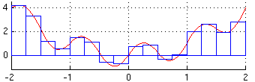

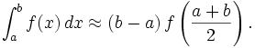
1. Write a program that, given a step size h, returns the sum of the areas of the rectangles as an approximation to the definite integral. (10 points)
2. We generally do not know what step size will be sufficient in order to approximate a definite integral within the precision available. Write an algorithm that iteratively determines a step size that approximates the integral with precision . (10 points)
3. An alternate method for approximating a definite integral uses trapezoids instead of rectangles:

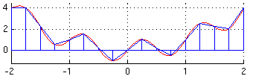

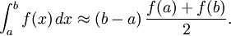

Modify your program from d. to use trapezoids instead of rectangles. (10 points)

Acknowledgment

The assignment is adapted from initial exercise designed by Prof. Christian Omlin

