**Name: Rohitashav Aggarwal**

**CPRG 200 RAD development**

**Lab 3 Assignment**

**Exception Handling cases and Data errors**

1)SQLException: (Delete record + save button)

This exception happens when you try to delete the data that is linked to another table. In order to handle it, we need sqlexception to catch any foreign key relationships. Please see attached:

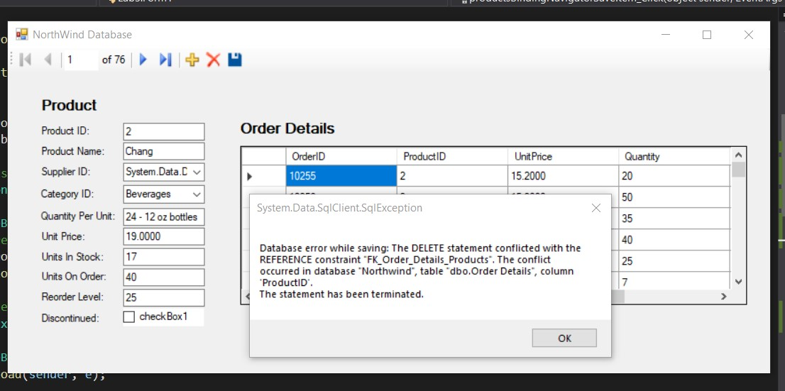

2) No Null Allowed Exception: (In this case add new data without Product name and discontinued field)

This exception is handled using nonullexception which monitors if any non-null constraint field is left empty. Please see attached two pictures:

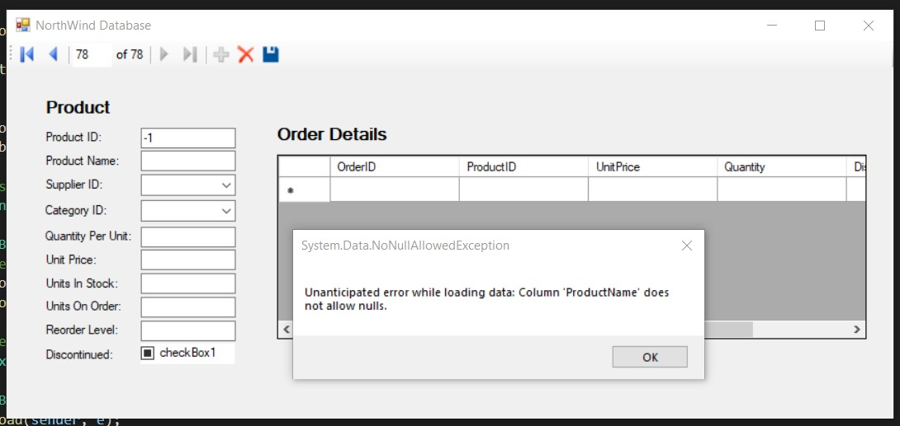

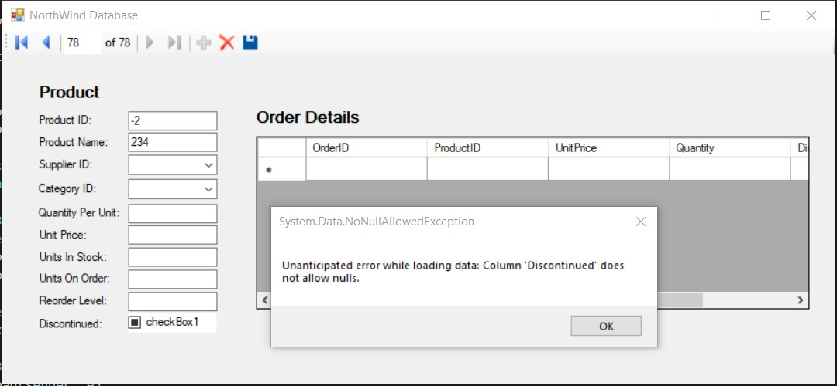

3) Concurrency Error: (insert data into products, then try changing the data from windows form)

This exception is handled using Concurrencyexception. It happens when a user tries to insert data into the table and another user tries to manipulate the data at the same time. In order to solve this issue, user should refresh the database before changing or adding new data. Please see attached:

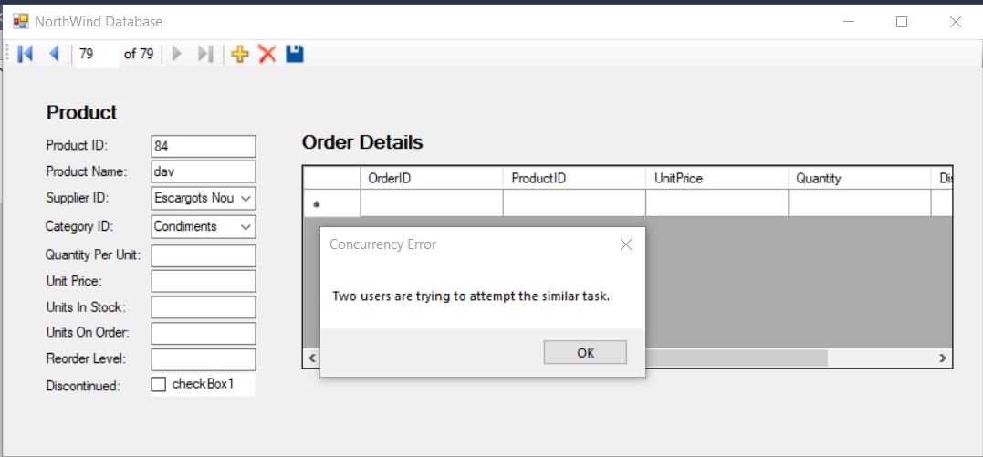

4) Windows form add new button error:

Double click the ADD new button without typing any data in the fields

This also gives a noNullException and was handled by disabling the add button once clicked and then enabling it once save button is clicked. After clicking the save button, the form reloads. Please see attached add new button is disabled.

