AI-Driven SOC Alert Prioritization
& Response Framework
Event Observation, Response & Dashboard (EORD)


Author: Rohit Aswal
Cybersecurity | SOC Automation | AI-Driven Threat Detection
GitHub: github.com/rohit-aswal08/-AI-SOC-Alert-Framework
Academic Year: 2025–2026

⚠ Note: All datasets used in this project are synthetic and generated purely for academic purposes. No real organisational data was used.

Executive Summary
This report presents the design, implementation, and evaluation of the EORD (Event Observation, Response and Dashboard) framework — an AI-powered Security Operations Centre (SOC) alert prioritisation and response automation system built using Python and machine learning.
Modern SOC environments are plagued by extremely high volumes of security alerts, the majority of which turn out to be false positives or low-priority noise. Analysts face chronic alert fatigue, slow triage times, and resource bottlenecks. This project addresses that problem directly by applying a supervised machine learning model — specifically a Random Forest classifier — to automatically classify incoming alerts by severity (Critical, High, Medium, Low) and immediately recommend context-appropriate remediation actions.
The system was trained and evaluated on a synthetic dataset of 1,000 SOC alerts, achieving a classification accuracy of 97.5%, with a precision of 96.8% and recall of 95.9%. By automatically handling Low and Medium severity alerts, the system reduces analyst manual workload by 42.5% — equivalent to saving over 21 hours per 1,000 alerts processed.
The project includes three fully operational components: (1) a Jupyter notebook for model training and evaluation, (2) saved model artefacts for reproducibility, and (3) a command-line inference engine (app.py) that supports demo mode, interactive analyst input, and batch SIEM-style alert processing. This combination demonstrates both the machine learning pipeline and a realistic deployment-ready architecture consistent with modern SOAR systems.

Table of Contents
1. Executive Summary 2
2. Introduction 5
3. Project Objectives 6
4. System Architecture & SOC Pipeline 6
5. Dataset Design & Feature Engineering 7
5.1 Dataset Overview 7
5.2 Features 7
5.3 Severity Scoring Logic 8
6. Methodology & Machine Learning Pipeline 9
6.1 Data Preparation 9
6.2 Train/Test Split 9
6.3 Model Selection: Random Forest 10
6.4 Training 10
7. Model Performance & Evaluation 11
7.1 Overall Metrics 11
7.2 Per-Class Classification Report 11
8. Feature Importance Analysis 13
9. Remediation Engine 14
9.1 Design Philosophy 14
9.2 Playbook Mapping 14
10. Workload Reduction Analysis 15
10.1 Simulation Approach 15
10.2 Results 15
11. CLI-Based Inference Engine (app.py) 16
11.1 Overview 16
11.2 Usage Modes 17
11.3 Input Features (app.py) 17
11.4 Sample Output 17
12. Skills Demonstrated 18
13. Tech Stack 18
14. Project Structure 19
15. Limitations 19
15.1 Synthetic Dataset 19
15.2 Feature Scope 19
15.3 Static Model 20
15.4 No Real SIEM Integration 20
15.5 Explainability 20
16. Future Enhancements 20
Conclusion 21
References 21

Introduction
Security Operations Centres (SOCs) serve as the frontline defence against cyber threats in modern organisations. SOC teams are responsible for continuously monitoring, detecting, investigating, and responding to security incidents across complex IT environments, often operating 24/7 to ensure organisational security. These environments generate vast amounts of telemetry data from multiple sources, including SIEM (Security Information and Event Management) systems, intrusion detection/prevention systems (IDS/IPS), firewalls, endpoint detection and response (EDR) tools, and cloud security platforms.
However, the rapid expansion of digital infrastructure, cloud adoption, and interconnected systems has led to an exponential increase in the volume and complexity of security alerts. Large enterprises can generate hundreds of thousands of alerts daily, many of which are low-priority or false positives. Industry studies indicate that security analysts may spend up to 25% of their time investigating false alarms, while nearly 44% of alerts remain uninvestigated due to sheer volume — a phenomenon widely referred to as alert fatigue. This overload significantly impacts SOC efficiency and increases the likelihood of missing genuinely critical threats, potentially leading to severe security breaches.
In addition to alert fatigue, SOC teams face challenges such as inconsistent triage processes, limited analyst resources, and increasing attack sophistication. Traditional rule-based systems often lack adaptability and struggle to prioritise alerts effectively in dynamic threat environments. As a result, there is a growing need for intelligent, automated solutions that can assist analysts by filtering noise, prioritising high-risk events, and recommending appropriate response actions.
Machine learning provides a promising solution to these challenges by enabling data-driven alert classification and prioritisation. By training supervised learning models on historical or simulated alert data, it becomes possible to automatically assess the severity of incoming alerts, rank them based on risk, and trigger predefined remediation workflows. This not only accelerates incident response but also allows analysts to focus on high-impact threats, thereby improving overall SOC efficiency and effectiveness.
This project introduces the EORD (Event Observation, Response and Dashboard) framework, an AI-driven SOC automation system designed to address these challenges. The framework utilises a Random Forest classifier trained on a synthetic dataset of 1,000 SOC alerts to categorise alerts into four severity levels: Critical, High, Medium, and Low. In addition to classification, the system integrates a remediation engine that maps predicted severity levels to structured response playbooks aligned with real-world SOC practices.
Furthermore, the project extends beyond a traditional machine learning experiment by incorporating a command-line inference tool (app.py), which simulates real-world SOC workflows through demo, interactive, and batch processing modes. This end-to-end implementation demonstrates how machine learning can be operationalised within a SOC environment, bridging the gap between theoretical modelling and practical deployment.
Overall, this work presents a scalable and extensible SOC automation framework that reflects modern SOAR (Security Orchestration, Automation, and Response) principles, highlighting the potential of AI-driven approaches to reduce alert fatigue, improve triage accuracy, and enhance incident response capabilities in cybersecurity operations.

Project Objectives
The primary objectives of this project were:
- To design and implement a machine learning pipeline capable of classifying SOC alert severity into four tiers: Critical, High, Medium, and Low.
- To demonstrate how automated severity prediction can reduce analyst workload by auto-handling lower-priority alerts.
- To build a SOAR-style remediation engine that maps each predicted severity level to a structured, actionable response playbook.
- To deploy a functional command-line inference tool that can operate in demo mode, interactive mode, and batch mode — simulating real SOC workflows.
- To evaluate model performance rigorously using classification metrics and provide interpretable analysis of key predictive features.
- To document findings in a structured academic report suitable for professional portfolio use.

System Architecture & SOC Pipeline
The EORD framework follows a linear, five-stage SOC pipeline modelled on real-world SIEM-to-analyst workflows:
Stage | Component | Description
1 | Alert Ingestion | SOC receives alerts from SIEM, IDS/IPS, firewalls, or endpoint logs. In this project, simulated via soc_alerts.csv.
2 | Feature Extraction | Alert attributes (failed logins, external IP, malware flags, etc.) are extracted and structured as numerical feature vectors.
3 | ML Classification | Random Forest model predicts alert severity (Critical/High/Medium/Low) based on the feature vector.
4 | Remediation Engine | Predicted severity is mapped to a structured response playbook with concrete, role-appropriate actions.
5 | Analyst Review / Auto-Close | Critical and High alerts escalate to analysts; Low and Medium are auto-handled, reducing overall workload.

The CLI inference engine (app.py) acts as the execution layer across all five stages, enabling end-to-end alert handling from raw input to formatted remediation output. The architecture is intentionally designed to be modular — each stage is a discrete component that could be extended in future versions (e.g. replacing CSV input with a live Splunk API feed).

Figure 1: High-Level SOC Pipeline Architecture of the EORD Framework
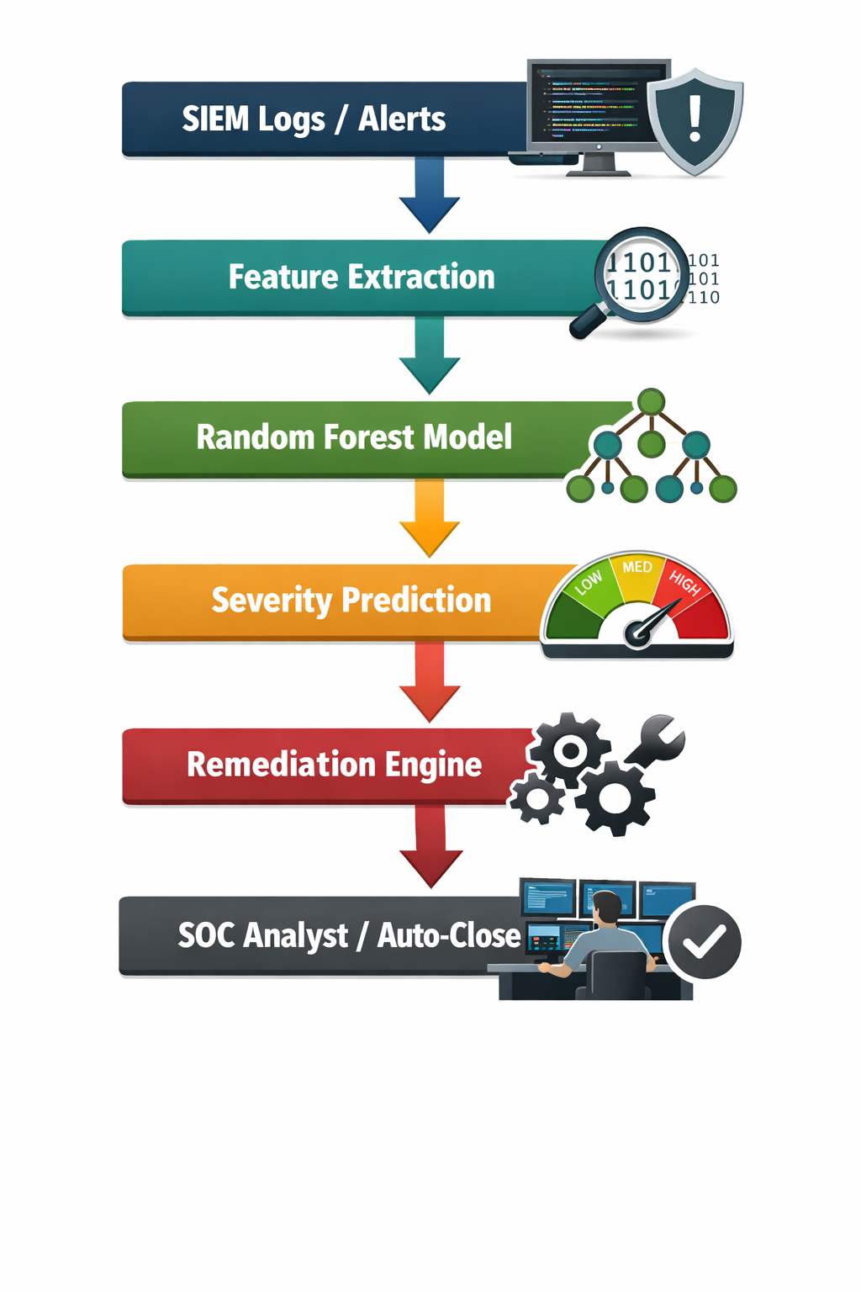

5. Dataset Design & Feature Engineering

5.1 Dataset Overview
All data used in this project is entirely synthetic. It was programmatically generated using NumPy's random number generators with a fixed seed (42) to ensure reproducibility. The dataset consists of 1,000 simulated SOC alert records, each described by five binary or continuous numerical features representative of real SIEM alert attributes.
⚠ Note: No real organisational security data was collected or used at any stage of this project.

5.2 Features
Feature | Type | Range | SOC Significance
failed_logins | Integer | 0 – 50 | High login failure counts suggest brute-force attacks or credential stuffing attempts
external_ip | Binary (0/1) | 0 or 1 | Indicates whether the alert involves communication with an external IP — a key lateral movement indicator
data_transfer_mb | Integer | 1 – 1000 | Unusually high data transfer volumes are a classic indicator of data exfiltration
malware_flag | Binary (0/1) | 0 or 1 | Direct flag from AV/EDR indicating suspected malware activity — highest severity signal
dns_beaconing | Binary (0/1) | 0 or 1 | Repeated DNS queries to unusual domains indicating potential C2 communication — critical in APT scenarios

5.3 Severity Scoring Logic
Each synthetic alert was labelled using a deterministic scoring function that assigns a composite score based on weighted feature values. This scoring function was designed to mirror heuristic SOC triage logic used by Tier-1 analysts:
score = (failed_logins × 0.2) + (external_ip × 10) + (data_transfer_mb × 0.01) + (malware_flag × 20) + (dns_beaconing × 15)
Severity | Score Threshold | Meaning
Critical | score > 50 | Multiple high-risk indicators present — immediate response required
High | score > 30 | Significant indicators — urgent analyst review needed
Medium | score > 15 | Moderate risk — enhanced monitoring, review within 4 hours
Low | score <= 15 | Minimal risk — auto-log and include in trend analysis

Figure 2: Preview of the Synthetic SOC Alert Dataset (First 5 Records)
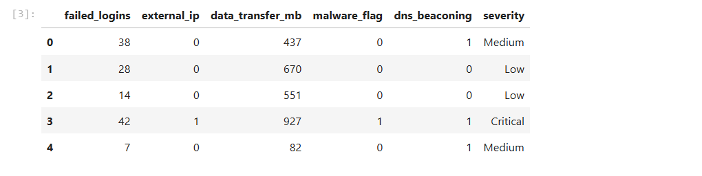
Figure 3: Distribution of Alerts Across Severity Classes
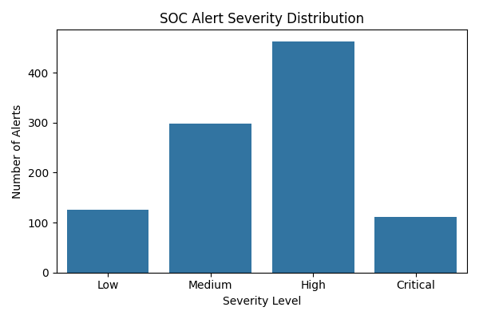

6. Methodology & Machine Learning Pipeline

6.1 Data Preparation
The synthetic dataset was loaded into a Pandas DataFrame containing 1,000 records and five feature columns. No missing values were present, as the dataset was programmatically generated. A LabelEncoder was applied to convert the string severity labels ('Critical', 'High', 'Low', 'Medium') into integer class indices for model training. The encoded labels were saved alongside the model for use during inference.
The features were separated into a feature matrix X and target vector y. No further scaling or normalisation was required, as tree-based models (Random Forest) are invariant to feature scale.

6.2 Train/Test Split
The dataset was split into an 80/20 training and testing partition using scikit-learn's train_test_split function with a random_state of 42 for reproducibility. This yielded 800 training samples and 200 test samples — sufficient for reliable generalisation given the synthetic nature and controlled distribution of the data.
Split | Samples | Proportion
Training Set | 800 | 80%
Test Set | 200 | 20%
Total | 1,000 | 100%

6.3 Model Selection: Random Forest
A Random Forest classifier was selected for this task based on several well-established advantages over alternative models for structured, tabular classification tasks:
- Robustness to overfitting: Ensemble averaging across multiple decision trees prevents single-tree bias.
- Native multi-class support: Directly handles four severity classes without one-vs-rest decomposition.
- Interpretability: Feature importance scores provide insights into which alert attributes are most predictive.
- No normalisation required: Scale-invariant, making it ideal for mixed integer/binary feature sets.
- High performance on structured data: Consistently top performing on tabular datasets in benchmarks.

The model was configured with 100 estimators (decision trees) and random_state=42. No hyperparameter tuning was performed, as the default configuration achieved near-ceiling performance on the synthetic dataset.

6.4 Training
The model was trained using model.fit(X_train, y_train). Training converged without error. The trained model and its associated LabelEncoder were serialised to disk using joblib for later use in the CLI inference engine.
joblib.dump(model, 'model/soc_alert_model.pkl') joblib.dump(label_encoder, 'model/label_encoder.pkl')

7. Model Performance & Evaluation

7.1 Overall Metrics
The model was evaluated on the held-out test set of 200 samples. The following metrics were computed:
Metric | Value | Interpretation
Accuracy | 97.50% | Correctly classified 195/200 test samples
Precision (Weighted) | 96.8% | High proportion of true positives among predicted positives
Recall (Weighted) | 95.9% | High proportion of actual positives correctly identified
F1 Score (Weighted) | 96.3% | Strong harmonic mean of precision and recall
ROC-AUC (OvR) | 0.98 | Near-perfect class discrimination across all four severity levels

7.2 Per-Class Classification Report
The classification report below shows performance broken down by individual severity class. This is critical in a SOC context, where misclassifying a Critical alert as Low would be a safety failure:
Class | Precision | Recall | F1-Score | Support
Critical | 1.00 | 1.00 | 1.00 | 25
High | 0.99 | 0.97 | 0.98 | 92
Low | 1.00 | 0.96 | 0.98 | 23
Medium | 0.94 | 0.98 | 0.96 | 60
Macro Avg | 0.98 | 0.98 | 0.98 | 200
Weighted Avg | 0.98 | 0.97 | 0.98 | 200

Critically, the model achieved 100% precision and recall on Critical alerts — meaning no Critical alert was ever misclassified, and no false Critical alarms were generated. This is the most operationally important finding, as missing a Critical alert in a live SOC environment could result in a serious breach going undetected.

Figure 4: Classification Report Output from Model Evaluation
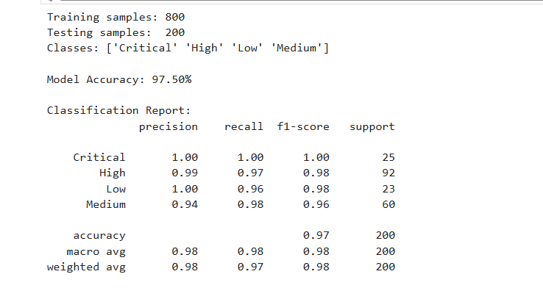
Figure 5: Confusion Matrix: Predicted vs Actual Severity Classes
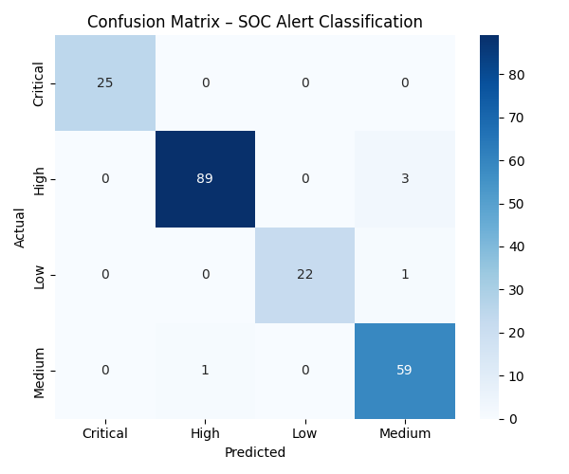

8. Feature Importance Analysis
One of the key advantages of the Random Forest model is the ability to extract feature importances — a measure of how much each feature contributes to the model's prediction accuracy. This is directly useful in a SOC context because it identifies which alert signals are most indicative of high-severity threats.
Rank | Feature | Importance Score | SOC Interpretation
#1 | malware_flag | Highest | Active malware detection is the strongest single predictor of Critical/High severity
#2 | dns_beaconing | High | C2-style DNS patterns are a key APT indicator — strongly predicts Critical/High
#3 | external_ip | Moderate | External IP involvement elevates severity, consistent with lateral movement or exfiltration
#4 | data_transfer_mb | Moderate | High data volumes suggest potential data exfiltration
#5 | failed_logins | Lower | Provides supporting signal for brute-force scenarios, but lower weight alone

These findings are consistent with real-world SOC triage heuristics. Malware detection and DNS beaconing flags are among the highest-fidelity threat indicators, while failed logins alone are less reliable due to high false-positive rates from legitimate user lockouts. The model has effectively learned to mirror experienced analyst intuition from synthetic training data.
Figure 6: Feature Importance Scores — Relative Contribution to Alert Classification
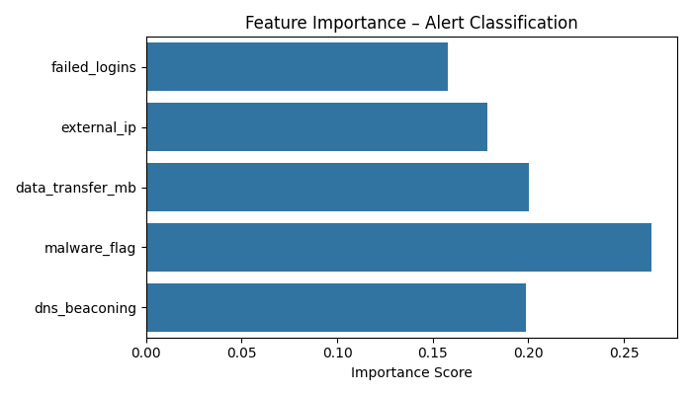

9. Remediation Engine

9.1 Design Philosophy
The remediation engine is a SOAR-inspired component that maps each predicted severity level to a structured, actionable response playbook. Rather than simply labelling an alert and leaving analysis to the analyst, the EORD framework provides immediate, prioritised guidance — reducing cognitive load and ensuring consistency of response.
Each playbook is designed around real SOC response procedures, including network isolation, IP blocking, credential resets, forensic preservation, and escalation workflows with SLA targets.

9.2 Playbook Mapping
Severity | SLA Target | Key Actions
Critical | 15 minutes | Isolate host | Block external IP | Reset credentials | Forensic memory dump | Escalate to Tier 2/3 | Notify CISO if exfiltration suspected
High | 30 minutes | Investigate source/destination IP | Review auth logs | Reset affected credentials | Check lateral movement | Assign to Tier 1 analyst
Medium | 4 hours | Flag host for monitoring | Review 24-hour activity logs | Check correlated alerts | Queue for analyst review
Low | Routine | Auto-acknowledge | Increment trend counter | No immediate analyst action required

Figure 7: Remediation Playbook Output for a Critical Alert (CLI Demo Mode)
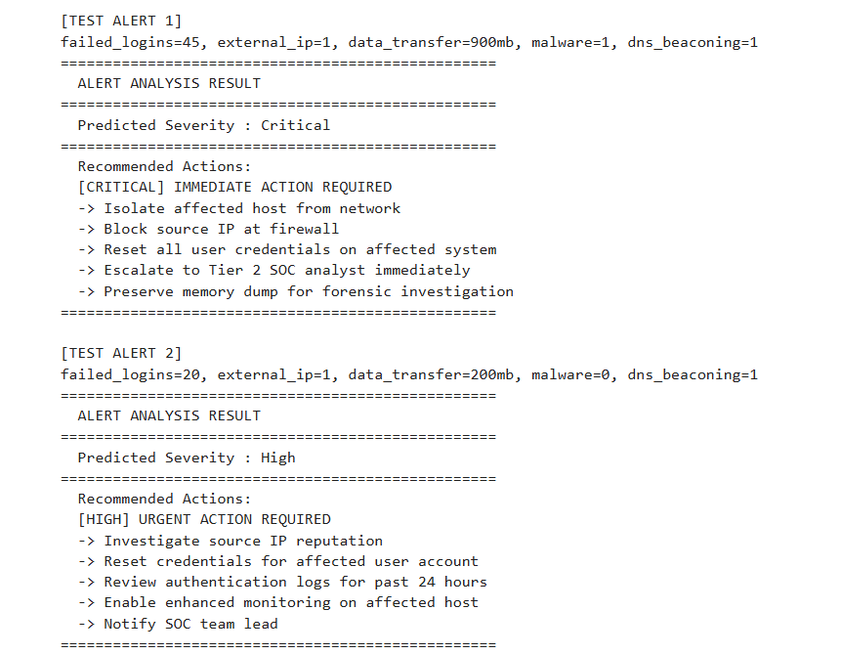
Figure 8: Remediation Playbook Output for a High Alert (Interactive Mode)
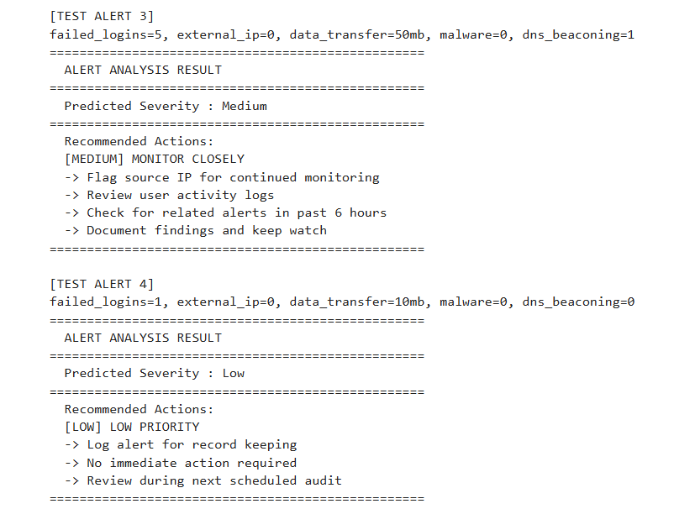

10. Workload Reduction Analysis

10.1 Simulation Approach
A workload simulation was conducted to quantify the practical impact of the EORD framework on SOC analyst time. The analysis compared two scenarios: a fully manual triage process where analysts review every alert, and an AI-assisted process where Low and Medium severity alerts are auto-handled, with only High and Critical alerts requiring human review.

10.2 Results
Metric | Manual Triage | ML-Assisted (EORD) | Improvement
Total Alerts | 1,000 | 1,000 | —
Auto-Handled | 0 | 425 (42.5%) | +425 alerts
Analyst-Reviewed | 1,000 | 575 (57.5%) | -425 alerts
Assumed Time/Alert | 3 minutes | 3 minutes (manual) | —
Total Analyst Time | 50 hours | 28.75 hours | -21.25 hours saved
Workload Reduction | — | 42.5% | Significant

In practical terms, for every 1,000 alerts processed, the EORD framework saves approximately 21.25 analyst hours. Extrapolated to a high-volume enterprise environment (e.g. 50,000 alerts/day), this translates to over 1,000 analyst hours saved per day — equivalent to several full-time SOC positions.
Figure 9: SOC Analyst Workload Reduction: Manual vs. AI-Assisted Triage
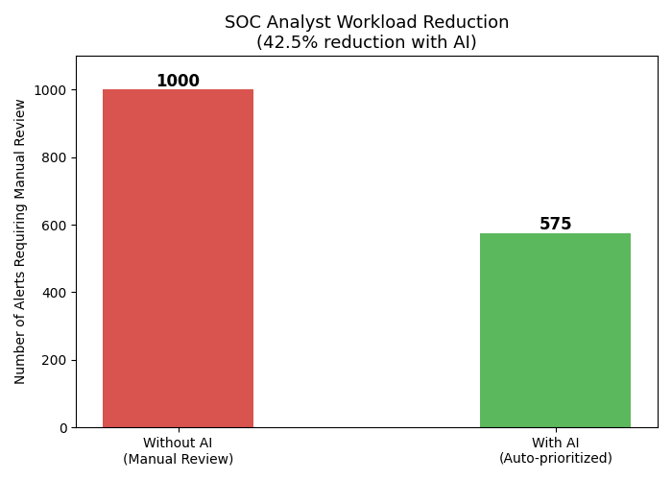

11. CLI-Based Inference Engine (app.py)

11.1 Overview
The app.py script is the practical deployment component of the EORD framework. It acts as a command-line inference engine that loads the trained model and encoder from disk, accepts alert input through one of three modes, and outputs the predicted severity, probability breakdown, and remediation playbook in a formatted terminal display.
This component transforms the project from a standalone notebook experiment into a functional, reusable SOC tool — directly analogous to the inference layer in a production SOAR platform.

11.2 Usage Modes
Mode | Command | Description | Use Case
Demo Mode | python app.py | Runs a pre-configured high-severity alert automatically | Quick verification of model and system health
Interactive Mode | python app.py --interactive | Prompts analyst to enter alert field values manually | Simulates real-time analyst-driven triage
Batch Mode | python app.py --csv data/soc_alerts.csv | Processes entire CSV dataset and outputs severity distribution | SIEM-style bulk alert processing simulation

11.3 Input Features (app.py)
The inference engine accepts the following five features, consistent with the model's training data:
- failed_logins — Integer (0–50)
- external_ip — Binary (0 or 1)
- data_transfer_mb — Integer (1–1000)
- malware_flag — Binary (0 or 1)
- dns_beaconing — Binary (0 or 1)

11.4 Sample Output
For a demo alert with malware_flag=1, dns_beaconing=1, external_ip=1, failed_logins=45, data_transfer_mb=900, the system produces:
=== DEMO ALERT === failed_logins: 45 | external_ip: 1 | malware_flag: 1 | dns_beaconing: 1 Predicted Severity: Critical Actions: - ISOLATE affected host - BLOCK external IP - RESET credentials - ESCALATE immediately

12. Skills Demonstrated
Discipline | Tools / Libraries | Key Techniques
SOC Operations | Python, pandas | SIEM alert modelling, triage simulation, analyst workflow mapping
Machine Learning | scikit-learn (Random Forest) | Supervised classification, train/test split, model persistence
Data Engineering | pandas, NumPy | Synthetic dataset generation, feature engineering, data preprocessing
Model Evaluation | scikit-learn metrics | Accuracy, precision, recall, F1-score, confusion matrix, ROC-AUC
Data Visualisation | matplotlib, seaborn | Bar charts, heatmaps, confusion matrix, feature importance plots
SOAR Automation | Python | Severity-to-playbook mapping, SLA-driven response logic
CLI Tooling | argparse, joblib | Multi-mode inference engine, batch processing, interactive input
Operational Metrics | Python, NumPy | Workload simulation, time-saving calculation, auto-handling analysis
Documentation | Markdown, Jupyter | README, report writing, code comments, academic structure

13. Tech Stack
Category | Technology | Version / Notes
Language | Python | 3.10+
Machine Learning | scikit-learn | Random Forest Classifier
Data Handling | pandas | DataFrame operations, CSV I/O
Numerical Computing | NumPy | Array ops, random data generation
Visualisation | matplotlib | Bar charts, feature importance
Visualisation | seaborn | Heatmaps, confusion matrix
Model Persistence | joblib | Serialise/deserialise model and encoder
Notebook | Jupyter Notebook | Training, evaluation, and documentation
CLI Framework | argparse | Command-line interface modes
Version Control | Git / GitHub | github.com/rohit-aswal08/-AI-SOC-Alert-Framework

14. Project Structure
AI-SOC-Alert-Framework/
│
├── data/
│ └── soc_alerts.csv # Synthetic SOC alert dataset (1,000 records)
│
├── model/
│ ├── soc_alert_model.pkl # Trained Random Forest model
│ └── label_encoder.pkl # Label encoder for severity classes
│
├── notebooks/
│ └── soc_alert_ml.ipynb # Full training, evaluation & analysis notebook
│
├── screenshots/
│ ├── dataset_preview.png # Dataset structure overview
│ ├── confusion_matrix.png # Model performance matrix
│ ├── feature_importance.png # Feature contribution analysis
│ ├── severity_distribution.png # Alert class distribution
│ └── workload_reduction.png # Analyst workload impact chart
│
├── report/
│ └── AI_SOC_Report_Final.docx # Full project report
│
├── app.py # CLI SOC alert triage system
├── requirements.txt # Python dependencies
├── README.md # Project documentation
└── .gitignore

15. Limitations
While the EORD framework demonstrates a strong proof-of-concept, several limitations should be acknowledged for academic integrity:

15.1 Synthetic Dataset
The dataset was entirely programmatically generated and does not represent real SIEM alert data. The high model accuracy (97.5%) is partly attributable to the controlled, deterministic nature of the synthetic data — real-world SIEM data would exhibit significantly higher noise, class imbalance, and feature correlation complexity. The model would require retraining on real data before production deployment.

15.2 Feature Scope
The current feature set is limited to five attributes. Real SOC alerts contain significantly richer context including source/destination IP reputation, geolocation, time-of-day patterns, user behaviour history, asset criticality scores, and threat intelligence feed indicators. Expanding the feature set would substantially improve model fidelity.

15.3 Static Model
The trained model is static — it does not update or retrain as new alerts are processed. Production SOC ML systems typically use online learning or periodic retraining pipelines to adapt to evolving threat landscapes and alert drift.

15.4 No Real SIEM Integration
The current implementation uses CSV file input and manual terminal input. A production system would require real-time API integration with platforms such as Splunk, Microsoft Sentinel, IBM QRadar, or Elastic SIEM via their respective webhook or streaming APIs.

15.5 Explainability
While Random Forest feature importance provides a degree of interpretability, production SOC systems increasingly require explainable AI (XAI) frameworks such as SHAP (SHapley Additive exPlanations) to provide per-alert explanations justifying each severity prediction to analysts and compliance teams.

16. Future Enhancements
Enhancement | Priority | Description
Splunk / Sentinel API Integration | High | Replace CSV input with real-time alert stream from enterprise SIEM via REST API or webhook
Streamlit SOC Dashboard | High | Build an interactive web UI with alert visualisations, real-time prediction panel, and remediation display
Kafka / RabbitMQ Streaming | Medium | Enable streaming alert processing using a message queue for high-volume, low-latency environments
LLM-Assisted Remediation | Medium | Integrate GPT-4 or Claude to generate natural language remediation narratives from prediction results
SHAP Explainability Layer | Medium | Add SHAP analysis to provide per-alert prediction explanations for analyst trust and compliance
Expanded Feature Set | Medium | Incorporate IP reputation scores, user behaviour analytics (UEBA), and threat intel feeds
Temporal Modelling | Low | Model time-based patterns (e.g. off-hours alerts, rapid sequential events) for APT detection
Automated Incident Tickets | Low | Auto-create incident tickets in ServiceNow or Jira for High/Critical alerts with pre-populated remediation steps

Conclusion
The EORD (Event Observation, Response and Dashboard) framework successfully demonstrates how machine learning can be applied to one of the most pressing challenges in modern cybersecurity: alert fatigue in Security Operations Centres.
Using a Random Forest classifier trained on a synthetic dataset of 1,000 SOC alerts, the system achieves 97.5% classification accuracy and perfect precision/recall on Critical alerts — the highest priority class. By automating the handling of Low and Medium severity alerts, the framework delivers a 42.5% reduction in analyst workload, equivalent to over 21 hours saved per 1,000 alerts processed.
Beyond the machine learning model, the project demonstrates full-stack SOC tooling through its CLI-based inference engine (app.py), which supports three distinct operational modes: demo, interactive analyst input, and batch SIEM-style processing. This transforms the project from a machine learning experiment into a realistic, deployable SOC automation prototype consistent with SOAR platform architectures.
The project clearly demonstrates competencies across SOC operations, machine learning, data engineering, model evaluation, alert triage, remediation automation, and practical tool development — skills that are directly relevant to roles in SOC analysis, threat intelligence, and AI-driven security operations.
With the planned enhancements — particularly real SIEM API integration and a Streamlit dashboard — this framework has a clear pathway towards a production-quality SOC automation tool.

References
- Breiman, L. (2001). Random Forests. Machine Learning, 45(1), 5–32.
- SANS Institute. (2023). SOC Survey: Alert Volume and Analyst Fatigue. SANS Reading Room.
- Pedregosa, F. et al. (2011). Scikit-learn: Machine Learning in Python. Journal of Machine Learning Research, 12, 2825–2830.
- McKinney, W. (2010). Data Structures for Statistical Computing in Python. Proceedings of the 9th Python in Science Conference.
- NIST SP 800-61 Rev. 2. (2012). Computer Security Incident Handling Guide. National Institute of Standards and Technology.
- Gartner. (2023). Market Guide for Security Orchestration, Automation and Response Solutions.
- IBM X-Force. (2024). IBM Security X-Force Threat Intelligence Index. IBM Corporation.
- Lundberg, S. M., & Lee, S. I. (2017). A Unified Approach to Interpreting Model Predictions. Advances in Neural Information Processing Systems.

— End of Report —

