SOC INCIDENT INVESTIGATION REPORT

Splunk BOTS v1 — Web Application Compromise

Field | Value
Incident Type | Web Application Compromise / Full Kill-Chain Investigation
Severity | Critical
Affected Asset | Joomla web server (192.168.250.70)
Primary Threat Actor IP | 40.80.148.42
Secondary C2 IP | 23.22.63.114

Prepared by Rohit Aswal
Purpose of this report
This report documents an end-to-end Security Operations Center (SOC) investigation using the Splunk BOTS v1 dataset. It is written in an incident-reporting style to show how evidence was collected, correlated, and translated into operational findings. The analysis confirms that the compromised Joomla server was subjected to reconnaissance, brute-force authentication, web-shell deployment, command-and-control communication, and data exfiltration.

1. Incident Overview
Attribute | Details
Dataset | Splunk BOTS v1
Analyst | Rohit Aswal
Investigation Type | Confirmed compromise investigation
Events Reviewed | ~33 million events across multiple sourcetypes
Primary Focus | HTTP activity, suspicious authentication, post-exploitation, C2, exfiltration
Business Interpretation | An internet-facing Joomla server was compromised and used for attacker-controlled follow-on activity
At a high level, the incident began with concentrated web reconnaissance from an external IP, followed by successful access to the Joomla administrator interface. After login, the attacker uploaded a PHP web shell and used a second external IP to maintain interactive control. Outbound traffic volumes then confirmed that the intrusion progressed beyond access and persistence into impact, specifically data exfiltration.

2. Executive Summary
The investigation identified a complete web-application compromise affecting the Joomla host 192.168.250.70. The primary malicious source, 40.80.148.42, generated 17,547 HTTP requests and showed behavior consistent with automated reconnaissance and exploitation attempts. The attacker targeted Joomla application paths, probed for administrative access, and attempted access to sensitive operating-system files via directory traversal style requests.
Authentication evidence showed repeated POST requests to /joomla/administrator/index.php, with successful HTTP 200 responses confirming that login attempts ultimately succeeded. Review of POST form data exposed the compromised credentials admin / batman. This moved the incident from suspicious scanning to confirmed unauthorized access.
Post-authentication activity showed the upload of a malicious PHP payload and the creation/use of /joomla/agent.php, indicating web-shell deployment. A second external IP, 23.22.63.114, repeatedly requested the agent.php resource at high frequency, consistent with automated command-and-control (C2) beaconing. Finally, network telemetry indicated approximately 19.8 MB of data transferred to the primary attacker IP, confirming successful exfiltration.

3. Scope and Data Sources
The objective of the investigation was not only to identify a suspicious IP, but to determine the full attack story: who initiated the activity, which techniques were used, whether access was obtained, how persistence was maintained, and whether the incident reached an impact stage. The analysis relied on correlating several sources of evidence in Splunk.
Source Type | Purpose in Investigation | Value
stream:http | Primary source for reconnaissance, login attempts, credential recovery, web-shell usage, and exfiltration | Highest-value source; directly exposed attacker HTTP behavior
suricata / DNS views | Validation of network visibility and source integrity | Demonstrated that IDS/network telemetry ingestion was functioning
Windows / host-related logs | Contextual host-level evidence where available | Useful for corroborating compromise in a broader SOC workflow

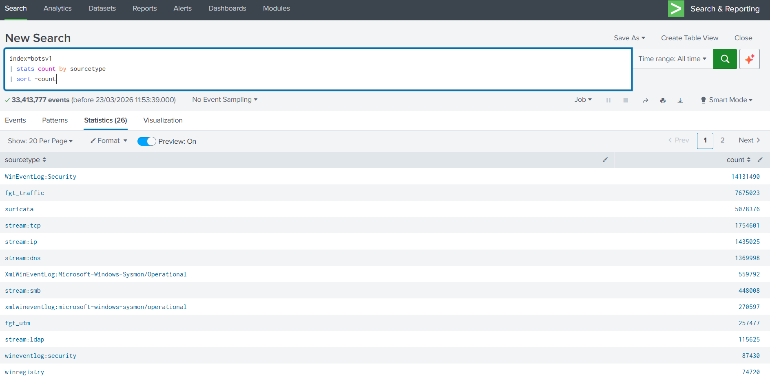
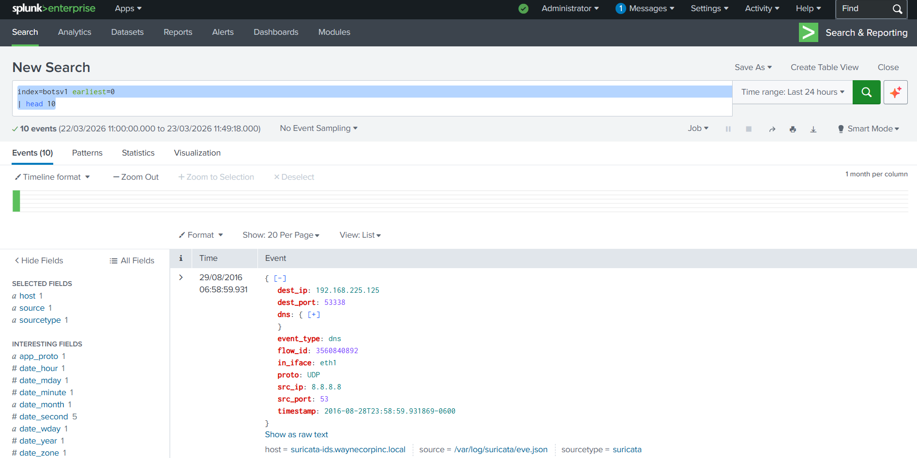

4. Investigation Methodology
- Validate data ingestion and identify the most useful sourcetypes for investigation.
- Establish a baseline of HTTP source IP activity to isolate the most anomalous external host.
- Pivot into URI paths to understand attacker intent and targeted application components.
- Examine authentication-related HTTP requests to determine whether access succeeded.
- Inspect POST form data and subsequent requests for payload delivery and web-shell behavior.
- Correlate post-exploitation activity with secondary infrastructure to identify C2.
- Quantify bytes_out / bytes_in to determine whether data left the environment.

5. Attack Narrative and Kill-Chain Diagram
The following simple process diagram can be retained as text or recreated as SmartArt/Shapes in Word. It gives a quick visual representation of how the incident unfolded.
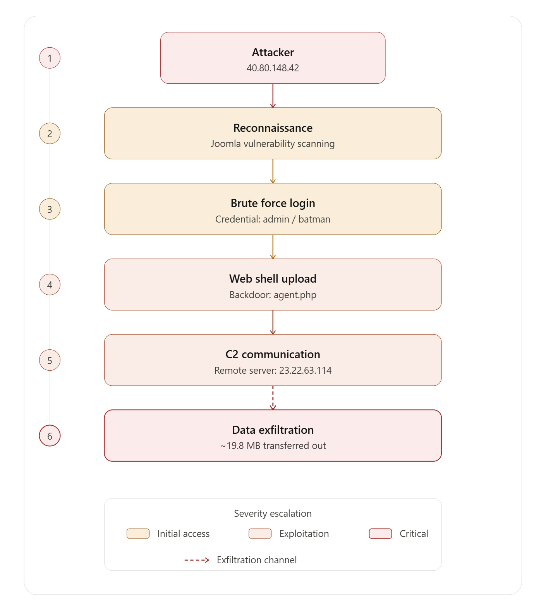
Narratively, this is important because it shows the incident did not stop at initial access. The evidence supports a progression through multiple attack stages: reconnaissance, valid-account use, malicious tool deployment, remote control, and impact.

6. Timeline of Events
Time | Observed Event | Interpretation
22:48:05 | POST form data contains username=admin and passwd=batman | Successful credential use / confirmed unauthorized access
22:50:31 | Large installer POST request associated with package upload | Likely malicious payload deployment through Joomla installer
22:51–23:21 | com_extplorer and related browsing requests | Post-compromise file-system enumeration
22:55 onward | Repeated requests to /joomla/agent.php from 23.22.63.114 | Automated C2 / beaconing behavior
Following control | ~19.8 MB transferred to 40.80.148.42 | Exfiltration and attacker impact confirmed

7. Detailed Findings

7.1 Initial anomaly identification — external source concentration
Review of stream:http activity showed that 40.80.148.42 generated 17,547 HTTP requests, far exceeding all other external addresses. In an enterprise SOC workflow, this is the sort of outlier that justifies a threat-hunting pivot because concentration of requests from one external host often reflects automated reconnaissance or exploitation rather than normal browsing behavior.
This observation did not, on its own, prove compromise, but it established a prioritized lead. The analyst could now focus on one source and assess intent by reviewing its requested URI paths and methods.
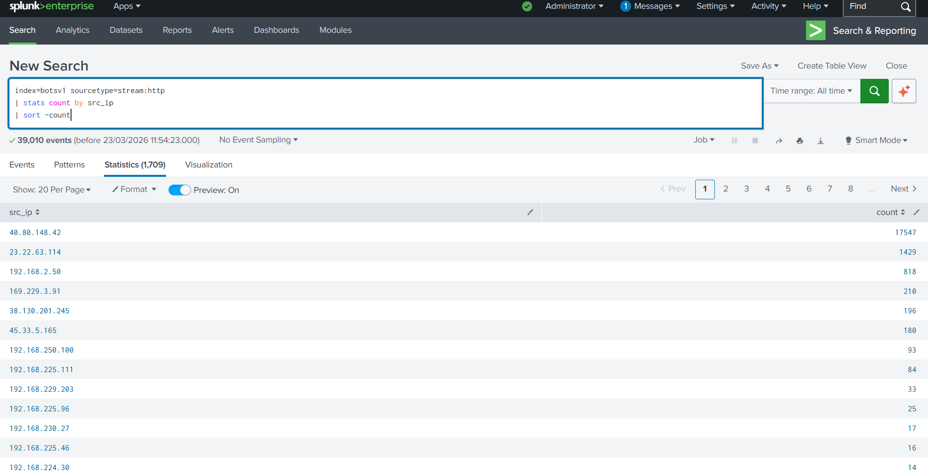

7.2 Reconnaissance and target profiling
When the suspicious source IP was pivoted into URI analysis, the most requested paths were Joomla-related. The attacker heavily targeted /joomla/index.php/component/search/ and also requested /joomla/administrator/index.php. Additional requests to /windows/win.ini and /boot.ini strongly suggested directory traversal or file-read testing. Taken together, these patterns indicate automated reconnaissance against a public-facing application with follow-on probing for privilege or system disclosure.
From a SOC perspective, the significance is that attacker intent became clear before access was confirmed. The activity was not generic browsing; it was structured enumeration against known-sensitive resources.
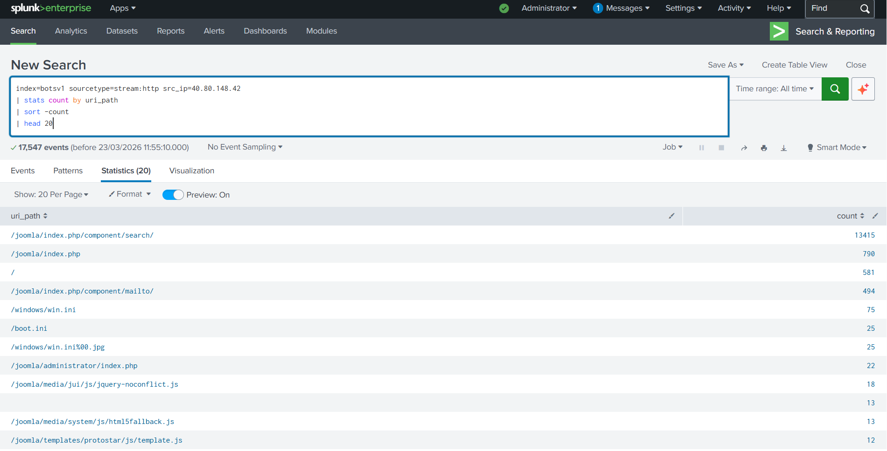

7.3 Authentication attack and successful access
Targeting of /joomla/administrator/index.php then shifted the investigation from reconnaissance into initial access. The request profile showed multiple POST submissions and successful HTTP 200 responses. In context, successful 200 responses on the administrator login path are a strong indicator that authentication worked, especially when preceded by repeated attack traffic from the same source.
This stage matters because it confirms the incident progressed from attempted compromise to actual unauthorized access. At this point, the server should be treated as compromised rather than merely scanned.
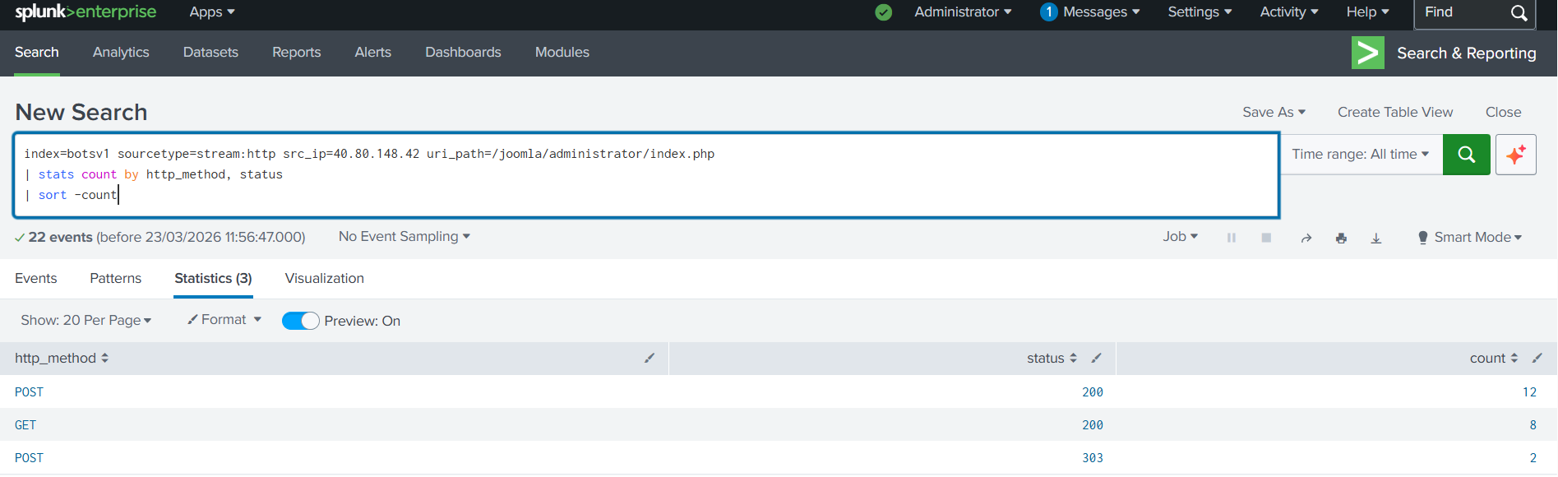

7.4 Credential exposure
Inspection of POST form data revealed explicit credentials: username=admin and passwd=batman. This is a crucial piece of evidence because it provides the exact mechanism of access and shows that the attacker used valid application credentials rather than bypassing authentication entirely.
For an incident report, this detail is operationally important: compromised credentials affect both containment and remediation. In a real environment, this would trigger forced password resets, credential review, and a wider search for reuse across systems.
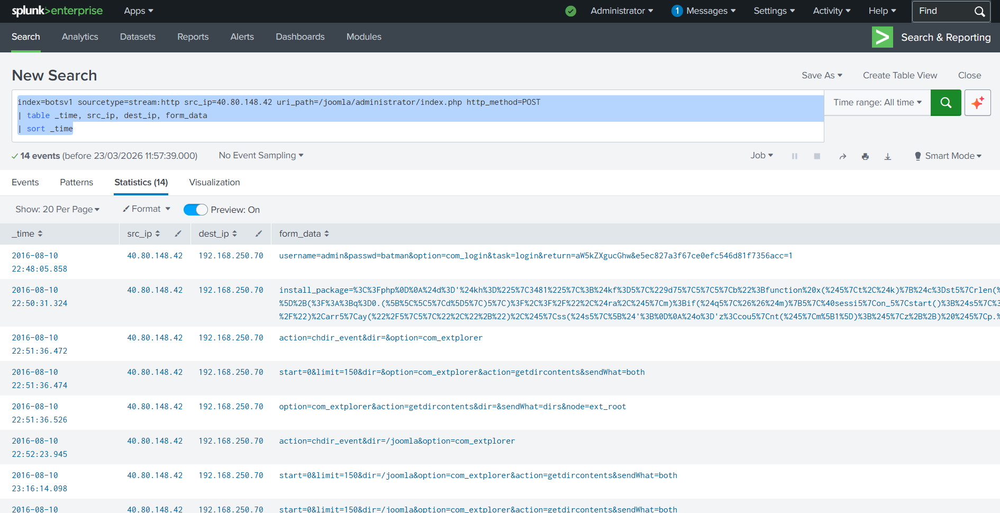

7.5 Web-shell deployment and post-exploitation activity
After login, the attacker submitted a large POST request associated with package installation. The content and subsequent behavior were consistent with malicious file upload and deployment of a PHP web shell. The observed presence/use of /joomla/agent.php, along with payload patterns including eval, base64_decode, and gzuncompress, supports the conclusion that attacker-controlled code was installed on the server.
Post-exploitation browsing activity, including com_extplorer requests, showed the attacker interacting with the environment beyond initial access. This behavior is typical of hands-on-keyboard or semi-automated exploration after compromise: mapping directories, validating file placement, and preparing for persistence or data theft.
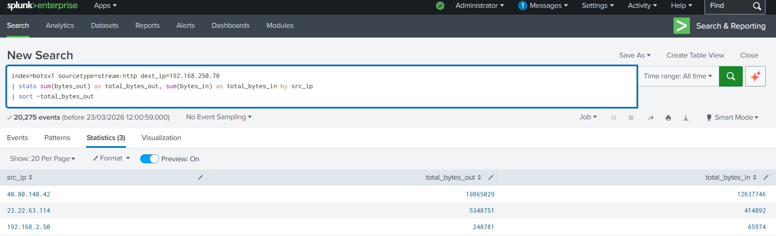

7.6 Command-and-control infrastructure
A second external IP, 23.22.63.114, repeatedly requested /joomla/agent.php approximately 194 times. The temporal spacing of these requests — on the order of roughly 100–400 milliseconds in several sequences — is far more consistent with automated beaconing than human browsing. This strongly suggests that the uploaded web shell was being used as an interactive command-and-control channel.
The use of separate infrastructure for C2 is also notable. It shows the primary reconnaissance/exploitation host and the control infrastructure may serve different roles in the attacker workflow. That distinction improves the quality of IOC reporting and helps defenders block the right indicators.
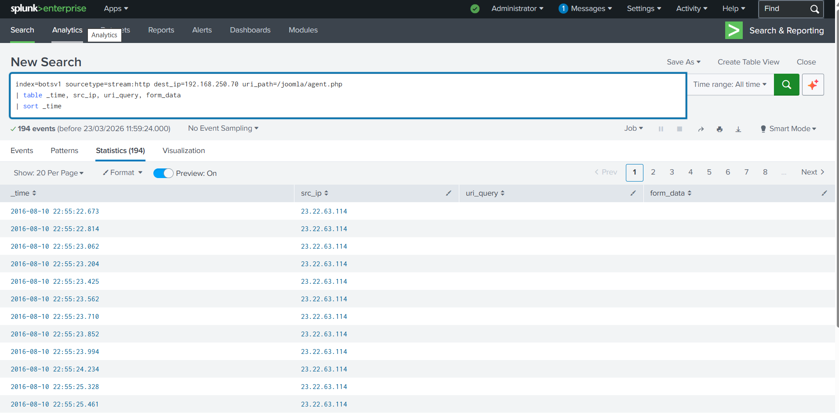

7.7 Data exfiltration and business impact
The final and most important validation step was analysis of bytes_out and bytes_in to external sources. This showed approximately 19.8 MB transferred to 40.80.148.42, with additional but smaller communication to 23.22.63.114. This changes the incident classification from attempted compromise or persistence-only activity to confirmed impact.
In a real SOC report, this is the difference between an intrusion with limited reach and a reportable data-loss event. Even without exact file content visibility, the volume of outbound transfer is sufficient to conclude that information left the environment under attacker control.
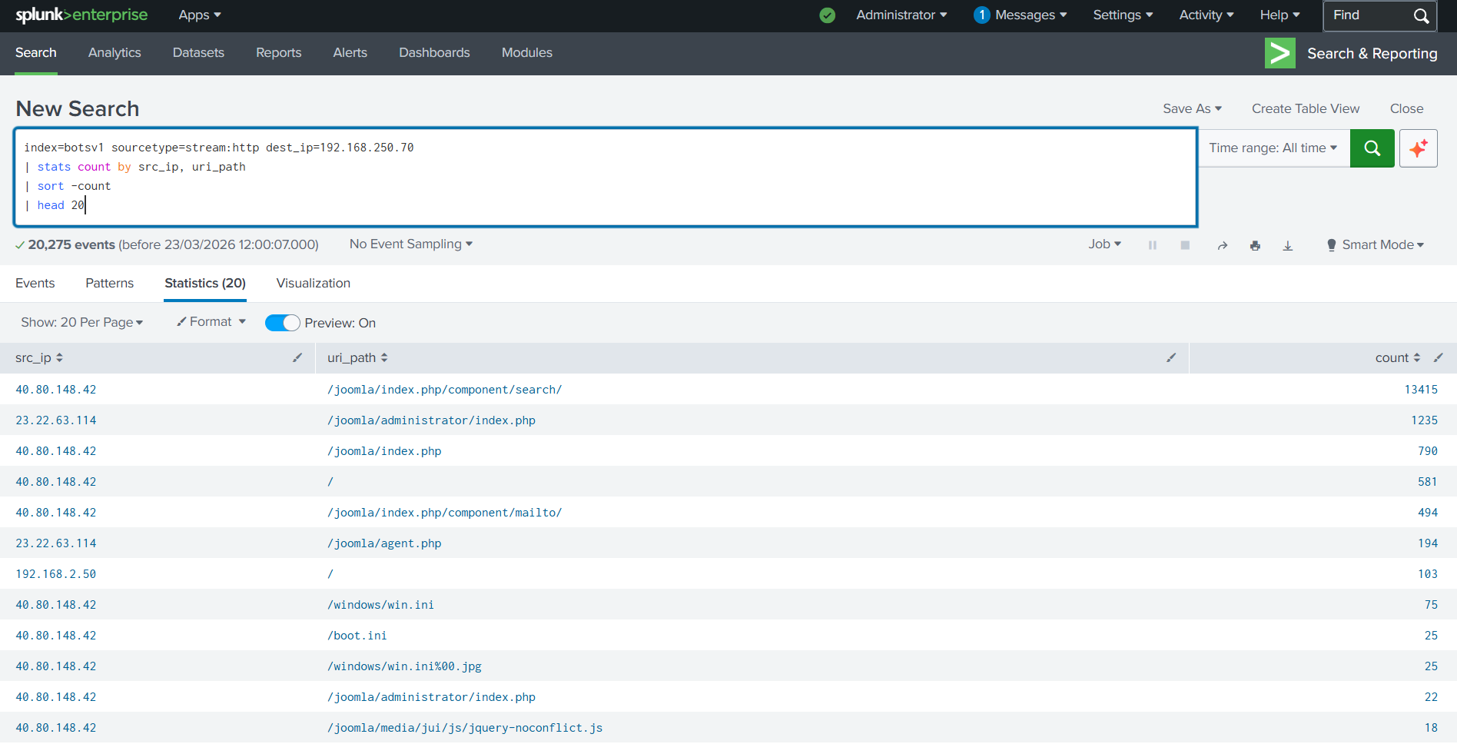

8. Evidence Summary Table
Stage | Primary Evidence | Key Value | Conclusion
Reconnaissance | URI path distribution | 13,415 requests to component/search from 40.80.148.42 | Automated application probing
Initial Access | Admin login POST activity | Successful HTTP 200 responses | Unauthorized access achieved
Credential Use | POST form data | admin / batman | Valid credentials compromised
Execution / Persistence | Payload upload + agent.php | Obfuscated PHP behavior | Web shell deployed
C2 | Repeated agent.php hits | 194 requests from 23.22.63.114 | Automated remote control
Impact | bytes_out analysis | ~19.8 MB to 40.80.148.42 | Data exfiltration confirmed

9. Indicators of Compromise (IOCs)
IOC Type | Value | Role | Response Action
IP Address | 40.80.148.42 | Primary attacker / recon / exfiltration destination | Block, investigate historical hits, search across perimeter logs
IP Address | 23.22.63.114 | Command-and-control infrastructure | Block, monitor for callbacks, hunt for related infrastructure
URI / File | /joomla/agent.php | Web shell / malicious control path | Remove file, image host, review web root integrity
Credential | admin / batman | Compromised admin credentials | Reset password, review reuse, enable MFA

10. MITRE ATT&CK Mapping
Technique ID | Technique | Why it applies
T1190 | Exploit Public-Facing Application | Attacker targeted internet-facing Joomla functionality with suspicious probing and abuse.
T1110 | Brute Force | Repeated login attempts culminated in successful authentication.
T1078 | Valid Accounts | Compromised credentials were used to gain legitimate-looking access.
T1505 | Server Software Component / Web Shell | Malicious PHP web shell was uploaded and used for post-compromise control.
T1071 | Application Layer Protocol | HTTP requests were used for ongoing C2 communication.
T1041 | Exfiltration Over C2 Channel | Outbound transfer to attacker infrastructure confirmed data theft.

11. Detection Logic and SPL Used
The investigation was driven by practical hunt-style SPL rather than a single signature. That is how many real SOC investigations begin: an analyst sees an anomaly, then pivots until the story is clear.
- Top external HTTP sources
index=botsv1 sourcetype=stream:http
| stats count by src_ip
| sort -count
- URI path distribution for attacker
index=botsv1 sourcetype=stream:http src_ip=40.80.148.42
| stats count by uri_path
| sort -count
| head 20
- Login activity on Joomla admin path
index=botsv1 sourcetype=stream:http src_ip=40.80.148.42 uri_path="/joomla/administrator/index.php"
| stats count by http_method, status
| sort -count
- Credential extraction
index=botsv1 sourcetype=stream:http src_ip=40.80.148.42 uri_path="/joomla/administrator/index.php" http_method=POST
| table _time, src_ip, dest_ip, form_data
| sort _time
- C2 summary
index=botsv1 sourcetype=stream:http dest_ip=192.168.250.70
| stats count by src_ip, uri_path
| sort -count
| head 20
- Exfiltration analysis
index=botsv1 sourcetype=stream:http dest_ip=192.168.250.70
| stats sum(bytes_out) as total_bytes_out, sum(bytes_in) as total_bytes_in by src_ip
| sort -total_bytes_out

12. Recommendations
Priority | Recommendation | Rationale
High | Implement account lockout after repeated failed login attempts | Would have reduced the brute-force window and increased attacker friction.
High | Reset and review all privileged Joomla credentials; enable MFA where possible | Addresses the immediate access vector and reduces reuse risk.
High | Remove malicious web shell artifacts and perform full host integrity review | agent.php indicates server-side code execution and possible wider tampering.
Medium | Deploy a web application firewall (WAF) and alert on sensitive path probing | Would improve visibility and reduce exploitability of public-facing applications.
Medium | Patch Joomla core and extensions, especially installer-related components | Reduces the chance of abuse after successful login or plugin misuse.
Medium | Alert on large outbound transfers from web servers to unknown external IPs | Would have accelerated detection of exfiltration.

13. Screenshot Placement Guide for Word Version
Screenshot File | Place in Section | Reason
SS1_raw_suricata_dns_log.png | 3. Scope and Data Sources | Shows that network/IDS logs were ingested and available.
SS2_sourcetype_distribution.png | 3. Scope and Data Sources | Proves breadth of data available in Splunk.
SS3_top_src_ip.png | 7.1 Initial anomaly identification | Visually supports attacker IP outlier.
SS4_uri_activity_distribution.png | 7.2 Reconnaissance and target profiling | Shows targeted Joomla paths and sensitive-file requests.
SS5_bruteforce_login_attempts.png | 7.3 Authentication attack and successful access | Proves POST/login success pattern.
SS6_credentials_extracted.png | 7.4 Credential exposure | Shows admin / batman in evidence.
SS7_post_exploitation_activity.png | 7.5 Web-shell deployment and post-exploitation activity | Supports payload upload and server browsing.
SS8_c2_agent_communication.png | 7.6 Command-and-control infrastructure | Shows repeated agent.php callbacks.
SS10_data_exfiltration.png | 7.7 Data exfiltration and business impact | Confirms ~19.8 MB outbound to attacker.
Tip: insert each screenshot directly below the 'Screenshot placeholder' line in the relevant section. In Word, use Insert → Pictures, then set width to roughly 5.8–6.2 inches so the image is readable without forcing awkward page breaks.

14. Conclusion
This investigation supports a confident conclusion that the Joomla host (192.168.250.70) was fully compromised by an external threat actor operating from 40.80.148.42. The evidence collected across stream:http telemetry, authentication logs, and network byte analysis does not leave meaningful ambiguity: the attacker moved through every stage of the kill chain, from initial reconnaissance through to confirmed data exfiltration, in a single coordinated operation.
The incident began with automated, high-volume web reconnaissance. The volume and structure of requests — 17,547 HTTP events concentrated from a single external source, targeting known-sensitive Joomla paths and probing for directory traversal opportunities — is not consistent with legitimate user behavior. This phase reflects deliberate pre-exploitation profiling of the target application, its structure, and its administrative interface.
Reconnaissance transitioned directly into an authentication attack. Repeated POST submissions to /joomla/administrator/index.php, followed by successful HTTP 200 responses, confirmed that the attacker achieved valid login. Inspection of POST form data recovered the exact credentials used: username admin and password batman. This finding is operationally significant beyond simply confirming access. It indicates that either weak credential hygiene, the absence of account lockout controls, or prior credential exposure allowed the attacker to authenticate without needing to exploit a code-level vulnerability. The server was entered through the front door.
Following authentication, the attacker deployed a PHP web shell through the Joomla installer mechanism. The presence and subsequent use of /joomla/agent.php, combined with obfuscated payload characteristics including eval, base64_decode, and gzuncompress, confirms that attacker-controlled server-side code was running on the host. Post-exploitation browsing via com_extplorer further demonstrates that the attacker was actively mapping the server's file system, not simply maintaining passive persistence.
Command-and-control activity was conducted from a second external IP, 23.22.63.114, which issued approximately 194 requests to /joomla/agent.php. The sub-second timing intervals between many of these requests are incompatible with manual browsing and strongly indicate automated beaconing. The use of separate infrastructure for exploitation and C2 reflects a degree of operational maturity on the attacker's part and complicates simple IP-based blocking as a sole defensive response.
The final and most consequential finding is the confirmation of data exfiltration. Network telemetry showed approximately 19.8 MB of outbound data transferred to 40.80.148.42. This volume, originating from a web server under active attacker control, is sufficient to conclude that information left the environment without authorization. Without full packet capture or endpoint forensics, the precise content of that transfer cannot be determined from this dataset alone; however, the combination of interactive file-system access via the web shell and the scale of outbound transfer is consistent with targeted data collection and theft.
In SOC classification terms, this incident meets the threshold for a confirmed, high-severity web application compromise with post-exploitation activity and demonstrated impact. It is not a scan, a failed intrusion attempt, or a low-confidence alert. Every stage of the attack — reconnaissance, initial access, execution, persistence, command-and-control, and exfiltration — is supported by direct evidence in the dataset.
From a detection and response standpoint, the investigation also highlights where earlier intervention was possible. Account lockout controls would have raised the cost of the brute-force phase. Web application firewall rules alerting on sensitive path enumeration would have flagged the reconnaissance stage before authentication succeeded. Outbound transfer thresholds on web servers would have accelerated detection of the exfiltration. None of these controls were in place or effective at the time of the incident, which allowed the attacker to complete the full kill chain without triggering a defensive response.
The case demonstrates that effective SOC analysis is not only about identifying a suspicious IP or matching a known signature. It requires iterative pivoting through evidence, timeline reconstruction, and the discipline to follow the story from first contact to final impact. That process, applied consistently, is what transforms raw log data into a defensible, actionable incident conclusion.

