EXPERIMENT NO. 1
Develop a semantic, multi-page technical documentation site
Name: Rohit Pujari Roll No.: 28 Date: ____________
Aim:
To develop the documentation website of “RailTrack”, a practice REST API for Indian Railways timetables, as four linked pages (Overview, Getting Started, Endpoints and Errors & FAQ) written in semantic HTML5 with landmarks, breadcrumbs, a skip link, accessible data tables, definition lists and disclosure widgets, and to check every page automatically with a script that tests the heading outline, the landmarks, the table headers and all internal links.
Theory:
Semantic HTML means choosing each element for what the content is, not for how it should look. A <div> or <span> says nothing about its content, while <nav>, <main>, <table> or <dl> tell the browser that the content is a menu, the main part of the page, tabular data or a list of terms. Browsers build an accessibility tree from these meanings, which screen readers use to jump between regions and headings; search engines and reader modes use the same information. The look is added separately with CSS, so the markup stays clean and easy to maintain.
Page structure and landmarks
Element | Use in the RailTrack docs
<header> | Site banner with the logo link and the API version written as <data value="2.1">
<nav aria-label="Documentation"> | Side menu of the four pages; the current page has aria-current="page"
<nav aria-label="Breadcrumb"> | An ordered list (Docs / Endpoints) showing where the page is; the two <nav> elements are told apart by their aria-label
<main id="content"> | The one main region of each page; target of the skip link
<section aria-labelledby> | Each section is named by the id of its own <h2>
<aside> | A side note about rate limits that is related to, but not part of, the main text
<footer>, <address>, <time> | Contact of the maintainers and a machine-readable update date

Content elements chosen for documentation
• <dl>, <dt>, <dd> and <dfn>: name-value pairs such as the key terms and the status codes; <dfn> marks the place where a term is defined.
• <ol> versus <ul>: the setup steps use an ordered list because the order matters; the list of possible applications uses an unordered list.
• <figure>, <pre>, <code>, <samp>, <kbd>: code listings are figures with a <figcaption>; <code> is code to type, <samp> is output from the program and <kbd> is a key on the keyboard.
• <abbr title>: gives the full form of REST, JSON and UTC when the pointer rests on the word.
• <details> and <summary>: each FAQ answer is a native disclosure widget that opens with mouse or keyboard without any JavaScript. The link faq.html#limits opens the page at the matching answer.
Accessible data tables
The endpoint table has a <caption>, column headers in <thead> with scope="col" and the first cell of each row written as <th scope="row">. A screen reader can then announce every cell together with its row and column header, for example “GET, Path, /trains/{number}”.
Headings, skip link and metadata
Every page has exactly one <h1>, <h2> for its sections and no skipped levels, so the heading outline is a correct table of contents. A “Skip to content” link is the first focusable element; it is moved off-screen with CSS and appears when it receives keyboard focus. Each page has lang="en", its own <title> and a meta description for search results.
Consistent pages and automatic checks
The small script make_pages.py writes the four pages from one layout function, so the header, menu and footer are identical everywhere and aria-current is set on the correct menu item automatically. The script check.js opens every page in Chromium through Playwright and tests the rules below.
Check | Rule
Language and metadata | lang="en" and a meta description are present
Headings | Exactly one <h1>; no level is skipped (for example <h2> followed by <h4>)
Landmarks | <header>, <nav>, <main> and <footer> all exist; the side menu has aria-current
Sections and tables | Every <section> has aria-labelledby; every <th> has a scope
Links | Every internal link points to an existing page and, with #id, to an existing id

Result of node check.js: all four pages passed, with 7 internal links per page and no broken link.
Important Code:
HTML - page skeleton (index.html)
<body>
<a class="skip" href="#content">Skip to content</a>
<header class="top">
<a class="brand" href="index.html">RailTrack <span>API Docs</span></a>
<p class="version">Version <data value="2.1">v2.1</data></p>
</header>
<div class="layout">
<nav class="side" aria-label="Documentation">
<ul>
<li><a href="index.html" aria-current="page">Overview</a></li>
<li><a href="getting-started.html">Getting Started</a></li>
<li><a href="endpoints.html">Endpoints</a></li>
<li><a href="faq.html">Errors &amp; FAQ</a></li>
</ul>
</nav>
<main id="content">
HTML - accessible table (endpoints.html)
<table>
<caption>Table 1: Endpoints of RailTrack API v2</caption>
<thead>
<tr><th scope="col">Method</th><th scope="col">Path</th><th scope="col">Returns</th></tr>
</thead>
<tbody>
<tr><th scope="row">GET</th><td><code>/trains/{number}</code></td><td>Timetable of one train</td></tr>
...
</tbody>
</table>
HTML - FAQ entry and CSS for the current page
<details id="limits" open>
<summary>What are the rate limits?</summary>
<p>100 requests per minute on the free plan and 1000 on the college plan.</p>
</details>
.side a[aria-current="page"] { border-left-color: #0f766e; color: #0f766e; font-weight: 600; background: #f0fdfa; }
.skip { position: absolute; left: -999px; }
.skip:focus { left: 12px; top: 8px; background: #fff; padding: 6px 10px; border: 2px solid #0f766e; }
Output:
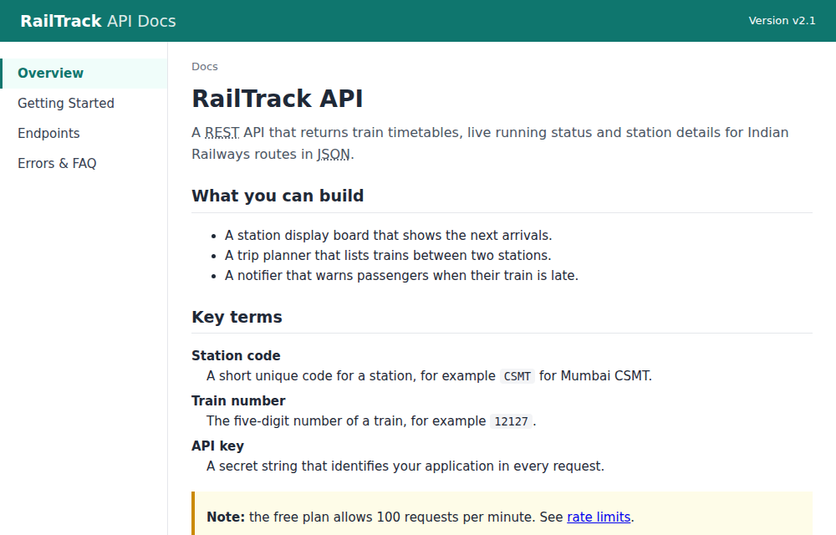
Figure 1.1: Overview page - side menu with aria-current, breadcrumb, <abbr>, <dl> with <dfn> and an <aside> note
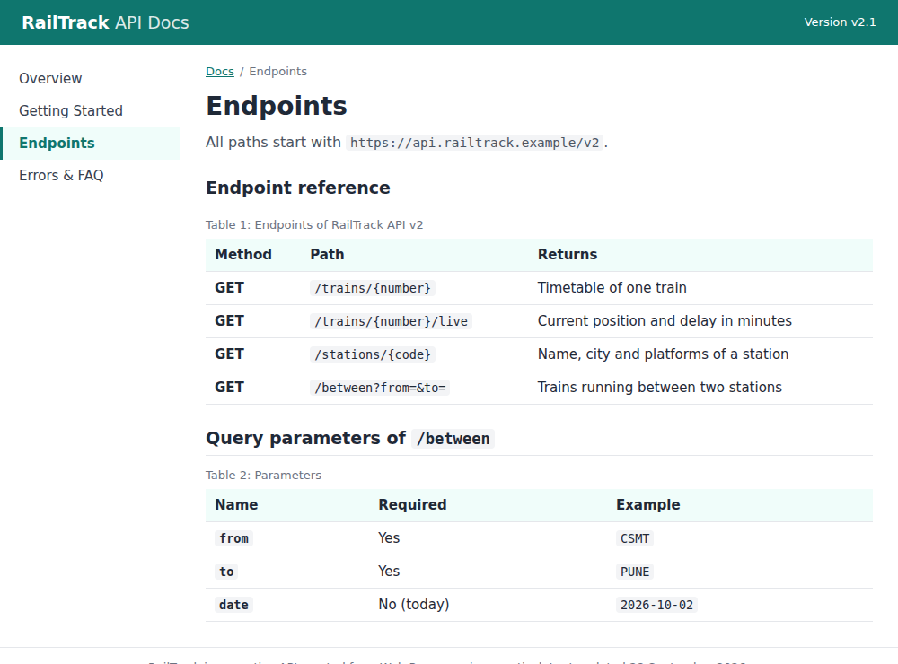
Figure 1.2: Endpoints page - tables with <caption>, column headers and row headers (th scope="row")
Conclusion:
A four-page technical documentation site was developed in semantic HTML5. Landmarks, breadcrumbs, a skip link and a correct heading outline made the pages easy to navigate, while definition lists, figures, accessible tables and <details> widgets gave each kind of content its proper meaning. The automatic check script confirmed that all four pages follow these rules and have no broken links.

