EXPERIMENT NO. 8
Implement custom middleware for user authorization in an Express app
Name: Rohit Pujari Roll No.: 28 Date: ____________
Aim:
To secure “CampusLibrary”, a library REST API built with Express on port 3008, using only hand-written middleware: a request logger, a signed-token authentication middleware (HMAC-SHA256, without any authentication library), a login-required check, a role-based authorize(...roles) factory, an owner-or-staff check for loan records, a rate limiter on the login route, and central 404 and error handlers.
Theory:
In Express a middleware is a function (req, res, next). It can read or change the request, end the request by sending a response, or call next() to hand control to the next function. Middleware registered with app.use() runs for every request in the order it was added; middleware passed as extra arguments to a route runs only for that route, from left to right, before the final handler. An error handler is recognised by its four parameters (err, req, res, next).
Signed tokens instead of server-side sessions
After a successful login the server returns a token made of two parts: base64url(payload) + "." + base64url(HMAC-SHA256(payload, secret)). The payload contains the user id, the role and an expiry time 15 minutes ahead. The client sends it back in the header Authorization: Bearer <token>. The server recomputes the HMAC with its secret; if even one character of the payload was changed (for example the role “student” replaced by “admin”), the signature no longer matches and the request is rejected. This is the same idea as a JSON Web Token, written by hand.
• Stateless: the server keeps nothing per login, so any number of server instances can check a token. The drawback is that a token cannot be cancelled before it expires, which is why the lifetime is short.
• Encoded, not encrypted: anyone can read the payload, so it holds no password or secret data.
• Password storage: passwords are never stored; crypto.scryptSync() stores a salted hash.
• Timing-safe comparison: crypto.timingSafeEqual() compares signatures in constant time, so an attacker cannot guess a signature byte by byte from response times.
The middleware chain
Middleware | Registered | Responsibility | On failure
requestLogger | app.use (global) | Gives each request an id; logs method, URL, status, user and time on the finish event | -
express.json() | app.use (global) | Parses the JSON body into req.body | 400 Invalid JSON body
authenticate | app.use (global) | If a Bearer token is present, verifies it and sets req.user; guests pass through | 401 Invalid token
requireLogin | per route | req.user must exist | 401 Login required
authorize(...roles) | per route | req.user.role must be in the list | 403 Forbidden
selfOr(...roles) | /api/loans/:userId | Own user id, or a staff role | 403 Forbidden
rateLimit(5, 60000) | /api/login | At most 5 login attempts per IP per minute | 429 Too many
404 and error handler | last | Unknown route / unexpected exception | 404 / 500

Authentication, authorization and status codes
Authentication answers “who are you?” (token check) and authorization answers “what may you do?” (role and ownership). authorize() and selfOr() are factory functions: calling authorize('librarian', 'admin') returns a new middleware that remembers the allowed roles through a closure. The API uses 401 when the caller is not logged in or the token is invalid, 403 when the caller is known but not allowed, 404 for a missing book or route and 429 for too many login attempts.
Route | Guest | Student | Librarian | Admin
GET /api/books | Yes | Yes | Yes | Yes
GET /api/me | 401 | Yes | Yes | Yes
GET /api/loans/:userId | 401 | Own only | Any user | Any user
POST /api/books | 401 | 403 | Yes | Yes
DELETE /api/books/:id | 401 | 403 | 403 | Yes

A test script (test.js) calls every route with fetch() as a guest, a student, the librarian and the admin, and also sends a wrong password and a tampered token. Its output is shown in Figure 8.1 and the matching server log in Figure 8.2.
Important Code:
Signing and verifying a token
const b64 = s => Buffer.from(s).toString('base64url');
function sign(user) {
const payload = b64(JSON.stringify({ sub: user.id, role: user.role, exp: Math.floor(Date.now() / 1000) + TOKEN_TTL }));
const sig = crypto.createHmac('sha256', SECRET).update(payload).digest('base64url');
return `${payload}.${sig}`;
}
function verify(token) {
const [payload, sig] = String(token).split('.');
if (!payload || !sig) throw new Error('malformed token');
const expected = crypto.createHmac('sha256', SECRET).update(payload).digest();
const given = Buffer.from(sig, 'base64url');
if (given.length !== expected.length || !crypto.timingSafeEqual(given, expected)) throw new Error('bad signature');
const data = JSON.parse(Buffer.from(payload, 'base64url').toString());
if (data.exp < Date.now() / 1000) throw new Error('token expired');
return data;
}
Authentication and authorization middleware
function authenticate(req, res, next) { // who are you? (optional)
const header = req.get('Authorization') || '';
if (!header.startsWith('Bearer ')) return next(); // guest request
try {
const data = verify(header.slice(7));
req.user = users.find(u => u.id === data.sub);
if (!req.user) throw new Error('unknown user');
next();
} catch (err) {
res.status(401).json({ error: `Invalid token: ${err.message}` });
}
}
const requireLogin = (req, res, next) =>
req.user ? next() : res.status(401).json({ error: 'Login required' });
const authorize = (...roles) => (req, res, next) =>
roles.includes(req.user.role) ? next()
: res.status(403).json({ error: `Role '${req.user.role}' cannot ${req.method} ${req.baseUrl}${req.path}` });
// Owner of the resource, or one of the given staff roles.
const selfOr = (...roles) => (req, res, next) =>
Number(req.params.userId) === req.user.id || roles.includes(req.user.role) ? next()
: res.status(403).json({ error: 'You can only view your own loans' });
Routes - middleware composed per route
app.get('/api/books', (req, res) => res.json(books)); // public
app.get('/api/me', requireLogin, ({ user }, res) => res.json({ id: user.id, username: user.username, role: user.role }));
app.get('/api/loans/:userId', requireLogin, selfOr('librarian', 'admin'),
(req, res) => res.json(loans.filter(l => l.userId === Number(req.params.userId))));
app.post('/api/books', requireLogin, authorize('librarian', 'admin'), (req, res) => { ... })
app.delete('/api/books/:id', requireLogin, authorize('admin'), (req, res) => { ... })
Output:
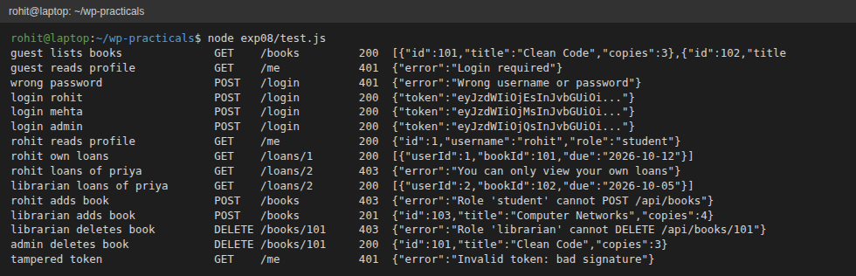
Figure 8.1: Output of test.js - 200, 201, 401 and 403 responses for guest, student, librarian and admin requests
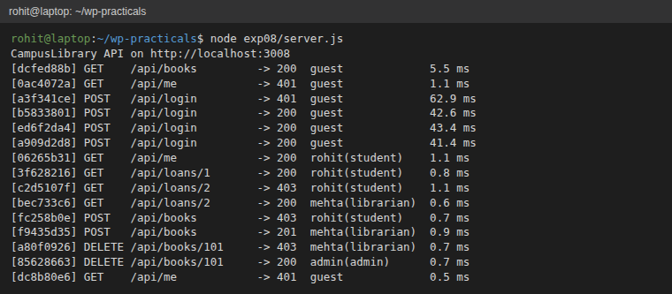
Figure 8.2: Server console written by the requestLogger middleware (request id, status, user and role, time)
Conclusion:
The CampusLibrary API was protected with custom Express middleware only. A hand-written HMAC-signed token identified the user without server-side sessions, authorize() and selfOr() enforced role and ownership rules, and the logger, rate limiter and error handlers completed the chain. The test script confirmed the correct 200, 201, 401 and 403 responses, and a tampered token was rejected.

