EXPERIMENT NO. 9
Design a blog database and write scripts to seed it with mock data
Name: Rohit Pujari Roll No.: 28 Date: ____________
Aim:
To design the SQLite database of “CodeJournal”, a developer blog with authors, posts, tags and threaded comments (replies to comments); to enforce data rules with constraints, speed up frequent queries with indexes and provide a statistics view; and to write a Node.js seed script (options --posts and --seed, a single transaction with rollback) and a query script that uses joins, aggregation and a recursive CTE, using Node.js's built-in node:sqlite module.
Theory:
Designing a database starts with the entities and their relationships. In CodeJournal an author writes many posts (one-to-many), a post has many tags and a tag belongs to many posts (many-to-many, stored in the junction table post_tags), and a post has many comments (one-to-many). A comment can also answer another comment, which is a one-to-many relationship of the comments table with itself (a self-referencing foreign key).
Tables
Table | Important columns | Constraints and purpose
authors | id, username, full_name, email, joined_on | username and email UNIQUE; CHECK on the e-mail pattern
posts | id, author_id FK, title, slug, body, status, views, published_at | slug UNIQUE (used in the URL); status IN ('draft', 'published'); views >= 0; a published post must have a date
tags | id, name | name UNIQUE COLLATE NOCASE, so "SQL" and "sql" are the same tag
post_tags | post_id FK, tag_id FK | Composite PRIMARY KEY (post_id, tag_id); junction table
comments | id, post_id FK, parent_id FK, name, body, created_at | parent_id NULL for a top-level comment, otherwise the id of the comment being answered

Integrity rules
• PRAGMA foreign_keys = ON: SQLite checks foreign keys only when this is switched on.
• ON DELETE CASCADE: deleting a post removes its tag links and comments; deleting a comment removes its replies.
• Table-level CHECK: CHECK (status = 'draft' OR published_at IS NOT NULL) compares two columns of the same row, which a column constraint cannot do.
• Normal form: author names and tag names are stored once and referenced by id, so the design is in third normal form. Dates are ISO text (YYYY-MM-DD), which sorts correctly as text.
Indexes and the view
SQLite automatically indexes primary keys and UNIQUE columns but not foreign keys, so indexes are added on posts(author_id), comments(post_id) and post_tags(tag_id), plus a composite index on posts(status, published_at) for “latest published posts”. EXPLAIN QUERY PLAN confirms that a search by author uses idx_posts_author instead of scanning the table (bottom of Figure 9.2). The view v_post_stats joins posts with authors and uses correlated sub-queries and GROUP_CONCAT() to return the comment count and tag list of every post, so programs can query it like a table.
Seeding strategy
• Options: --posts N and --seed S are read from process.argv; the file is deleted and re-created from schema.sql on every run.
• Reproducible data: a small seeded random generator (mulberry32) is used instead of Math.random(), so the same --seed always creates exactly the same rows.
• Realistic rules: about 80% of posts are published; drafts have no date and 0 views, which satisfies the CHECK constraint. Only published posts get comments, and about 40% of comments get a reply from the author.
• Prepared statements are created once and reused for every row, which is faster and safe from SQL injection. INSERT OR IGNORE skips a tag that was already chosen for the same post.
• One transaction: all inserts run between BEGIN and COMMIT; on any error ROLLBACK leaves the database empty instead of half-filled. Result: “Seeded codejournal.db (seed=7) in 4.2 ms” (Figure 9.1).
Queries
Query | SQL features | Result
1. Posts and views per author | LEFT JOIN with the condition in ON, GROUP BY, SUM() | Every author listed, busiest first
2. Most used tags | JOIN, GROUP BY, ORDER BY, LIMIT | Top five tags
3. Top posts | SELECT from the view v_post_stats | Title, views, comments, tags
4. Comment thread | WITH RECURSIVE, depth and sort path | Each reply printed under its parent

Important Code:
schema.sql - posts, threaded comments and the view
CREATE TABLE posts (
id INTEGER PRIMARY KEY,
author_id INTEGER NOT NULL REFERENCES authors(id) ON DELETE CASCADE,
title TEXT NOT NULL,
slug TEXT NOT NULL UNIQUE,
body TEXT NOT NULL,
status TEXT NOT NULL DEFAULT 'draft' CHECK (status IN ('draft', 'published')),
views INTEGER NOT NULL DEFAULT 0 CHECK (views >= 0),
published_at TEXT,
CHECK (status = 'draft' OR published_at IS NOT NULL) -- published posts need a date
);
CREATE TABLE comments (
id INTEGER PRIMARY KEY,
post_id INTEGER NOT NULL REFERENCES posts(id) ON DELETE CASCADE,
parent_id INTEGER REFERENCES comments(id) ON DELETE CASCADE, -- NULL = top-level, else a reply
name TEXT NOT NULL,
body TEXT NOT NULL,
created_at TEXT NOT NULL
);
CREATE VIEW v_post_stats AS
SELECT p.id, p.title, a.username AS author, p.status, p.views,
(SELECT COUNT(*) FROM comments c WHERE c.post_id = p.id) AS comment_count,
(SELECT GROUP_CONCAT(t.name, ', ') FROM post_tags pt JOIN tags t ON t.id = pt.tag_id
WHERE pt.post_id = p.id) AS tag_list
FROM posts p JOIN authors a ON a.id = p.author_id;
seed.js - seeded random numbers and one transaction
let s = Number(args.seed || 7) >>> 0;
const rand = () => { s = (s + 0x6D2B79F5) >>> 0; let t = s; t = Math.imul(t ^ (t >>> 15), t | 1);
t ^= t + Math.imul(t ^ (t >>> 7), t | 61); return ((t ^ (t >>> 14)) >>> 0) / 4294967296; };
db.exec('BEGIN'); // one transaction for all rows
try {
// ... insert authors, tags, posts, post_tags and comments with prepared statements ...
db.exec('COMMIT');
} catch (err) {
db.exec('ROLLBACK'); // nothing half-inserted
console.error('Seeding failed, rolled back:', err.message);
process.exit(1);
}
queries.js - recursive CTE for the comment thread
WITH RECURSIVE thread(id, depth, sort_path, name, body) AS (
SELECT id, 0, printf('%05d', id), name, body FROM comments WHERE post_id = ? AND parent_id IS NULL
UNION ALL
SELECT c.id, t.depth + 1, t.sort_path || '/' || printf('%05d', c.id), c.name, c.body
FROM comments c JOIN thread t ON c.parent_id = t.id)
SELECT substr(' ', 1, depth * 3) || name AS commenter, body FROM thread ORDER BY sort_path`, busiest.post_id);
Output:
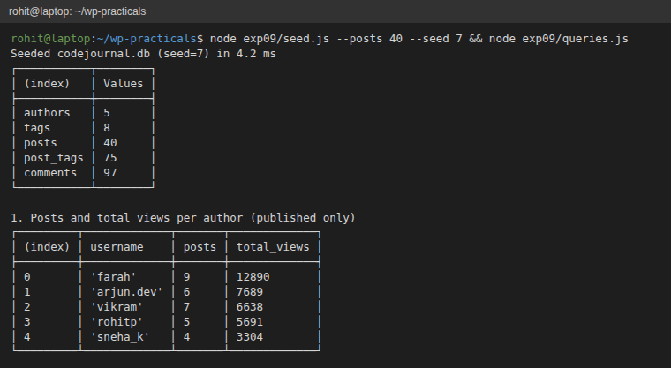
Figure 9.1: Seeding with --posts 40 --seed 7 (row counts) and query 1
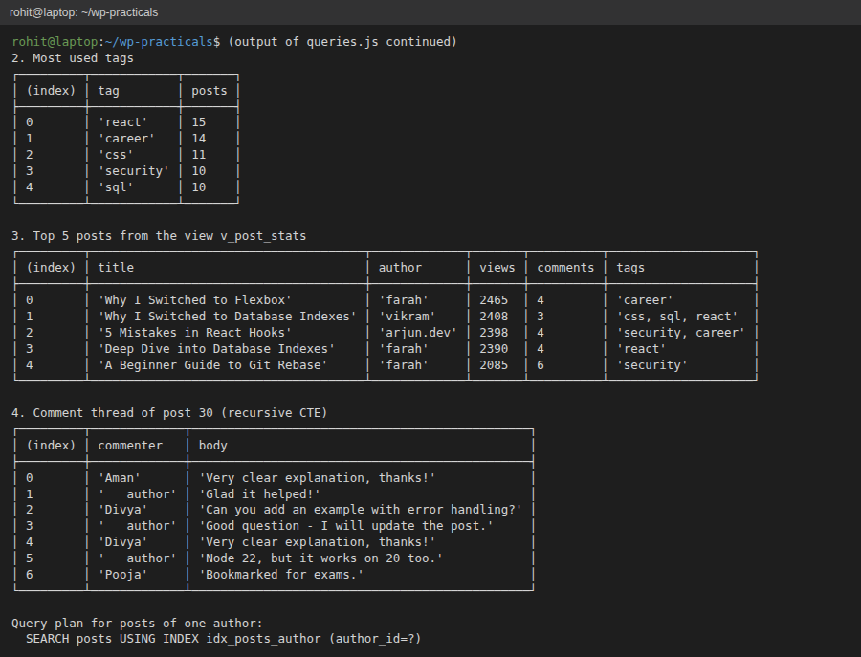
Figure 9.2: Queries 2-4 (tags, the view, the recursive comment thread) and the query plan
Conclusion:
A normalised SQLite database for a developer blog was designed with foreign keys, CHECK constraints, a junction table for tags and a self-referencing comments table for replies. Indexes and a view supported the common queries. The seed script generated reproducible mock data inside a single transaction, and the query script demonstrated joins, aggregation, the view and a recursive CTE.

