

**PIMPRI CHINCHWAD EDUCATION TRUST'S PIMPRI CHINCHWAD COLLEGE OF ENGINEERING**

**DEPARTMENT OF COMPUTER ENGINEERING**

**Mini Project Report**

**TITLE: “GRE ANALYZER”**

**SUBJECT: Database Management System**

**YEAR: TE Computer (2015 Course)**

**Submitted By:**

**Rohit Bangar TECOC306**

**Piyush Chaudhari TECOC311**

**Under the guidance of –**

**Mrs.Prof.Sushma Vispute.**



PIMPRI CHINCHWAD COLLEGE OF ENGINEERING

DEPARTMENT OF COMPUTER ENGINEERING

**CERTIFICATE**

This is to certify that, the project entitled

**“GRE ANALYZER**”

is successfully carried out as a mini project successfully submitted by

following students of “PCET's Pimpri Chinchwad College of Engineering,

Nigdi, Pune-44**”.**

**Under the guidance of Mrs.Prof.Sushma Vispute.**

In the partial fulfillment of the requirements for the T.E. (Computer Engineering)

**ROHIT B.BANGAR TECOC306**

**PIYUSH R.CHUDHARI TECOC311**

**Project Guide:**

**Mrs.Prof.Sushma Vispute.**

**ABSTRACT**

In this project we are predicting the universities for students (as per entered three universities) who going to apply for the Masters in same country or in other country.

These criteria are depend on the score of the GRE ,world rank of the university and the preference given by the student.so, whenever the input is given by user according to the previous datasets it predict the universities .

so ,this will help lot of students who want to take admission in different universities.

As well as the selection criteria for the universities are depend on the three parameters preferences, world rank of university and the number of students applied for the universities ,these numbers of applied student previous years depends on the previous year datasets which are already present.

So, selection of an universities for student is being easy and very efficient who going to apply for masters.

**INDEX**

|  |  |  |
| --- | --- | --- |
| **Chapter** | **Content** | **Page No.** |
| **1** | **1.1 - Introduction**  **1.2 – Problem Statement**  **1.3 - Scope** | **5**  **5**  **5** |
| **2** | **2.1 – Project Design**  **2.2 – Technical Details**  **2.3 – Detailed Design of Modules**  **2.4 – Analysis** | **6**  **7**  **8**  **10** |
| **3** | **3.1 – Results & Discussion**  **3.2 – Source Code**  **3.3 – Screen-Shots including GUI** | **11**  **11**  **24** |
| **4** | **4.1 – Conclusion** | **27** |

**FIGURE INDEX**

|  |  |  |
| --- | --- | --- |
| **Figure No.** | **Figure Name** | **Page No.** |
| **1** | **FlowChart** | **6** |
| **2** | **Prediction by System** | **10** |
| **3** | **Admin and Validation** | **24** |
| **4** | **Validation 2** | **25** |
| **5** | **Main Window** | **26** |
| **6** | **Final Output** | **26** |

**Chapter 1**

**1.1 INTRODUCTION**

**1.2 Problem Statement:**

- An GRE Analyzer who going to predict the university for Masters by taking score and preferences from the user

- Draw bar graph of No. of Student applied for universities

- Predict the university from the given preferences.

**1.3 Objectives of Project:**

* The main objective of this project is to predict the university for the M.S. from given preferences.
* Therefore, users should be able to check according to the score in which university they may be selected.
* Developing a platform for students to check in which university they got select.

**1.4 Scope:**

- Can be used at private coaching center who takes coaching for GRE as well as in colleges where students are interested in GRE.

- We can also improve the prediction algorithm and improve the college prediction.

**Chapter 2**

**2.1 PROJECT DESIGN**

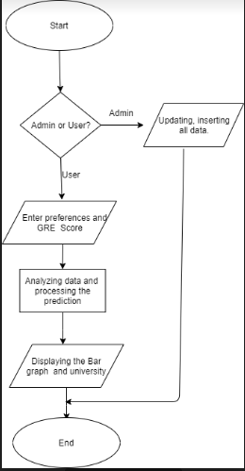

**Fig:Flowchart of System**

**2.2 Technical Details:**

**Platform used:**

Pycharm Professionals, oracle Database, SQL developer.

**Backend Language:** Python,3.6,SQL

**Frontend Language:**

PyQT5.

**Python libraries used:**

* cx_Oracle
* Statistics
* Pandas
* Numpy
* Matplotlib
* PyQt5

**2.3 Detailed design of modules / functionality with explanation:**

**Module 1: User Module(Analysis)**

* In this module input will be

1.Preferences

2.GRE Score

* After taking GRE Score and Preferences from the user it will check the preferences and Score it will predict the university
* If the three preferences are same or Score is less than 0 or more than 340 or the two preferences are same then it will provide the error message so, here we provided the validation to the UI through UI coding as well as from database by applying the NOT NULL constraint.
* We performing the operations on the database not on CSV file so accordingly all data such as previous dataset as well as current year data is available in database.

**Module 2: Admin Panel(Database Operations)**

**Admin**

University list Operation Adding Student data.

**1. University list Operation:**

* In this we are performing the operations on the database from universities as are performing the CURD operations.
* These operations are:

-Insert

-Update

-Delete

1. Insert:

Here, we are inserting the new university in list of the universities we already have

1. Update:

Here, we are updating the university in list of the universities with respect to world rank.

1. Delete:

Here, we are inserting the deleting university in list of the universities we already have .

**2. Student list Operation:**

In this section we are adding the data of the student we got already admitted to the university. This data will be helpful to improve the dataset that will be helpful for next year data analysis.

Operation: Insert

It consist of Insertion of Name, University Name, GRE Score,TOFEL Score.

**Analysis : Prediction of the University:**

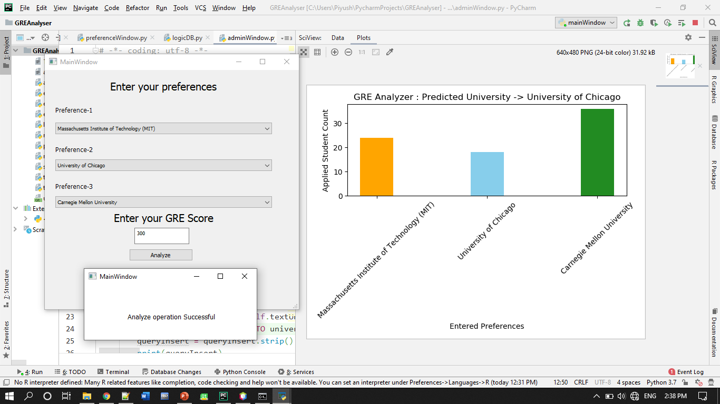

**Fig :Prediction of System**

**Chapter 3:**

**RESULTS & DISCUSSION**

**3.1 Source code: –**

**MAINWINDOW.Py**

from PyQt5 import QtCore, QtGui, QtWidgets

import adminWindow

import preferenceWindow

class Ui_mainWindow(object):

def openPrefWindow(self):

self.window = QtWidgets.QMainWindow()

self.ui = preferenceWindow.Ui_prefMainWindow()

self.ui.setupUi(self.window)

self.window.show()

def openAdminWindow(self):

self.window = QtWidgets.QMainWindow()

self.ui = adminWindow.Ui_adminMainWindow()

self.ui.setupUi(self.window)

self.window.show()

def setupUi(self, mainWindow):

mainWindow.setObjectName("mainWindow")

mainWindow.setWindowModality(QtCore.Qt.WindowModal)

mainWindow.resize(529, 256)

mainWindow.setAutoFillBackground(False)

self.centralwidget = QtWidgets.QWidget(mainWindow)

self.centralwidget.setObjectName("centralwidget")

self.buttonPrediction = QtWidgets.QPushButton(self.centralwidget)

self.buttonPrediction.setGeometry(QtCore.QRect(90, 110, 151, 51))

self.buttonPrediction.setObjectName("buttonPrediction")

self.buttonPrediction.clicked.connect(self.openPrefWindow)

self.buttonAdmin = QtWidgets.QPushButton(self.centralwidget)

self.buttonAdmin.setGeometry(QtCore.QRect(300, 110, 151, 51))

self.buttonAdmin.setObjectName("buttonAdmin")

self.buttonAdmin.clicked.connect(self.openAdminWindow)

self.labGREAnalyzer = QtWidgets.QLabel(self.centralwidget)

self.labGREAnalyzer.setGeometry(QtCore.QRect(90, 50, 341, 31))

font = QtGui.QFont()

font.setPointSize(15)

font.setBold(True)

font.setUnderline(False)

font.setWeight(75)

self.labGREAnalyzer.setFont(font)

self.labGREAnalyzer.setAlignment(QtCore.Qt.AlignCenter)

self.labGREAnalyzer.setObjectName("labGREAnalyzer")

mainWindow.setCentralWidget(self.centralwidget)

self.statusbar = QtWidgets.QStatusBar(mainWindow)

self.statusbar.setObjectName("statusbar")

mainWindow.setStatusBar(self.statusbar)

self.retranslateUi(mainWindow)

QtCore.QMetaObject.connectSlotsByName(mainWindow)

def retranslateUi(self, mainWindow):

_translate = QtCore.QCoreApplication.translate

mainWindow.setWindowTitle(_translate("mainWindow", "MainWindow"))

self.buttonPrediction.setText(_translate("mainWindow", "Prediction"))

self.buttonAdmin.setText(_translate("mainWindow", "Admin"))

self.labGREAnalyzer.setText(_translate("mainWindow", "GRE Analyzer"))

if __name__ == "__main__":

import sys

import cx_Oracle

connection = cx_Oracle.connect("piyush/piyushchaudhari@localhost")

cursor = connection.cursor()

app = QtWidgets.QApplication(sys.argv)

mainWindow = QtWidgets.QMainWindow()

ui = Ui_mainWindow()

ui.setupUi(mainWindow)

mainWindow.show()

sys.exit(app.exec_())

**ADMINWINDOW.Py**

from PyQt5 import QtCore, QtGui, QtWidgets

import cx_Oracle

connection = cx_Oracle.connect("piyush/piyushchaudhari@localhost")

# cursor = connection.cursor()

class Ui_adminMainWindow(object):

def doUniInsert(self):

cursor = connection.cursor()

insertUniName = str(self.textUniInsertName.toPlainText().strip())

insertUniWRank = int(self.textUniInsertWRank.toPlainText().strip())

insertUniCountry = str(self.textUniInsertCountry.toPlainText().strip())

queryInsert = f'INSERT INTO university_list VALUES (\'{insertUniName}\', {insertUniWRank}, \'{insertUniCountry}\')'

queryInsert = queryInsert.strip()

print(queryInsert)

print(insertUniName)

cursor.execute(queryInsert)

connection.commit()

# print("piyu")

def doUniUpdate(self):

cursor = connection.cursor()

updateUniName = str(self.comboUniUpdateSelect.currentText().strip())

updatedWorldRank = int(self.plainTextUniUpdateWRank.toPlainText().strip())

qryToUpdateWR = f'UPDATE UNIVERSITY_LIST SET WORLD_RANK = {updatedWorldRank} WHERE UNIVERSITY_NAME = \'{updateUniName}\''

print(qryToUpdateWR)

qryToUpdateWR = qryToUpdateWR.strip()

cursor.execute(qryToUpdateWR)

connection.commit()

def doUniDelete(self):

cursor = connection.cursor()

deleteUniName = str(self.comboUniDeleteSelect.currentText().strip())

qryToDeleteUni = f'DELETE FROM UNIVERSITY_LIST WHERE UNIVERSITY_NAME = \'{deleteUniName}\''

print(qryToDeleteUni)

qryToDeleteUni = qryToDeleteUni.strip()

cursor.execute(qryToDeleteUni)

connection.commit()

def doStuInsert(self):

cursor = connection.cursor()

insertedStudentname = str(self.textStudInsertName.toPlainText().strip())

insertedStudUniversityname = str(self.textStudInsertUniName.toPlainText().strip())

insertedStudGREScore = int(self.textStudInsertGREScore.toPlainText().strip())

insertedStudTOEFLScore = int(self.textStudInsertTOEFLScore.toPlainText().strip())

qryToInsertInAdmittedStud = f'INSERT INTO ADMITTED_STUDENTS VALUES (\'{insertedStudentname}\',\'{insertedStudUniversityname}\', {insertedStudGREScore}, {insertedStudTOEFLScore})'

print(qryToInsertInAdmittedStud)

qryToInsertInAdmittedStud = qryToInsertInAdmittedStud.strip()

cursor.execute(qryToInsertInAdmittedStud)

connection.commit()

def setupUi(self, adminMainWindow):

adminMainWindow.setObjectName("adminMainWindow")

adminMainWindow.resize(744, 640)

self.centralwidget = QtWidgets.QWidget(adminMainWindow)

self.centralwidget.setObjectName("centralwidget")

self.labelAdminPanel = QtWidgets.QLabel(self.centralwidget)

self.labelAdminPanel.setGeometry(QtCore.QRect(280, 10, 141, 31))

font = QtGui.QFont()

font.setPointSize(15)

self.labelAdminPanel.setFont(font)

self.labelAdminPanel.setAlignment(QtCore.Qt.AlignCenter)

self.labelAdminPanel.setObjectName("labelAdminPanel")

self.labelMUniversities = QtWidgets.QLabel(self.centralwidget)

self.labelMUniversities.setGeometry(QtCore.QRect(20, 46, 131, 20))

font = QtGui.QFont()

font.setPointSize(12)

font.setBold(True)

font.setWeight(75)

self.labelMUniversities.setFont(font)

self.labelMUniversities.setObjectName("labelMUniversities")

self.labelUniInsert = QtWidgets.QLabel(self.centralwidget)

self.labelUniInsert.setGeometry(QtCore.QRect(20, 90, 51, 20))

font = QtGui.QFont()

font.setPointSize(11)

self.labelUniInsert.setFont(font)

self.labelUniInsert.setObjectName("labelUniInsert")

self.labelUniUpdate = QtWidgets.QLabel(self.centralwidget)

self.labelUniUpdate.setGeometry(QtCore.QRect(20, 210, 61, 20))

font = QtGui.QFont()

font.setPointSize(11)

self.labelUniUpdate.setFont(font)

self.labelUniUpdate.setObjectName("labelUniUpdate")

self.comboUniUpdateSelect = QtWidgets.QComboBox(self.centralwidget)

self.comboUniUpdateSelect.setGeometry(QtCore.QRect(60, 260, 291, 31))

self.comboUniUpdateSelect.setObjectName("comboUniUpdateSelect")

universityList = ["Massachusetts Institute of Technology (MIT)",

"Stanford University",

"Harvard University",

"California Institute of Technology (Caltech)",

"University of Chicago",

"Princeton University",

"Cornell University",

"University of Pennsylvania",

"Yale University",

"Columbia University",

"University of Michigan",

"Johns Hopkins University",

"Duke University",

"University of California, Berkeley (UCB)",

"Northwestern University",

"University of California, Los Angeles (UCLA)",

"New York University (NYU)",

"University of California, San Diego (UCSD)",

"Carnegie Mellon University",

"University of Wisconsin-Madison",

"Brown University",

"University of Texas at Austin",

"University of Washington",

"Georgia Institute of Technology",

"University of Illinois at Urbana-Champaign",

"Rice University",

"University of North Carolina, Chapel Hill",

"Pennsylvania State University",

"Boston University",

"Australian National University",

"University of Melbourne",

"University of Sydney",

"University of New South Wales (UNSW Sydney)",

"University of Queensland",

"Monash University",

"University of Western Australia",

"Tsinghua University",

"Peking University",

"Fudan University",

"Zhejiang University",

"Shanghai Jiao Tong University",

"University of Science and Technology of China",

"University of Oxford",

"University of Cambridge",

"UCL (University College London)",

"Imperial College London",

"University of Edinburgh",

"University of Manchester",

"King's College London",

"London School of Economics and Political Science (LSE)",

"University of Bristol",

"University of Warwick",

"University of Glasgow",

"Durham University",

"University of Sheffield",

"University of Birmingham",

"University of Leeds",

"University of Nottingham",

"University of Southampton",

"University of St Andrews"]

self.comboUniUpdateSelect.addItems(universityList)

self.labelUniUpdateSelect = QtWidgets.QLabel(self.centralwidget)

self.labelUniUpdateSelect.setGeometry(QtCore.QRect(150, 230, 101, 20))

self.labelUniUpdateSelect.setObjectName("labelUniUpdateSelect")

self.labelUniUpdateWRank = QtWidgets.QLabel(self.centralwidget)

self.labelUniUpdateWRank.setGeometry(QtCore.QRect(460, 230, 31, 20))

self.labelUniUpdateWRank.setObjectName("labelUniUpdateWRank")

self.plainTextUniUpdateWRank = QtWidgets.QPlainTextEdit(self.centralwidget)

self.plainTextUniUpdateWRank.setGeometry(QtCore.QRect(430, 260, 91, 31))

self.plainTextUniUpdateWRank.setObjectName("plainTextUniUpdateWRank")

self.textUniInsertName = QtWidgets.QTextEdit(self.centralwidget)

self.textUniInsertName.setGeometry(QtCore.QRect(60, 150, 251, 31))

self.textUniInsertName.setObjectName("textUniInsertName")

self.textUniInsertWRank = QtWidgets.QTextEdit(self.centralwidget)

self.textUniInsertWRank.setGeometry(QtCore.QRect(320, 150, 91, 31))

self.textUniInsertWRank.setObjectName("textUniInsertWRank")

self.textUniInsertCountry = QtWidgets.QTextEdit(self.centralwidget)

self.textUniInsertCountry.setGeometry(QtCore.QRect(430, 150, 141, 31))

self.textUniInsertCountry.setObjectName("textUniInsertCountry")

self.labelUniInsertName = QtWidgets.QLabel(self.centralwidget)

self.labelUniInsertName.setGeometry(QtCore.QRect(140, 120, 101, 20))

self.labelUniInsertName.setObjectName("labelUniInsertName")

self.labelUniInsertWRank = QtWidgets.QLabel(self.centralwidget)

self.labelUniInsertWRank.setGeometry(QtCore.QRect(330, 120, 71, 21))

self.labelUniInsertWRank.setObjectName("labelUniInsertWRank")

self.labelUniInsertCountry = QtWidgets.QLabel(self.centralwidget)

self.labelUniInsertCountry.setGeometry(QtCore.QRect(470, 120, 51, 21))

self.labelUniInsertCountry.setObjectName("labelUniInsertCountry")

self.labelMStudent = QtWidgets.QLabel(self.centralwidget)

self.labelMStudent.setGeometry(QtCore.QRect(20, 430, 241, 20))

font = QtGui.QFont()

font.setPointSize(12)

font.setBold(True)

font.setWeight(75)

self.labelMStudent.setFont(font)

self.labelMStudent.setObjectName("labelMStudent")

self.labelStudInsert = QtWidgets.QLabel(self.centralwidget)

self.labelStudInsert.setGeometry(QtCore.QRect(20, 460, 51, 20))

font = QtGui.QFont()

font.setPointSize(11)

self.labelStudInsert.setFont(font)

self.labelStudInsert.setObjectName("labelStudInsert")

self.labelStudInsertUniName = QtWidgets.QLabel(self.centralwidget)

self.labelStudInsertUniName.setGeometry(QtCore.QRect(340, 490, 101, 20))

self.labelStudInsertUniName.setObjectName("labelStudInsertUniName")

self.labelStudInsertGREScore = QtWidgets.QLabel(self.centralwidget)

self.labelStudInsertGREScore.setGeometry(QtCore.QRect(530, 490, 61, 21))

self.labelStudInsertGREScore.setObjectName("labelStudInsertGREScore")

self.labelStudInsertTOEFLScore = QtWidgets.QLabel(self.centralwidget)

self.labelStudInsertTOEFLScore.setGeometry(QtCore.QRect(640, 490, 31, 21))

self.labelStudInsertTOEFLScore.setObjectName("labelStudInsertTOEFLScore")

self.textStudInsertUniName = QtWidgets.QTextEdit(self.centralwidget)

self.textStudInsertUniName.setGeometry(QtCore.QRect(290, 530, 201, 31))

self.textStudInsertUniName.setObjectName("textStudInsertUniName")

self.textStudInsertGREScore = QtWidgets.QTextEdit(self.centralwidget)

self.textStudInsertGREScore.setGeometry(QtCore.QRect(510, 530, 91, 31))

self.textStudInsertGREScore.setObjectName("textStudInsertGREScore")

self.textStudInsertTOEFLScore = QtWidgets.QTextEdit(self.centralwidget)

self.textStudInsertTOEFLScore.setGeometry(QtCore.QRect(620, 530, 71, 31))

self.textStudInsertTOEFLScore.setObjectName("textStudInsertTOEFLScore")

self.textStudInsertName = QtWidgets.QTextEdit(self.centralwidget)

self.textStudInsertName.setGeometry(QtCore.QRect(70, 530, 201, 31))

self.textStudInsertName.setObjectName("textStudInsertName")

self.labelStudInsertName = QtWidgets.QLabel(self.centralwidget)

self.labelStudInsertName.setGeometry(QtCore.QRect(150, 490, 31, 20))

self.labelStudInsertName.setObjectName("labelStudInsertName")

self.labelUniDelete = QtWidgets.QLabel(self.centralwidget)

self.labelUniDelete.setGeometry(QtCore.QRect(20, 320, 61, 20))

font = QtGui.QFont()

font.setPointSize(11)

self.labelUniDelete.setFont(font)

self.labelUniDelete.setObjectName("labelUniDelete")

self.comboUniDeleteSelect = QtWidgets.QComboBox(self.centralwidget)

self.comboUniDeleteSelect.setGeometry(QtCore.QRect(60, 370, 291, 31))

self.comboUniDeleteSelect.setObjectName("comboUniDeleteSelect")

universityList1 = ["Massachusetts Institute of Technology (MIT)",

"Stanford University",

"Harvard University",

"California Institute of Technology (Caltech)",

"University of Chicago",

"Princeton University",

"Cornell University",

"University of Pennsylvania",

"Yale University",

"Columbia University",

"University of Michigan",

"Johns Hopkins University",

"Duke University",

"University of California, Berkeley (UCB)",

"Northwestern University",

"University of California, Los Angeles (UCLA)",

"New York University (NYU)",

"University of California, San Diego (UCSD)",

"Carnegie Mellon University",

"University of Wisconsin-Madison",

"Brown University",

"University of Texas at Austin",

"University of Washington",

"Georgia Institute of Technology",

"University of Illinois at Urbana-Champaign",

"Rice University",

"University of North Carolina, Chapel Hill",

"Pennsylvania State University",

"Boston University",

"Australian National University",

"University of Melbourne",

"University of Sydney",

"University of New South Wales (UNSW Sydney)",

"University of Queensland",

"Monash University",

"University of Western Australia",

"Tsinghua University",

"Peking University",

"Fudan University",

"Zhejiang University",

"Shanghai Jiao Tong University",

"University of Science and Technology of China",

"University of Oxford",

"University of Cambridge",

"UCL (University College London)",

"Imperial College London",

"University of Edinburgh",

"University of Manchester",

"King's College London",

"London School of Economics and Political Science (LSE)",

"University of Bristol",

"University of Warwick",

"University of Glasgow",

"Durham University",

"University of Sheffield",

"University of Birmingham",

"University of Leeds",

"University of Nottingham",

"University of Southampton",

"University of St Andrews"]

self.comboUniDeleteSelect.addItems(universityList1)

self.labelUniDeleteSelect = QtWidgets.QLabel(self.centralwidget)

self.labelUniDeleteSelect.setGeometry(QtCore.QRect(150, 340, 101, 20))

self.labelUniDeleteSelect.setObjectName("labelUniDeleteSelect")

self.buttonUniInsert = QtWidgets.QPushButton(self.centralwidget)

self.buttonUniInsert.setGeometry(QtCore.QRect(620, 150, 81, 31))

self.buttonUniInsert.setObjectName("buttonUniInsert")

self.buttonUniInsert.clicked.connect(self.doUniInsert)

self.buttonUniUpdate = QtWidgets.QPushButton(self.centralwidget)

self.buttonUniUpdate.setGeometry(QtCore.QRect(620, 260, 81, 31))

self.buttonUniUpdate.setObjectName("buttonUniUpdate")

self.buttonUniUpdate.clicked.connect(self.doUniUpdate)

self.buttonUniDelete = QtWidgets.QPushButton(self.centralwidget)

self.buttonUniDelete.setGeometry(QtCore.QRect(620, 370, 81, 31))

self.buttonUniDelete.setObjectName("buttonUniDelete")

self.buttonUniDelete.clicked.connect(self.doUniDelete)

self.buttonStudentInsert = QtWidgets.QPushButton(self.centralwidget)

self.buttonStudentInsert.setGeometry(QtCore.QRect(320, 580, 81, 31))

self.buttonStudentInsert.setObjectName("buttonStudentInsert")

self.buttonStudentInsert.clicked.connect(self.doStuInsert)

adminMainWindow.setCentralWidget(self.centralwidget)

self.statusbar = QtWidgets.QStatusBar(adminMainWindow)

self.statusbar.setObjectName("statusbar")

adminMainWindow.setStatusBar(self.statusbar)

self.retranslateUi(adminMainWindow)

QtCore.QMetaObject.connectSlotsByName(adminMainWindow)

def retranslateUi(self, adminMainWindow):

_translate = QtCore.QCoreApplication.translate

adminMainWindow.setWindowTitle(_translate("adminMainWindow", "MainWindow"))

self.labelAdminPanel.setText(_translate("adminMainWindow", "ADMIN PANEL"))

self.labelMUniversities.setText(_translate("adminMainWindow", "UNIVERSITIES"))

self.labelUniInsert.setText(_translate("adminMainWindow", "INSERT"))

self.labelUniUpdate.setText(_translate("adminMainWindow", "UPDATE"))

self.labelUniUpdateSelect.setText(_translate("adminMainWindow", "SELECT UNIVERSITY"))

self.labelUniUpdateWRank.setText(_translate("adminMainWindow", "RANK"))

self.labelUniInsertName.setText(_translate("adminMainWindow", " UNIVERSITY NAME"))

self.labelUniInsertWRank.setText(_translate("adminMainWindow", "WORLD RANK"))

self.labelUniInsertCountry.setText(_translate("adminMainWindow", "COUNTRY"))

self.labelMStudent.setText(_translate("adminMainWindow", "STUDENTS GOT ADMITTED"))

self.labelStudInsert.setText(_translate("adminMainWindow", "INSERT"))

self.labelStudInsertUniName.setText(_translate("adminMainWindow", " UNIVERSITY NAME"))

self.labelStudInsertGREScore.setText(_translate("adminMainWindow", "GRE SCORE"))

self.labelStudInsertTOEFLScore.setText(_translate("adminMainWindow", "TOFEL"))

self.labelStudInsertName.setText(_translate("adminMainWindow", "NAME"))

self.labelUniDelete.setText(_translate("adminMainWindow", "DELETE"))

self.labelUniDeleteSelect.setText(_translate("adminMainWindow", "SELECT UNIVERSITY"))

self.buttonUniInsert.setText(_translate("adminMainWindow", "INSERT"))

self.buttonUniUpdate.setText(_translate("adminMainWindow", "UPDATE"))

self.buttonUniDelete.setText(_translate("adminMainWindow", "DELETE"))

self.buttonStudentInsert.setText(_translate("adminMainWindow", "INSERT"))

if __name__ == "__main__":

import sys

app = QtWidgets.QApplication(sys.argv)

adminMainWindow = QtWidgets.QMainWindow()

ui = Ui_adminMainWindow()

ui.setupUi(adminMainWindow)

adminMainWindow.show()

sys.exit(app.exec_())

**LOGICDB.Py**

import pandas as pd

import numpy as np

import matplotlib.pyplot as plt

import statistics

import cx_Oracle

connection = cx_Oracle.connect("piyush/piyushchaudhari@localhost")

def queryExecutor(qry1, qry2, qry3):

totalCountOfUni = 0

reqAvgGREScore = 0

p = [] # empty list to have GRE SCORE of Selected applied Universities

cursor = connection.cursor()

l = list(cursor.execute(qry1))

totalCountOfUni = totalCountOfUni + len(l)

o = [p.append(i[1]) for i in l]

l = list(cursor.execute(qry2))

totalCountOfUni = totalCountOfUni + len(l)

o = [p.append(i[1]) for i in l]

l = list(cursor.execute(qry3))

totalCountOfUni = totalCountOfUni + len(l)

o = [p.append(i[1]) for i in l]

reqAvgGREScore = statistics.mean(p)

return totalCountOfUni, reqAvgGREScore

def logicDBFunc(pref1, pref2, pref3):

cursor = connection.cursor()

view = f'CREATE VIEW pref_uni AS SELECT preference1, preference2, preference3, GRE_SCORE FROM student_gre'

cursor.execute(view)

queryp1 = f'select preference1, GRE_SCORE from pref_uni where preference1 = \'{pref1}\''

queryp2 = f'select preference2, GRE_SCORE from pref_uni where preference2 = \'{pref1}\''

queryp3 = f'select preference3, GRE_SCORE from pref_uni where preference3 = \'{pref1}\''

count1, average1 = queryExecutor(queryp1, queryp2, queryp3)

# delUniSelected = Ui_prefMainWindow.comboUniDeleteSelect.currentText()

# print(delUniSelected)

# queryDelete = 'delete from UNIVERSITY_LIST where university_name = \'{}\''.format(delUniSelected)

queryp4 = f'select preference1, GRE_SCORE from pref_uni where preference1 = \'{pref2}\''

queryp5 = f'select preference2, GRE_SCORE from pref_uni where preference2 = \'{pref2}\''

queryp6 = f'select preference3, GRE_SCORE from pref_uni where preference3 = \'{pref2}\''

count2, average2 = queryExecutor(queryp4, queryp5, queryp6)

queryp7 = f'select preference1, GRE_SCORE from pref_uni where preference1 = \'{pref3}\''

queryp8 = f'select preference2, GRE_SCORE from pref_uni where preference2 = \'{pref3}\''

queryp9 = f'select preference3, GRE_SCORE from pref_uni where preference3 = \'{pref3}\''

count3, average3 = queryExecutor(queryp7, queryp8, queryp9)

view1 = f'DROP VIEW pref_uni'

cursor.execute(view1)

# print("piyu")

cursor.close()

y = [count1, count2, count3]

avgList = [average1, average2, average3]

logicOfAdmission = list(zip(y, avgList))

logicOfAdmission.sort(reverse=False)

toRetrievePreference = {average1: pref1, average2: pref2, average3: pref3}

xLabel = [pref1, pref2, pref3]

colours = ['#FFA500', '#87CEEB', '#228B22']

plt.xlabel("Entered Preferences")

plt.ylabel("Applied Student Count")

plt.bar(x=np.arange(1, 4), height=y, color=colours, width=0.3)

titleMsgUni = toRetrievePreference[logicOfAdmission[0][1]]

titleMsg = f'GRE Analyzer : Predicted University -> {titleMsgUni}'

plt.title(titleMsg)

plt.xticks(np.arange(1, 4), xLabel, rotation=45)

plt.show()

**OUTPUTS:**

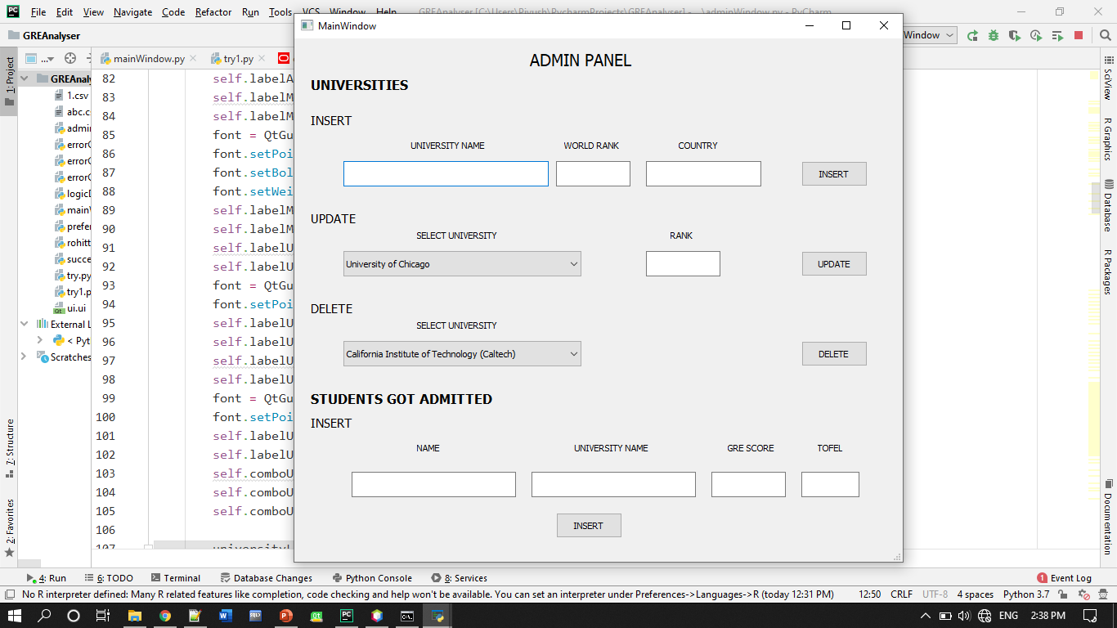

**Fig:AdminPanel**

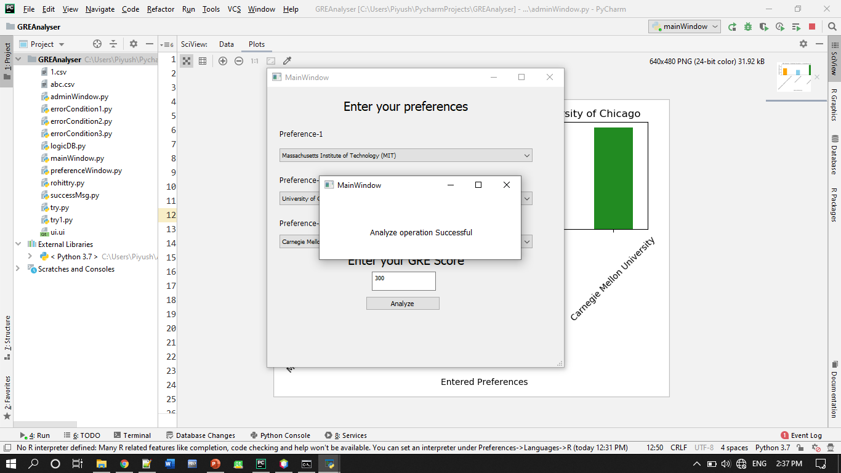

**Fig:Validation**

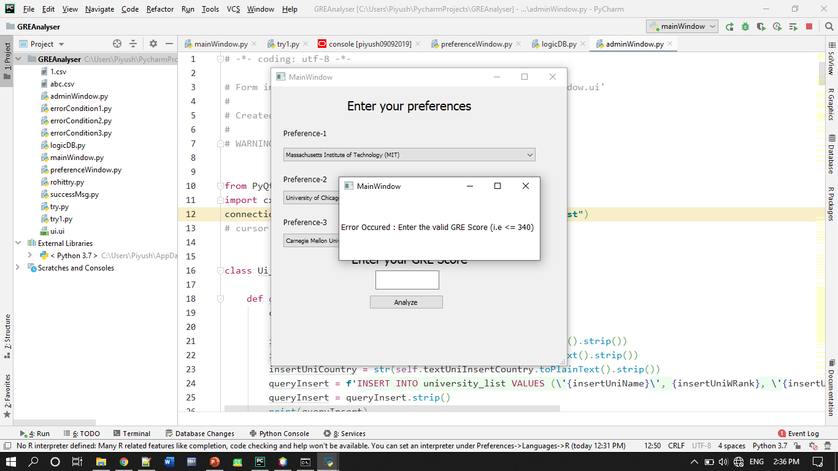

**Fig:Validation2**

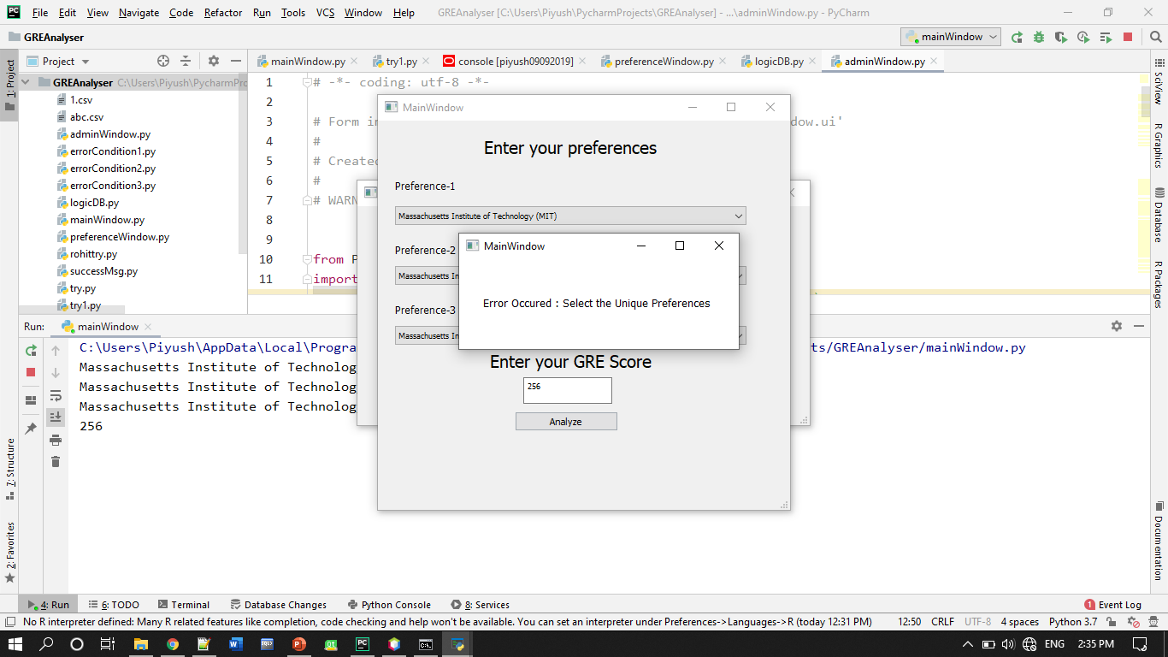

**Fig:Validation3**

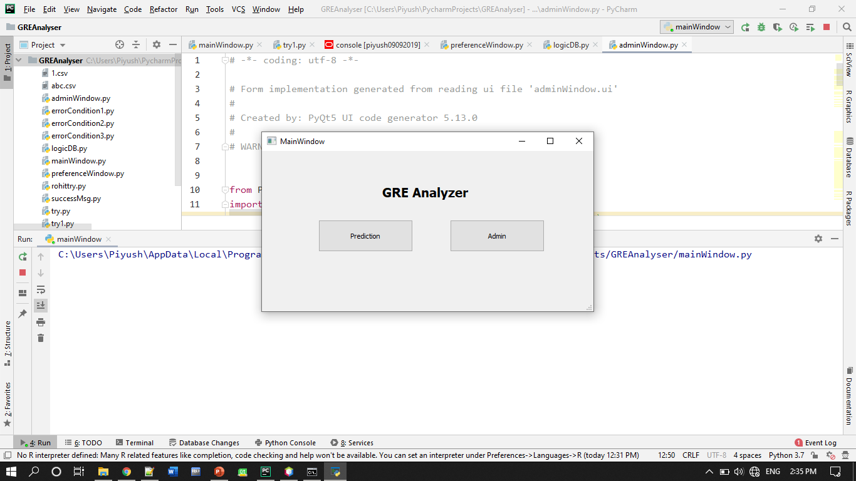

**Fig:MainWindow**



**Fig:Final Output**

**Chapter 4**

**CONCLUSION**

**Through this project skills that we have acquired are** :

* Team work &Time management .
* We are now comfortable with Oracle Database and python language .
* We studied matplotlib in bar plot for analysis part .
* We are able to develop new algorithm that analyze the University.