**What is the difference between $scope and $rootscope in angularjs?**

$scope is an object that is accessible from current component e.g Controller, Service only.

$rootScope refers to an object which is accessible from everywhere of the application. You can think $rootScope as global variable and $scope as local variables.

rootScope is attached to ng-app

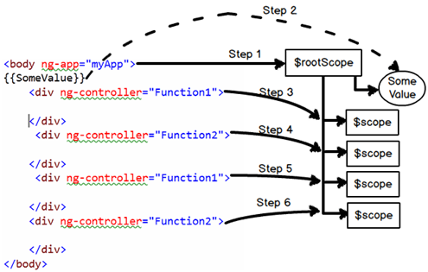

Variables set at the root-scope are available to the controller scope via prototypical inheritance.

Explain the concept of digest cycle, watchers and dirty checking?

Angular is a MVW framework. It helps us to bind the model and the view. In other words when any change happens in the model the view gets updated. This updation of the model and the view is done by a loop called as digest cycle.

Digest cycle follows four important steps:-

1. Step 1:- Some kind of event is triggered by the end user like typing (onchange), button click etc and due to this activity model value changes.
2. Step 2:- Angular first checks if the new value and old values are same. If they are same he does not do anything. If they are not it then it invokes the digest cycle.
3. Step 3:- Digest cycle then runs through the scope objects to check which objects are getting affected because of this change. Every object in the scope have watchers. Watchers as the name says it listens whether the model has changed or not. Digest cycle informs the watchers about the model change and then watchers synchronize the view with the model data.
4. Step 4 :- In step 3 watchers update the view and due that update its very much possible that the model changes again. Now due to this model change we have to reevaulate the view again. So the digest loop runs once again to ensure that all things are synched up. This second loop which runs is termed as dirty check loop.

Below is the figure where in we have highlighted all the four steps.

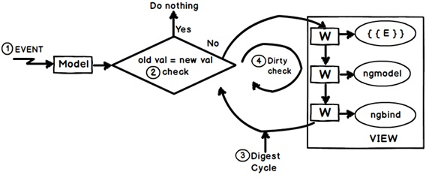

So summarizing definitions for the above three concepts:-

* Digest cycle: - It is a simple loop which updates the model and view.
* Watchers :- They are listeners which are attached to expression and angular directives and fire when the model data changes.
* Dirty check :- This is a extra digest loop which runs to check any cascading left over updates due to the first digest cycle.

## Can we force the digest cycle to run manually?

Yes , you can force it to run manually by calling the “$apply()” method.

**A Simple promise in Angularjs**

**SERVICE**

ScalyrApp.service('LogService', ['$http', function($http){

this.logApiURL = "https://www.scalyr.com/fake/getLiveTail";

this.getLogsSer = function(inputString){

var logPromise = $http.get(this.logApiURL, {

params:{

query : inputString

}

});

return logPromise;

}

}])

**CONTROLLER**

var logPromise = LogService.getLogsSer('hi');

logPromise.then($scope.success, $scope.failure);

$scope.success – function(response){

}

$scope. failure – function(error){

}

## HTTP POST in Angular ?

Var myData = {};

myData.CustomerName = &ldquo;Test&rdquo;

$http({ method: "POST",

data: myData,

url: "http://www.xyz.com"})

.success(function (data, status, headers, config)

{

// Here goes code after success

}

## What is dependency injection and how does it work in Angular?

What is a service?

* It provides us method to keep data across the lifetime of the angular app
* It provides us method to communicate data across the controllers in a consistent way
* This is a singleton object and it gets instantiated only once per application
* It is used to organize and share data and functions across the application

What is Singleton object

In angularjs services create a singleton object..i.e it creats a single instance or copy of that object.

Except for $scope