**SVKM’s NMIMS**

**Mukesh Patel School of Technology Management & Engineering**

**Database Management System**

**Project Report**

|  |  |  |
| --- | --- | --- |
| Program :- BTech AIML |  | |
| Semester:- IVth |  | |
| Name of the Project:- NextGen Airport Control System |  | |
|  | | |
| Details of Project Members |  |  |
| Batch : | Roll No. | Name |
| B | C264 | Rohit Badgujar |
| B | C229 | Vaibhav Gujrathi |
| B | C243 | Muzammil Khatik |
| Date of Submission: | | |

**Github link of your project:**

**Note:**

1. Create a readme file if you have multiple files
2. All files must be properly named (Example:R004_DBMSProject)
3. Submit all relevant files of your work ( Report, all SQL files, Any other files)
4. **Plagiarism is highly discouraged (Your report will be checked for plagiarism)**

**Rubrics for the Project evaluation:**

|  |  |
| --- | --- |
| First phase of evaluation:  Innovative Ideas (5 Marks)  Design and Partial implementation (5 Marks) | 10 marks |
| Final phase of evaluation  Implementation, presentation and viva, Self-Learning and Learning Beyond classroom | 10 marks |

**Project Report**

**NextGen Airport Control System**

**By**

**Rohit Badgujar C264**

**Vaibhav Gujrathi C229**

**Muzammil Khatik C243**

**Course: DBMS**

**AY: 2024-25**

**Table of Contents**

|  |  |  |
| --- | --- | --- |
| **Sr no.** | **Topic** | **Page no.** |
| **1** | Storyline | 1 |
| **2** | Components of Database Design | 1 |
| **3** | Entity Relationship Diagram | 2 |
| **4** | Relational Model | 2 |
| **5** | Normalization | 3 |
| **6** | SQL Queries | 3 |
| **7** | Learning from the Project | 8 |
| **8** | Project Demonstration | 13 |
| **9** | Self-learning beyond classroom | 13 |
| **10** | Learning from the project | 13 |
| **8** | Challenges faced | 13 |
| **9** | Conclusion | 13 |

**I. Storyline**

The Airport Management System (AMS) facilitates airline operations by managing flight schedules, passenger information, ticketing, and journey details. It allows passengers to book flights, stores their personal information, and tracks their travel history. The system links tickets, flights, and schedules to efficiently manage airport traffic and resources

**II. Components of Database Design**

**Entities and Attributes:**

* **Passenger**
  + P_ID (PK)
  + First_Name
  + Last_Name
  + P_age
  + Residence
  + Phone_no
  + Relative_phone_no
  + Email
  + Passport_no (Unique)
  + Ticket_PNR (FK)
* **Journey**
  + Journey_ID (PK)
  + Meal
  + Other_Info
* **Schedule**
  + Schedule_ID (PK)
  + Depar_location
  + Arri_location
  + Depar_time
  + Arri_time
  + Depar_date
  + Arri_date
* **Flight**
  + Flight_no (PK)
  + Schedule_ID (FK)
  + Journey_ID (FK)
* **Ticket**
  + Ticket_PNR (PK)
  + Journey_ID (FK)
  + Schedule_ID (FK)
  + Fair
  + Class
  + Status

**III. Entity Relationship Diagram**

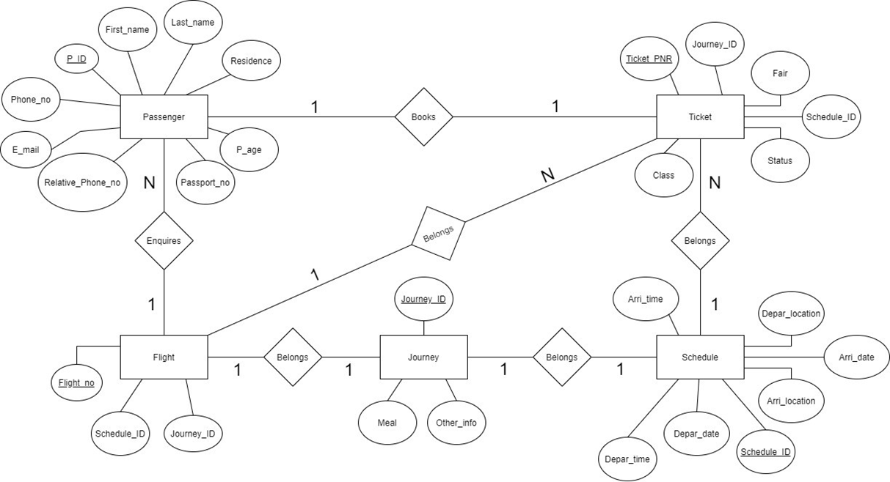

**IV. Relational Model**

Each entity has been translated into a relational schema:

Passenger(P_ID, First_Name, Last_Name, P_age, Residence, Phone_no, Relative_phone_no, Email, Passport_no, Ticket_PNR)

Journey(Journey_ID, Meal, Other_Info)

Schedule(Schedule_ID, Depar_location, Arri_location, Depar_date, Arri_date, Depar_time, Arri_time)

Flight(Flight_no, Schedule_ID, Journey_ID)

Ticket(Ticket_PNR, Journey_ID, Schedule_ID, Fair, Class, Status)

**V. Normalization**

Third Normal Form (3NF) is a database design principle that ensures:

No transitive dependencies exist.

Every non-key attribute is fully dependent only on the primary key.

The database is structured in a way that eliminates redundancy and promotes data integrity.

📦 How 3NF is Applied in Our Project

Our Airport Management System database strictly follows 3NF by organizing data across multiple related tables, each focused on a single entity. Here’s how:

1. Passenger Table

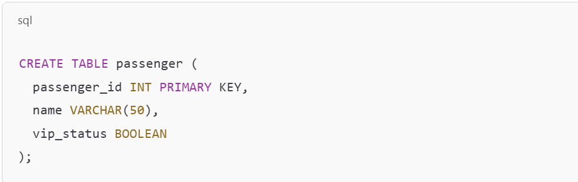

* Each attribute depends only on the primary key passenger_id.
* Passenger-related data is not mixed with tickets or flights.
* No transitive dependencies.

2. Flight Table

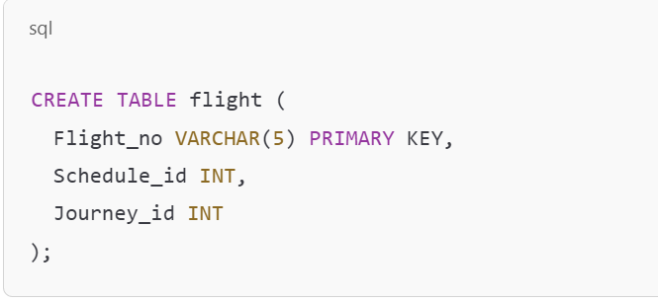

* Flight_no is the primary key.
* Foreign keys Schedule_id and Journey_id link to other normalized tables.
* All attributes depend only on the primary key.

3. Ticket Table

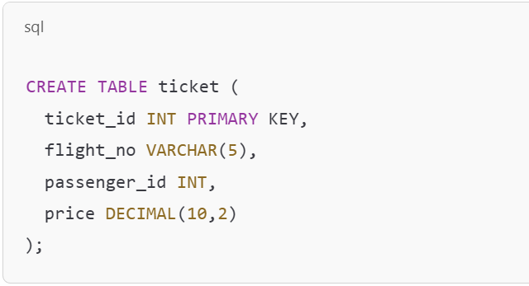

* Connects passengers and flights through foreign keys.
* Ticket table does not store passenger names or flight times.
* Ensures data is only stored once, avoiding duplication.

**VI. SQL Queries**

1. Find the information of the passengers who are below 18 years.

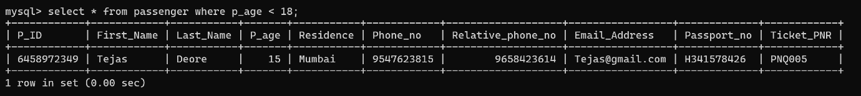select * from passenger where p_age < 18;

1. Find the departure time and date ofticket PNR = PNQ002.

select depar_date, depar_time from schedule where schedule_id=(select schedule_id from ticket where ticket_PNR='PNQ002');

1. Find the ticket_pnr whose ticket is not confirmed.

select ticket_pnr from ticket where status='NOT CONFIRMED';

1. Show the passenger’s name along with the class in which they will travel.

select passenger.First_Name as "Passenger Name", ticket.class as "Class" from ticket inner join passenger on passenger.Ticket_PNR=ticket.ticket_PNR;

1. Show name, passport number, class and ticket PNR of all the passengers.

select passenger.first_name as "Passenger Name", passenger.passport_no as "Passport Number", ticket.class as "Class" ,ticket.Ticket_pnr as "Ticket PNR" from passenger left join ticket on Ticket.ticket_pnr=passenger.ticket_pnr order by class;

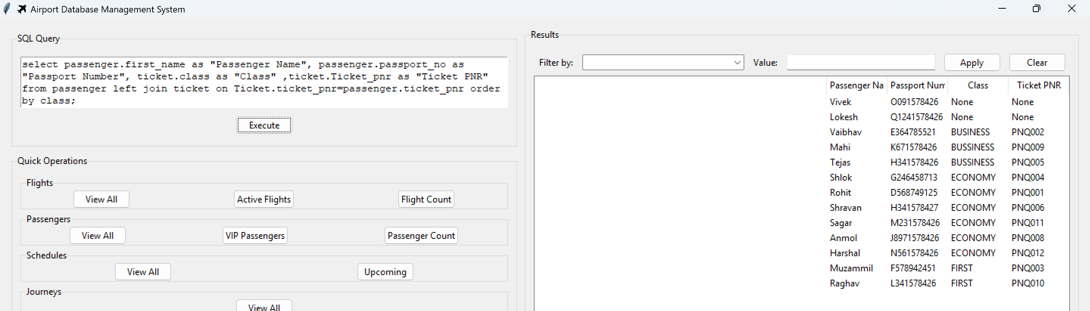

1. Find the Phone number and name of the passenger who is going to Dubai select first_name as "Name", phone_no as "Phone Number" from passenger where ticket_pnr=(select ticket_pnr from ticket where schedule_id=(select schedule_id from schedule where arri_location='Dubai'));

1. Find total number of passengers.

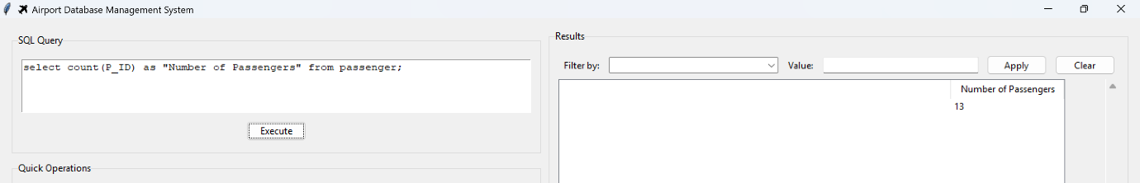select count(P_ID) as "Number of Passengers" from passenger;

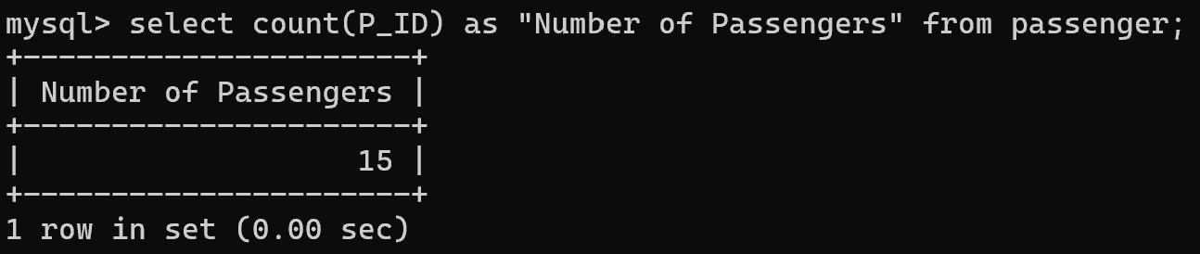

1. Find the flight number going to New York.

select flight_no from flight where schedule_id=(select schedule_id from schedule where Arri_location='New York');

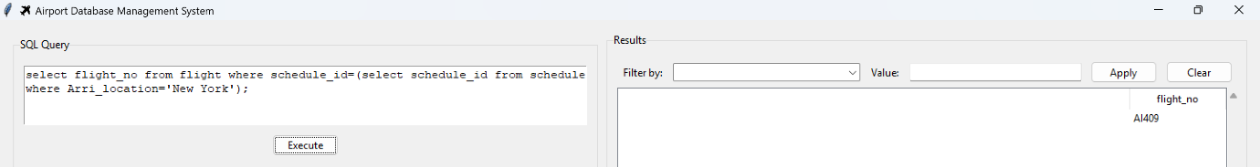

1. Find the Flights coming from Dubai, before 30/10/21.

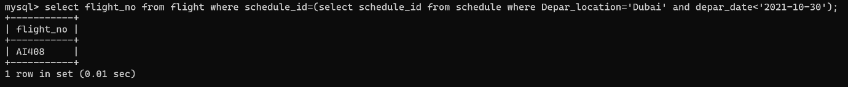select flight_no from flight where schedule_id=(select schedule_id from schedule where Depar_location='Dubai' and depar_date<'2021-10-30');

1. Find passengers residing in Mumbai.

select * from passenger where residence='Mumbai';

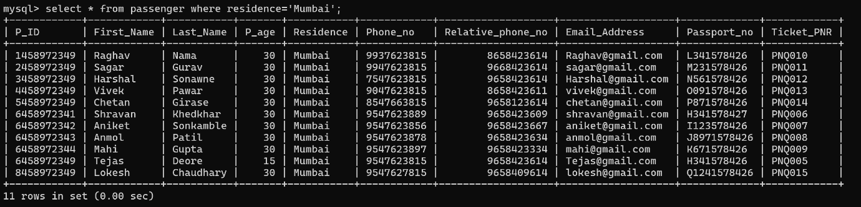

1. Find the ticket PNR of Raghav.

select Ticket_pnr from passenger where first_name='Rohit';

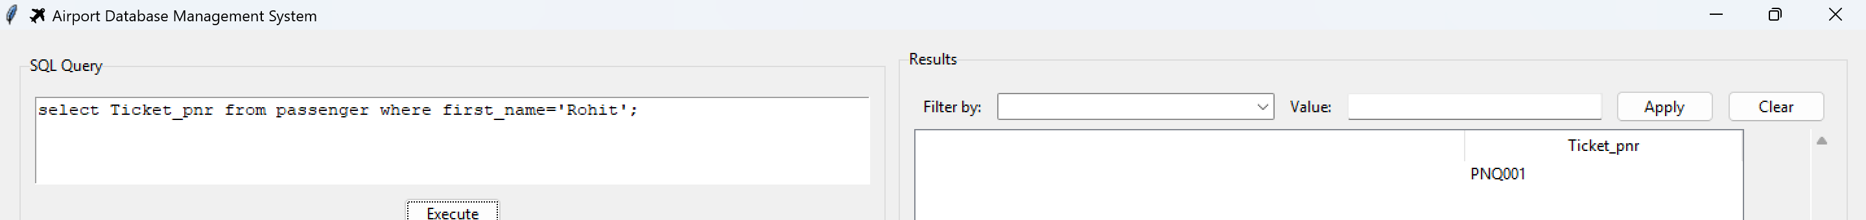

1. List the details of customer

whose phone number start with 64.

select * from passenger where phone_no like '64%';

**VI. Project demonstration**

* **Tools Used:** MySQL 5.5 Command Line Clint
* **Technologies:** SQL, ER Diagram Tools
* **Screenshots:**

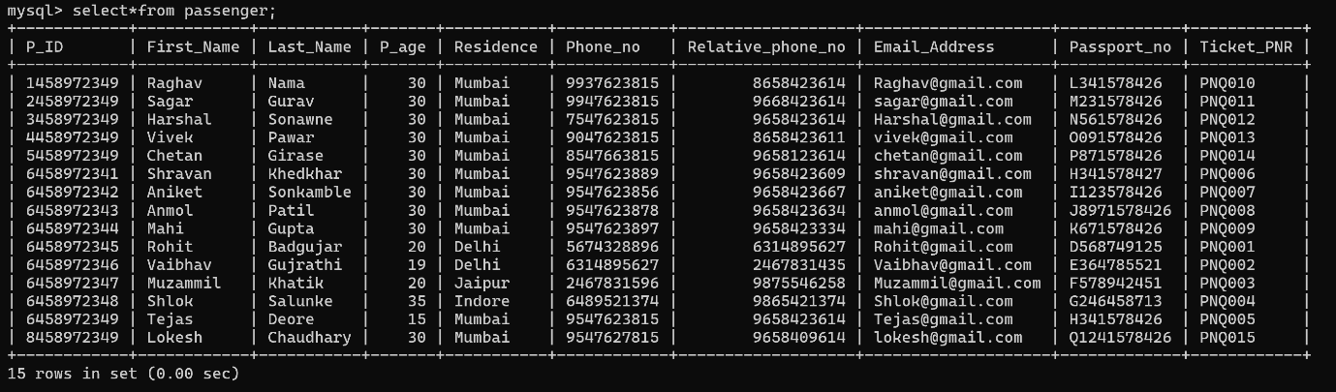

**VII. Self -Learning beyond classroom**

:

Use of real-life airline system modeling

Learned advanced SQL joins and subqueries

Explored normalization beyond BCNF

Used ER diagram tools for clear design representation

**VIII. Learning from the Project**

Practical understanding of DBMS principles

Team collaboration and project documentation SQL

proficiency and database design experience

**IX. Challenges Faced**

Mapping entity relationships with multiple dependencies

Data insertion errors due to foreign key constraints

Time formatting issues in SQL Server

**X. Conclusion**

The Airport Management System successfully demonstrates a real-world DBMS application. The project enhanced our understanding of relational databases, normalization, and SQL querying, and laid a foundation for more advanced data systems development.