nanoGPT Hyperparameter Optimization
Detailed experimental report | Members 3 and 4
Shakespeare character-level language modeling • 64 completed configurations
Prepared from recovered experiment_results.csv and graph artifacts. This document covers only Members 3 and 4; the team report must integrate Members 1 and 2.

1. Objective and experimental design
The objective was to compare nanoGPT configurations on character-level next-token prediction using the Shakespeare dataset. Member 3 tested four transformer layers; Member 4 tested six. Each member evaluated the full factorial grid of attention heads (4/8), embedding widths (128/256), batch sizes (8/16), training iterations (1,000/2,000), and dropout (0.1/0.2), giving 32 configurations per member and 64 in total. Block size remained 128.
Parameter | Member 3 | Member 4
Transformer layers | 4 | 6
Attention heads | 4, 8 | 4, 8
Embedding dimension | 128, 256 | 128, 256
Batch size | 8, 16 | 8, 16
Maximum iterations | 1,000, 2,000 | 1,000, 2,000
Dropout | 0.1, 0.2 | 0.1, 0.2
Block size | 128 | 128
Training used the nanoGPT implementation on Google Colab with an NVIDIA Tesla T4 GPU and the Shakespeare character-level dataset. The notebook preparation output reported 1,003,854 training tokens, 111,540 validation tokens, and vocabulary size 65. Runs recorded final training and validation losses, elapsed time, and completion status.

2. Member-wise performance
Metric | Member 3 | Member 4
Completed runs | 32 | 32
Mean training loss | 2.1067 | 2.0584
Mean validation loss | 2.1661 | 2.1347
Sum of recorded run times (s) | 770.65 | 1069.55
The six-layer group achieved a mean validation loss lower by 0.0314 (about 1.45%) than the four-layer group. Recorded elapsed time was higher for Member 4. One Member 3 run has no elapsed-time value, so the reported sums do not constitute a complete matched time comparison.
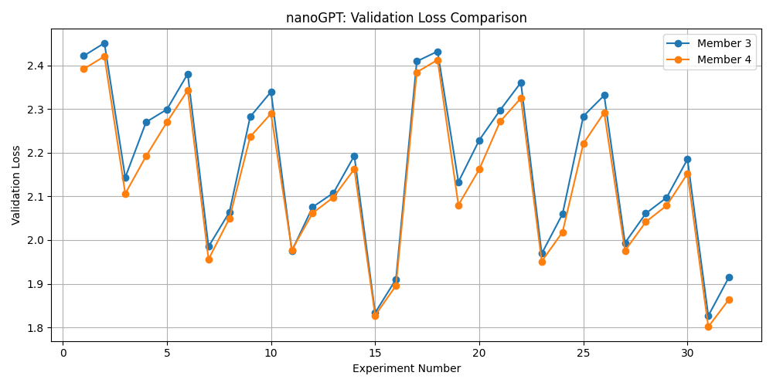
Figure 1. Final validation loss for all 32 configurations per member.
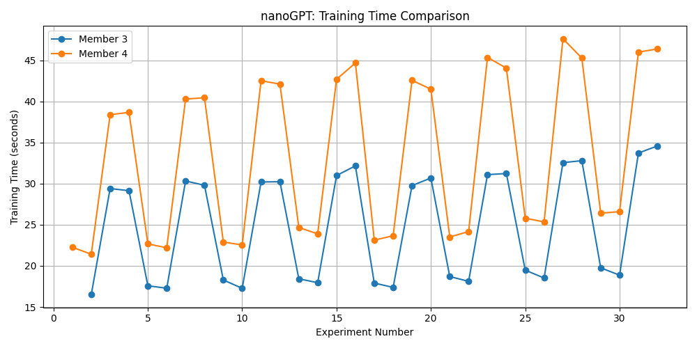
Figure 2. Recorded training time per experiment; missing values are not interpreted as zero.

3. Hyperparameter analysis
The following averages aggregate the 64 completed configurations. Because the grid is balanced, they provide descriptive comparisons across the tested settings. They do not establish causal effects outside the experimental setup or statistical significance across independent training seeds.
n_layer: 4: 2.1661; 6: 2.1347
n_head: 4: 2.1566; 8: 2.1443
n_embd: 128: 2.2262; 256: 2.0746
batch_size: 8: 2.2212; 16: 2.0797
max_iters: 1000: 2.2882; 2000: 2.0127
dropout: 0.1: 2.1152; 0.2: 2.1857
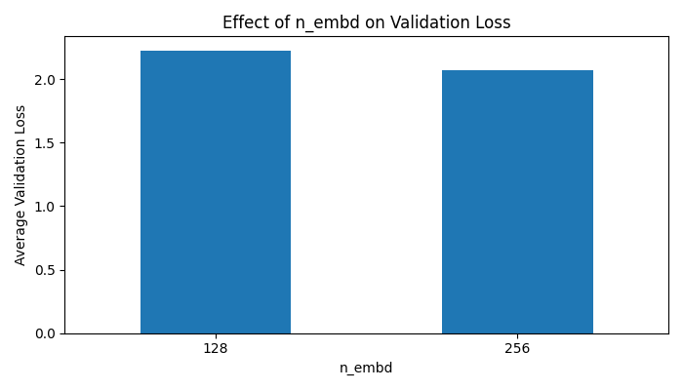
Figure 3. Embedding width and mean validation loss.
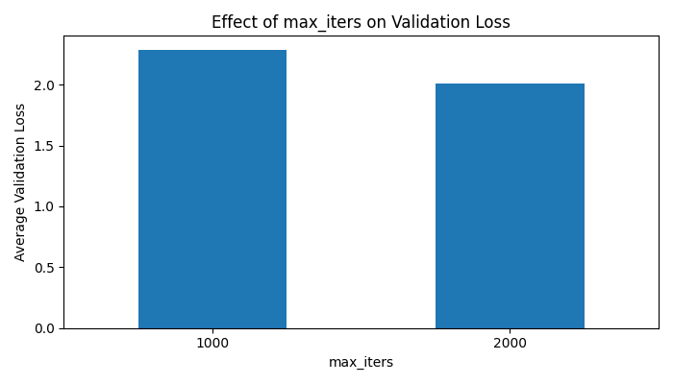
Figure 4. Iteration budget and mean validation loss.
The strongest mean separation was between 1,000 and 2,000 iterations, followed by embedding dimension and batch size. Increasing batch size or iterations also changes the number of training tokens processed, so those comparisons should not be interpreted as equal-compute comparisons. Dropout 0.1 performed better than 0.2 on average in this grid.

4. Best-performing model
Field | Value
member | 4
experiment | 31
block_size | 128
n_layer | 6
n_head | 8
n_embd | 256
batch_size | 16
max_iters | 2000
dropout | 0.1
train_loss | 1.6346
val_loss | 1.8013
training_time_sec | 45.99
Member 4, Experiment 31 had the lowest observed validation loss (1.8013) and training loss of 1.6346, with a gap of 0.1667. The original notebook reported approximately 4.77 million parameters and generated Shakespeare-like speaker labels and fragments, although many sentences were not coherent. This is a qualitative observation, not a quantitative language-quality score.

5. Additional factor comparisons
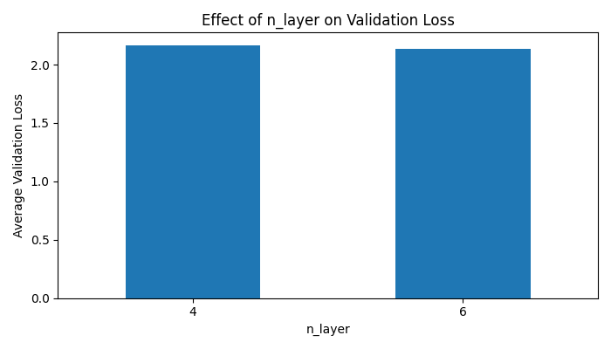
Figure 5. Transformer depth comparison.
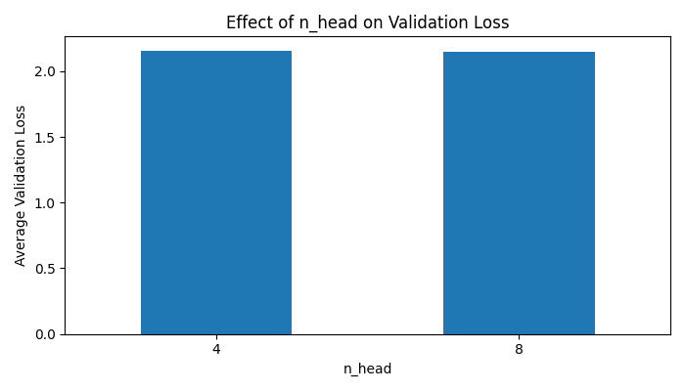
Figure 6. Attention-head comparison.
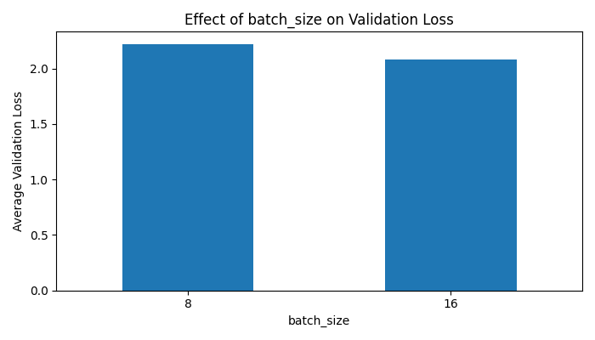
Figure 7. Batch-size comparison.
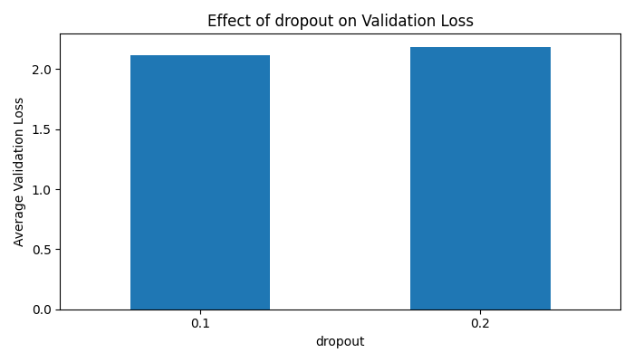
Figure 8. Dropout comparison.

6. Recovery and reproducibility notes
All 64 experiment records are present in the recovered final CSV. Earlier Google Drive synchronization/storage problems left only 50 records in the original CSV. Member 4 Experiments 19–32 were reconstructed from saved notebook training outputs, and the original 50-record CSV was preserved as a backup. The final results archive includes the restored CSV and eight regenerated graphs, but not every original training log or model checkpoint. Specifically, some Member 4 training artifacts for later experiments were unavailable in the checked Drive folders. The archived measurements are not substitutes for those missing files.
To reproduce the work, retain the original Colab notebook, nanoGPT source version, dataset preparation steps, full experiment grid, final CSV, and available logs. Training anew may yield different losses because only one recorded run per configuration is available.

7. Conclusion
Across the 64 recorded nanoGPT runs, the six-layer configurations produced slightly lower average validation loss than the four-layer configurations. The best recorded setting was Member 4 Experiment 31: six layers, eight heads, embedding width 256, batch size 16, 2,000 iterations, and dropout 0.1. Its final validation loss was 1.8013. The findings favor larger embedding width and longer training within this limited grid, while demonstrating trade-offs in training time and incomplete evidence of generated-text coherence.

Appendix A. Complete experiment summary
Each row lists the final metrics recorded for one experiment. Times are seconds; “—” indicates a missing time measurement.

Member 3: 32 experiments
Exp | Heads | Emb | Batch | Iters | Drop | Train | Val | Time
1 | 4 | 128 | 8 | 1000 | 0.1 | 2.3992 | 2.4216 | —
2 | 4 | 128 | 8 | 1000 | 0.2 | 2.4274 | 2.4512 | 16.50
3 | 4 | 128 | 8 | 2000 | 0.1 | 2.0899 | 2.1433 | 29.40
4 | 4 | 128 | 8 | 2000 | 0.2 | 2.2374 | 2.2701 | 29.14
5 | 4 | 128 | 16 | 1000 | 0.1 | 2.2804 | 2.2992 | 17.58
6 | 4 | 128 | 16 | 1000 | 0.2 | 2.3631 | 2.3805 | 17.28
7 | 4 | 128 | 16 | 2000 | 0.1 | 1.9014 | 1.9850 | 30.32
8 | 4 | 128 | 16 | 2000 | 0.2 | 2.0222 | 2.0638 | 29.80
9 | 4 | 256 | 8 | 1000 | 0.1 | 2.2216 | 2.2822 | 18.28
10 | 4 | 256 | 8 | 1000 | 0.2 | 2.2952 | 2.3396 | 17.27
11 | 4 | 256 | 8 | 2000 | 0.1 | 1.8727 | 1.9752 | 30.20
12 | 4 | 256 | 8 | 2000 | 0.2 | 2.0027 | 2.0756 | 30.23
13 | 4 | 256 | 16 | 1000 | 0.1 | 2.0555 | 2.1080 | 18.43
14 | 4 | 256 | 16 | 1000 | 0.2 | 2.1549 | 2.1931 | 17.95
15 | 4 | 256 | 16 | 2000 | 0.1 | 1.6880 | 1.8335 | 30.98
16 | 4 | 256 | 16 | 2000 | 0.2 | 1.7840 | 1.9101 | 32.16
17 | 8 | 128 | 8 | 1000 | 0.1 | 2.3847 | 2.4092 | 17.91
18 | 8 | 128 | 8 | 1000 | 0.2 | 2.4141 | 2.4321 | 17.38
19 | 8 | 128 | 8 | 2000 | 0.1 | 2.0746 | 2.1331 | 29.76
20 | 8 | 128 | 8 | 2000 | 0.2 | 2.1882 | 2.2288 | 30.68
21 | 8 | 128 | 16 | 1000 | 0.1 | 2.2743 | 2.2973 | 18.70
22 | 8 | 128 | 16 | 1000 | 0.2 | 2.3447 | 2.3608 | 18.12
23 | 8 | 128 | 16 | 2000 | 0.1 | 1.8873 | 1.9690 | 31.09
24 | 8 | 128 | 16 | 2000 | 0.2 | 2.0133 | 2.0598 | 31.23
25 | 8 | 256 | 8 | 1000 | 0.1 | 2.2295 | 2.2836 | 19.48
26 | 8 | 256 | 8 | 1000 | 0.2 | 2.2881 | 2.3314 | 18.52
27 | 8 | 256 | 8 | 2000 | 0.1 | 1.8797 | 1.9936 | 32.55
28 | 8 | 256 | 8 | 2000 | 0.2 | 1.9888 | 2.0610 | 32.79
29 | 8 | 256 | 16 | 1000 | 0.1 | 2.0317 | 2.0973 | 19.76
30 | 8 | 256 | 16 | 1000 | 0.2 | 2.1481 | 2.1851 | 18.87
31 | 8 | 256 | 16 | 2000 | 0.1 | 1.6845 | 1.8266 | 33.72
32 | 8 | 256 | 16 | 2000 | 0.2 | 1.7872 | 1.9157 | 34.57

Member 4: 32 experiments
Exp | Heads | Emb | Batch | Iters | Drop | Train | Val | Time
1 | 4 | 128 | 8 | 1000 | 0.1 | 2.3716 | 2.3916 | 22.26
2 | 4 | 128 | 8 | 1000 | 0.2 | 2.4060 | 2.4207 | 21.42
3 | 4 | 128 | 8 | 2000 | 0.1 | 2.0246 | 2.1062 | 38.38
4 | 4 | 128 | 8 | 2000 | 0.2 | 2.1374 | 2.1921 | 38.66
5 | 4 | 128 | 16 | 1000 | 0.1 | 2.2631 | 2.2700 | 22.67
6 | 4 | 128 | 16 | 1000 | 0.2 | 2.3394 | 2.3428 | 22.20
7 | 4 | 128 | 16 | 2000 | 0.1 | 1.8259 | 1.9561 | 40.28
8 | 4 | 128 | 16 | 2000 | 0.2 | 1.9451 | 2.0491 | 40.44
9 | 4 | 256 | 8 | 1000 | 0.1 | 2.2123 | 2.2366 | 22.90
10 | 4 | 256 | 8 | 1000 | 0.2 | 2.2752 | 2.2896 | 22.54
11 | 4 | 256 | 8 | 2000 | 0.1 | 1.8217 | 1.9776 | 42.51
12 | 4 | 256 | 8 | 2000 | 0.2 | 1.9274 | 2.0619 | 42.10
13 | 4 | 256 | 16 | 1000 | 0.1 | 2.0070 | 2.0980 | 24.67
14 | 4 | 256 | 16 | 1000 | 0.2 | 2.1022 | 2.1627 | 23.89
15 | 4 | 256 | 16 | 2000 | 0.1 | 1.6618 | 1.8275 | 42.68
16 | 4 | 256 | 16 | 2000 | 0.2 | 1.7413 | 1.8956 | 44.67
17 | 8 | 128 | 8 | 1000 | 0.1 | 2.3645 | 2.3844 | 23.13
18 | 8 | 128 | 8 | 1000 | 0.2 | 2.3992 | 2.4126 | 23.66
19 | 8 | 128 | 8 | 2000 | 0.1 | 1.9962 | 2.0802 | 42.56
20 | 8 | 128 | 8 | 2000 | 0.2 | 2.1087 | 2.1620 | 41.48
21 | 8 | 128 | 16 | 1000 | 0.1 | 2.2612 | 2.2713 | 23.51
22 | 8 | 128 | 16 | 1000 | 0.2 | 2.3212 | 2.3250 | 24.17
23 | 8 | 128 | 16 | 2000 | 0.1 | 1.8078 | 1.9512 | 45.34
24 | 8 | 128 | 16 | 2000 | 0.2 | 1.9144 | 2.0184 | 44.05
25 | 8 | 256 | 8 | 1000 | 0.1 | 2.1973 | 2.2209 | 25.79
26 | 8 | 256 | 8 | 1000 | 0.2 | 2.2774 | 2.2920 | 25.35
27 | 8 | 256 | 8 | 2000 | 0.1 | 1.8148 | 1.9756 | 47.61
28 | 8 | 256 | 8 | 2000 | 0.2 | 1.9112 | 2.0417 | 45.27
29 | 8 | 256 | 16 | 1000 | 0.1 | 1.9941 | 2.0790 | 26.41
30 | 8 | 256 | 16 | 1000 | 0.2 | 2.0859 | 2.1522 | 26.59
31 | 8 | 256 | 16 | 2000 | 0.1 | 1.6346 | 1.8013 | 45.99
32 | 8 | 256 | 16 | 2000 | 0.2 | 1.7186 | 1.8646 | 46.37

