nanoGPT: Architecture and Hyperparameter Experiments
Student Report Draft — My 64 Experiments
Dataset: character-level Shakespeare | Architecture: GPT-style decoder-only Transformer | Experiment grid: 64 of 128 planned configurations
Scope note: This is a source-grounded draft for Member 1. The second member’s 64 configurations (block size 128) and the professor’s exact 17 code-reading question answers are not included.

1. Introduction
For this assignment, we worked with nanoGPT to see how changing the model settings affects its results. We trained the model on Shakespeare text at the character level, which means it learns to predict the next character instead of the next whole word. I mainly wanted to see which settings gave a lower validation loss, how long the runs took, and whether the generated text actually looked like Shakespeare.

2. Architecture and code overview
When I looked through model.py, the main parts were the attention layer, the Transformer block, the model configuration, and the GPT class. The attention mask is important because the model should only use characters it has already seen, not characters that come later. Each block combines attention with another neural network layer, and the residual connections help information move through the model.
In train.py, the program reads the prepared data, makes batches of input and target characters, and updates the model during training. For our experiments I used a separate run for every setting. I kept gradient accumulation at 1, checked the loss every 100 iterations, used 20 evaluation batches, and turned compilation off. The runs used float16 on the Colab GPU. The sample.py file is used later to load a saved model and generate text.
This is just my understanding of the main files. The individual code-reading questions from the assignment still need to be added separately.

3. Experimental methodology
I used the Shakespeare character dataset provided with nanoGPT. After preparing it, there were 1,003,854 training tokens, 111,540 validation tokens, and 65 unique characters. Since we have two people in the group, I worked on the 64 experiments with block_size set to 64. My teammate is handling the other 64 experiments with block_size set to 128.
Hyperparameter | Values tested in Member 1
block_size | 64 (fixed)
n_layer | 4, 6
n_head | 4, 8
n_embd | 128, 256
batch_size | 8, 16
max_iters | 1000, 2000
dropout | 0.1, 0.2
For my part, I changed six settings: number of layers, attention heads, embedding size, batch size, training iterations, and dropout. Each one had two possible values, so that made 64 combinations in total. I ran them using a Colab script instead of starting each one manually. The script saved the logs, losses, training time, and checkpoint information. The losses in the tables are the last evaluation losses written in each log.

4. Quantitative results
All 64 of my experiments finished, and none were marked as failed. Together they took about 27.44 minutes. The average final validation loss was 2.2280. The best result was exp_047, which reached a validation loss of 1.9359. I used validation loss to compare the models because it gives a better idea of how the model performs on text it was not trained on.
Rank | ID | Layers | Heads | Embedding | Batch | Iters | Dropout | Train | Val
1 | exp_047 | 6 | 4 | 256 | 16 | 2000 | 0.1 | 1.7746 | 1.9359
2 | exp_063 | 6 | 8 | 256 | 16 | 2000 | 0.1 | 1.7966 | 1.9448
3 | exp_015 | 4 | 4 | 256 | 16 | 2000 | 0.1 | 1.7954 | 1.9512
4 | exp_031 | 4 | 8 | 256 | 16 | 2000 | 0.1 | 1.8055 | 1.9524
5 | exp_048 | 6 | 4 | 256 | 16 | 2000 | 0.2 | 1.8673 | 2.0013
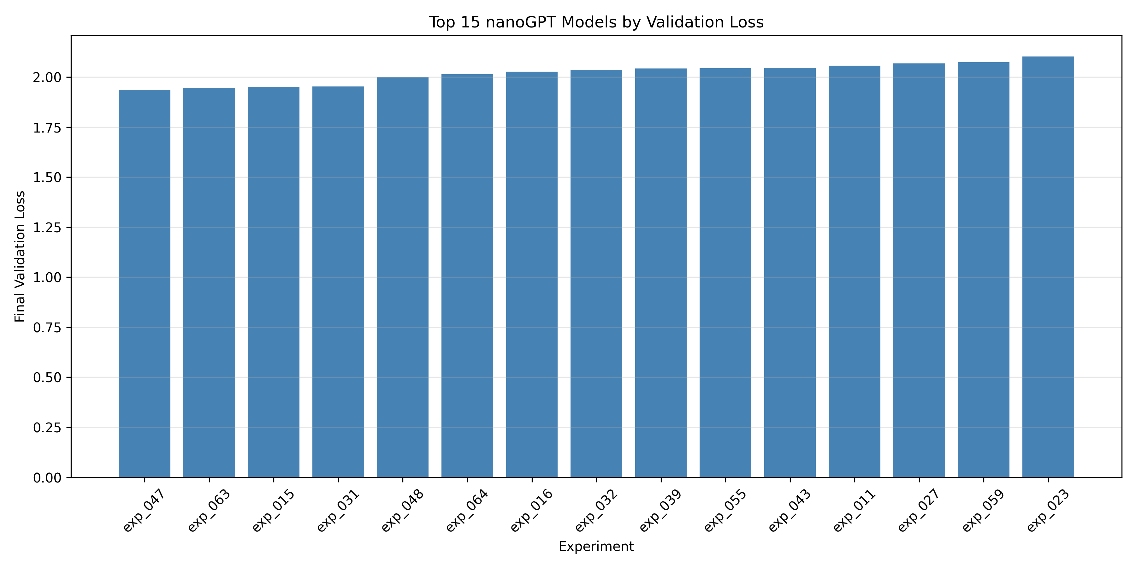
Figure 1. Top 15 experiments ranked by final validation loss.

5. Hyperparameter effects
Training iterations: The 2,000-iteration runs averaged 2.1105 validation loss, compared with 2.3455 for the 1,000-iteration runs. So, in these experiments, training longer generally helped.
Embedding size: Models with 256 embeddings averaged 2.1598, while models with 128 averaged 2.2962. The larger embedding size seemed useful here.
Dropout: A dropout of 0.1 averaged 2.2009, which was a little better than 0.2 at 2.2552. More dropout was not automatically better in this setup.
Layers: Six-layer models averaged 2.2156, compared with 2.2405 for four layers. The difference was there, but it was not very large.
Attention heads: Four heads averaged 2.2269 and eight heads averaged 2.2291. These were almost the same, so increasing the head count did not make much difference in the overall average.
Batch size: Batch size 16 averaged 2.1722, compared with 2.2839 for batch size 8. The larger batch worked better on average for this set of runs.
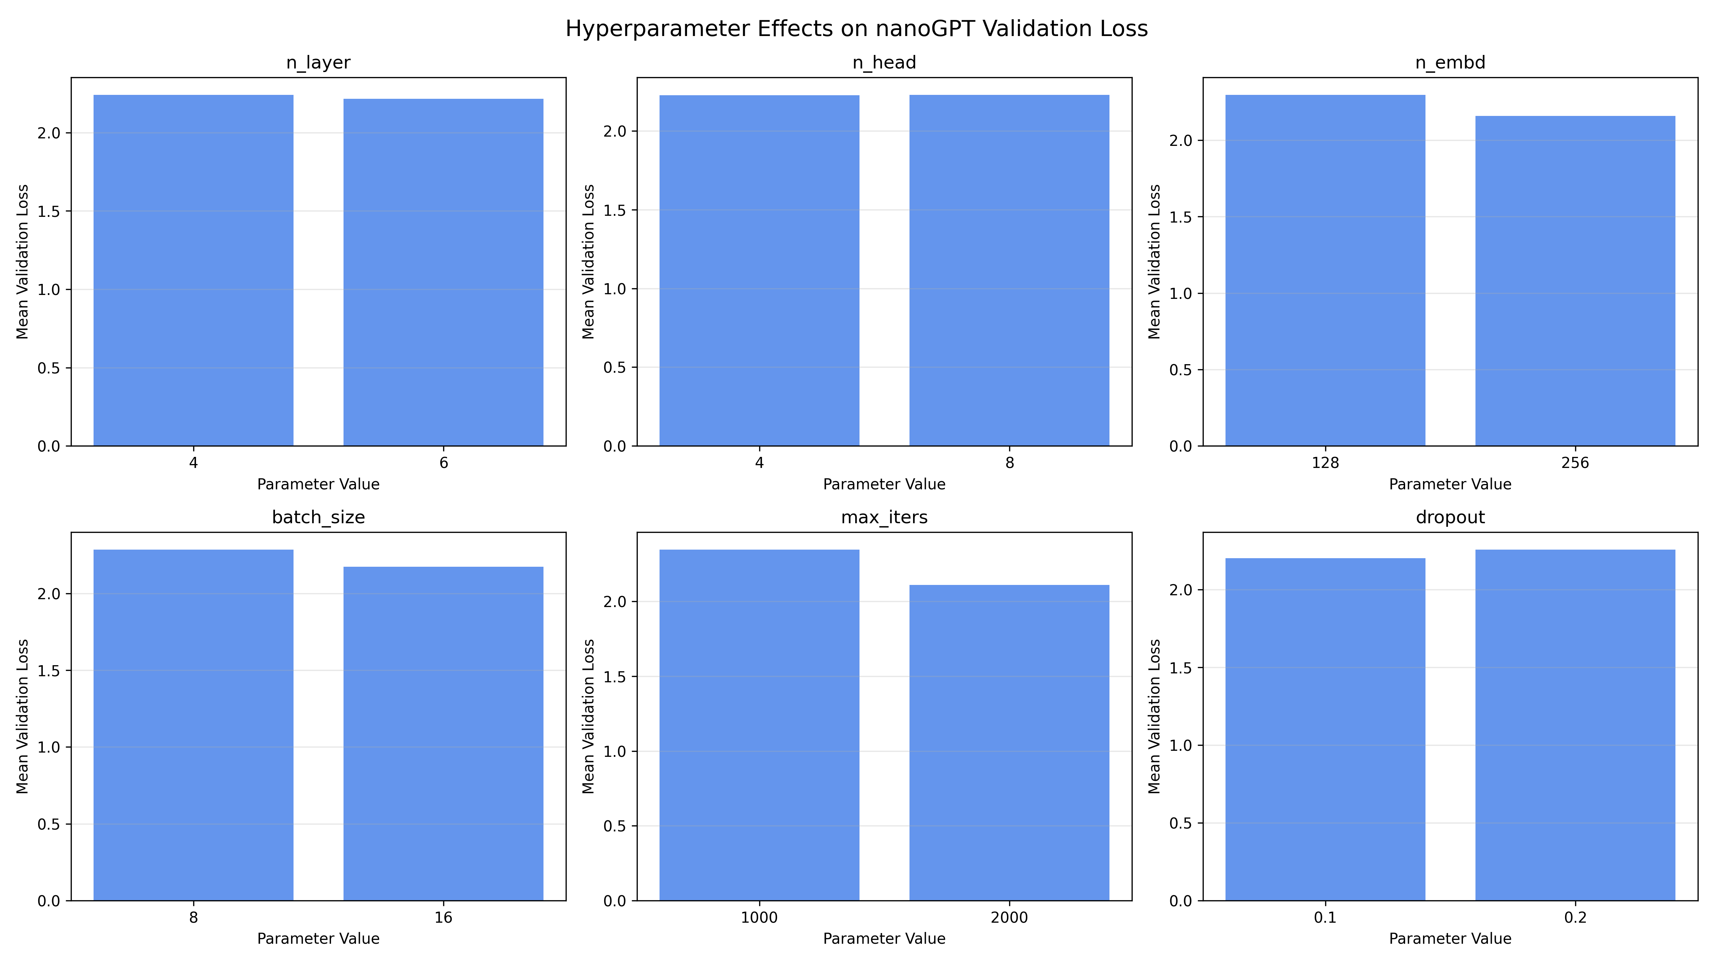
Figure 2. Mean final validation loss grouped by hyperparameter value.
Looking at these averages, the clearest improvements came from using 2,000 iterations and an embedding size of 256. I also noticed that a lower dropout value worked slightly better. But these are averages from my runs, not proof that one setting will always be better. The other settings also change from experiment to experiment.

6. Training efficiency
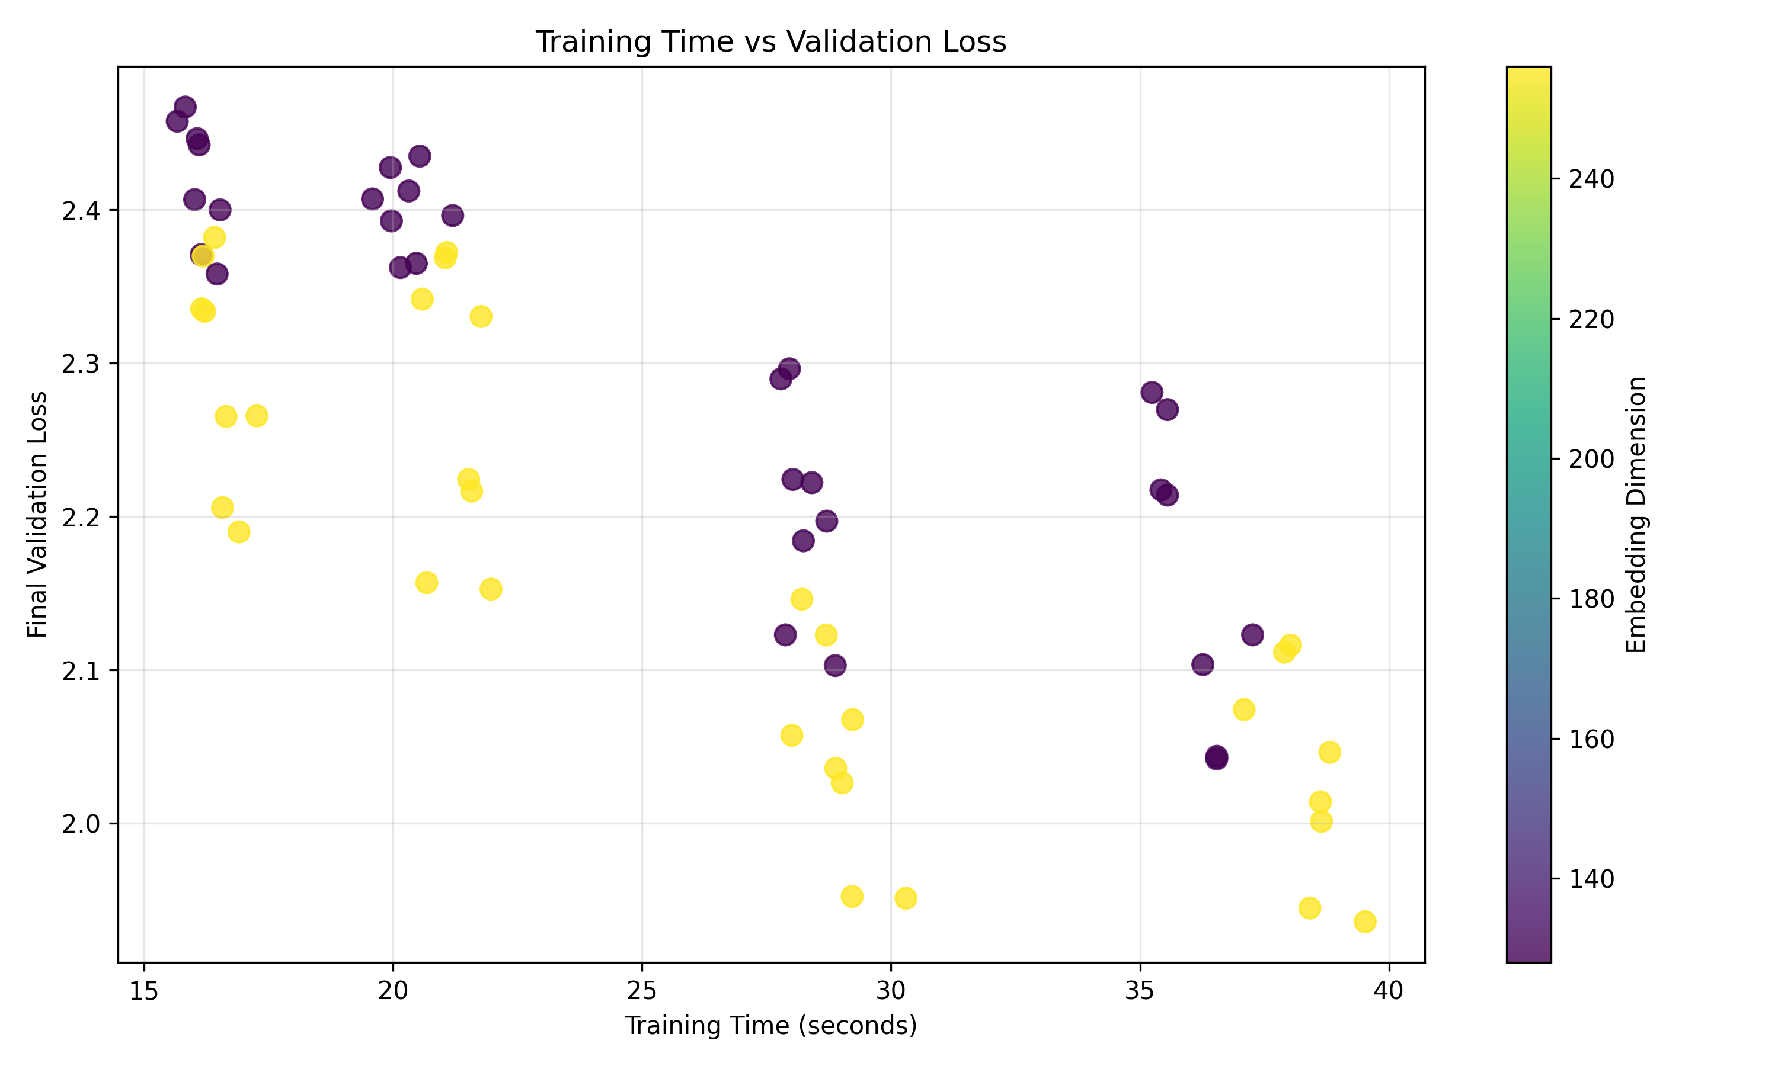
Figure 3. Training time versus final validation loss; point color indicates embedding width.
I also compared the training time with validation loss. Some longer runs had better losses, which makes sense because the model had more time to learn. Still, spending more time did not always mean getting the best result. For example, exp_047 took 39.52 seconds and gave the lowest validation loss in my results. These times are from my Colab session, so they might be different on another GPU.

7. Generalization and learning curves
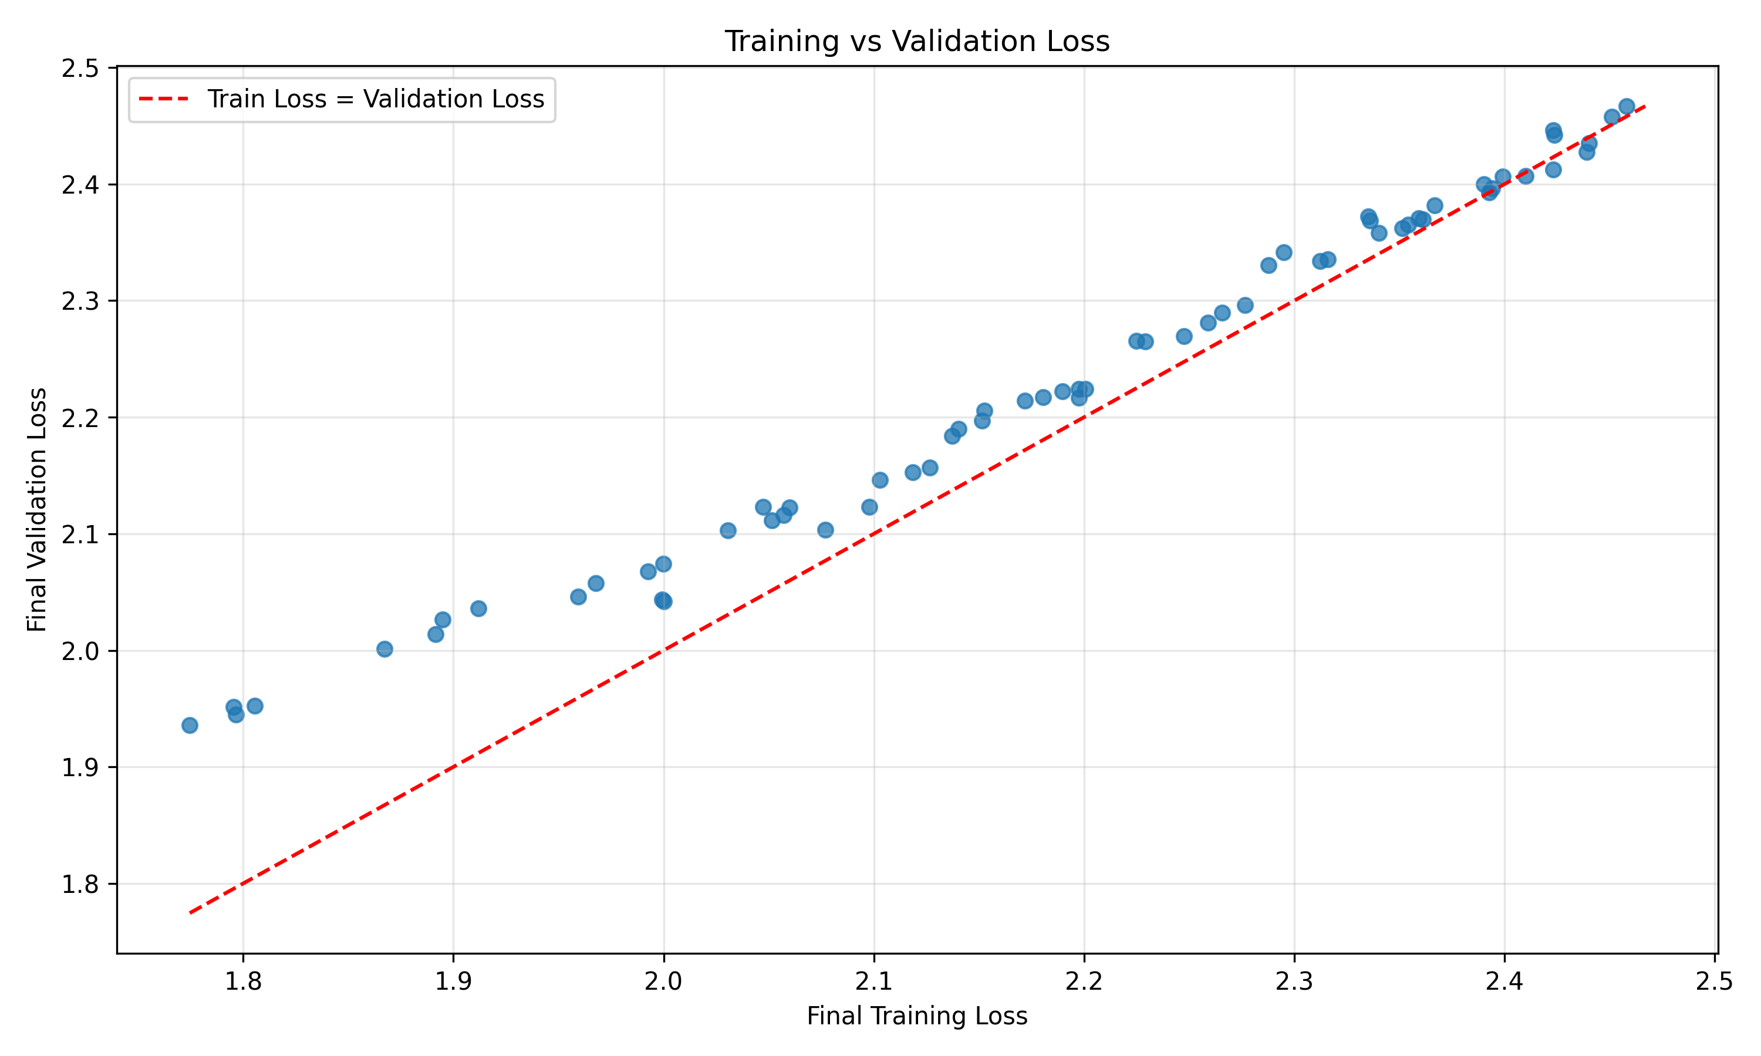
Figure 4. Final training loss versus validation loss; the diagonal indicates equal losses.
For exp_047, the training loss ended at 1.7746 and the validation loss at 1.9359. The difference is 0.1613. That tells me the model performed a bit better on the training data than on the validation data. I would not call this serious overfitting just from that number, but it is something worth checking in the loss curves.
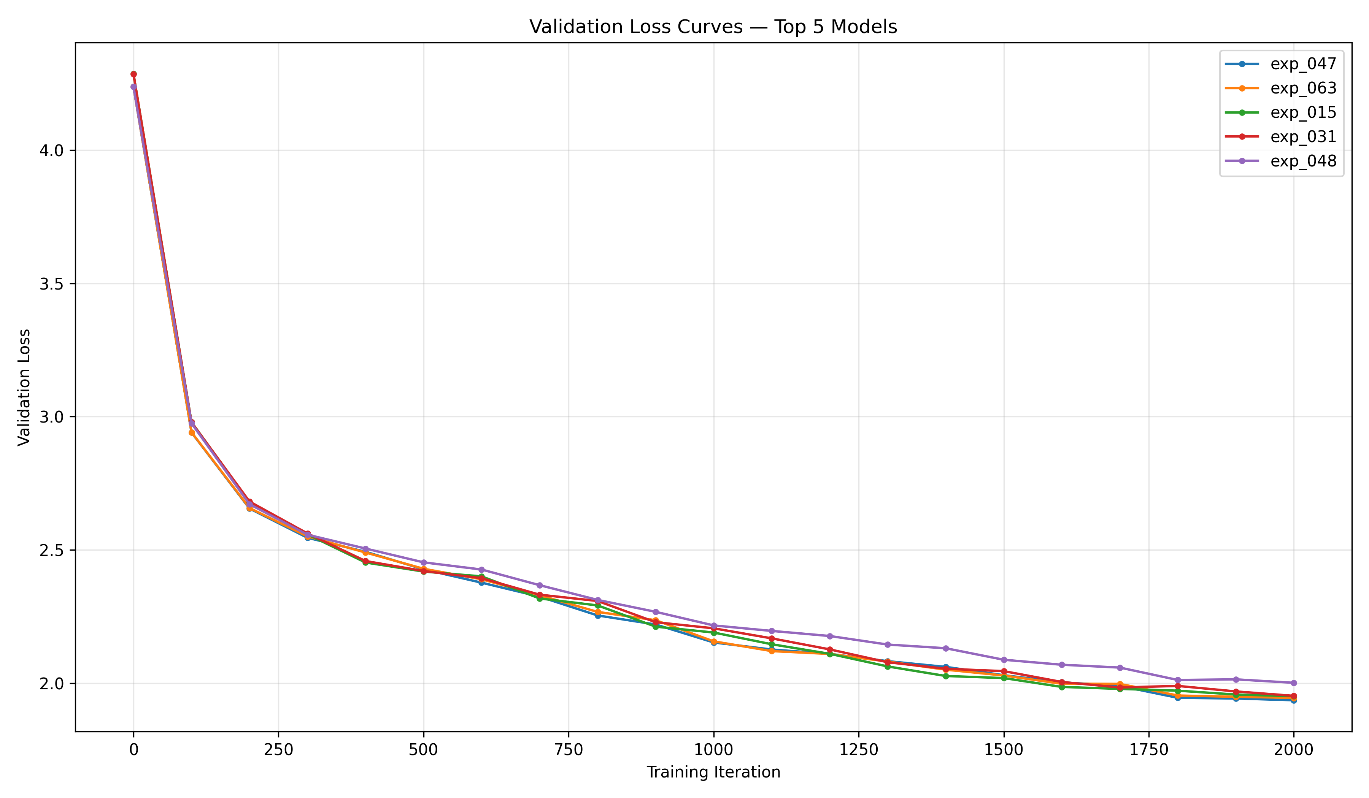
Figure 5. Validation-loss trajectories of the five best configurations.
The loss curves helped me see how the better models changed during training, rather than only looking at their final scores. One thing to keep in mind is that some models ran for 1,000 iterations and others for 2,000. So the final results are useful, but comparing them at the same iteration would be fairer when discussing how quickly they learned.

8. Text generation: best checkpoint
After training, I loaded the saved checkpoint for exp_047 and tested text generation with sample.py. The model had about 4.74 million parameters. I used temperature 0.8, top-k 40, and asked it to generate three samples of 300 new tokens each. Sampling ran on CPU after I restored the checkpoint from the backup.
Part of the generated output was: ‘VINCES: Cone, his are like love thee seet roughter. LOUCES: Ter, I’ll wourd mut and a mobe ...’
The output was interesting because it did look a little like a play. It used speaker names, colons, and short dialogue-style lines. But a lot of the words did not make sense, and the sentences were not really meaningful. My impression is that the model picked up the style and character patterns better than the actual meaning. I only included a short excerpt here; the full text file should be attached with the final submission.

9. Limitations and reproducibility
There are a few limits to these results. First, I only ran the block_size=64 half, so I cannot say which model is best out of all 128 experiments yet. We also did not repeat each configuration with different random seeds, which means the results could change a little between runs. Finally, training time depends on the Colab machine. I saved the CSV results, training logs, graphs, and the best checkpoint so the work can be checked later.
For reproducibility, I used nanoGPT at commit 3adf61e154c3fe3fca428ad6bc3818b27a3b8291 and prepared the dataset with data/shakespeare_char/prepare.py. The main files were model.py, train.py, and sample.py. I selected the best model using the lowest final validation loss.

10. Conclusion
Overall, I learned that even a small GPT model can give noticeably different results when we change its training settings. In my 64 experiments, exp_047 did best with a validation loss of 1.9359. Longer training and larger embeddings generally helped, while changing the number of attention heads did not have much effect on the average loss. The text generation was not perfect, but it showed that the model had learned some Shakespeare-like formatting. Once my teammate's experiments are added, we can compare both context lengths and make a final conclusion for the full project.

Appendix: remaining items before final submission
Still to finish: (1) add my teammate's exp_065–exp_128 results and update the graphs, (2) answer the 17 code-reading questions from the handout, (3) attach the complete generated samples and GitHub link, and (4) confirm that our two-person split is acceptable for the assignment.

