**SIT725 – APPLIED SOFTWARE ENGINEERING**

**TASK - 3.2P GETTING GRAPHICAL**

**GitHub Link:** [**https://github.com/rohitbondala277/SIT725/tree/master/week3**](https://github.com/rohitbondala277/SIT725/tree/master/week3)

**Code:**

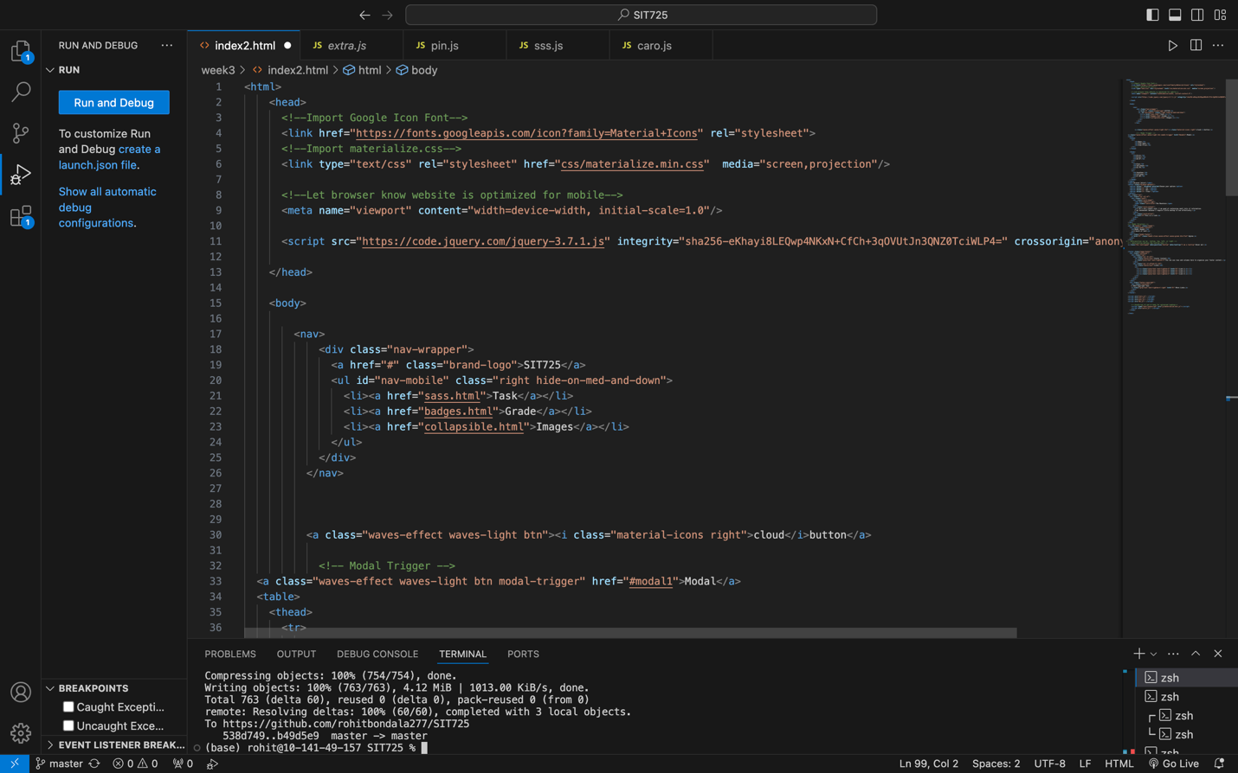

**Results from Browser after running the Code:**

In this webpage using the materialize I have inserted an toolbar, a table , a button and a modal, a footer, a hover me button that pops up a message when hovered onto it, a dropdown box and an image card.

