Docker explanation:
Docker is a container management service. The keywords of Docker are develop, ship and run anywhere. The whole idea of Docker is for developers to easily develop applications, ship them into containers which can then be deployed anywhere.
For example: Lets consider a linux based application which has been written both in Ruby and Python. This application requires a specific version of Linux, Ruby and Python. In order to avoid any version conflicts on user’s end, a Linux Docker container can be created with the required versions of Ruby and Python installed along with the application. Now the end users can use the application easily by running this container without worrying about the dependencies or any version conflicts.
What is Virtualization?
Virtualization is the technique of importing a Guest operating system on top of a Host operating system. This technique was a revelation at the beginning because it allowed developers to run multiple operating systems in different virtual machines all running on the same host. This eliminated the need for extra hardware resource.
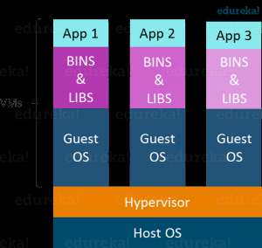

The advantages of Virtual Machines or Virtualization are:
- Multiple operating systems can run on the same machine
- Maintenance and Recovery were easy in case of failure conditions
- Total cost of ownership was also less due to the reduced need for infrastructure
As you know nothing is perfect, Virtualization also has some shortcomings. Running multiple Virtual Machines in the same host operating system leads to performance degradation. This is because of the guest OS running on top of the host OS, which will have its own kernel and set of libraries and dependencies. This takes up a large chunk of system resources, i.e. hard disk, processor and especially RAM.
Another problem with Virtual Machines which uses virtualization is that it takes almost a minute to boot-up. This is very critical in case of real-time applications.
Following are the disadvantages of Virtualization:
Running multiple Virtual Machines leads to unstable performance
Hypervisors are not as efficient as the host operating system
Boot up process is long and takes time
What is hypervisor :
A hypervisor (or virtual machine monitor, VMM, virtualizer) is computer software, firmware or hardware that creates and runs virtual machines.A computer on which a hypervisor runs one or more virtual machines is called a host machine, and each virtual machine is called a guest machine. The hypervisor presents the guest operating systems with a virtual operating platform and manages the execution of the guest operating systems

What is Containerization?
Containerization is the technique of bringing virtualization to the operating system level. While Virtualization brings abstraction to the hardware, Containerization brings abstraction to the operating system. Do note that Containerization is also a type of Virtualization. Containerization is however more efficient because there is no guest OS here and utilizes a host’s operating system, share relevant libraries & resources as and when needed unlike virtual machines. Application specific binaries and libraries of containers run on the host kernel, which makes processing and execution very fast. Even booting-up a container takes only a fraction of a second. Because all the containers share, host operating system and holds only the application related binaries & libraries. They are lightweight and faster than Virtual Machines.
Advantages of Containerization over Virtualization:
Containers on the same OS kernel are lighter and smaller
Better resource utilization compared to VMs
Boot-up process is short and takes few seconds
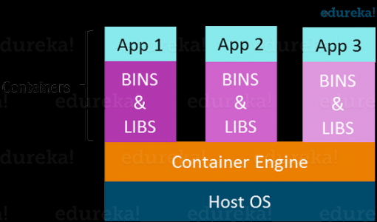

Virtualization vs Containerization
Virtualization and Containerization both let you run multiple operating systems inside a host machine.
Virtualization deals with creating many operating systems in a single host machine. Containerization on the other hand will create multiple containers for every type of application as required.
