**What is GitHub?**

GitHub is a Git repository hosting service. GitHub also facilitates with many of its features, such as access control and collaboration. It provides a Web-based graphical interface.

GitHub is an American company. It hosts source code of your project in the form of different programming languages and keeps track of the various changes made by programmers.

It offers both distributed version control and source code management (SCM) functionality of Git. It also facilitates with some collaboration features such as bug tracking, feature requests, task management for every project.

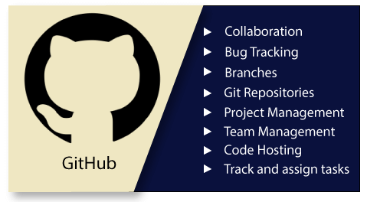

**Git vs SVN:**

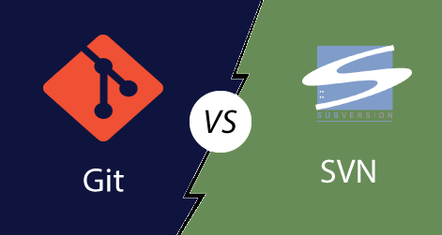

|  |  |
| --- | --- |
| **Git** | **SVN** |
| It's a distributed version control system. | It's a Centralized version control system |
| Git is an SCM (source code management). | SVN is revision control. |
| Git has a cloned repository. | SVN does not have a cloned repository. |
| Git stored content as metadata. | SVN stores content as files. |
| Git has more content protection than SVN. | SVN's content is less secure than Git. |
| Git is distributed under GNU (General public license). | SVN is distributed under the open-source license. |

Localized Version Control System:

The localized version control method is a common approach because of its simplicity. But this approach leads to a higher chance of error. In this approach, you may forget which directory you're in and accidentally write to the wrong file or copy over files you don't want to.

Centralized Version Control System:

The developers needed to collaborate with other developers on other systems. The localized version control system failed in this case. To deal with this problem, Centralized Version Control Systems were developed.

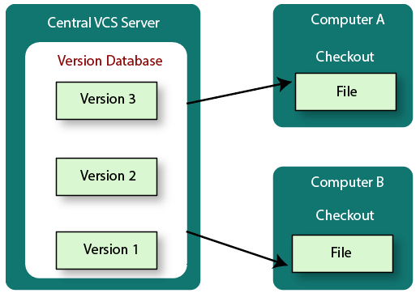

Distributed Version Control System

Centralized Version Control System uses a central server to store all the database and team collaboration. But due to single point failure, which means the failure of the central server, developers do not prefer it. Next, the Distributed Version Control System is developed.

In a Distributed Version Control System (such as Git, Mercurial, Bazaar or Darcs), the user has a local copy of a repository. So, the clients don't just check out the latest snapshot of the files even they can fully mirror the repository. The local repository contains all the files and metadata present in the main repository.

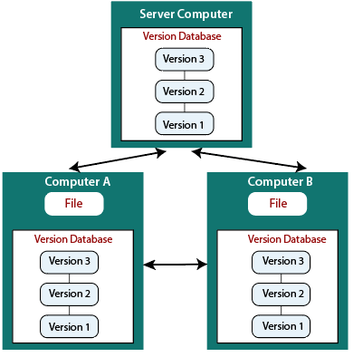

|  |  |
| --- | --- |
| **Centralized Version Control System** | **Distributed Version Control System** |
| In CVCS, The repository is placed at one place and delivers information to many clients. | In DVCS, Every user has a local copy of the repository in place of the central repository on the server-side. |
|  |  |
| It is the most straightforward system based on the concept of the central repository. | It is flexible and has emerged with the concept that everyone has their repository. |
| In CVCS, the server provides the latest code to all the clients across the globe. | In DVCS, every user can check out the snapshot of the code, and they can fully mirror the central repository. |
| CVCS is easy to administrate and has additional control over users and access by its server from one place. | DVCS is fast comparing to CVCS as you don't have to interact with the central server for every command. |
| The popular tools of CVCS are **SVN** (Subversion) and **CVS**. | The popular tools of DVCS are **Git** and **Mercurial**. |
| CVCS is easy to understand for beginners. | DVCS has some complex process for beginners. |
| If the server fails, No system can access data from another system. | if any server fails and other systems were collaborating via it, that server can restore any of the client repositories |