Department of Computer Engineering
Program name :- Computer Engineering Class: S.Y. B. Tech
Div:- A
Name of Student: Rohit Pradipkumar Chaudhari Batch:- A2 Course Name:- Engineering Economics
PRN No :- 251110023 Roll No:- 12122 Sem :- 3rd Course :- Engineering Economics

 | 
SMARTBRIDGE | SKILLWALLET
SaveIQ – Smart Savings: Savings Goal Management Web Application
Project Description :-
SaveIQ is a web-based savings-goal management application that helps users define financial targets, record the amount already saved, and monitor progress through a clear dashboard. Users can create goals by entering a goal name, target amount, current savings, deadline, and category.
The dashboard summarizes active goals, total savings, total target amount, and overall progress. Each goal card displays its saved amount, target amount, and completion percentage, while an overall progress ring presents the saved and remaining totals. The application uses Google Sheets as its data store and Google Apps Script for server-side processing and web app hosting.
The current project implements the core dashboard and savings-goal workflow. The repository notes that AI Insights is currently a placeholder, while transaction management and settings screens are not yet implemented. The project is designed as a responsive web interface and formats financial values in Indian rupees.
Technology & AI :-
Frontend: HTML5 / CSS3 / JavaScript
Backend: Google Apps Script
Data Storage: Google Sheets with Users, Goals, Transactions, and Settings sheets
Goal Processing: Create savings goals, validate amounts, calculate totals, and display progress
Hosting: Google Apps Script web app deployment
Source Control: GitHub repository — https://github.com/rohitchaudhari13/SaveIQ

Key Features :-
- Savings dashboard with active goal count, total saved, total target, and overall progress
- Create a savings goal with name, target amount, amount already saved, deadline, and category
- Goal cards showing saved amount, target amount, and percentage completed
- Overall progress ring with saved and remaining amounts
- Google Sheets storage for goals and supporting data tables
- Responsive layout for desktop and smaller screens
- Financial amounts displayed in Indian rupees (₹)
- Guided goal-creation form with basic field validation
Scenarios :-
Scenario 1: A user opens SaveIQ and reviews the dashboard summary, including active goals, total saved, total target, and overall progress.
Scenario 2: A user selects New Goal or Add goal and enters a goal name, positive target amount, amount already saved, optional deadline, and category.
Scenario 3: After the user creates a goal, the dashboard refreshes to show the new goal card, saved amount, target amount, and percentage progress.
Scenario 4: A user reviews the overall progress ring and remaining amount to understand how much more needs to be saved toward the combined targets.
Milestones :-
Milestone 1 – Project Planning & UI/UX Design
Define the savings-goal use case and design a clear dashboard with summary cards, goal progress cards, an overall progress ring, and a goal-creation modal.
Milestone 2 – Google Apps Script Backend
Implement the Apps Script entry point and reusable HTML templates to serve the web application.
Milestone 3 – Google Sheets Data Storage
Create and initialize the spreadsheet tables used for users, goals, transactions, and settings; implement goal retrieval, creation, and dashboard totals.
Milestone 4 – Goal Progress and Validation
Validate goal names and monetary amounts, calculate progress from saved and target amounts, and display saved and remaining totals.
Milestone 5 – Testing, Documentation & Deployment
Review the main goal-creation workflow, document the application, maintain the source code on GitHub, and deploy the web app through Google Apps Script.
Conclusion :-
SaveIQ provides a focused way to set savings targets and track progress. Its dashboard combines goal creation, per-goal progress indicators, and overall savings totals in a single interface, with Google Sheets providing the underlying data storage.
Expected Outcome :-
The expected outcome is a usable savings-goal dashboard where a user can create a goal, record an initial saved amount, set a target and deadline, and monitor progress through goal cards and an overall summary.

Detailed Technical Documentation
This section provides implementation-oriented documentation for SaveIQ, retaining the original report structure and formatting while adapting the content to the Google Apps Script and Google Sheets project.

1. Detailed User Scenarios

Scenario 1: Review the dashboard
The user opens the deployed SaveIQ web app. The dashboard loads the active-goal count, total saved, total target, overall progress percentage, and the available savings-goal cards.

Scenario 2: Open the goal-creation form
The user selects New Goal or Add goal. A modal form appears with fields for goal name, target amount, amount already saved, deadline, and category.

Scenario 3: Enter and validate goal details
The user supplies a goal name, a target amount greater than zero, and a non-negative saved amount. The deadline and category may also be provided. The form validates the required values before the goal is submitted.

Scenario 4: Create a savings goal
When the user selects Create Goal, the application stores the goal through the Apps Script backend and Google Sheets. The dashboard is refreshed to include the new goal and updated totals.

Scenario 5: Monitor individual goal progress
Each goal card shows the amount saved, target amount, category, and completion percentage. Progress is calculated from the saved amount divided by the target amount, with the displayed value capped at 100%.

Scenario 6: Review overall savings progress
The dashboard combines the saved amounts and target amounts to calculate overall progress. The progress ring and remaining amount help the user understand the current position against all targets.

2. Technical Architecture
SaveIQ follows a browser–application–spreadsheet architecture. HTML, CSS, and JavaScript render the interface in the browser. Google Apps Script serves the web app and handles goal-related operations. Google Sheets stores the application tables and goal records.
User / Browser
↓
HTML + CSS + JavaScript interface
↓ Apps Script calls
Google Apps Script backend
↓ read / write data
Google Sheets (Users, Goals, Transactions, Settings)
The project reads the spreadsheet identifier from the SPREADSHEET_ID Script Property. The repository README instructs the developer to initialize the sheets using setupDatabase and verify the connection with testDatabase before deploying the web app.

3. Prerequisites and Environment Setup
Prerequisites include a Google account, access to Google Apps Script, a Google spreadsheet for application data, and a browser. The project source files are maintained in the SaveIQ GitHub repository.

Activity 3.1: Prepare the spreadsheet
Create a Google spreadsheet and copy its spreadsheet ID from the URL. Keep the ID available for the Apps Script configuration step.

Activity 3.2: Create the Apps Script project
Open Google Apps Script, create a project, and add the source files using the filenames listed in the repository README.

Activity 3.3: Add the application files
Copy Code.gs, Database.gs, AI.gs, Notifications.gs, index.html, Styles.html, and Script.html into the Apps Script project, preserving the expected file names.

Activity 3.4: Configure the spreadsheet ID
In Apps Script Project Settings, add the SPREADSHEET_ID Script Property and set its value to the spreadsheet ID. Do not place private credentials in public source files.
SPREADSHEET_ID=your_google_spreadsheet_id

Activity 3.5: Initialize and deploy
Run setupDatabase and grant the requested Google Sheets permissions. Run testDatabase to check the connection, then select Deploy → New deployment and choose Web app.
Open the deployed web app URL. Choose the execution identity and access level appropriate for the intended use. When code changes are made, update the deployment to use the latest version.

4. Backend Implementation and Data Workflow

Activity 4.1: Apps Script application setup
Code.gs serves the web application and includes the reusable HTML files. Apps Script functions provide the server-side operations used by the browser interface.

Activity 4.2: Google Sheets data model
The repository defines Users, Goals, Transactions, and Settings sheets. The Goals table includes goal ID, user ID, name, target amount, saved amount, deadline, category, creation time, and status.

Activity 4.3: Validate and store goals
Goal names are required, target amounts must be greater than zero, and saved amounts cannot be negative. Valid goal data is stored in Google Sheets and used to refresh dashboard totals and goal cards.

Activity 4.4: Main data operations
Function / Component | Type | Purpose
doGet(e) | Apps Script | Serves the SaveIQ web application.
setupDatabase() | Apps Script | Creates the Users, Goals, Transactions, and Settings sheets and headers when needed.
testDatabase() | Apps Script | Checks access to the configured spreadsheet and reports basic database details.
Goal creation workflow | UI + Apps Script | Validates and stores a goal, then refreshes dashboard totals and goal cards.
Dashboard summary | Apps Script + Sheets | Reads goal records and calculates total saved, total target, and progress.

Activity 4.5: Financial calculations
Goal progress = (saved amount ÷ target amount) × 100. Overall progress = (total saved ÷ total target) × 100. Remaining amount = total target − total saved. The dashboard caps the displayed overall progress at 100%.

5. Frontend Page Walkthrough

Activity 5.1: Savings dashboard
The dashboard displays active goals, total saved, total target, and overall progress. Goal cards show their individual progress, and the right-side summary presents the saved and remaining amounts.

Activity 5.2: New Goal action
The New Goal button opens the goal-creation modal. The modal provides fields for the goal name, target amount, already-saved amount, deadline, and category.

Activity 5.3: Goal details and categories
Users can enter a descriptive goal name, set a monetary target, provide an initial saved amount, choose a deadline, and select a category such as General or another available option.

Activity 5.4: Goal progress cards
After a goal is created, its card shows the category, saved amount, target amount, and percentage completed, allowing users to compare progress across goals.

Activity 5.5: Overall progress summary
The overall progress ring visualizes the combined savings progress and lists the saved and remaining amounts. AI Insights, Transactions, and Settings are visible as navigation items, but the repository README identifies these as placeholder or not-yet-implemented functionality.

6. Testing Plan and Evidence
The following are proposed functional tests based on the repository description and supplied interface screenshots. They are not claimed as completed or passed. Execute each test and record the actual result.
Test ID | Test action | Expected result
TC-01 | Open the deployed web app | SaveIQ dashboard loads and displays its summary cards.
TC-02 | Create a goal with valid details | The new goal is saved and appears in the dashboard.
TC-03 | Submit a blank goal name | The form validation prevents an invalid goal from being created.
TC-04 | Enter a target amount of zero or less | The target amount is rejected by validation.
TC-05 | Enter a negative saved amount | The saved amount is rejected by validation.
TC-06 | Create a goal with a deadline and category | The saved goal card shows the supplied details.
TC-07 | Review overall progress | Saved total, target total, remaining amount, and progress are calculated from available goals.
TC-08 | Run setupDatabase and testDatabase | The spreadsheet tables are initialized and the connection test reports database information.
TC-09 | Open AI Insights or Transactions | Confirm actual behavior; the README currently describes these areas as placeholders or not yet implemented.
Testing evidence should include the test input, observed result, date, and PASS/FAIL status. Do not mark a test as passed until it has been executed.

7. Deployment and Source Control

Activity 7.1: Maintain source control
The public GitHub repository contains Code.gs, Database.gs, AI.gs, Notifications.gs, index.html, Styles.html, Script.html, and README documentation. Review the repository README for current setup instructions.

Activity 7.2: Configure deployment
Configure SPREADSHEET_ID in Apps Script Project Settings, initialize the Google Sheets tables, and deploy the application as a web app. Choose the execution and access settings carefully for the intended audience.

Activity 7.3: Verify the deployed application
Open the deployed URL and test dashboard loading, goal creation, input validation, saved amounts, target amounts, deadlines, categories, and progress calculations. Record observed results before describing deployment tests as passed.

8. Application Screenshots
The following screenshots were supplied for this report. They document the SaveIQ dashboard, goal-creation modal, individual goal cards, and updated overall progress. Values shown are demonstration data.
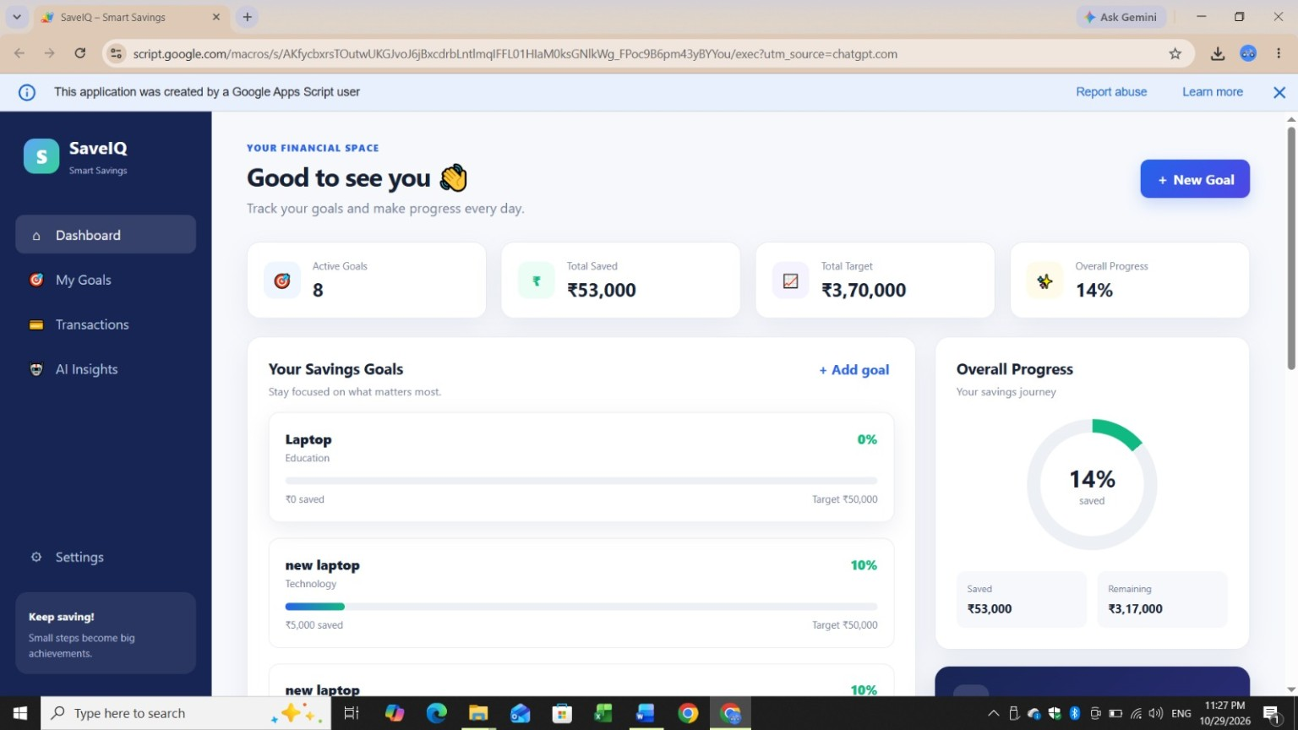
Figure 1. SaveIQ dashboard showing active goals, total saved, total target, and overall progress.
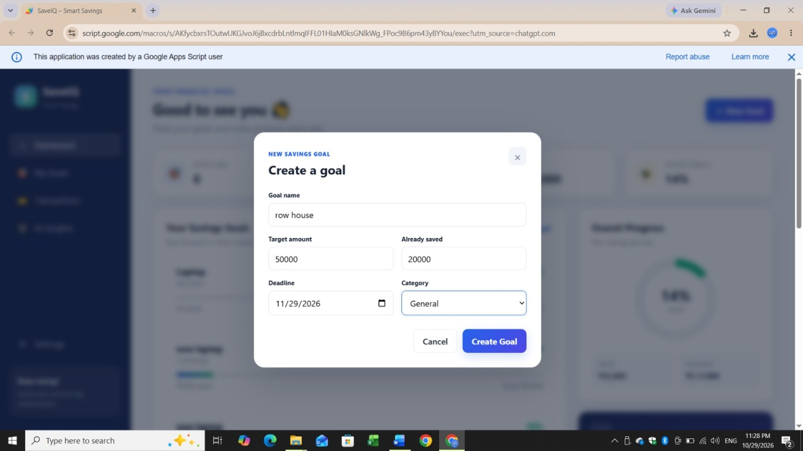
Figure 2. New Savings Goal modal with goal name, target amount, amount already saved, deadline, and category.
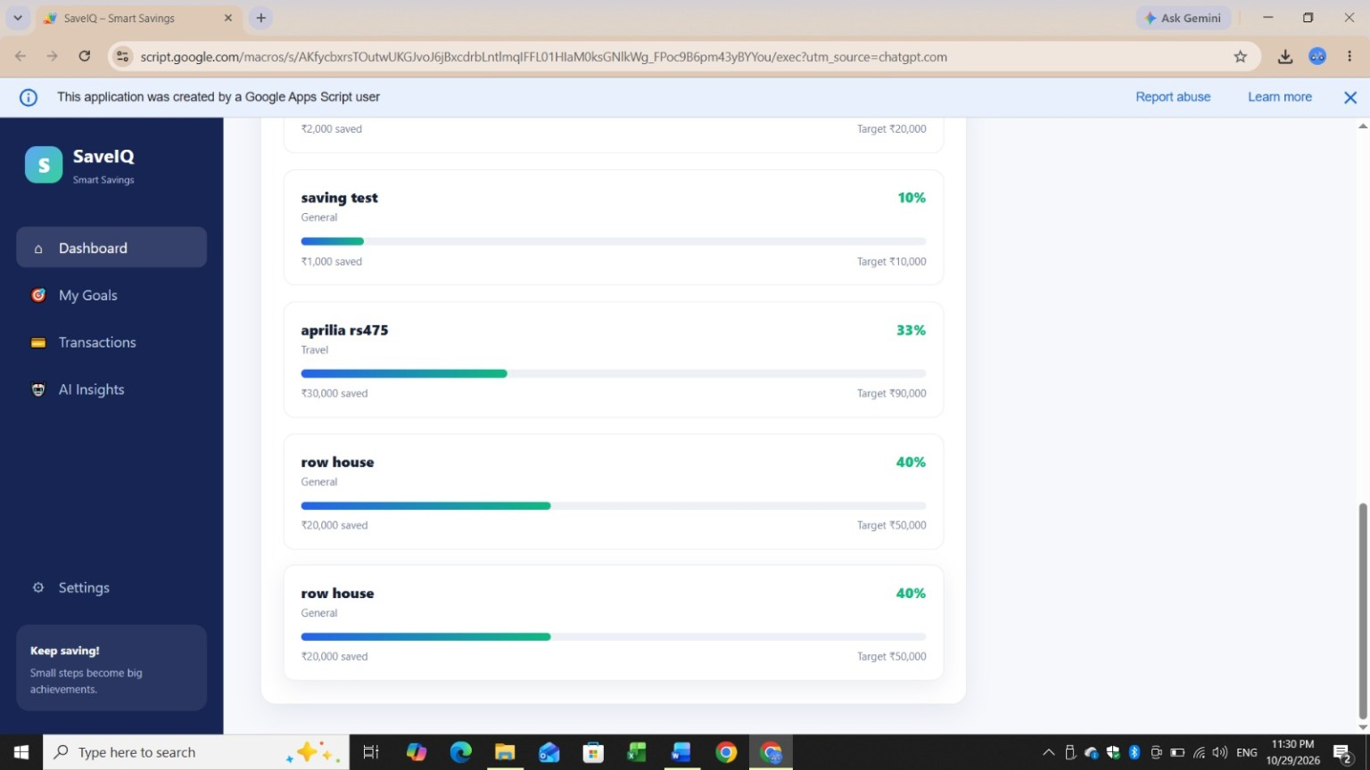
Figure 3. Goal cards showing saved amounts, target amounts, categories, and percentage progress.
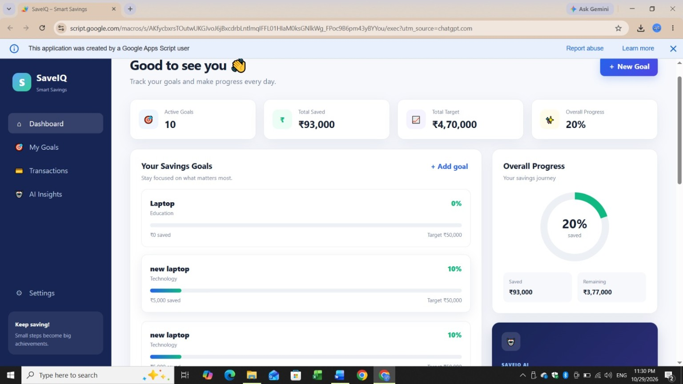
Figure 4. Updated dashboard summary and overall savings progress after goals have been added.

