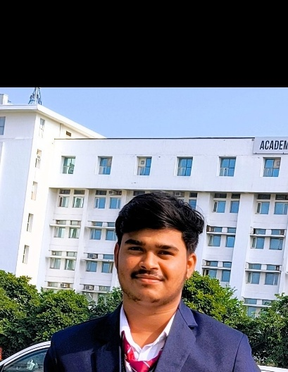

EDUCATION

Bachelors in Computer Science Engineering | Chandigarh University, Gharuan
Session: 2023-2027

Intermediate (CBSE) |Purvanchal Public School, Kauriram
Session: 2021-2023 | Percentage: 61.33%

ROHIT CHAWDHARI

Address: Gorakhpur, Uttar Pradesh
E-mail: rohitchawdhari48@gmail.com

Phone: +91 7307650576
Github: https://github.com/rohitchawdhari

PROFESSIONAL SUMMARY

A passionate and goal-oriented Computer Science Engineering student with strong programming, problem-solving, and research skills. Currently working on an AI-based logistics optimization research paper and seeking hands-on opportunities to grow technically and professionally.

TECHNICAL COMPETENCIES

C++ | DSA | PYTHON | VS CODE

INTERPERSONAL SKILLS

Team Leadership | Management & Coordination | Decision Making
INTERESTS & HOBBIES

Traveling | Online Gaming | Cricket
LANGUAGES KNOWN

English | Hindi

Matriculation (CBSE) | St. Xavier’s High School, Sameda Azamgarh
Session: 2020-2021 | Percentage: 78.17%

TRAINING & PROJECTS

Forage | Virtual Internship – Investment Banking Analyst
March 2025
- Performed M&A target selection and investment analysis using industry-standard frameworks
- Designed presentations and data summaries for client-side recommendations

Forage | Virtual Internship – Software Engineering Intern
March 2025
- Worked on relational database design and software architecture planning
- Practiced advanced data structures and data munging in simulation environment

Research Paper | QuickRetain AI (Conference Presentation)
Chandigarh University |August 2025
- ML/DL-based churn prediction (AUC≈0.91)
- Blinkit vs BigBasket retention analysis
- Emphasized explainable, scalable AI systems

ACADEMIC ACHIEVEMENTS

- Python for Everybody – University of Michigan (Coursera)
- Ranked in top 5% of university coding competition

CERTIFICATIONS & AWARDS

  - Python for Everybody – University of Michigan (Coursera)
  - Team Skills – LinkedIn Learning
  - Interpersonal Skills with Cultural Knowledge & Intrapersonal Awareness
  - Advanced Software Engineering Job Simulation – Forage (March 2025)
  - Investment Banking Job Simulation – Forage (Mar 2025)

EXTRA CURRICULAR & CO-CURRICULAR ACHIEVEMENT

  - 🏏 Winner (1st Place) – Cricket Tournament organized by CSBIZ Nexus Society, Chandigarh University (March 2025)
  - 🔐 Winner (1st Place) – HackTrack: Treasure Hunt by Apex Techno Warriors, Chandigarh University (Feb 2025)

