**TEST CASES:**

**Test case 1:**

No. of processes =11

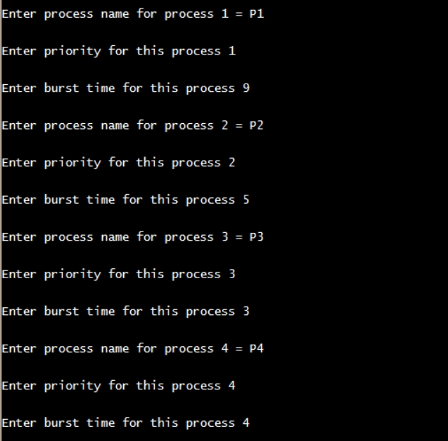

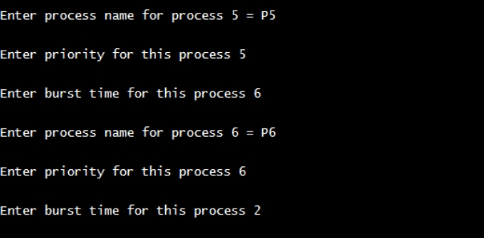

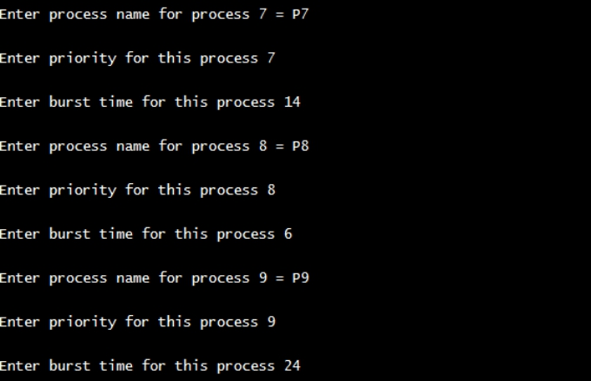

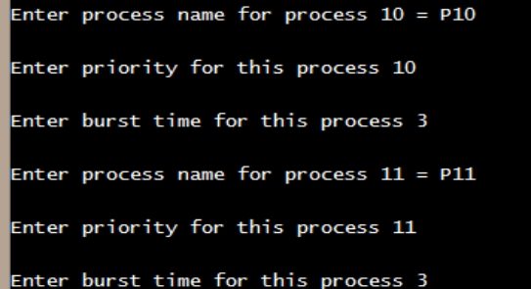

Till now we have entered all the processes with their process IDs , priorities and burst times.

Now let’s distribute all the processes in 3 different queues of our choice.

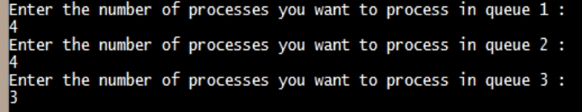

**Round Robin Scheduling on queue 1:**

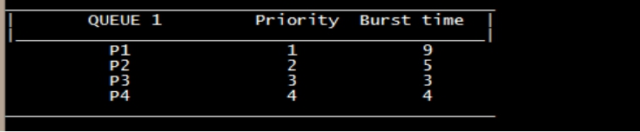

Now enter arrival times :

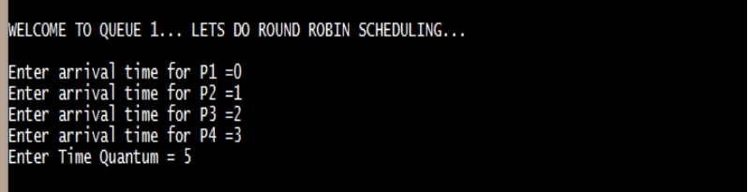

**ANSWER:**

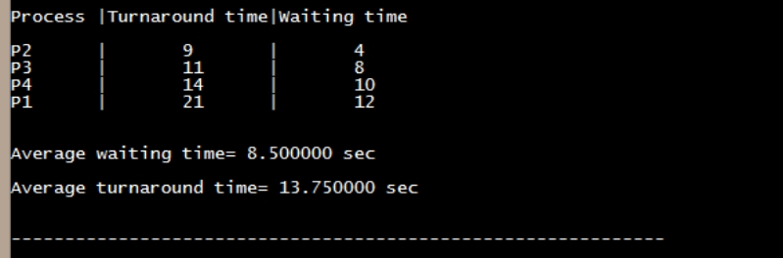

**Priority Scheduling Algorithm on queue 2:**

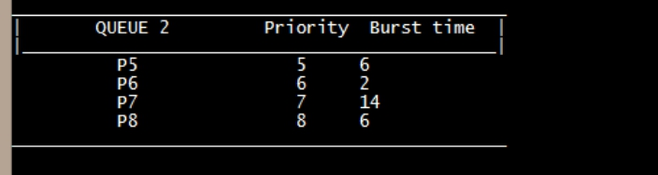

**ANSWER:**

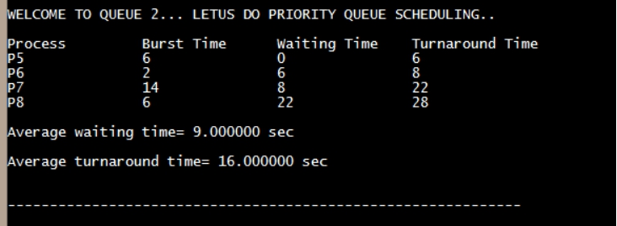

**FCFS Algorithm on queue 3:**

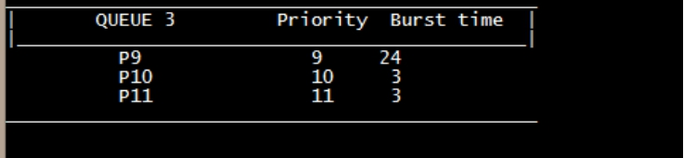

**Answer:**

