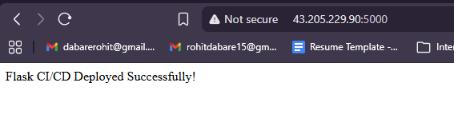
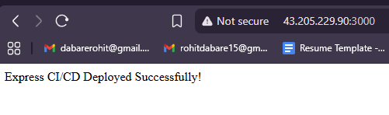
Successful deployment of the pipeline:
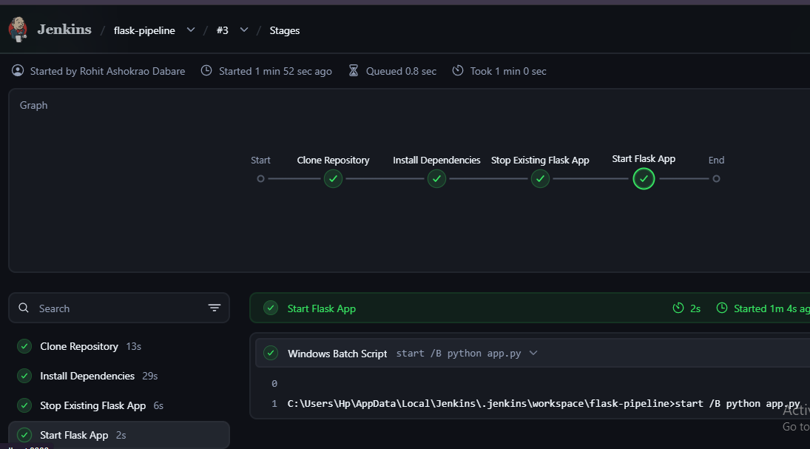
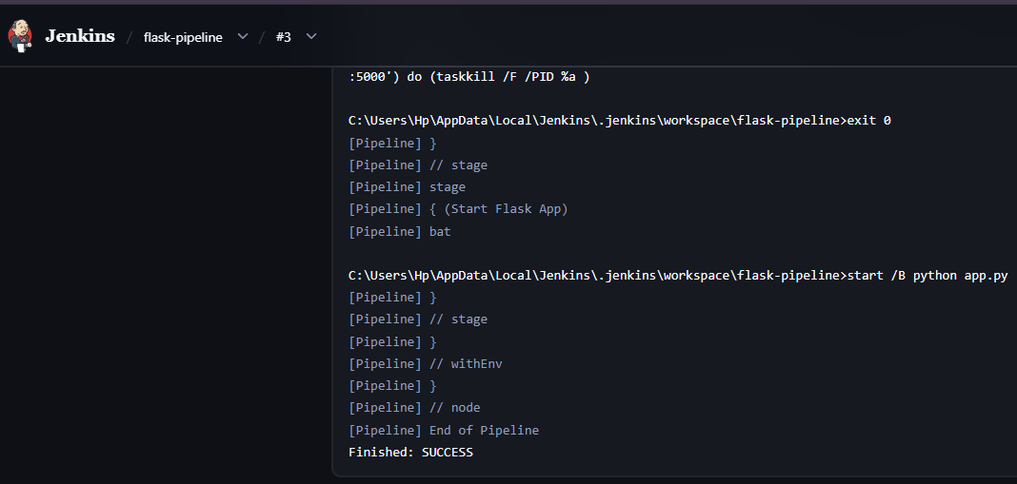
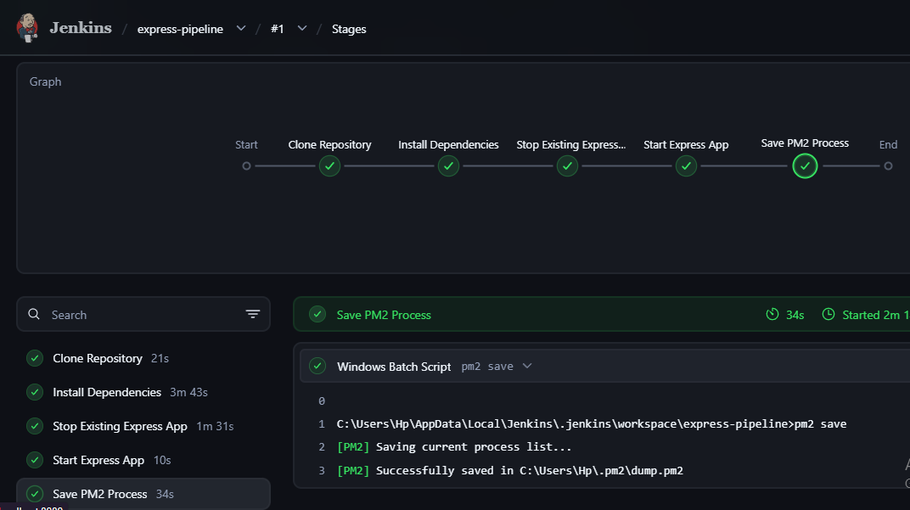
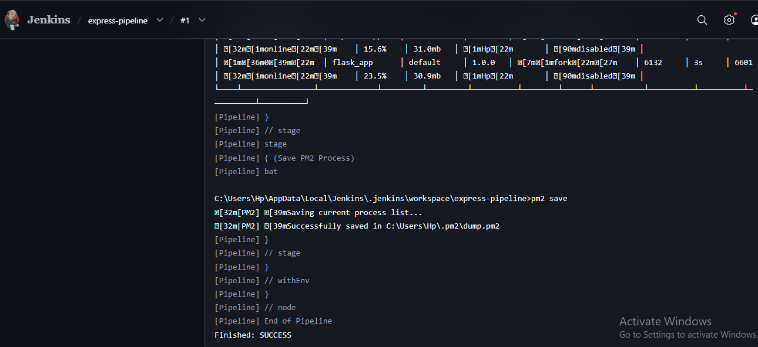
Git Repo : flask - https://github.com/rohitdabare15/flask-cicd-app
Git Repo : Express - https://github.com/rohitdabare15/express-cicd-app

