WEEK 2 DATA SCIENCE TASK

Advanced Data Visualization & Storytelling
Case Study: Turning Wine Chemistry Data into a Clear Story
Python • Pandas • Matplotlib • scikit-learn

1. Introduction and Objective
The purpose of this project is to communicate patterns in a complex dataset through a sequence of visualizations. Rather than presenting charts as isolated figures, the report builds a narrative: establish what is in the data, compare groups, examine relationships, identify broader patterns, and discuss implications. The intended audience includes non-technical readers who need a clear explanation of what the measurements suggest.

2. Dataset and Preparation
This report uses the public Wine Recognition dataset, originally from the UCI Machine Learning Repository and available through scikit-learn. It contains 178 samples, 13 numeric chemical measurements, and three wine classes. The same dataset was used in Week 1 to maintain continuity.
Dataset source: https://archive.ics.uci.edu/dataset/109/wine
Loader documentation: https://scikit-learn.org/stable/modules/generated/sklearn.datasets.load_wine.html
Preparation included validating numeric features, checking duplicate records, excluding rows with missing target labels, and using median imputation only if numeric missing values existed. No unnecessary changes were applied to already complete data. Before PCA, features were standardized because they use different scales.

3. Method and Storytelling Strategy
- Start with a count chart to establish sample coverage by class.
- Compare alcohol distributions to show within-class spread and between-class differences.
- Use a scatter plot to explore two-feature relationships and class overlap.
- Use a correlation heatmap to show relationships across all numeric measurements.
- Use Principal Component Analysis (PCA) to summarize 13 measurements in two dimensions.
- Compare scaled means of selected features to summarize class profiles.
The charts move from simple context to more complex relationships. Titles state the main takeaway, axes are labelled, legends identify groups, and captions explain why each chart matters.

4. Visualization 1 — Class Distribution
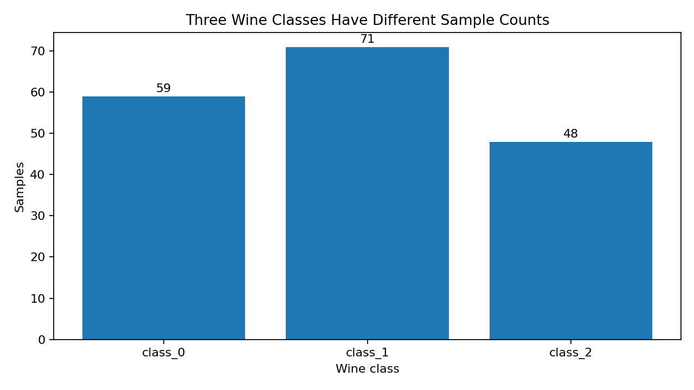
What the chart says: The chart shows 59, 71, and 48 samples in the three classes. Their sizes are not identical, but each class has a meaningful number of examples.
Visualization rationale: A bar chart is appropriate for comparing counts across discrete categories. It gives the reader context before group comparisons.

5. Visualization 2 — Alcohol by Class
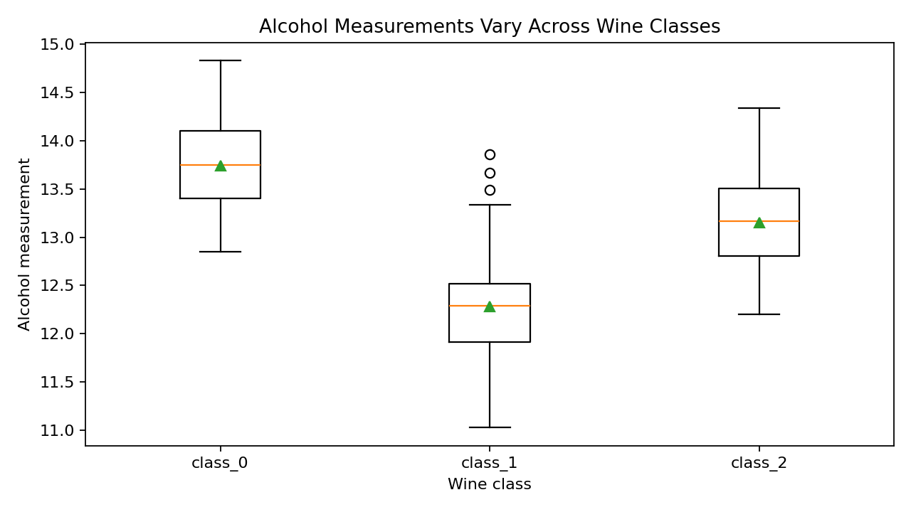
What the chart says: The box plot compares the median, spread, and possible extreme values of alcohol measurements in each class. Differences suggest alcohol may be informative, but overlap means one measurement alone may not perfectly separate classes.
Visualization rationale: Box plots summarize distributions compactly and make group comparisons easier.

6. Visualization 3 — Flavanoids vs Color Intensity
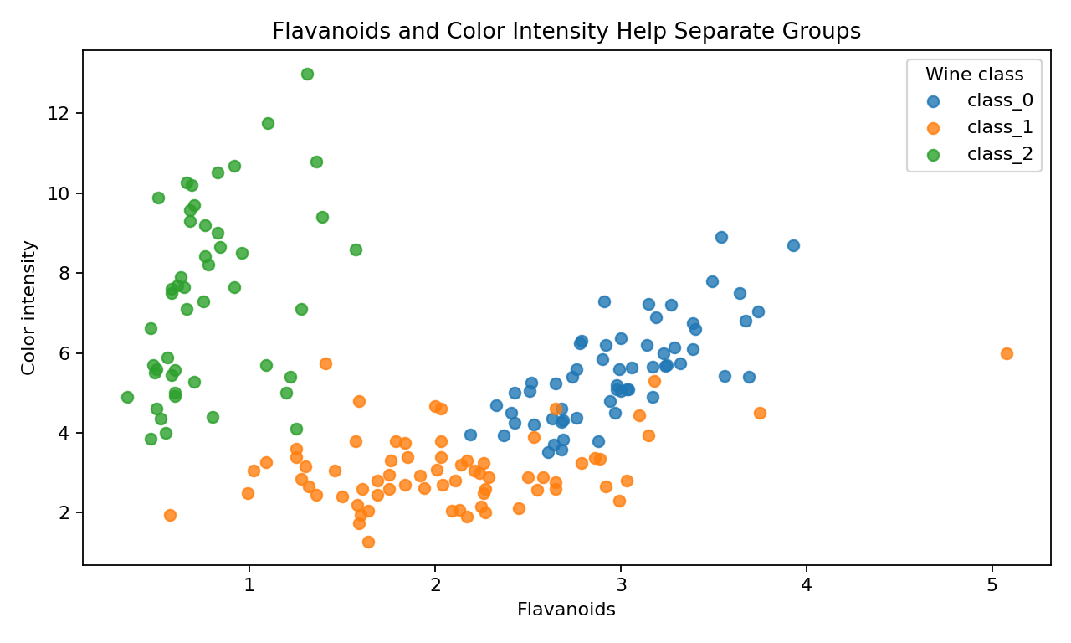
What the chart says: Each point is one sample; axes show flavanoids and color intensity, and the legend distinguishes classes. The point clouds occupy different regions, although some overlap remains. Combining features may therefore be more informative than using one alone.
Visualization rationale: A scatter plot reveals relationships, clusters, and overlap between two continuous measurements.

7. Visualization 4 — Correlation Heatmap
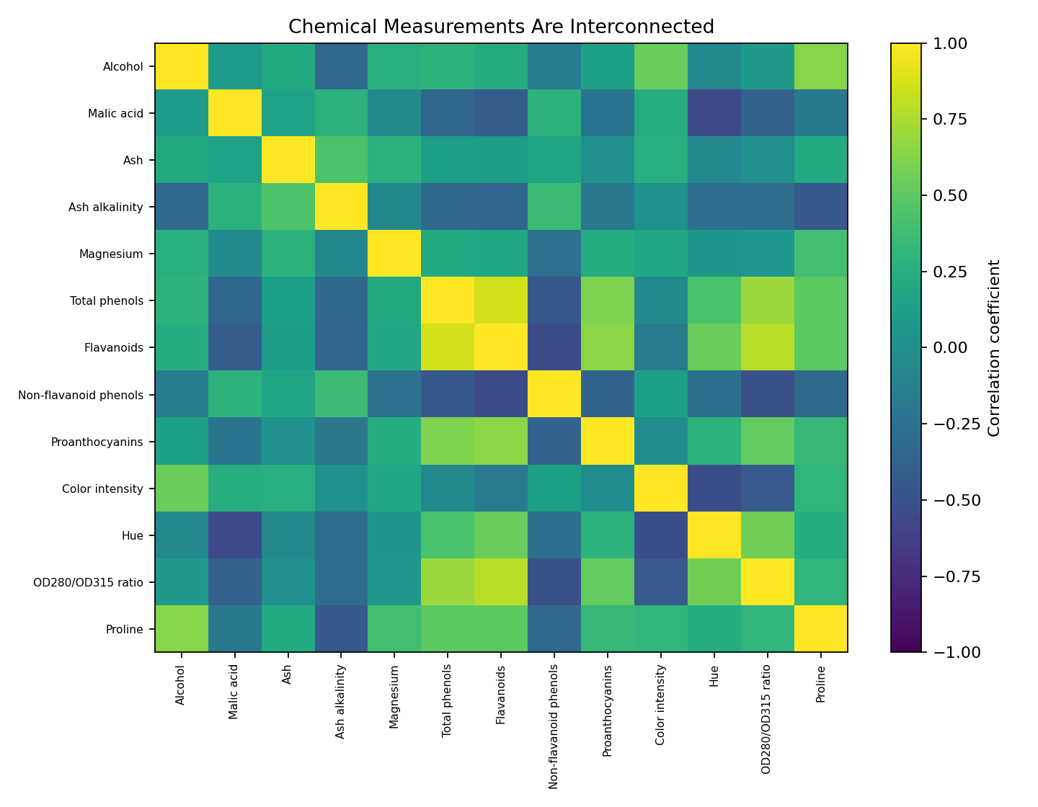
What the chart says: The heatmap summarizes pairwise linear correlations among 13 measurements. Values near +1 indicate features tend to increase together; values near -1 indicate an inverse relationship; values near zero indicate weaker linear association.
Visualization rationale: A heatmap presents many relationships in one compact view. Correlation can reveal overlapping information but does not prove causation.

8. Visualization 5 — PCA Overview
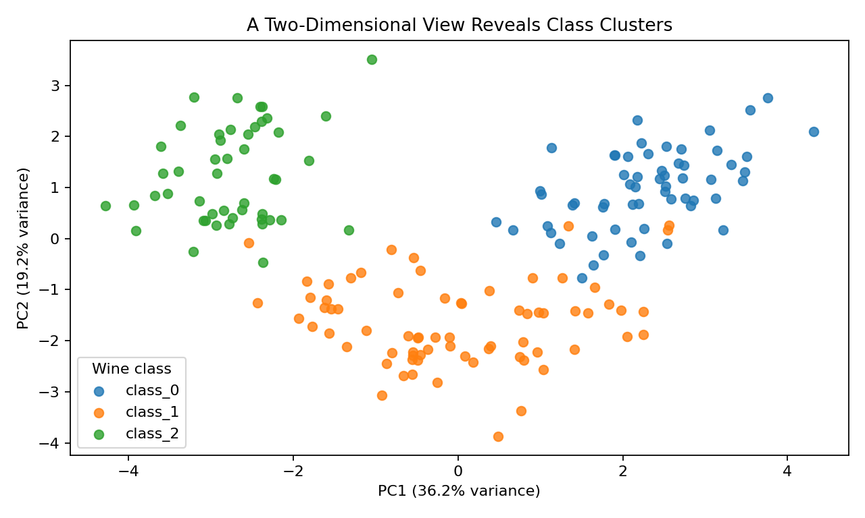
What the chart says: PCA summarizes the standardized 13 measurements into two principal components. PC1 explains 36.2% of variance and PC2 explains 19.2%, a combined 55.4%. The plot shows broad grouping in a compressed view; overlap means it is not a perfect classifier.
Visualization rationale: PCA helps readers see whether many measurements jointly form groups. Standardization prevents variables with larger numeric scales from dominating.

9. Visualization 6 — Relative Feature Profiles
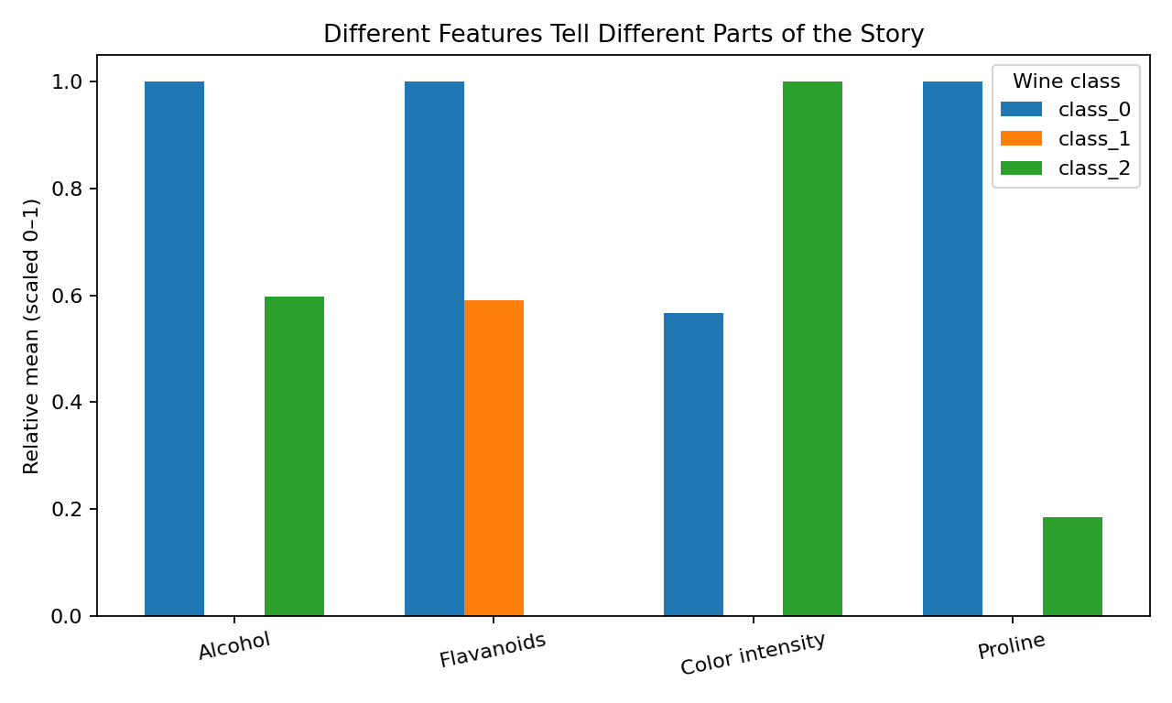
What the chart says: The grouped bar chart compares class averages for alcohol, flavanoids, color intensity, and proline after scaling each feature's class means to 0–1. This makes relative class patterns comparable despite different units; scaled values are not physical measurements.
Visualization rationale: A multi-feature profile summarizes several differences in one view and avoids relying on a single indicator.

10. Overall Story and Key Findings
- The three classes have different sample counts, so class context should be considered.
- Alcohol measurements vary by class, but overlap prevents using alcohol alone as a reliable identification rule.
- The flavanoids-versus-color-intensity plot suggests combinations of chemical features can reveal group structure.
- The correlation heatmap shows some measurements are related and may carry overlapping information.
- PCA gives a compact overview of the joint structure of standardized measurements, while some overlap remains.
- The feature profile shows that classes differ across multiple measurements rather than one universal indicator.

11. Business and Scientific Implications
In a wine laboratory or quality-control setting, visual summaries can help analysts compare batches, identify unusual measurements, and decide which chemical tests deserve further investigation. If class differences are stable and validated, a future classification model could support screening or research workflows. However, this dataset does not directly measure consumer preference, market value, or overall wine quality. Operational decisions would require domain expertise, representative external data, and validation for the intended use.

12. Limitations and Next Steps
- The dataset is small and may not represent all varieties, producers, or regions.
- Visual separation is not the same as validated prediction; future modelling should use a stratified train/test split and report class-wise precision, recall, F1-score, and a confusion matrix.
- Correlation is not causation, and PCA can hide structure by compressing 13 dimensions into two.
- Future work could use interactive Plotly charts, uncertainty intervals, and an external dataset to test whether findings generalize.

13. Conclusion
This report presents a coherent visual narrative, moving from sample counts to group distributions, two-feature relationships, overall correlations, multivariate structure, and a comparison of selected feature profiles. The charts suggest that chemical measurements contain patterns associated with the three classes, while demonstrating why several features and careful validation are needed. Effective visualization turns numerical tables into an accessible story for decision-makers.

14. Reproducibility
Install dependencies: pip install pandas numpy matplotlib scikit-learn
Run: python week2_advanced_visualization.py
The accompanying Python script recreates the visualizations and can be uploaded to the project's GitHub repository.

References
UCI Machine Learning Repository — Wine dataset: https://archive.ics.uci.edu/dataset/109/wine
scikit-learn load_wine documentation: https://scikit-learn.org/stable/modules/generated/sklearn.datasets.load_wine.html
Matplotlib documentation: https://matplotlib.org/stable/
Pandas documentation: https://pandas.pydata.org/docs/

