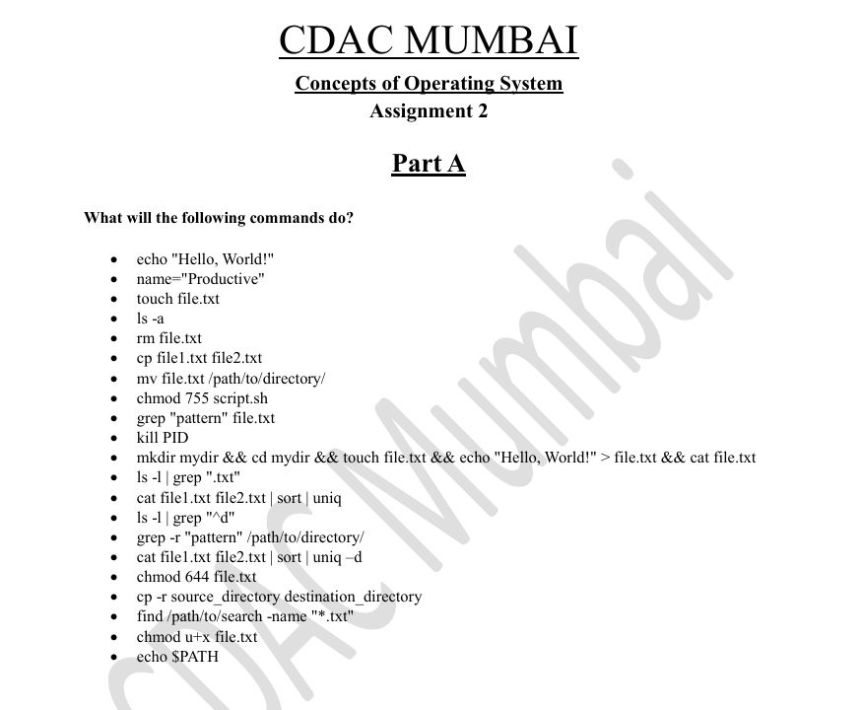

1. It will print Hello, World! On terminal



1. it will make name variable of type string and its value = “Productive”



1. touch is handy if someone wants to make files or multiple files at a time

1. This command will list all the files be it hidden or normal

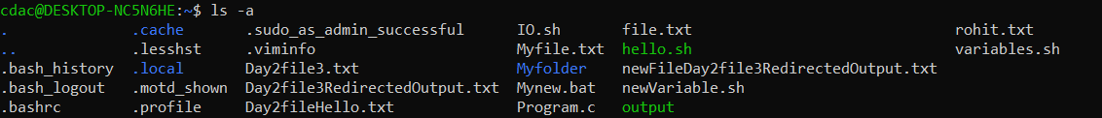

1. This command remove or delete the file

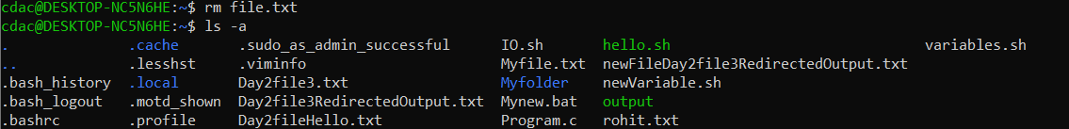

1. It copies the content of file1.txt to another file2.txt

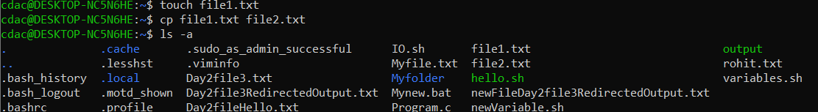

1. This command moves file1.txt to specified folder



1. By using chmod 755 file_name.sh we can change or give the permissions to u, g and o.



1. Using grep command we can search particular content or pattern in any file
2. This command will kill the specified PID process.
3. This command will print Hello, World and in background we have used here “&& ” to run multiple commands at a time. So it made a directory mydir then navigated to mydir in that it formed file.txt and printing hello Worl! And all these ouput are redirecting into file1.txt and after that we are printing the content of file1.txt.



1. This command will find the files which has ending names with .txt and list all the files in long form

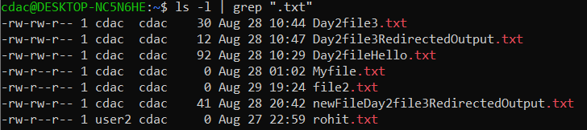

1. This command will find unique content of 2 files

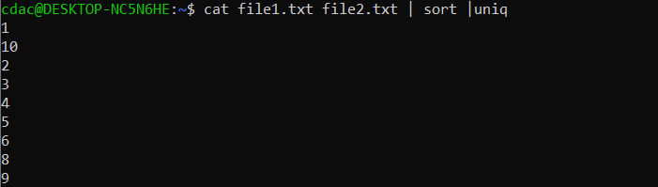

1. This command will find starting “d” when we do ls -l

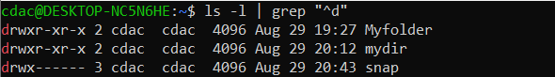

1. This command will search specified patten into directory



1. Using uniq -d we can only output lines that are repeated in the input



1. What this command (chmod 644 file2.txt) will do is , it will give the read write permission to user/owner, read permission to group , and read permission to other user



1. This command will copy files recursively from src_directory to destination_directory
2. This command will search the file which is ending with “.txt” format.

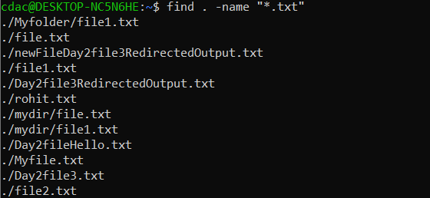

1. This command will give permission to usr/owner to execute the files



1. This command will print the PATH which is an environment variable listing a set of paths to directories where executable may be found

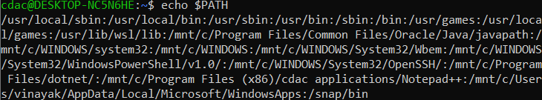

**Part B**

**Identify True or False:**

1. **ls** is used to list files and directories in a directory.

Ans. **True**

1. **mv** is used to move files and directories.

Ans. **True**

1. **cd** is used to copy files and directories.

Ans. **False,** because cd is use to change the directory and cp is use to copy the files.

4. **pwd** stands for "print working directory" and displays the current directory.

Ans. **True ,** it stands for print working directory.

1. **grep** is used to search for patterns in files.

Ans. **True**

1. **chmod 755 file.txt** gives read, write, and execute permissions to the owner, and read and execute permissions to group and others.

Ans . **True**

1. **mkdir -p directory1/directory2** creates nested directories, creating directory2 inside directory1 if directory1 does not exist.

Ans . **True**

1. **rm -rf file.txt** deletes a file forcefully without confirmation.

Ans. **True**

**Identify the Incorrect Commands:**

1. **chmodx** is used to change file permissions.

**Incorrect. (chmod)**

1. **cpy** is used to copy files and directories.

**Incorrect. (cp)**

1. **mkfile** is used to create a new file.

**Incorrect. (touch/nano/vim)**

1. **catx** is used to concatenate files.

**Incorrect. (cat)**

1. **rn** is used to rename files.

**Incorrect. (mv)**

**Part C**

**Question 1: Write a shell script that prints "Hello, World!" to the terminal.**

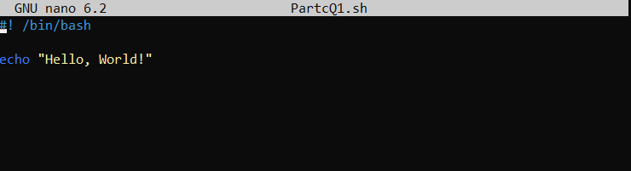

**OUTPUT:**



**Question 2: Declare a variable named "name" and assign the value "CDAC Mumbai" to it. Print the value of the variable.**

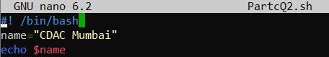

**OUTPUT:**



**Question 3: Write a shell script that takes a number as input from the user and prints it.**

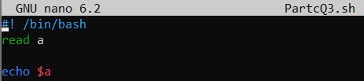

**OUTPUT:**



**Question 4: Write a shell script that performs addition of two numbers (e.g., 5 and 3) and prints the result.**

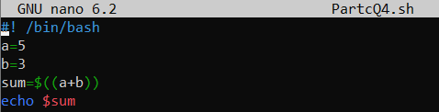

**OUTPUT:**



**Question 5: Write a shell script that takes a number as input and prints "Even" if it is even, otherwise prints "Odd".**

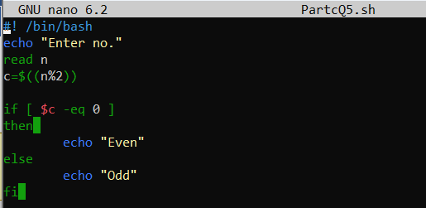

**OUTPUT:**

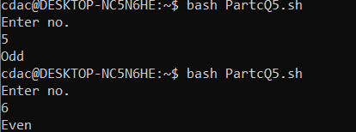

**Question 6: Write a shell script that uses a for loop to print numbers from 1 to 5.**

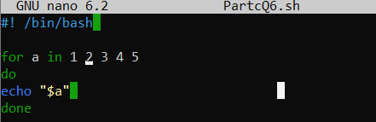

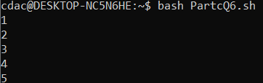

**Question 7: Write a shell script that uses a while loop to print numbers from 1 to 5.**

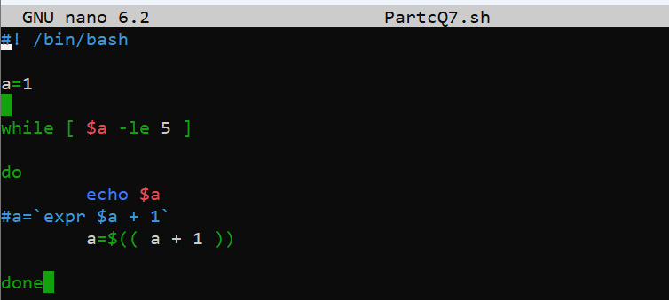



**Question 8: Write a shell script that checks if a file named "file.txt" exists in the current directory. If it does, print "File exists", otherwise, print "File does not exist".**

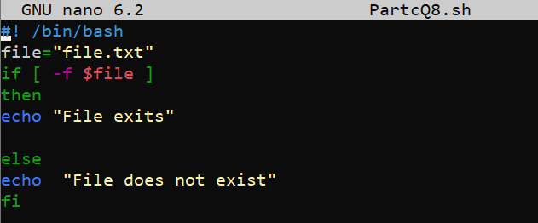



**Question 9: Write a shell script that uses the if statement to check if a number is greater than 10 and prints a message accordingly.**

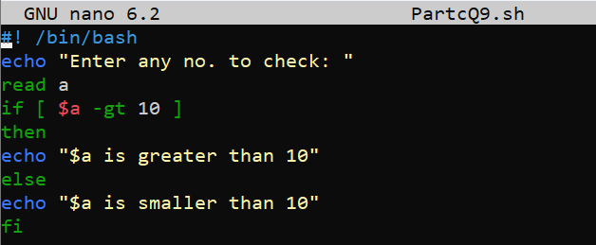

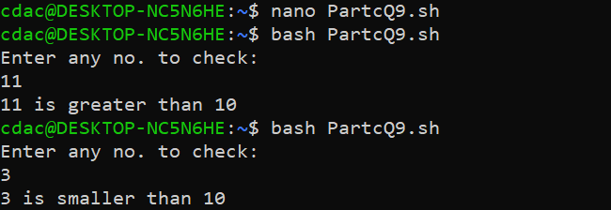

**Question 10: Write a shell script that uses nested for loops to print a multiplication table for numbers from 1 to 5. The output should be formatted nicely, with each row representing a number and each column representing the multiplication result for that number.**

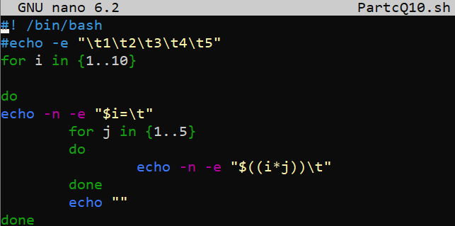

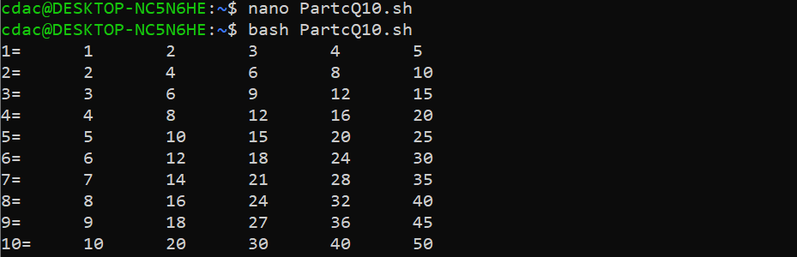

**Question 11: Write a shell script that uses a while loop to read numbers from the user until the user enters a negative number. For each positive number entered, print its square. Use the break statement to exit the loop when a negative number is entered.**

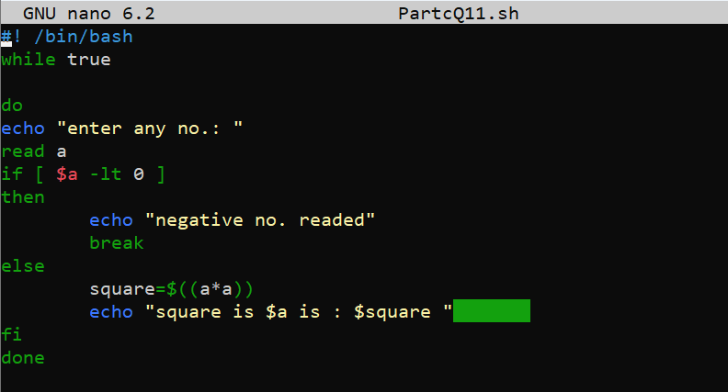

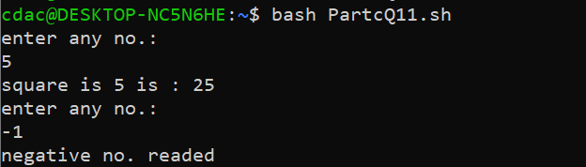

PART E

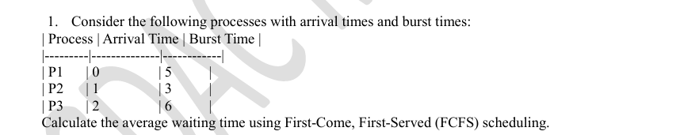

Ans 1:

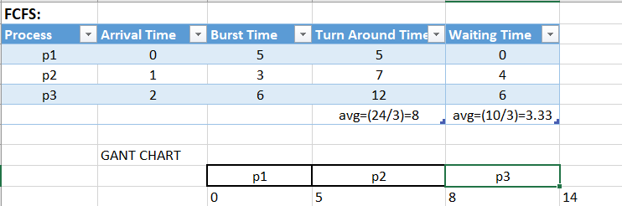

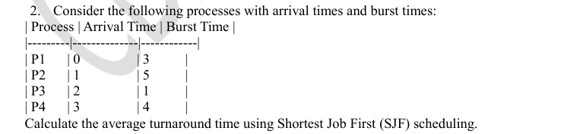

Ans 2:

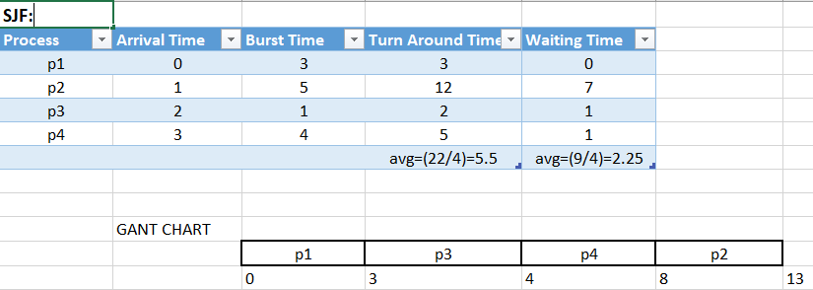

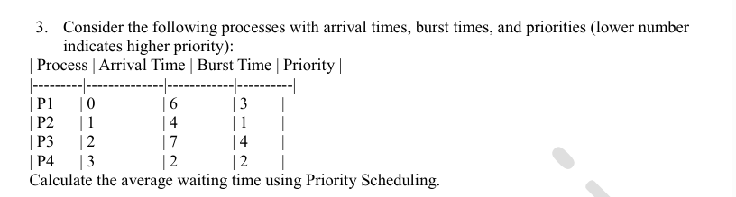

Ans3.

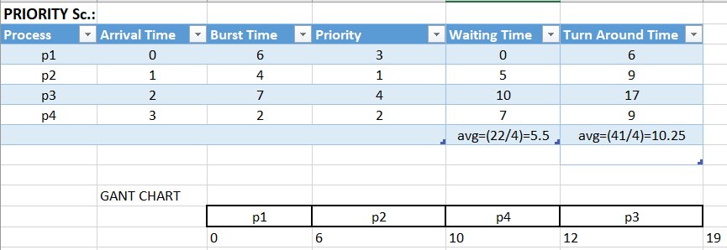

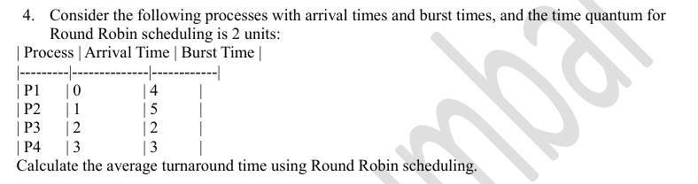

Ans4.

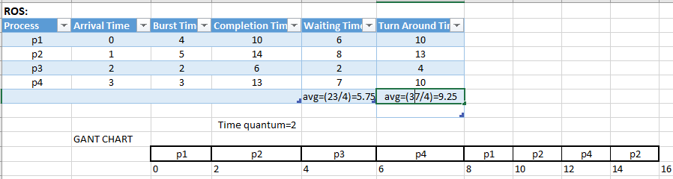

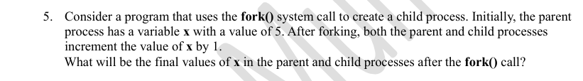

Ans5: 