**Use the Settings app**

1. Launch the Settings app.

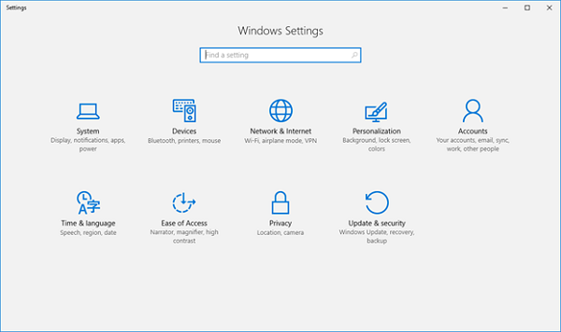

1. Next, select **Accounts**.

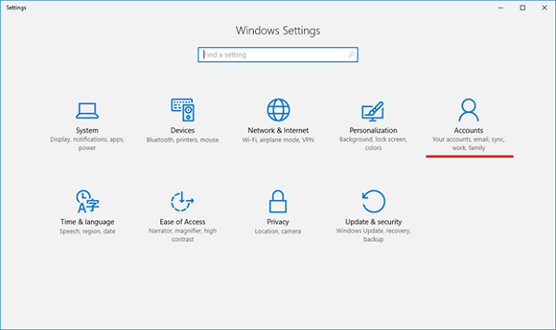

1. Navigate to **Access work or school**.

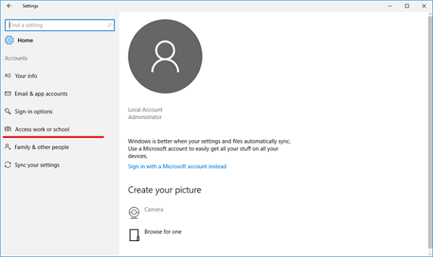

1. Select **Enroll only in device management.**

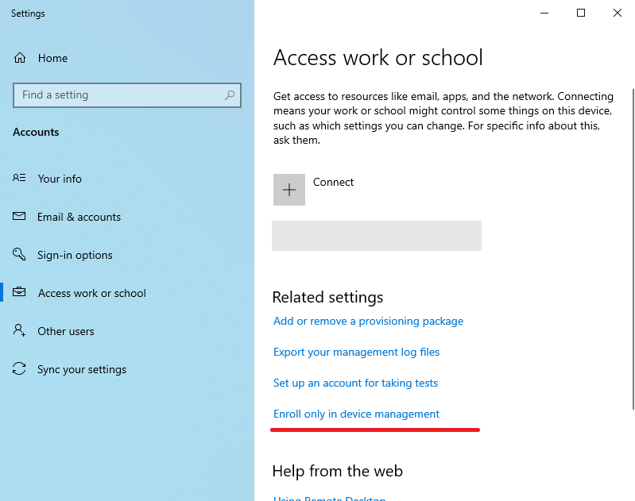

1. Enter the email address provided by our enterprise. The email address should follow the format, ‘enterpriseenrollment.*domain_name*.com’. Then, click **Next** and wait.

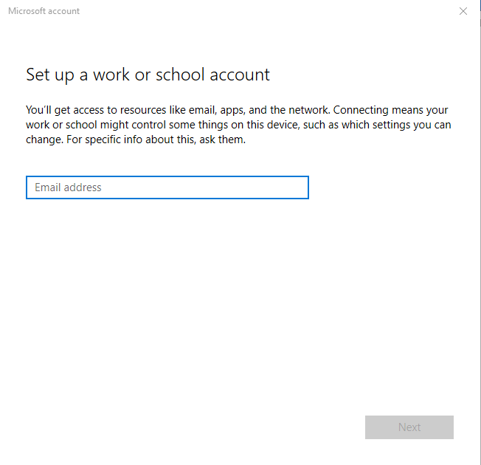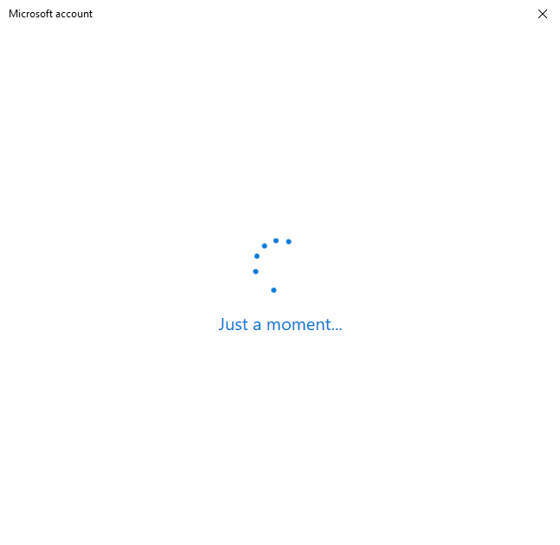

1. If this page appears, manually enter the MDM Server URL provided in the portal. Then, click **Next.**

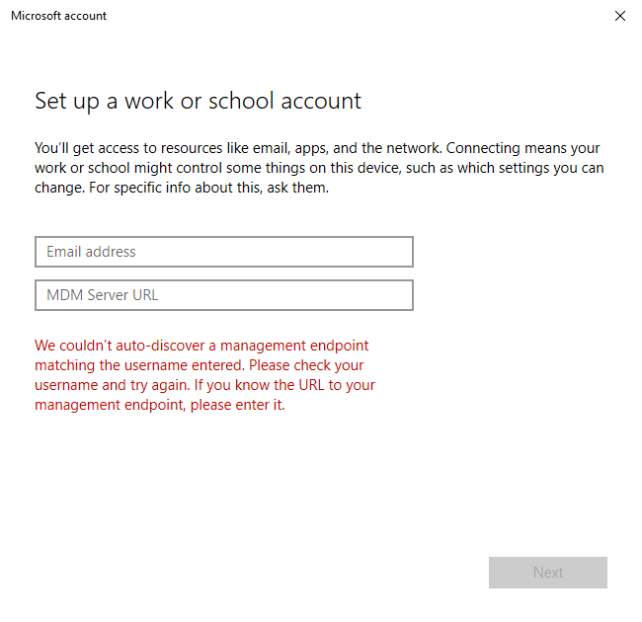

1. Next, enter any username and password. Then, click **Next** and wait.

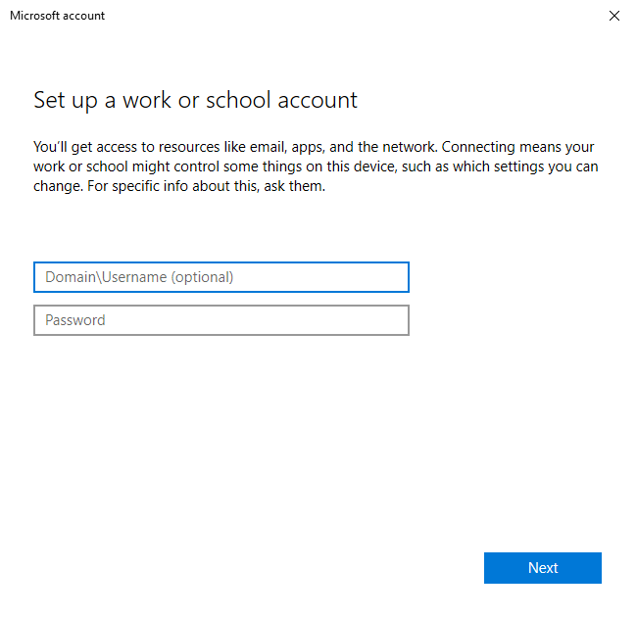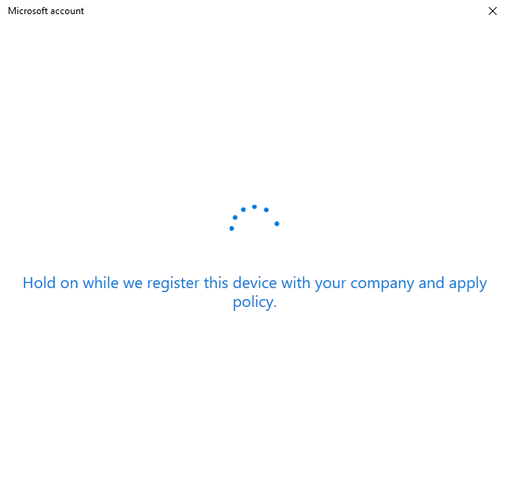

1. Once enrolment is completed, the page below will appear. Click on **Got it**.

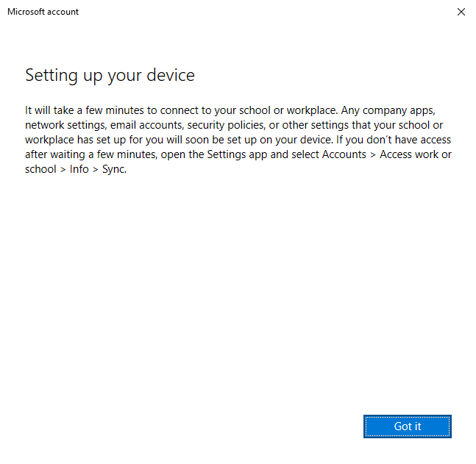

1. Navigate back to **Access work or school** and select **Info.**

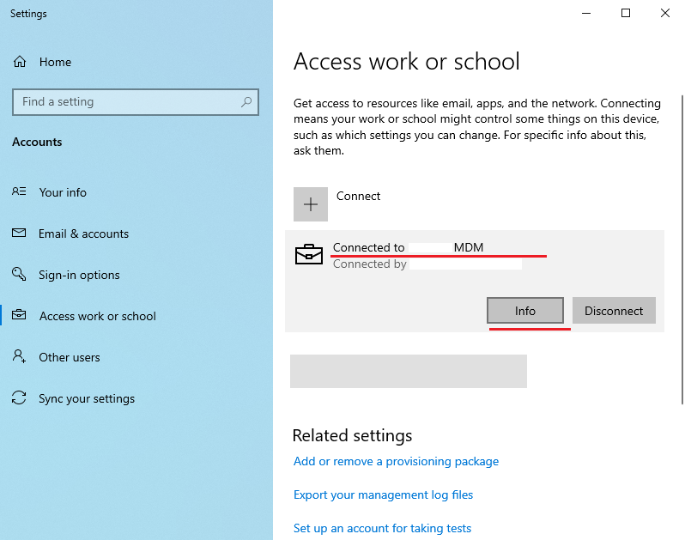

1. Lastly, select **Sync**, wait for a few seconds, and ensure that the sync was successful.

