Exam Marks Automation & Analytics
Auto-loading of student answers + a competency-wise analytics dashboard

Prepared by Rohit Kumar

1. Overview
This document summarises a small internal toolset I have built that automates two things we currently do by hand: (a) entering every student's exam answers into the software's database, and (b) analysing the marks in Excel. The result is a meaningful reduction in manual effort and a richer set of insights than we have had before.
2. The problem it solves
After every exam we fill a marks Excel workbook (one row per student, one column per question) and currently hand-enter each student's answers into the database. For a single paper with four sections and 137 students this is roughly 4,110 answer rows typed in manually - a slow, error-prone task that repeats every paper.
Separately, the same Excel is used to judge how the class did, eyeballing competency codes and band counts. The calculations are already in the workbook, but they live in spreadsheets that are easy to misread and hard to share with leadership in a presentable form.
3. What I built
3.1 Auto-insertion of answer rows
A Python script (script.py) reads the marks Excel and the paper's questions from the database, then inserts every student's answer rows directly into the answer table - transactionally, so a run either completes fully or rolls back. One command loads all four sections:
python script.py --all --overwrite
For the last paper this loaded 4,110 rows (A=900, B=1050, C=960, D=1200) in under a second, with no manual typing. The script is dynamic - it auto-detects sheets, question count, question types, max marks and students from the workbook, so it works for any future exam paper without code changes.
3.2 Analytics dashboard (browser, no install)
A single self-contained HTML file (dashboard.html) turns the same Excel into around 25 graphs across six tabs - Overview, Competency, Questions, Students, Sections, and Bands. It runs entirely in the browser: double-click the file, pick the Excel, and every chart appears instantly. Nothing is uploaded anywhere and no one needs to install anything to view the graphs.
4. Screenshots of the dashboard
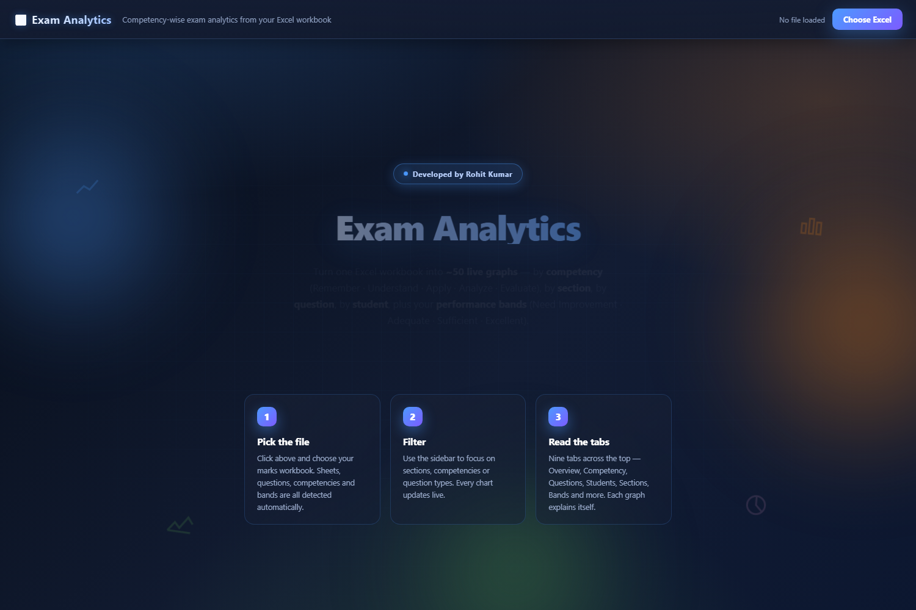

Cover screen - the first thing a user sees. 'Developed by Rohit Kumar', animated aurora background, and a one-click upload.
4.1 Overview tab
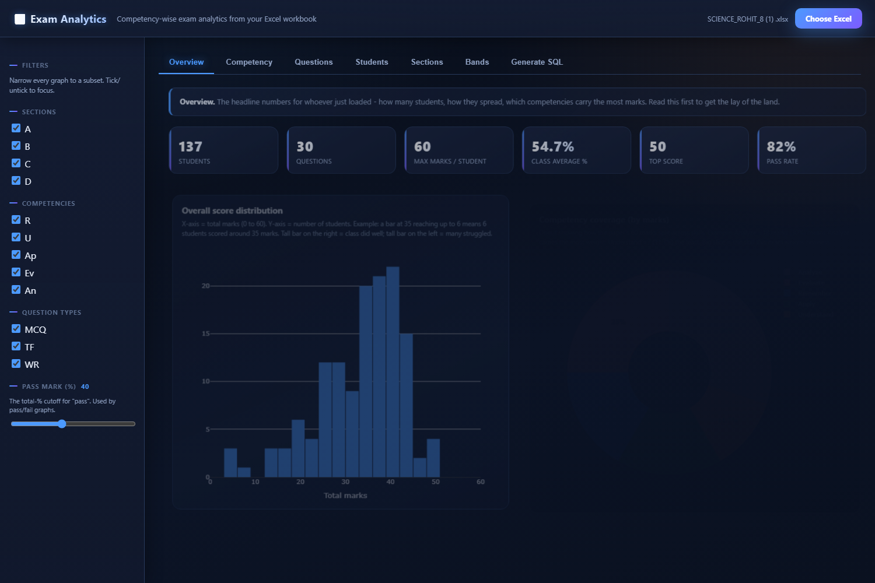

Overview tab - headline KPIs (students, avg %, pass rate) plus the score distribution histogram and competency coverage donut.
4.2 Competency tab
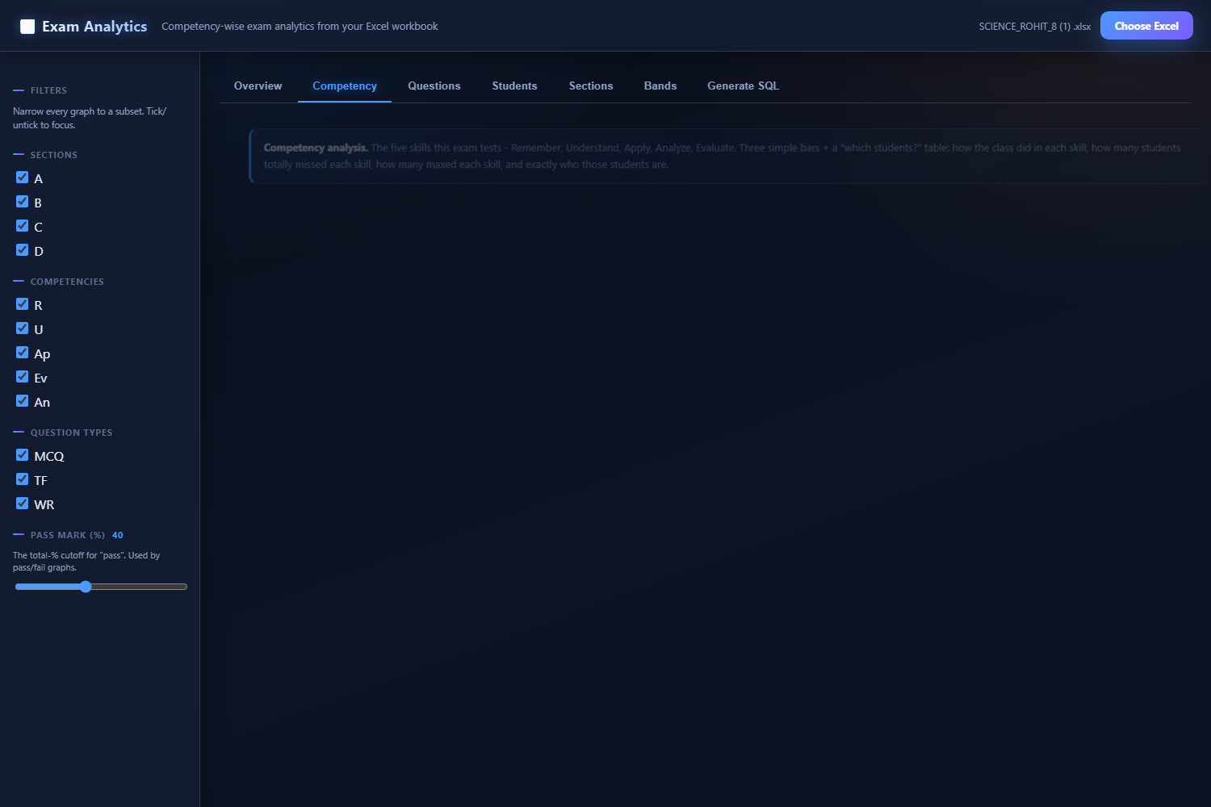

Competency tab - average % per skill, zero-scorers, full-scorers, and a 'which students scored 0 / maxed each skill' table naming the exact students.
4.3 Questions tab
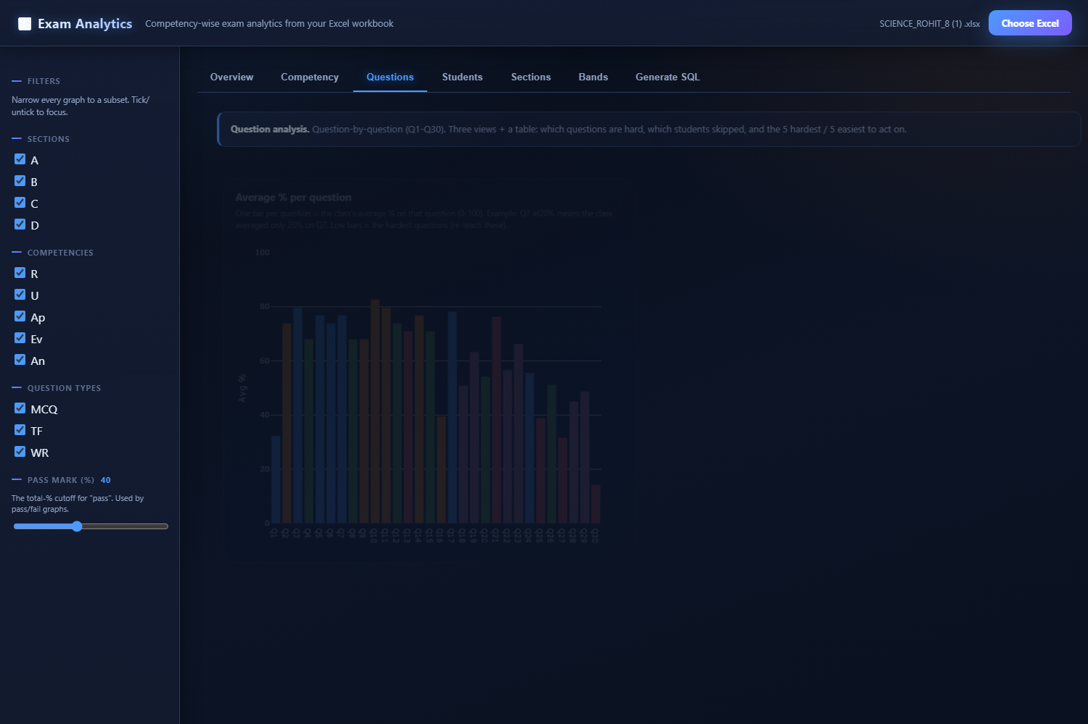

Questions tab - average % per question, attempt rate, and the Hardest 5 / Easiest 5 tables ranking what to re-teach and what's working.
4.4 Students tab
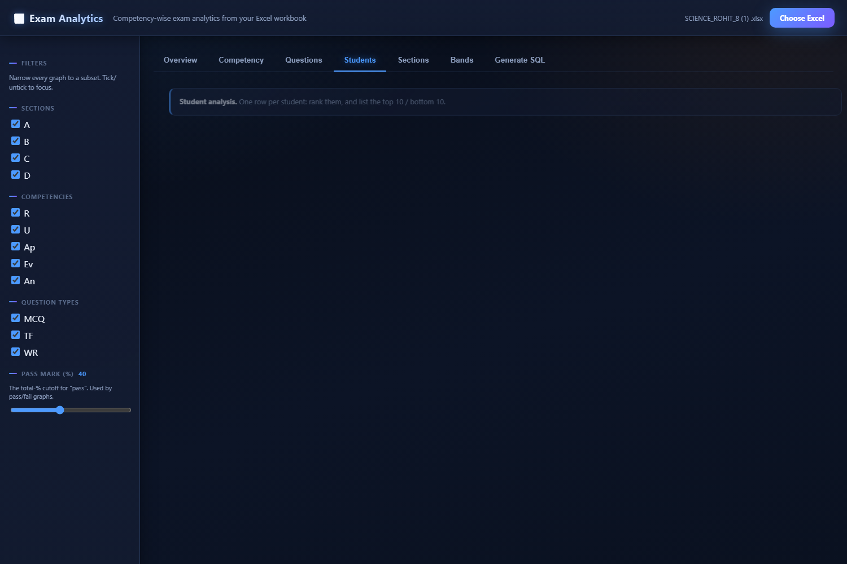

Students tab - every student ranked best-to-worst (hover shows the student), with Top 10 toppers and Bottom 10 strugglers tables broken down by skill.
4.5 Sections tab
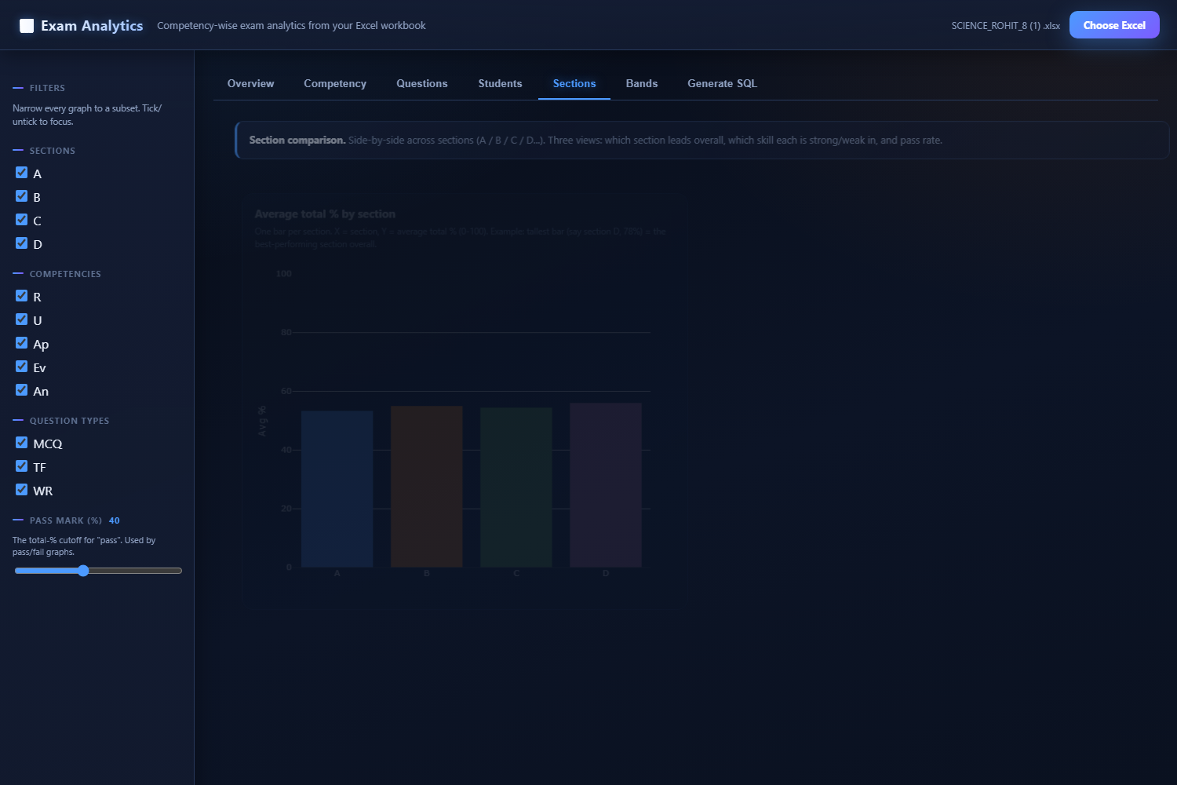

Sections tab - which section leads overall, which skill each section is strong/weak in, and pass rate per section.
4.6 Bands tab
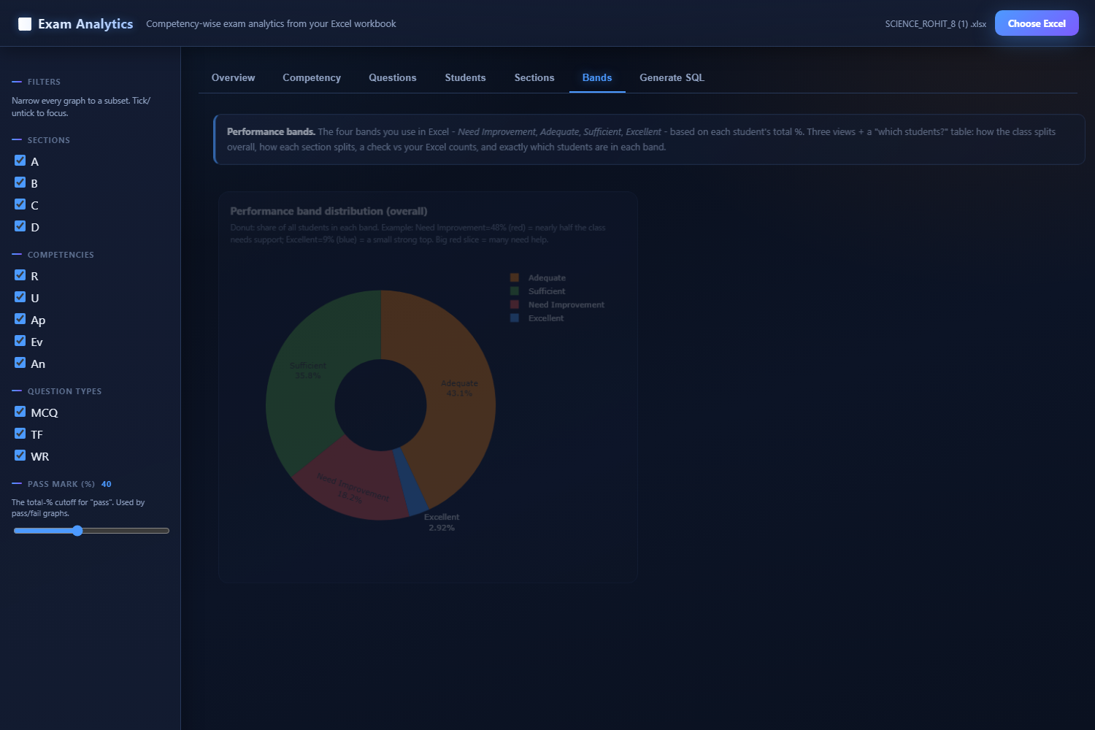

Bands tab - the four performance bands (Need Improvement / Adequate / Sufficient / Excellent) as a donut, a per-section split, and the 'which students are in each band' table.
4.7 Generate SQL tab
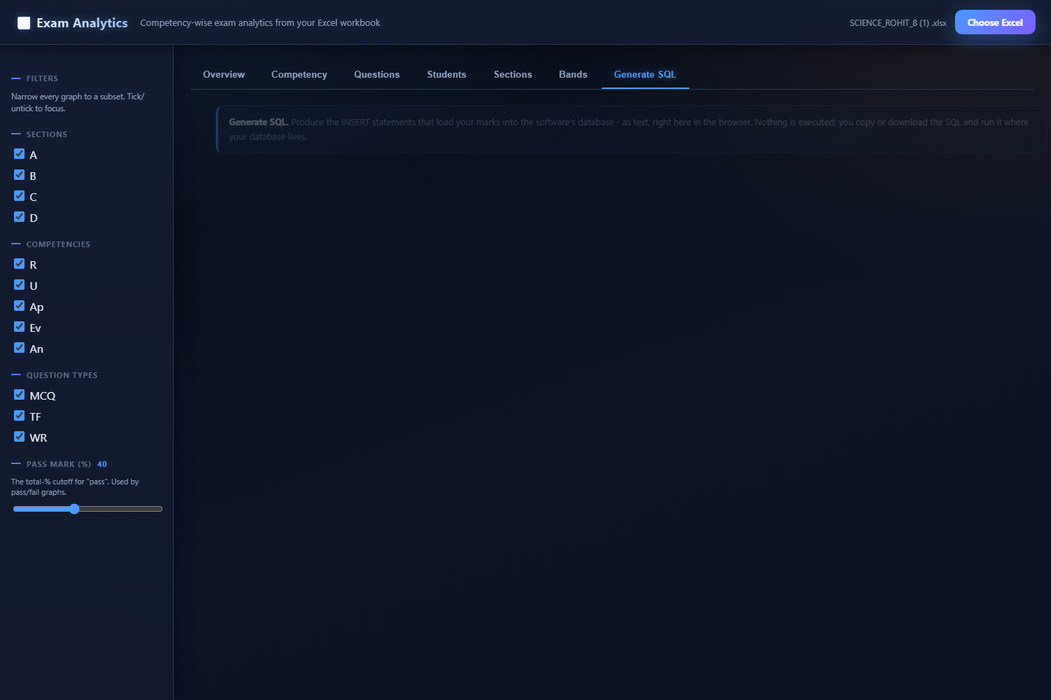

Generate SQL tab (optional) - produces the INSERT statements as text in the browser; gated by a metadata file that only a DB-access user can produce.
5. Key insights now available
Each graph carries a plain-language caption with a concrete example, so a non-technical reader can understand it without prior context. The insights that were not easily visible before:
- Competency analysis: which skill the class finds easy or hard - Remember / Understand / Apply / Analyze / Evaluate - with average % per skill.
- Question analysis: the single questions that tripped the class up, and the ones everyone got right - with a Hardest 5 / Easiest 5 ranking to act on.
- Student analysis: every student ranked best-to-worst, plus Top 10 toppers and Bottom 10 strugglers tables broken down by skill.
- Section comparison: side-by-side across sections - which section leads overall, which skill each section is strong/weak in, and pass rate per section.
- Performance bands: the four performance bands (Need Improvement / Adequate / Sufficient / Excellent) as a donut and per-section split - and a 'which students are in each band' table that names the exact students, not just counts.
- Who exactly: a 'which students scored 0 / maxed each skill' table - the exact student IDs behind each competency count, so support can be targeted by name.
6. Time & effort saved
For each exam paper, roughly 4,000 answer rows that used to be hand-entered now load in seconds. Re-runs are clean (--overwrite removes the previous paper's rows first). The dashboard eliminates the spreadsheet eyeballing - the same graphs can be produced for leadership in one click instead of re-working the Excel every time.
7. Security
The dashboard never connects to the database - it only reads the Excel in the browser, so no database credentials are ever exposed to anyone viewing the graphs. The insertion command runs only on the database machine. There is no SQL injection surface (the browser only generates inert text, it does not execute anything). A separate, optional 'Generate SQL' tab in the dashboard can produce the INSERT statements as text (for someone without direct DB access to copy/run) - gated by a small metadata file that only a DB-access user can produce.
8. How to use
8.1 Insert marks into the database
On the database machine, once:
pip install openpyxl mysql-connector-python
Then for each exam:
python script.py --all --overwrite
8.2 View the graphs
Anyone, no install needed:
start dashboard.html (then pick the Excel)
8.3 (Optional) Generate SQL in the browser
One-time, on the DB machine:
python script.py --export-meta
Then in the dashboard, load that JSON to unlock the 'Generate SQL' tab.
9. Future-proof
Nothing in the toolset is hardcoded to a specific exam - question count, competency codes, sheet names, question types, max marks and student rows are all detected from the workboot at run time. When the exam structure changes (more questions, new competencies, different sheet names), the same files adapt automatically. The only thing to update for a new paper is the paper id in config.py (or pass it on the command line) and, for the optional browser SQL tab, regenerating the small metadata file.

- End of document -

