Project-01: Building Scalable, Secure, and High-Performance Web Applications with AWS 3-Tier Architecture

Project Overview
The primary objective of this project is to deploy a scalable, highly available, and secure python application using a 3-tier architecture on Amazon Web Services (AWS). The solution should leverage AWS services such as Amazon EC2, Amazon RDS, Amazon VPC, Application Load Balancer, and Auto Scaling to ensure optimal performance, fault tolerance, security, and availability.

Task 1 : Design and Configure the AWS Networking Infrastructure
Create a VPC using an appropriate CIDR block.
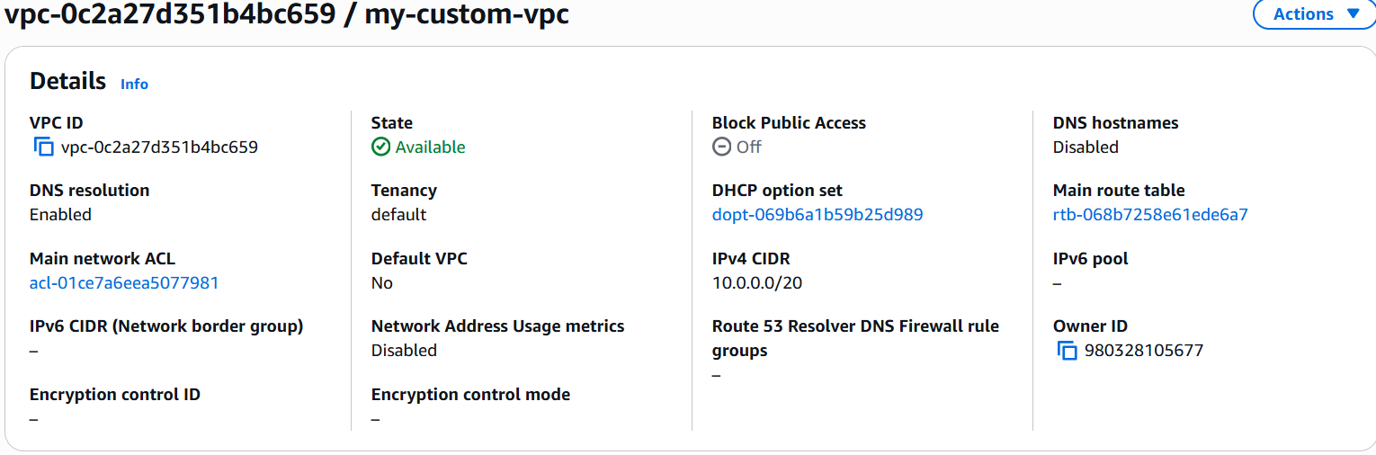

Create 6 Subnets distributed across 2 Availability Zones.
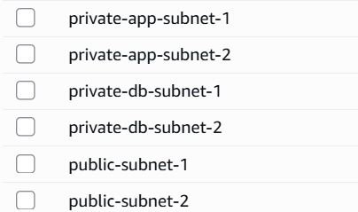
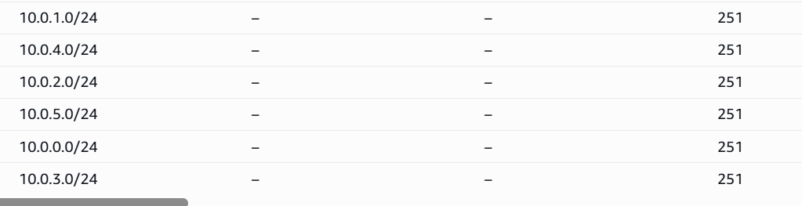
Internet Gateway
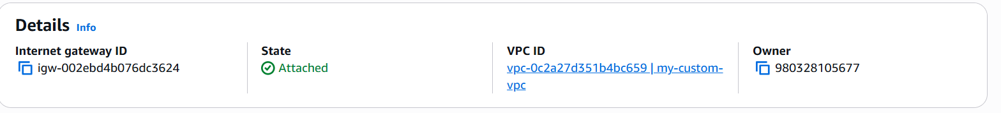

NAT Gateway
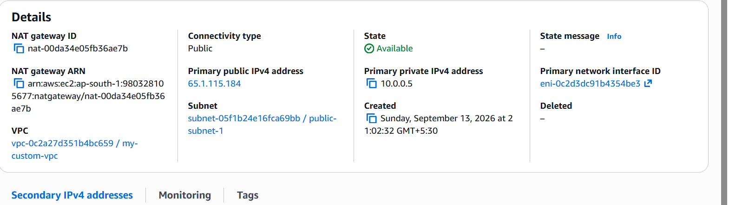

Route Tables
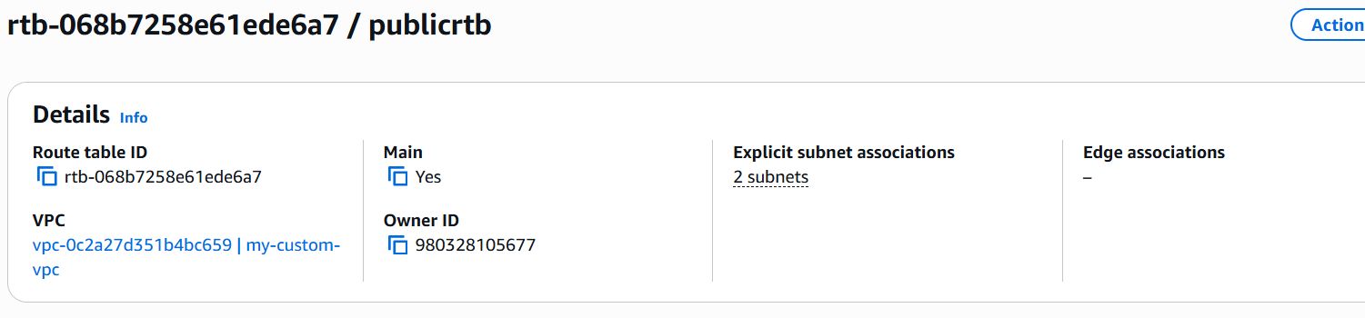
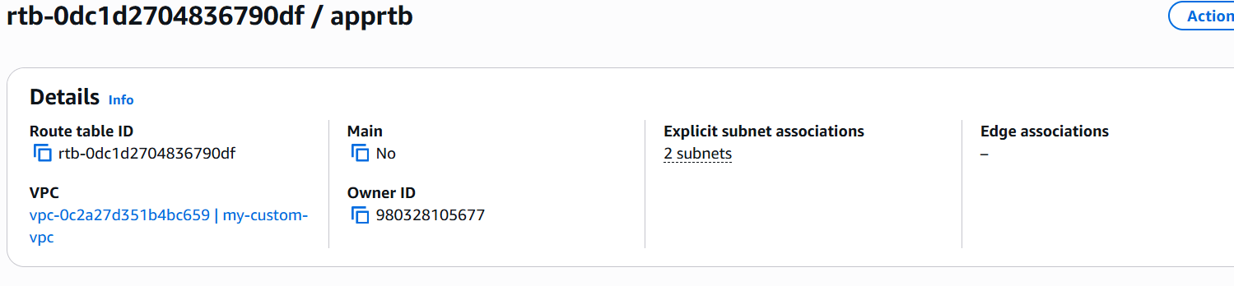
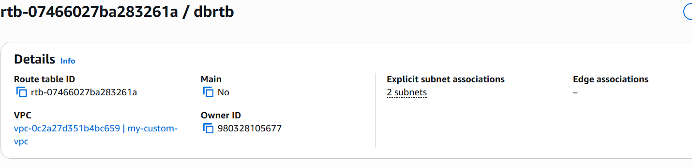

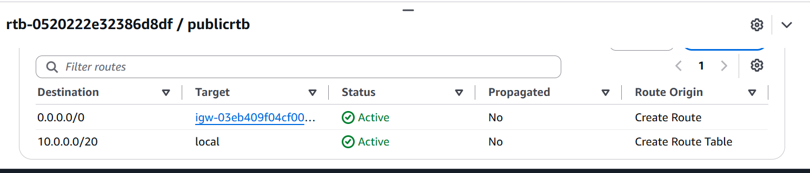
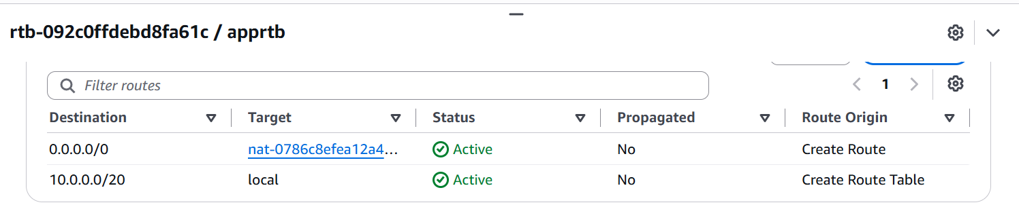
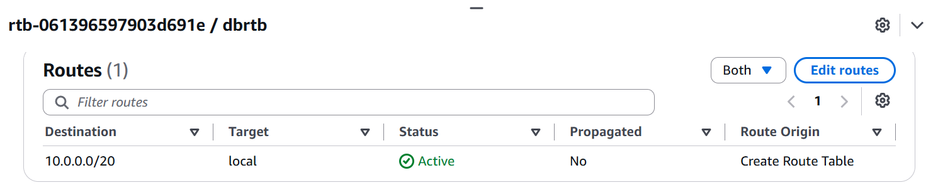
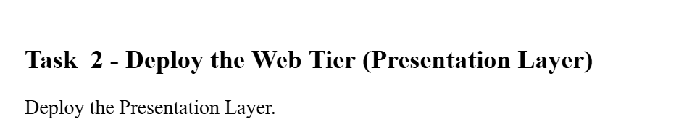
Launch EC2 instances in the Public Subnets.
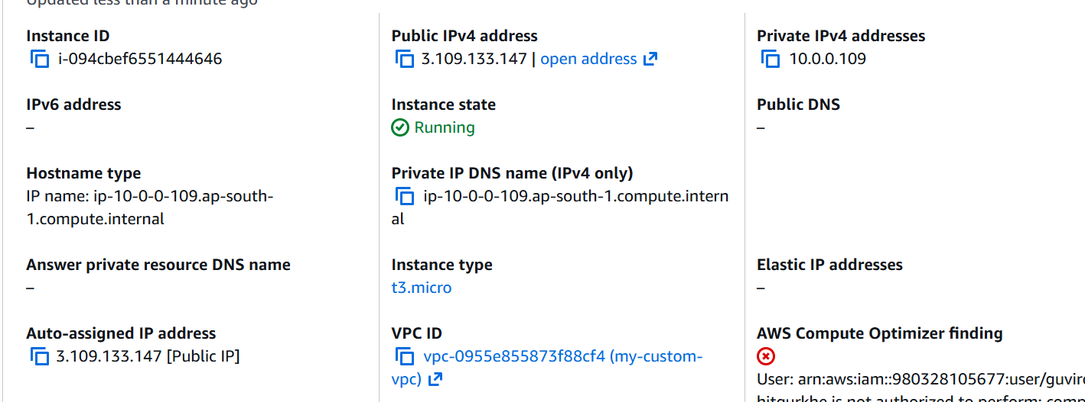
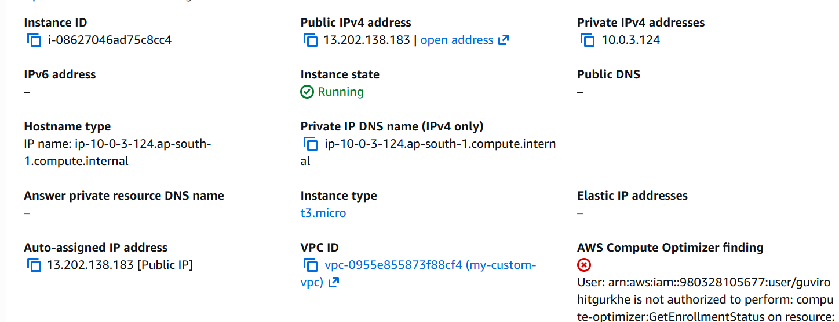
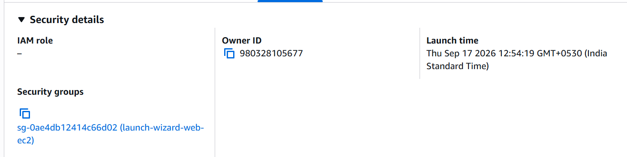
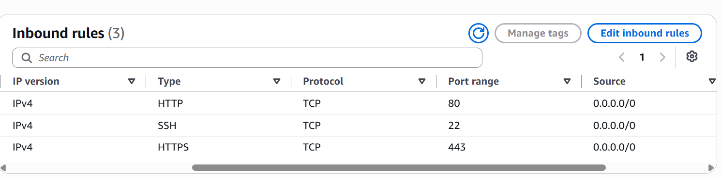
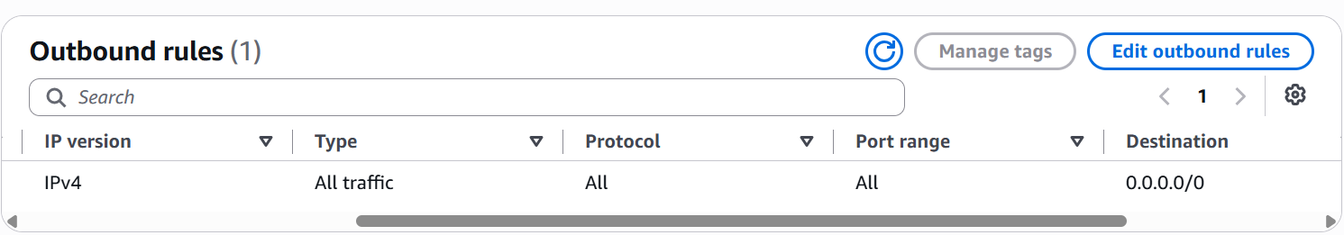

Connect to the instance.
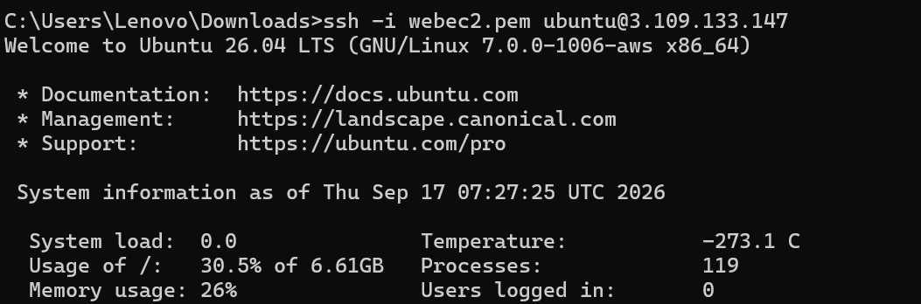

Install Nginx.
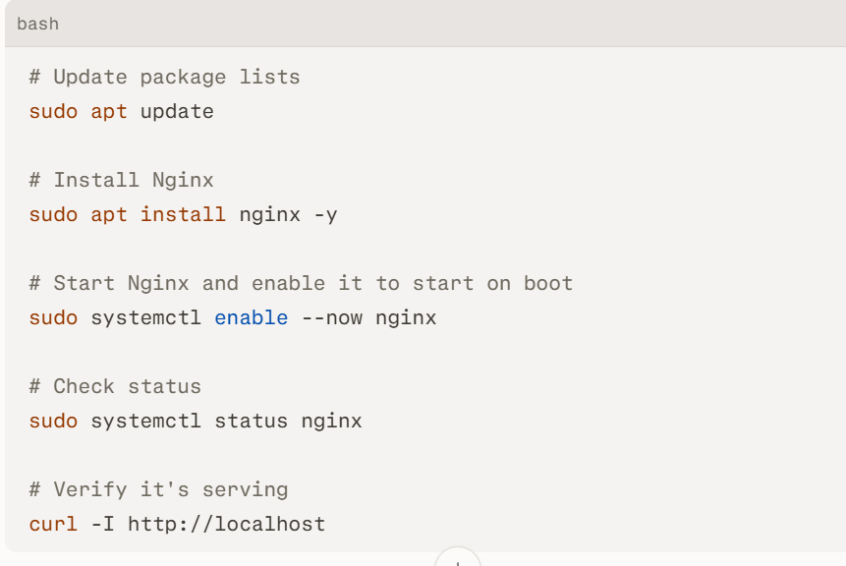
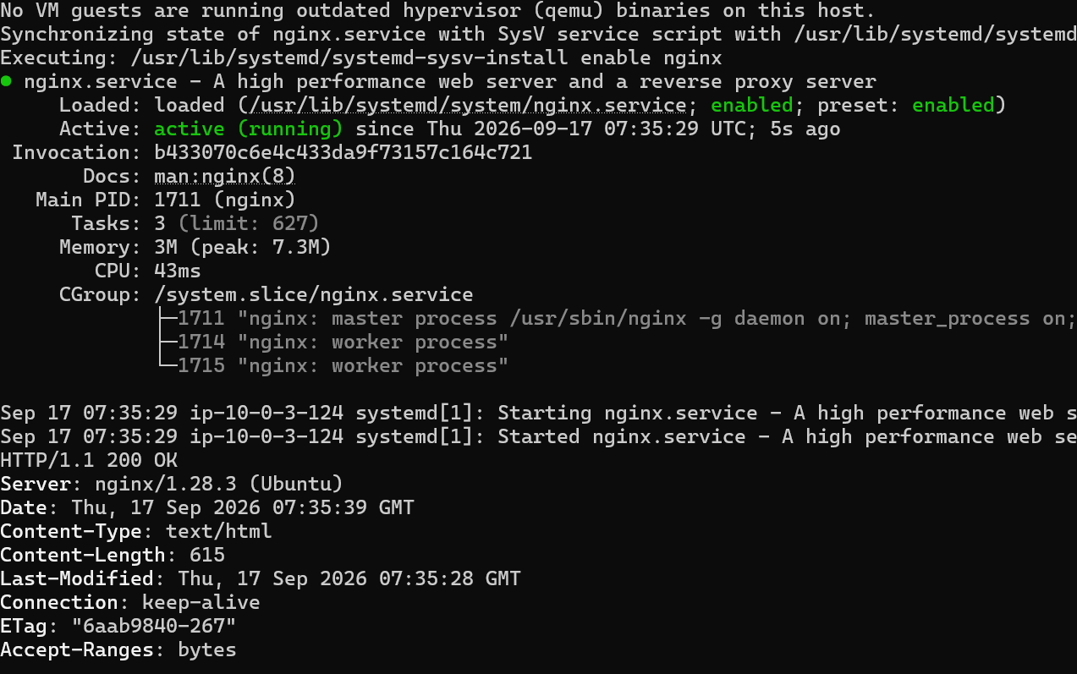

Copy the provided HTML files.
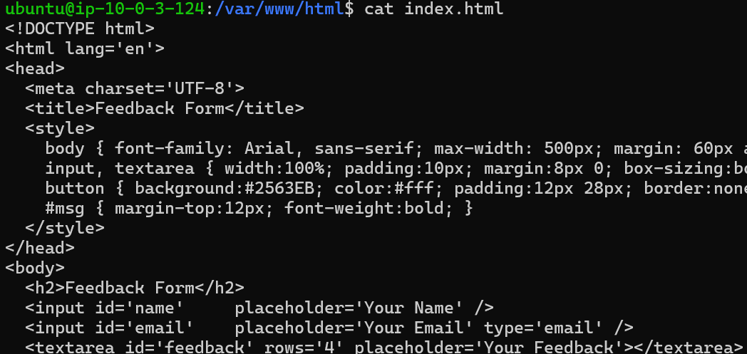
Verify the web page is accessible.
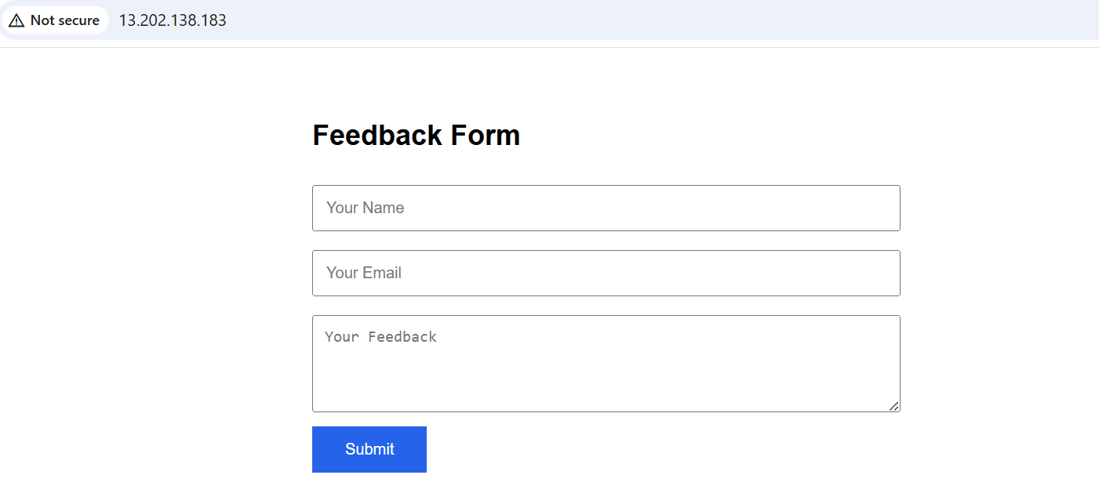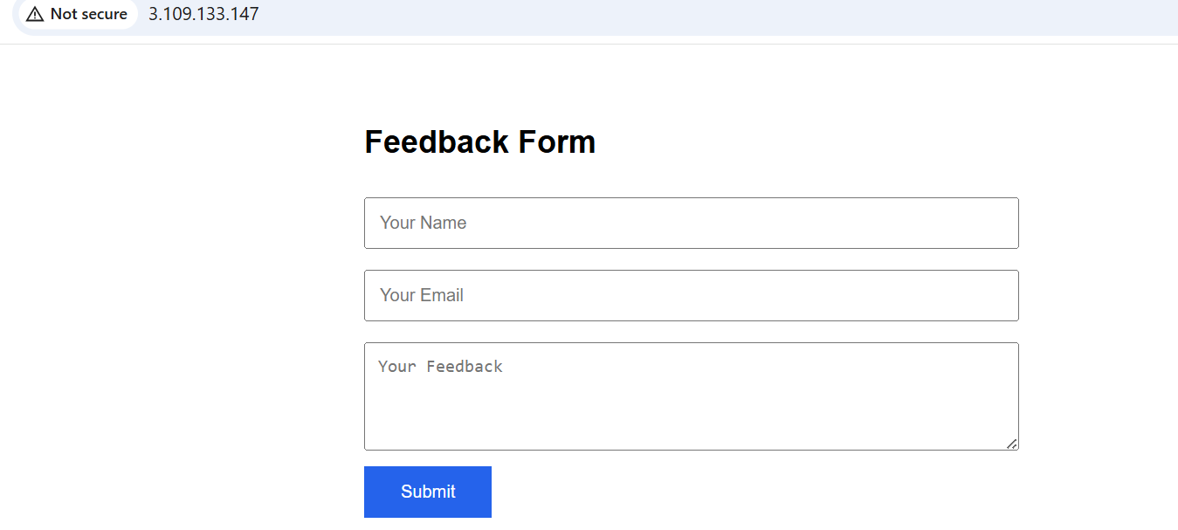

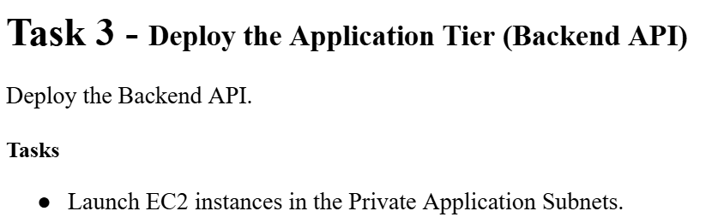
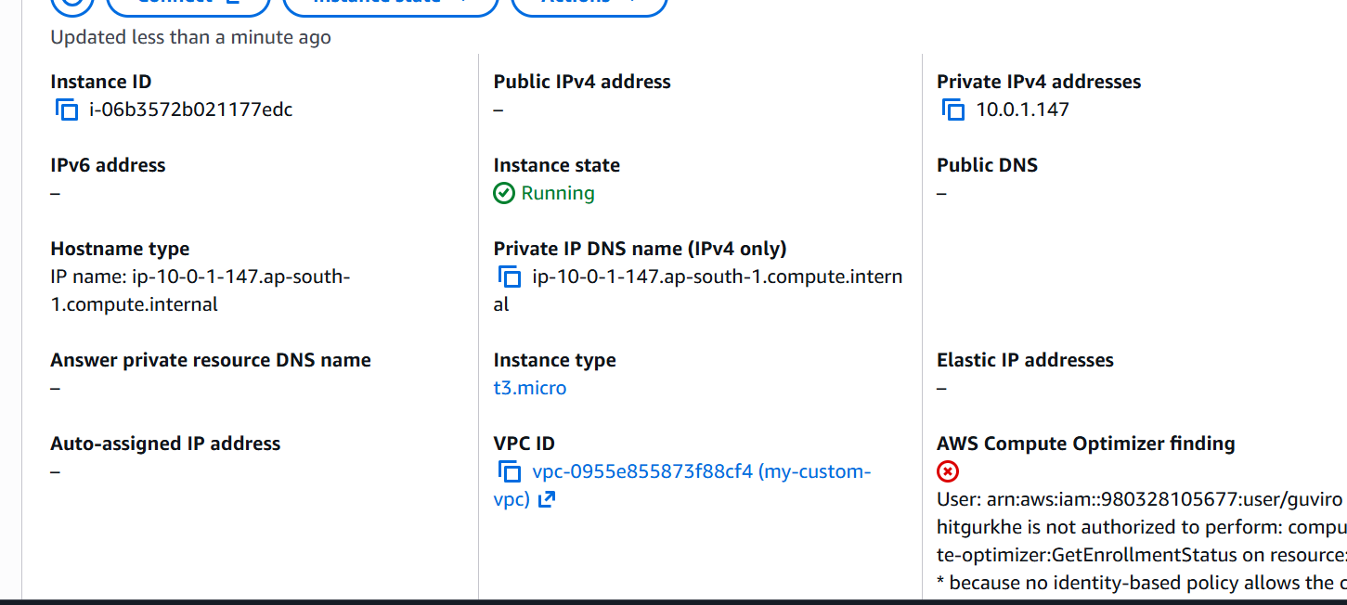
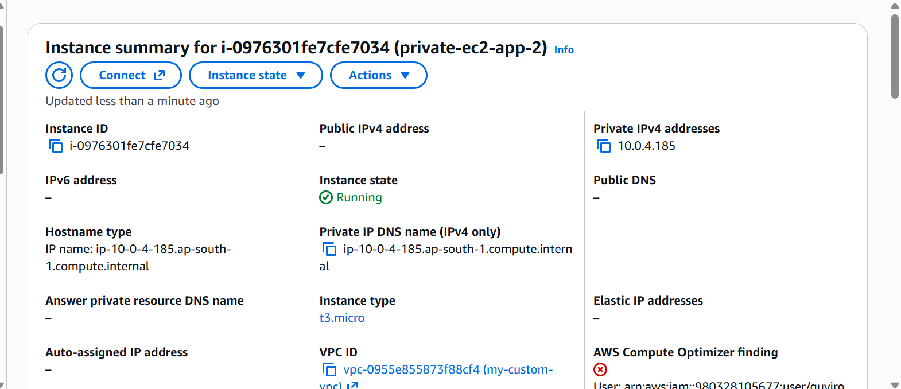
- Connect through the Bastion Host (if used) or Session Manager.
- Install Python 3.
- Install Flask and required Python packages.

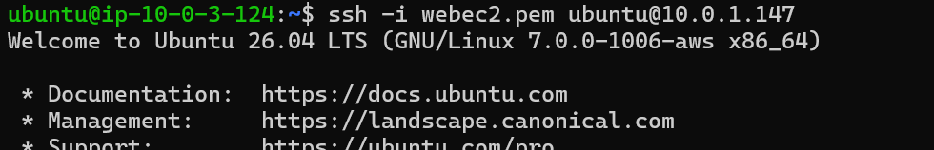
- 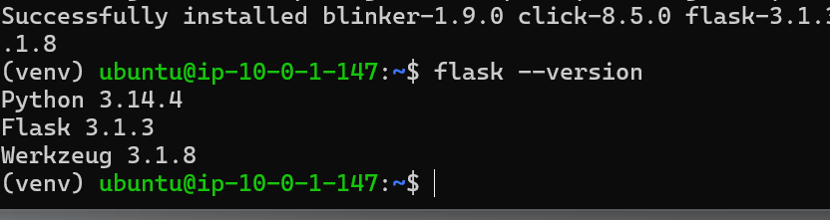Run the Flask application on Port 5000.
- Verify the application is running.
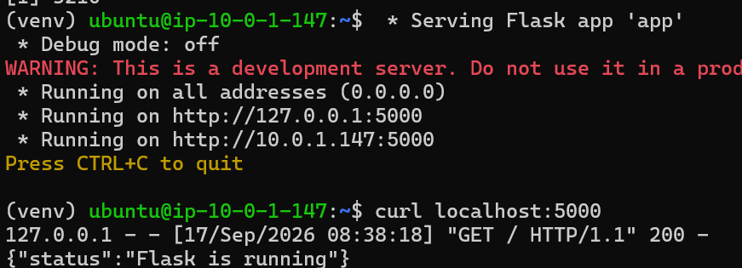

Task 4 - Deploy and Configure the Database Tier
Deploy the Database Layer.

Tasks

- Create an Amazon RDS MySQL instance.
- Deploy the database in the Database Subnets.
- Configure database credentials.
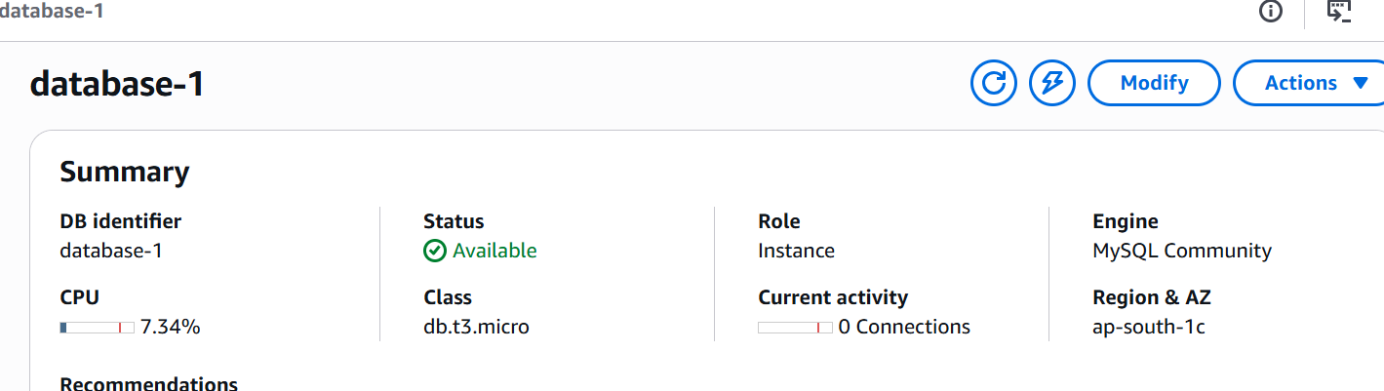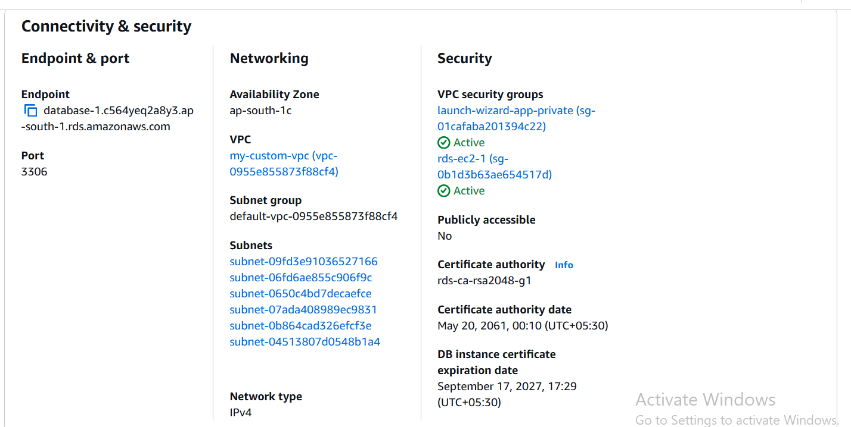

- Connect DB in App Ec2 terminal.
- Execute the provided SQL commands in the terminal.
- Verify connectivity from the Flask application.
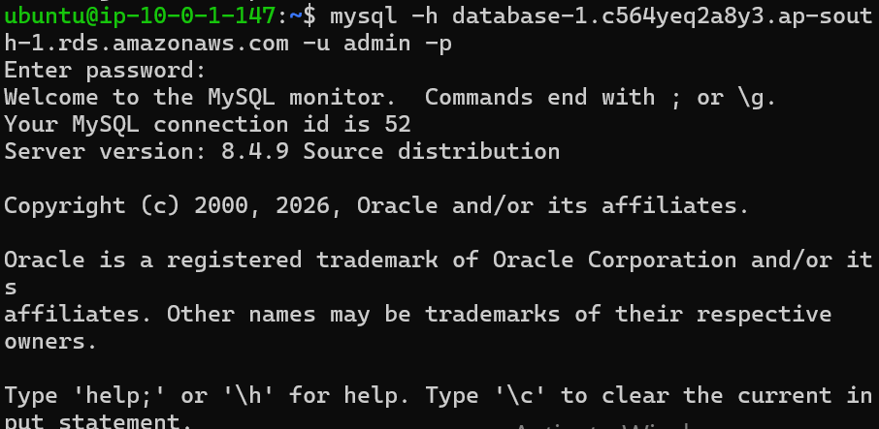
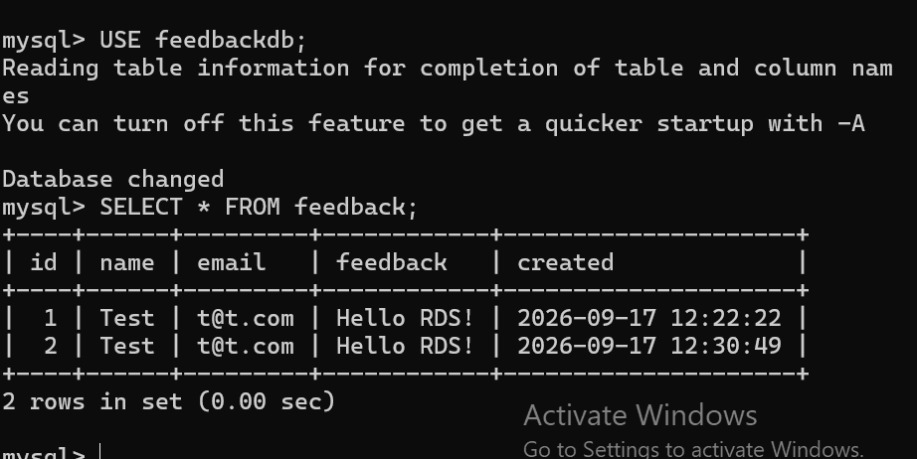

Task 5 - Implement Network and Instance Security
Create Security Groups with appropriate inbound and outbound rules.
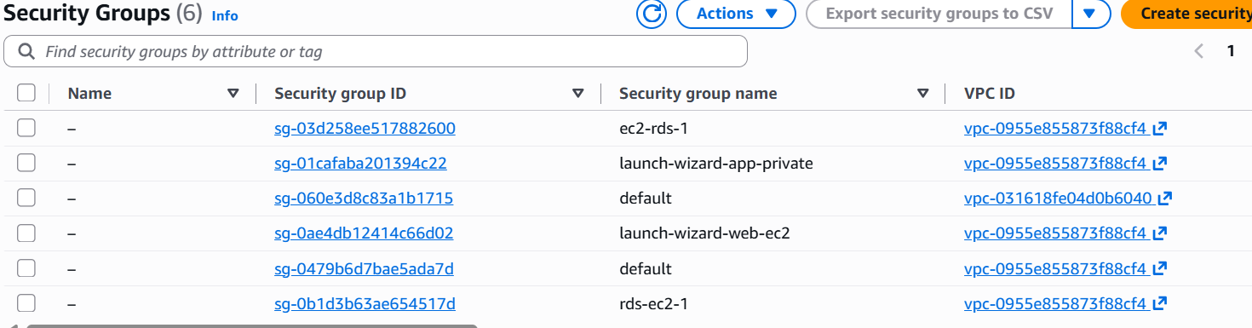
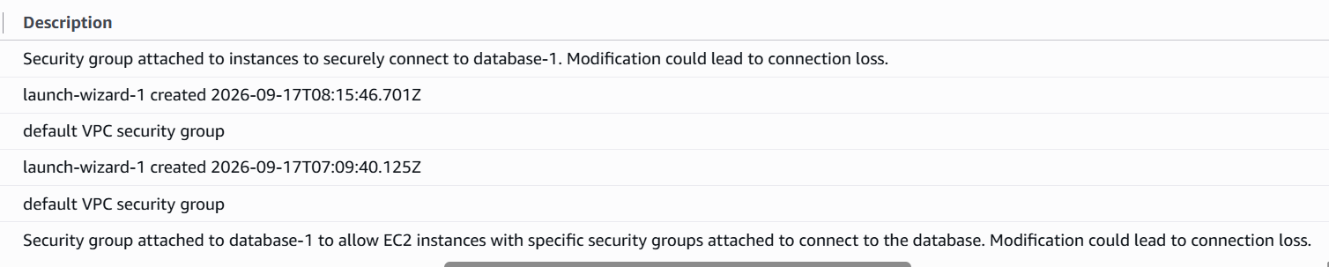
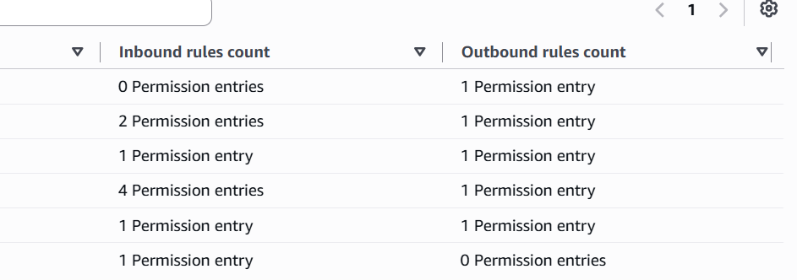
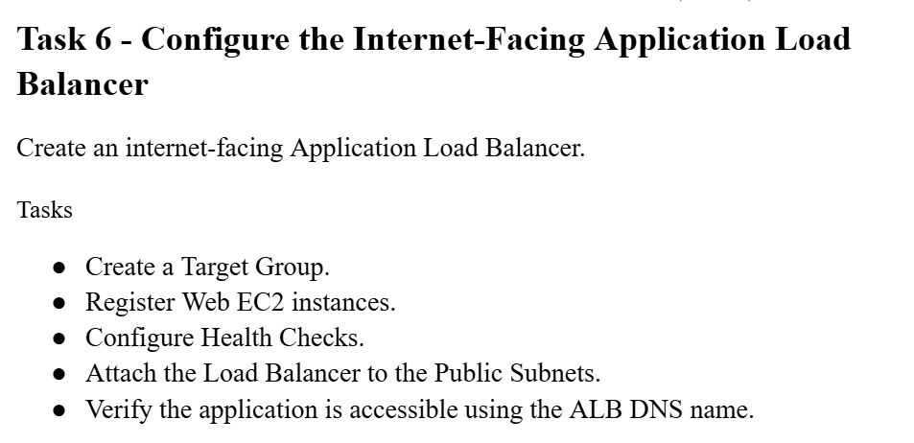
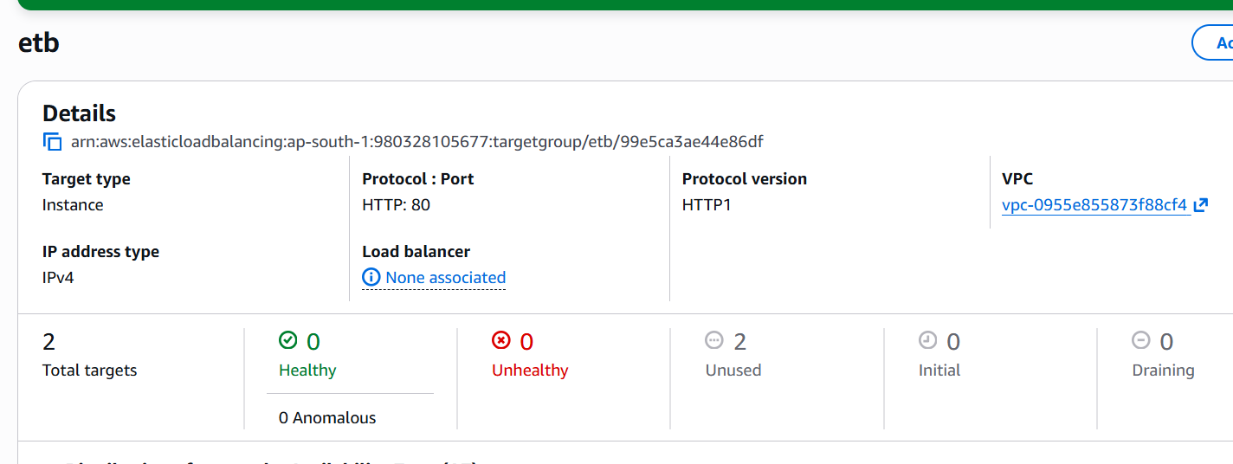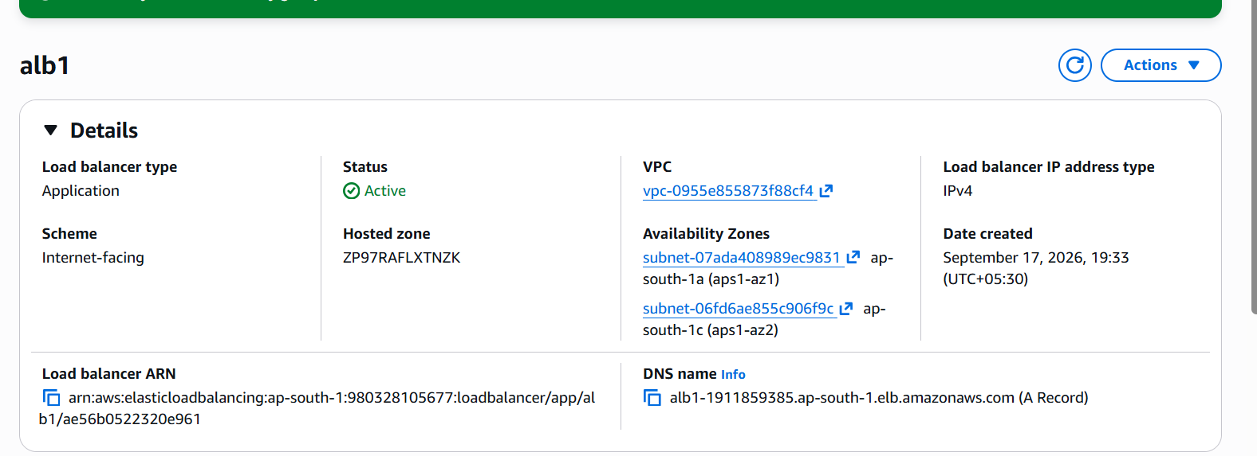
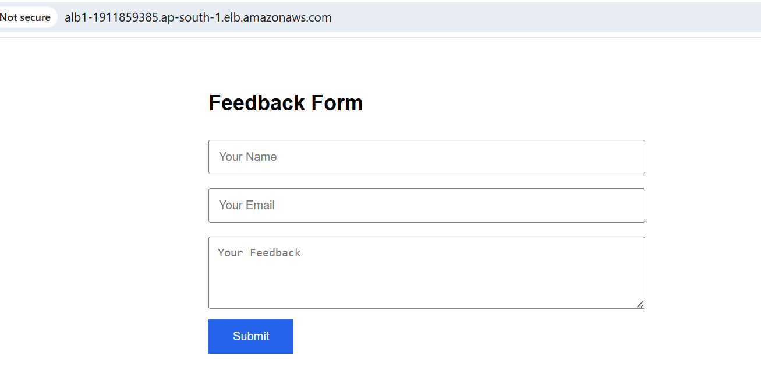

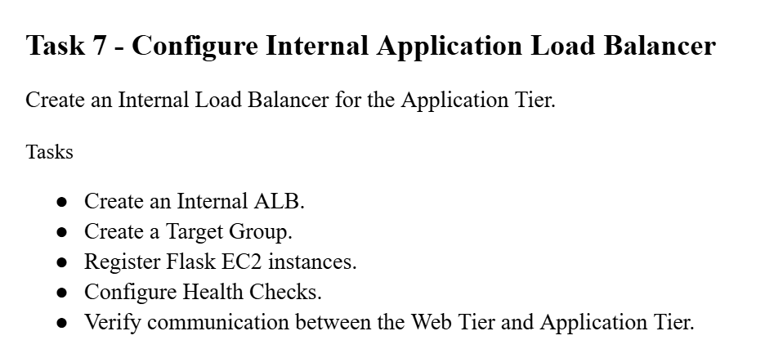
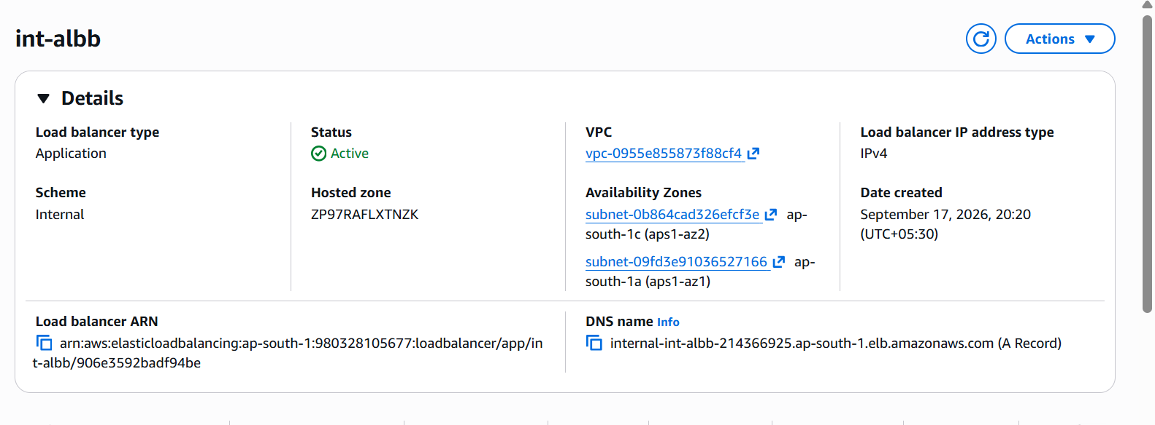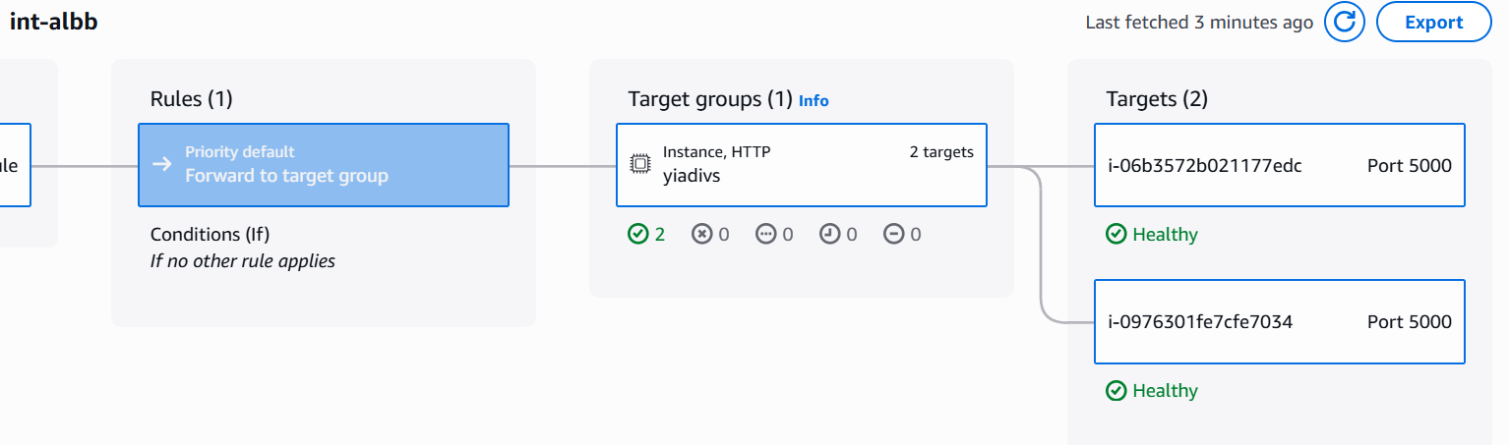

Task 8 - Configure Nginx Reverse Proxy for API Routing
Update the Nginx configuration.
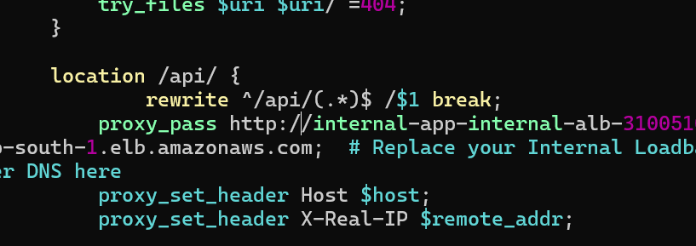
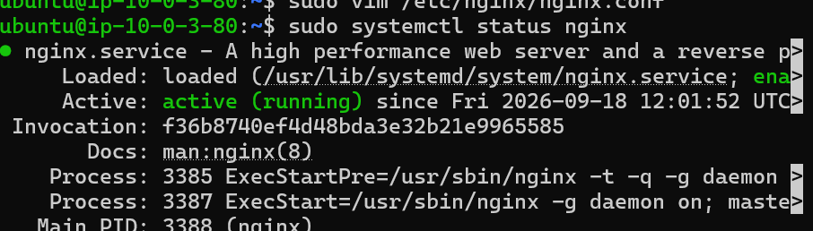
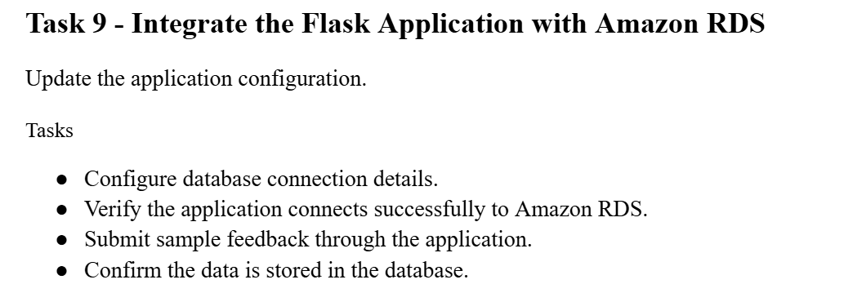
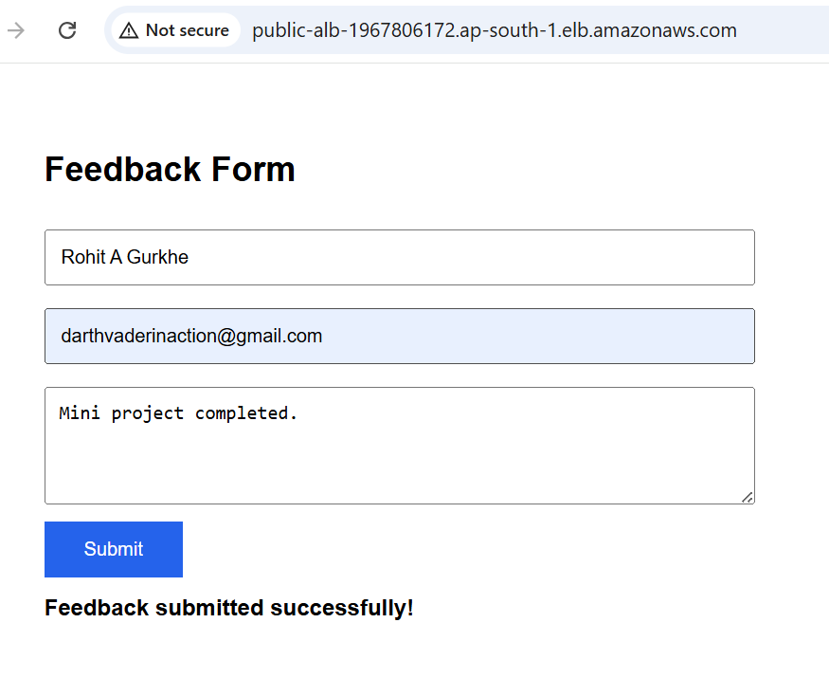
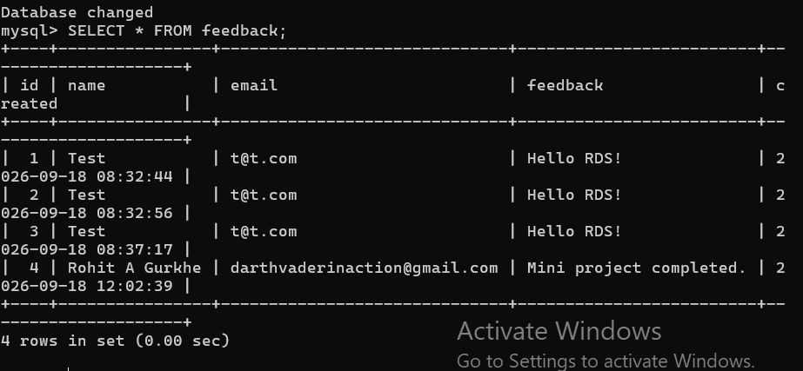
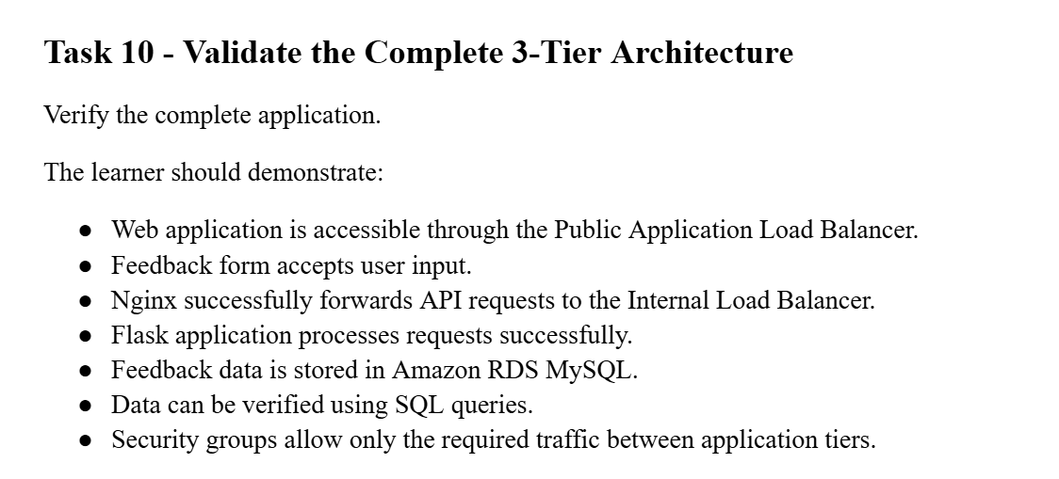

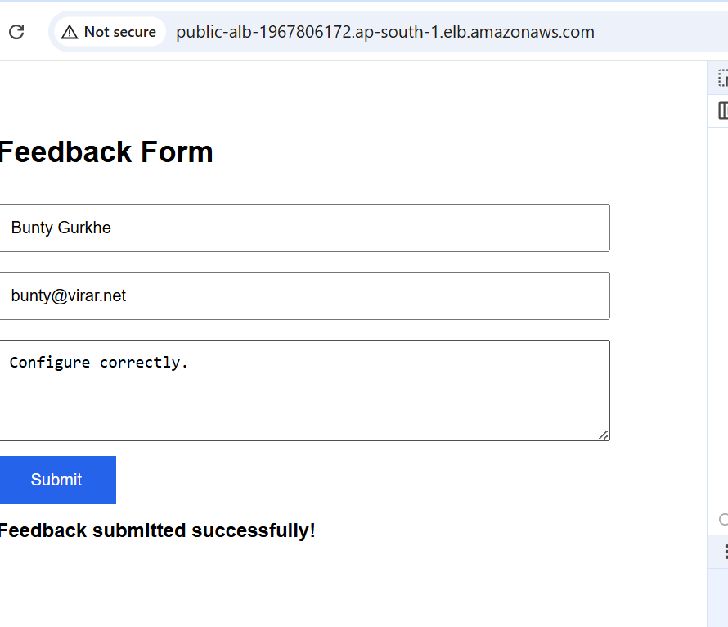
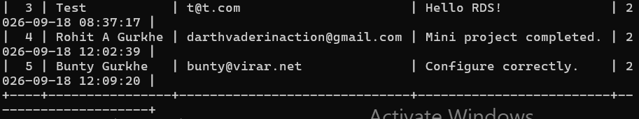

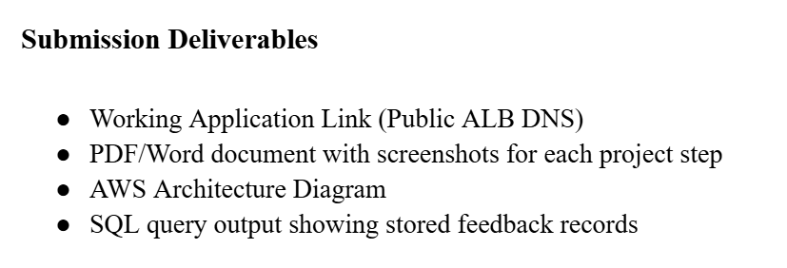
http://public-alb-1967806172.ap-south-1.elb.amazonaws.com/

Project01.docx

