PROJECT REPORT

Emotion, Sentiment and Sarcasm Analysis of Social Media Text
An understandable guide to the data, the models and the results
Rohit Gurung
November 2026

Contents
1. The Project in One Page
2. Key Terms
3. Exploring the Data
4. How the System Works
5. Results
6. Improvements Tried and Rejected
7. The Application
8. Limitations
9. Conclusion
AI Assistance Statement
References

1. The Project in One Page
This project reads a short social media post and answers three questions: what emotion does it express, is it positive, negative or neutral, and could it be sarcastic? It comes with a Streamlit web app where anyone can paste a post and see the answer.
Sarcasm makes this hard. The post "I just love it when my phone dies at 2%" contains the word love, but the writer is annoyed. A system that only counts words gets this wrong.
The project went through two stages. It first trained a simple keyword model (TF-IDF with a Linear SVM). That model scored 96% on its own test data, but only 30% on real human-written comments. The project then trained a RoBERTa transformer on real comments and tweets. RoBERTa makes every final decision in the app, and the keyword model stays visible as a comparison.
Table 1. Final results of the RoBERTa system on test data it never trained on
What was tested | Rows | Result
Emotion in Reddit comments (GoEmotions) | 3,799 | Accuracy 0.728, macro-F1 0.688
Emotion in tweets (SemEval-2018) | 1,606 | Accuracy 0.757, macro-F1 0.531
Sarcasm (iSarcasmEval) | 1,394 | Precision 0.705, recall 0.335, F1 0.454
Irony (SemEval-2018) | 784 | Precision 0.783, recall 0.511, F1 0.619
Sentiment (TweetEval) | 12,280 | Accuracy 0.543, macro-F1 0.543

In plain words: the system is good at everyday emotions, and it is careful about sarcasm: when it says a post is sarcastic it is usually right, but it misses many sarcastic posts. It is weak on rare emotions in tweets and on sentiment, and section 8 explains why.

2. Key Terms
Table 2. The terms used in this report
Term | Meaning
Accuracy | The share of posts the model got right.
Precision | Of the posts the model flagged, how many were truly that class.
Recall | Of the posts truly in that class, how many the model found.
F1 | One score that combines precision and recall. 1.0 is perfect.
Macro-F1 | The average F1 across all classes, with each class counted equally. A rare emotion matters as much as a common one.
TF-IDF | Turns text into numbers based on which words appear and how unusual they are. It ignores meaning and word order beyond pairs of words.
Linear SVM | A simple classifier that learns a weight for each word.
Transformer | A neural network that reads the whole sentence and uses the context around each word.
RoBERTa | The transformer used here. This version was pretrained on tweets.
Train, validation, test | Data to learn from, data to make choices with, and data kept aside for the final score.
Data leakage | When something in the input gives away the answer, so the score looks better than it should.

3. Exploring the Data
Before training anything, the data was explored to see what the models would learn from. Several problems found here shaped the whole project.

3.1 The datasets
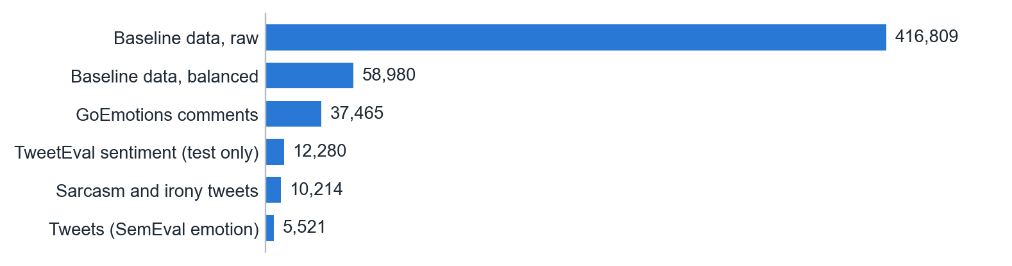
Figure 1. Number of rows in each dataset.
Table 3. What each dataset was used for
Dataset | Used for | Who labelled it
Baseline data (text2.csv, final.csv) | Training the TF-IDF model | Emotion labels came with the data. Sentiment came from a word list.
GoEmotions (Reddit comments) | Training and testing emotion | People
SemEval-2018 Affect in Tweets | Training and testing emotion | People
iSarcasmEval | Training and testing sarcasm | The authors of the tweets
SemEval-2018 Irony | Training and testing sarcasm | People
TweetEval | Testing sentiment only | People

3.2 Cleaning the baseline data
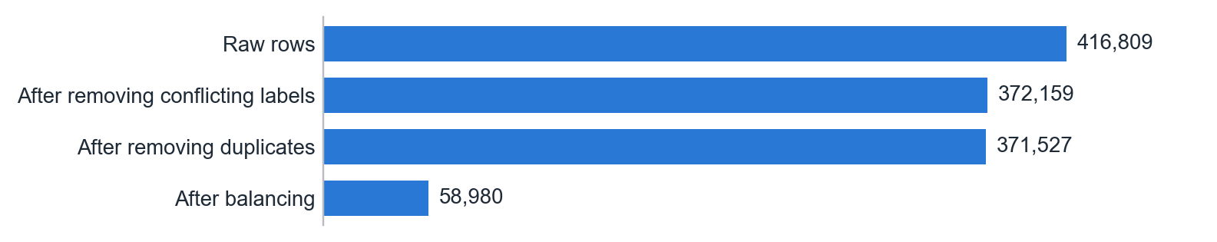
Figure 2. Rows left after each cleaning step of the baseline data.
What it shows: most rows survive cleaning, and the large drop comes from balancing.
Why it matters: 44,650 rows had emojis added that revealed the label, which is data leakage. Removing those emojis left texts that appeared with conflicting labels, so those rows were dropped. Without this step the model could score well just by reading the emoji.

3.3 How the emotions are spread
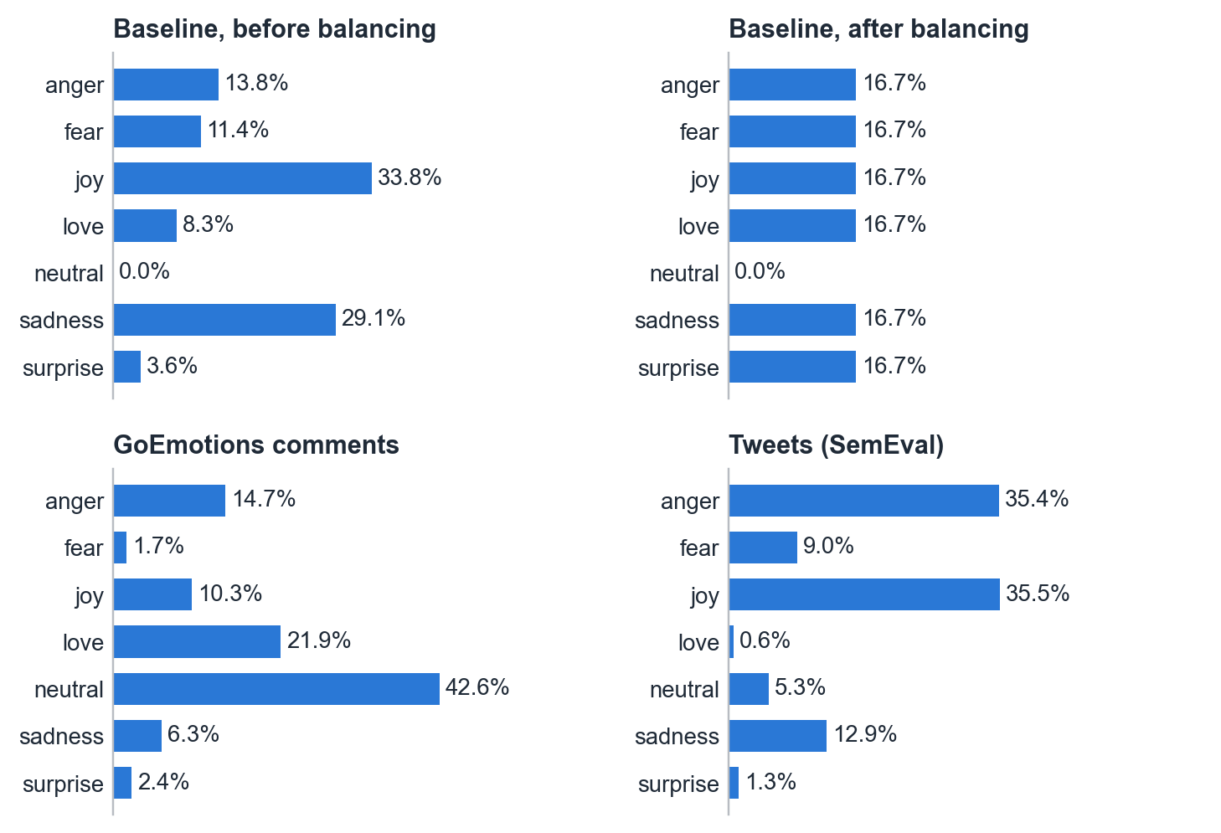
Figure 3. Share of rows for each emotion in each dataset.
What it shows: balancing gave the baseline data exactly 16.7% per emotion. The real datasets are very uneven. Neutral is 42.6% of GoEmotions, and love is only 0.6% of the tweets.
Why it matters: real text is not balanced, so a model has to cope with rare classes. RoBERTa was trained with larger weights on rare emotions. The tweet test set still has only 10 love rows and 17 surprise rows, so those two scores are unreliable.

3.4 How people write in each dataset
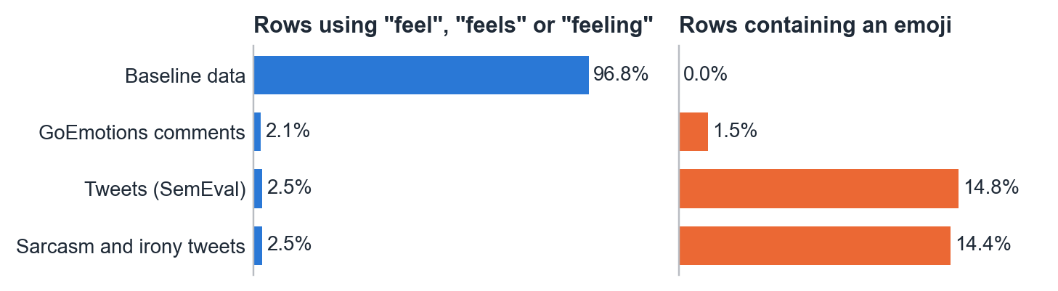
Figure 4. Two differences in writing style between the datasets.
What it shows: 96.8% of the baseline data uses the word feel, feels or feeling, as in "i feel really helpless". In the real datasets this is about 2%. The cleaned baseline data has no emojis at all, while about 15% of tweets have one.
Why it matters: this is the most important finding in the project. The baseline data does not look like social media, so a model trained on it learns a pattern that real posts do not follow.
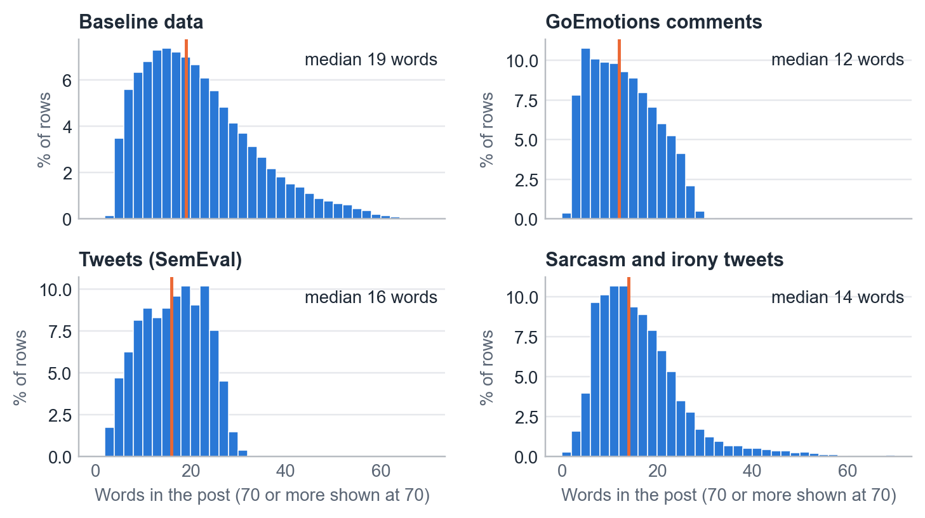
Figure 5. Length of posts in words. The orange line marks the median.
What it shows: posts are short, with a median of 12 to 19 words.
Why it matters: a limit of 64 tokens is enough for almost every post, which keeps training fast. Short posts also give a model little context, which adds to the difficulty.

3.5 Sarcasm data
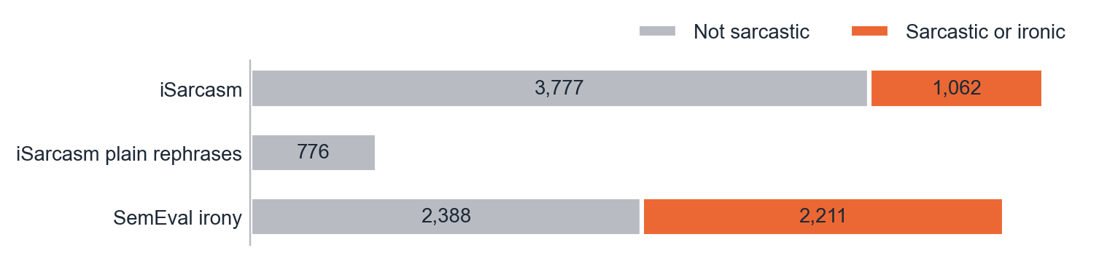
Figure 6. Sarcastic and non-sarcastic rows by source.
What it shows: iSarcasm has far more plain tweets than sarcastic ones, and SemEval irony is close to even. iSarcasm authors also wrote what they really meant, giving 776 plain rephrases.
Why it matters: the rephrases show the model the same idea with and without sarcasm. In the SemEval data, hashtags such as #not revealed the answer, so they were removed.

3.6 Checking the sentiment labels
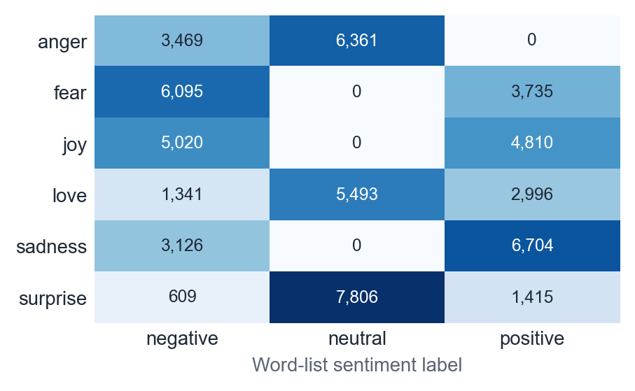
Figure 7. Emotion against word-list sentiment in the baseline data.
What it shows: 6,704 sadness rows are labelled positive, and 5,020 joy rows are labelled negative.
Why it matters: the baseline's sentiment labels came from a word list and often contradict the emotion. A high sentiment score on this data only proves the model can copy that word list. The final app therefore works out sentiment from the emotion instead.

4. How the System Works
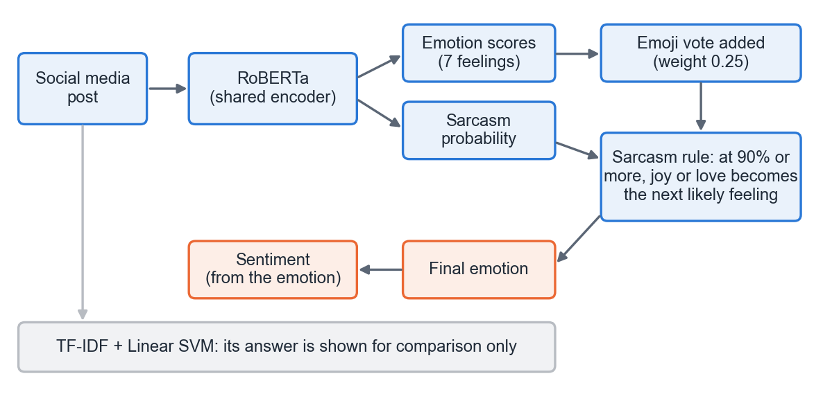
Figure 8. How a post becomes a final answer.
- Reading the post. Usernames and links are replaced by placeholders, and RoBERTa reads the text.
- Two outputs, one reader. The same network gives scores for seven emotions (anger, fear, joy, love, sadness, surprise, neutral) and a sarcasm probability.
- Emoji vote. Known emojis add a vote to the emotion scores with a weight of 0.25. A post with only emojis uses the vote alone.
- Sarcasm rule. If sarcasm is 90% or more and the top emotion is joy or love, the system picks the next most likely emotion, leaving out neutral.
- Sentiment. Joy and love are positive. Anger, fear and sadness are negative. Surprise and neutral are neutral.

4.1 The baseline model
The TF-IDF model uses single words and pairs of words, up to 50,000 features, with a Linear SVM. It was trained on the cleaned, balanced data with an 80/20 split. It has six emotions and no neutral class.

4.2 Training RoBERTa
Table 4. Training setup
Setting | Value
Starting model | cardiffnlp/twitter-roberta-base-2022-154m
Training rows | 29,920 comments, 3,485 tweets with emotions, 6,736 sarcasm rows, and 462 extra tweets counted 3 times (41,527 in total)
Learning rate, epochs, batch size | 0.00002, 3 epochs, 32 posts
Maximum post length | 64 tokens
Rare classes | Larger loss weights, using the square root of inverse frequency
Random seed | 42

Each row only trains the output it has a label for. GoEmotions comments also count as not sarcastic, which stops the model from seeing sarcasm everywhere. The 462 extra tweets are sarcastic tweets given an emotion taken from what their authors really meant. These labels were produced by the model, so some are wrong.

4.3 Keeping the test fair
- The test data was never used for training.
- The best epoch and the sarcasm threshold were chosen on validation data.
- Text that appeared in more than one split was removed.
- Before each improvement experiment, pass rules were written down, and the change was rejected if it failed them.

5. Results

5.1 Overall
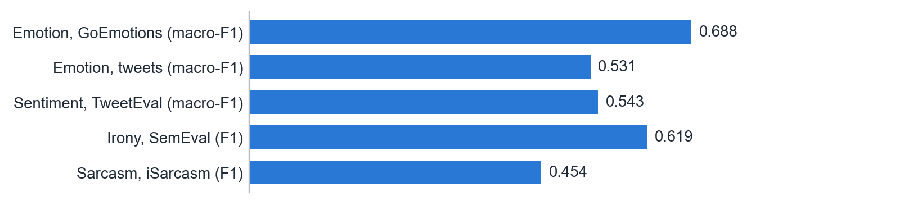
Figure 9. Final test scores. Longer is better, and 1.0 is perfect.

5.2 Each emotion
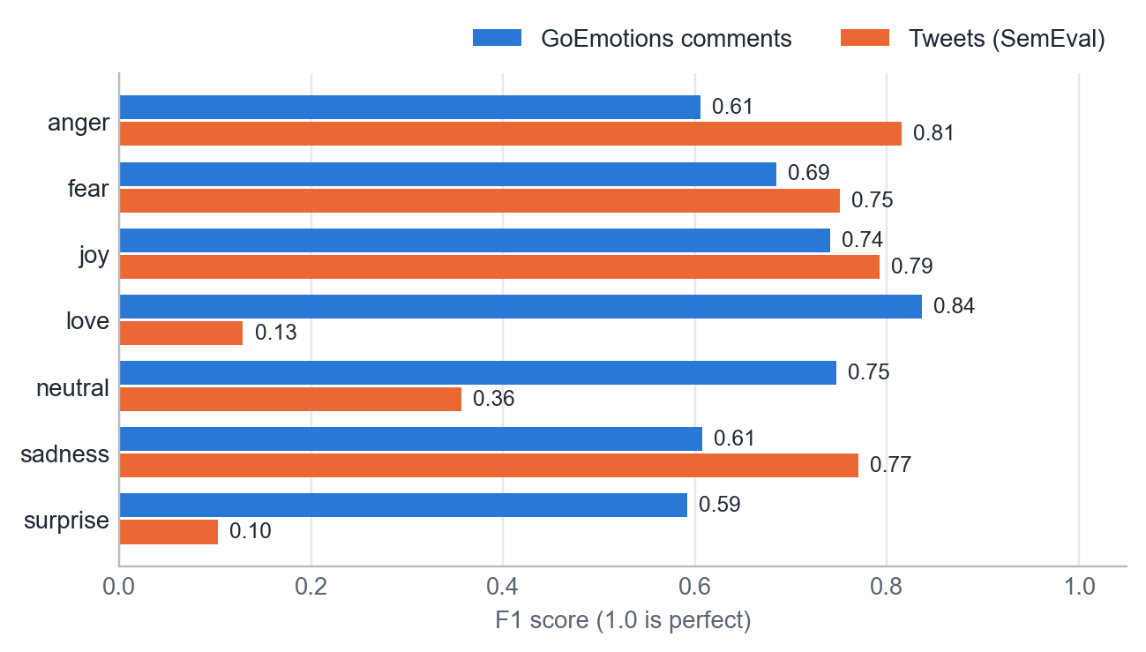
Figure 10. F1 for each emotion on the two test sets.
What it shows: on comments, every emotion scores between 0.59 and 0.84. On tweets, anger, fear, joy and sadness score 0.75 to 0.81, while love and surprise fall to 0.13 and 0.10.
Why it happens: these two emotions are rare in the tweet data, with only 21 love and 50 surprise rows for training. That is why tweet macro-F1 (0.531) is much lower than tweet accuracy (0.757).
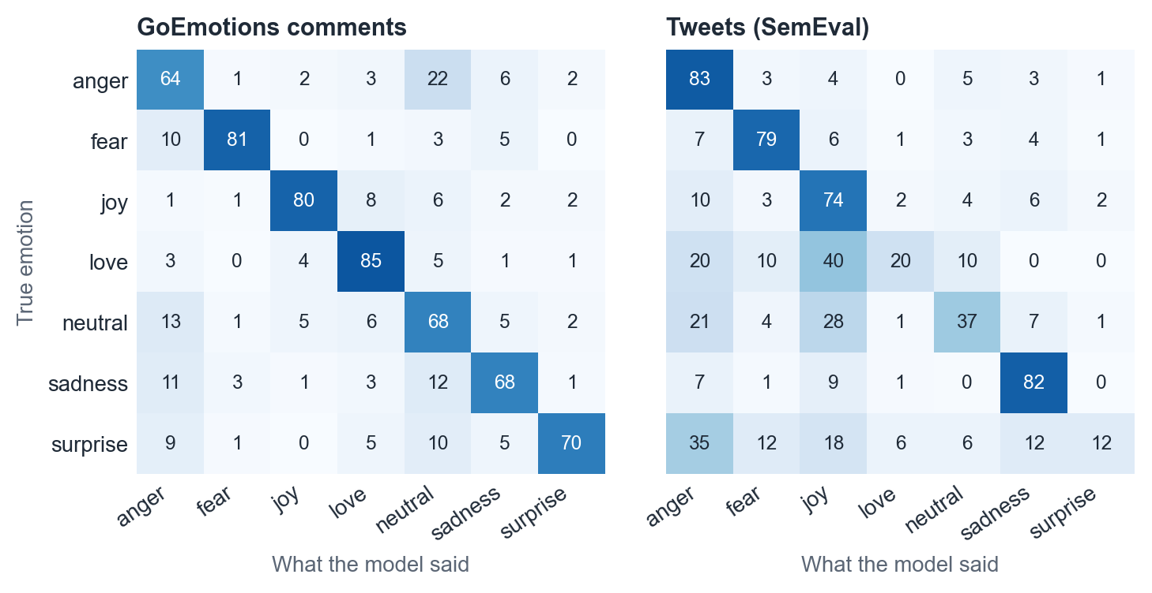
Figure 11. Where the answers go, as a percentage of each true emotion. Dark squares on the diagonal are correct answers.
What it shows: on comments, the most common mistake is reading anger as neutral (22%). On tweets, love is often read as joy (40%), and surprise as anger (35%).

5.3 Choosing the sarcasm threshold
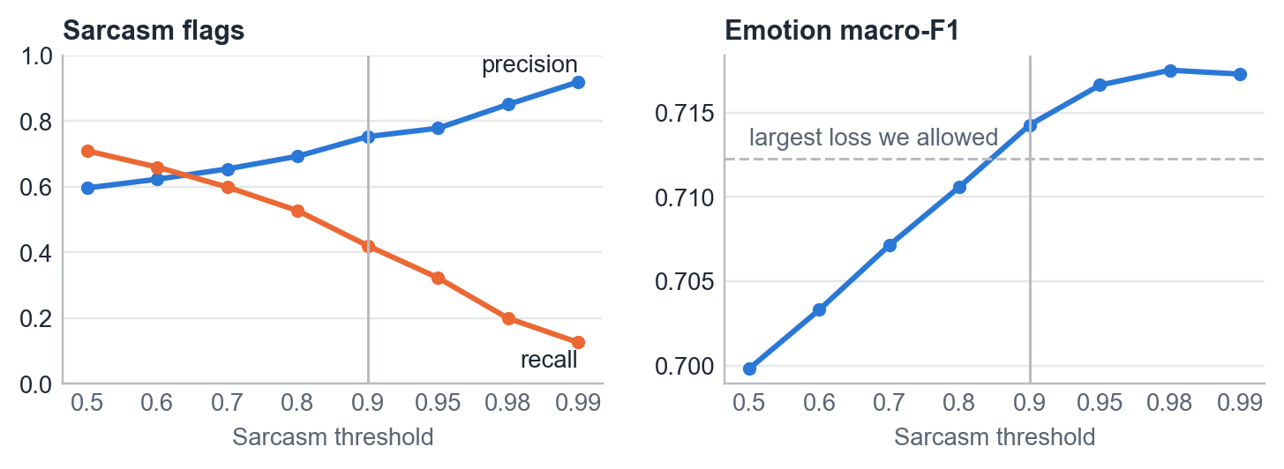
Figure 12. The effect of the sarcasm threshold on validation data. The vertical line marks the chosen value, 0.90.
What it shows: a higher threshold makes sarcasm flags more trustworthy but finds fewer sarcastic posts. A lower threshold also harms emotion scores, because more genuine joy and love gets overturned.
The choice: 0.90 is the lowest threshold that costs no more than 0.005 validation emotion macro-F1. At 0.90 the validation precision is 0.75 and recall is 0.42.

5.4 Why the keyword model was not enough
Table 5. TF-IDF + Linear SVM scores
Test | Accuracy | Macro-F1
Emotion, its own test split | 0.9627 | 0.9625
Sentiment, its own test split | 0.9456 | 0.9455
Emotion, human-written comments (six emotions) | 0.3048 | 0.2863

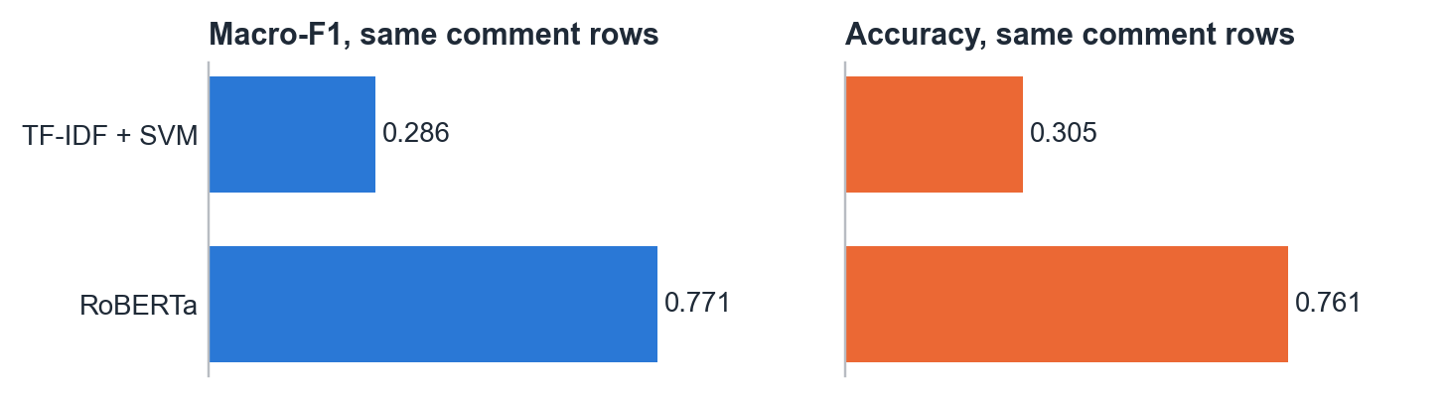
Figure 13. Both models on the same 2,195 GoEmotions test comments, leaving out neutral.
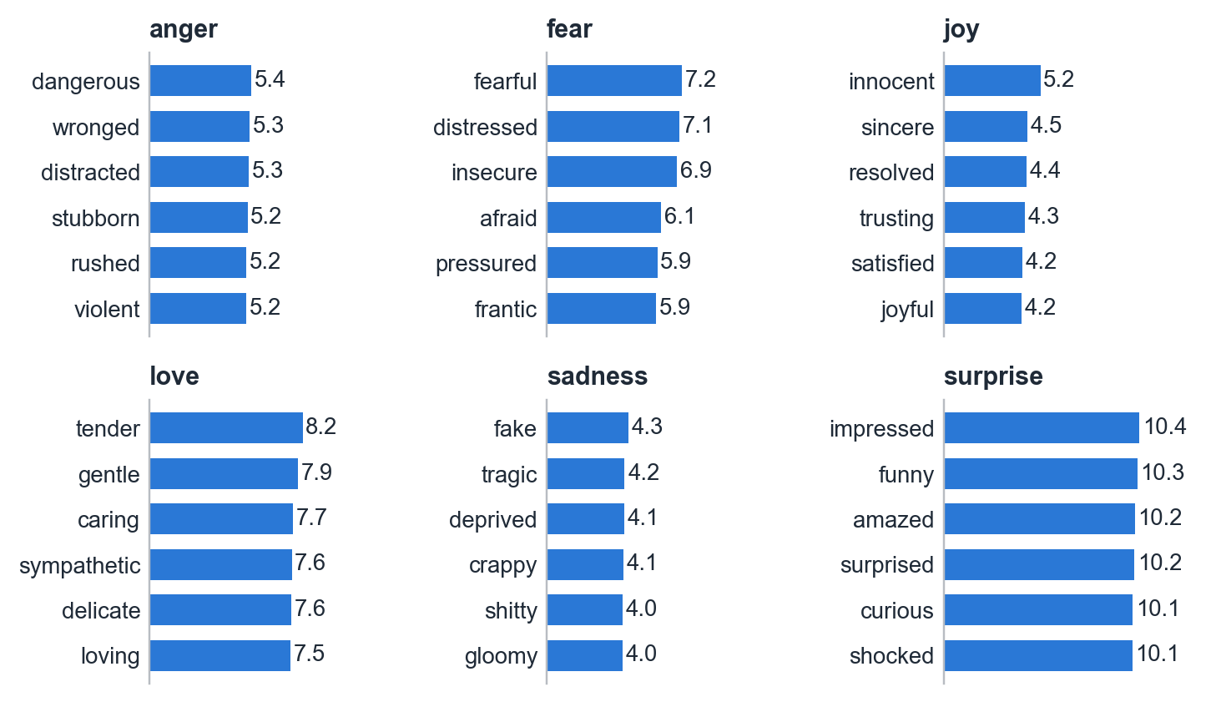
Figure 14. Words with the largest learned weight for each emotion in the keyword model.
What it shows: the keyword model learned adjectives that complete "i feel ...", such as tender, fearful and amazed. Real posts rarely state their emotion this way, so its 96% did not transfer.
Table 6. Example posts through both models
Post | RoBERTa | Keyword model
I just love it when my phone dies at 2% | Anger (sarcasm 99%) | Joy
I got the job!!! | Joy | Fear
My dog died today 😢 | Sadness | Anger
you are the sweetest person i know ❤️ | Love | Anger
my hands won't stop shaking before this interview | Fear | Anger
The meeting is at 3pm on Tuesday. | Neutral | Joy
i miss my grandma every single day | Sadness | Sadness

6. Improvements Tried and Rejected
Two further ideas were tested to raise macro-F1. Neither met its pass rules, so neither is in the final system.
Table 7. Experiments on the final model
Experiment | Result | Decision
Adjust the score of each emotion separately | GoEmotions rose from 0.6878 to 0.7084, but tweets fell from 0.5310 to 0.5292 | Rejected: one test set fell
Retrain with 9,475 extra rows carrying mixed emotion labels | Validation 0.7170 (needed above 0.7173), GoEmotions 0.6813 (needed 0.6878), tweets 0.5186 (needed 0.5310). Only sarcasm passed, at iSarcasm F1 0.4854. | Rejected: 3 of 4 checks failed

A rejected idea is still a useful result. Tuning on the same data has stopped helping, and the main limit is the small number of love and surprise tweets.

7. The Application
The Streamlit app has a wall of example posts and a text box. For each post it shows the emotion, sentiment and sarcasm reading, with a gradient coloured by the emotion. The "How this was decided" panel shows the steps, including the keyword model's answer for comparison.
To run it, the trained model must be in models/emotion_sarcasm/. From the project folder, install the packages with pip install -r requirements.txt, then start the app with python -m streamlit run src/app.py. Every graph in this report can be redrawn with python report/make_figures.py.

8. Limitations
- The system misses about two-thirds of sarcasm on iSarcasm, and about 3 in 10 of its flags there are wrong.
- Love and surprise in tweets are poorly detected, and their test scores come from only 10 and 17 rows.
- Sentiment is worked out from the emotion, so it scores only 0.543 on TweetEval. Neutral makes up nearly half of that data, and the model is not trained on sentiment directly.
- The emoji vote uses a fixed table, so an emoji counts the same whatever the post says.
- Some sarcastic training labels are machine-generated, and irony labels stand in for sarcasm in the SemEval rows.
- The system handles English only.

9. Conclusion
The main lesson is that a high score on easy, unrealistic data can be misleading. Data exploration showed that 96.8% of the baseline text followed one writing pattern, which explains why the keyword model fell from 96% to 30% on real comments. On the same real comments, RoBERTa reached 0.771 macro-F1, compared with 0.286 for the keyword model.
The final system handles everyday emotions well and can catch some sarcastic posts that a keyword model reads literally. Sarcasm is only partly solved. The most useful next step is more tweet data for love and surprise, and a sentiment output trained directly on labelled sentiment.

AI Assistance Statement
AI tools were used in this project. Claude, by Anthropic, assisted with writing and debugging code, running experiments, and drafting documentation and this report. Decisions on the project's direction and on which final model to use were made by the project author.

References
- Abu Farha, I., Oprea, S., Wilson, S., and Magdy, W. (2022). SemEval-2022 Task 6: iSarcasmEval, Intended Sarcasm Detection in English and Arabic. Proceedings of SemEval-2022.
- Barbieri, F., Camacho-Collados, J., Espinosa Anke, L., and Neves, L. (2020). TweetEval: Unified Benchmark and Comparative Evaluation for Tweet Classification. Findings of EMNLP 2020.
- Demszky, D., Movshovitz-Attias, D., Ko, J., Cowen, A., Nemade, G., and Ravi, S. (2020). GoEmotions: A Dataset of Fine-Grained Emotions. Proceedings of ACL 2020.
- Liu, Y., et al. (2019). RoBERTa: A Robustly Optimized BERT Pretraining Approach. arXiv:1907.11692.
- Loureiro, D., Barbieri, F., Neves, L., Espinosa Anke, L., and Camacho-Collados, J. (2022). TimeLMs: Diachronic Language Models from Twitter. Proceedings of ACL 2022, System Demonstrations.
- Mohammad, S., Bravo-Marquez, F., Salameh, M., and Kiritchenko, S. (2018). SemEval-2018 Task 1: Affect in Tweets. Proceedings of SemEval-2018.
- Van Hee, C., Lefever, E., and Hoste, V. (2018). SemEval-2018 Task 3: Irony Detection in English Tweets. Proceedings of SemEval-2018.

