

Department of Computer Science and Engineering


A Technical Seminar Report
on
Quantum Computing: Future of Computation

Submitted By :
A.ROHITH REDDY
22891A0501

Department of Computer Science and Engineering

Vision
To ignite a new era of computation by embracing the infinite possibilities of quantum mechanics, becoming a global hub for innovation, education, and research. We aspire to transform students into visionary leaders who harness quantum technologies to redefine intelligence, solve humanity’s grand challenges, and create a smarter, sustainable, and empowered world.

Mission
- To provide world-class education and research opportunities in quantum computing and emerging computational technologies.
- To foster innovation and creativity by encouraging students to explore beyond classical paradigms of computation.
- To bridge the gap between theory and practice through hands-on projects, seminars, and industry collaborations.
- To prepare future-ready professionals equipped with quantum skills to meet the global demands of IT, AI, and scientific research.
- To promote interdisciplinary learning by integrating quantum computing with artificial intelligence, cryptography, material science, and healthcare.

Program Educational Objectives

- To create and sustain a community of learning in which students acquire knowledge and apply in their concerned fields with due consideration for ethical, ecological, and economic issues.
- To provide knowledge based services so as to meet the needs of the society and industry.
- To make the students understand, design and implement the concepts in multiple arenas.
- To educate the students in disseminating the research findings with good soft skills so as to become successful entrepreneurs.

PREFACE

I have made this report file on the topic Quantum computing: future of computation. I have tried my best to elucidate all the relevant detail to the topic to be included in the report. While in the beginning I have tried to give a general view about this topic.

Table of Contents

TITLE PAGE NO.

- ACKNOWLEDGEMENT
- CERTIFICATE
- ABSTRACT 8
- INTRODUCTION 9
- HISTORY 10
- TECHNIQUES/METHODS 11
- EXAMPLES 13
- MOTIVES 15
- ILLUSTRATIONS 16
- HOW IT WORKS 18
- ADVANTAGES 24
- APPLICATIONS 26
- LIMITATIONS 29
- CONCLUSION 31
- REFERENCES 32

ACKNOWLEDGEMENT

I would like to thank respected, Dr. G. RajaVikram Head of the Department for giving me such a wonderful opportunity to expand my knowledge for my own branch and giving me guidelines to present a seminar report. It helped me a lot to realize of what we study for.

I would like to thank respected technical seminar co-ordinator, Mrs. M. Archana for organizing seminars with the continuous support.

Secondly, I would like to thank my parents who patiently helped me as I went through my work and helped to modify and eliminate some of the irrelevant or unnecessary stuff.

Thirdly, I would like to thank my friends who helped me to make my work more organized and well-stacked till the end.

Last but not the least, I would thank the Almighty for giving me strength to complete my report on time.

Name and signature of the student

CERTIFICATE
This is to certify that the Technical Seminar Report entitled “Quantum Computing: Future of Computation” is being submitted by A.ROHITH bearing R. No 22891A0501, in IV B.Tech I Semester Computer Science and Engineering is a record bonafide work carried out by him/her.

Coordinator Head of the Department

1. ABSTRACT

Quantum computing represents a radical shift from the traditional methods of computation by harnessing the laws of quantum mechanics—superposition, entanglement, and quantum interference. Unlike classical machines limited to binary bits, quantum systems operate with qubits, which can exist in multiple states at once, enabling vast parallelism. This unique capability empowers quantum processors to tackle computational challenges that would take classical supercomputers millions of years.
This seminar explores the foundation and potential of quantum computing, highlighting quantum gates, circuits, and landmark algorithms such as Shor’s for factorization and Grover’s for database search. We also examine its transformative applications across domains including cryptography, artificial intelligence, drug discovery, climate modeling, and optimization of global supply chains. These advancements promise to reshape industries by accelerating innovation and providing solutions beyond the reach of conventional computation.
However, the field is not without barriers. Qubit decoherence, noise sensitivity, and the immense difficulty of error correction remain significant challenges, while scalability continues to be a frontier yet to be conquered. Despite these limitations, breakthroughs by organizations such as IBM, Google, and academic research communities signal steady progress toward practical systems.
QUANTUM COMPUTING: FUTURE OF COMPUTATION envisions a new era where quantum principles redefine speed, security, and intelligence, ultimately transforming science, technology, and society.

2. INTRODUCTION

Quantum Computing is a revolutionary model of computation that applies the laws of quantum mechanics to solve problems that are difficult or impossible for classical systems. Unlike conventional computers that rely on binary bits restricted to 0 or 1, quantum computers use qubits, which can exist in multiple states at once through superposition. When combined with entanglement and interference, qubits enable massive parallelism, allowing quantum computers to explore many possibilities simultaneously and solve certain problems exponentially faster than traditional machines.
Quantum computing is not just about speed but about introducing a fundamentally different way of processing information. Algorithms like Shor’s algorithm for factoring large numbers and Grover’s algorithm for searching databases demonstrate how quantum systems can outperform classical approaches. Potential applications include cryptography, artificial intelligence, drug discovery, financial modeling, and climate prediction, making it a technology with wide-ranging impact.
At the same time, quantum computing faces serious challenges. Qubits are fragile and easily disturbed by noise, leading to instability and errors. Building scalable systems requires advanced error-correction and highly controlled environments, often at near absolute-zero temperatures. Despite these obstacles, rapid progress is being made. Companies such as IBM, Google, and Microsoft are investing heavily, with milestones like Google’s claim of achieving quantum supremacy and IBM’s development of processors exceeding 1000 qubits.
This report explores Quantum Computing in detail—covering its principles, history, architecture, advantages, applications, limitations, and its role in shaping the future of computation.

3. HISTORY

The origins of quantum computing can be traced back to the early 1980s, when physicist Richard Feynman first suggested that classical computers were inherently inefficient at simulating quantum systems. He proposed the idea of building a machine that could directly use the principles of quantum mechanics to perform such computations more naturally and efficiently. Around the same time, Yuri Manin, a Russian mathematician, also discussed similar concepts, laying the intellectual foundation for the field.
The next major milestone came in the mid-1980s with the work of David Deutsch at the University of Oxford, who introduced the concept of a universal quantum computer. Deutsch formalized the idea that quantum machines could simulate any physical system, just as classical computers simulate logical ones. His work provided the first theoretical framework for understanding how quantum algorithms could function.
In the 1990s, breakthroughs in quantum algorithms proved the practical importance of quantum computing. In 1994, Peter Shor developed an algorithm that could factor large numbers exponentially faster than the best-known classical algorithms. This discovery demonstrated that quantum computers could one day break widely used cryptographic systems like RSA, sparking huge interest worldwide. Shortly after, Lov Grover introduced Grover’s algorithm for database search, showing how quantum computing could speed up problem-solving in a wide range of fields.
From the 2000s onward, advances shifted toward experimental hardware. Companies such as IBM, Google, and startups like D-Wave began constructing early quantum processors. While D-Wave focused on adiabatic quantum computing for optimization problems, IBM and Google pursued gate-based quantum computing. In 2019, Google announced that it had achieved “quantum supremacy”, solving a task in 200 seconds that would take the fastest supercomputer thousands of years. IBM, in parallel, introduced scalable roadmaps and in 2023 unveiled processors exceeding 1000 qubits.
Today, quantum computing history continues to evolve rapidly. Governments, industries, and universities worldwide are investing billions into research to address challenges like qubit stability, error correction, and scalability.

4. QUANTUM COMPUTING

4.1 .QUBITS
The foundation of quantum computing lies in the quantum bit (qubit). Unlike a classical bit, which exists in a single state of either 0 or 1, a qubit can exist in a linear combination of both states due to superposition. This unique property exponentially increases the computational capacity of a quantum system as the number of qubits grows. For instance, while a classical computer with 3 bits can represent 8 possible states one at a time, a quantum system with 3 qubits can represent all 8 states simultaneously. Physical qubits can be realized in different forms such as trapped ions, superconducting circuits, photons, and quantum dots, with each having its own advantages in terms of stability and scalability.

4.2. SUPERPOSITION
Superposition is one of the most remarkable principles of quantum mechanics. It allows a qubit to exist in multiple states simultaneously, unlike classical bits which are limited to a single value. This means a quantum computer can explore a vast solution space at once, making it extremely powerful for solving problems like optimization and simulation. For example, in drug discovery, superposition enables quantum systems to simulate multiple molecular interactions at the same time, a task that classical supercomputers struggle to achieve. However, superposition is also fragile; external interference can collapse the state into a single value, which is a significant challenge in practical implementations.

4.3. ENTANGLEMENT
Entanglement is another fundamental concept in quantum mechanics that provides quantum computers with their unique edge. When two or more qubits are entangled, their states become correlated in such a way that the state of one instantly affects the other, even if they are physically separated by large distances. This property allows for highly efficient information transfer and parallel processing. In computation, entanglement is crucial for quantum teleportation, secure quantum communication, and enhancing algorithmic performance. It is also the backbone of quantum cryptography, enabling secure communication channels that are theoretically immune to eavesdropping.

4.4. QUANTUM GATES AND CIRCUITS

Just as classical computers use logic gates (AND, OR, NOT) to process information, quantum computers use quantum gates to manipulate qubits. Quantum gates are reversible and operate by changing the probability amplitudes of qubit states. Key gates include the Hadamard (H) gate, which places a qubit into superposition; the CNOT (Controlled-NOT) gate, which creates entanglement; and the Pauli gates (X, Y, Z), which rotate qubits on the Bloch sphere. Quantum gates are combined into quantum circuits, which form the backbone of quantum algorithms. Unlike classical circuits, quantum circuits exploit superposition and entanglement, enabling computations that scale exponentially with the number of qubits.

4.5. QUANTUM ALGORITHMS
Quantum algorithms demonstrate the true potential of quantum systems. The most famous is Shor’s algorithm, introduced in 1994, which can factorize large integers exponentially faster than the best classical methods. This poses a direct threat to current cryptographic systems, particularly RSA encryption. Another key example is Grover’s algorithm, which accelerates unstructured search problems by reducing the number of required steps from N to √N. Beyond these, algorithms such as the Quantum Fourier Transform (QFT) and Variational Quantum Eigensolver (VQE) are paving the way for applications in simulation, optimization, and machine learning. Together, these algorithms highlight why quantum computing is considered a paradigm shift in the computational sciences.

5. QUANTUM COMPUTING EXAMPLES

5.1 SHOR’S ALGORITHM – PRIME FACTORIZATION
Shor’s Algorithm, introduced in 1994, is one of the most significant discoveries in quantum computing. It allows large integers to be factorized exponentially faster than classical algorithms, posing a direct threat to RSA and other cryptographic systems. By leveraging quantum parallelism and Fourier transforms, Shor’s method showcases the disruptive potential of quantum computers in cybersecurity.The power of Shor’s algorithm lies in its real-world consequences. Modern financial transactions, government communication, and online privacy rely on RSA encryption, which could be broken by a sufficiently powerful quantum computer. Although today’s quantum machines cannot yet run Shor’s algorithm at scale, successful small demonstrations have already proven its practicality, highlighting the urgent need for post-quantum cryptography.
5.2 GROVER’S ALGORITHM – DATABASE SEARCH
Grover’s Algorithm, proposed in 1996, provides a quadratic speedup for searching unsorted databases. While a classical computer may require N steps, Grover’s algorithm reduces this to √N, making it highly effective for large-scale search problems. Its applications extend to optimization, AI, and cryptanalysis, where faster search methods can significantly improve problem-solving efficiency.
Beyond search, Grover’s algorithm impacts fields such as cybersecurity and optimization science. In cryptography, it can cut brute-force attacks on symmetric encryption keys in half, which pushes for stronger encryption standards. In logistics and artificial intelligence, Grover’s method reduces computational time in decision-making and training models, making it a versatile tool in practical problem-solving.

5.3.IBM QUANTUM EXPERIENCE – REAL-WORLD CLOUD-BASED QUANTUM COMPUTING
IBM Quantum Experience, launched in 2016, provides global access to real quantum computers via the cloud. It allows students, researchers, and developers to design and run quantum circuits, making learning and experimentation widely accessible. This initiative has accelerated research, democratized technology, and established IBM as a leader in advancing practical quantum computing applications worldwide.
Today, IBM continues to expand its roadmap with more powerful quantum processors, including systems exceeding 1000 qubits. Thousands of research papers and academic projects have emerged from IBM’s platform, making it a global hub for innovation. By giving free and paid access, IBM has ensured that quantum computing education and research are no longer limited to elite institutions.

5.4. GOOGLE’S QUANTUM SUPREMACY – 2019 MILESTONE IN PERFORMANCE
In 2019, Google’s Sycamore processor achieved quantum supremacy by solving a problem in 200 seconds that would take classical supercomputers thousands of years. While the task was not practically useful, it marked a historic milestone proving quantum computers can outperform classical systems. This breakthrough ignited global interest and competition in quantum research and development.
Google’s achievement sparked debates, with IBM suggesting classical systems could still solve the task faster than Google estimated. Nevertheless, Sycamore’s success proved that quantum advantage is real and achievable. This demonstration encouraged governments, tech giants, and research labs worldwide to invest billions in quantum technology, accelerating progress toward practical, large-scale applications.

5.5.QUANTUM TELEPORTATION – INFORMATION TRANSFER USING ENTANGLEMENT
Quantum teleportation, first demonstrated in 1997, enables the transfer of a quantum state from one particle to another using entanglement and classical communication. Unlike physical teleportation, it transfers information rather than matter. This principle is fundamental for secure communication systems, quantum networks, and the future quantum internet, ensuring privacy and reliability beyond classical methods.

6.MOTIVES

The primary motive behind quantum computing is the need for computational power beyond the limits of classical systems. Traditional computers struggle with problems that grow exponentially in complexity, such as simulating molecules, optimizing global networks, or factoring large numbers for cryptography. Quantum computing, with its principles of superposition, entanglement, and quantum parallelism, promises to solve these challenges far more efficiently. This motivation stems from the demand for breakthroughs in areas like drug discovery, material design, artificial intelligence, and secure communication.
Another key motive is the impact on industry, security, and society. Quantum algorithms such as Shor’s and Grover’s highlight how encryption, cybersecurity, and database search can be redefined with quantum technologies. Governments and tech companies are motivated by both the economic opportunity and the strategic advantage quantum systems can provide. Achievements like Google’s quantum supremacy and IBM’s cloud-based quantum access show that quantum computing is no longer theoretical but an inevitable part of the future of computation. The ultimate motive is to build fault-tolerant, scalable quantum computers that can transform science, industry, and global technology.
A further motive lies in the pursuit of innovation and scientific discovery. Quantum computing encourages collaboration between physicists, computer scientists, and engineers, pushing the boundaries of knowledge. It also motivates the development of post-quantum cryptography to secure future digital infrastructure against potential threats. Ultimately, the vision is not only to solve existing computational barriers but also to open up new possibilities in fields like climate modeling, quantum chemistry, financial modeling, and deep learning, where classical approaches fall short.

7. ILLUSTRATIONS

7.1.Figure 1: Quantum Computing Flow (Input–Process–Output)
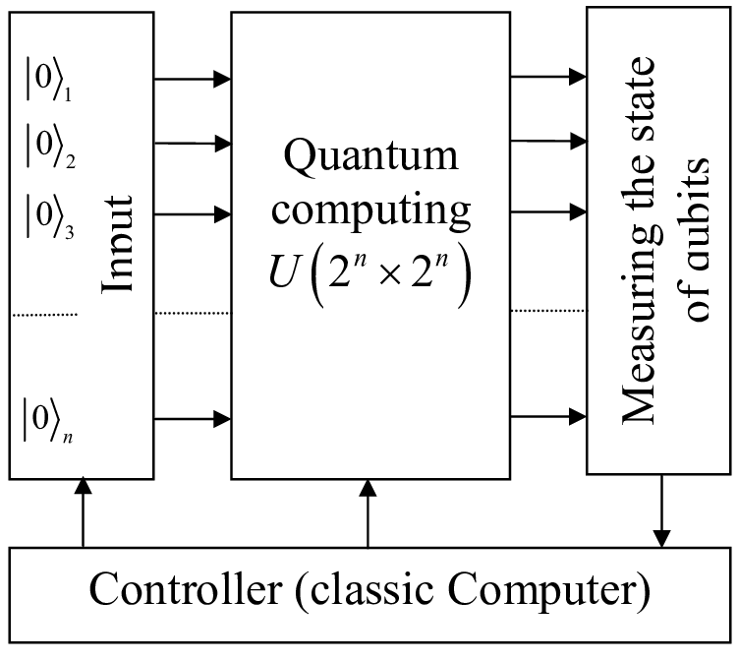
This image shows the basic working principle of a quantum computer.
- Input: Qubits (|0⟩ states).
- Process: Quantum computing operations (unitary transformations).
- Output: Measured qubit states.
A classical controller manages the entire process, bridging classical and quantum computations.

7.2,Figure 2: Classical vs Quantum Computing
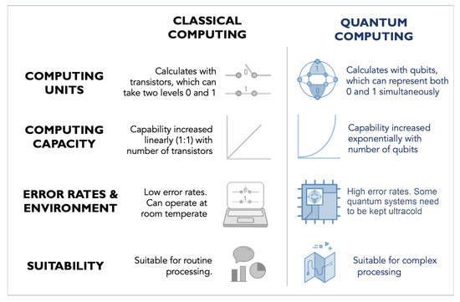
This comparison highlights the differences:
- Units: Transistors (classical) vs Qubits (quantum).
- Capacity: Linear growth vs Exponential growth.
- Error & Environment: Classical stable at room temp vs Quantum needing ultracold conditions.
- Suitability: Classical for routine tasks vs Quantum for complex problems.

8.HOW IT WORKS
Figure 1: work flow of quantum computing:
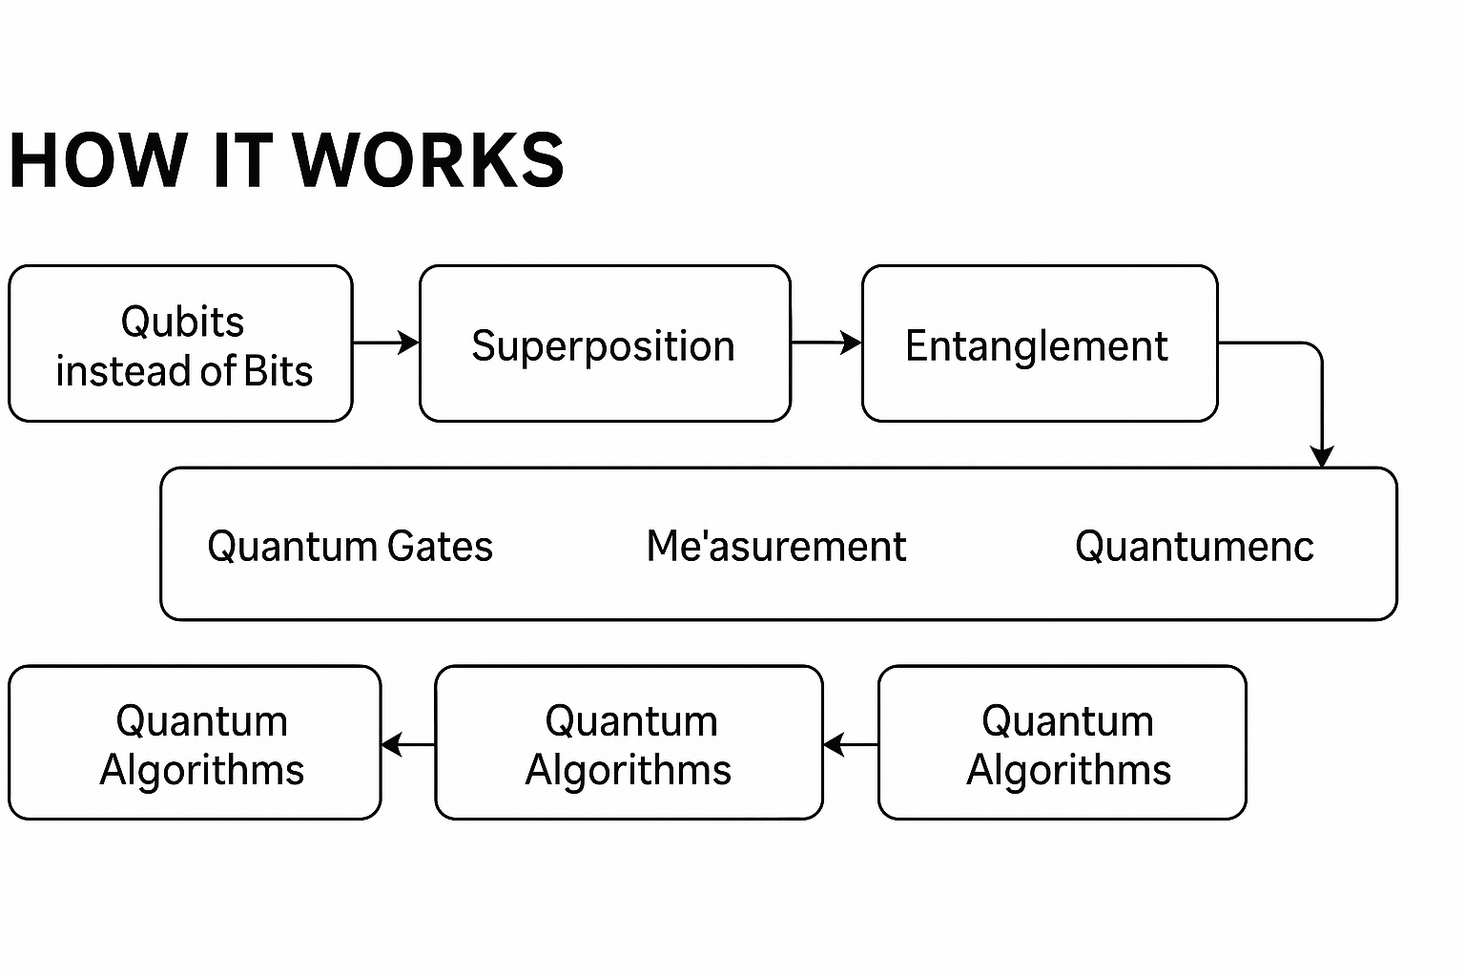

8.1.Workflow of quantum computing:

• Qubits instead of Bits
Classical computers rely on bits, which can only represent a single value of either 0 or 1 at a time. Quantum computers, in contrast, use quantum bits, or qubits, which can exist as 0, 1, or in a combination of both at the same time. This unique property arises from quantum mechanical principles, allowing qubits to store and process exponentially more information than classical bits. For example, two classical bits represent four possible combinations but only one at a time, while two qubits can represent all four combinations simultaneously. This scalability is the reason quantum systems hold immense promise in tackling problems that classical systems find infeasible. Qubits can be realized using different physical technologies such as superconducting circuits, trapped ions, and photons, each having its own advantages and limitations. Thus, qubits form the very foundation of quantum computation, offering unmatched computational potential compared to traditional digital systems.
• Superposition
Superposition is one of the fundamental principles of quantum mechanics that gives quantum computers their power. It allows a single qubit to exist in a combination of both 0 and 1 simultaneously, instead of being limited to one definite state. Mathematically, it is expressed as ∣ψ⟩=α∣0⟩+β∣1⟩, where α and β are complex probability amplitudes. When multiple qubits are placed in superposition, the system can represent an enormous number of states at once, providing massive parallelism. This property allows quantum computers to perform computations on many possibilities simultaneously, giving them an exponential advantage in solving complex problems.
• Entanglement
Entanglement is another key principle in quantum computing that creates strong correlations between qubits. When two or more qubits are entangled, the state of one qubit becomes directly dependent on the state of the other, even if they are separated by large distances. This “spooky action at a distance,” as Einstein called it, enables faster communication and more efficient problem-solving within a quantum system. Entanglement increases the computational power of quantum machines by allowing qubits to share information instantly. It is essential for advanced quantum algorithms, teleportation, cryptography, and error correction, making it one of the most powerful quantum resources.
Quantum Gates
Quantum gates are the building blocks of quantum circuits, similar to logic gates in classical computers, but far more powerful. Unlike classical gates such as AND, OR, and NOT, which operate on binary inputs, quantum gates manipulate qubits using principles of superposition and entanglement. Common quantum gates include the Hadamard gate (H), which places qubits in superposition, the Pauli-X gate, which flips states, and the CNOT gate, which creates entanglement between qubits. These gates are represented as unitary matrices that perform reversible operations. By combining multiple gates, quantum algorithms are constructed, enabling quantum processors to perform highly complex computations.
• Quantum Circuits
Quantum circuits provide the framework for executing quantum algorithms by arranging a sequence of quantum gates that act on qubits. Just as classical circuits consist of interconnected logic gates, quantum circuits consist of interconnected quantum gates that manipulate qubit states. A quantum circuit typically starts with initializing qubits in a known state, followed by applying a series of gates that transform these states through superposition and entanglement. The circuit ends with the measurement of qubits, yielding the final output. Quantum circuits allow for the design of algorithms like Shor’s and Grover’s, demonstrating the superior problem-solving power of quantum systems.
• Interference
Quantum interference is the mechanism that enhances the efficiency of quantum algorithms by amplifying correct solutions and suppressing incorrect ones. When multiple computational paths are available in a quantum circuit, interference ensures that the probabilities of wrong answers cancel out, while the probabilities of correct answers become stronger. This principle is critical in search and optimization algorithms such as Grover’s, where interference helps locate the right solution faster than classical approaches. Without interference, superposition alone would only create many possibilities without guiding towards the correct one. Therefore, interference is the fine-tuning mechanism that makes quantum computation practical.
• Measurement
Measurement is the final step in quantum computation and plays a crucial role in extracting results from qubits. While qubits can exist in superposition during computation, once they are measured, they collapse into a definite classical state of either 0 or 1. The outcome depends on the probability amplitudes determined during the quantum operations. Since measurement is probabilistic, quantum algorithms often need to be run multiple times to achieve reliable results. This step bridges the quantum and classical worlds, as the measured values can then be processed by classical systems for interpretation, analysis, or further use in hybrid computing.
• Quantum Parallelism
Quantum parallelism is the remarkable ability of quantum computers to evaluate multiple inputs simultaneously, thanks to superposition. In a system with n qubits, a quantum computer can represent possible states at once. For example, a 50-qubit quantum computer can represent over one quadrillion states simultaneously. This means quantum processors can explore vast solution spaces in parallel, something classical machines cannot do efficiently. Quantum parallelism gives exponential speedup in solving problems like database searches, optimization tasks, and molecular simulations. However, the challenge lies in designing algorithms that can effectively extract useful results from this massive parallelism.
• Quantum Algorithms
Quantum algorithms are specifically designed to exploit quantum principles such as superposition, entanglement, and interference to solve problems more efficiently than classical algorithms. Famous examples include Shor’s Algorithm, which can factor large numbers exponentially faster than classical methods, threatening modern encryption systems, and Grover’s Algorithm, which provides quadratic speedup in searching unsorted databases. Newer quantum machine learning algorithms are also being developed for pattern recognition and optimization. These algorithms prove that quantum computers are not just theoretical but can provide significant practical advantages. Their continued development is crucial to unlocking the full potential of quantum technologies.
• Decoherence
Decoherence is one of the greatest challenges in building stable quantum computers. It occurs when qubits interact with their surrounding environment, such as vibrations, radiation, or electromagnetic fields, causing them to lose their quantum properties. This leads to the collapse of superposition and entanglement, reducing the accuracy and reliability of computations. Decoherence limits the amount of time qubits can perform operations, known as coherence time. Currently, superconducting qubits and trapped ions achieve coherence times ranging from microseconds to milliseconds. Controlling decoherence is essential for scaling up quantum computers to handle real-world, large-scale, and error-free computational tasks effectively.
• Quantum Error Correction
Quantum systems are highly prone to errors due to decoherence, noise, and imperfections in hardware. Quantum error correction (QEC) is a method that protects quantum information by encoding logical qubits into multiple physical qubits. This redundancy allows detection and correction of errors without destroying quantum states. Techniques like surface codes and stabilizer codes are widely researched for practical error correction. However, implementing QEC is resource-intensive, often requiring thousands of physical qubits for a single reliable logical qubit. Despite this challenge, error correction is critical to achieving fault-tolerant quantum computing and is an active area of global scientific research.
• Physical Realizations
Qubits can be implemented using several physical systems, each with its own strengths and challenges. Superconducting qubits use electronic circuits cooled to near absolute zero and are pursued by IBM and Google. Trapped ions use lasers to manipulate ions suspended in magnetic fields, developed by IonQ and Honeywell. Photonic qubits use particles of light and are valued for scalability. Topological qubits aim to provide stability through exotic quasiparticles. Other methods include diamond-based NV centers and quantum dots. Each approach represents a path toward building practical, scalable quantum computers capable of revolutionizing industries, science, and technology in the future.

9.ADVANTAGES OF QUANTUM COMPUTING

• Massive Parallelism
Quantum computers can process many possibilities simultaneously due to superposition, providing exponential speedups for certain problems.
• Faster Problem Solving
Complex problems like optimization, cryptography, and drug discovery can be solved in much less time compared to classical computers.
• Efficient Cryptanalysis
Algorithms like Shor’s Algorithm can factor large numbers quickly, potentially breaking classical encryption but also leading to stronger quantum-safe cryptography.
• Enhanced Search Capabilities
With Grover’s Algorithm, quantum systems can search unsorted databases much faster than classical systems.
• Optimization in Real-World Problems
Quantum computing offers efficient solutions in logistics, finance, manufacturing, and supply chain optimization.
• Simulation of Quantum Systems
Quantum computers can simulate molecular and atomic interactions accurately, revolutionizing drug design, materials science, and chemistry.
• Reduced Energy Consumption for Complex Tasks
While classical supercomputers need enormous power, quantum systems can achieve results with lower energy usage in specific applications.
• Machine Learning and AI Enhancement
Quantum machine learning algorithms can handle large datasets and complex models more efficiently, boosting AI research and applications.
• Breakthroughs in Scientific Research
Quantum computation accelerates discoveries in physics, astronomy, and climate modeling, handling calculations classical systems cannot manage.
• Future-Proof Technology
Quantum computing represents the next frontier of computation, offering solutions to problems currently considered impossible for classical systems.

​

10.APPLICATIONS OF QUANTUM COMPUTING

1. Cryptography
Quantum computing has a profound impact on cryptography because it can easily break many classical encryption techniques, such as RSA, by factoring large numbers exponentially faster. At the same time, it enables the development of quantum-safe encryption methods, such as quantum key distribution (QKD), which uses the principles of quantum mechanics to secure data. These approaches ensure that sensitive information, like banking transactions or government communications, remains secure in the era of powerful quantum computers.

2. Drug Discovery & Healthcare
Quantum computers can simulate molecules, proteins, and complex biological systems at a scale impossible for classical computers. This capability accelerates drug discovery, vaccine development, and treatment design, significantly reducing the time and cost of clinical research. Pharmaceutical companies could use quantum models to test thousands of molecular interactions digitally, avoiding expensive lab trials. In healthcare, quantum computing may also help in personalized medicine, predicting how specific drugs will interact with individual genetic makeups.

3. Financial Modeling
The financial industry relies heavily on predictions, risk analysis, and optimization. Quantum computers can process vast amounts of market data simultaneously, identifying hidden patterns and correlations that classical systems might miss. This helps in fraud detection, credit risk management, and portfolio optimization, allowing financial institutions to make more accurate decisions. By simulating different economic scenarios, quantum systems can improve market forecasting and trading strategies, ultimately reducing risks while maximizing profits for banks, investment firms, and insurers.
4. Artificial Intelligence & Machine Learning
Quantum computing has the potential to revolutionize artificial intelligence by drastically reducing the time needed to train models. Quantum algorithms can process and analyze massive datasets much faster, enabling more efficient neural networks and advanced machine learning techniques. This leads to improvements in areas such as natural language processing, image recognition, and decision-making systems. Combining AI with quantum computing could unlock smarter, more autonomous systems with enhanced predictive capabilities across industries, from healthcare to robotics.

5. Weather Forecasting & Climate Modeling
Predicting weather patterns and modeling climate change requires analyzing enormous datasets with countless variables. Quantum computers can handle such complex simulations more efficiently, providing more accurate forecasts of natural disasters like hurricanes, floods, or droughts. This capability can save lives by improving early warning systems. In climate science, quantum simulations can help researchers model greenhouse gas impacts, ocean currents, and long-term climate shifts, offering insights into mitigating global warming and creating sustainable solutions for future generations.

6. Logistics & Supply Chain Optimization
Quantum computing can greatly improve logistics by solving optimization problems faster than classical computers. This includes planning delivery routes, transportation schedules, and resource allocation for large-scale operations. Companies can save costs and time by using quantum algorithms to minimize fuel consumption, reduce delivery delays, and manage supply chains more efficiently. In global trade, this technology can ensure smoother distribution of goods, improving resilience against disruptions like pandemics, geopolitical conflicts, or natural disasters.

7. Cybersecurity
While quantum computers threaten traditional encryption methods, they also provide solutions for next-generation security. Using quantum key distribution (QKD), communications can be made theoretically unbreakable since any attempt at interception alters the quantum states. Quantum cybersecurity can secure sensitive systems in finance, healthcare, and government, protecting against cyberattacks. Furthermore, quantum systems can detect malicious patterns more effectively, strengthening digital defenses. As cyber threats grow more advanced, quantum-enhanced security will play a critical role in safeguarding data.

8. Material Science
Designing new materials requires simulating atomic and molecular interactions, which is extremely complex for classical systems. Quantum computing can model these interactions precisely, enabling breakthroughs in superconductors, advanced batteries, solar cells, and lightweight materials. For example, quantum simulations could help create ultra-efficient energy storage solutions or stronger yet lighter alloys for aerospace. In renewable energy, quantum-designed materials may improve efficiency and durability, making technologies like wind turbines and solar panels more sustainable and cost-effective.

9. Space Exploration & Astronomy
Quantum computing supports space science by analyzing vast amounts of cosmic data collected from telescopes and satellites. It can simulate spacecraft systems, planetary conditions, and interstellar navigation, aiding future space missions. Additionally, quantum algorithms can optimize satellite communications, ensuring faster and more secure data transfer. In astronomy, quantum models may help understand complex cosmic phenomena like black holes, dark matter, and galaxy formations, giving scientists deeper insights into the origins and evolution of the universe.

10. Government & Defence
Governments and defence organizations can harness quantum computing for secure communications, intelligence analysis, and strategic defence planning. Quantum-based encryption ensures that military communications remain safe from adversaries. In intelligence, quantum systems can analyse large datasets quickly, improving national security decision-making. Defence applications also include logistics management, battlefield simulations, and advanced weapon system design. By staying ahead in quantum technology, nations can strengthen their security infrastructure, protect critical systems, and maintain an advantage in global defence strategies.

11. LIMITATIONS

1. Decoherence and Noise
Quantum states are highly fragile and easily disturbed by external noise, vibrations, or temperature fluctuations. Even a small environmental interaction can collapse the quantum state, causing errors in computation. Maintaining coherence for longer times requires extremely controlled conditions, such as near absolute-zero temperatures, which makes quantum computers highly complex and expensive to operate in real-world scenarios. This limitation severely restricts the stability and scalability of current quantum processors.
2. Error Rates and Quantum Error Correction
Unlike classical computers, quantum systems have much higher error rates due to unstable qubits. Quantum error correction is essential but requires many physical qubits to represent one logical qubit, greatly increasing hardware demands. For example, correcting a single error may need thousands of qubits, which is far beyond the capacity of present-day quantum systems. This makes practical error-free quantum computation one of the biggest challenges in this field.
3. Hardware Scalability
Scaling quantum computers to thousands or millions of qubits is extremely difficult. Current devices only support tens or hundreds of qubits, which are insufficient for solving large, real-world problems. The complexity increases as more qubits are added, requiring advanced cooling, shielding, and connectivity. Developing reliable, scalable hardware that can maintain qubit stability and coherence while handling larger computations is one of the toughest engineering challenges in quantum technology.
4. High Cost and Infrastructure Requirements
Quantum computers need ultra-cold environments, vacuum chambers, and specialized infrastructure to function, making them extremely expensive to build and maintain. Only a handful of large organizations and research institutes currently have access to them. The cost of scaling this technology for widespread industrial or commercial use is enormous, limiting accessibility for smaller businesses, startups, and educational institutions. This financial barrier slows down mass adoption and development.
5. Limited Algorithms and Applications
Although a few famous algorithms like Shor’s and Grover’s demonstrate the power of quantum computing, the number of practical quantum algorithms remains limited. Many industries are still exploring how to adapt problems for quantum systems. Furthermore, not all problems benefit from quantum computation; only specific ones such as cryptography, optimization, and molecular simulation show major advantages. This restricts the current utility of quantum computers compared to their hype.
6. Lack of Skilled Workforce
Quantum computing combines physics, mathematics, and computer science, requiring highly specialized expertise. The global workforce of quantum scientists, engineers, and programmers is very limited. As a result, there is a shortage of professionals capable of developing new algorithms, building reliable hardware, and advancing practical applications. This knowledge gap slows innovation and prevents rapid scaling of quantum technology into mainstream industries

12. CONCLUSION

Quantum computing represents one of the most revolutionary technological frontiers of the 21st century, promising computational power far beyond the reach of classical systems. By harnessing the unique properties of quantum mechanics such as superposition, entanglement, and interference, quantum computers can process vast amounts of data simultaneously and solve problems that would take traditional machines centuries to compute. Their potential applications are transformative, spanning across cryptography, drug discovery, artificial intelligence, climate modeling, and financial optimization. These breakthroughs could reshape industries, accelerate scientific discovery, and solve some of humanity’s most pressing challenges. However, this immense potential is balanced by serious limitations such as decoherence, error rates, high infrastructure costs, and the shortage of practical algorithms. Thus, while quantum computing offers a glimpse into a new era of computation, it is still in a stage of early development and experimentation.
Looking ahead, the future of quantum computing lies in overcoming these challenges through technological innovation and global collaboration. Advances in error correction, scalable hardware, and the discovery of new quantum algorithms will determine the pace of progress. Governments, research institutes, and industries are already investing heavily in quantum research, aiming to unlock its power for strategic, scientific, and economic advantage. While it may take years or even decades before quantum computers become mainstream, the journey itself is driving advancements in physics, engineering, and computer science. Ultimately, quantum computing will not replace classical computing but will complement it, providing solutions to problems that are otherwise intractable. It symbolizes a paradigm shift in how humanity approaches computation—moving from deterministic binary logic to the probabilistic world of quantum mechanics. In this sense, quantum computing is not just a technological leap but also a profound rethinking of the future of computation, innovation, and human progress.

13.REFERENCES

- IBM Research. What is Quantum Computing?
https://www.ibm.com/topics/quantum-computing
- Google Quantum AI. Quantum Computing Research and Breakthroughs.
https://quantumai.google
- Microsoft Quantum. Introduction to Quantum Computing.
https://learn.microsoft.com/en-us/azure/quantum/overview-quantum-computing
- National Institute of Standards and Technology (NIST). Post-Quantum Cryptography.
https://csrc.nist.gov/projects/post-quantum-cryptography
- Nature Journal. The Future of Quantum Computing.
https://www.nature.com/articles/d41586-019-02936-3

