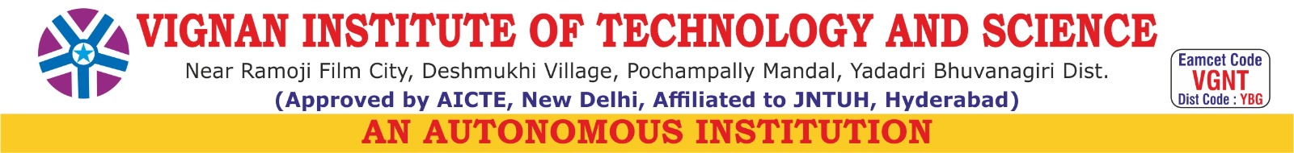
DEPARTMENT OF COMPUTER SCIENCE AND ENGINEERING
B.TECH IV YEAR I SEM SECTION-A A.Y:2025-26
MAJOR PROJECT ABSTRACT
TITLE OF MAJOR PROJECT: Generative Adversarial Networks For 3D Reconstruction of Archaeology Artifacts
BATCH NO | ROLL NUMBER | STUDENT NAME | PHONE NUMBER | E-MAIL ID
 | 22891A0547 | P.Jasnavi | 8074075507 | potharlajasnavi@gmail.com
A6 | 22891A0517 | K.Renu Sree | 9032827697 | kandagatlarenusree903@gmail.com
 | 22891A0511 | G.Rajya Lakshmi | 8688910875 | gummadirajyalakshmi8@gmail.com
 | 22891A0528 | M.Kalpana | 9390079363 | mattamadugukalpana@gmail.com
GUIDE NAME: Dr.R.Akshara
ABSTRACT:

Archaeological artifacts are often discovered in damaged, eroded, or incomplete states due to environmental effects and the passage of time. These imperfections make it difficult for researchers to analyze, study, and preserve such valuable cultural remains. Traditional restoration and reconstruction processes are labor-intensive, time-consuming, and often depend on manual expertise, which can lead to inconsistencies and errors. There is a growing need for modern techniques that can assist in restoring these artifacts more efficiently and accurately.

This project focuses on developing an intelligent system for the digital reconstruction of archaeological artifacts. Using advanced artificial intelligence and deep learning methods, the system is designed to identify missing or damaged portions and generate realistic 3D models that closely resemble the original form. The process ensures that even incomplete or fragmented artifacts can be digitally restored, allowing for accurate visualization and interpretation without physical intervention.

The reconstructed 3D models are refined, visualized, and analyzed to assist in research, education, and museum exhibitions. This project provides a non-destructive, scalable, and efficient solution for cultural heritage preservation. It supports archaeologists, historians, and conservators by offering digital replicas that can be easily shared, studied, and displayed, contributing to the advancement of digital archaeology and the sustainable preservation of our shared heritage. The outcomes of this work highlight the potential of artificial intelligence in cultural conservation, bridging the gap between technology and history. It promotes wider access to archaeological knowledge and encourages global collaboration in heritage research.

Project Guide Project Coordinator HOD

