# Technical Report: Rohith's Portfolio Landing Page Component

This report analyzes the `Landing` component of Rohith's portfolio website, detailing its purpose, key modules, and data models. The component is implemented using React, leveraging various animation libraries and custom components.

1. Project Purpose:

The `Landing` component serves as the main entry point for Rohith's online portfolio. Its purpose is to provide a visually appealing and interactive introduction to Rohith's skills, experience, and projects, encouraging visitors to explore his work further. The component integrates animations to enhance the user experience and showcase projects effectively.

2. Key Modules, Classes, and Functions:

The `Landing` component utilizes several external libraries and custom components:

React Libraries: `react`, `react-icons`, `@emailjs/browser`, `framer-motion`, `gsap`, `gsap/ScrollTrigger`. These provide the foundation for the component's functionality, animation, and interactive elements.

Custom Components: `CustomCursor`, `GooeyNav`, `InteractiveText`, `SplitText`, `SpotlightCard`, `TiltedCard`. These encapsulate reusable UI elements and animation logic, contributing to a modular and maintainable design.

Key Functions:

`sendEmail(e)`: Handles form submission using `emailjs` to send contact emails. Includes error handling.

`toggleMobileMenu()`: Toggles the mobile navigation menu's visibility.

`handleNavClick(e, href)`: Handles navigation clicks, smoothly scrolling to the specified section.

3. Data Models or Entities:

The component uses the following data structures:

`navItems` Array: An array of objects, each representing a navigation item with a `label` and `href` (link). Example: `{ label: "About Me", href: "#about" }`

`certifications` Array: An array of objects, each describing a certification with `text`, `link`, `image`, and `description` properties.

`techStack` Array: An array of objects, representing technologies in Rohith's tech stack. Each object contains `name`, `icon`, and `description` fields.

4. Component Structure and Interactions:

The `Landing` component is structured using a combination of React functional components and hooks:

State Management: The component manages state using `useState` hooks for `isContactModalOpen` (contact form visibility) and `mobileMenuOpen` (mobile menu visibility).

Animation: The component employs `framer-motion` and `gsap` with `ScrollTrigger` for various animations and smooth scrolling interactions. Animations are triggered on component mount and in response to scrolling events. These animations enhance the user experience by adding visual flair to elements as they enter the viewport.

Responsiveness: The component uses Tailwind CSS for styling and adapts to different screen sizes using responsive design principles. A mobile menu is provided for smaller screens.

Custom Cursor: The `CustomCursor` component enhances the user experience with custom cursor interactions.

5. External Dependencies:

The project relies on several external libraries for functionality and styling. These libraries should be managed using a package manager like npm or yarn. Note that the paths to the custom components (`./Effects/`) are relative and will need to be adjusted based on the actual project file structure.

6. Further Development:

Future improvements could include:

Implementing server-side validation for the contact form.

Adding more sophisticated animations and transitions.

Integrating analytics tracking to monitor user engagement.

Replacing placeholder images with actual content.

This report provides a high-level overview of the `Landing` component. A detailed UML diagram would require deeper analysis of the internal structure and interactions of the custom components, which are not fully defined here. However, a simple class diagram for the data models can be easily represented. This would show the `navItems`, `certifications`, and `techStack` objects and their respective attributes.

## **Class_Diagram**

** Illustrates the classes (components, data models), their attributes, and methods.

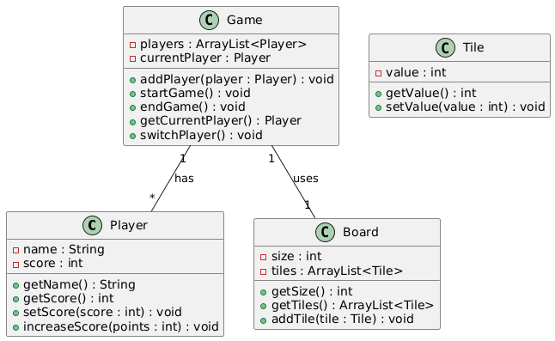

## **Component_Diagram**

** Shows the React components, their relationships (composition, inheritance), and dependencies.

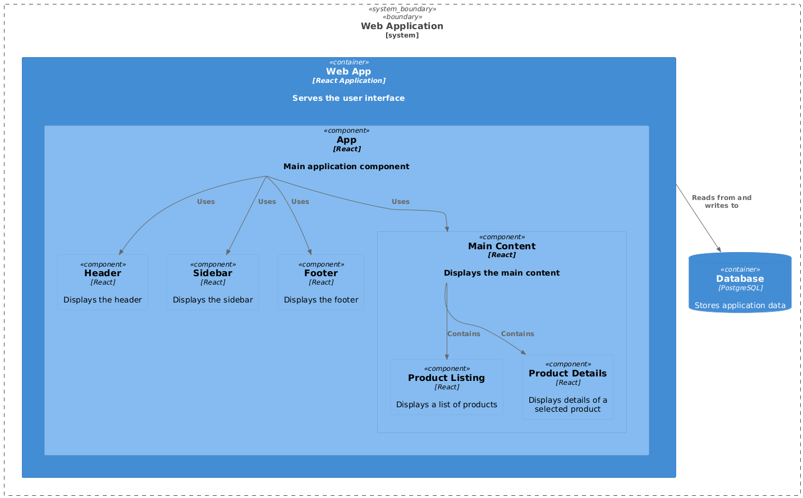

## **Sequence_Diagram**

** Models the interactions between components during a user action (e.g., clicking a navigation link).

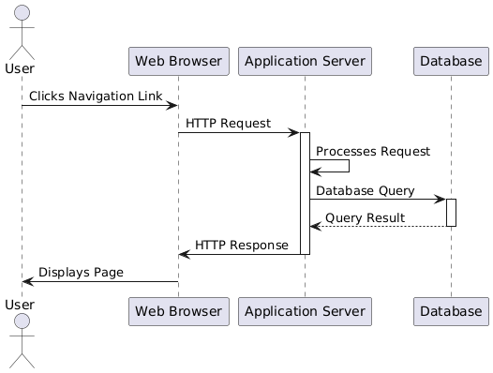

## **State_Machine_Diagram**

** Depicts the different states of components (e.g., `mobileMenuOpen`) and transitions between them.

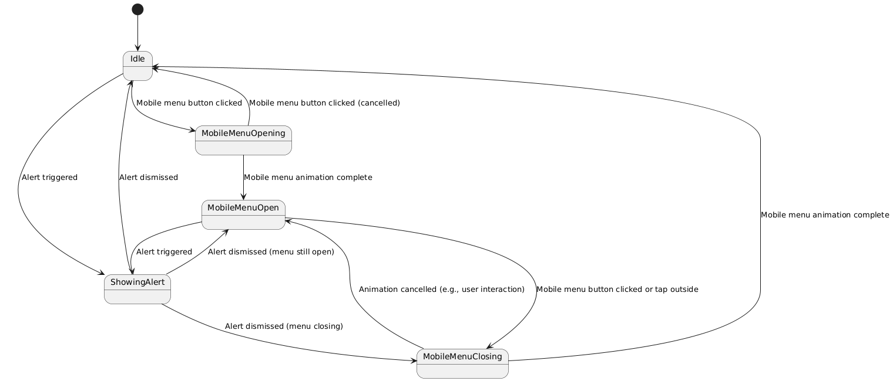

## **Activity_Diagram**

** Visualizes the flow of actions and decisions within a specific function (e.g., `sendEmail`).

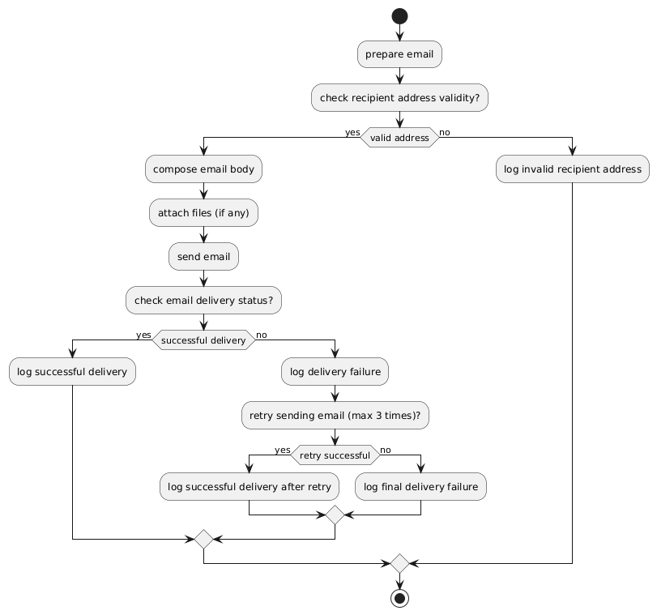

## **Package_Diagram**

** Organizes the code into logical packages (e.g., Effects package containing custom components).

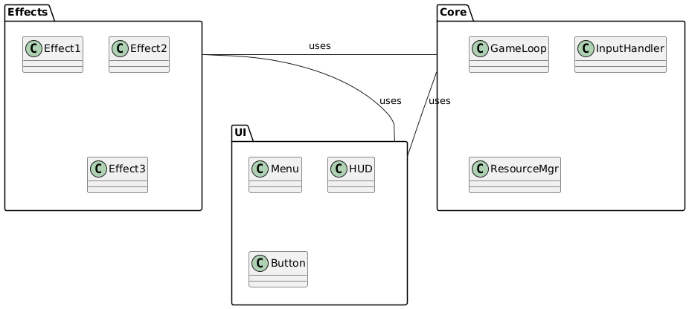

## **Use_Case_Diagram**

** Shows how users interact with the system (e.g., viewing projects, sending an email). (Less crucial here but useful for overall system design)

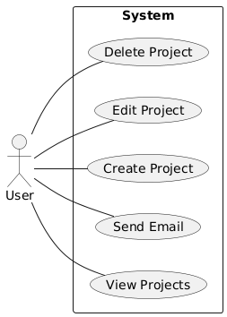

## **Data_Model_Diagram_Entity-Relationship_Diagram_-_ERD**

** Illustrates the structure of the data used by the application, such as the `certifications` and `techStack` arrays.

