# Technical Report: React Landing Page Component

This report documents the `Landing` component, a React-based webpage component for a portfolio website. It details the component's purpose, key modules, and data models.

1. Project Purpose:

The `Landing` component serves as the main entry point for a personal portfolio website. Its purpose is to present the developer's skills, experience, and projects in an engaging and visually appealing manner. It includes sections for navigation, a hero section, about the developer, tech stack, projects, experience, certifications, and a contact form.

2. Key Modules, Classes, and Functions:

The `Landing` component utilizes several external libraries and custom components:

React Libraries: `react`, `react-icons`, `framer-motion`, `@emailjs/browser`. These provide the core React functionality, icons, animations, and email sending capabilities.

GSAP Libraries: `gsap`, `ScrollTrigger`. These power the sophisticated scroll-based animations within the component.

Custom Components: `CustomCursor`, `GooeyNav`, `InteractiveText`, `SplitText`, `SpotlightCard`, `TiltedCard`. These encapsulate reusable UI elements and animations specific to the portfolio's design.

The component utilizes the following key functions:

`sendEmail(e)`: Handles form submission and sends an email using `emailjs`. Includes error handling for successful and unsuccessful submissions.

`toggleMobileMenu()`: Toggles the visibility of the mobile navigation menu.

`handleNavClick(e, href)`: Handles navigation clicks, scrolling smoothly to the specified section and closing the mobile menu if open.

3. Data Models or Entities:

The component uses two primary data structures:

`navItems` Array: An array of objects, each representing a navigation item with a `label` (text displayed) and `href` (target anchor). Example: `{ label: "About Me", href: "#about" }`

`certifications` Array: An array of objects, each representing a certification with `text`, `link` (to the certificate), `image` (path to preview), and `description`. Example: `{ text: "Google Machine Learning", link: "...", image: "/MachineLearningPreview.webp", description: "..." }`

`techStack` Array: Similar structure to `certifications`, storing information about the developer's tech stack, including `name`, `icon` (image path), and `description`.

4. Animation and Interactions:

Framer Motion and GSAP are extensively used throughout the component to provide a range of visual effects:

Scroll-based animations: GSAP's `ScrollTrigger` is used to create animations that trigger based on scroll position, providing a dynamic user experience.

Component-level animations: Framer Motion's `motion` component and its `initial`, `animate`, and `transition` properties are used for smooth transitions and animations of various UI elements. This provides a polished and interactive feel.

Custom cursor: A `CustomCursor` component enhances user interaction by providing a custom cursor experience.

5. Summary:

The `Landing` component is a well-structured and sophisticated React component leveraging various libraries to create a visually engaging and interactive user experience. The use of animation and custom components promotes code reusability and maintainability. The data models are clearly defined, making the component data-driven and easy to extend. Further documentation of the custom components (`CustomCursor`, `GooeyNav`, etc.) would enhance the overall understanding.

## **Class_Diagram**

** Shows the classes, their attributes, methods, and relationships (inheritance, association, composition, aggregation). This would illustrate the structure of the `Landing` component and its interaction with other components (e.g., `GooeyNav`, `SpotlightCard`, `CustomCursor`).

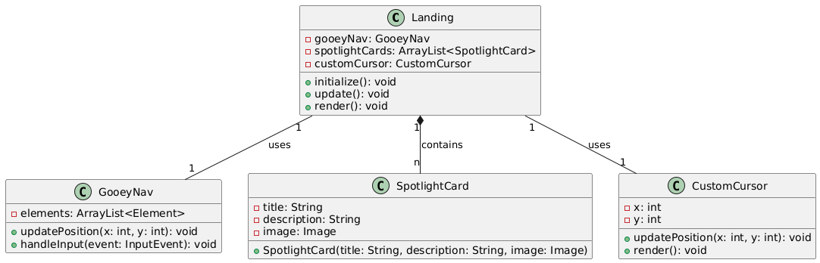

## **Component_Diagram**

** Depicts the high-level components of the system and their dependencies. This is especially useful for visualizing the relationship between the `Landing` component and its sub-components like `Effects/CustomCursor`, `Effects/GooeyNav`, etc. and their interactions.

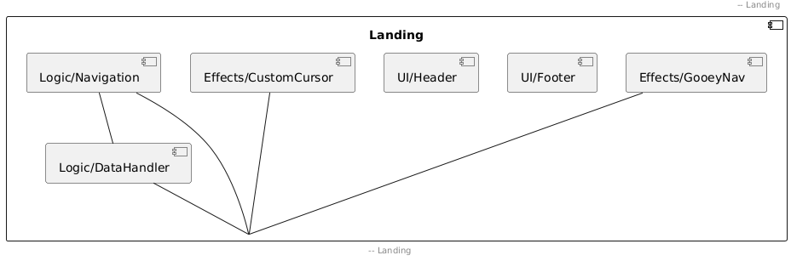

## **Sequence_Diagram**

** Illustrates the interactions between objects over time in response to a specific event (e.g., user clicking a navigation item). This would detail how different components react to user input and internal events, such as the steps involved in sending an email.

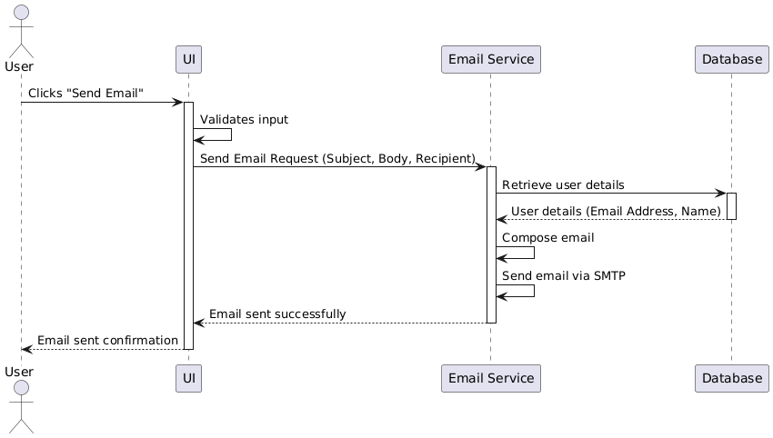

## **State_Machine_Diagram_for_Landing_component**

** Models the different states of the `Landing` component (e.g., `mobileMenuOpen`, `isContactModalOpen`) and the transitions between them triggered by events (e.g., button clicks).

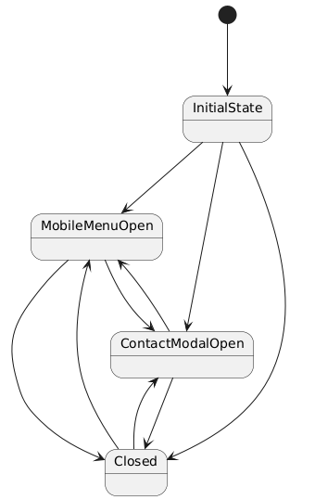

## **Activity_Diagram_for_sendEmail_function**

** Shows the flow of activities within the `sendEmail` function, including potential branches for success or failure scenarios. This will help document the email sending process.

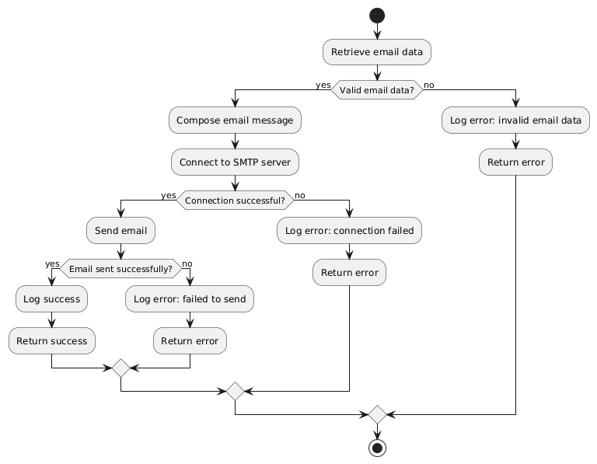

## **Package_Diagram**

** Organizes the code into logical groups or packages (`Effects` package in this case). Useful for understanding the overall architecture.

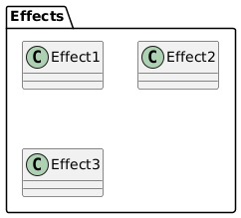

## **Data_Model_Diagram_Entity-Relationship_Diagram_-_ERD**

** Represents the structure of the data used in the application (e.g., the `certifications` and `techStack` arrays). This could show the attributes of each entity (Certification, TechStack) if they were to be stored in a database.

