Technical Report

**Generate a detailed Word document and UML diagrams for this component**

Generated on: June 15, 2025

# **Technical Report: Plant Analysis Component**

This report documents the React component `Analyze`, designed for plant disease diagnosis. The component allows users to upload or capture an image of a plant, provide details about the plant type and watering frequency, and receive a diagnosis and recommendation.

## **1. Project Purpose**

The primary purpose of the `Analyze` component is to provide a user-friendly interface for plant disease diagnosis. Users input plant information and an image, which is then sent to a backend service for analysis. The results, including a diagnosis and recommendations, are displayed to the user.

## **2. Key Modules, Classes, and Functions**

The component utilizes several key modules and functions:

1. `axios`: For making HTTP requests to the backend analysis service.

2. `motion` (from `framer-motion`): For animations and transitions within the UI.

3. `React` Hooks (`useEffect`, `useRef`, `useState`): For managing component state and side effects.

4. `FaArrowLeft`, `FaCamera`, `FaCheckCircle`, `FaExclamationTriangle`, `FaImages`, `FaSpinner` (from `react-icons/fa`): React icons used for visual cues.

5. `useNavigate` (from `react-router-dom`): For navigation within the application.

6. `Webcam` (from `react-webcam`): For capturing images using the user's webcam.

7. `handleImageChange`: Handles image uploads from the user's gallery.

8. `dataURLtoFile`: Converts a data URL (from the webcam) into a File object for submission.

9. `handleCapture`: Captures an image from the webcam.

10. `handleAnalyze`: Sends the image and user input to the backend for analysis. This function includes error handling and loading state management.

## **3. Data Models or Entities**

The component interacts with the following data models:

1. User Input: This comprises `plantType` (string, e.g., "neem"), `waterFreq` (string, representing days), `language` (string, e.g., "english"), and `image` (File object).

2. Analysis Result: The backend returns a JSON object with `prediction` (string, e.g., "Healthy_Plants", "DiseaseX") and `recommendation` (string, containing advice). The `prediction` field indicates the plant's health status, and the `recommendation` provides suggestions based on the analysis. These fields are stored in the `result` state.

## **4. Component Structure and Workflow**

The `Analyze` component is structured to:

1. Display a form for user input (plant type, water frequency, language, and image upload/capture).

2. Handle image uploads and webcam capture.

3. Send the data to the backend (`https://backend-lj86.onrender.com/analyze`) using `axios` with authentication.

4. Display a loading indicator while waiting for the backend response.

5. Display the analysis results with appropriate visual cues (green for healthy, red for unhealthy).

6. Provide a link to cure information if the plant is not healthy.

The component uses React's state management to track user input, the analysis status, and the results. Error handling is included to manage issues like missing images, authentication failures, or backend errors. The use of `framer-motion` provides smooth animations and transitions, improving the user experience. The `useEffect` hook cleans up the preview URL to avoid memory leaks.

## **5. Technology Stack**

React.js

Axios

Framer Motion

React Icons

React Router Dom

React Webcam

This report provides a high-level overview of the `Analyze` component. A more detailed analysis would include a UML class diagram (beyond the scope of a simple markdown report) and a thorough testing strategy. However, this information should provide sufficient technical documentation for understanding the component's functionality and structure.

# Diagrams

## Class Diagram

** Illustrates the classes (`Analyze` component, potential backend classes like `PlantAnalyzer`), their attributes (state variables), and methods (functions).

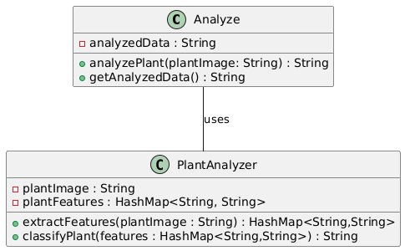

## Sequence Diagram

** Shows the sequence of interactions between the React component, the user, and the backend during the plant analysis process.

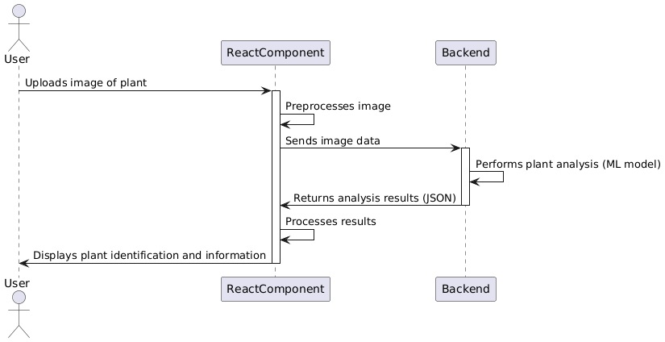

## Activity Diagram

** Models the workflow of the plant analysis, including user actions, image processing, API calls, and result display.

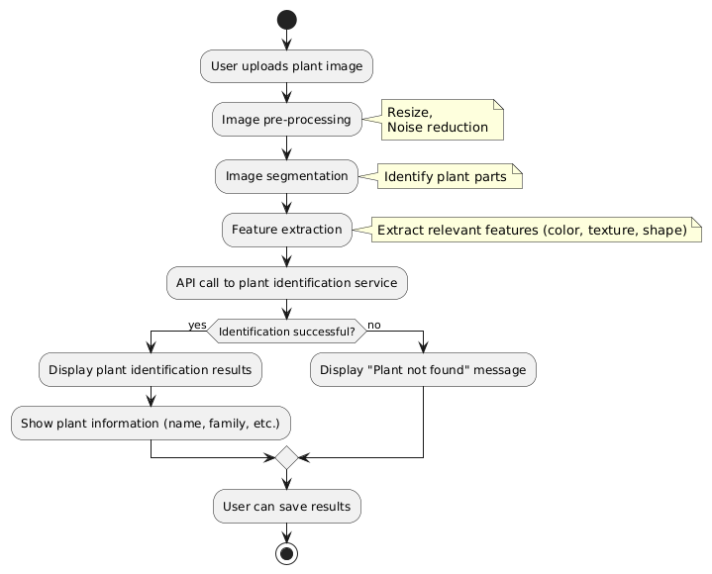

## Use Case Diagram

** Represents the interactions between the user and the system (plant analysis application).

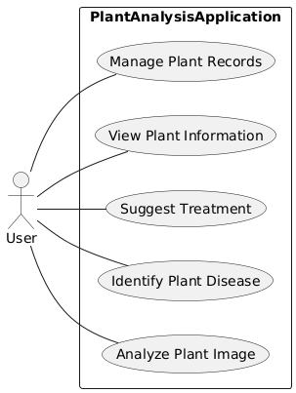

## Component Diagram

** (Less crucial here, but could be used) Shows the high-level structure of the React application, including the `Analyze` component and its relationships with other components (if any).

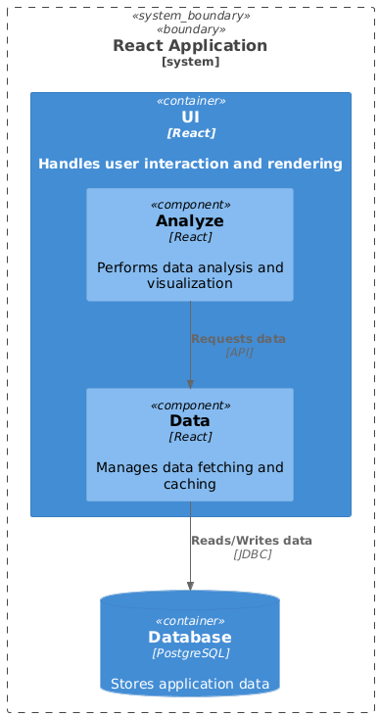

## State Machine Diagram

** Models the different states of the `Analyze` component (e.g., idle, loading, error, success) and transitions between them triggered by user actions or API responses.

