Yahoo + DSP Display — Geo Incrementality Test Design
Matched Market Test (MMT) | 3-Cell Design | MDF-1629

What We're Testing
Whether running Yahoo display ads and DSP (Scope3) display ads in select U.S. markets drives more enrollments to Chime. The two partners are tested independently against the same control group, allowing us to measure the incremental lift of each channel separately.

Test Design
- 10 Yahoo Test markets → Yahoo display ads ON
- 10 DSP (Scope3) Test markets → DSP display ads ON
- 10 Control markets → no display ads from either partner
- Enrollments are compared within each matched triplet to estimate incremental lift driven by each partner's display spend

Market Selection
- Excluded the 26 largest U.S. DMAs (too dominant — would skew results) and the 50 smallest markets (too few enrollments to detect meaningful lift)
- Excluded 20 additional DMAs already running in active geo tests
- Matched each Yahoo market with a similar DSP market and a Control market into a "triplet" — matched on historical weekly enrollment volume and trend correlation (Feb 2025 – Apr 2026)
- Cell assignment within each triplet done to maximise enrollment balance across all three cells

Matched Markets
Each row is a matched triplet. Ads run only in Yahoo Test and DSP Test markets; Control markets receive no display spend from either partner.
Yahoo Test (ads ON) | DSP (Scope3) Test (ads ON) | Control Holdout (ads OFF)
Tampa-St. Petersburg-Sarasota, FL | Washington, DC | Orlando-Daytona Beach-Melbourne, FL
Flint-Saginaw, MI | Columbia, SC | La Crosse-Eau Claire, WI
Wichita-Hutchinson, KS | Greenville-New Bern-Washington, NC | Waco-Temple-Bryan, TX
Lincoln-Hastings-Kearney, NE | Hartford-New Haven, CT | Salt Lake City, UT
Tri-Cities, TN/VA | Tyler-Longview, TX | Spokane, WA
Tulsa, OK | Biloxi-Gulfport-Pascagoula, MS | Ft. Wayne, IN
Laredo, TX | Huntsville-Decatur, AL | Amarillo, TX
Medford-Klamath Falls, OR | Wichita Falls, TX-Lawton, OK | Davenport-Rock Island-Moline, IL/IA
Chico-Redding, CA | Huntington-Charleston, WV | Fargo-Valley City, ND
Springfield-Holyoke, MA | Palm Springs, CA | Duluth, MN-Superior, WI

Pre-Test Validation
Test and control markets show strong alignment in weekly enrollments over the pre-period (Feb 2025 – Apr 2026). Each triplet was selected to maximise the week-to-week correlation between its three markets, giving confidence that any divergence during the campaign can be attributed to the ads. The chart below shows the enrollment profile across matched markets — overlapping lines confirm tight matching.
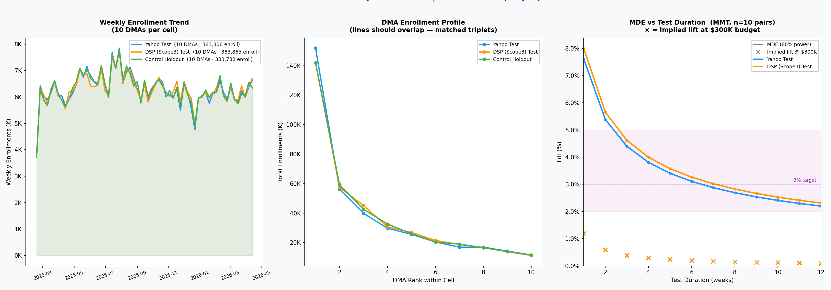
Fig 1: Left — weekly enrollment trend by cell. Centre — DMA enrollment profile (overlapping lines = good match). Right — minimum detectable effect vs. test duration.

Test Recommendation
We recommend concentrating the $300K budget per partner into a 3-week flight. Concentrating spend into fewer weeks produces a stronger weekly signal, which is easier to detect against normal week-to-week market fluctuations. Spreading the same budget over 4–6 weeks weakens the detectable signal and reduces our confidence in the result.
- Recommended flight duration: 3 weeks
- Budget: $300K per partner
- Assumed iCPE: $400
- Expected incremental enrollments: ~750 per partner
- Spend pacing: ~$10K per market per week
- Lift this budget is expected to drive: ~4%
- Statistical power: ~70% for both Yahoo and DSP
- Flight structure: Week 1 allows the campaigns to exit the platform learning phase; Weeks 2–3 are the primary measurement window

Note: Expected incremental enrollments are the same for both partners ($300K ÷ $400 iCPE = 750) and are held equal by design. Actual results will depend on delivery, true iCPE, and whether ads reach incremental audiences in each market.

