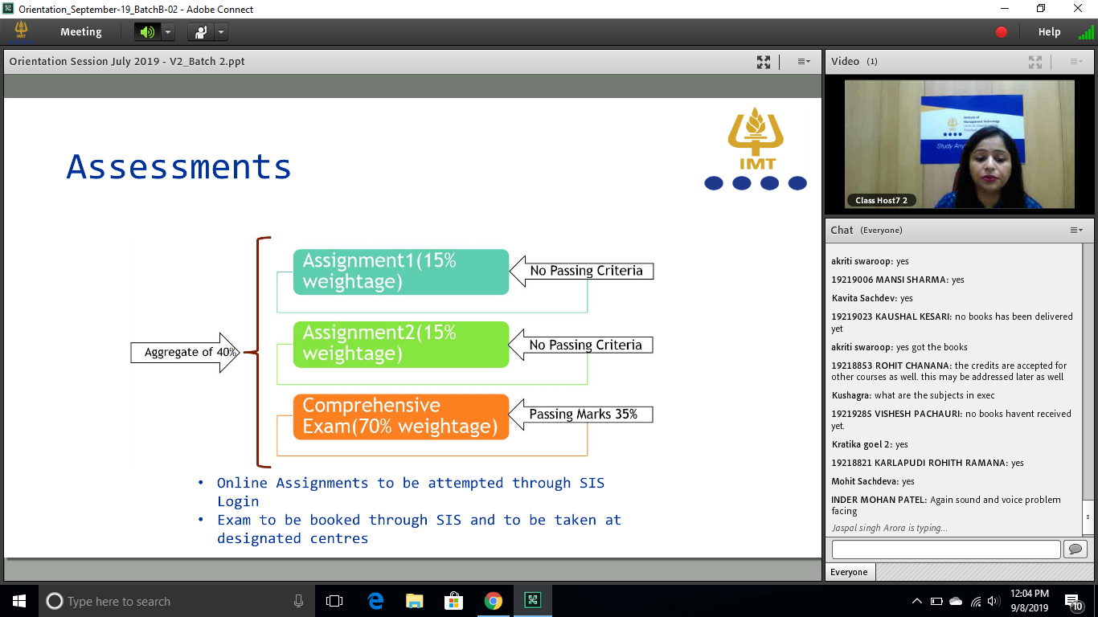

What about dual degree ?

[www.imtcld.ac.in](http://www.imtcld.ac.in) >Student zne > SIS > Roll Number

Student Care Services

Whether IMT gives us an Alumni status

Placement assistance or guidance

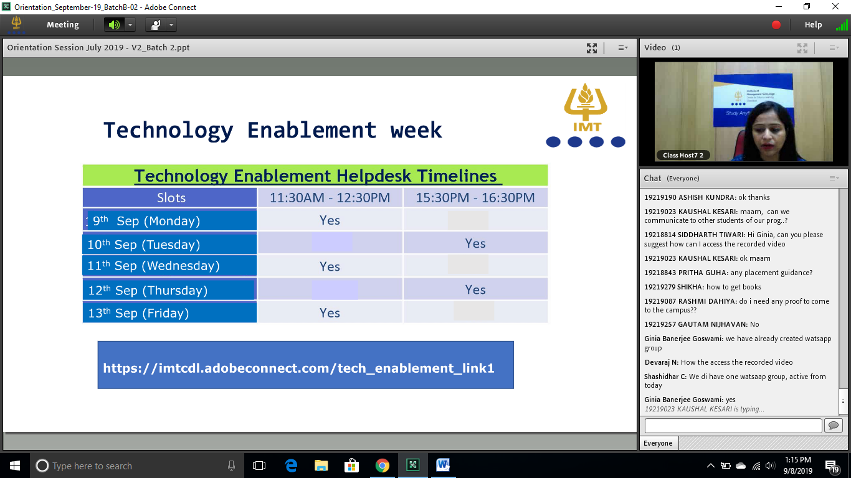

Financial Accouting EXAM view

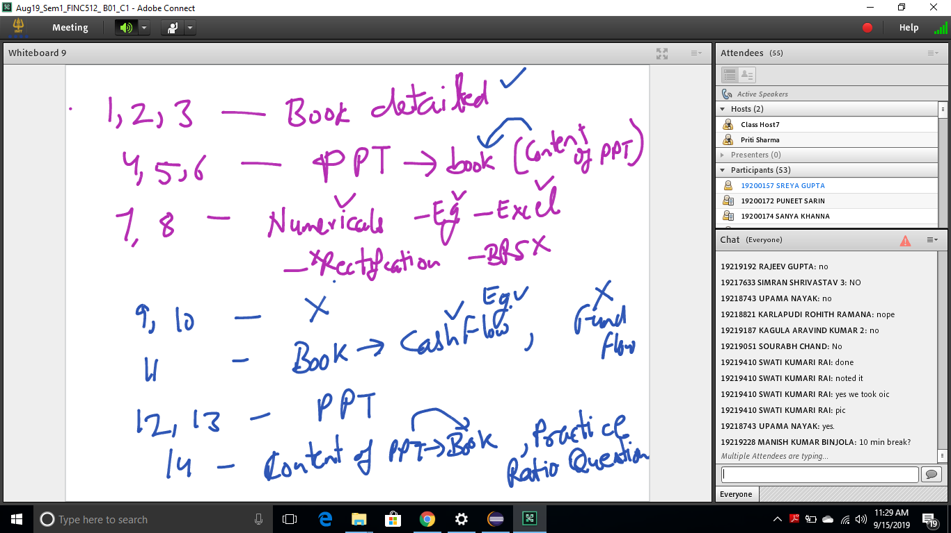

Fin Acc:

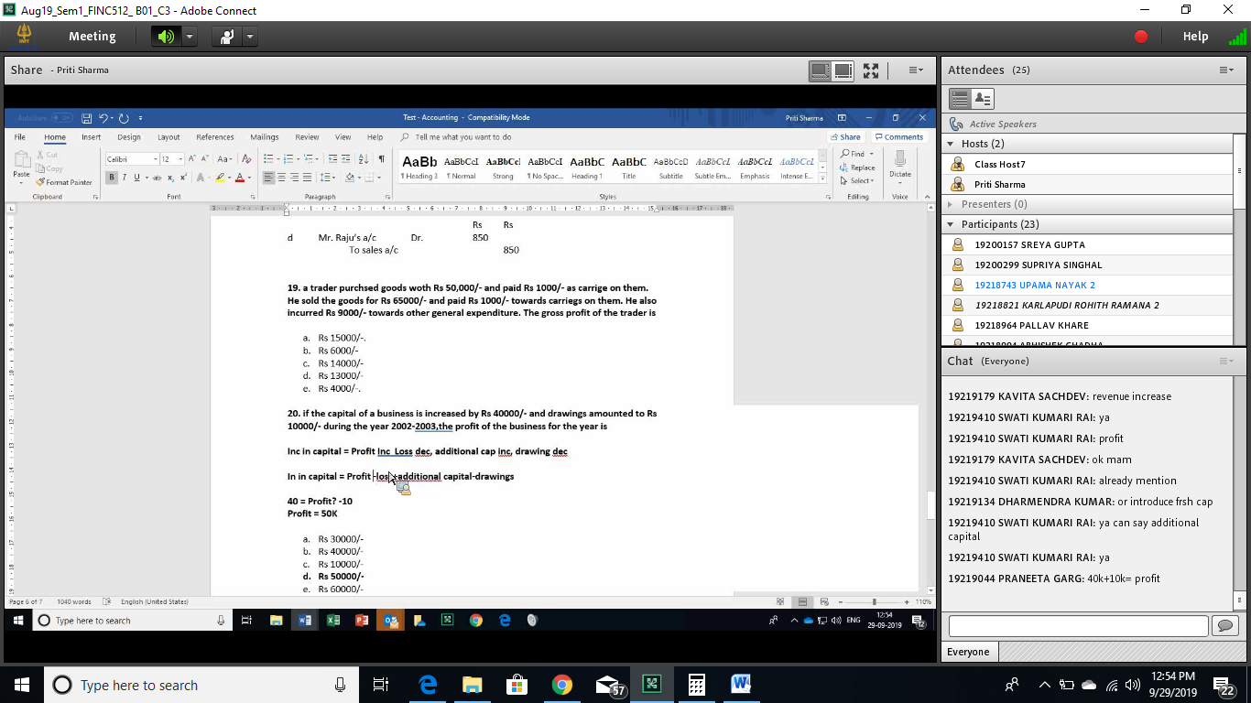

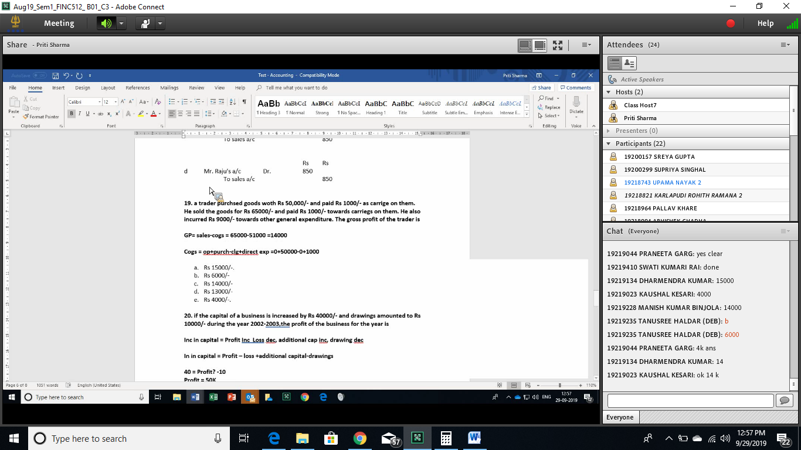

[priti.sharma@imtcdl.ac.in](mailto:priti.sharma@imtcdl.ac.in)