**Data Clustering (K-means and K-medians)**

**k-means clustering algorithm:**

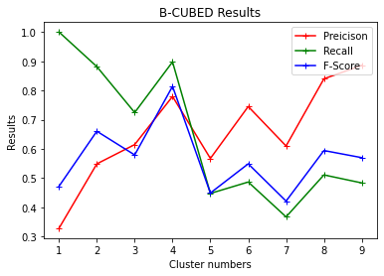

**Figure 1: K-means algorithm from clusters 1-9**

**k-means clustering algorithm with normalisation:**

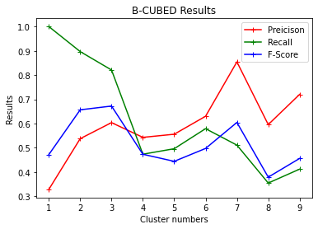

**Figure 2: K-means algorithm with Normalisation from clusters 1-9**

**k-medians clustering algorithm:**

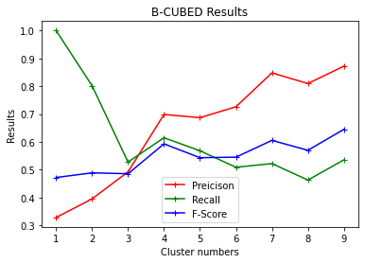

**Figure 3: K-medians algorithm from clusters 1-9**

**k-medians clustering algorithm with normalisation:**

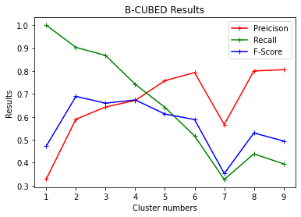

**Figure 4: K-medians algorithm with Normalisation from clusters 1-9**

**Outputs:**

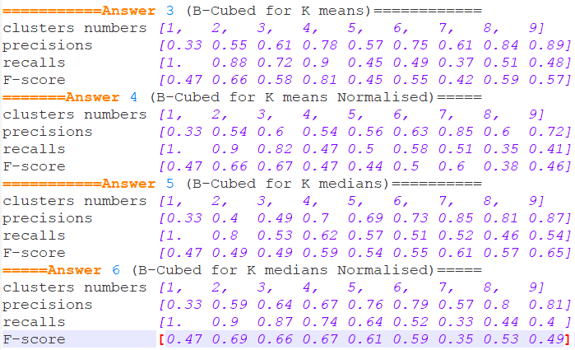

**Figure 5: Comparison of different clustering obtained from task 3-6.**

The above tasks 3-6 implement the clustering algorithm K-means and K-medians. The following algorithm iterated 100 times and, on an average, it converged towards the cluster K = 4. And as we know there are 4 data sets provided to the algorithm so it makes sense to have 4 different clusters. Each of the algorithm is good in its way, k-means minimises the variance within the cluster whereas k-medians minimises absolute deviations.

Coming to the point of normalisation, it is observed that normalisation affects the k-means negatively while positively to k-medians as f-score increases.

However, output would vary for different instances and trying out different combinations to find the best fit for the algorithm is advisable.