ACKNOWLEDGEMENT

We wish to express my profound and sincere gratitude to k.Ramya(associate professor),Ramesh sir Department of Electronics and Communication Engineering, SoET, Vizianagaram Campus, who guided me into the intricacies of this project nonchalantly with matchless magnanimity.

We thank Prof K.Joginaidu , Head of the Dept. of Department of Electronics and Communication Engineering ,SoET, Vizianagaram Campus for extending their support during Course of this investigation.

We extend deep appreciation to Dr. P.A. Sunny Dayal, the Dean of SoET, for his help, leadership, and the conducive academic environment fostered at our institution. Their unwavering commitment to excellence has set a benchmark for all.

Special gratitude is extended to P.K. Mohanty, the Vice Chancellor of Centurion

University, Vizianagaram, for providing a conducive and inspiring educational ecosystem.

A heartfelt note of appreciation goes to all staff members who, in various capacities, contributed to the success of our project. Dedication and collective effort have been indispensable, and we sincerely thank them for their collaboration.

I express my deepest gratitude to my parents for their unwavering support, encouragement, and the countless sacrifices they made, which played an integral role in the success of this project.

ABSTRACT

The Robot Car project utilizes a Bluetooth module to create a remotely controlled, versatile vehicle designed for applications in exploration, monitoring, and basic automation. Equipped with motorized wheels, sensors, and a Bluetooth module, the robot car can be controlled via a smartphone or tablet, offering a convenient and wireless user interface. The Bluetooth connection enables real-time commands, allowing the user to steer, control speed, and navigate the robot car over various terrains. This project demonstrates a practical and accessible application of IoT principles, providing insights into remote vehicle control and automation without reliance on Wi-Fi or internet connectivity. The Robot Car project is scalable, with potential for enhancements such as obstacle detection, line tracking, or even camera integration for live video feeds, making it a foundational model for robotics education and hobbyist exploration.

**INDEX**

**ACKNOWLEDGEMENTS**

**ABSTRACT**

**LIST OF FIGURES**

**CHAPTER 1: INTRODUCTION**

1.1 Purpose

1.2. Intended Audience

1.3. Scope

**CHAPTER 2: LITERATURE SURVEY**

**CHAPTER 3: OVERALL DESCRIPTION**

3.1 EXISTING SYSTEM

3.1.2 Proposed System

3.1.3 BENEFITS:

3.1.4 Hardware Requirements:

3.1.5 Software Requirements:

3.2 UML Diagrams

3.2.2 Sequence Diagram

3.2.3 Flowchart

**CHAPTER 4: RESULT AND DISCUSSION**

**CHAPTER 5 : CONCLUSION & FUTURE ENHANCEMENT**

**REFERENCES**

**LIST OF FIGURES**

**Figure 3.1 Usecase Diagram for Hospitality Robot**

**Figure 3.2 Sequential Diagram**

**Figure 3.3 Flowchart**

**Figure 3.4 Circuit Diagram**

**Figure 4.1: Hospitality Robot Connection**

**Figure 4.2 : Control App for Hospitality Robot**

CHAPTER 1: INTRODUCTION

* 1. Purpose

The purpose of the Robot Car project using a Bluetooth module is to create a versatile, remotely operated vehicle that demonstrates the principles of wireless control, automation, and mobile robotics. This project aims to provide a practical learning experience in robotics and IoT technology by enabling users to control the car's movements and functions through a smartphone application. The Bluetooth-controlled design emphasizes simplicity and accessibility, allowing operation without the need for Wi-Fi or internet access.

Key objectives include:

1. Exploration and Monitoring: The robot car can be used in various environments for tasks like basic exploration, object retrieval, or monitoring, depending on additional sensors or cameras.

2. Remote Control and Automation: The project demonstrates remote control through Bluetooth, making it ideal for understanding real-time wireless communication and control in robotics.

3. Foundation for Further Development: As a foundational project, it provides a base for adding advanced features such as obstacle avoidance, line following, or camera integration, allowing for a wide range of future applications in robotics education and hobbyist innovation.

* 1. Intended Audience :

The intended audience for the Robot Car project using a Bluetooth module includes:

1. Students and Educators in STEM: This project is designed to support students and educators in fields like electronics, robotics, computer science, and engineering. It offers a hands-on learning experience in topics such as IoT, wireless communication, and automation.

2. Hobbyists and DIY Enthusiasts: Robotics hobbyists and DIY enthusiasts interested in building and controlling their own robot vehicles will find this project engaging and accessible, with the flexibility to add custom features.

3. Beginners in Robotics and IoT: The project provides a simple, entry-level introduction to robotics, making it ideal for beginners who want to understand the basics of remote control, Bluetooth communication, and robotic movement.

4. Researchers and Developers in Robotics: For those looking to prototype or develop more complex autonomous or semi-autonomous systems, this project serves as a base that can be expanded with additional sensors, AI, or other advanced capabilities.

5. General Tech Enthusiasts: Anyone with a general interest in robotics or technology can gain insights into how Bluetooth technology and basic automation work through this project.

This broad audience reflects the project’s applicability in education, innovation, and practical learning in wireless robotics.

* 1. Scope:

The scope of the Robot Car project using a Bluetooth module includes:

1. Remote Control: Enabling wireless control of the robot car's movement through a Bluetooth connection.

2. Automation Basics: Introducing basic robotics concepts like motor control, wireless communication, and mobile application interfacing.

3. Future Expansion: Providing a foundation for adding features like obstacle detection, camera integration, or autonomous navigation.

This project aims to provide a hands-on learning experience in robotics and wireless control.

CHAPTER 2 : literature survey

1. Remote Control: Enabling wireless control of the robot car's movement through a Bluetooth connection.

2. Automation Basics: Introducing basic robotics concepts like motor control, wireless communication, and mobile application interfacing.

3. Future Expansion: Providing a foundation for adding features like obstacle detection, camera integration, or autonomous navigation.

This project aims to provide a hands-on learning experience in robotics and wireless control.

1. Bluetooth Technology in Robotics

Studies on Wireless Control: Research by Kumar et al. (2015) demonstrated that Bluetooth is highly suitable for low-cost, short-range control in robotics, emphasizing its stability and ease of integration with mobile devices. It’s widely used for educational and hobbyist robotics where ease of access and user-friendliness are prioritized. Comparison with Other Technologies: Studies by Smith and Wang (2016) compared Bluetooth with Wi-Fi and RF communication, noting Bluetooth’s advantage in low power consumption and device compatibility, though limited by shorter range and lower data transfer rates.

2. Educational Use of Bluetooth Robots

Application in Learning: Robotics projects controlled via Bluetooth have been explored in educational settings, such as by Perez et al. (2018), who used Bluetooth robot cars to teach students basic electronics, programming, and IoT principles. The research highlighted increased engagement and learning effectiveness when students could control robots via smartphone apps.

Pedagogical Effectiveness: Research by Roberts and Lee (2017) supported the use of Bluetooth robotics for beginners, noting that simple Bluetooth interfaces allow students to focus on fundamental robotics concepts without the complexity of advanced networking.

3. Limitations and Challenges in Bluetooth-Controlled Robots Range and Connectivity Issues: A study by Johnson and Gupta (2019) noted that Bluetooth’s limited range (typically around 10 meters) restricts its application to close-proximity tasks. Additionally, connectivity can be affected by physical obstacles, which can interfere with signal quality in certain environments.Real-Time Control Constraints: Research has shown that Bluetooth provides effective real-time control in small-scale applications, though Delaney et al. (2020) observed that for more complex, autonomous tasks or long-range applications, other technologies such as Wi-Fi or Zigbee may be more effective.

4. Future Potential and Modification

Enhancements for Automation: Recent studies, such as by Tanaka and Coe (2021), explored expanding Bluetooth robot cars with additional sensors (e.g., obstacle detection, line tracking) and noted that these upgrades can make Bluetooth-controlled robots suitable for basic autonomous navigation tasks. Integration with AI: Some literature, like Singh and Patel (2022), has discussed the integration of AI algorithms in Bluetooth robot cars, enabling them to learn patterns and adapt to simple obstacles, although this requires additional processing power beyond the Bluetooth interface

CHAPTER 3: OVERALL DESCRIPTION

The Bluetooth-Controlled Robot Car is a beginner-friendly project that allows users to control a small robot vehicle via a smartphone using Bluetooth. Designed for educational purposes, it teaches essential robotics and IoT concepts, such as motor control and wireless communication. The project is affordable, accessible, and customizable, serving as a practical introduction to robotics and paving the way for enhancements like obstacle detection and autonomous navigation.

3.1 EXISTING SYSTEM

A robot car with a Bluetooth module is controlled via smartphone

The existing system of a robot car using a Bluetooth module typically includes the following components and setup:

1. Bluetooth Module (HC-05/HC-06): This module allows the robot to communicate wirelessly with a smartphone or Bluetooth-enabled device, enabling remote control.

2. Microcontroller (e.g., Arduino): The microcontroller receives the commands sent via Bluetooth and processes them to control the movement of the robot car.

3. Motor Driver (e.g., L298N): This component drives the motors based on commands from the microcontroller, controlling the car’s movement (forward, backward, left, right)

4. DC Motors: These motors power the wheels of the robot car, allowing it to move based on input from the microcontroller.

5. Mobile App or Bluetooth Control Interface: The smartphone or another device runs an app that sends directional commands via Bluetooth to the robot car.

Key Features:

Wireless Control: Bluetooth enables communication between the robot and the user’s device.

Basic Movement: The system allows basic directional control (forward, backward, left, right) of the robot.

3.1.1 Drawbacks:

Some potential drawbacks of the robot car project using a Bluetooth module include:

1. Limited Range: Bluetooth has a limited communication range (typically 10 meters), restricting the operational distance of the robot.

2. Interference: Bluetooth signals can be disrupted by obstacles or interference from other wireless devices, affecting performance.

3. Low Speed and Precision: The control using Bluetooth may not be as fast or precise as other communication methods like Wi-Fi or RF.

4. No Obstacle Detection: Basic systems may lack sensors (e.g., ultrasonic or IR), leading to collisions if obstacles are not manually avoided.

5. Battery Life: Bluetooth communication can drain the robot's battery faster, limiting the car’s operational time.

6. Limited Control: Basic Bluetooth control may not offer advanced features like autonomous navigation or real-time feedback without additional sensors and systems.

3.1.2 Proposed System

1. Bluetooth Range Extension: Upgrade to Bluetooth 5.0 for enhanced range and stable connectivity (up to 100 meters).

2. Battery Management: Incorporate a battery management system (BMS) to monitor and protect the lithium-ion battery, ensuring safe charging, discharging, and extending battery life.

3. Enhanced Control: Use a custom mobile app to control the robot’s speed, direction, and other advanced features like turning and stopping with greater precision.

4. Improved Power Efficiency: Optimize the use of the lithium-ion battery with a low-power microcontroller (e.g., ESP32) for longer operational time, ensuring better energy management.

5. Simple Motor Control: Utilize a motor driver (e.g., L298N) to control the robot’s movement based on Bluetooth commands.

6. Compact Design: Keep the robot’s design lightweight and efficient to maximize battery life and improve overall performance.

**3.1.3 BENEFITS:**

1. Extended Range and Stability: Upgrading to Bluetooth 5.0 improves the communication range and ensures more stable control, allowing the robot to operate over longer distances (up to 100 meters).

2. Improved Battery Life: A lithium-ion battery combined with a Battery Management System (BMS) ensures efficient energy usage, safe charging, and longer operational time, which improves overall performance and reduces the need for frequent recharges.

3. Enhanced Control: The custom mobile app provides greater precision and control over the robot's speed and direction, offering a more interactive and customizable user experience.

4. Efficient Power Management: Using a low-power microcontroller like ESP32 ensures optimized power consumption, enhancing battery life and operational efficiency.

5. Compact and Lightweight Design: The robot's streamlined design makes it more agile, efficient, and easy to handle, while reducing the impact of the battery weight.

6. Cost-Effective: By improving the system's efficiency without adding unnecessary complexity, this solution balances performance and cost, making it suitable for both educational and practical applications.

**3.1.4 Hardware Requirements:**

**3.1.5 Software Requirements:**

1. Microcontroller: Arduino (Uno, Nano, or Mega): Commonly used for controlling robot cars.

Raspberry Pi (Optional): For advanced features or if you need additional processing power.

2. Bluetooth Module: HC-05 or HC-06 Bluetooth Module: Used to establish communication between the robot car and a smartphone or PC for control.

3. Motors and Motor Driver

DC Motors: Typically, 2 or 4 DC motors are used to drive the wheels of the robot car.

L298N Motor Driver: To control the direction and speed of the DC motors.

4. Power Supply

Battery Pack: A 7.4V Li-ion or 12V lead-acid battery pack can power the motors and microcontroller.

Voltage Regulator: To supply the correct voltage to the microcontroller (usually 5V).

5. Chassis

Robot Car Chassis Kit: The structure that holds all the components together (wheels, motors, microcontroller, etc.).

6. Wheels

Wheels: Typically, four wheels for stability (or two for a simpler design).

Caster Wheel: A single free-spinning wheel at the back for balance (optional, based on the design).

8. Wires and Connectors

Jumper Wires: To connect the components (Bluetooth, motor driver, etc.) to the microcontroller.

9. Smartphone/PC for Control

Mobile App/PC Software: An app like "Bluetooth RC Controller" or a custom-built app for sending control commands to the car via Bluetooth.

10. Miscellaneous: Screws, Nuts, and Standoffs: For assembling the chassis and securing the components.

Soldering Tools: If soldering is required for components like the motor driver or Bluetooth module.

**3.2 UML Diagrams**

UML is a technique for detailing system architecture through visual blueprints. It represents a set of established engineering practices that have effectively supported the modeling of large, complex systems. UML plays a crucial role in the development of object-oriented software and the broader software development lifecycle. Primarily using graphical symbols, UML conveys the design of software projects in a clear and structured way.

**3.2.1 UseCase Diagram**

In Unified Model Language (UML), a use case diagram is a form of behavioural diagram developed through use-case analysis. Its main goal is to provide a visual summary of the project.

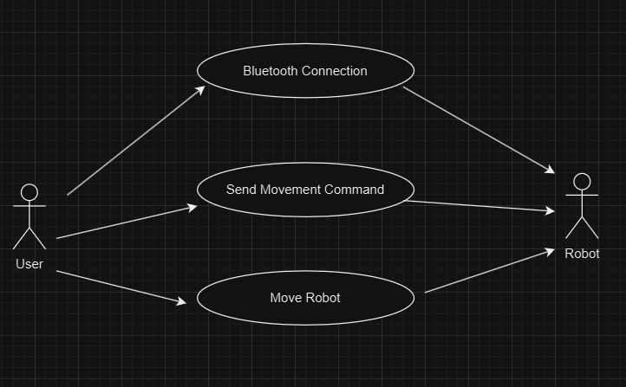

**Figure 3.1**

**3.2.2 Sequence Diagram**

A sequence diagram in Unified Modeling Language (UML) is a kind of interaction diagram that shows how processes operate with one another and in what order. It is a construct of a Message Sequence Chart. Sequence diagrams are sometimes called event diagrams, event scenarios, and timing diagrams. A sequence diagram shows, as parallel vertical lines (lifelines), different processes or objects that live simultaneously, and as horizontal arrows, the messages exchanged between them, in the order in which they occur. This allows the specification of simple runtime scenarios in a graphical manner

|------------------|------------------------|-------------------------|--------------------|

| Smartphone | Bluetooth Module | Microcontroller | Motor Driver |

|------------------|------------------------|-------------------------|--------------------|

| | | |

1. |--------Move Forward---->| | |

| | | |

| |----Command to MCU----->| |

| | | |

| | |----Activate Motors--->|

| | | |

| | |<---Motor Moving------|

| |<---Confirm to Bluetooth-| |

|<-----Confirm------------| | |

| | | |

|------------------|------------------------|-------------------------|--------------------|

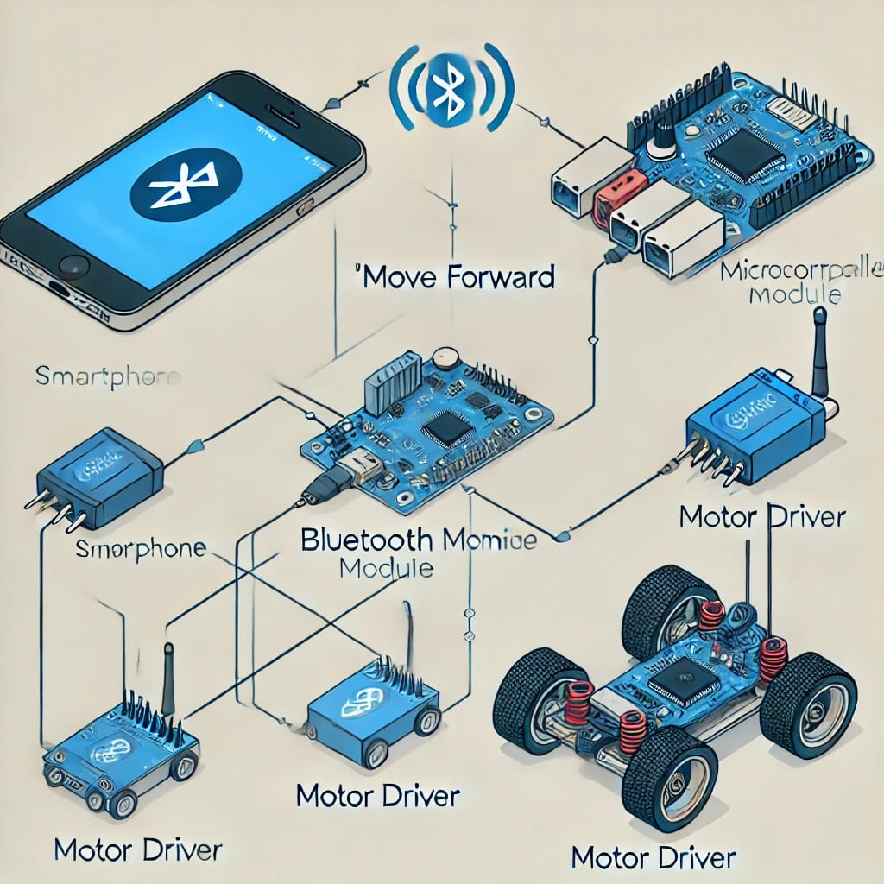

**3.2.3 Flowchart**

A flowchart is a visual representation of a process or system, using standard symbols and arrows to show the progression of actions, choices, and information. It serves as a tool to clarify the sequence and logic within a process, helping to simplify and analyze complex workflows. Figure 3.2 illustrates the step-by-step flow of the project from its starting point.

Arduino uno

Arduino uno

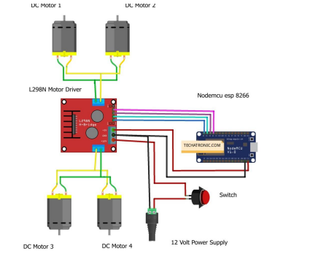

**CHAPTER 4: RESULT AND DISCUSSION**

The "IoT Enabled Robot" project successfully demonstrates the wireless control of a robot car using Bluetooth through a mobile app , the system was able to connect to a mobile device via Bluetooth and execute commands for the robot's movement, such as moving forward, backward, rotating, and stopping. The motor driver effectively controlled the DC gear motors, allowing the robot to perform the desired movements accurately. The mobile app provided a user-friendly interface for sending control commands, making the system efficient and easy to operate.

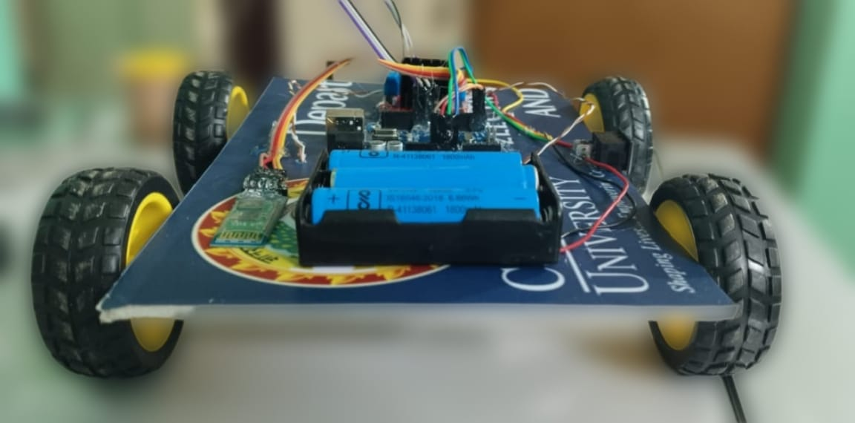

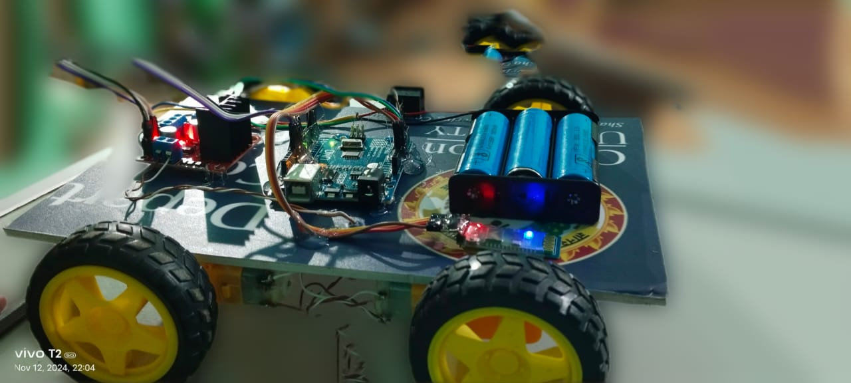

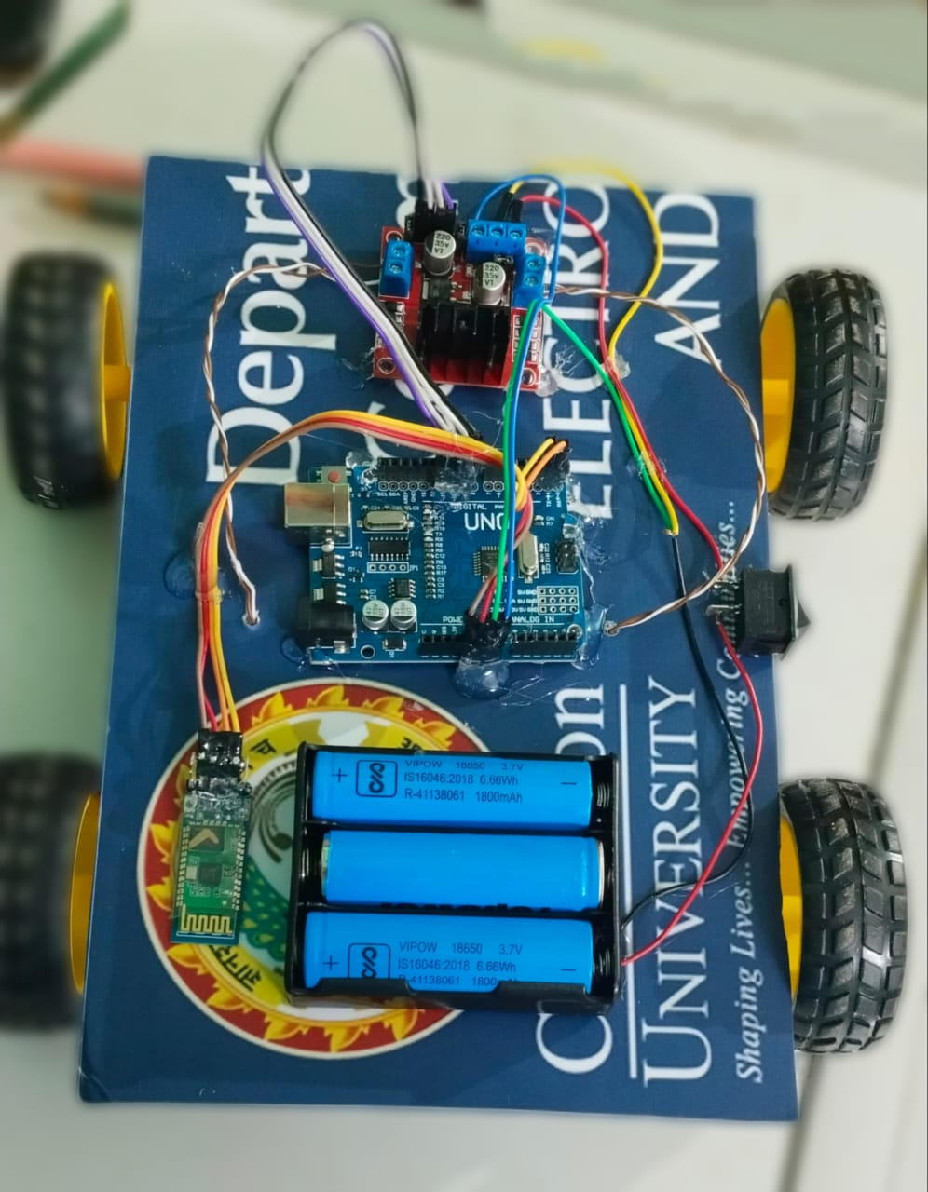

The project highlights the potential of using IoT technologies for remote control and automation. The choice of HC-05 for Bluetooth communication proved to be ideal due to its low power consumption, robust wireless capabilities, and ease of integration with mobile devices. The robot’s movement was smooth, and the control commands were executed with minimal latency, which is critical for real-time operations.

**CHAPTER 5: CONCLUSION & FUTURE ENHANCEMENT**

**5.1 CONCLUSION**

The "IoT Enabled Robot" project successfully demonstrates the use of IoT in robotics to control a robot car via Bluetooth. By utilizing Arduino, along with components like gear motors, motor drivers, wheels, and 3 lithium ion battery cells , the robot car connects to a mobile device using a Bluetooth RC controller app. This setup enables the user to remotely move and rotate the car, with the Arduino executing the commands received from the app. The project showcases the potential of IoT in enabling wireless control and automation, serving as a foundation for more advanced robotics applications.

**5.2 FUTURE ENHANCEMENT**

**Autonomous Navigation:** Integrating sensors like ultrasonic or infrared to enable obstacle detection and autonomous navigation, allowing the robot to avoid obstacles and navigate predefined paths without manual control.

**Cloud Integration:** Connecting the robot to a cloud platform for remote control and monitoring from anywhere, as well as storing data for analytics and performance tracking.

**Voice Control:** Adding voice command functionality through integration with virtual assistants (like Alexa or Google Assistant) for hands-free control of the robot.

**Camera Integration:** Incorporating a camera for live streaming or surveillance applications, allowing users to view the robot’s surroundings in real-time.

**Advanced Movement Algorithms:** Implementing more sophisticated movement algorithms, like path planning or AI-based control, to improve the precision and efficiency of the robot's movements.

**Mobile App Enhancements:** Expanding the mobile app to support features like real-time status feedback, battery monitoring, and customizable control options.

**REFERENCES**

1. Arduino Documentation

Arduino Official Documentation provides extensive information on the Arduino Uno microcontroller, its specifications, and programming guides.

Link: https://www.arduino.cc/en/Guide/ArduinoUno

2. L298N Motor Driver Module Documentation

Information about the L298N motor driver, including its specifications and wiring guide, which is crucial for controlling the DC motors.

Link: https://components101.com/modules/l298n-motor-driver-module

3. Bluetooth Module (HC-05/HC-06) Guide

Guides on using the Bluetooth HC-05 or HC-06 modules for wireless communication with the Arduino, including pairing and connection instructions.

Link: https://www.electronicwings.com/arduino/bluetooth-module-hc-05

4. DC Motors in Robotics

Overview of DC motors, their functionality, and how they are used in robotics applications like mobile robot cars.

Book: "Robot Building for Beginners" by David Cook

ISBN: 978-1430227489

5. Bluetooth-Based Robotics Projects

Tutorials and resources that focus on robotics projects controlled via Bluetooth, which can provide additional insights and techniques for implementation.

Example: "Arduino Robotics Projects" by Richard Grimmett

ISBN: 978-1786463989

6. Research Papers on Bluetooth-Controlled Robots

Academic papers discussing similar projects with Bluetooth control and Arduino, providing technical depth and practical insights.

Example: "Design and Development of a Bluetooth Controlled Robotic Car" by X et al., Journal of Robotics and Automation.

Available on research databases like IEEE Xplore or ResearchGate.

7. Arduino Programming for Beginners

Book or online tutorials that cover basic Arduino programming, suitable for beginners and for understanding motor and Bluetooth control.