**Research Proposal: Enhancing Cognitive Processing of Accents as a Phenomenon of Human Information Processing**

**Part 1: Literature Review and Identify Problems**

**1. Introduction**

In our increasingly globalized world, characterized by the interconnectedness of cultures and economies, cross-regional communication has become paramount across various domains, including business, education, diplomacy, and interpersonal relationships. As we navigate this complex landscape of intercultural interactions, one significant and intricate phenomenon within the realm of human information processing stands out – the cognitive processing of accents during these cross-regional exchanges.

Accents, resembling audible fingerprints of cultural and regional identity, have the potential to enrich our global discourse. They encapsulate the richness and diversity of human expression. However, they can also pose subtle yet formidable challenges, influencing the cognitive processes that underpin effective communication.

The cognitive processing of accents affects various aspects of communication, including cognitive load, comprehension, the effectiveness of communication, and the ability to adapt cognitively to ensure inclusivity. This multifaceted cognitive phenomenon extends to both familiar and unfamiliar accents, making it a subject of significance not only in social settings but also in professional, educational, and diplomatic contexts.

Understanding and addressing this specific phenomenon within human information processing, the cognitive processing of accents, is not merely an academic exercise; it is a practical necessity. This research proposal aims to unravel this complex cognitive phenomenon, which involves the processing of accents during cross-regional communication. It also seeks to present practical design implications aimed at enhancing the cognitive adaptation to accents, contributing to improved information processing, and ultimately enhancing the effectiveness of these interactions. In the pages that follow, this proposal outlines a structured approach to studying this multifaceted issue, with the ultimate goal of addressing the cognitive processing of accents and fostering inclusive, effective global communication.

**2. Literature Review**

The diversity of our world's languages, cultures, and regions is an invaluable asset, enriching our global society. Accents are audible expressions of cultural and regional identity, and they offer us a unique glimpse into the multifaceted linguistic tapestry of our world. However, these accents can also be significant barriers to effective cross-regional communication. The literature highlights several key areas of concern:

**Accent-Induced Cognitive Load**: When individuals are exposed to accents different from their own, it can lead to increased cognitive load as they work harder to process the spoken language. This cognitive processing phenomenon affects comprehension and information retention. Research by Adank et al. (2009) suggests that listeners often need to exert additional cognitive effort to recognize and interpret words when they are pronounced with unfamiliar accents. This increased cognitive load can impact not only the speed but also the depth of understanding, potentially leading to delays or misunderstandings in communication.

**Misinterpretation and Communication Breakdown**: Accents can lead to misinterpretations and misunderstandings, hindering effective communication and potentially resulting in conflicts or errors. Accurate interpretation is vital in cross-regional communication, and difficulties arising from accents can lead to mistakes, misinformation, and interpersonal tensions. A study by Van Engen and Bradlow (2007) found that listeners often struggle to recognize sentences when presented in unfamiliar accents, contributing to a higher rate of misinterpretation and communication breakdown.

**Cognitive Adaptation and Inclusivity**: Cognitive adaptation to various accents is a crucial aspect of human information processing. Neglecting these cognitive processes can limit inclusivity and result in unequal participation in cross-regional dialogues. Munro and Derwing (1995) highlight the challenges faced by second language learners who develop accents when acquiring a new language, emphasizing the importance of cognitive adaptation to ensure effective participation in communication.

**3. Research Objectives**

This research aims to address the challenges associated with the cognitive processing of accents in cross-regional communication. The following research objectives are outlined:

1. **Understanding Cognitive Processes**: Investigate the cognitive processes involved in accent recognition and comprehension to gain deeper insights into how individuals process spoken language with diverse accents.
2. **Impact of Cognitive Load**: Assess the impact of accent-induced cognitive load on information processing, focusing on how cognitive load affects the speed and depth of understanding during cross-regional communication.
3. **Addressing Misinterpretation and Communication Breakdown**: Explore the consequences of misinterpretation and communication breakdown resulting from accents and seek strategies to mitigate these challenges.
4. **Enhancing Cognitive Adaptation and Inclusivity**: Identify approaches to improve cognitive adaptation to various accents, ensuring inclusivity in cross-regional communication for all participants.

These research objectives are vital for understanding, addressing, and improving the cognitive processing of accents in cross-regional communication. This study aims to contribute to more effective and inclusive global communication by offering practical solutions and insights.

**4. Problem Statement**

The problem can be defined as follows:

Phenomenon: Cognitive Processing of Accents in Cross-Regional Communication as a Specific Phenomenon of Human Information Processing, impacting cognitive load, comprehension, effective communication, and cognitive adaptation for inclusivity.

**Part 2: Design Implication**

To address the challenge of the cognitive processing of accents in cross-regional communication, we propose the design implication of "Cognitive Accent Adaptation." This implies developing training or technology solutions that enhance individuals' cognitive adaptation to diverse accents, thereby reducing cognitive load, improving comprehension, and fostering effective communication.

**Rationale:**

1. Reduced Cognitive Load: Cognitive accent adaptation can significantly reduce cognitive load, making it easier for individuals to process and understand accents different from their own.
2. Enhanced Comprehension: Improved cognitive adaptation will lead to better comprehension of spoken language with different accents, contributing to more effective and error-free communication.
3. Improved Cognitive Adaptation and Inclusivity: Implementing cognitive accent adaptation aligns with the cognitive processes involved in understanding accents and ensures inclusivity and effective cross-regional communication.

**2. Figures**

A potential design concept could involve a training program or technology that progressively exposes users to a variety of accents, helping them adapt their cognitive processes.

Below are the graphs that tell us about the average response times for the English listener groups.

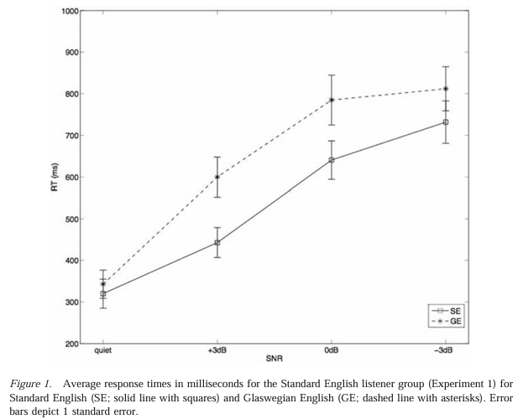

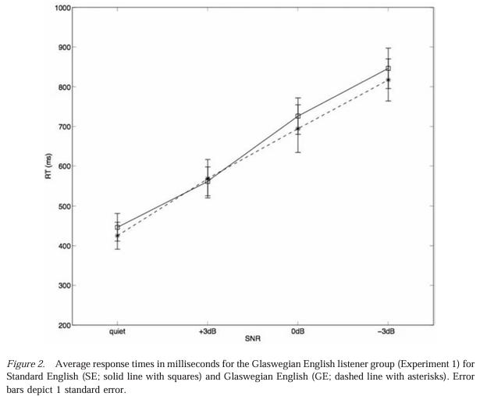

**Part 3: Expected Results**

**1. Evaluation Plan**

To evaluate the effectiveness of the proposed design implication, we will conduct a longitudinal study:

**Longitudinal Study:**

* Participants will engage in a cognitive accent adaptation program or use a technology solution.
* Data will be collected on cognitive load, comprehension, communication effectiveness, and perceptions of inclusivity.

**2. Expected Results**

We anticipate the following results:

1. Reduced Cognitive Load: Participants undergoing cognitive accent adaptation will exhibit significantly reduced cognitive load when processing accents, facilitating better information processing and comprehension.
2. Enhanced Comprehension: Users will demonstrate improved comprehension and effective communication in cross-regional interactions.
3. Improved Cognitive Adaptation and Inclusivity: Participants will report feeling more adaptable to diverse accents and more included in cross-regional communication, leading to a more inclusive and collaborative environment.

This research aims to understand how individuals perceive and process spoken language with diverse accents, and how these cognitive processes impact their ability to comprehend, communicate effectively, and adapt inclusively in cross-regional communication.

The specific objectives of this research include:

* Investigating the cognitive processes involved in accent recognition and understanding.
* Assessing the impact of accent-induced cognitive load on information processing.
* Exploring the consequences of misinterpretation and communication breakdown resulting from accents.
* Identifying the need for cognitive adaptation to ensure inclusivity in cross-regional communication.

The ultimate goal is to propose design implications and strategies to enhance the cognitive adaptation to accents, reducing cognitive load, improving comprehension, and fostering effective and inclusive communication in a globalized world.

By implementing cognitive accent adaptation strategies, we aim to address the information processing challenge of the cognitive processing of accents in cross-regional communication, fostering effective and inclusive interactions in our globalized world.

**Part 4: Prospective Solutions**

**1. Technology Solutions:** To address the challenge of the cognitive processing of accents in cross-regional communication, we propose a multifaceted approach. These technology solutions aim to make the cognitive adaptation to accents more accessible and user-friendly:

**1.1 Accent Recognition Software:** Develop software and applications that automatically recognize the user's level of familiarity with different accents. These tools can then provide tailored exercises and resources to improve accent comprehension.

**1.2 Speech-to-Text Integration:** Integrate speech-to-text technology into communication platforms and applications. This feature could provide real-time text transcriptions of spoken conversations, aiding in comprehension, particularly for users less familiar with certain accents.

**1.3 Virtual Language Assistants:** Virtual assistants, such as AI-driven chatbots or voice-activated assistants, can be programmed to recognize and adapt to the user's accent. These assistants could help users navigate conversations more smoothly.

**2. Cognitive Training Applications:**

* **2.1 Brain Training Apps:** Incorporate accent recognition and understanding exercises into cognitive training applications. These apps can offer engaging and effective ways for users to enhance their cognitive adaptation to accents.

**3. Accessibility Features:**

* **3.1 Accessible Communication Devices:** Develop devices with accessibility features, such as adjustable speech recognition models. These devices could adapt to the user's unique accent or linguistic background, enhancing their ease of communication.

**4. Data-Driven Insights:**

* **4.1 Data Analytics:** Leverage data analytics to identify common patterns of accent-related communication challenges. Insights from these data analyses can inform the design of training programs and technologies for better user-specific adaptations.

**5. Language Learning Platforms:**

* **5.1 Enhanced Language Learning Modules:** Language learning platforms can incorporate accent adaptation modules, facilitating improved comprehension and interactions between learners and native speakers.

These proposed solutions offer a holistic approach to enhancing the cognitive adaptation to accents in cross-regional communication. Recognizing the importance of both training and technology, this multifaceted strategy empowers individuals to communicate more effectively in diverse linguistic environments, fostering inclusivity and collaboration.

**Conclusion**

This research project aims to enhance the cognitive processing of accents in cross-regional communication as a specific phenomenon of human information processing by addressing the cognitive processes involved in understanding diverse accents. The proposed "Cognitive Accent Adaptation" design implication, supported by empirical evidence, has the potential to make cross-regional communication more effective, inclusive, and user-friendly for individuals from diverse regions.

**References:**

1. Adank, P., Evans, B. G., Stuart-Smith, J., & Scott, S. K. (2009). Comprehension of familiar and unfamiliar native accents under adverse listening conditions. Journal of Experimental Psychology: Human Perception and Performance, 35(2), 520-529.
2. Munro, M. J., & Derwing, T. M. (1995). Foreign accent, comprehensibility, and intelligibility in the speech of second language learners. Language Learning, 45(1), 73-97.