Project Title: Onion Storage Technology

Team members:
- NALLANDULA DHARANE SUHASS REDDE
- SHEELAM GAGAN REDDY
- MUVVALA ROHITH

Problem Statement of Project:

Onion is a major commercial crop in India, but poor storage practices cause heavy post-harvest losses of 20–40%. Most farmers use traditional storage methods that fail to control temperature and humidity, leading to rotting, sprouting, and fungal attacks. Due to this, farmers are forced to sell onions immediately after harvest at low prices. Lack of proper storage also causes seasonal price fluctuations, benefiting traders instead of producers. These losses reduce farmer income, discourage production, and create market instability. Climate variations further worsen storage conditions. The absence of affordable, scientific storage solutions remains a major challenge affecting both productivity and profitability in onion farming. Developing cost-effective and durable storage systems is essential to minimize losses and stabilize farmers’ earnings.

Proposed Idea:

To reduce post-harvest losses and improve farmer income, scientific and affordable onion storage systems must be adopted. Onions should be stored in well-ventilated structures that maintain ideal conditions—temperature between 25–30°C and relative humidity of 65–70%. Use of improved storage designs like the NHRDF model or kandha chal (improved ventilated storage structures) with elevated floors, side ventilation, and slotted walls can reduce losses to below 10%.
Farmers can form cooperative storage units or Farmer Producer Organizations (FPOs) to collectively build and manage such facilities, reducing individual costs. Additionally, promoting solar-powered or low-energy cold storage in regions with high temperature and humidity can further extend shelf life. Government support through subsidies, training on post-harvest management, and promotion of value addition (onion flakes, powder, etc.) can stabilize prices and increase farmer profits.

Project Execution:

- Conceptual framework and System Design:
Since Onions are the vegetables which still respires even after harvesting vegetables which needs proper storage conditions so that there won’t be any losses, and if any improper storage conditions such as high temperature, improper humidity, poor ventilation, gas accumulation, and light exposure will decrease the shelf life of the onions and it can lead to sprouting, rotting, dehydration and quality loss which makes them unfit for selling and farmers gets huge loss. To address this issue, a smart storage monitoring system is designed using sensor-based technology which operates on a closed loop control principle.
Temperature and humidity sensors are used here to measure and maintain the optimal environmental conditions, while gas sensors monitors air quality of the storage cell and any changes in the air quality caused by the respiration and an early spoilage. A light sensor ensures to maintain the storage cell to be dark which helps in prevention of sprouting, and with the help of load cells to measure weight loss of the onions due to the dehydration over time. All sensor data is processed by an ESP32 controller, which automatically controls ventilation fans and a humidifier to regulate airflow and moisture levels. This system continuously maintains favorable storage conditions, reduces post-harvest losses and helps the extension of the shelf life of onions in a cost-effective manner.

- Methodology:
This smart onion storage device is designed which works under sensor-controlled storage unit, which maintains the optimal environmental conditions for the extended shelf life of onions. This system is powered via dc supply and buck convertors are used to power up toe modules which takes low voltages like esp32 and other sensor modules which ensures safe operation of the components in the system. The ESP32 module is our main control unit of the system which gathers all the information about the conditions of the storage cell and processes the data to maintain the good storage conditions. The data that gathered are: temperature, humidity, light intensity and gas concentration inside the storage unit. These parameters are critical for the storage and any variations in temperature, excess or insufficient or excess humidity, gas buildup, light exposure are the primary caused for the decrease of the shelf life of onions because of the after effects like sprouting and rotting during storage.

The collected data from the sensors are gathered at ESP32 and the data is compared with the pre-defined optimal values in the system program. When any of the sensor data is not following the pre-defined conditions, the corresponding equipment will work and regulates the value to the optimal values like temperature if it rises than the optimal temperature the ESP32 triggers the cooling mechanism and the fans used for ventilation to reduce internal heat and improving the air flow to prevent gases buildup which ensures the optimal conditions. If the humidity is fallen the humidifier is turned on to prevent the dehydration of the onion, and for the increased humidity ESP32 module triggers increased airflow or controlled heating to reduce the moisture buildup in the onion. This fan circulates through filter cartridge which helps in removal of spoilage gases and delays sprouting or rotting. Light sensor ensures not to have light in the storage unit and any unwanted light exposure is addressed promptly to the owner.

The system is designed to be adaptable for various regions with different climates and different storage conditions with the help of modification of the pre-defined threshold values through regular software updates to the ESP32. On addition ESP32 has inbuilt wireless capability like Bluetooth and Wi-Fi which makes us to transmit the sensor readings to a mobile, enabling remote monitoring of onion quality and storage conditions.

By integrating the continuous monitoring system, automatic control, user accessibility which completes the Smart Onion Storage Device, which provides an efficient and low-cost solution to reduce post-harvest losses and improve Onion Storage Mannagment.

- Simple Schematic: (Made in KiCad)
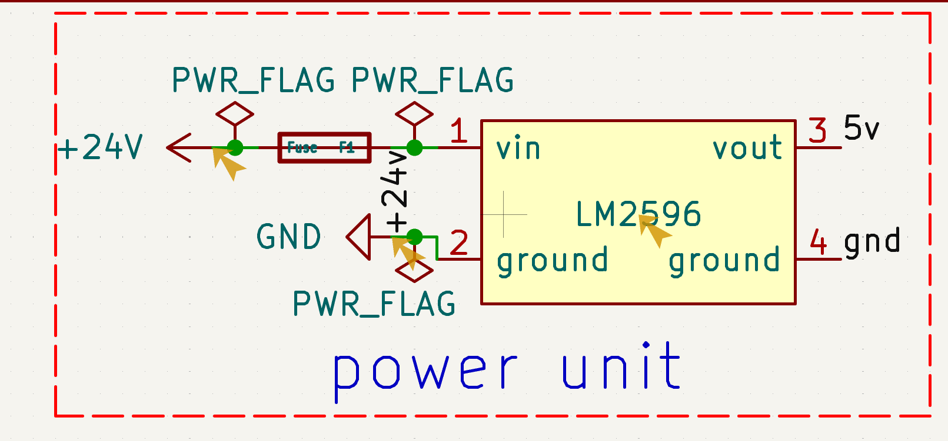
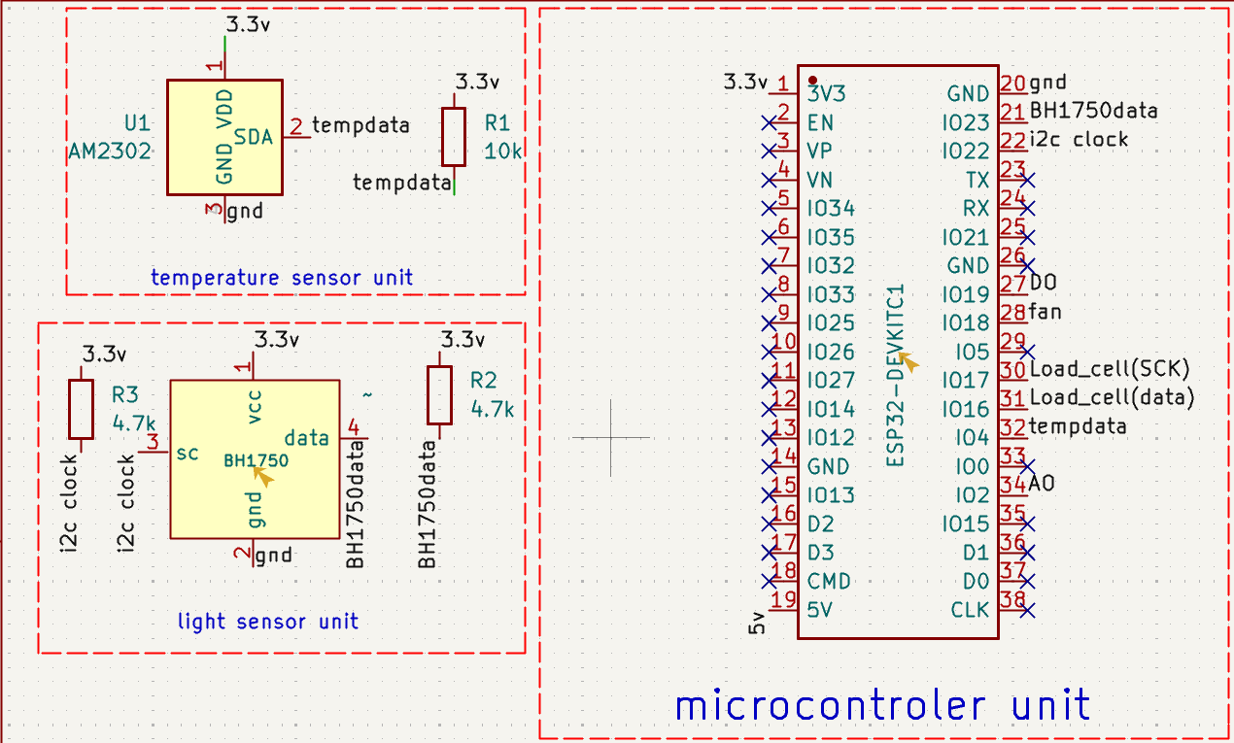

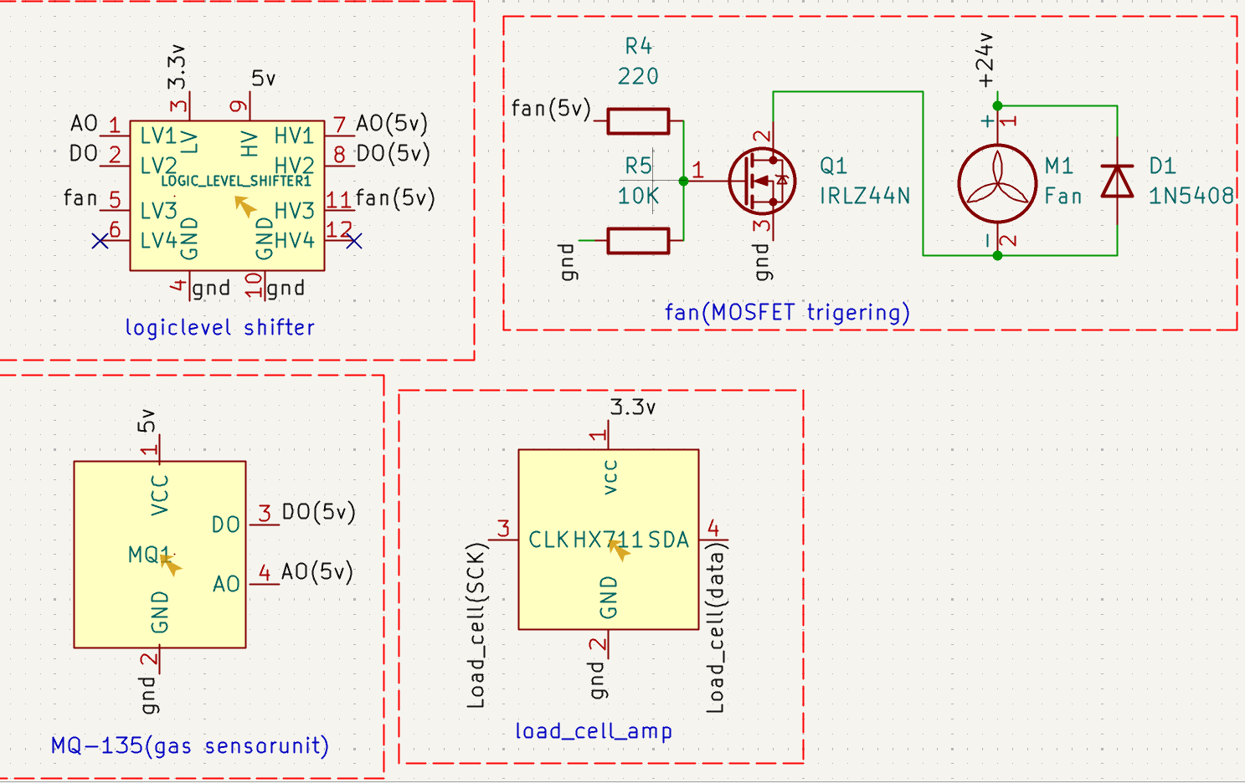

- Sample Code:

/*************************************************
* Smart Onion Storage System - ESP32
* Sensors: DHT22, BH1750, HX711
* Actuators: Fan, Humidifier (via MOSFET)
*************************************************/

#include <Arduino.h>
#include <DHT.h>
#include <Wire.h>
#include <BH1750.h>
#include "HX711.h"

/* ---------- Pin Definitions ---------- */
#define DHTPIN 4
#define DHTTYPE DHT22

#define HX711_DOUT 19
#define HX711_SCK 18

#define FAN_PIN 26
#define HUMIDIFIER_PIN 27

/* ---------- Objects ---------- */
DHT dht(DHTPIN, DHTTYPE);
BH1750 lightMeter;
HX711 scale;

/* ---------- Thresholds ---------- */
float TEMP_THRESHOLD = 30.0; // °C
float HUM_THRESHOLD = 65.0; // %

/* ---------- Setup ---------- */
void setup() {
Serial.begin(115200);

pinMode(FAN_PIN, OUTPUT);
pinMode(HUMIDIFIER_PIN, OUTPUT);

digitalWrite(FAN_PIN, LOW);
digitalWrite(HUMIDIFIER_PIN, LOW);

// Start sensors
dht.begin();

Wire.begin(21, 22); // SDA, SCL
lightMeter.begin(BH1750::CONTINUOUS_HIGH_RES_MODE);

scale.begin(HX711_DOUT, HX711_SCK);
scale.set_scale(); // Calibrate later
scale.tare(); // Zero the scale

Serial.println("Smart Onion Storage System Started");
}

/* ---------- Main Loop ---------- */
void loop() {
/* ---- Read DHT22 ---- */
float humidity = dht.readHumidity();
float temperature = dht.readTemperature(); // Celsius

if (isnan(humidity) || isnan(temperature)) {
Serial.println("Failed to read from DHT sensor!");
delay(2000);
return;
}

/* ---- Read Light ---- */
float lux = lightMeter.readLightLevel();

/* ---- Read Load Cell ---- */
float weight = scale.get_units(5); // average of 5 readings

/* ---- Control Fan ---- */
if (temperature > TEMP_THRESHOLD) {
digitalWrite(FAN_PIN, HIGH);
} else {
digitalWrite(FAN_PIN, LOW);
}

/* ---- Control Humidifier ---- */
if (humidity < HUM_THRESHOLD) {
digitalWrite(HUMIDIFIER_PIN, HIGH);
} else {
digitalWrite(HUMIDIFIER_PIN, LOW);
}

/* ---- Serial Monitor Output ---- */
Serial.println("-------- System Status --------");
Serial.print("Temperature: ");
Serial.print(temperature);
Serial.println(" °C");
Serial.print("Humidity: ");
Serial.print(humidity);
Serial.println(" %");

Serial.print("Light: ");
Serial.print(lux);
Serial.println(" lx");

Serial.print("Weight: ");
Serial.print(weight);
Serial.println(" units");

Serial.print("Fan: ");
Serial.println(digitalRead(FAN_PIN) ? "ON" : "OFF");

Serial.print("Humidifier: ");
Serial.println(digitalRead(HUMIDIFIER_PIN) ? "ON" : "OFF");

Serial.println("--------------------------------\n");

delay(2000);
}

Equipment and Budget:

Module | Purpose | Cost | Quantity
ESP32 | Micro Controller | ₹541 | 1
MQ-135 | Measures ammonia, sulfur-related VOCs, alcohol, CO2 | ₹470 | 1
BH1750 | Light Sensor | ₹571 | 1
9225 DC24V Cooling Fan | Fan | ₹89 | 1
LM2596 | Buck Converter | ₹73 | 2
DC24V Alloy Air Humidifier | Humidifier | ₹426 | 1
24v DC SMPS | Power | ₹1778 | 1
Load Cell + HX711 | Weight Loss Monitoring | ₹36 | 1
IRLZ44N | MOSFET for Fan and Humidifier trigger | ₹39 | 1
DHT-22 | Temperature & RH | ₹146 | 1
Resistor (10k) | MOS Gate Trigger for Fan | ₹1 | 2
resistor (220) | MOS Excess current Protection | ₹2 | 1
resistor (4.7k) | I²C Communication Pulldown | ₹1 | 2
1N5408 | Flyback diode | ₹4 | 3
100 µF + 1µF | Decoupling Capacitor | ₹5 | 1
3 A fuse | Fuse | ₹8 | 1
logic level shifter | Helps for shifting in the logic | 15 | 1

Overall Project Budget: 4500 – 5000, inclusive of equipment and supplementary costs.

Declaration and Signature:

Signature of Faculty advisor: Signature of Mentor:

Communication Address:
IIT Tirupati, Yerpedu,
517619,
Muvvala Rohith
Registration No.: EE24B032
Contact Number: 8179559575

