**Userguide**

by following the link your instructor give, you can get:

[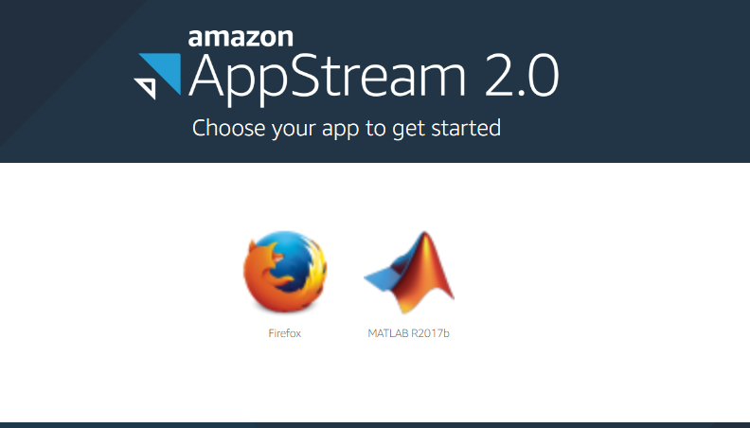](https://insidelabs-git.mathworks.com/wyu/R2017b-GPU-Workshop/uploads/e262f9490674293dc22c4de0ce8a65b2/image.png)

User can start MATLAB or a web browser on the same machine, MATLAB need 5-10 minutes to start; after the startup, it takes no time to reconnect it if you closed your page and reopen it again.

On the Appstream Windows, you can find 6 buttons on the left top corner:

[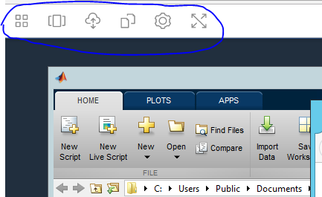](https://insidelabs-git.mathworks.com/wyu/R2017b-GPU-Workshop/uploads/f974208d4a0acbd5e0305be559b5188e/image.png)

*a.* First button allows you to start a new application inside same instance

*b.* Second button allows you to switch between the applications including different MATLAB Windows

*c.* Third button allows you upload/download files between your computer and instance, be aware, the data you upload won't sit on instance permanently, it will be deleted once instance stop.

Here is the upload looks like at temp directory:

[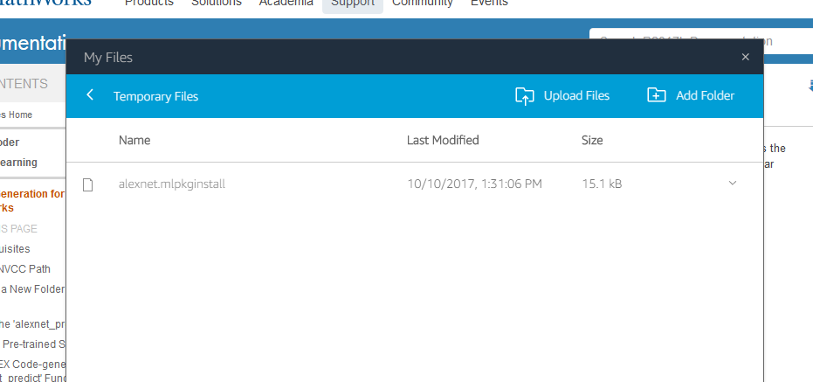](https://insidelabs-git.mathworks.com/wyu/R2017b-GPU-Workshop/uploads/8aed928ff3a9791db44b5c1422f70de4/image.png)

You can find your file by using MATLAB to browse:

C:\Users\PhotonUser\My Files\Temporary Files

[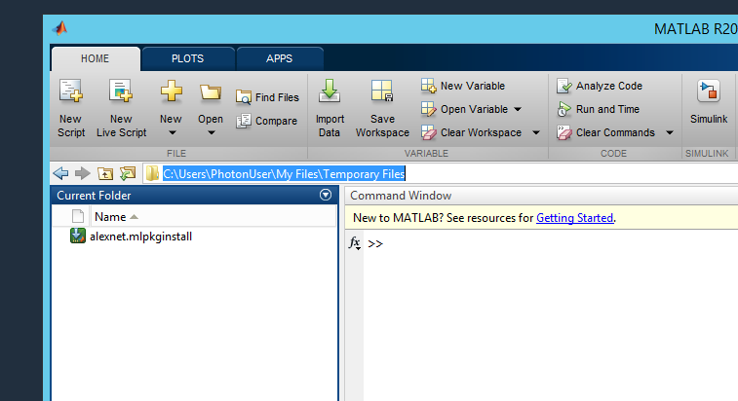](https://insidelabs-git.mathworks.com/wyu/R2017b-GPU-Workshop/uploads/bafc618bfa83b357429f41291a10a3b3/image.png)

*e.* Fourth button will let user to cut/paste

*f.* Fifth button is setting

*g.* Sixth button allow user switch to full screen mode