ASSIGNMENT 1

**Rohith M 3122 21 5001 085**

# Insertion Sort

In [49]:

**import** random

**def** insertionsort(array): l1**=**time.time()

**for** step **in** range(1, len(array)): key **=** array[step]

j **=** step **-** 1

*# Compare key with each element on the left of it until an element smaller t # For descending order, change key<array[j] to key>array[j].*

**while** j **>=** 0 **and** key **<** array[j]: array[j **+** 1] **=** array[j]

j **=** j **-** 1

*# Place key at after the element just smaller than it.*

array[j **+** 1] **=** key l2**=**time.time()

**return** (l2**-**l1)**\***1000

## Creating array of random numbers

In [51]:

randomlist10**=**[]

**for** i **in** range(0,10):

n **=** random.randint(1,10000) randomlist10.append(n)

randomlist100**=**[]

**for** i **in** range(0,100):

n **=** random.randint(1,10000) randomlist100.append(n)

randomlist1000**=**[]

**for** i **in** range(0,1000):

n **=** random.randint(1,10000) randomlist1000.append(n)

randomlist10k**=**[]

**for** i **in** range(0,10000):

n **=** random.randint(1,10000) randomlist10k.append(n)

randomlist100k**=**[]

**for** i **in** range(0,100000):

n **=** random.randint(1,10000) randomlist100k.append(n)

In [52]:

*#performing sorting*

times**=**[]

times.append(insertionsort(randomlist10)) times.append(insertionsort(randomlist100)) times.append(insertionsort(randomlist1000)) times.append(insertionsort(randomlist10k)) times.append(insertionsort(randomlist100k))

## Plotting

In [55]:

x**=**[10,100,1000,10000,100000]

**import** numpy **as** np x**=**np.array(x)

**import** matplotlib.pyplot **as** plt plt.plot(x,times)

plt.xlabel("SIZE") plt.ylabel("TIME")

Out[55]:

Text(0, 0.5, 'TIME')

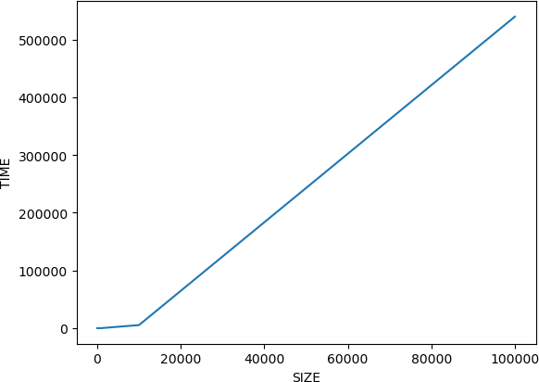

# Shell Sort

In [72]:

**def** shellsort(array): l1**=**time.time() n**=**len(array)

interval **=** n **//** 2

**while** interval **>** 0:

**for** i **in** range(interval, n): temp **=** array[i]

j **=** i

**while** j **>=** interval **and** array[j **-** interval] **>** temp: array[j] **=** array[j **-** interval]

j **-=** interval array[j] **=** temp

interval **//=** 2 l2**=**time.time()

**return** (l2**-**l1)**\***1000

## Creating array of random numbers

In [73]:

randomlist10**=**[]

**for** i **in** range(0,10):

n **=** random.randint(1,10000) randomlist10.append(n)

randomlist100**=**[]

**for** i **in** range(0,100):

n **=** random.randint(1,10000) randomlist100.append(n)

randomlist1000**=**[]

**for** i **in** range(0,1000):

n **=** random.randint(1,10000) randomlist1000.append(n)

randomlist10k**=**[]

**for** i **in** range(0,10000):

n **=** random.randint(1,10000) randomlist10k.append(n)

randomlist100k**=**[]

**for** i **in** range(0,100000):

n **=** random.randint(1,10000) randomlist100k.append(n)

In [74]:

*#performing sorting*

times**=**[]

times.append(shellsort(randomlist10)) times.append(shellsort(randomlist100)) times.append(shellsort(randomlist1000)) times.append(shellsort(randomlist10k)) times.append(shellsort(randomlist100k))

## Plotting

In [75]:

x**=**[10,100,1000,10000,100000]

**import** numpy **as** np x**=**np.array(x)

**import** matplotlib.pyplot **as** plt plt.plot(x,times)

plt.xlabel("SIZE") plt.ylabel("TIME")

Out[75]:

Text(0, 0.5, 'TIME')

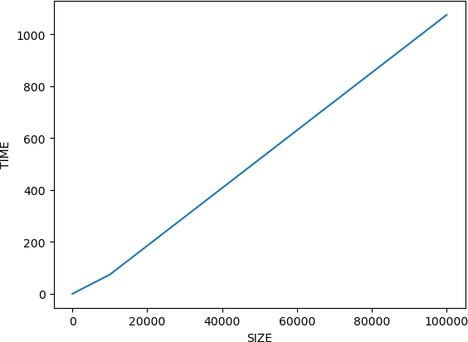

# Radix Sort

In [86]:

**def** countingSort(array, place): size **=** len(array)

output **=** [0] **\*** size count **=** [0] **\*** 10

**for** i **in** range(0, size):

index **=** array[i] **//** place count[index **%** 10] **+=** 1

**for** i **in** range(1, 10):

count[i] **+=** count[i **-** 1]

i **=** size **-** 1

**while** i **>=** 0:

index **=** array[i] **//** place

output[count[index **%** 10] **-** 1] **=** array[i] count[index **%** 10] **-=** 1

i **-=** 1

**for** i **in** range(0, size): array[i] **=** output[i]

**def** radixsort(array): l1**=**time.time()

max_element **=** max(array)

place **=** 1

**while** max_element **//** place **>** 0: countingSort(array, place) place **\*=** 10

l2**=**time.time()

**return** (l2**-**l1)**\***1000

## Creating array of random numbers

In [87]:

randomlist10**=**[]

**for** i **in** range(0,10):

n **=** random.randint(1,10000) randomlist10.append(n)

randomlist100**=**[]

**for** i **in** range(0,100):

n **=** random.randint(1,10000) randomlist100.append(n)

randomlist1000**=**[]

**for** i **in** range(0,1000):

n **=** random.randint(1,10000) randomlist1000.append(n)

randomlist10k**=**[]

**for** i **in** range(0,10000):

n **=** random.randint(1,10000) randomlist10k.append(n)

randomlist100k**=**[]

**for** i **in** range(0,100000):

n **=** random.randint(1,10000) randomlist100k.append(n)

In [89]:

*#performing sorting*

times**=**[]

times.append(radixsort(randomlist10)) times.append(radixsort(randomlist100)) times.append(radixsort(randomlist1000)) times.append(radixsort(randomlist10k)) times.append(radixsort(randomlist100k))

## Plotting

In [92]:

x**=**[10,100,1000,10000,100000]

**import** numpy **as** np x**=**np.array(x)

**import** matplotlib.pyplot **as** plt plt.plot(x,times)

plt.xlabel("SIZE") plt.ylabel("TIME")

Out[92]:

Text(0, 0.5, 'TIME')

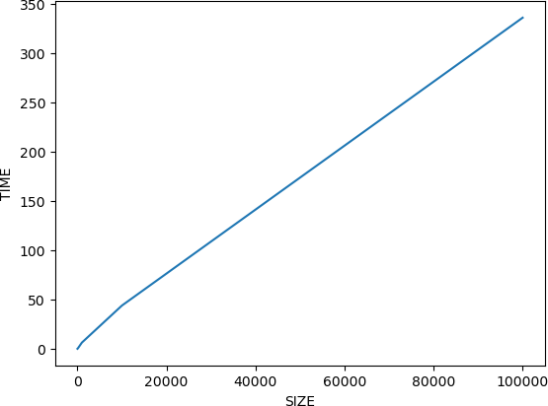

# SEARCHING

**BINARY SEARCH NON RECURSIVE**

In [129]:

**def** binarysearch(arr, x): l1**=**time.time()

found**=**0

left, right **=** 0, len(arr) **-** 1

**while** left **<=** right:

mid **=** (left **+** right) **//** 2

**if** arr[mid] **==** x: found**=**1

l2**=**time.time()

**return** (l2**-**l1)**\***1000

**elif** arr[mid] **<** x: left **=** mid **+** 1

**else**:

right **=** mid **-** 1

## Creating array of random numbers

In [114]:

randomlist10**=**[]

**for** i **in** range(0,10):

n **=** random.randint(1,10000) randomlist10.append(n)

randomlist100**=**[]

**for** i **in** range(0,100):

n **=** random.randint(1,10000) randomlist100.append(n)

randomlist1000**=**[]

**for** i **in** range(0,1000):

n **=** random.randint(1,10000) randomlist1000.append(n)

randomlist10k**=**[]

**for** i **in** range(0,10000):

n **=** random.randint(1,10000) randomlist10k.append(n)

randomlist100k**=**[]

**for** i **in** range(0,100000):

n **=** random.randint(1,10000) randomlist100k.append(n)

## Sorting using Shell Sort

In [115]:

**def** shellsort(array): l1**=**time.time() n**=**len(array)

interval **=** n **//** 2

**while** interval **>** 0:

**for** i **in** range(interval, n): temp **=** array[i]

j **=** i

**while** j **>=** interval **and** array[j **-** interval] **>** temp: array[j] **=** array[j **-** interval]

j **-=** interval array[j] **=** temp

interval **//=** 2 l2**=**time.time()

**return** array

**def** chooserandombeforesort(array):

r_in**=**random.randint(1,len(array))

**return** array[r_in]

*#Choosing elements before sort*

x10**=**chooserandombeforesort(randomlist10) x100**=**chooserandombeforesort(randomlist100)

x1000**=**chooserandombeforesort(randomlist1000) x10k**=**chooserandombeforesort(randomlist10k)

x100k**=**chooserandombeforesort(randomlist100k) randomlist10**=**shellsort(randomlist10)

randomlist100**=**shellsort(randomlist100)

randomlist1000**=**shellsort(randomlist1000) randomlist10k**=**shellsort(randomlist10k)

randomlist100k**=**shellsort(randomlist100k)

In [116]:

*#performing searching*

times**=**[]

times.append(binarysearch(randomlist10,x10)) times.append(binarysearch(randomlist100,x100))

times.append(binarysearch(randomlist1000,x1000)) times.append(binarysearch(randomlist10k,x10k))

times.append(binarysearch(randomlist100k,x100k)) times

Out[116]:

[0.0040531158447265625,

0.0030994415283203125,

0.005245208740234375,

0.0069141387939453125,

0.009298324584960938]

## Plotting

In [117]:

x**=**[10,100,1000,10000,100000]

**import** numpy **as** np x**=**np.array(x)

**import** matplotlib.pyplot **as** plt plt.plot(x,times)

plt.xlabel("SIZE") plt.ylabel("TIME")

Out[117]:

Text(0, 0.5, 'TIME')

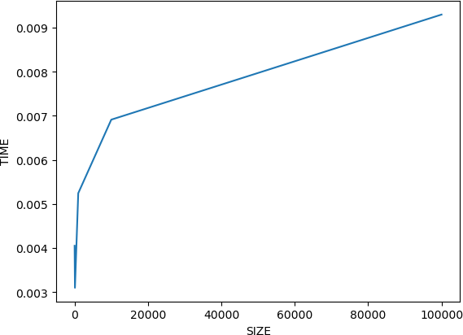

# BINARY SEARCH RECURSIVE

In [120]:

**def** binary_search(arr, x, left, right):

**if** left **>** right:

**return -**1

mid **=** (left **+** right) **//** 2

**if** arr[mid] **==** x:

**return** mid

**elif** arr[mid] **<** x:

**return** binary_search(arr, x, mid **+** 1, right)

**else**:

**return** binary_search(arr, x, left, mid **-** 1)

## Creating array of random numbers

In [121]:

randomlist10**=**[]

**for** i **in** range(0,10):

n **=** random.randint(1,10000) randomlist10.append(n)

randomlist100**=**[]

**for** i **in** range(0,100):

n **=** random.randint(1,10000) randomlist100.append(n)

randomlist1000**=**[]

**for** i **in** range(0,1000):

n **=** random.randint(1,10000) randomlist1000.append(n)

randomlist10k**=**[]

**for** i **in** range(0,10000):

n **=** random.randint(1,10000) randomlist10k.append(n)

randomlist100k**=**[]

**for** i **in** range(0,100000):

n **=** random.randint(1,10000) randomlist100k.append(n)

## Sorting using Shell Sort

In [122]:

**def** shellsort(array): l1**=**time.time() n**=**len(array)

interval **=** n **//** 2

**while** interval **>** 0:

**for** i **in** range(interval, n): temp **=** array[i]

j **=** i

**while** j **>=** interval **and** array[j **-** interval] **>** temp: array[j] **=** array[j **-** interval]

j **-=** interval array[j] **=** temp

interval **//=** 2 l2**=**time.time()

**return** array

**def** chooserandombeforesort(array):

r_in**=**random.randint(1,len(array))

**return** array[r_in]

*#Choosing elements before sort*

x10**=**chooserandombeforesort(randomlist10) x100**=**chooserandombeforesort(randomlist100)

x1000**=**chooserandombeforesort(randomlist1000) x10k**=**chooserandombeforesort(randomlist10k)

x100k**=**chooserandombeforesort(randomlist100k) randomlist10**=**shellsort(randomlist10)

randomlist100**=**shellsort(randomlist100)

randomlist1000**=**shellsort(randomlist1000) randomlist10k**=**shellsort(randomlist10k)

randomlist100k**=**shellsort(randomlist100k)

In [125]:

*#performing searching*

times1**=**[]

l1**=**time.time()

binary_search(randomlist10,x10,0,len(randomlist10)) l2**=**time.time()

times1.append((l2**-**l1)**\***1000) l1**=**time.time()

binary_search(randomlist100,x100,0,len(randomlist100)) l2**=**time.time()

times1.append((l2**-**l1)**\***1000) l1**=**time.time()

binary_search(randomlist1000,x1000,0,len(randomlist1000)) l2**=**time.time()

times1.append((l2**-**l1)**\***1000) l1**=**time.time()

binary_search(randomlist10k,x10k,0,len(randomlist10k)) l2**=**time.time()

times1.append((l2**-**l1)**\***1000) l1**=**time.time()

binary_search(randomlist100k,x100k,0,len(randomlist100k)) l2**=**time.time()

times1.append((l2**-**l1)**\***1000) times1

Out[125]:

[0.18405914306640625,

0.15783309936523438,

0.11396408081054688,

0.10585784912109375,

0.1087188720703125]

## Plotting

In [126]:

x**=**[10,100,1000,10000,100000]

**import** numpy **as** np x**=**np.array(x)

**import** matplotlib.pyplot **as** plt plt.plot(x,times)

plt.xlabel("SIZE") plt.ylabel("TIME")

Out[126]:

Text(0, 0.5, 'TIME')



**## Comparring Non Recurrsive and Recursive**

In [127]:

x**=**[10,100,1000,10000,100000]

**import** numpy **as** np x**=**np.array(x)

**import** matplotlib.pyplot **as** plt plt.plot(x,times)

plt.plot(x,times1) plt.xlabel("SIZE") plt.ylabel("TIME")

Out[127]:

Text(0, 0.5, 'TIME')

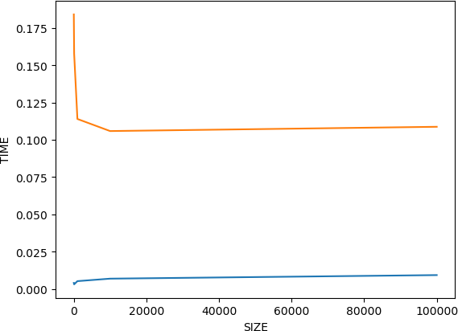

# Comparring Non Recurrsive and Recursive for size 1000

In [134]:

randomlist1000**=**[]

**for** i **in** range(0,1000):

n **=** random.randint(1,10000) randomlist1000.append(n)

x1000**=**chooserandombeforesort(randomlist1000) randomlist1000**=**shellsort(randomlist1000)

print(str(binarysearch(randomlist1000,x1000))**+**" is the time taken for size 1000 arr randomlist1000**=**[]

**for** i **in** range(0,1000):

n **=** random.randint(1,10000) randomlist1000.append(n)

x1000**=**chooserandombeforesort(randomlist1000) randomlist1000**=**shellsort(randomlist1000)

l1**=**time.time()

binary_search(randomlist1000,x1000,0,len(randomlist1000)) l2**=**time.time()

print(str((l2**-**l1)**\***1000) **+**" is the time taken to search recursively in size 1000 arra

0.006198883056640625 is the time taken for size 1000 array to search non recursively

0.07772445678710938 is the time taken to search recursively in size 10 00 array

In [ ]: