Homework-1 M. Rohith
11-04-2024 3122 21 5001 085

HOMEWORK

Program code:

App.js

function App(name) {
var person = {
name: "Todo List of Alice Zara",
task: ["Finish IP Project", "Take test in Lab", "Prepare for SAT"],
theme: {
backgroundColor: "grey",
color: "yellow",
width: "550px",
height: "800px",
borderRadius: "20px",
margin: "10px",
textAlign: "center",
}
};

const avatarStyle = {
height: "500px",
width: "400px",
borderRadius: "10px",
};

const headingStyle = {
backgroundColor: "black",
color: "pink",
padding: "10px",
borderTopLeftRadius: "20px",
borderTopRightRadius: "20px",
}

const listStyle = {
fontSize: "18px",
fontWeight: "bold",
}

// const btnStyle = {
// backgroundColor: "rgba(65, 228, 112, 0.91)",
// border: "0",
// padding: "10px",
// fontWeight: "bold",
// fontSize:"18px",
// }

return (
<div style={person.theme}>
<h1 style={headingStyle}>{person.name}</h1>
<img src="https://i.pinimg.com/originals/f3/51/38/f35138e723387b870b5904a70a2608d1.jpg" alt={`${name} profile pic`} style={avatarStyle} />
<hr/>
{person.task.map((task, index) => (
<p key={index} style={listStyle}>{task}</p>
))}
{/* <button style={btnStyle}> All Complet </button> */}
</div>
);
}

export default App;

Output:

npx create-react-app homework

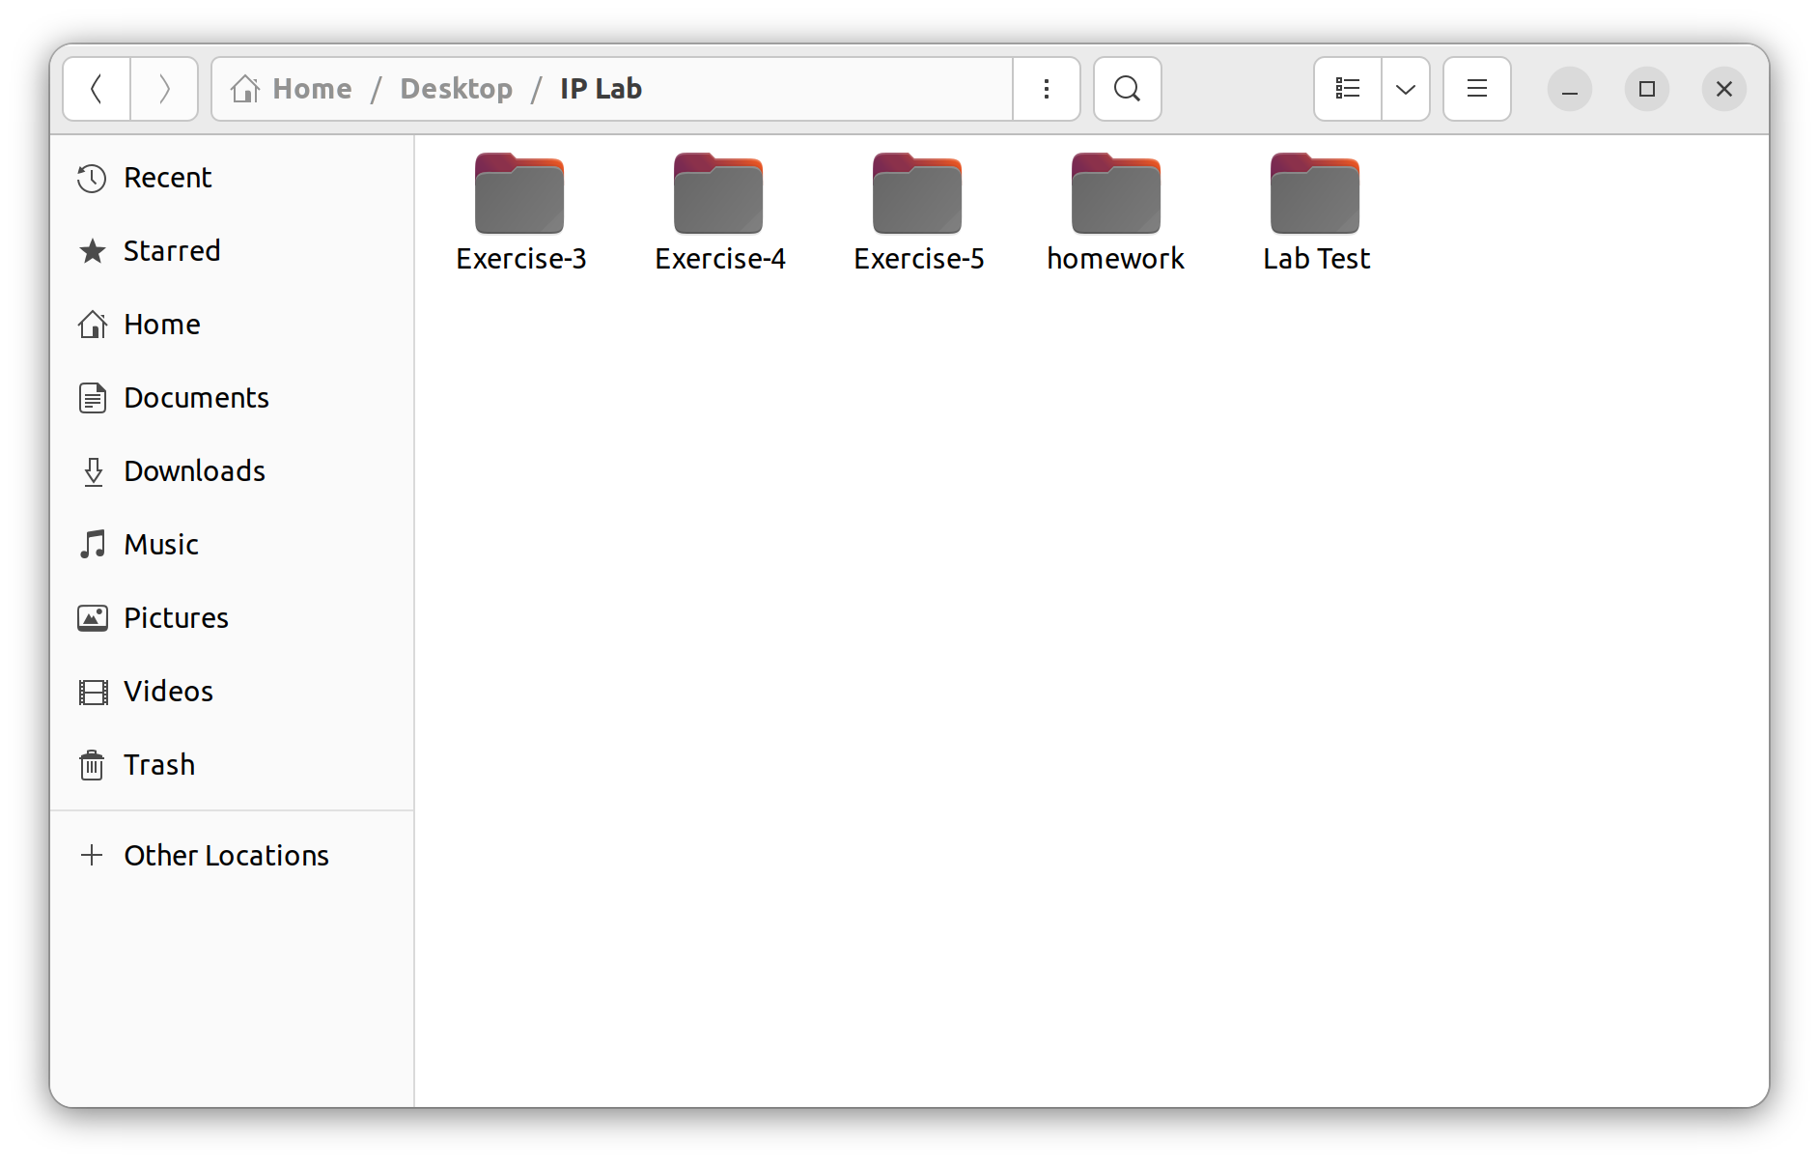

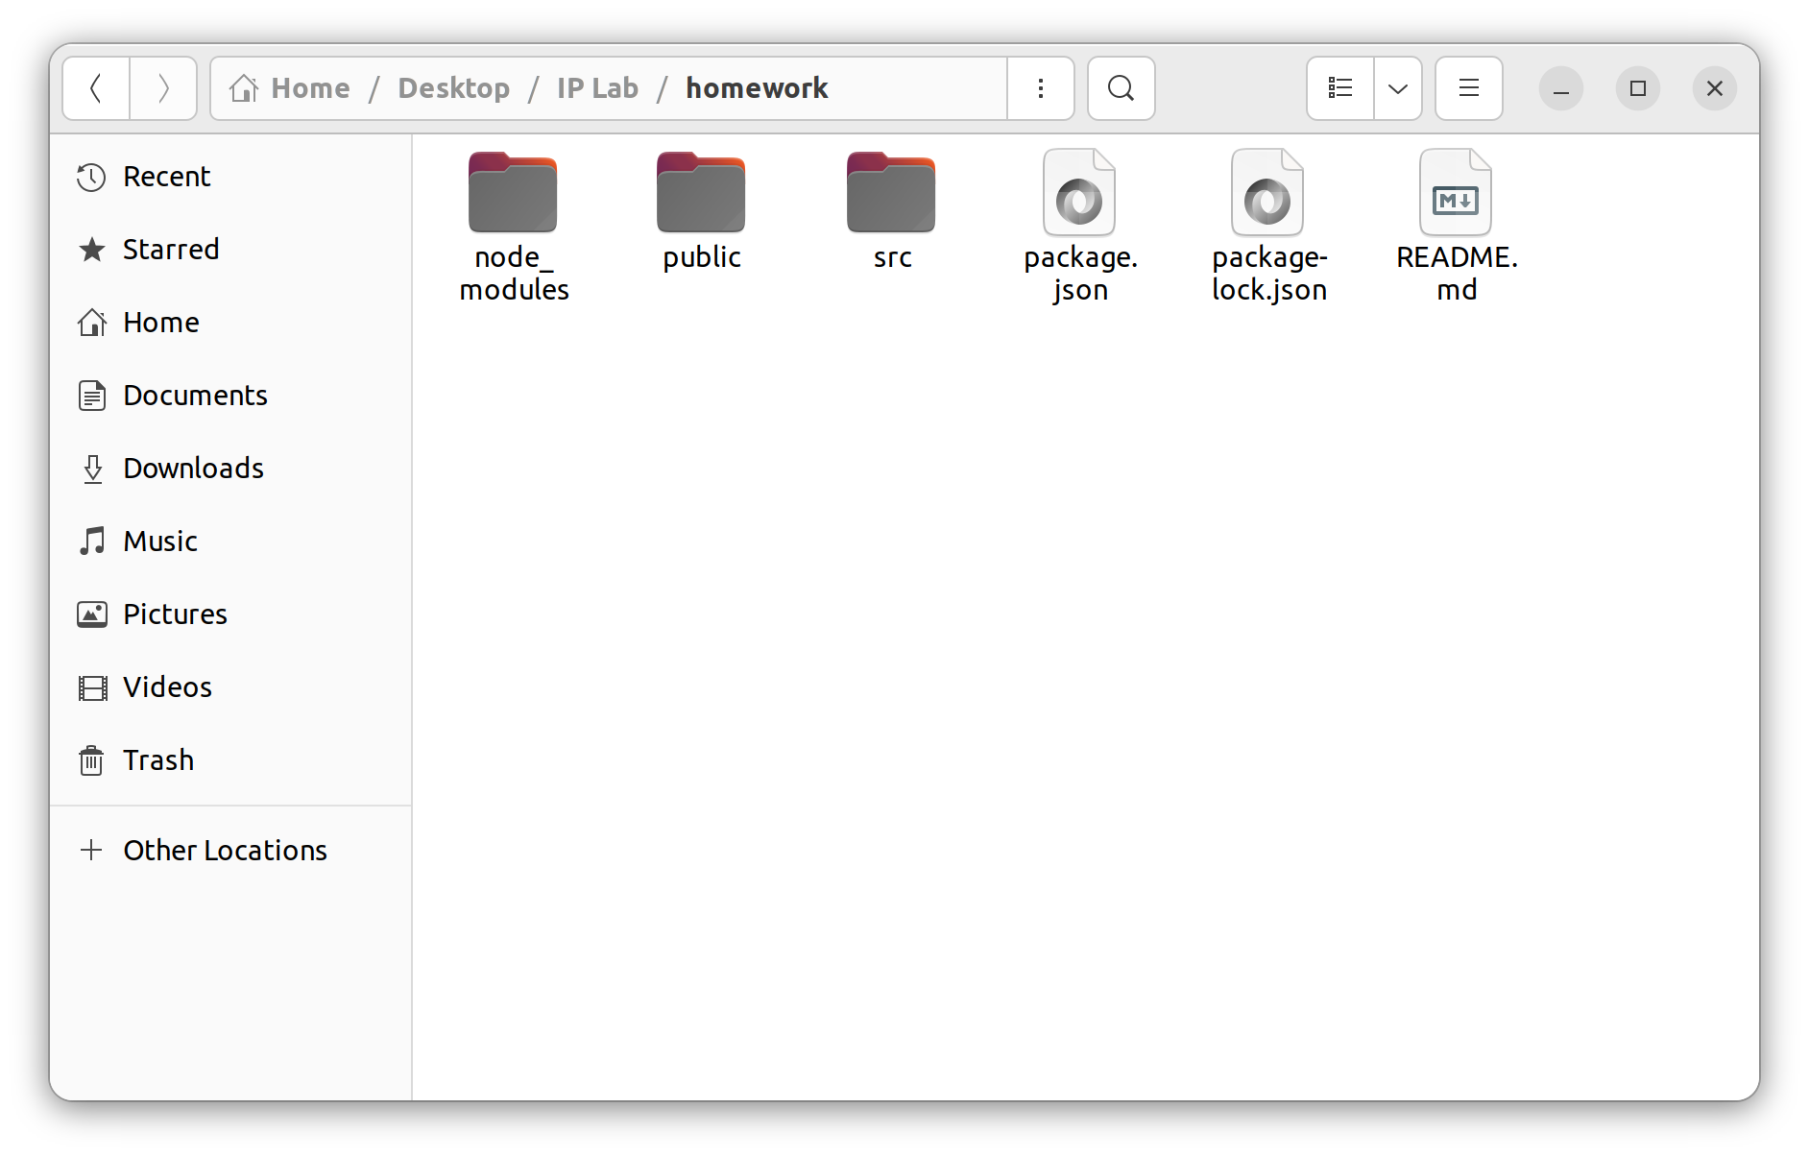
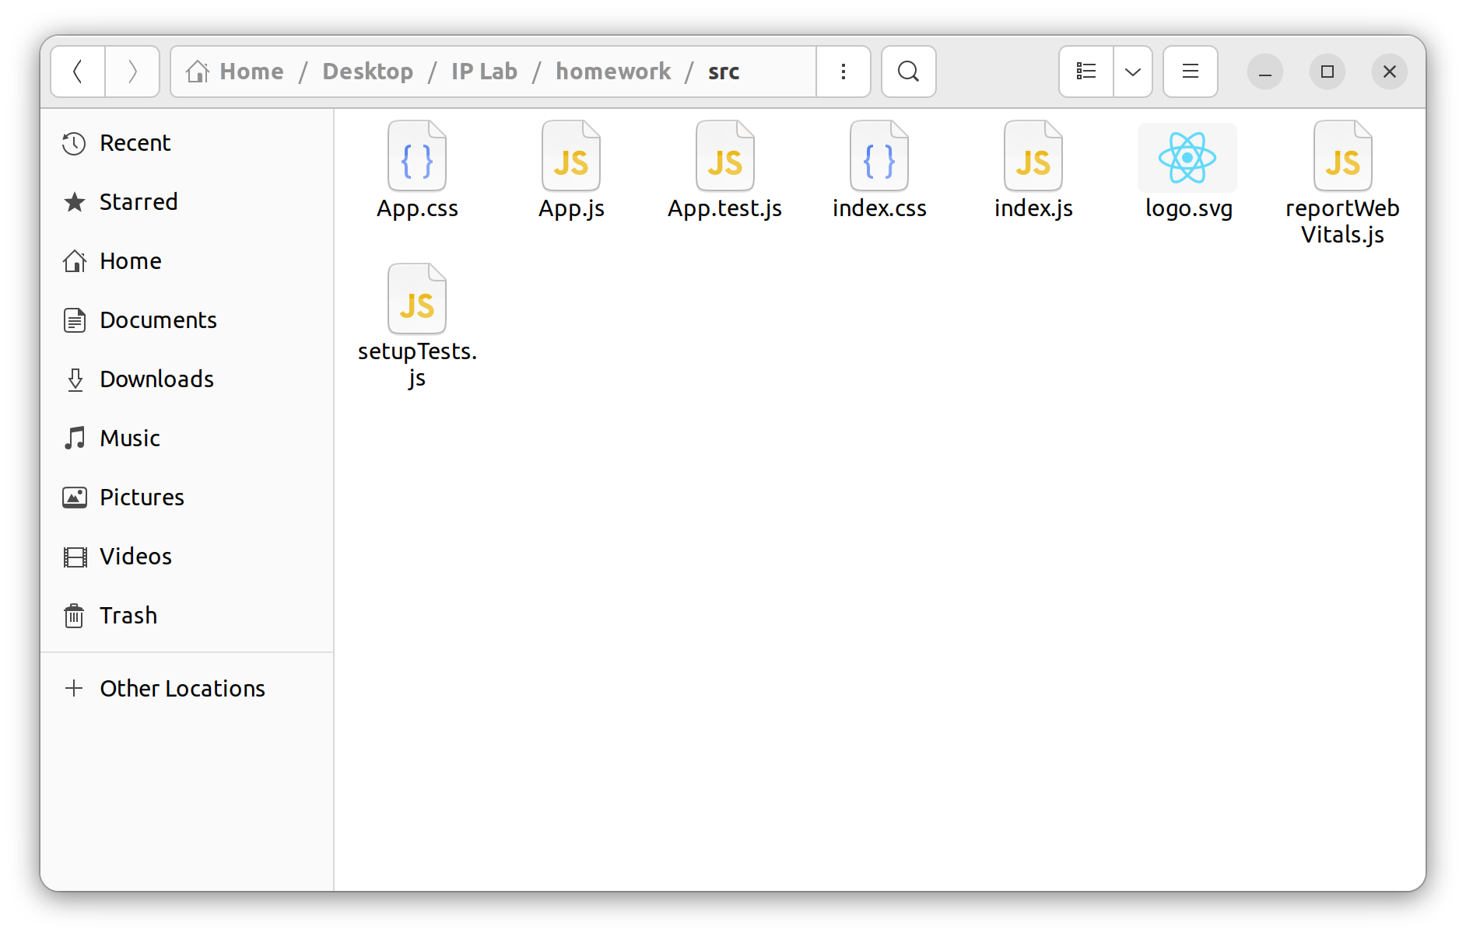
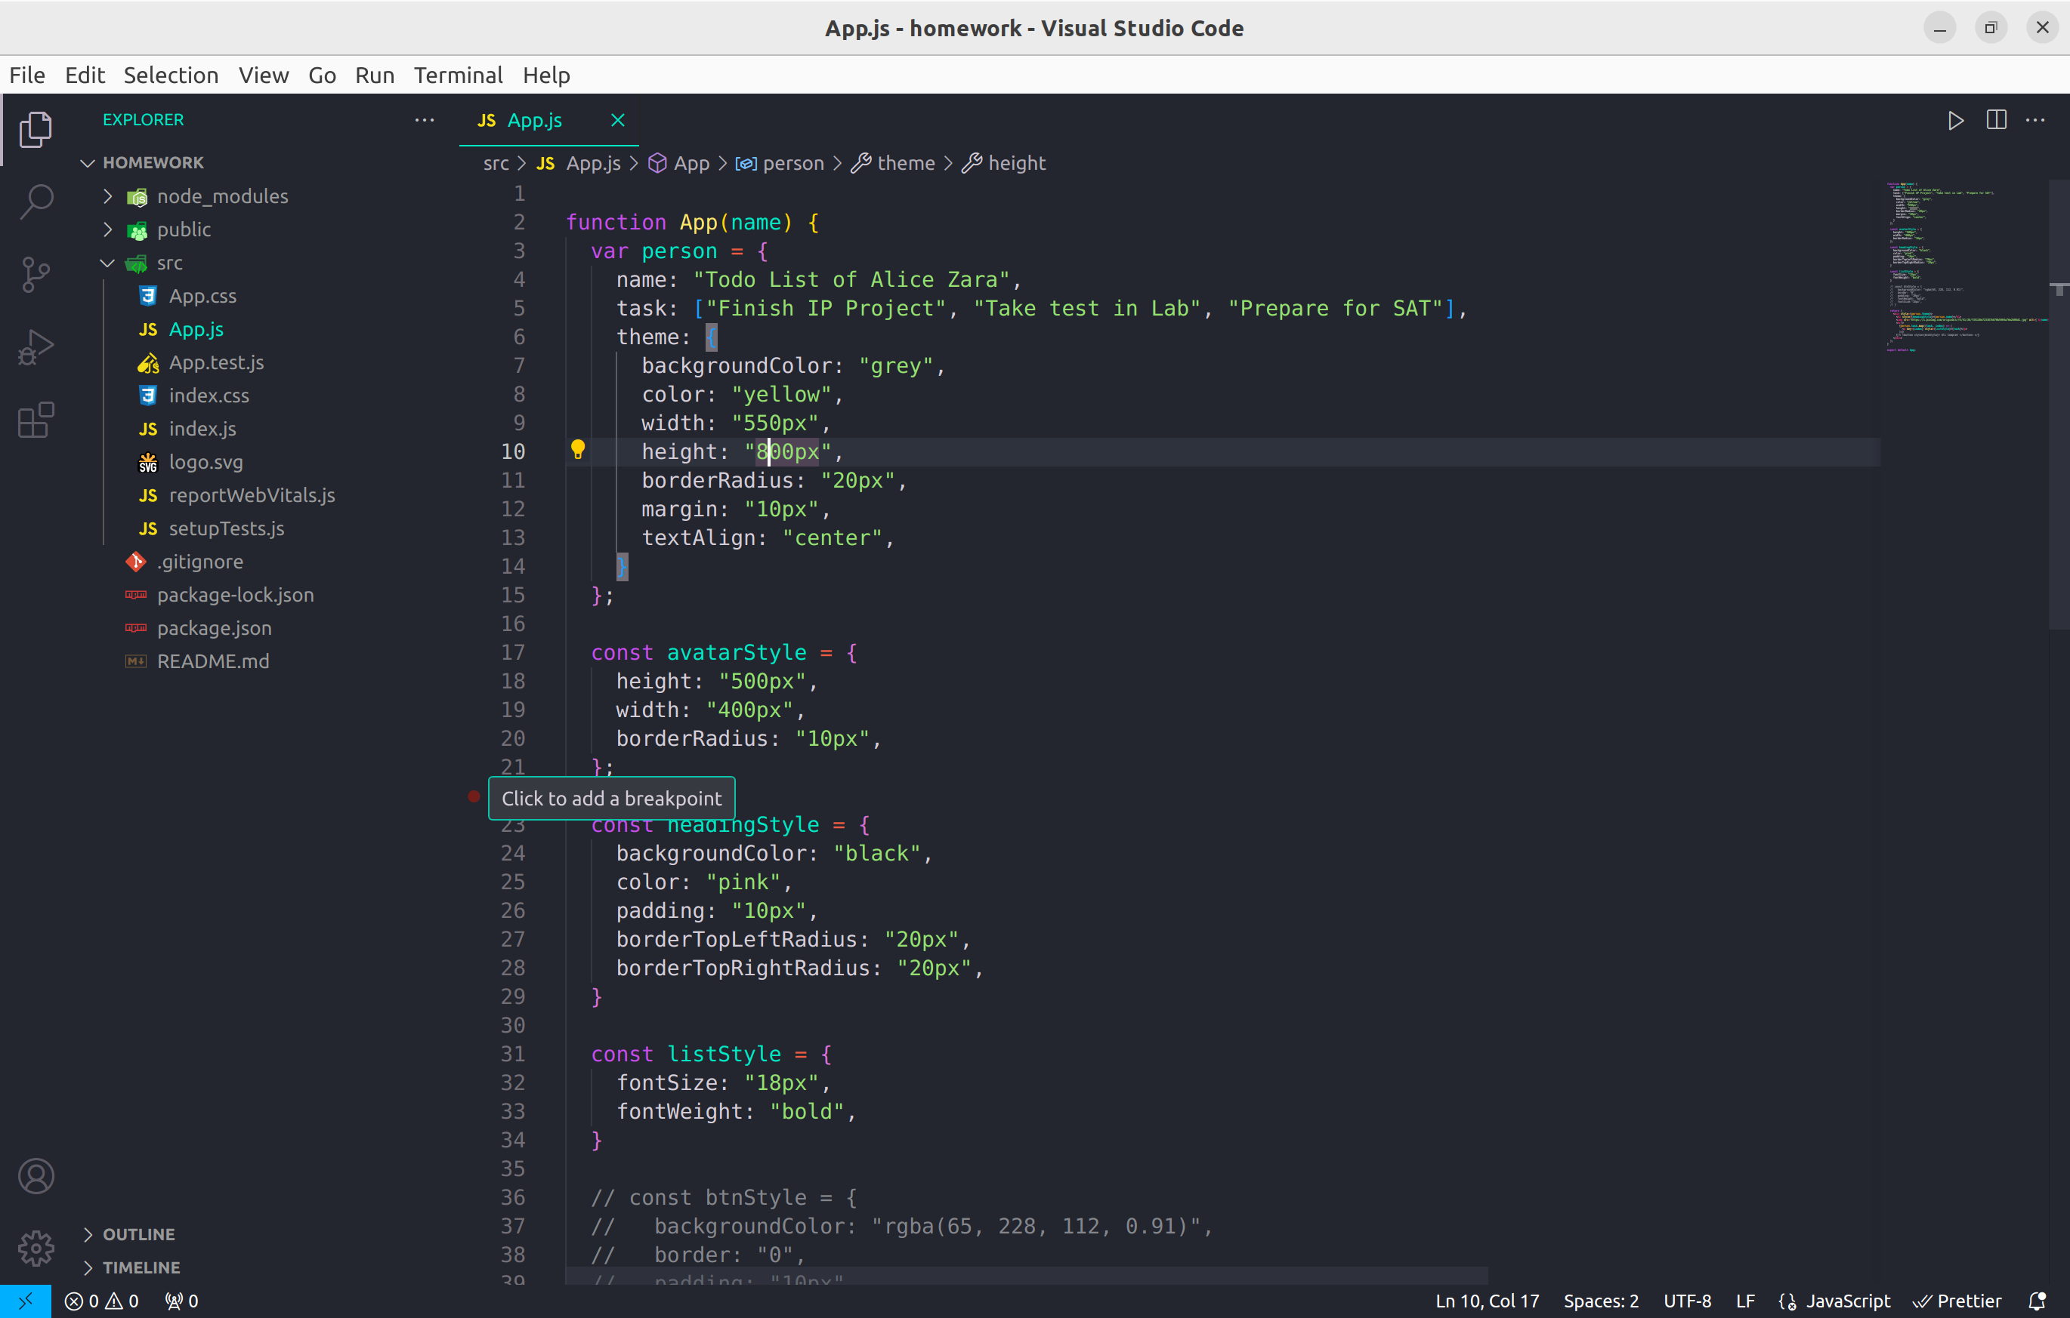
npm start

