# Linear Regression

## Linear Regression

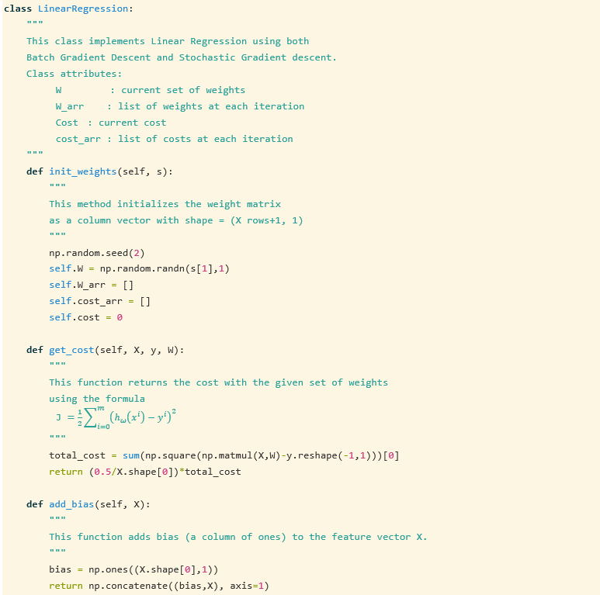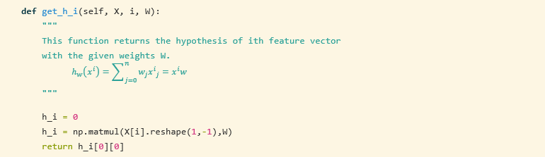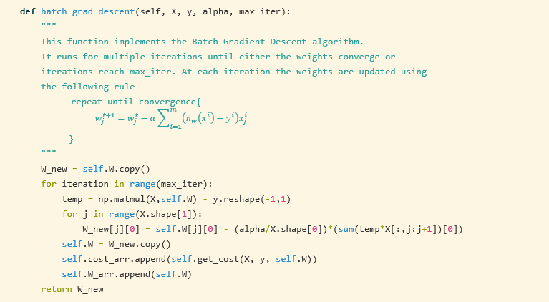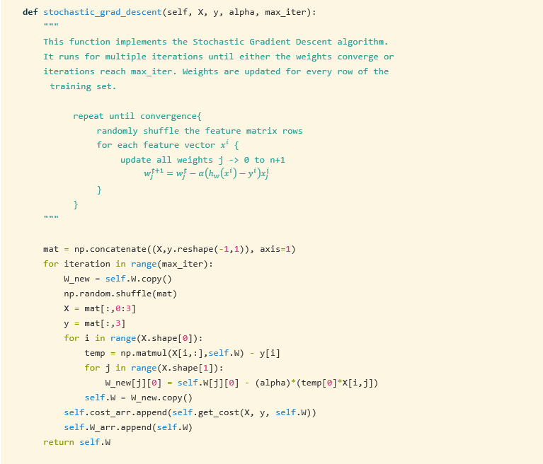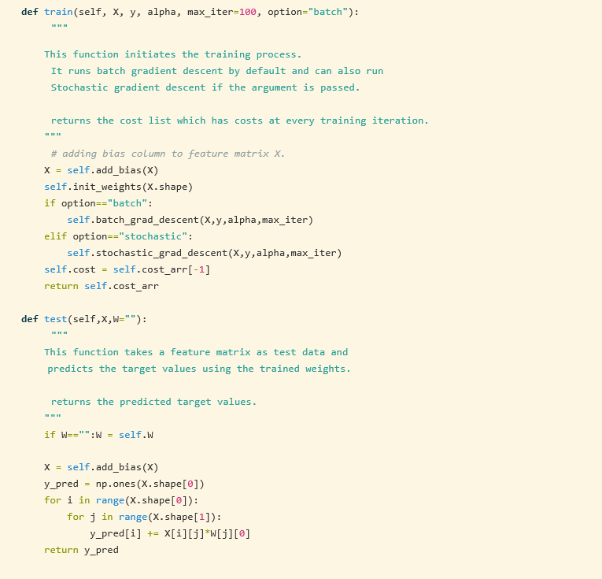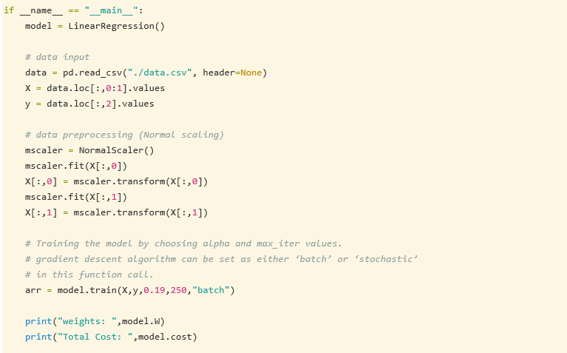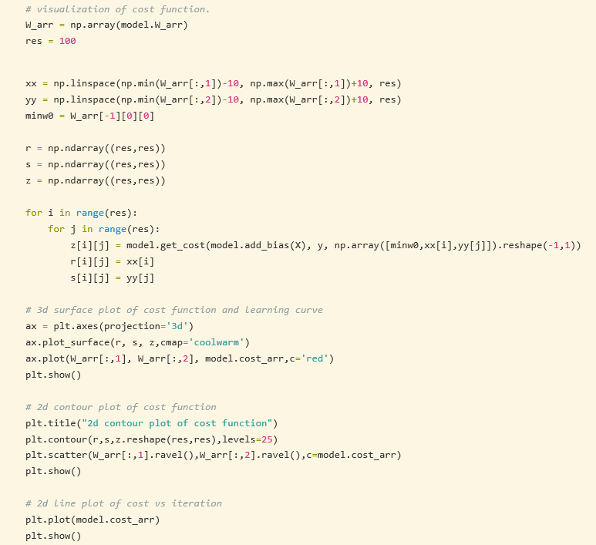

### Results:

|  |  |
| --- | --- |
|  |  |
| Batch Gradient Descent | Stochastic Gradient Descent |
| weights:  w0 = 14.9047221  w1 = 0.36752656  w2 = 1.6965344  Total Cost: 9.403235190130703 | weights:  w0 = 14.95107574  w1 = 0.39873559  w2 = 1.75867644  Total Cost: 9.407225072389698 |
|  |  |

### Plots:

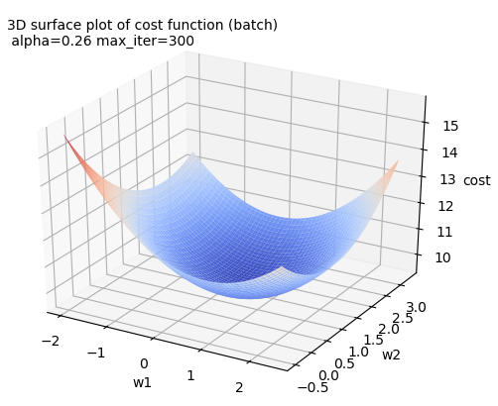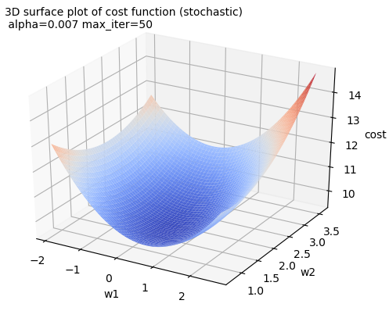

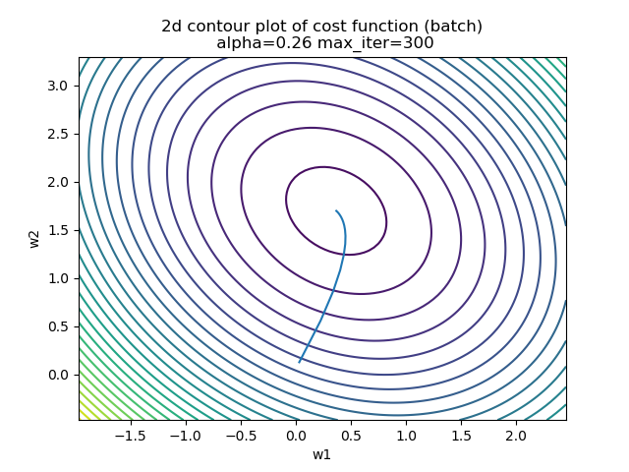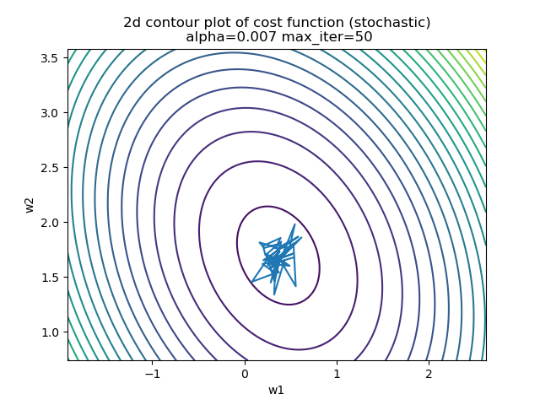

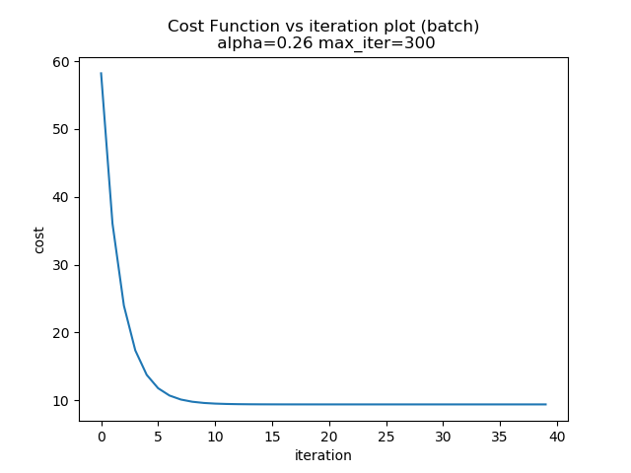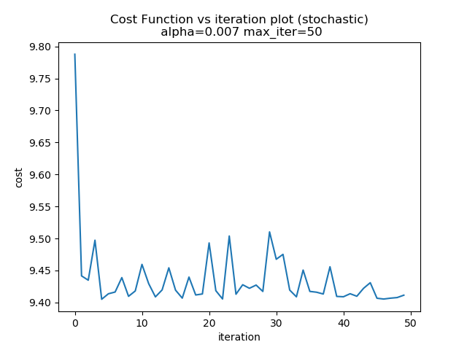

## Ridge Regression

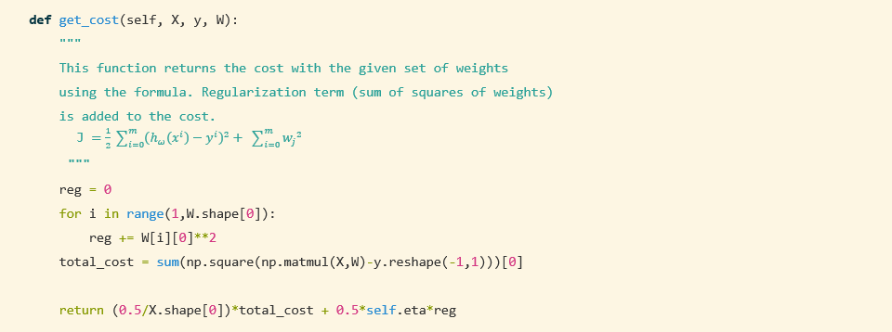

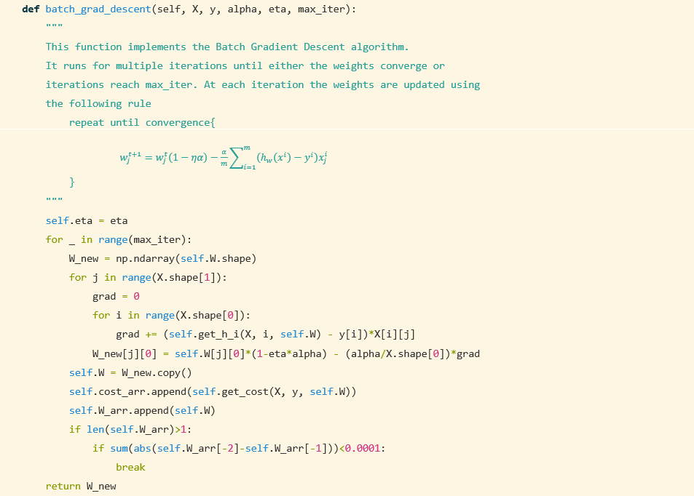

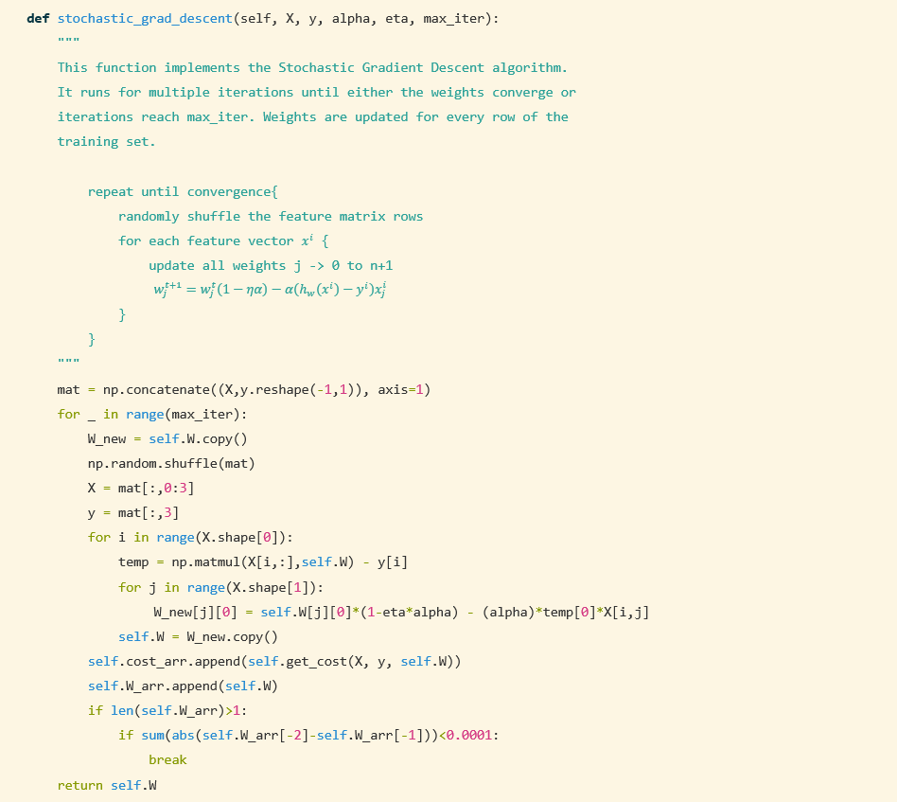

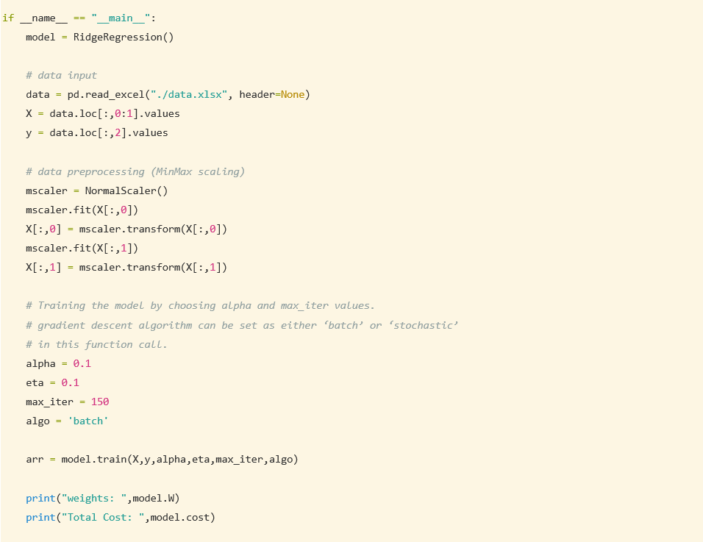

Results:

|  |  |
| --- | --- |
|  |  |
| Batch Gradient Descent | Stochastic Gradient Descent |
| weights:  w0 = 14.75716074  w1 = 0.36824758  w2 = 1.67956428  Total Cost: 9.429059509401734 | weights:  w0 = 14.8376096  w1 = 0.18609906  w2 = 1.76646287  Total Cost: 9.421065885290048 |
|  |  |
|  |  |

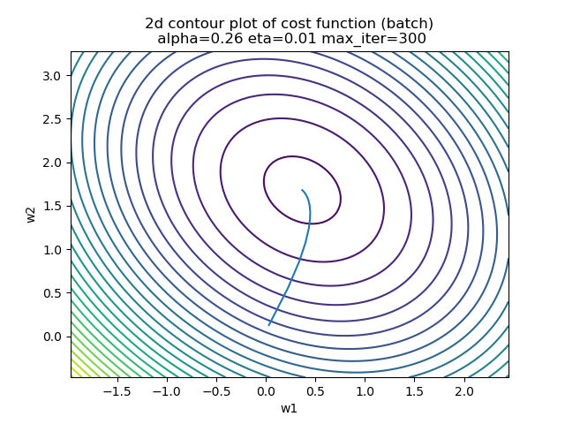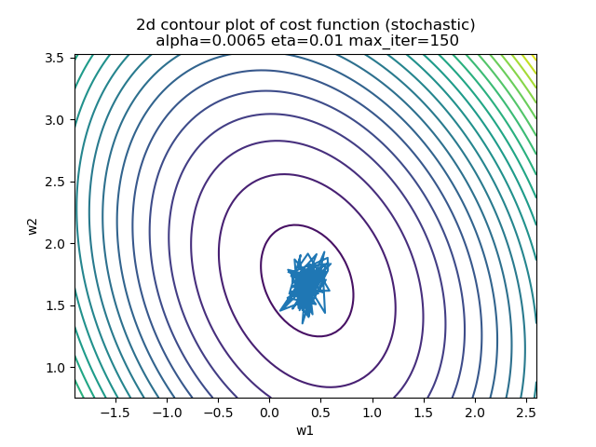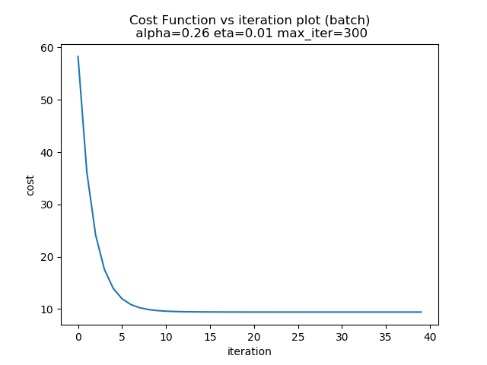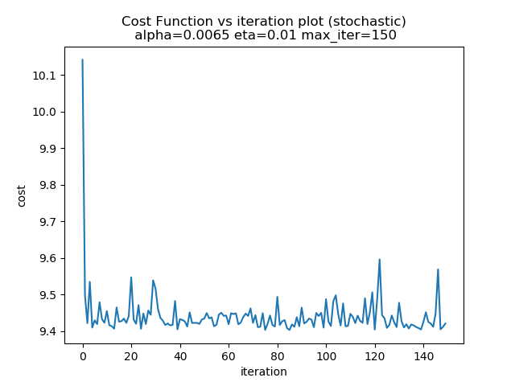

## Least Angle Regression

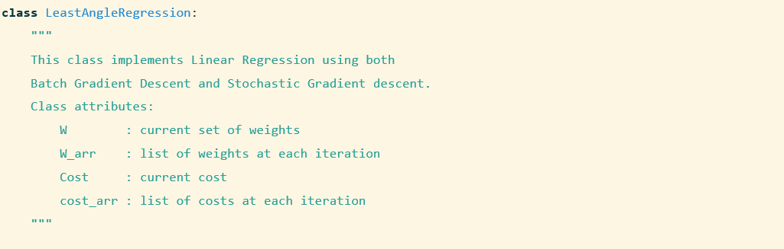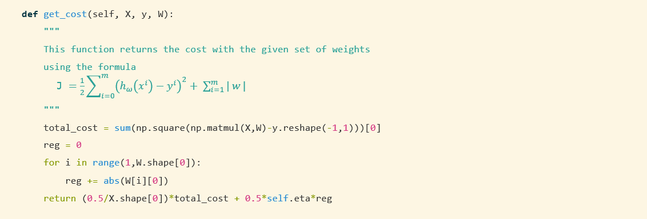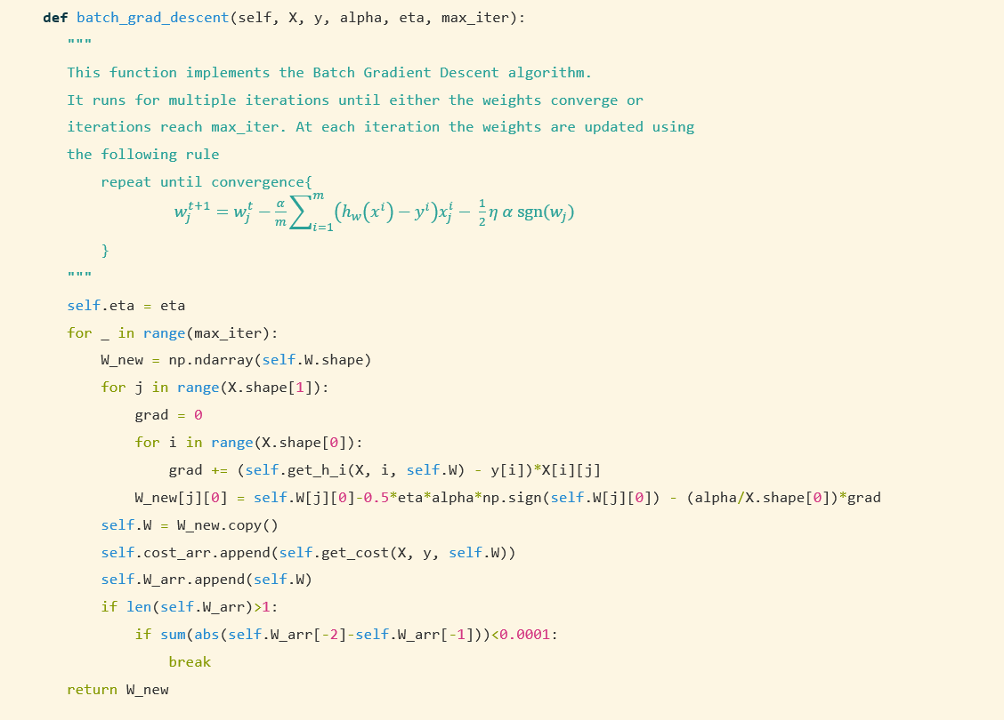

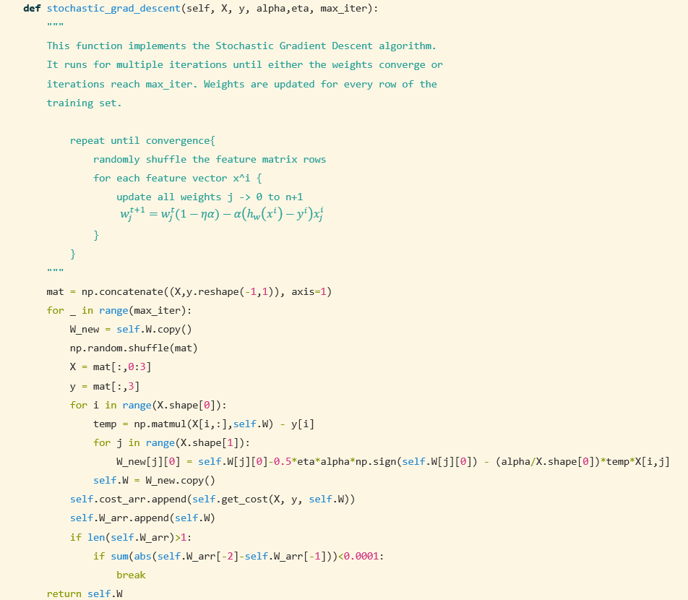

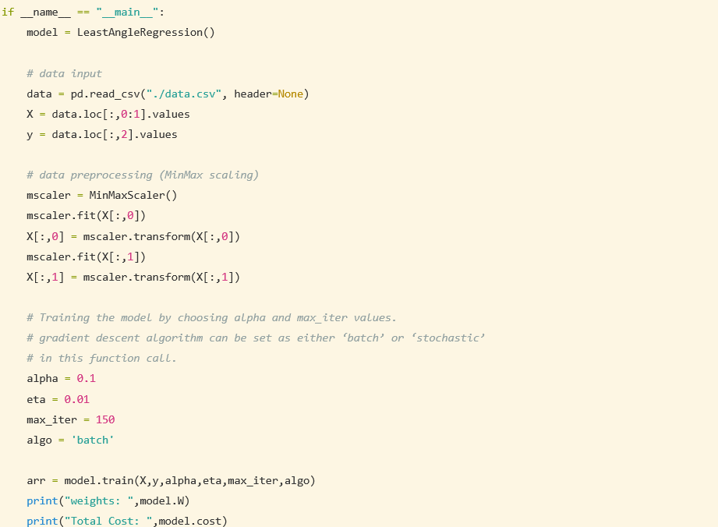

Results:

|  |  |
| --- | --- |
|  |  |
| Batch Gradient Descent | Stochastic Gradient Descent |
| weights:  w0 = 8.70076276  w1 = 8.70076276  w2 = 4.58278454  Total Cost: 9.80262939490788 | weights:  w0 = 10.11557396  w1 = 1.71982718  w2 = 8.10088578  Total Cost: 9.42485150686 |

## 

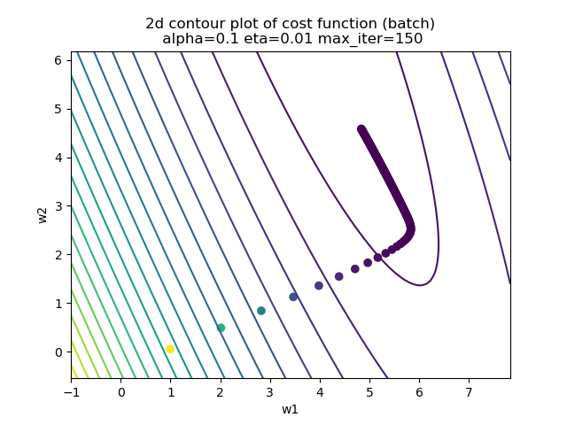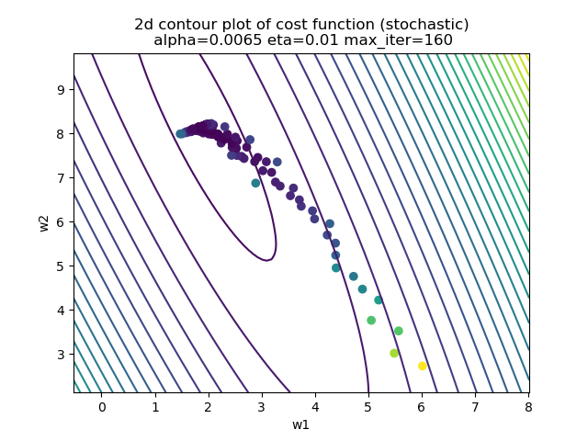

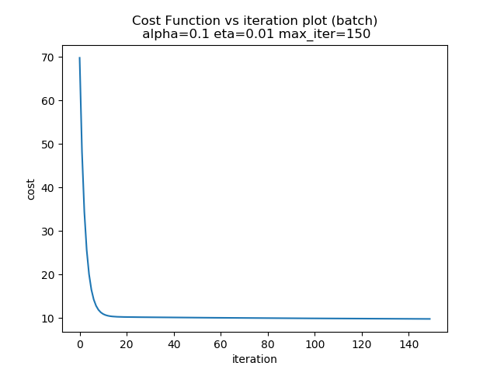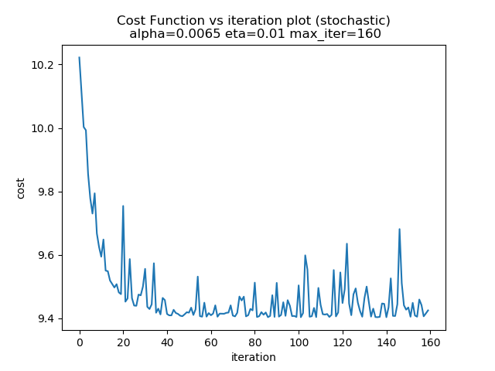

## Vectorized Linear Regression

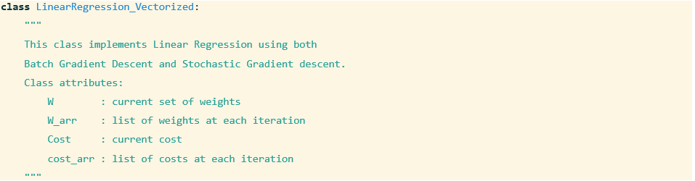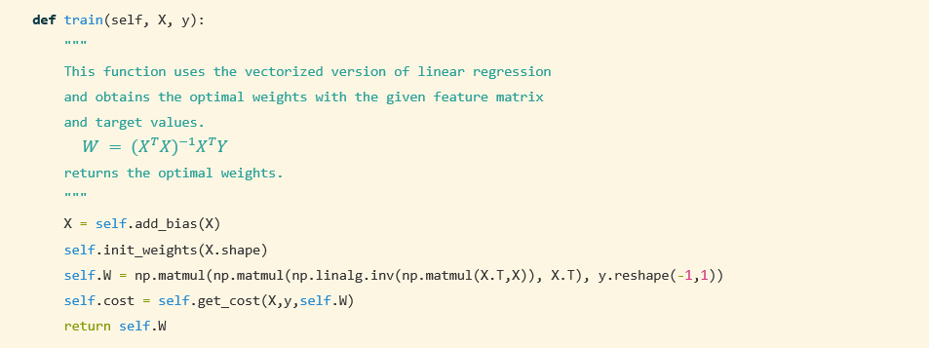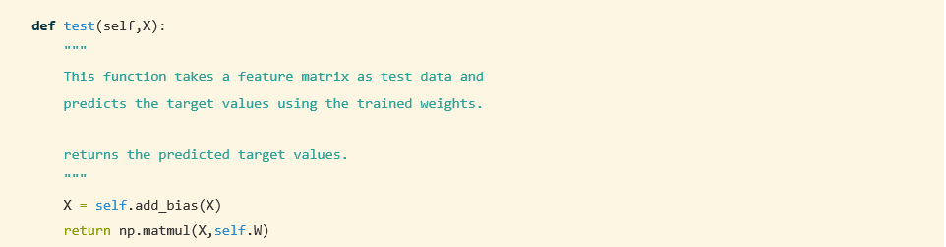

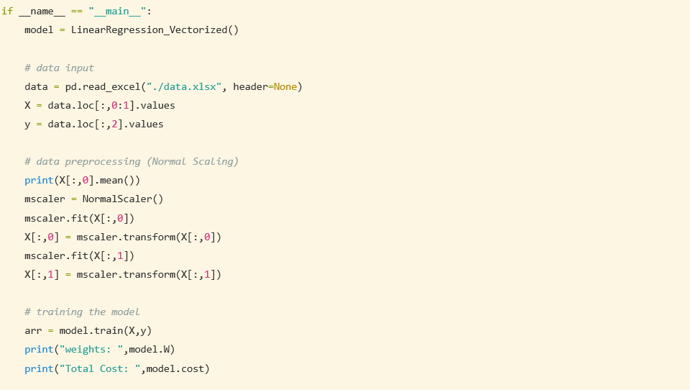

Results:

weights:

w0 = 14.90479943

w1 = 0.36737803

w2 = 9.403235170782

Total Cost: 9.80262939490788

