## Likelihood Ratio Test

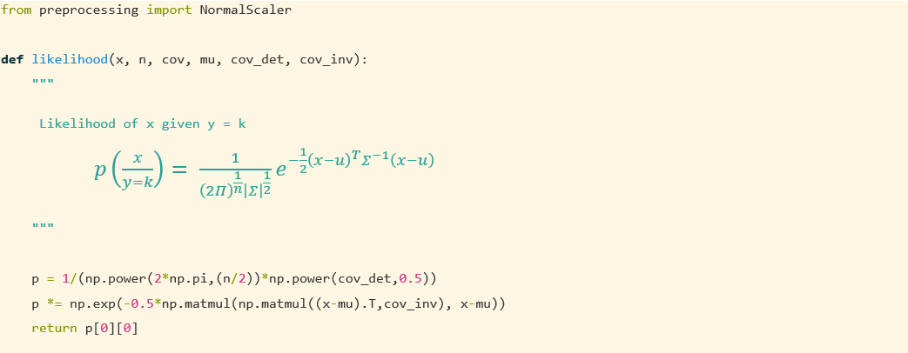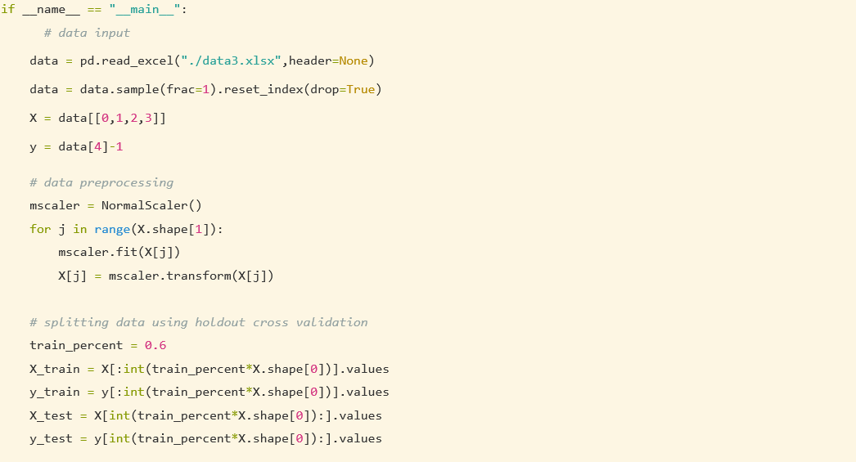

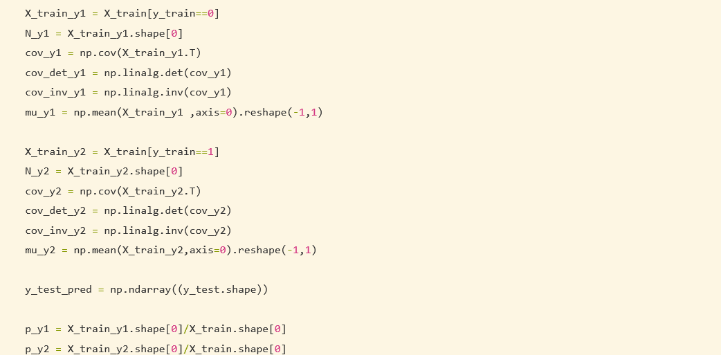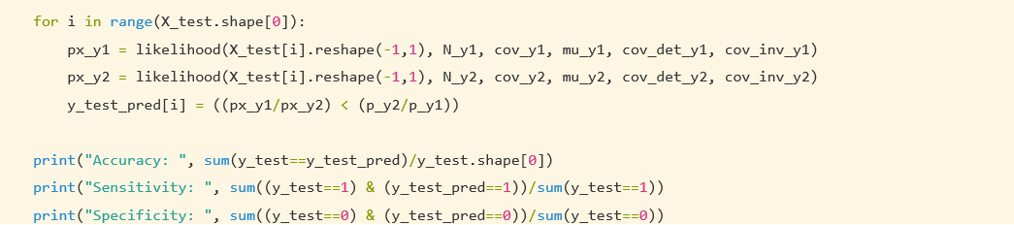

Results:

Accuracy: 1.0

Sensitivity: 1.0

Specificity: 1.0

## Maximum a Posteriori



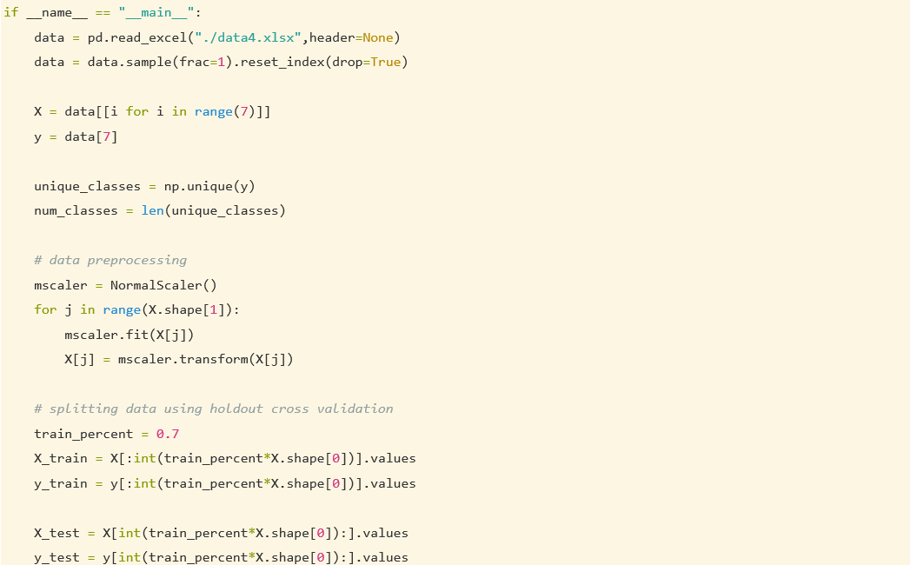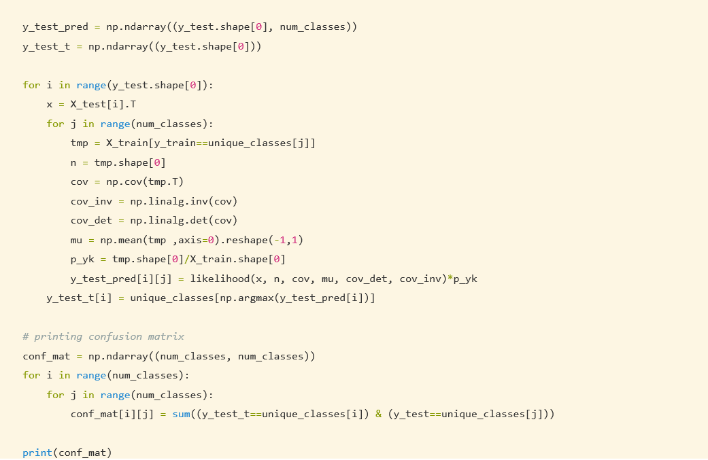

Results:

Confusion Matrix: [[ 7. 0. 0.]

[10. 13. 5.]

[ 0. 3. 7.]]

## Maximum Likelihood test

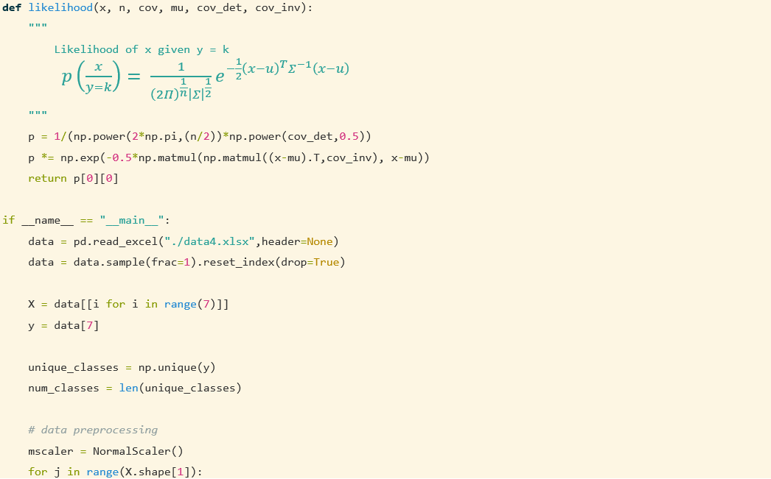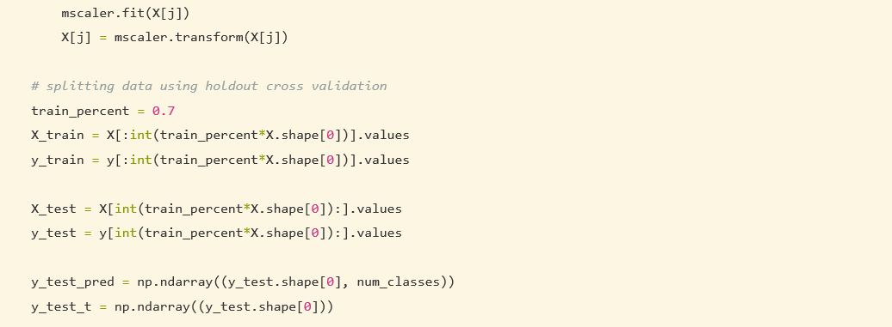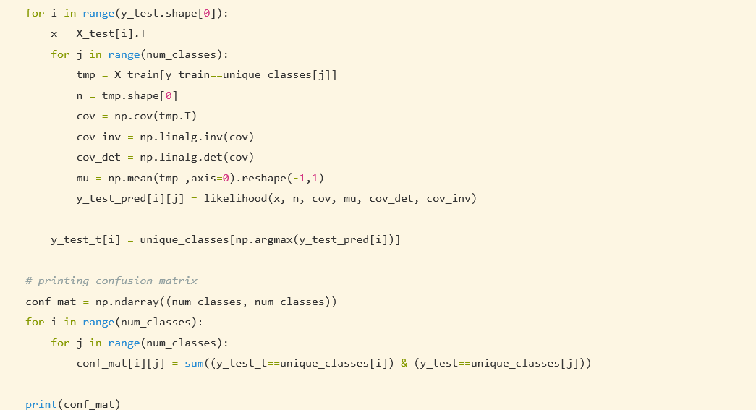

Results:

Confusion Matrix

[[ 4. 1. 0.]

[ 9. 12. 10.]

[ 0. 5. 4.]]

Name: S Rohith

Id: 2017A7PS0034H