Mobile Device Usage and User Behavior Classification

Rohith Reddy

2024-11-07

## Introduction:

In this project, we explore a Mobile Device Usage and User Behavior Dataset to predict user behavior classes using multiple machine learning models. We implement four different classification models: Random Forest, K-Nearest Neighbors (KNN), and Support Vector Machine (SVM) and Naive Bayes followed by performance evaluation and comparison.

# Load necessary libraries

library(randomForest)

## randomForest 4.7-1.2

## Type rfNews() to see new features/changes/bug fixes.

library(caret)

## Loading required package: ggplot2

##   
## Attaching package: 'ggplot2'

## The following object is masked from 'package:randomForest':  
##   
## margin

## Loading required package: lattice

library(class)  
library(e1071)  
library(ggplot2)  
library(reshape2)  
library(gmodels)  
library(caTools)

## 1. Data Loading and Preprocessing

# Load the dataset  
data <- read.csv("C:/Users/Dell/Desktop/int234/project/user_behavior_dataset.csv")  
colnames(data)

## [1] "User.ID" "Device.Model"   
## [3] "Operating.System" "App.Usage.Time..min.day."   
## [5] "Screen.On.Time..hours.day." "Battery.Drain..mAh.day."   
## [7] "Number.of.Apps.Installed" "Data.Usage..MB.day."   
## [9] "Age" "Gender"   
## [11] "User.Behavior.Class"

Loading Dataset of User Behavior to perform predictive analysis and see the result of different classifications models to find that which model is giving high accuracy.

# Ensure 'User.Behavior.Class' is a factor  
data$User.Behavior.Class <- as.factor(data$User.Behavior.Class)  
data <- data[sapply(data, is.atomic)]  
#Key Features/Structure of the data  
str(data)

## 'data.frame': 700 obs. of 11 variables:  
## $ User.ID : int 1 2 3 4 5 6 7 8 9 10 ...  
## $ Device.Model : chr "Google Pixel 5" "OnePlus 9" "Xiaomi Mi 11" "Google Pixel 5" ...  
## $ Operating.System : chr "Android" "Android" "Android" "Android" ...  
## $ App.Usage.Time..min.day. : int 393 268 154 239 187 99 350 543 340 424 ...  
## $ Screen.On.Time..hours.day.: num 6.4 4.7 4 4.8 4.3 2 7.3 11.4 7.7 6.6 ...  
## $ Battery.Drain..mAh.day. : int 1872 1331 761 1676 1367 940 1802 2956 2138 1957 ...  
## $ Number.of.Apps.Installed : int 67 42 32 56 58 35 66 82 75 75 ...  
## $ Data.Usage..MB.day. : int 1122 944 322 871 988 564 1054 1702 1053 1301 ...  
## $ Age : int 40 47 42 20 31 31 21 31 42 42 ...  
## $ Gender : chr "Male" "Female" "Male" "Male" ...  
## $ User.Behavior.Class : Factor w/ 5 levels "1","2","3","4",..: 4 3 2 3 3 2 4 5 4 4 ...

Split Dataset into Training and Testing Sets

set.seed(123)   
train_indices <- createDataPartition(data$User.Behavior.Class, p = 0.7, list = FALSE)  
trainData <- data[train_indices, ]  
testData <- data[-train_indices, ]

## 2. Model Training and Evaluation

2.1 Random Forest Model

rf_model <- randomForest(User.Behavior.Class ~ ., data = trainData, ntree = 500, mtry = 3, importance = TRUE)  
print(rf_model)

##   
## Call:  
## randomForest(formula = User.Behavior.Class ~ ., data = trainData, ntree = 500, mtry = 3, importance = TRUE)   
## Type of random forest: classification  
## Number of trees: 500  
## No. of variables tried at each split: 3  
##   
## OOB estimate of error rate: 0%  
## Confusion matrix:  
## 1 2 3 4 5 class.error  
## 1 96 0 0 0 0 0  
## 2 0 103 0 0 0 0  
## 3 0 0 101 0 0 0  
## 4 0 0 0 98 0 0  
## 5 0 0 0 0 96 0

2.1.1 Analysis of Accuracy of KNN model

# Predict and evaluate  
predictions_rf <- predict(rf_model, newdata = testData)  
conf_matrix_rf <- table(testData$User.Behavior.Class, predictions_rf)  
accuracy_rf <- sum(diag(conf_matrix_rf)) / sum(conf_matrix_rf)  
cat("Random Forest Accuracy:", accuracy_rf * 100, "%\n")

## Random Forest Accuracy: 100 %

2.1.2 Variable Importance Plot

varImpPlot(rf_model, main = "Variable Importance for Random Forest")

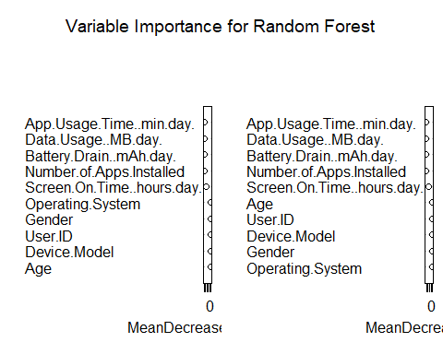

2.2 K-Nearest Neighbors (KNN) Model

2.2.1 Preprocess: Normalize Features and Add Noise

normalize <- function(x) { (x - min(x)) / (max(x) - min(x)) }  
numeric_columns <- sapply(data, is.numeric)  
data_n <- as.data.frame(lapply(data[, numeric_columns], normalize))  
data_n$User.Behavior.Class <- data$User.Behavior.Class  
set.seed(123)  
noise <- matrix(rnorm(n = nrow(data_n) * (ncol(data_n) - 1), mean = 0, sd = 0.1), nrow = nrow(data_n))  
data_n[, -ncol(data_n)] <- data_n[, -ncol(data_n)] + noise  
# Summary of data with noise  
summary(data_n)

## User.ID App.Usage.Time..min.day. Screen.On.Time..hours.day.  
## Min. :-0.1723 Min. :-0.1888 Min. :-0.1799   
## 1st Qu.: 0.2444 1st Qu.: 0.1555 1st Qu.: 0.1496   
## Median : 0.5116 Median : 0.3679 Median : 0.3671   
## Mean : 0.4997 Mean : 0.4276 Mean : 0.3923   
## 3rd Qu.: 0.7452 3rd Qu.: 0.7186 3rd Qu.: 0.5852   
## Max. : 1.2401 Max. : 1.2058 Max. : 1.1595   
## Battery.Drain..mAh.day. Number.of.Apps.Installed Data.Usage..MB.day.  
## Min. :-0.1920 Min. :-0.2230 Min. :-0.1943   
## 1st Qu.: 0.1803 1st Qu.: 0.1781 1st Qu.: 0.1138   
## Median : 0.4427 Median : 0.4438 Median : 0.2971   
## Mean : 0.4513 Mean : 0.4575 Mean : 0.3441   
## 3rd Qu.: 0.7172 3rd Qu.: 0.7089 3rd Qu.: 0.5407   
## Max. : 1.1517 Max. : 1.1525 Max. : 1.0995   
## Age User.Behavior.Class  
## Min. :-0.2245 1:136   
## 1st Qu.: 0.2444 2:146   
## Median : 0.4875 3:143   
## Mean : 0.4980 4:139   
## 3rd Qu.: 0.7485 5:136   
## Max. : 1.1850

2.2.2 Train-Test Split and KNN Model

train_index <- sample(1:nrow(data_n), 0.7 * nrow(data_n))  
data_train <- data_n[train_index, ]  
data_test <- data_n[-train_index, ]  
train_labels <- data_n$User.Behavior.Class[train_index]  
test_labels <- data_n$User.Behavior.Class[-train_index]  
  
k <- 50 # Adjust as needed  
test_pred_knn <- knn(train = data_train[, -ncol(data_train)], test = data_test[, -ncol(data_test)], cl = train_labels, k = k)  
conf_matrix_knn <- table(test_labels, test_pred_knn)  
conf_matrix_knn

## test_pred_knn  
## test_labels 1 2 3 4 5  
## 1 40 2 0 0 0  
## 2 4 38 1 0 0  
## 3 0 2 42 0 0  
## 4 0 0 3 40 0  
## 5 0 0 0 1 38

2.2.3 Analysis of Accuracy of KNN model.

accuracy_knn <- sum(test_pred_knn == test_labels) / length(test_labels)  
cat("KNN Accuracy:", round(accuracy_knn * 100, 2), "%\n")

## KNN Accuracy: 93.84 %

2.3 Naive Bayes Model with Feature Reduction

2.3.1 Features and Normalization

data_reduced <- data_n[, 1:2] # Example: Adjust based on feature selection  
split <- sample.split(data$User.Behavior.Class, SplitRatio = 0.7)  
train_set <- subset(data_reduced, split == TRUE)  
test_set <- subset(data_reduced, split == FALSE)  
train_labels <- subset(data$User.Behavior.Class, split == TRUE)  
test_labels <- subset(data$User.Behavior.Class, split == FALSE)

2.3.2 Train and Evaluate Naive Bayes Model

nb_model <- naiveBayes(train_set, train_labels)  
pred_labels_nb <- predict(nb_model, test_set)  
conf_matrix_nb <- table(test_labels, pred_labels_nb)  
conf_matrix_nb

## pred_labels_nb  
## test_labels 1 2 3 4 5  
## 1 26 15 0 0 0  
## 2 15 19 10 0 0  
## 3 1 7 31 4 0  
## 4 0 0 7 27 8  
## 5 0 0 0 10 31

2.3.3 Analysis of Accuracy of Naive Bayes Model.

accuracy_nb <- sum(diag(conf_matrix_nb)) / sum(conf_matrix_nb)  
cat("Naive Bayes Accuracy with reduced features:", round(accuracy_nb * 100, 2), "%\n")

## Naive Bayes Accuracy with reduced features: 63.51 %

2.4 Support Vector Machine (SVM)

2.4.1 Train and Evaluate SVM Model

svm_model <- svm(User.Behavior.Class ~ ., data = trainData, kernel = "radial", cost = 0.09, scale = TRUE)  
predictions_svm <- predict(svm_model, newdata = testData)  
conf_matrix_svm <- table(testData$User.Behavior.Class, predictions_svm)  
conf_matrix_svm

## predictions_svm  
## 1 2 3 4 5  
## 1 39 1 0 0 0  
## 2 0 43 0 0 0  
## 3 0 0 42 0 0  
## 4 0 0 0 41 0  
## 5 0 0 0 0 40

2.4.2 Analysis of Accuracy of SVM

accuracy_svm <- sum(diag(conf_matrix_svm)) / sum(conf_matrix_svm)  
cat("SVM Accuracy:", accuracy_svm * 100, "%\n")

## SVM Accuracy: 99.51456 %

3.Visualizations of Confusion Matrices

3.1 Random Forest Confusion Matrix

conf_matrix_rf_df <- as.data.frame(conf_matrix_rf)  
colnames(conf_matrix_rf_df) <- c("Actual", "Predicted", "Count")  
  
ggplot(data = conf_matrix_rf_df, aes(x = Actual, y = Predicted)) +  
 geom_tile(aes(fill = Count), color = "white") +  
 scale_fill_gradient(low = "white", high = "blue") +  
 geom_text(aes(label = Count), vjust = 1) +  
 labs(title = "Confusion Matrix for Random Forest", x = "Actual", y = "Predicted") +  
 theme_minimal()

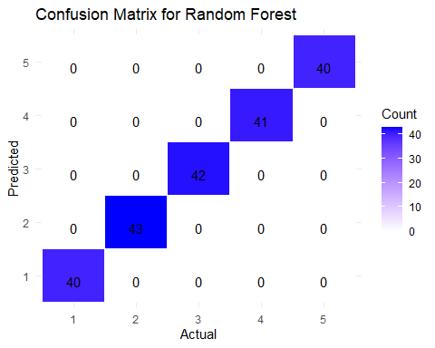

3.2 KNN Confusion Matrix

conf_matrix_knn_df <- as.data.frame(conf_matrix_knn)  
colnames(conf_matrix_knn_df) <- c("Actual", "Predicted", "Count")  
  
ggplot(data = conf_matrix_knn_df, aes(x = Actual, y = Predicted)) +  
 geom_tile(aes(fill = Count), color = "white") +  
 scale_fill_gradient(low = "white", high = "blue") +  
 geom_text(aes(label = Count), vjust = 1) +  
 labs(title = "Confusion Matrix for KNN", x = "Actual", y = "Predicted") +  
 theme_minimal()

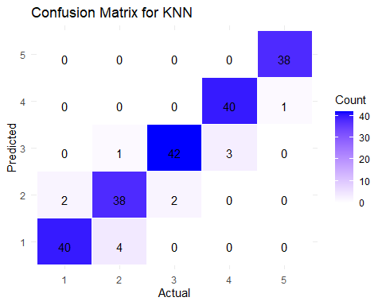

3.3 Naive Bayes Confusion Matrix

conf_matrix_nb_df <- as.data.frame(conf_matrix_nb)  
colnames(conf_matrix_nb_df) <- c("Actual", "Predicted", "Count")  
  
ggplot(data = conf_matrix_nb_df, aes(x = Actual, y = Predicted)) +  
 geom_tile(aes(fill = Count), color = "white") +  
 scale_fill_gradient(low = "white", high = "blue") +  
 geom_text(aes(label = Count), vjust = 1) +  
 labs(title = "Confusion Matrix for Naive Bayes", x = "Actual", y = "Predicted") +  
 theme_minimal()

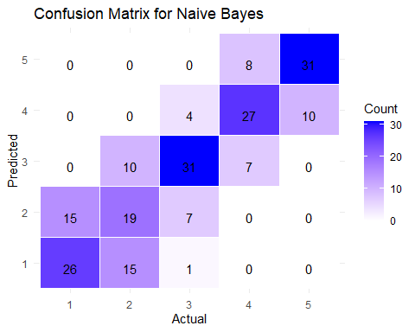

3.4 SVM Confusion Matrix

conf_matrix_svm_df <- as.data.frame(conf_matrix_svm)  
colnames(conf_matrix_svm_df) <- c("Actual", "Predicted", "Count")  
  
ggplot(data = conf_matrix_svm_df, aes(x = Actual, y = Predicted)) +  
 geom_tile(aes(fill = Count), color = "white") +  
 scale_fill_gradient(low = "white", high = "blue") +  
 geom_text(aes(label = Count), vjust = 1) +  
 labs(title = "Confusion Matrix for SVM", x = "Actual", y = "Predicted") +  
 theme_minimal()

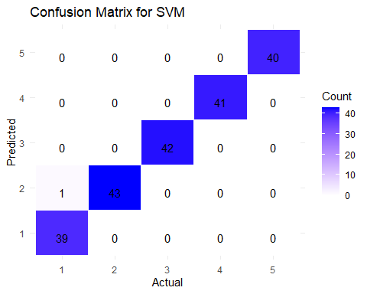

1. Model Comparison

* 4.1 Accuracy Comparison of Models

accuracies <- data.frame(  
 Model = c("KNN", "Naive Bayes", "Random Forest", "SVM"),  
 Accuracy = c(accuracy_knn, accuracy_nb, accuracy_rf, accuracy_svm)  
)  
  
ggplot(data = accuracies, aes(x = Model, y = Accuracy, fill = Model)) +  
 geom_bar(stat = "identity") +  
 geom_text(aes(label = paste0(round(Accuracy * 100, 2), "%")), vjust = -0.5, size = 5) +  
 scale_y_continuous(labels = scales::percent_format(accuracy = 1), limits = c(0, 1)) +  
 labs(title = "Model Accuracy Comparison", x = "Model", y = "Accuracy") +  
 theme_minimal() +  
 theme(legend.position = "none")

