Hungrify Food Ordering Database Description

The Hungrify Food Ordering Database is a compact, AI-ready relational schema designed to manage users, restaurants, menu items, orders, and deliveries while enabling intelligent personalization, allergen detection, and operational analytics. At its foundation lies the users table, which stores all types of system participants—customers, restaurant owners, delivery partners, and administrators. It includes essential fields such as username, password, email, phone, and roles (as JSON for flexible access control). Additional attributes like verified, active, and last_login allow tracking engagement and security. The admin table maintains a one-to-one relationship with users, extending it with administrative configurations, permissions, and dashboard settings for system management.
The restaurants table captures key business details, including the restaurant’s name, cuisine type, address, city, and geographic coordinates. It also holds restaurant_meta, a JSON field used to store delivery zones, operational preferences, and special attributes such as “halal” or “pure-veg”. Each restaurant record links to an owner in the users table, ensuring proper account association and ownership management.
Central to the schema is the food_items table, which stores each menu item’s core information such as display name, descriptions, price, availability, preparation time, and images. It includes a rating column for user feedback and a quantity field for stock tracking. For intelligent search, the schema uses a FULLTEXT index on name and description, enabling the system to interpret natural-language queries like “find spicy vegan dishes under ₹300”. Each food item is enriched by a corresponding record in the food_item_profiles table (a 1:1 mapping), which serves as the AI feature layer. This table includes nutritional data such as calories, proteins, and fats, along with fields like spice_score, spice_level, tags, and allergens (stored as JSON). It also maintains computed boolean flags (has_milk, has_peanuts, is_vegan, is_gluten_free) generated from the allergen list. These computed and indexed attributes make allergen-aware filtering and recommendation queries both simple and fast.
The ingredients table lists all raw ingredients with their corresponding allergen metadata, while the food_item_ingredients table acts as a junction that connects items with ingredients, specifying whether an ingredient is removable. This design allows the system to determine whether a dish can be modified to suit dietary preferences, such as making it dairy-free or nut-free, by analyzing the removal_effects JSON field.
The orders table records every customer purchase with full context, linking to the user and restaurant involved. It captures order status, total amount, and embedded payment information including payment_method, payment_status, and transaction_ref, removing the need for a separate payment table. The order_items table represents individual dishes within an order and includes the ordered quantity, unit price, customizations, and an item_snapshot JSON field that preserves the item’s allergen and nutritional profile at the time of purchase. This ensures historical traceability and accurate analytics even if menu data changes later.
Each order is connected to a single record in the deliveries table, forming a one-to-one relationship. Deliveries track which delivery partner handled the order, their vehicle type, delivery status, and estimated versus actual delivery times. Additional data such as GPS coordinates or ETA predictions can be stored in delivery_meta for performance analysis. This structure makes it easy to monitor the delivery lifecycle—from assignment to completion—and calculate delivery efficiency or delay metrics.
Together, these interconnected tables form a seamless data flow that mirrors the complete customer experience—from discovering restaurants and browsing personalized menus to placing orders, tracking deliveries, and receiving intelligent recommendations. The schema is optimized for both transactional efficiency and analytical depth, using JSON fields for flexibility, generated attributes for allergen detection, and strategic indexing for fast AI-driven querying. By integrating user behavior, nutritional data, and operational metrics, the Hungrify database transforms raw order and menu data into actionable insights. It empowers real-time recommendations, dietary-aware filtering, and performance analytics, making the platform both highly adaptive for users and data-rich for administrators—all within a cohesive, scalable, and intelligent design.
ER- Diagram

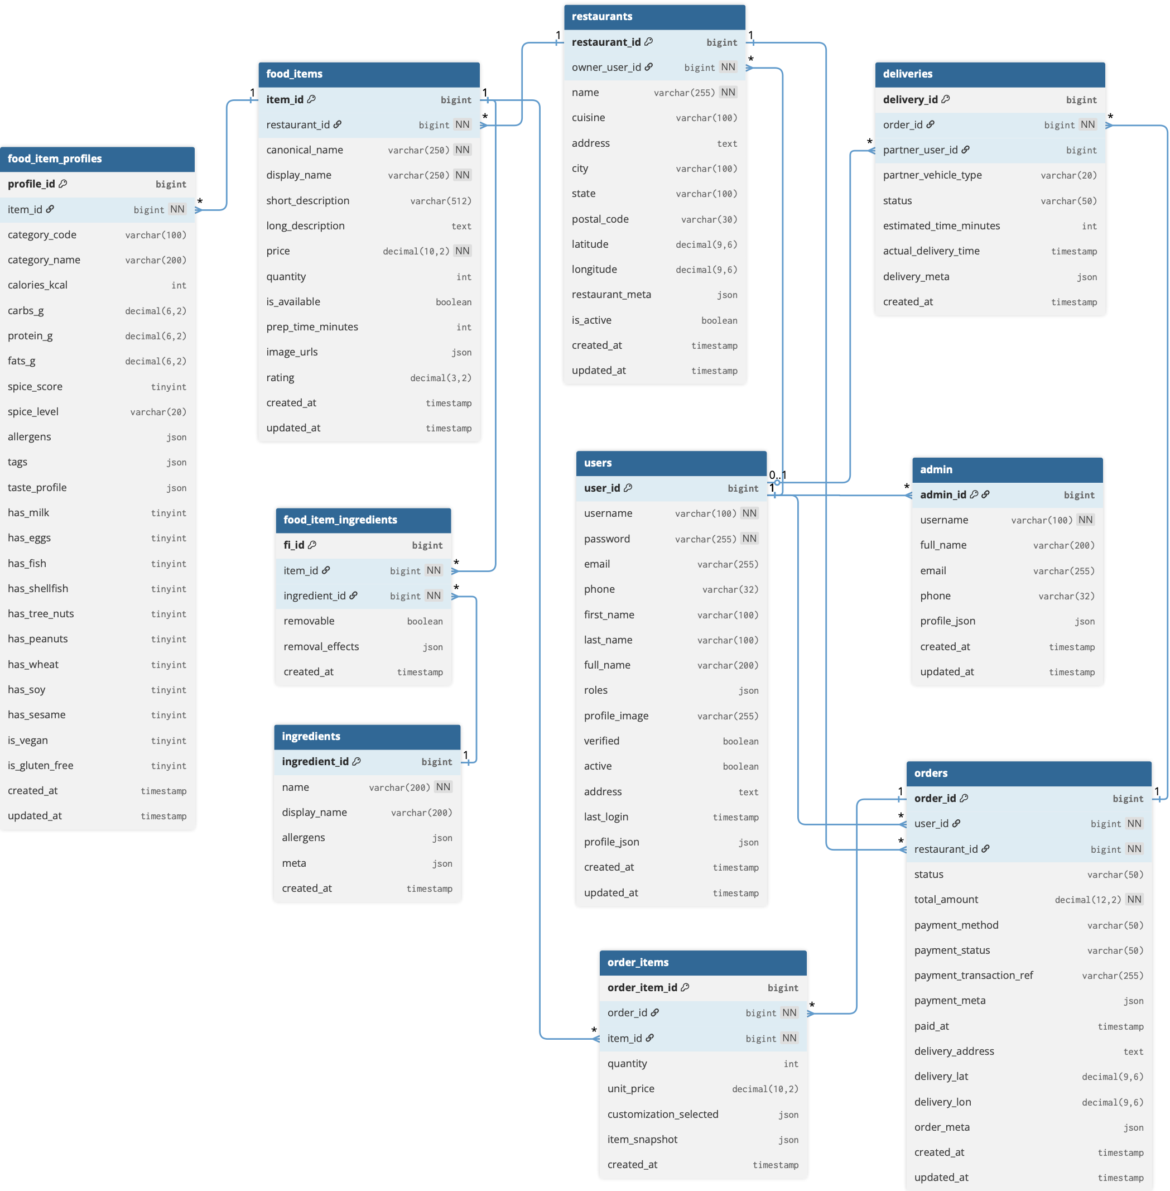

Data Directory

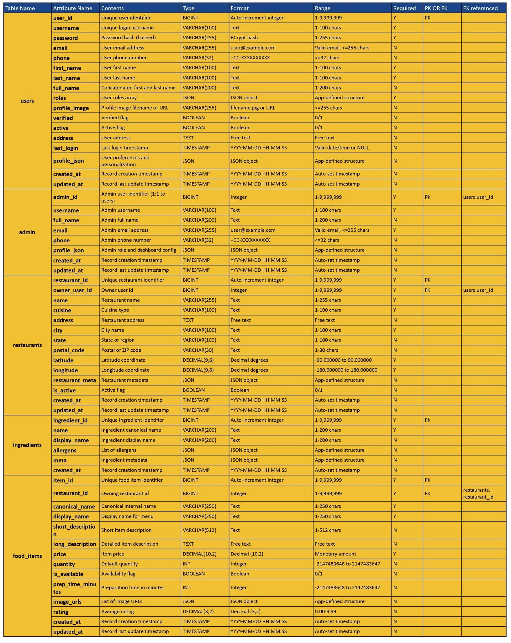

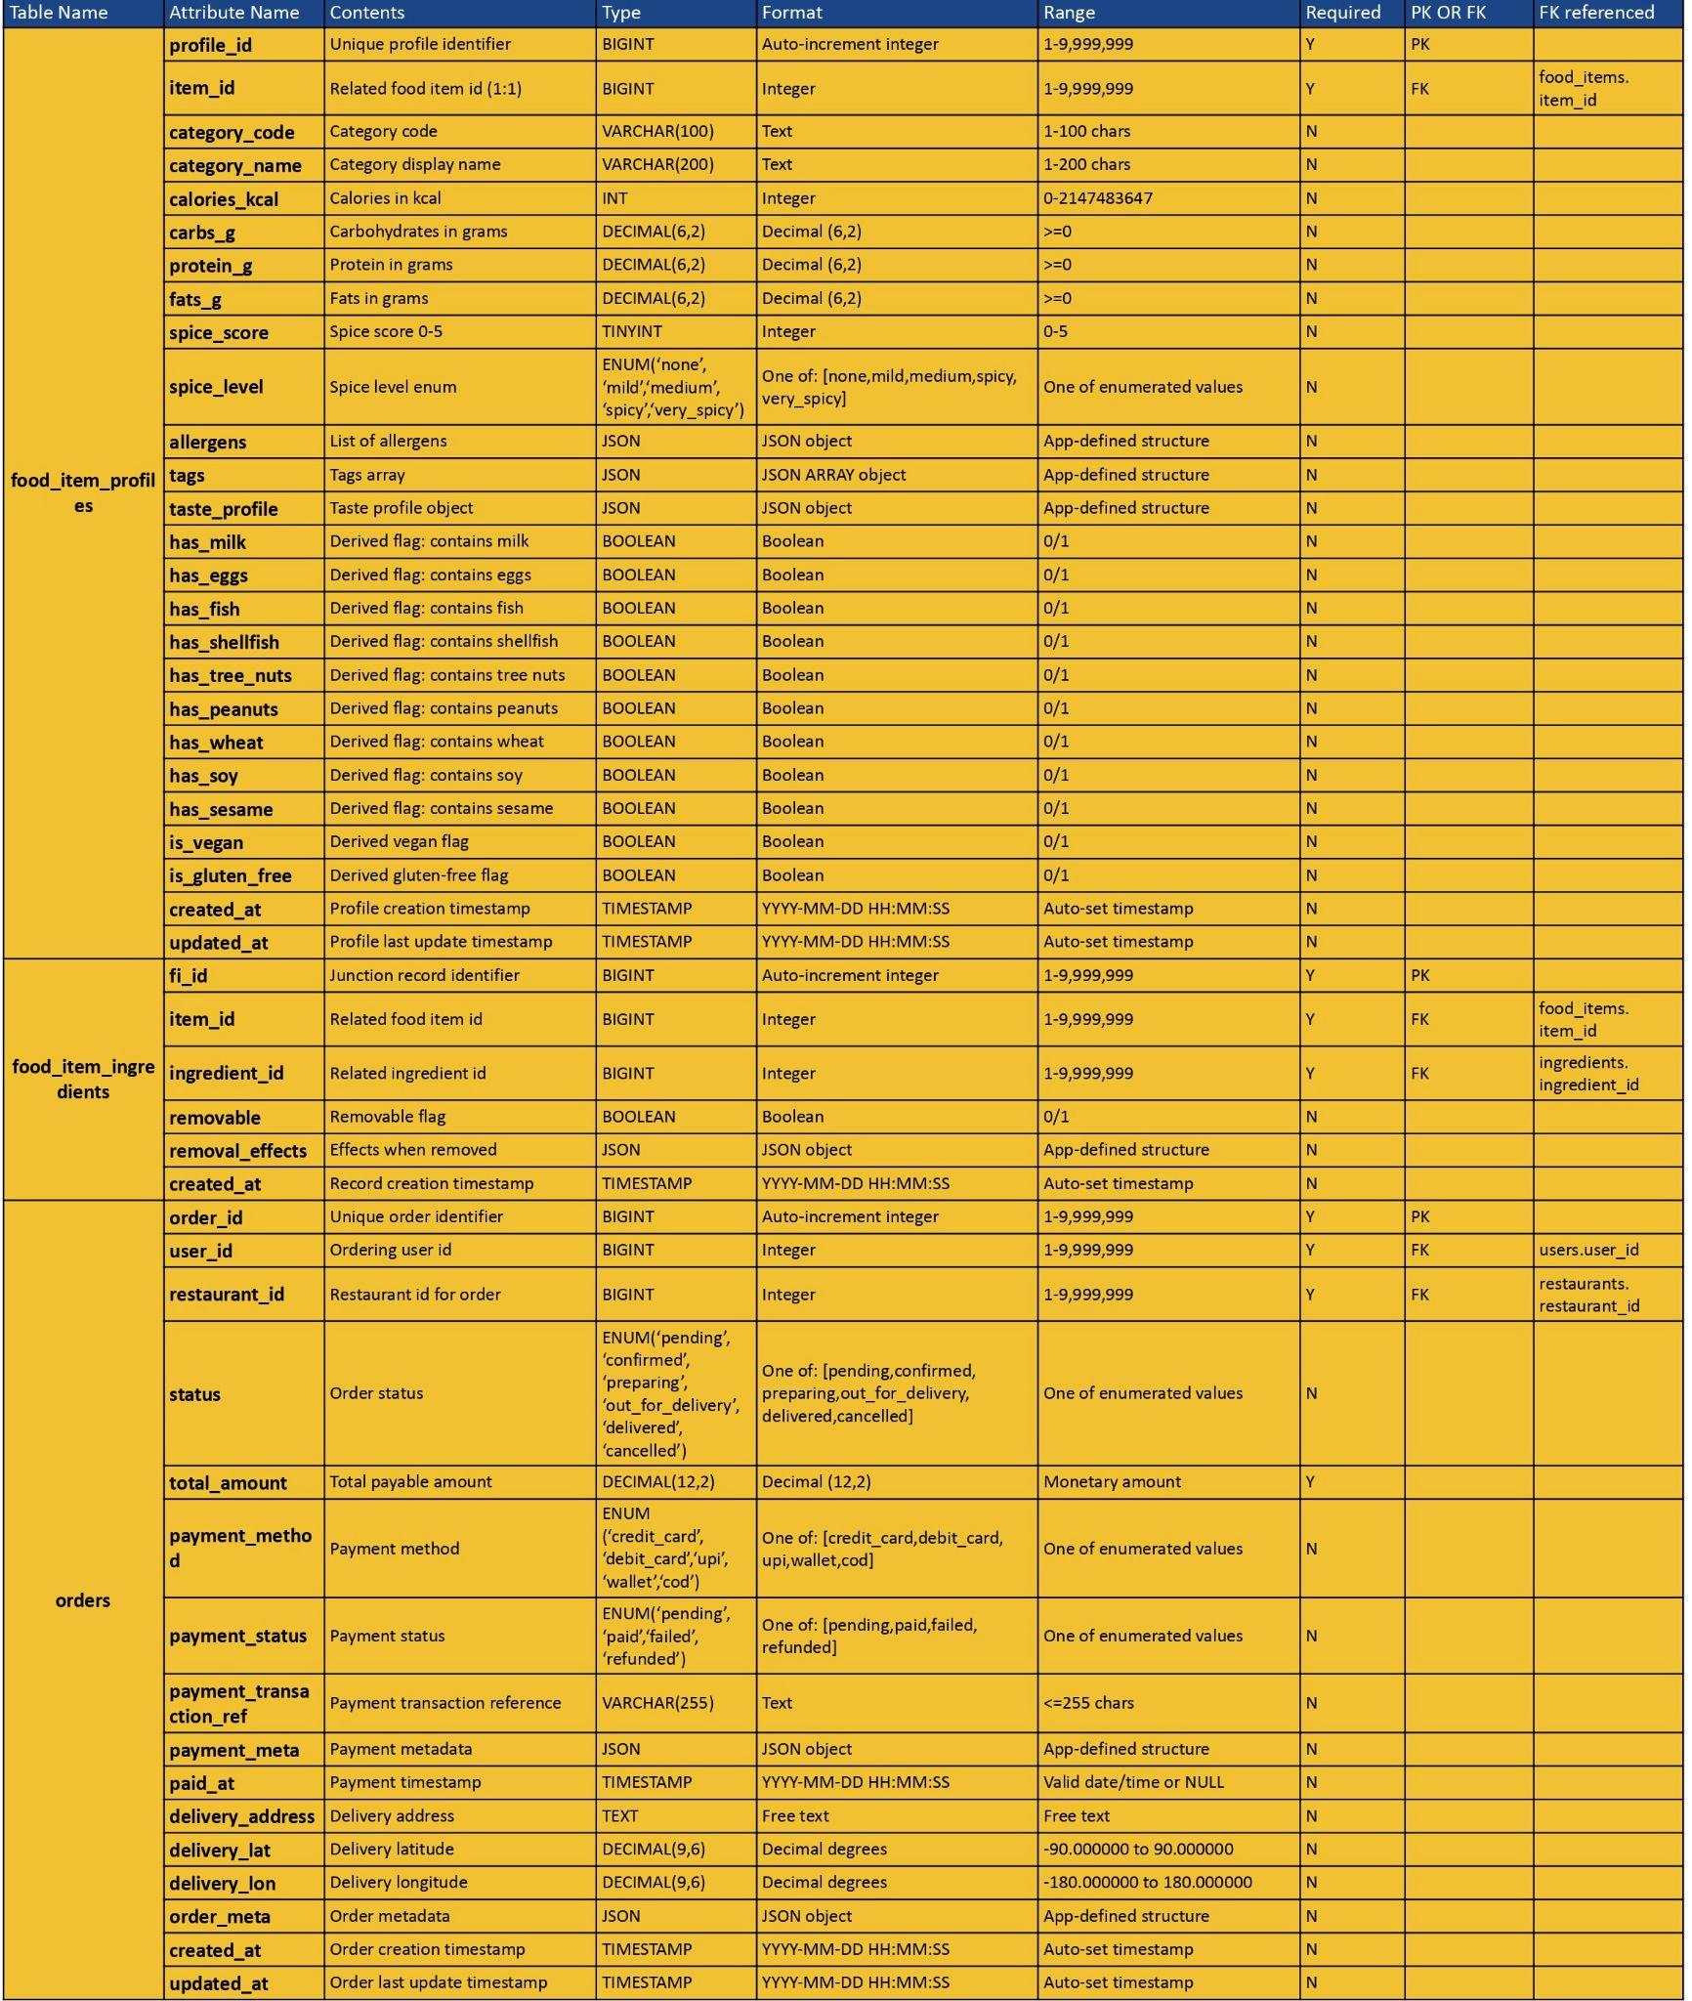

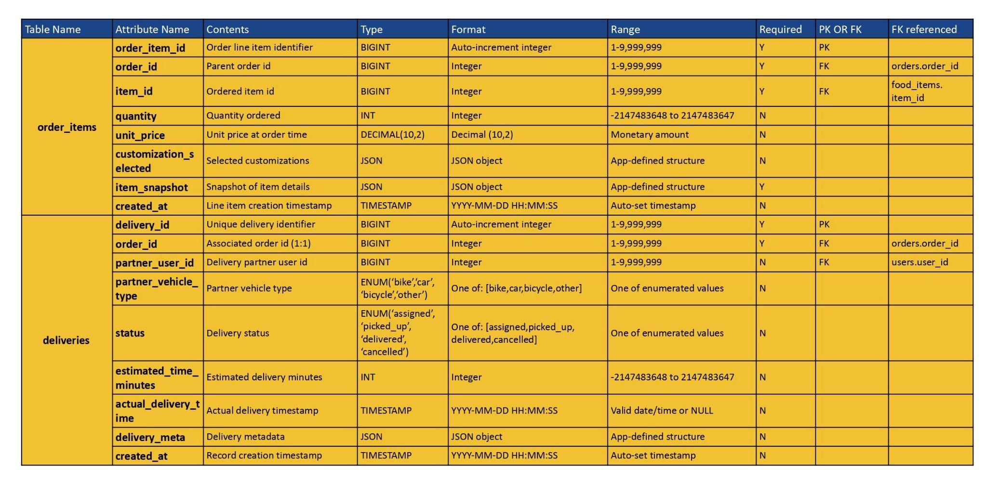

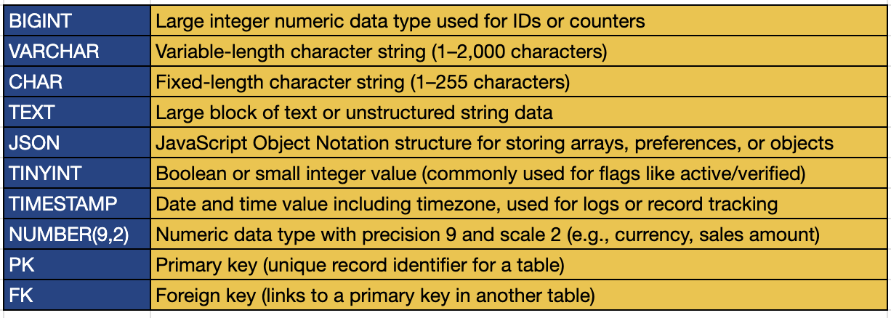

Sample Data
