EXPT.NO : 1A | ARRAY BASED IMPLEMENTATION OF STACK
DATE:

AIM

ALGORITHM

PROGRAM
class Arraystack():
def __init__(self):
self.data=[]
def __len__(self):
return len(self.data)
def is_empty(self):
return len(self.data)==0
def push(self,e):
self.data.append(e)
def top(self):
if self.is_empty():
raise Empty(Stack is empty)
return self.data[-1]
def pop(self):
if self.is_empty():
raise Empty(Stack is empty)
return self.data.pop()

S=Arraystack()
S.push(90)
S.push(37)
print(len(S))
print(S.pop())
print(S.is_empty())
print(S.pop())
print(S.is_empty())
S.push(67)
S.push(39)
print(S.top())
S.push(45)
print(len(S))
print(S.pop())
S.push(67)

OUTPUT
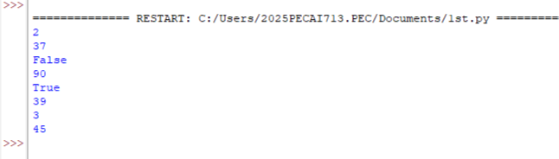

RESULT

EXPT.NO : 1A | ARRAY BASED IMPLEMENTATION OF QUEUE
DATE:

AIM

ALGORITHM

PROGRAM
class Arrayqueue:
DEFAULT_CAPACITY=5
def __init__(self):
self.data=[None]
self.size=0
self.front=0
def __len__(self):
return self.size()
def is_empty(self):
return self.size==0
def first(self):
if self.is_empty():
raise Exception("Queue is empty")
return self.data[self.front]
def display(self):
for i in self.data:
print(i)
def dequeue(self):
if self.is_empty():
raise Exception("Queue is empty")
answer=self.data[self.front]
self.data[self.front]=None
self.front=(self.front+1)%len(self.data)
self.size-=1
return answer
def enqueue(self,e):
if self.size==len(self.data):
self.resize(2*len(self.data))
avail=(self.front+self.size)%len(self.data)
self.data[avail]=e
self.size+=1
def resize(self,cap):
old=self.data
self.data=[None]*cap
walk=self.front
for k in range(self.size):
self.data[k]=old[walk]
walk=(1+walk)%len(old)
self.front=0
q=Arrayqueue()
q.enqueue(64)
q.enqueue(77)
q.enqueue(69)
print(q.dequeue())
print(q.is_empty())
print(q.first())
q.display()

OUTPUT
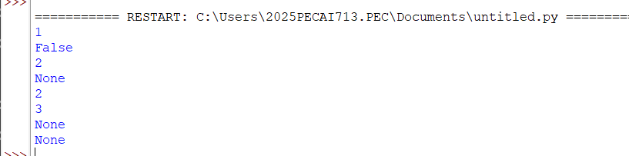

RESULT

EXPT.NO : 2 | EVALUATING POSTFIX EXPRESSION
DATE:

AIM

ALGORITHM

PROGRAM
def evaluate_postfix(postfix_expr):
stack = []
operators = {'+', '-', '*', '/', '%', '^'}
for elem in postfix_expr:
if elem not in operators:
stack.append(float(elem))
else:
b = stack.pop()
a = stack.pop()
if elem == '+':
stack.append(a + b)
elif elem == '-':
stack.append(a - b)
elif elem == '*':
stack.append(a * b)
elif elem == '/':
stack.append(a / b)
elif elem == '%':
stack.append(a % b)
elif elem == '^':
stack.append(a ** b)
return stack.pop()
postfix = "236*+"
print("{}: {}".format(postfix, evaluate_postfix(postfix)))
postfix = "23*6+"
print("{}: {}".format(postfix, evaluate_postfix(postfix)))
postfix = "23*42/+"
print("{}: {}".format(postfix, evaluate_postfix(postfix)))

OUTPUT
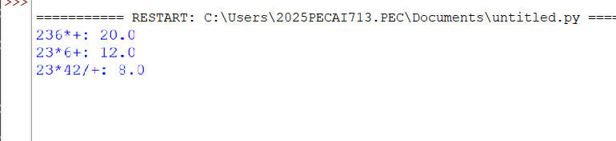

RESULT

EXPT.NO : 3 | BINARY SEARCH TREE OPERATIONS
DATE:

AIM

ALGORITHM

PROGRAM
class Node:
def __init__(self, key):
self.key = key
self.left = None
self.right = None
def inorder(root):
if root is not None:
inorder(root.left)
print(root.key)
inorder(root.right)
def insert(node, key):
if node is None:
return Node(key)
if key < node.key:
node.left = insert(node.left, key)
else:
node.right = insert(node.right, key)
return node
def minValueNode(node):
current = node
while current.left is not None:
current = current.left
return current
def deleteNode(root, key):
if root is None:
return root
if key < root.key:
root.left = deleteNode(root.left, key)

elif key > root.key:
root.right = deleteNode(root.right, key)
else:
if root.left is None:
temp = root.right
root = None
return temp
elif root.right is None:
temp = root.left
root = None
return temp
temp = minValueNode(root.right)
root.key = temp.key
root.right = deleteNode(root.right, temp.key)
return root
root = None
root = insert(root, 15)
root = insert(root, 10)
root = insert(root, 20)
root = insert(root, 8)
root = insert(root, 12)
root = insert(root, 16)
root = insert(root, -2)
print("Inorder traversal of the given tree")
inorder(root)
print("\nDelete 12")
root = deleteNode(root, 12)
print("Inorder traversal of the modified tree")
inorder(root)

OUTPUT
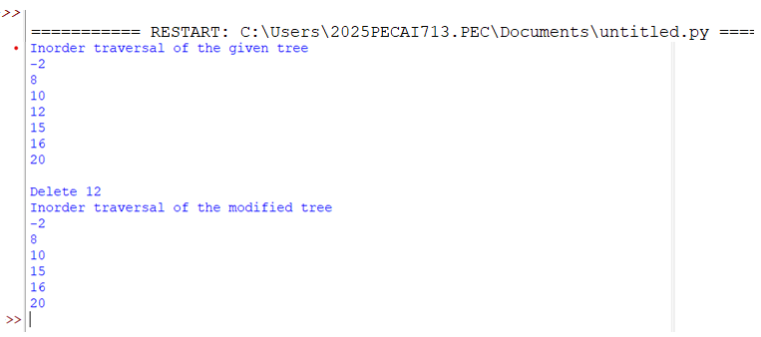

RESULT

EXPT.NO : 4 | AVL TREE IMPLEMENTATION
DATE:

AIM

ALGORITHM

PROGRAM
class treeNode(object):
def __init__(self, value):
self.value = value
self.l = None
self.r = None
self.h = 1
class AVLTree(object):
def insert(self, root, key):
if not root:
return treeNode(key)
elif key < root.value:
root.l = self.insert(root.l, key)
else:
root.r = self.insert(root.r, key)
root.h = 1 + max(self.getHeight(root.l),
self.getHeight(root.r))
b = self.getBal(root)
if b > 1 and key < root.l.value:
return self.rRotate(root)
if b < -1 and key > root.r.value:
return self.lRotate(root)
if b > 1 and key > root.l.value:
root.l = self.lRotate(root.l)
return self.rRotate(root)
if b < -1 and key < root.r.value:
root.r = self.rRotate(root.r)
return self.lRotate(root)
return root
def lRotate(self, z):
y = z.r
T2 = y.l
y.l = z
z.r = T2
z.h = 1 + max(self.getHeight(z.l),
self.getHeight(z.r))
y.h = 1 + max(self.getHeight(y.l),
self.getHeight(y.r))
return y
def rRotate(self, z):
y = z.l
T3 = y.r
y.r = z
z.l = T3
z.h = 1 + max(self.getHeight(z.l),
self.getHeight(z.r))
y.h = 1 + max(self.getHeight(y.l),
self.getHeight(y.r))
return y
def getHeight(self, root):
if not root:
return 0
return root.h
def getBal(self, root):
if not root:
return 0
return self.getHeight(root.l) - self.getHeight(root.r)
def preOrder(self, root):
if not root:
return
print("{0} ".format(root.value), end="")
self.preOrder(root.l)
self.preOrder(root.r)
Tree = AVLTree()
root = None
root = Tree.insert(root, 1)
root = Tree.insert(root, 2)
root = Tree.insert(root, 3)
root = Tree.insert(root, 4)
root = Tree.insert(root, 5)
root = Tree.insert(root, 6)
print("Preorder traversal of the constructed AVL tree is")
Tree.preOrder(root)
print()

OUTPUT
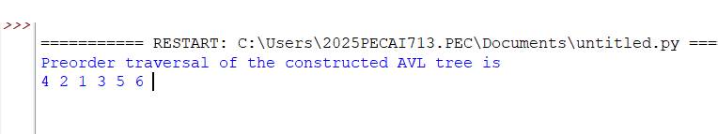

RESULT

EXPT.NO : 5 | RED BLACK TREE IMPLRMRNTATION
DATE:

AIM

ALGORITHM

PROGRAM
import sys
class Node():
def __init__(self, item):
self.item = item
self.parent = None
self.left = None
self.right = None
self.color = 1
class RedBlackTree():
def __init__(self):
self.TNULL = Node(0)
self.TNULL.color = 0
self.TNULL.left = None
self.TNULL.right = None
self.root = self.TNULL
def pre_order_helper(self, node):
if node != self.TNULL:
sys.stdout.write(str(node.item) + " ")
self.pre_order_helper(node.left)
self.pre_order_helper(node.right)
def in_order_helper(self, node):
if node != self.TNULL:
self.in_order_helper(node.left)
sys.stdout.write(str(node.item) + " ")
self.in_order_helper(node.right)
def post_order_helper(self, node):
if node != self.TNULL:
self.post_order_helper(node.left)
self.post_order_helper(node.right)
sys.stdout.write(str(node.item) + " ")
def search_tree_helper(self, node, key):
if node == self.TNULL or key == node.item:
return node
if key < node.item:
return self.search_tree_helper(node.left, key)
return self.search_tree_helper(node.right, key)
def minimum(self, node):
while node.left != self.TNULL:
node = node.left
return node
def left_rotate(self, x):
y = x.right
x.right = y.left
if y.left != self.TNULL:
y.left.parent = x
y.parent = x.parent
if x.parent == None:
self.root = y
elif x == x.parent.left:
x.parent.left = y
else:
x.parent.right = y
y.left = x
x.parent = y
def right_rotate(self, x):
y = x.left
x.left = y.right
if y.right != self.TNULL:
y.right.parent = x
y.parent = x.parent
if x.parent == None:
self.root = y
elif x == x.parent.right:
x.parent.right = y
else:
x.parent.left = y
y.right = x
x.parent = y
def fix_insert(self, k):
while k.parent.color == 1:
if k.parent == k.parent.parent.right:
u = k.parent.parent.left
if u.color == 1:
u.color = 0
k.parent.color = 0
k.parent.parent.color = 1
k = k.parent.parent
else:
if k == k.parent.left:
k = k.parent
self.right_rotate(k)
k.parent.color = 0
k.parent.parent.color = 1
self.left_rotate(k.parent.parent)
else:
u = k.parent.parent.right
if u.color == 1:
u.color = 0
k.parent.color = 0
k.parent.parent.color = 1
k = k.parent.parent
else:
if k == k.parent.right:
k = k.parent
self.left_rotate(k)
k.parent.color = 0
k.parent.parent.color = 1
self.right_rotate(k.parent.parent)
if k == self.root:
break
self.root.color = 0
def insert(self, key):
node = Node(key)
node.parent = None
node.item = key
node.left = self.TNULL
node.right = self.TNULL
node.color = 1
y = None
x = self.root
while x != self.TNULL:
y = x
if node.item < x.item:
x = x.left
else:
x = x.right
node.parent = y
if y == None:
self.root = node
elif node.item < y.item:
y.left = node
else:
y.right = node
if node.parent == None:
node.color = 0
return
if node.parent.parent == None:
return
self.fix_insert(node)
def rb_transplant(self, u, v):
if u.parent == None:
self.root = v
elif u == u.parent.left:
u.parent.left = v
else:
u.parent.right = v
v.parent = u.parent
def delete_node_helper(self, node, key):
z = self.TNULL
while node != self.TNULL:
if node.item == key:
z = node
if node.item <= key:
node = node.right
else:
node = node.left
if z == self.TNULL:
print("Cannot find key in the tree")
return
y = z
y_original_color = y.color
if z.left == self.TNULL:
x = z.right
self.rb_transplant(z, z.right)
elif z.right == self.TNULL:
x = z.left
self.rb_transplant(z, z.left)
else:
y = self.minimum(z.right)
y_original_color = y.color
x = y.right
if y.parent == z:
x.parent = y
else:
self.rb_transplant(y, y.right)
y.right = z.right
y.right.parent = y
self.rb_transplant(z, y)
y.left = z.left
y.left.parent = y
y.color = z.color
def delete_node(self, item):
self.delete_node_helper(self.root, item)
def print_helper(self, node, indent, last):
if node != self.TNULL:
sys.stdout.write(indent)
if last:
sys.stdout.write("R----")
indent += " "
else:
sys.stdout.write("L----")
indent += "| "
s_color = "RED" if node.color == 1 else "BLACK"
print(str(node.item) + "(" + s_color + ")")
self.print_helper(node.left, indent, False)
self.print_helper(node.right, indent, True)
def print_tree(self):
self.print_helper(self.root, "", True)
if __name__ == "__main__":
bst = RedBlackTree()
bst.insert(55)
bst.insert(40)
bst.insert(65)
bst.insert(60)
bst.insert(75)
bst.insert(57)
bst.print_tree()
print("\nAfter deleting an element")
bst.delete_node(40)
bst.print_tree()

OUTPUT
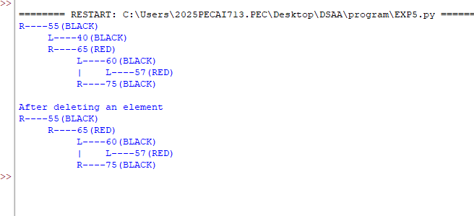

RESULT

EXPT.NO : 6 | QUICK SORT
DATE:

AIM

ALGORITHM

PROGRAM
def quickSort(arr):
if len(arr) <= 1:
return arr
else:
pivot = arr[0]
left = []
right = []
for i in range(1, len(arr)):
if arr[i] < pivot:
left.append(arr[i])
else:
right.append(arr[i])
return quickSort(left) + [pivot] + quickSort(right)
# Driver Code
arr = [10, 7, 8, 9, 1, 5]
print("Original array is:")
print(arr)
sorted_arr = quickSort(arr)
print("Sorted array is:")
print(sorted_arr)

OUTPUT
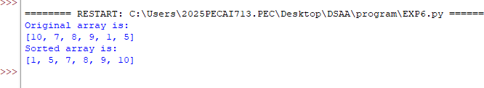

RESULT

EXPT.NO : 7 | MINIMUM COST SPANNING TREE USING GREEDY APPROACH
DATE:

AIM

ALGORITHM

PROGRAM
INF = 999999
N = 5 # Number of vertices in graph
# Creating graph by adjacency matrix method
G = [
[0, 9, 75, 0, 0],
[9, 0, 95, 19, 42],
[75, 95, 0, 51, 66],
[0, 19, 51, 0, 31],
[0, 42, 66, 31, 0]
]
selected = [0, 0, 0, 0, 0]
no_edge = 0
selected[0] = True
print("Edge : Weight")
while (no_edge < N - 1):
minimum = INF
a = 0
b = 0
for m in range(N):
if selected[m]:
for n in range(N):
if ((not selected[n]) and G[m][n]):
if minimum > G[m][n]:
minimum = G[m][n]
a = m
b = n
print(str(a) + "-" + str(b) + ":" + str(G[a][b]))
selected[b] = True

no_edge += 1

OUTPUT
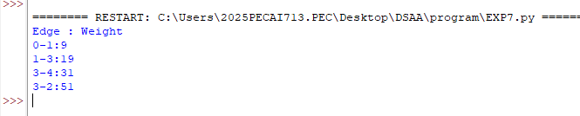

RESULT

EXPT.NO : 8 | HUFFMAN CODING
DATE:

AIM

ALGORITHM

PROGRAM
from collections import Counter
import heapq
class node:
def __init__(self, freq, symbol, left=None, right=None):
self.freq = freq
self.symbol = symbol
self.left = left
self.right = right
self.huff = ''
def __lt__(self, nxt):
return self.freq < nxt.freq
def printNodes(node, val=''):
newVal = val + node.huff
if node.left:
printNodes(node.left, newVal)
if node.right:
printNodes(node.right, newVal)
if not node.left and not node.right:
print(node.symbol, ":", newVal)
# Main Program
chars = ['A', 'B', 'C', 'D']
freq = [5, 1, 6, 3]
nodes = []
for x in range(len(chars)):
heapq.heappush(nodes, node(freq[x], chars[x]))
while len(nodes) > 1:
left = heapq.heappop(nodes)
right = heapq.heappop(nodes)
left.huff = '0'
right.huff = '1'
newNode = node(left.freq + right.freq,
left.symbol + right.symbol,
left, right)
heapq.heappush(nodes, newNode)
printNodes(nodes[0])

OUTPUT
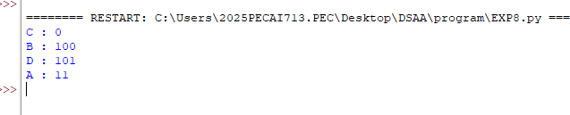

RESULT

EXPT.NO : 9 | SPARSE MATRIX TRANSPOSE
DATE:

AIM

ALGORITHM

PROGRAM
sparseMatrix = [
[0, 0, 3, 0, 4],
[0, 0, 5, 7, 0],
[0, 0, 0, 0, 0],
[0, 2, 6, 0, 0]
]
size = 0
for i in range(4):
for j in range(5):
if sparseMatrix[i][j] != 0:
size += 1
rows, cols = (3, size)
compactMatrix = [[0 for i in range(cols)] for j in range(rows)]
k = 0
for i in range(4):
for j in range(5):
if sparseMatrix[i][j] != 0:
compactMatrix[0][k] = i
compactMatrix[1][k] = j
compactMatrix[2][k] = sparseMatrix[i][j]
k += 1
for i in compactMatrix:
print(i)

OUTPUT
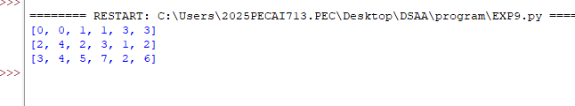

RESULT

EXPT.NO : 10 | ALL PAIRS SHORTEST PATH PROBLEM USING DYNAMIC PROGRAMMING
DATE:

AIM

ALGORITHM

PROGRAM
INF = 99999
def floydWarshall(graph, n):
dist = graph
for k in range(n):
for i in range(n):
for j in range(n):
dist[i][j] = min(dist[i][j],
dist[i][k] + dist[k][j])
print(dist)
return dist
graph = [
[0, 5, INF, INF],
[50, 0, 15, 5],
[30, INF, 0, 15],
[15, INF, 5, 0] ]
floydWarshall(graph, 4)

OUTPUT
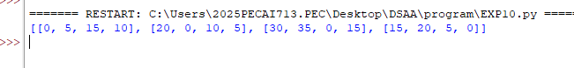

RESULT

EXPT.NO : 11 | BACKTRACKING – N QUEENS PROBLEM
DATE:

AIM

ALGORITHM

PROGRAM
N = 4
def printSolution(board):
for i in range(N):
for j in range(N):
print(board[i][j], end=" ")
print()
def isSafe(board, row, col):
for i in range(col):
if board[row][i] == 1:
return False
i = row
j = col
while i >= 0 and j >= 0:
if board[i][j] == 1:
return False
i -= 1
j -= 1
i = row
j = col
while i < N and j >= 0:
if board[i][j] == 1:
return False
i += 1
j -= 1
return True
def solveNQUtil(board, col):
if col >= N:
return True
for i in range(N):
if isSafe(board, i, col):
board[i][col] = 1
if solveNQUtil(board, col + 1):
return True
board[i][col] = 0
return False
def solveNQ():
board = [[0 for x in range(N)] for y in range(N)]
if not solveNQUtil(board, 0):
print("Solution does not exist")
return False
printSolution(board)
return True
# Driver Code
solveNQ()

OUTPUT
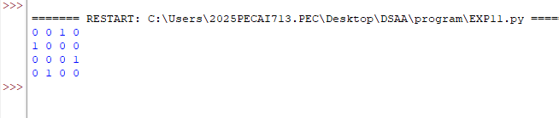

RESULT

EXPT.NO : 12 | PROGRAM TO IMPLEMENT TRAVELLING SALESMAN PROBLEM
DATE:

AIM

ALGORITHM

PROGRAM
import math
maxsize = float('inf')
def copyToFinal(curr_path):
final_path[:N + 1] = curr_path[:]
final_path[N] = curr_path[0]
def firstMin(adj, i):
min = maxsize
for k in range(N):
if adj[i][k] < min and i != k:
min = adj[i][k]
return min
def secondMin(adj, i):
first, second = maxsize, maxsize
for j in range(N):
if i == j:
continue
if adj[i][j] <= first:
second = first
first = adj[i][j]
elif adj[i][j] <= second and \
adj[i][j] != first:
second = adj[i][j]
return second
def TSPRec(adj, curr_bound, curr_weight,
level, curr_path, visited):
global final_res
if level == N:
if adj[curr_path[level - 1]][curr_path[0]] != 0:
curr_res = curr_weight + adj[curr_path[level - 1]][curr_path[0]]
if curr_res < final_res:
copyToFinal(curr_path)
final_res = curr_res
return
for i in range(N):
if adj[curr_path[level - 1]][i] != 0 and \
visited[i] == False:
temp = curr_bound
curr_weight += adj[curr_path[level - 1]][i]
if level == 1:
curr_bound -= ((firstMin(adj, curr_path[level - 1]) +
firstMin(adj, i)) / 2)
else:
curr_bound -= ((secondMin(adj, curr_path[level - 1]) +
firstMin(adj, i)) / 2)
if curr_bound + curr_weight < final_res:
curr_path[level] = i
visited[i] = True
TSPRec(adj, curr_bound, curr_weight,
level + 1, curr_path, visited)
curr_weight -= adj[curr_path[level - 1]][i]
curr_bound = temp
visited = [False] * len(visited)
for j in range(level):
if curr_path[j] != -1:
visited[curr_path[j]] = True
def TSP(adj):
curr_bound = 0
curr_path = [-1] * (N + 1)
visited = [False] * N
for i in range(N):
curr_bound += (firstMin(adj, i) +
secondMin(adj, i))
curr_bound = math.ceil(curr_bound / 2)
visited[0] = True
curr_path[0] = 0
TSPRec(adj, curr_bound, 0, 1, curr_path, visited)
adj = [[0, 10, 15, 20],
[10, 0, 35, 25],
[15, 35, 0, 30],
[20, 25, 30, 0]]
N = 4
final_path = [None] * (N + 1)
visited = [False] * N
final_res = maxsize
TSP(adj)
print("Minimum cost :", final_res)
print("Path Taken : ", end=' ')
for i in range(N + 1):
print(final_path[i], end=' ')

OUTPUT
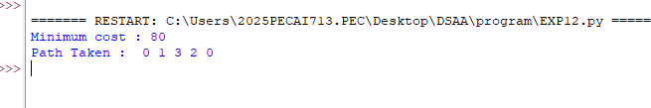
RESULT

EXPT.NO : 13 | APPROXIMATION ALGORITHM FOR KNAPSACK PROBLEM
DATE:

AIM

ALGORITHM

PROGRAM
class Item:
def __init__(self, value, weight):
self.value = value
self.weight = weight
class Node:
def __init__(self, level, profit, bound, weight):
self.level = level
self.profit = profit
self.bound = bound
self.weight = weight
def bound(u, n, W, arr):
if u.weight >= W:
return 0
profit_bound = u.profit
j = u.level + 1
totweight = u.weight
while j < n and totweight + arr[j].weight <= W:
totweight += arr[j].weight
profit_bound += arr[j].value
j += 1
if j < n:
profit_bound += (W - totweight) * arr[j].value / arr[j].weight
return profit_bound
def knapsack(W, arr, n):
arr.sort(key=lambda x: x.value / x.weight, reverse=True)
queue = []
u = Node(-1, 0, 0, 0)
v = Node(-1, 0, 0, 0)
u.bound = bound(u, n, W, arr)
queue.append(u)
max_profit = 0
while queue:
u = queue.pop(0)
if u.level == -1:
v.level = 0
if u.level == n - 1:
continue
v.level = u.level + 1
v.weight = u.weight + arr[v.level].weight
v.profit = u.profit + arr[v.level].value
if v.weight <= W and v.profit > max_profit:
max_profit = v.profit
v.bound = bound(v, n, W, arr)
if v.bound > max_profit:
queue.append(Node(v.level, v.profit, v.bound, v.weight))
v.weight = u.weight
v.profit = u.profit
v.bound = bound(v, n, W, arr)
if v.bound > max_profit:
queue.append(Node(v.level, v.profit, v.bound, v.weight))
return max_profit
W = 10
arr = [Item(40, 2), Item(50, 3.14), Item(100, 1.98), Item(95, 5), Item(30, 3)]
n = len(arr)
print("Maximum profit is", knapsack(W, arr, n))

OUTPUT
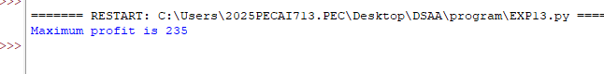

RESULT

