EXPT.NO : 1A | ARRAY BASED IMPLEMENTATION OF STACK
DATE:

AIM

ALGORITHM

PROGRAM
class Arraystack():
def __init__(self):
self.data=[]
def __len__(self):
return len(self.data)
def is_empty(self):
return len(self.data)==0
def push(self,e):
self.data.append(e)
def top(self):
if self.is_empty():
raise Empty(Stack is empty)
return self.data[-1]
def pop(self):
if self.is_empty():
raise Empty(Stack is empty)
return self.data.pop()

S=Arraystack()
S.push(90)
S.push(37)
print(len(S))
print(S.pop())
print(S.is_empty())
print(S.pop())
print(S.is_empty())
S.push(67)
S.push(39)
print(S.top())
S.push(45)
print(len(S))
print(S.pop())
S.push(67)

OUTPUT
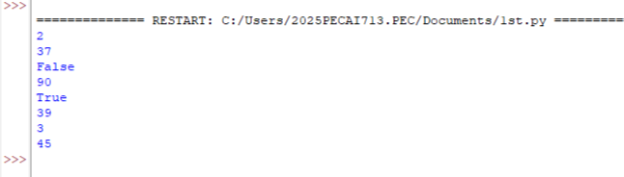

RESULT

EXPT.NO : 1A | ARRAY BASED IMPLEMENTATION OF QUEUE
DATE:

AIM

ALGORITHM

PROGRAM
class Arrayqueue:
DEFAULT_CAPACITY=5
def __init__(self):
self.data=[None]
self.size=0
self.front=0
def __len__(self):
return self.size()
def is_empty(self):
return self.size==0
def first(self):
if self.is_empty():
raise Exception("Queue is empty")
return self.data[self.front]
def display(self):
for i in self.data:
print(i)
def dequeue(self):
if self.is_empty():
raise Exception("Queue is empty")
answer=self.data[self.front]
self.data[self.front]=None
self.front=(self.front+1)%len(self.data)
self.size-=1
return answer
def enqueue(self,e):
if self.size==len(self.data):
self.resize(2*len(self.data))
avail=(self.front+self.size)%len(self.data)
self.data[avail]=e
self.size+=1
def resize(self,cap):
old=self.data
self.data=[None]*cap
walk=self.front
for k in range(self.size):
self.data[k]=old[walk]
walk=(1+walk)%len(old)
self.front=0
q=Arrayqueue()
q.enqueue(64)
q.enqueue(77)
q.enqueue(69)
print(q.dequeue())
print(q.is_empty())
print(q.first())
q.display()

OUTPUT
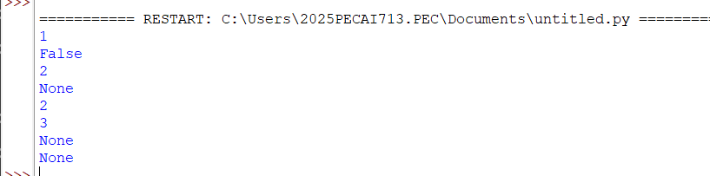

RESULT

EXPT.NO : 2 | EVALUATING POSTFIX EXPRESSION
DATE:

AIM

ALGORITHM

PROGRAM
def evaluate_postfix(postfix_expr):
stack = []
operators = {'+', '-', '*', '/', '%', '^'}
for elem in postfix_expr:
if elem not in operators:
stack.append(float(elem))
else:
b = stack.pop()
a = stack.pop()
if elem == '+':
stack.append(a + b)
elif elem == '-':
stack.append(a - b)
elif elem == '*':
stack.append(a * b)
elif elem == '/':
stack.append(a / b)
elif elem == '%':
stack.append(a % b)
elif elem == '^':
stack.append(a ** b)
return stack.pop()
postfix = "236*+"
print("{}: {}".format(postfix, evaluate_postfix(postfix)))
postfix = "23*6+"
print("{}: {}".format(postfix, evaluate_postfix(postfix)))
postfix = "23*42/+"
print("{}: {}".format(postfix, evaluate_postfix(postfix)))

OUTPUT
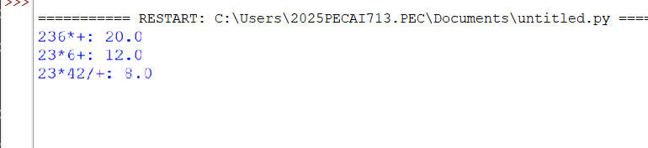

RESULT

EXPT.NO : 3 | BINARY SEARCH TREE OPERATIONS
DATE:

AIM

ALGORITHM

PROGRAM
class Node:
def __init__(self, key):
self.key = key
self.left = None
self.right = None
def inorder(root):
if root is not None:
inorder(root.left)
print(root.key)
inorder(root.right)
def insert(node, key):
if node is None:
return Node(key)
if key < node.key:
node.left = insert(node.left, key)
else:
node.right = insert(node.right, key)
return node
def minValueNode(node):
current = node
while current.left is not None:
current = current.left
return current
def deleteNode(root, key):
if root is None:
return root
if key < root.key:
root.left = deleteNode(root.left, key)

elif key > root.key:
root.right = deleteNode(root.right, key)
else:
if root.left is None:
temp = root.right
root = None
return temp
elif root.right is None:
temp = root.left
root = None
return temp
temp = minValueNode(root.right)
root.key = temp.key
root.right = deleteNode(root.right, temp.key)
return root
root = None
root = insert(root, 15)
root = insert(root, 10)
root = insert(root, 20)
root = insert(root, 8)
root = insert(root, 12)
root = insert(root, 16)
root = insert(root, -2)
print("Inorder traversal of the given tree")
inorder(root)
print("\nDelete 12")
root = deleteNode(root, 12)
print("Inorder traversal of the modified tree")
inorder(root)

OUTPUT
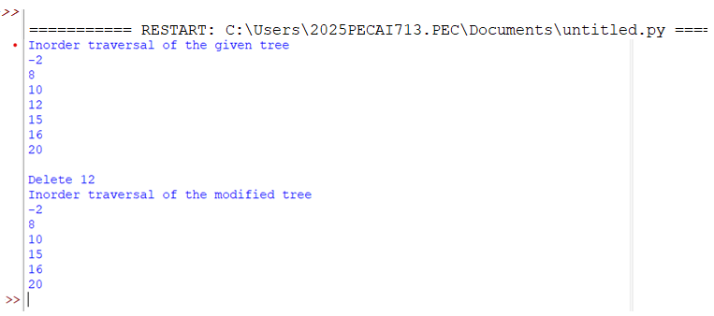

RESULT

EXPT.NO : 4 | AVL TREE IMPLEMENTATION
DATE:

AIM

ALGORITHM

PROGRAM
class treeNode(object):
def __init__(self, value):
self.value = value
self.l = None
self.r = None
self.h = 1
class AVLTree(object):
def insert(self, root, key):
if not root:
return treeNode(key)
elif key < root.value:
root.l = self.insert(root.l, key)
else:
root.r = self.insert(root.r, key)
root.h = 1 + max(self.getHeight(root.l),
self.getHeight(root.r))
b = self.getBal(root)
if b > 1 and key < root.l.value:
return self.rRotate(root)
if b < -1 and key > root.r.value:
return self.lRotate(root)
if b > 1 and key > root.l.value:
root.l = self.lRotate(root.l)
return self.rRotate(root)
if b < -1 and key < root.r.value:
root.r = self.rRotate(root.r)
return self.lRotate(root)
return root
def lRotate(self, z):
y = z.r
T2 = y.l
y.l = z
z.r = T2
z.h = 1 + max(self.getHeight(z.l),
self.getHeight(z.r))
y.h = 1 + max(self.getHeight(y.l),
self.getHeight(y.r))
return y
def rRotate(self, z):
y = z.l
T3 = y.r
y.r = z
z.l = T3
z.h = 1 + max(self.getHeight(z.l),
self.getHeight(z.r))
y.h = 1 + max(self.getHeight(y.l),
self.getHeight(y.r))
return y
def getHeight(self, root):
if not root:
return 0
return root.h
def getBal(self, root):
if not root:
return 0
return self.getHeight(root.l) - self.getHeight(root.r)
def preOrder(self, root):
if not root:
return
print("{0} ".format(root.value), end="")
self.preOrder(root.l)
self.preOrder(root.r)
Tree = AVLTree()
root = None
root = Tree.insert(root, 1)
root = Tree.insert(root, 2)
root = Tree.insert(root, 3)
root = Tree.insert(root, 4)
root = Tree.insert(root, 5)
root = Tree.insert(root, 6)
print("Preorder traversal of the constructed AVL tree is")
Tree.preOrder(root)
print()

OUTPUT
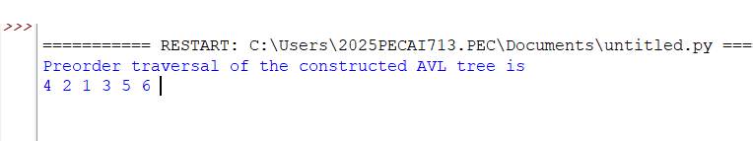

RESULT

