Capstone Project

Review-1 Report

**Team details:**

Rohith Reddy Dirisala (19BCE7303)

Hruthik Yadav Madati (19BCN7092)

**Online Auction system**

**Motivation:**

Traditional Auction houses have been around for a very long time. But they have certain shortcomings such as the scope of the bidding which is mostly restricted to local population. So, we are building a website for the auctions to be available for larger section of people and can be completed effectively.

The system is designed to allow users to set up their products for auctions and bidders to register and bid for various products available for bidding. Since the items are put to bidding online, we cannot the verify the entities put by regular users online. Hence, we are considering to allow the items of enterprises only to be put on the website for bidding. This ensures the quality of the products put on the website.

**Problem Identification:**

In a traditional auction, potential buyers get the chance to examine items up close and ask questions before purchasing. Bidders get an idea about what type of items will go up for auction and can estimate how much items may go for. Traditional auctions allow buyers to discuss items with the seller and get details about them before the auction begins. Traditional auctions also allow buyers to make educated purchasing decisions in person.

The main difference between traditional auctions and online auctions is that online auctions are meant for convenience. Items are listed on auction house websites in a catalog fashion, and buyers can click on them to learn more details about them. An online auction may be less expensive for sellers due to the elimination of costs associated with holding a traditional auction, but may limit buyers.Once buyers see items they are interested in, they can bid for purchases using their credit card information.

Online auctions are available to more potential buyers, not just buyers located in a specific area near the auction house. Having a wider range of bidders during an auction can be beneficial to the seller.

**Project Phases:**

1. Information gathering
2. Planning
3. Web design(Front-end development)
4. Back-end development
5. Content creation
6. Testing
7. Deployment

**Project Timeline:**

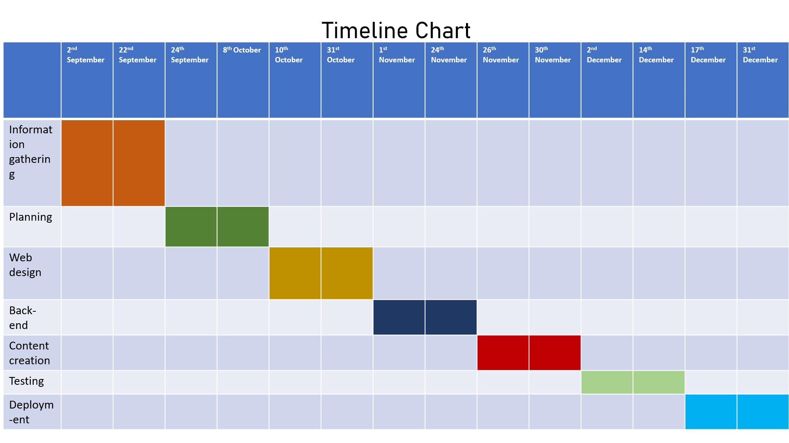

**Softwares/Tools used:**

**Front-end development:**

* HTML5
* CSS3
* JavaScript
* Visual studio code

**Back-end:**

* MySQL
* Java
* Php
* Eclipse IDE

**Testing:**

* Webload
* Burp Suite

**Web-Hosting:**

* Amazon Ec2 instances

**Collaboration:**

* GitHub
* Microsoft teams

**Other Documentation:**



***Use-case diagram:***

**System**

Admin

Seller

Customer